1. Simulator code
   1. 网络构建（很据点的个数和总的链接个数）,分两步进行：
2. Basic：逐渐增加点，分别连接到已有点。此步骤保证了所有点之间是连接的。
3. Random：随机选择两个点，建立连接。最终使连接数到达nMaxLinks。
   1. 模拟传播过程，获取在稳定前（不再传播）的步骤

稳定不表示所有点都被传播。

1. Experiments code

T1: Nodes with Links over Threshold of T1 will marked as T1



T2: Nodes with Links over Threshold of T2 and less than Threshold of T1 will marked as T2

P1: Probability of T1 to spread

P2: Probability of T2 to spread

函数列表如下，分别测试Threshold of T1 and Threshold Of T2， Probability of T1 to spread and Probability of T2 to spread, Probability of T2 to spread, Probability of T1 to spread, Threshold of T1, Threshold Of T2等参数的影响。

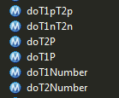



1. 实验结果

采用1000个点根据不同参数进行实验，结果如simulator.xlsx

* 1. Steps和 MaxLinks的关系

呈 Inverse曲线

* 1. Steps和Threshold of T1的关系

拟合度不好，Quadratic最高，只有.633

* 1. Steps和 Probability of T1 to spread的关系

S曲线拟合为.934

* 1. Steps和Threshold of T2的关系

Quadratic拟合为 .923

* 1. Steps和 Probability of T2 to spread的关系

S和Inverse曲线拟合度都为 .953

* 1. Steps和 Probability of T1 to spread, Probability of T2 to spread

呈曲面，有明确转折点

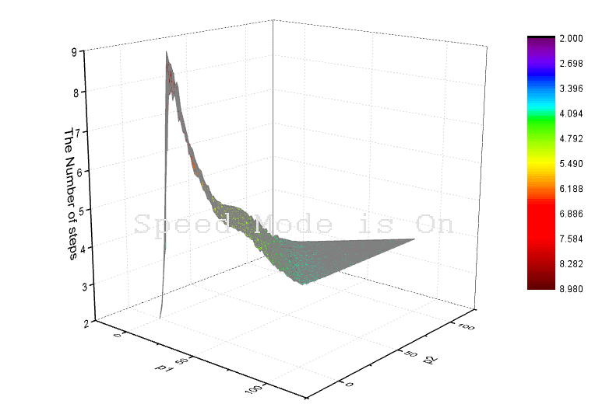

* 1. Steps和Threshold of T1, Threshold of T2

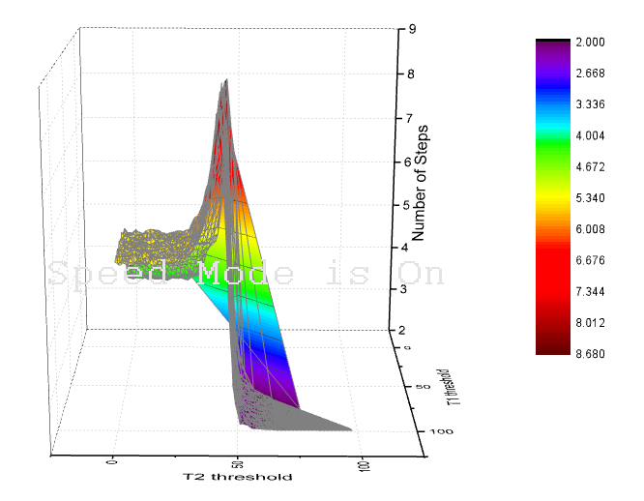



To do in future:

1. Visualize for diffusion
2. Statics the number of Spread nodes
3. P with followers



1. Read from network simulator
2. Probability to geolocation
3. Times



1. How did Tweets spread in spatial space?

