Task 1: Prompt Categorization

Categorize the following prompts into types (Instructional, Conversational, Visual, etc.) and
explain your reasoning:
- 'Generate a logo for a tech startup using neon colors.'
- 'Explain blockchain to a 5-year-old.'
- 'You are a UX designer. Suggest improvements to this app layout.'

1. "Generate a logo for a tech startup using neon colors."
- Category: Visual / Creative
- Reasoning: This prompt requests the creation of a visual element—a logo—focused on specific stylistic criteria (neon colors). It involves creativity and design, typically associated with visual outputs.

2. "Explain blockchain to a 5-year-old."
- Category: Instructional / Educational
- Reasoning: This prompt asks for an explanation tailored to a very young audience, which is an educational or instructional task. It involves simplifying complex information for teaching purposes.

3. "You are a UX designer. Suggest improvements to this app layout."
- Category: Professional / Advisory / Instructional
- Reasoning: This prompt requests a professional critique and suggestions, invoking a role-based perspective (UX designer). It’s advisory and instructional, focusing on improving design usability.

Task 2: Refinement Practice

Given vague prompts, refine them to be more effective. Example:
Original: 'Make a poster.' → Refined: 'Create a poster for a school science fair with a blue
background, cartoon robots, and bold text saying SCIENCE EXPO 2025.'

1. Original:
"Write a story."
Refined:
"Write a short story about a young explorer discovering a hidden treasure in a magical forest, aimed at children aged 8-12."

2. Original:
"Design a website."
Refined:
"Design a clean, modern website homepage for a local bakery featuring a pastel color scheme, images of fresh pastries, and an easy-to-use online ordering button."

3. Original:
"Create a presentation."
Refined:
"Create a 10-slide presentation explaining the impact of climate change on ocean life, including visuals like graphs, photos, and bullet points for a high school science class."

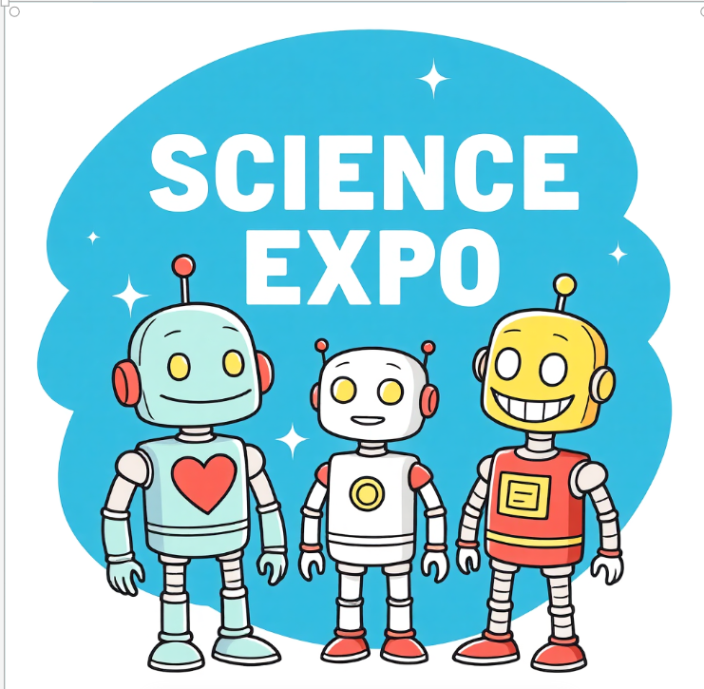

Task 3: Prompt Design Exercise

Design 5 original prompts for different domains:
- One for ChatGPT (text-based)
- One for DALL·E (image-based)
- One for SORA (video-based)
- One for coding or logic
- One for education or training

1. ChatGPT (text-based):
- Why it fits: ChatGPT excels at generating natural, nuanced text. This prompt taps into creative writing and role-playing by asking for a letter “from the perspective” of a specific character.
- Effectiveness: It gives clear guidance (motivational letter), specifies the tone (encouraging), and adds an interesting twist (historical figure’s perspective) that challenges the model to adopt a unique voice.
“Write a motivational letter from the perspective of a famous historical figure encouraging someone to pursue their dreams despite setbacks.”

Dear Dreamer,
I am Cristiano Ronaldo, and I want to tell you that every great achievement begins with a single step and a heart full of courage. Life will throw challenges your way, but remember, it is through perseverance that we rise above. Keep your eyes on your dreams, for they hold the promise of a brighter tomorrow. Do not be disheartened by failures; each one teaches you a lesson vital for success. Stand firm, and your efforts will bear fruit.
Yours sincerely,
Abraham Lincoln

2. DALL·E (image-based):
- Why it fits: DALL·E is designed to generate detailed images from descriptive text. This prompt paints a vivid picture with specific visual elements and atmosphere (sunset, neon accents).
- Effectiveness: It combines setting (futuristic cityscape at sunset), objects (floating gardens, skyscrapers, flying cars), and style (sleek, neon accents) — all clear descriptors that help guide the image creation.
“Create a futuristic cityscape at sunset featuring floating gardens, sleek skyscrapers with neon accents, and flying cars.”



3. SORA (video-based):
- Why it fits: SORA specializes in video production. This prompt focuses on creating an educational animation with clear content (bee pollination), duration (30 seconds), style (simple graphics), and tone (cheerful narration).
- Effectiveness: Specifies length and format, subject matter, and presentation style, ensuring the video is concise, informative, and engaging.
“Produce a 30-second animated explainer video showing how bees pollinate flowers and why they are vital for ecosystems, using simple graphics and cheerful narration.”

4. Coding or logic:
- Why it fits: This is a classic programming problem requiring logic and coding skills.
- Effectiveness: The prompt is clear about the input (list of names), output (dictionary grouped by first letter), and the programming language (Python), making the task precise and executable.

“Write a Python script that takes a list of names and returns a dictionary grouping the names by their first letter.”

program :
from collections import defaultdict
def group_names_by_first_letter(names):
grouped = defaultdict(list)
for name in names:
if name: # make sure it's not an empty string
first_letter = name[0].upper()
grouped[first_letter].append(name)
return dict(grouped)

# Example usage:
names_list = ["Alice", "Arjun", "Bob", "Bella", "Charlie", "Catherine", "David"]
result = group_names_by_first_letter(names_list)
print(result)

output :
{
'A': ['Alice', 'Arjun'],
'B': ['Bob', 'Bella'],
'C': ['Charlie', 'Catherine'],
'D': ['David']
}

5. Education or training:
- Why it fits: Education and training prompts involve creating structured content aimed at teaching or skill-building.
- Effectiveness: It defines the target audience (adults, beginners), the topic (financial literacy), and key concepts to cover (budgeting, saving, credit scores), helping ensure the workshop is focused and accessible.

Design a beginner-friendly workshop outline to teach adults basic financial literacy, covering budgeting, saving, and understanding credit scores.”

1. Introduction (10 minutes)
- Welcome & icebreaker: “What’s one thing you wish you knew about money earlier?”
- Workshop goals: Budgeting, Saving, and Understanding Credit Scores.
- Set expectations: No jargon, practical tips, open discussion.

2. Part One: Budgeting Basics (45 minutes)

Key Concepts:
- Why budgeting matters
- Needs vs. Wants
- The 50/30/20 rule (Needs/Wants/Savings)

Activities:
- Budget Game: Give participants a sample monthly income and a list of expenses. In small groups, they create a simple budget.
- Reflection: Ask, “Which expenses surprised you the most?”

Takeaway Tool:
- Handout or template for a simple monthly budget.

3. Part Two: Saving Smart (35 minutes)

Key Concepts:
- Importance of emergency funds
- Short-term vs. long-term savings goals
- Different savings options (savings accounts, recurring deposits, etc.)

Activities:
- Savings Goal Exercise: Each participant writes down one short-term and one long-term savings goal, then shares how they could achieve it.
- Discuss small strategies (round-up savings, auto-transfer, cutting small expenses).

Takeaway Tool:
- Goal-setting worksheet.

4. Part Three: Understanding Credit Scores (40 minutes)

Key Concepts:
- What a credit score is and why it matters
- Factors that affect credit scores (payment history, credit usage, etc.)
- How to build and maintain good credit

Activities:
- Credit Score Quiz: True/False style (e.g., “Paying only the minimum balance boosts your credit score” → False).
- Group discussion on myths vs. facts.

Takeaway Tool:
- Handout with credit score tips and myth-busting facts.

5. Wrap-Up & Action Plan (15 minutes)
- Quick recap of 3 key lessons: Budget, Save, Credit.
- Ask each participant to share one financial habit they will start this week.
- Provide resources: websites, budgeting apps, recommended books.

6. Optional Q&A + Networking (15 minutes)
- Open floor for questions.
- Encourage participants to exchange contacts for accountability partners.

Practice Activity (Live Testing)

Test your prompts using tools like:
- ChatGPT (for text or logic)
- DALL·E (for image generation)
- Canva AI or other visual tools
- Analyze the results and refine if necessary

1. ChatGPT prompt: Motivational letter from a historical figure

Prompt:
“Write a motivational letter from the perspective of a famous historical figure encouraging someone to pursue their dreams despite setbacks.”

Output (sample):
Dear Dreamer,
I am Abraham Lincoln, and I want to tell you that every great achievement begins with a single step and a heart full of courage. Life will throw challenges your way, but remember, it is through perseverance that we rise above. Keep your eyes on your dreams, for they hold the promise of a brighter tomorrow. Do not be disheartened by failures; each one teaches you a lesson vital for success. Stand firm, and your efforts will bear fruit.
Yours sincerely,
Abraham Lincoln

2. DALL.E

“Create a futuristic cityscape at sunset featuring floating gardens, sleek skyscrapers with neon accents, and flying cars.”

3 . Canva AI or other visual tools

“Design a poster about saving money for beginner”

