***A-100 Apprentice Testing and Tracking System***

***Spring 2015***

***Fairfield University***

*Developed By:*

*Divya Kamath*

*Subbarayudu Bodavula*

*Sohail Syed*

*Luke Auger*

*Nicholas Cummings*

*Sagar K S Gowda*

***Introduction***

The A-100 Online Apprentice Testing and Tracking system is a web based system for Apprentices and instructors. It allows Apprentices to take tests and get feedback from instructors on other soft skills. Apprentices are able to view and take tests assigned by instructors, as well as view results from past tests and track their own progress. Each Apprentice is given a Username and password. Instructors will be able to use the software to assign tests and provide feedback to Apprentices for other skills. Instructors can also use the software to track Apprentice’s progress. Instructors will also be given a username and password.

The software is accessed through a web browser, so it can be accessed by Apprentices and instructors anywhere there is an internet connection.

The backend for the software is written in MySQL, so there will need to be an installation of that on a standalone server.

**New User Registration:**

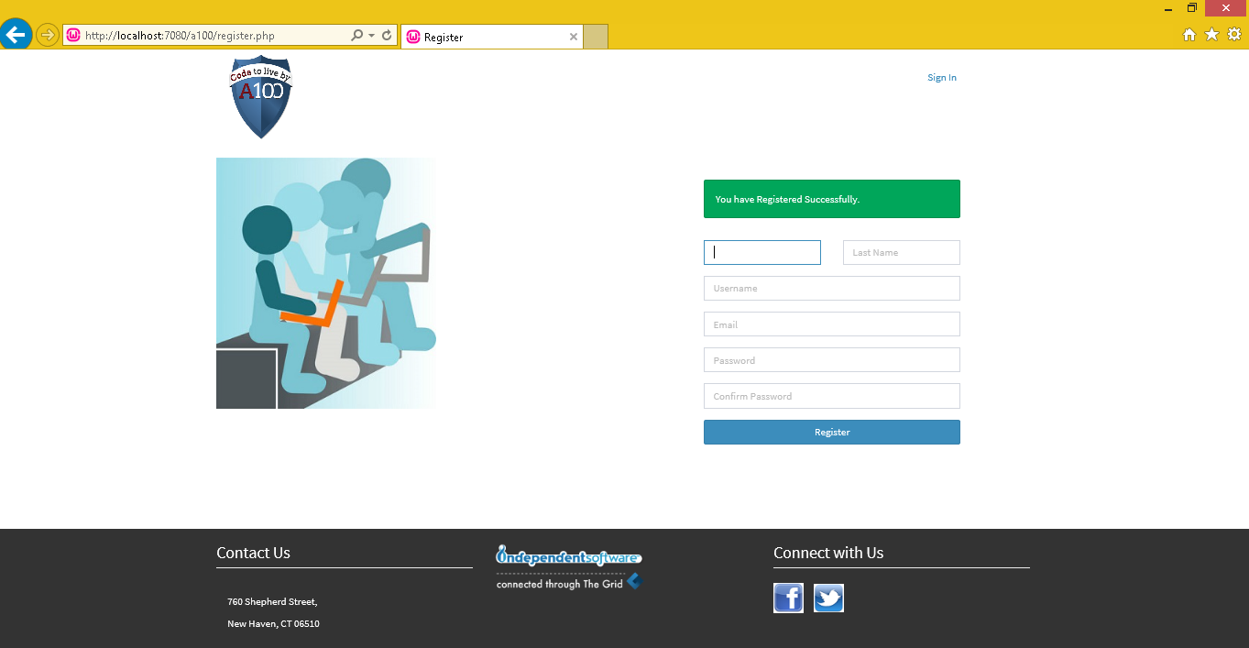

Here the Apprentice selects a username and password, and provides an email address to attach to the account. This email can be used to reset the Apprentices password if it is lost.

**Login:**

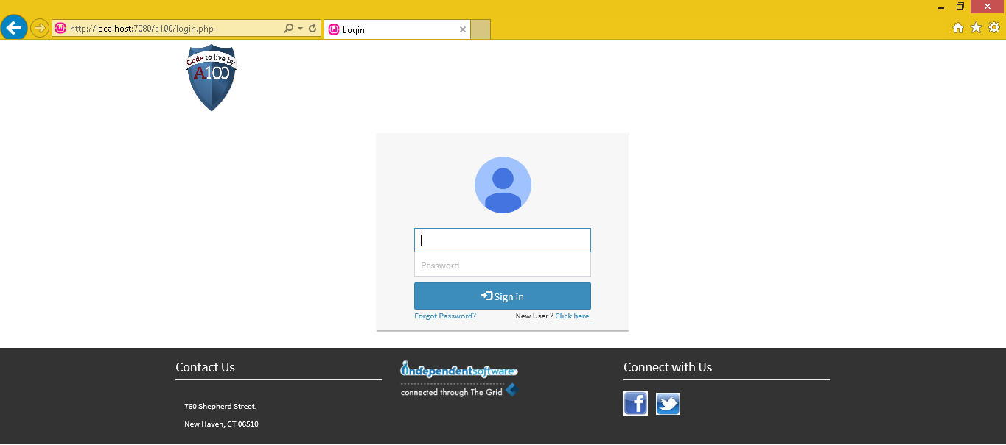

This is the homepage of the software, both Apprentices and instructors login from this screen and will be taken to their unique homepages. There is also a “forgot password” button from which Apprentices and administrators can reset their password using the email address linked to the account.

**Incorrect Password/Password Reset:**

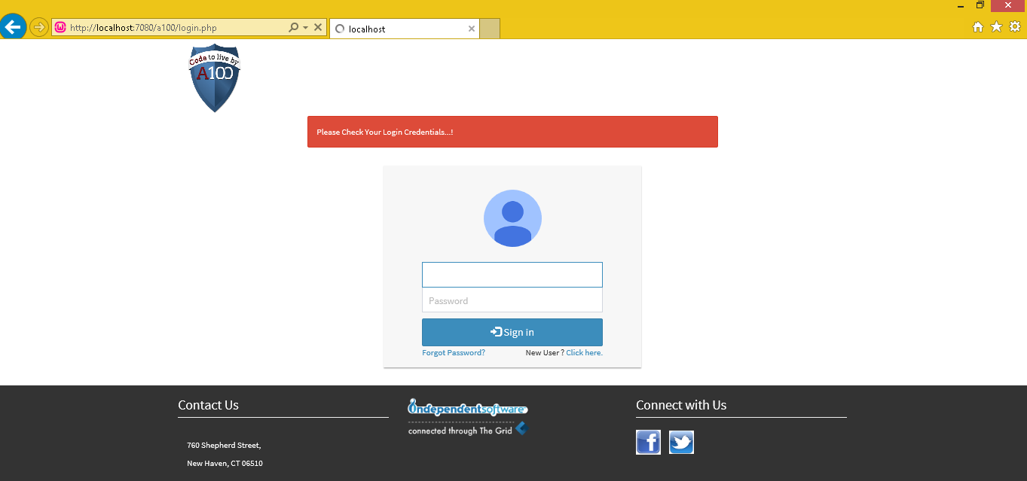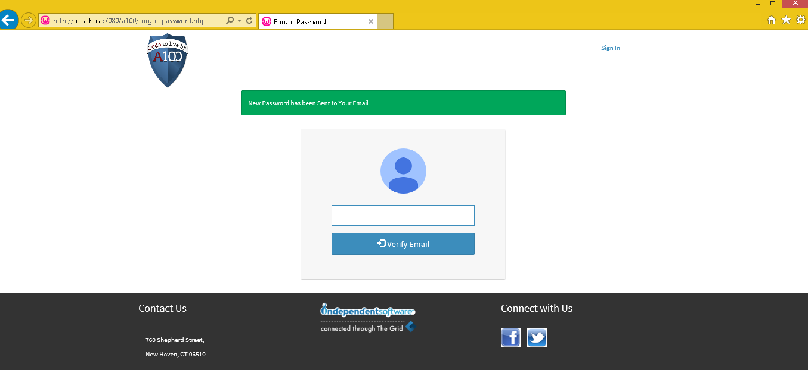

If the password or username entered is incorrect, the user is notified and prompted to re-enter both. If the password has been lost, it can be reset by clicking “Forgot password.” There, the user can enter the email attached to the account and a password reset will be sent.

**Apprentice’s** **Panel:**

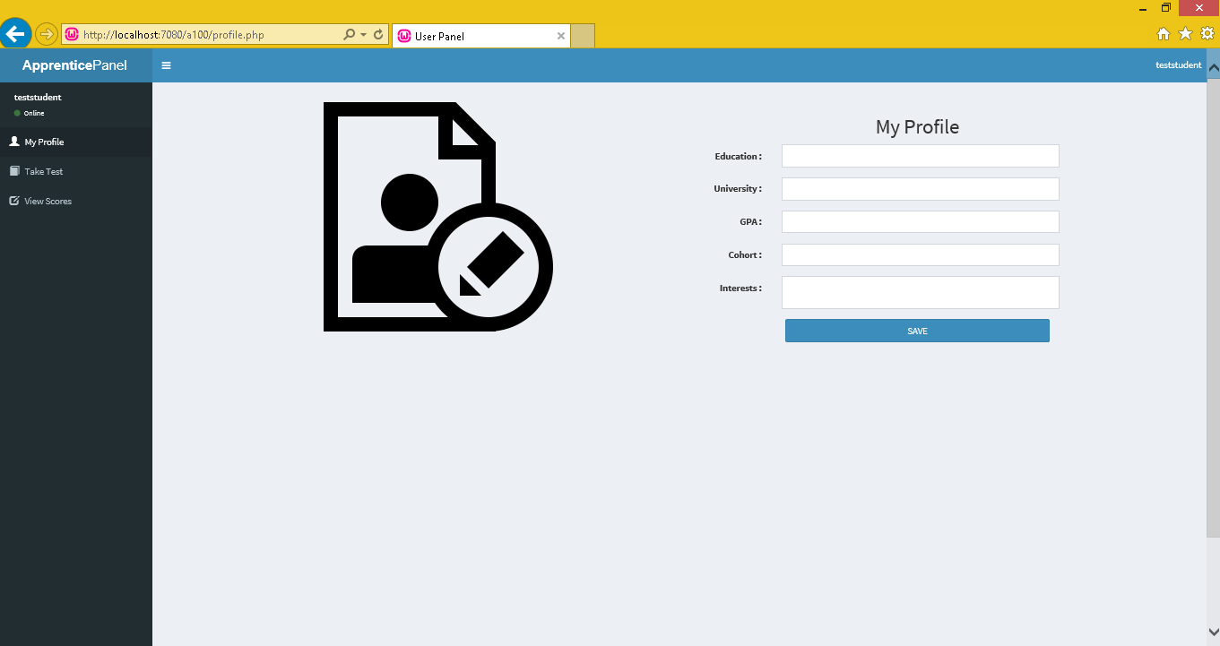

At the left of the Apprentice page is the navigation buttons for the Apprentice portal. “Take Tests” will take the Apprentice to a page with a list of the tests they have been assigned. “View Scores” will take the Apprentice to a page where they can view their results on both online tests and any other evaluations or feedback an instructor has given them. “My Profile” will take an Apprentice to their account page where they can change their password.

**Logout:**

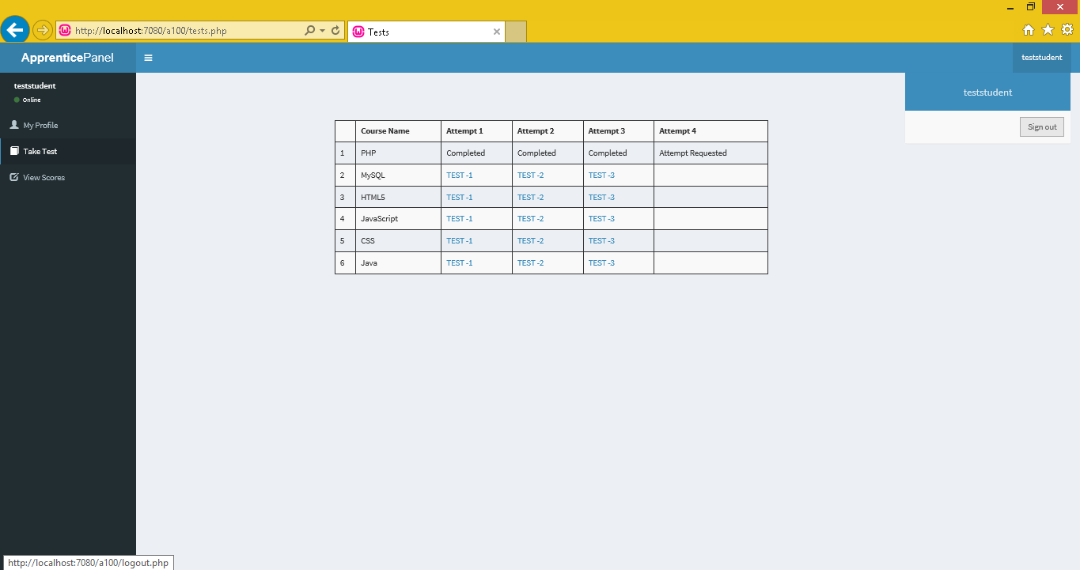

The Apprentice can logout by clicking their account name on the top right of any page. Never log out in the middle of a test as the answers will be lost.

**Testing:**

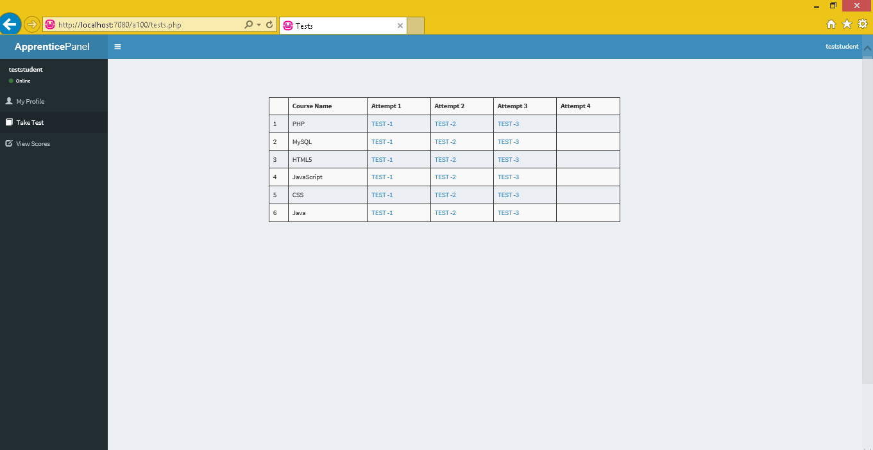

After navigating to “Take Tests” using the navigation bar, the Apprentice will be presented with an option to take any tests the instructor has uploaded. Clicking the button will initiate the test. Once the test is complete, it will be scored by the instructor who then can share the results with the Apprentice. The default number of times a test can be taken is three. If the Apprentice exhausts these and wishes to retake the test, they can send a retake request to the instructor, using the button displayed in the 4th column:

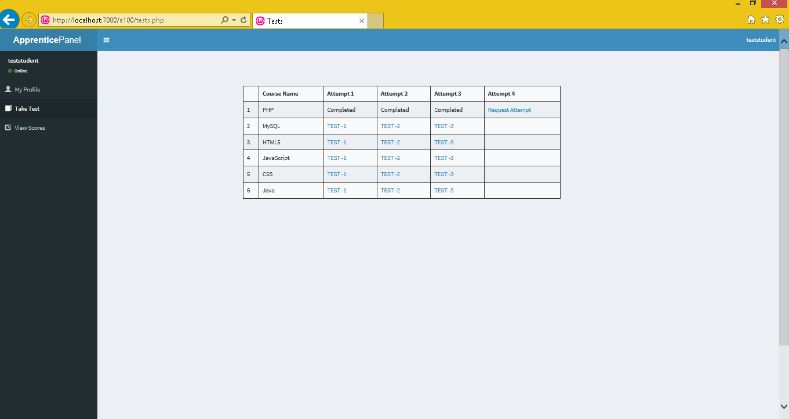

If the request is granted, a link labelled “Attempt 4” will appear which will allow the Apprentice to test again.

When a test is completed, the link will be replaced by the text “completed.”

**Viewing Results:**

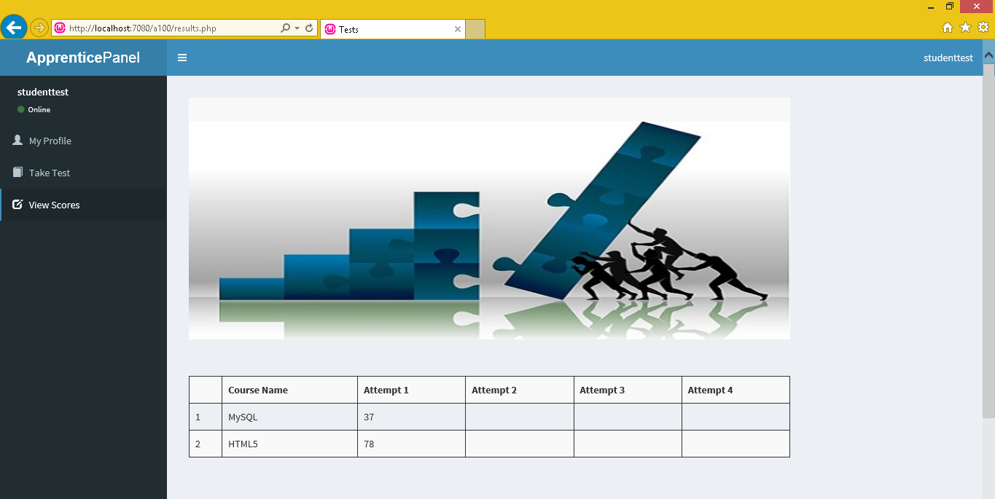

On this screen, the Apprentice can view the results of the tests he or she has taken. The name of the course is displayed in the left hand column, and the scores for the tests to the right. Tests are in order from least recent to most recent, left to right. This way, the Apprentice is able to compare old results to new ones and see improvement and progress in each course.

**Administrator Panel:**

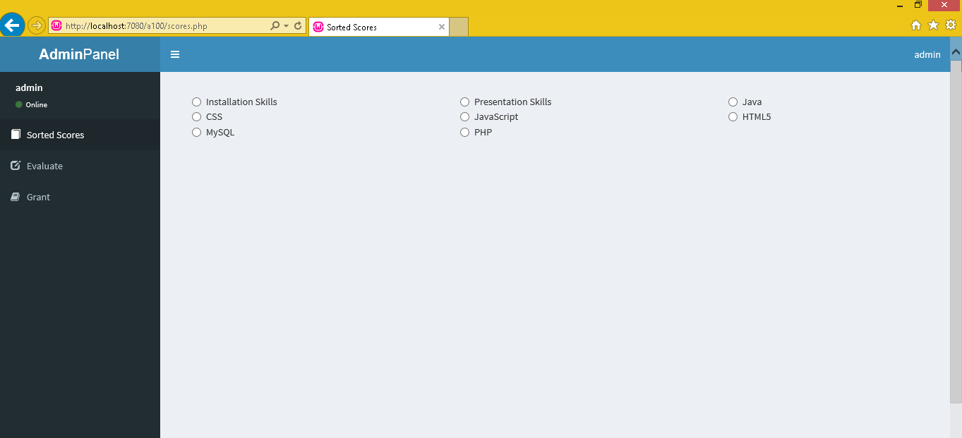

At the left of the instructor page is the main navigation buttons for the instructor portal. “Sorted Scores” will take the instructor to a list of graded tests can be viewed for each Apprentice. Tests can also be sorted by type of test taken. In “Evaluate,” the instructor can upload tests to be taken by the Apprentices. From this page, they can also provide feedback or grades for soft skills such as presentation skills or interview skills. “Grant” will take the instructor to a page where they can grant additional attempts at tests for Apprentices.

**Logout:**

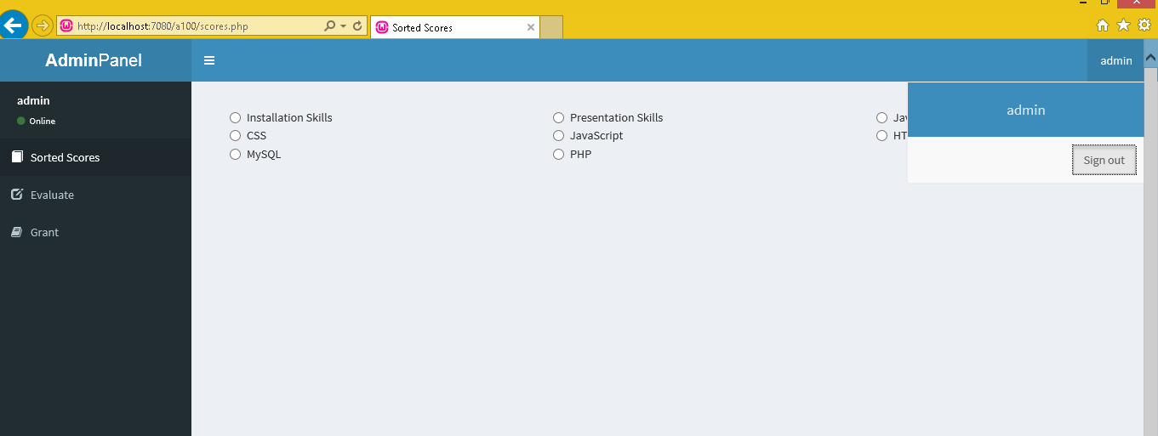

The administrator can logout by clicking their account name on the top right of any page. Never log out in the middle of grading or assigning a test as progress may not save.

**Evaluating Test Attempts:**

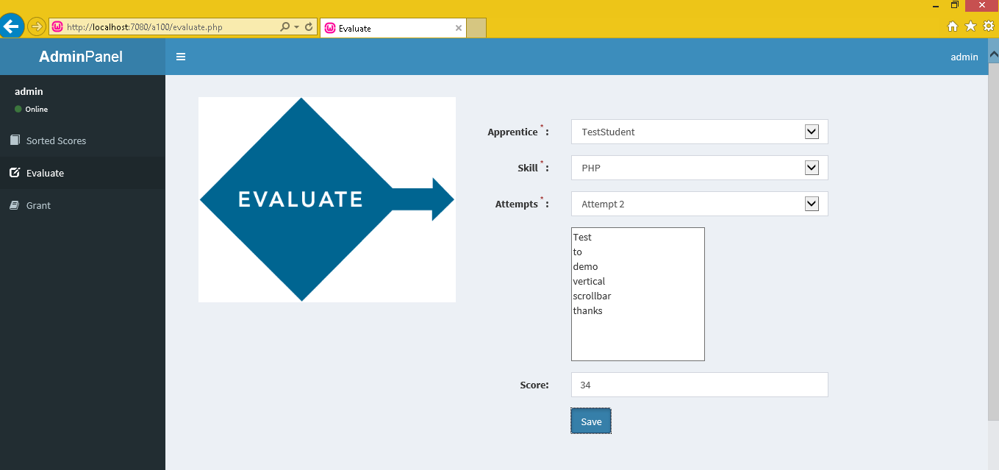

On the “Evaluate” page, the instructor can enter scores.

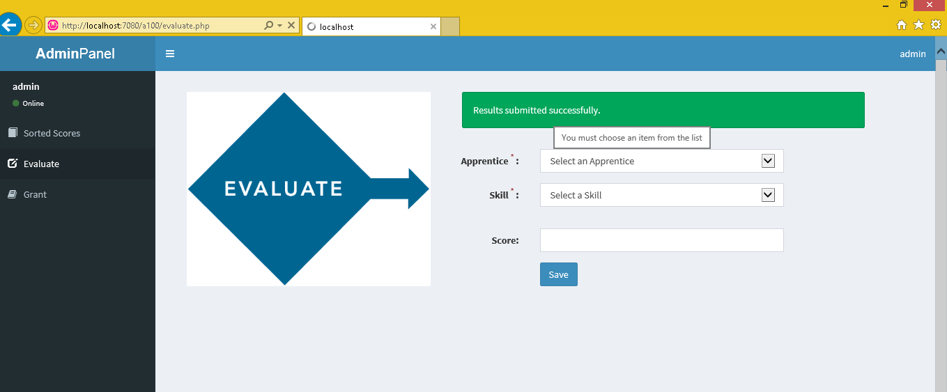

From here, the instructor will also be able to give feedback on soft skills observed in the classroom, such as presentation or speaking skills. When an instructor gives feedback and uploads it, the Apprentice can see the feedback or grade via the “View Scores” link at the left of their homepage.

**Apprentice** **Attempt Requests:**

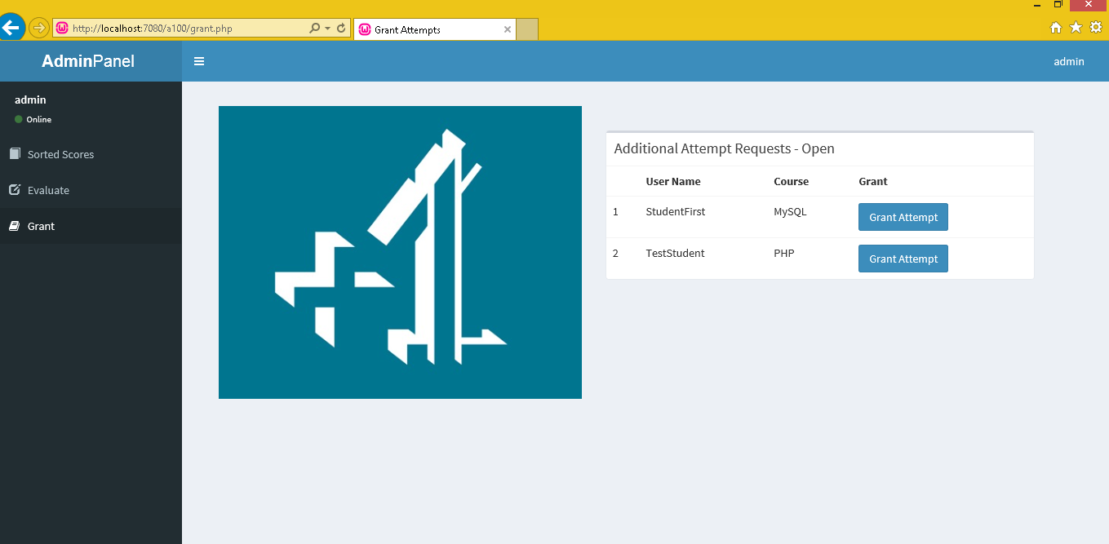

In the “Grant” page, the instructor can view requests from Apprentices for additional attempts for tests. Clicking “Grant Attempt” will give the Apprentice an additional request and the Apprentice will be able to then access that test again.

**Viewing Apprentice’s** **Results:**

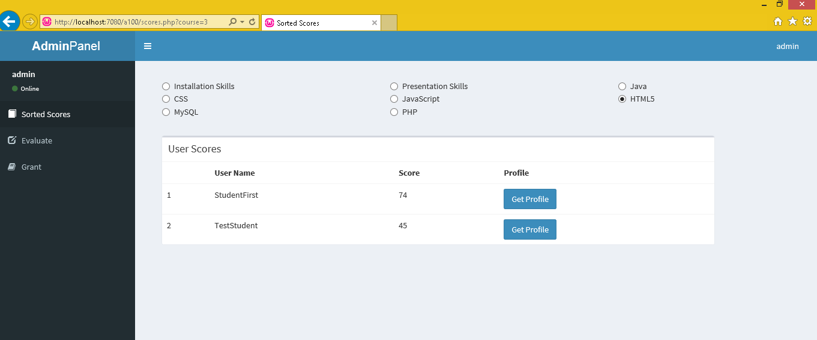

On the “Sorted Scores” page, the instructor can view the grades of all Apprentices, and sort results by type of test and skill. In the above example, the HTML button is clicked, so only Apprentices who have taken an HTML evaluation and their scores will be displayed. Results will be displayed in descending order, with the highest scores at the top.