CUSTOMER CHURN ANALYSIS
AND PREDICTION
Using Machine Learning

IBM SkillsBuild Academic Internship – Data Analytics with AI
Project Report
Prepared by
Sagar KC
B.Tech – Computer Science & Engineering

1. Executive Summary
Customer churn is more than a percentage on a dashboard. It represents customers who stop using a service and therefore creates a business need to understand who is leaving, what patterns appear among churned customers, and where analytical attention can be focused.
This project follows a complete data analytics story: start with raw customer records, clean the data, understand the customer base, discover important churn patterns, build a machine learning model, and finally translate the results into practical retention actions.
The analysis uses the Telco Customer Churn dataset containing 7,043 customer records and 21 original columns. After preparation, the dataset contained no missing values and no duplicate rows. The observed overall churn rate was 26.54%.
The analysis shows meaningful differences across contract type, internet service, payment method, tenure and monthly charges. For example, the observed churn rate was 42.71% for month-to-month customers compared with 2.83% for two-year customers. Customers in the first 12 months also showed an observed churn rate of 47.44%.
A Logistic Regression model was developed to estimate customer churn probability. On the held-out test set, the model achieved an ROC-AUC of 84.16% and recall of 78.34%. The resulting customer-level probabilities were converted into Low, Medium and High risk groups to support targeted analysis.
The final message of the project is simple: analytics can help move a business from looking backward at churn to identifying customer patterns and prioritizing where retention attention may be useful.

Project at a Glance
Measure | Result
Total customers | 7,043
Observed churned customers | 1,869
Observed churn rate | 26.54%
Average monthly charges | 64.76
Average tenure | 32.37 months

2. Business Problem and Project Objectives

2.1 The Business Question
A customer database contains many individual records, but raw records do not immediately explain why churn is happening. A useful analytical project therefore needs to connect customer attributes and service characteristics with an observable business outcome.
The central question for this project is:
Which customer and service characteristics are associated with higher observed churn, and can a machine learning model estimate which customers have a higher probability of leaving?

2.2 Problem Statement
Analyze customer behavior and service characteristics to identify the key factors contributing to customer churn and develop a machine learning model to predict customers at risk of leaving, enabling businesses to take targeted retention actions.

2.3 Objectives
- Clean and prepare the customer churn dataset for reliable analysis.
- Measure the overall churn rate and important customer KPIs.
- Explore churn patterns across contracts, services, payment methods, tenure and charges.
- Build a classification model that estimates churn probability.
- Create customer-level risk categories from predicted probabilities.
- Translate analytical findings into practical, targeted business actions.

2.4 Analytical Storyline
The project is organized as a progression rather than as a collection of charts:
Raw Data → Clean Data → Customer Story → Churn Patterns → Risk Prediction → Business Action
This structure keeps the analysis focused on the business question and connects each stage to the next.

3. Data Understanding and Preparation

3.1 Dataset
The project uses the Telco Customer Churn dataset from Kaggle. It contains customer demographic information, tenure, subscribed services, contract information, payment method and billing information.
Dataset source:
https://www.kaggle.com/datasets/blastchar/telco-customer-churn

3.2 Original Structure
The original dataset contains 7,043 rows and 21 columns, including:
customerID, gender, SeniorCitizen, Partner, Dependents, tenure, PhoneService, MultipleLines, InternetService, OnlineSecurity, OnlineBackup, DeviceProtection, TechSupport, StreamingTV, StreamingMovies, Contract, PaperlessBilling, PaymentMethod, MonthlyCharges, TotalCharges and Churn.

3.3 Data Preparation Steps
- Converted TotalCharges from text/object representation to numeric values.
- Handled blank TotalCharges values for zero-tenure customers by setting them to zero.
- Filled any remaining TotalCharges missing values using the median.
- Removed duplicate rows.
- Stripped unnecessary whitespace from text fields.
- Validated the final dataset for missing values and duplicates.

3.4 Data Quality Result
Quality Check | Final Result
Rows | 7,043
Columns | 21
Missing values | 0
Duplicate rows | 0
The cleaned dataset became the foundation for both exploratory analysis and machine learning. Keeping the preparation step explicit makes the later results easier to reproduce and audit.

4. Understanding the Customer Base

4.1 Starting with the Customer Picture
Before asking which customers are at risk, it is useful to understand the scale and profile of the customer base. The dataset contains 7,043 customers, of whom 1,869 are recorded as churned. This corresponds to an observed churn rate of 26.54%.
The average monthly charge is 64.76 and the average tenure is 32.37 months. These measures provide a baseline for interpreting the segment-level patterns that follow.

4.2 What the First View Tells Us
- Churn is not evenly distributed across customer groups.
- Contract type shows a particularly large difference in observed churn rates.
- Tenure is another strong descriptive dimension: the newest customer group shows substantially higher observed churn than the longest-tenure group.
- Monthly charges and service choices also show different observed churn patterns.

4.3 Important Interpretation
These are descriptive relationships in the dataset. A higher observed churn rate for a segment does not prove that the segment characteristic itself causes churn. The purpose of the analysis is to identify patterns that merit business attention and further investigation.

5. Dashboard Story — Executive Overview
The first dashboard page answers the opening management questions: How large is the customer base? How many customers churned? What is the overall observed churn rate? What broad segment differences deserve attention?
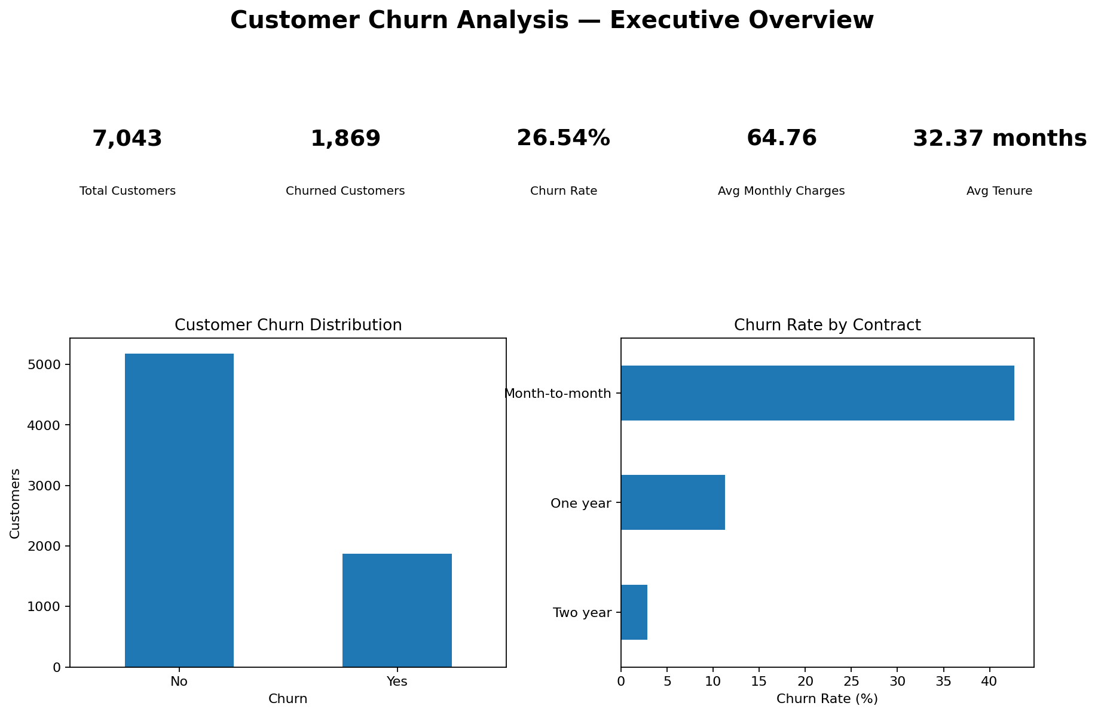
Figure 1. Executive Overview Dashboard

Story from Page 1
The executive view establishes the baseline before moving into detailed drivers. The 26.54% observed churn rate indicates that churn is a substantial part of the customer outcome in this dataset. The contract comparison then provides a clear signal for deeper analysis: month-to-month customers have much higher observed churn than customers on longer contracts.

6. Customer and Service Segments

6.1 Contract
Observed churn by contract type was 42.71% for month-to-month customers, 11.27% for one-year customers and 2.83% for two-year customers. This is one of the clearest segment differences in the analysis.

6.2 Internet Service
Observed churn was 41.89% among Fiber optic customers, 18.96% among DSL customers and 7.40% among customers with no internet service.

6.3 Payment Method
The electronic check segment had an observed churn rate of 45.29%. The corresponding figures were 19.11% for mailed check, 16.71% for automatic bank transfer and 15.24% for automatic credit card payment.

6.4 Tenure
Customers with 0–12 months of tenure had an observed churn rate of 47.44%, while the 49–72 month group had an observed churn rate of 9.51%. The intermediate groups were 28.71% for 13–24 months and 20.39% for 25–48 months.

6.5 Monthly Charges
Observed churn was 11.64% for customers paying up to 40, 23.92% for 41–70, 37.82% for 71–100 and 28.05% for customers above 100.

7. Dashboard Story — Customer & Service Analysis
The second dashboard page brings the segment story together. Instead of looking at a single attribute, it allows the analyst to compare contract, service, payment, tenure and monthly-charge patterns as different lenses on the same churn outcome.
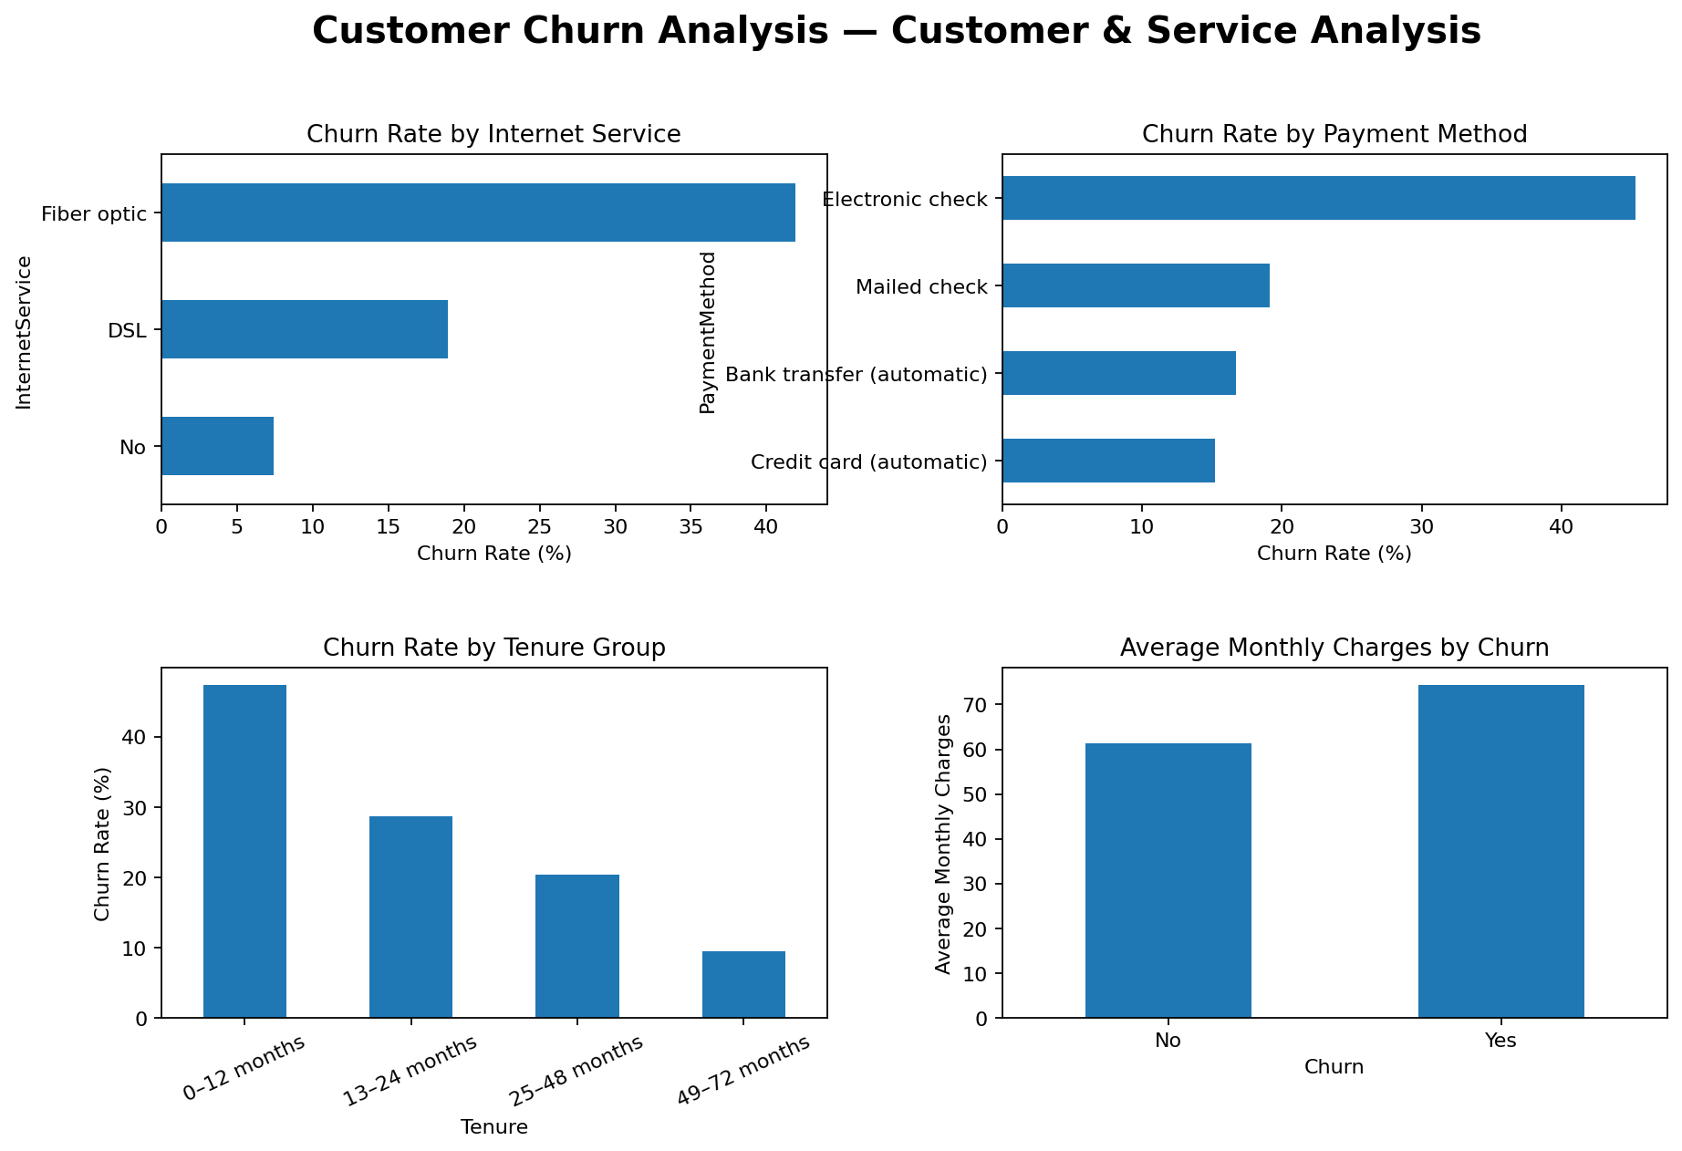
Figure 2. Customer and Service Analysis Dashboard

A Combined Segment Signal
One notable observed segment is the combination of month-to-month contract and Fiber optic service, where the observed churn rate is 54.61%. This combined view illustrates why segment analysis can be more informative than relying on a single KPI. It also provides a concrete group for deeper business investigation.

8. From Description to Prediction

8.1 Why Add Machine Learning?
Exploratory analysis explains what patterns are visible in historical data. A prediction model adds a different capability: it produces an estimated churn probability for an individual customer based on the information supplied to the model.
The purpose here is not to claim certainty about who will churn. Instead, the probability can be used as an analytical prioritization signal for retention planning.

8.2 Model
A Logistic Regression classifier was used with class balancing enabled. The customer ID and target-related derived fields were excluded from the modelling features. Numerical variables were median-imputed and standardized. Categorical variables were imputed and one-hot encoded.
The dataset was divided into training and test sets using an 80/20 stratified split with random_state 42.

8.3 Model Performance
Metric | Test Result
Accuracy | 73.81%
Precision | 50.43%
Recall | 78.34%
F1 Score | 61.36%
ROC-AUC | 84.16%

8.4 Reading the Results
The recall of 78.34% means the model identified a substantial share of the actual churn cases in the test set. The ROC-AUC of 84.16% indicates good separation between churn and non-churn cases in this evaluation. Precision is lower than recall, which is important when considering how many customers might be flagged for additional attention.

9. Dashboard Story — Risk, Prediction & Action
The third dashboard page completes the analytical journey. It connects predicted risk with business interpretation so that the project does not stop at model metrics.
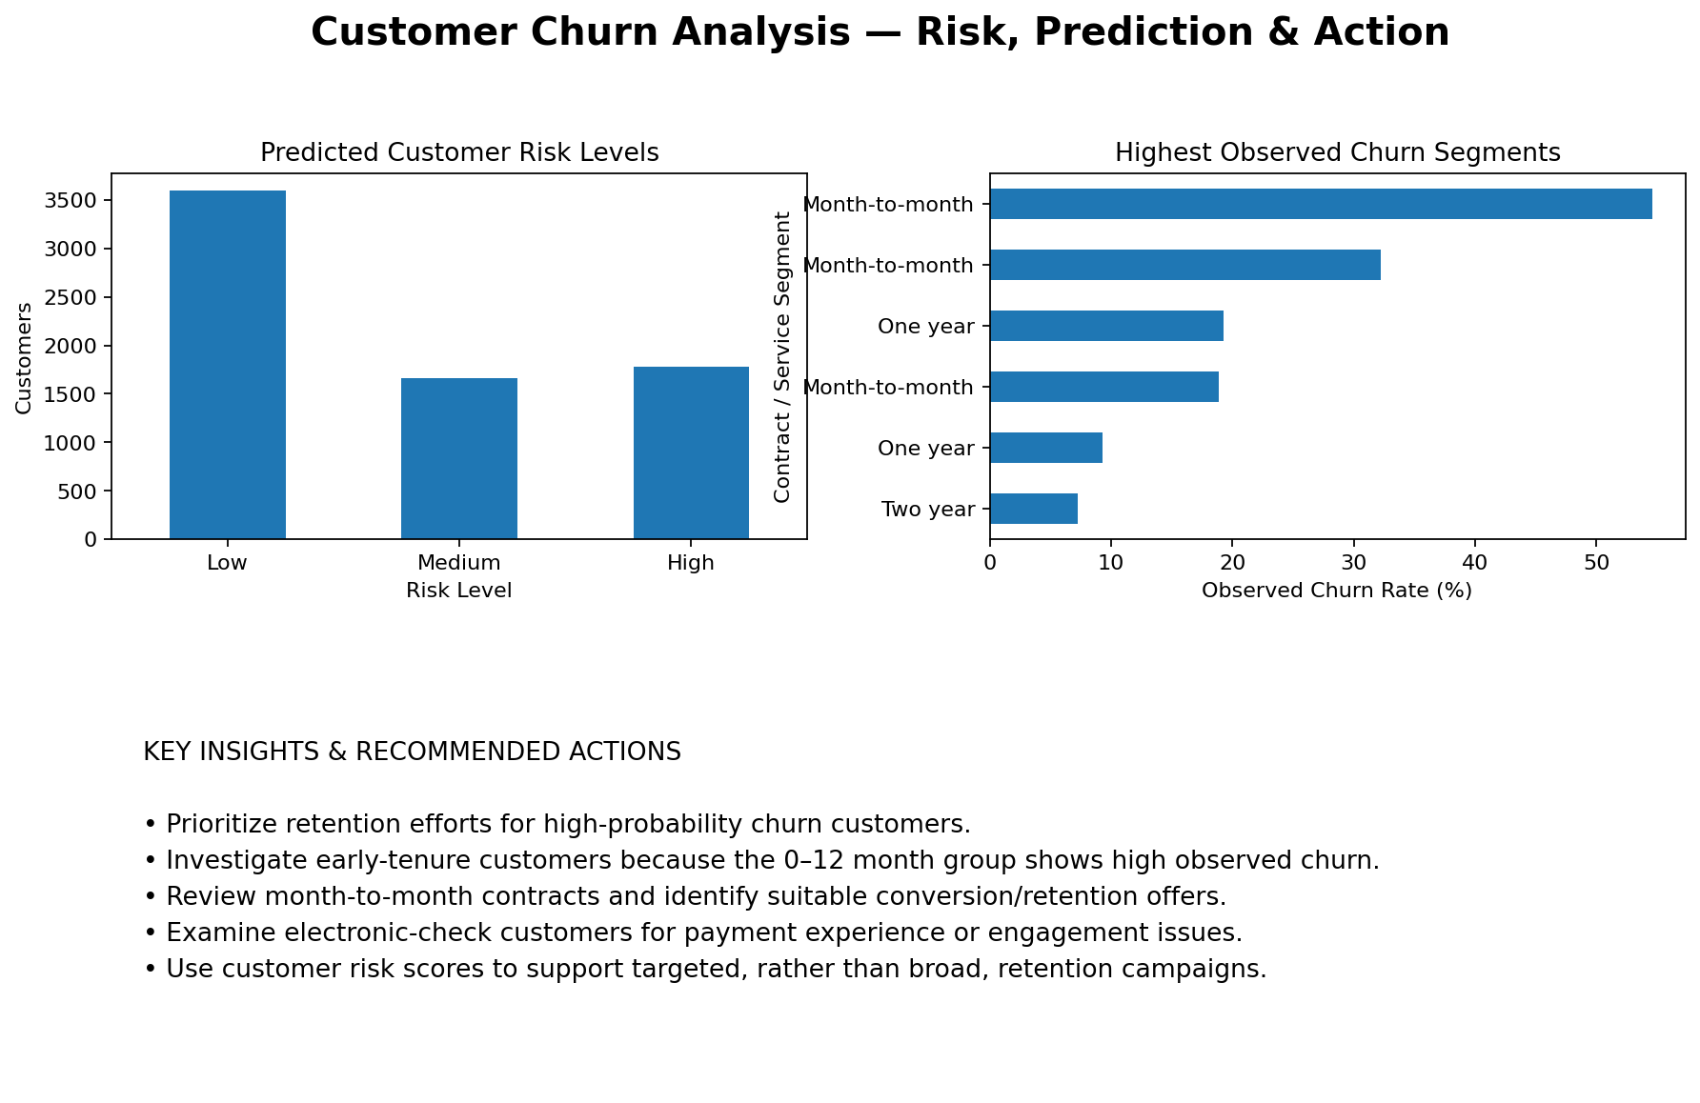
Figure 3. Risk, Prediction and Action Dashboard

Risk Segmentation
Customer probabilities were grouped into three analytical categories: Low risk below 40%, Medium risk from 40% to 70%, and High risk above 70%. The model produced 1,784 customers in the High-risk category and 1,664 in the Medium-risk category, with the remaining customers classified as Low risk.

10. Business Insights and Action Plan

10.1 What the Analysis Suggests
- The first 12 months deserve attention because this group has the highest observed churn rate among the tenure groups analyzed.
- Month-to-month customers show a substantially higher observed churn rate than longer-contract customers.
- The electronic-check payment segment shows a high observed churn rate and may warrant investigation into payment experience and customer engagement.
- Fiber optic customers show higher observed churn than the other internet-service groups in this dataset.
- Higher monthly-charge groups show higher observed churn than the lowest-charge group, although the relationship is not strictly monotonic.

10.2 Suggested Retention Workflow
- Step 1 — Identify customers with high predicted churn probability.
- Step 2 — Review their contract, tenure, service and billing characteristics.
- Step 3 — Apply an appropriate retention or customer-support intervention.
- Step 4 — Track whether churn outcomes change after intervention.
- Step 5 — Periodically retrain and evaluate the model as new customer data becomes available.

10.3 Business Value
The value of the project comes from connecting several analytical layers. KPIs provide the scale of the issue, segmentation explains where differences appear, and prediction produces a customer-level prioritization signal. Together, these components create a repeatable workflow for data-driven retention analysis.

11. Limitations, Conclusion and Future Scope

11.1 Limitations
- The analysis is based on the supplied Telco Customer Churn dataset and therefore reflects that dataset's population and variables.
- Observed segment differences are descriptive and should not be interpreted as proof of causation.
- The model's probability is a prediction signal, not a guarantee that an individual customer will churn.
- The chosen probability thresholds are analytical risk bands and may need business validation before operational use.

11.2 Future Scope
- Compare Logistic Regression with additional classification algorithms.
- Tune probability thresholds based on the cost of false positives and missed churn cases.
- Add time-based validation if future customer observations become available.
- Monitor model performance after deployment and retrain when customer behavior changes.
- Evaluate retention actions using measurable outcomes such as churn reduction and campaign response.

11.3 Conclusion
This project demonstrates an end-to-end customer churn analytics workflow. Starting from raw customer records, the project establishes data quality, measures important KPIs, explores churn patterns, visualizes the customer story and applies machine learning to estimate churn probability.
The analysis identified substantial differences across contract, tenure, internet service, payment method and monthly-charge segments. The Logistic Regression model achieved an ROC-AUC of 84.16% on the held-out test set, while customer-level risk scoring created a practical bridge from technical modelling to business analysis.
The final outcome is therefore not simply a model or a dashboard. It is a structured analytical story: understand the customer base, identify meaningful patterns, estimate risk, and use the evidence to guide focused business investigation and retention planning.

11.4 Tools Used
Python • Pandas • NumPy • Matplotlib • Scikit-learn • Logistic Regression

End of Project Report

