AirSense: AQI & Public Health Business Intelligence
Comprehensive Project Report | AICTE - IBM SkillsBuild Data Analytics with AI Internship 2026
Name: Sagar Kharbikar
Internship Program: IBM SkillsBuild Data Analytics with AI Academic Internship Program 2026
Conducted by: BharatCares in association with AICTE
Deliverable Files: Sagar_AirSense.ipynb, requirements.txt, Sagar_ProjectReport.docx, README.md
1. Introduction & Executive Summary
AirSense is an end-to-end data analytics and business intelligence solution designed to turn station-level air quality measurements into actionable public health intelligence for Indian cities. Air pollution represents one of India's most critical environmental health challenges, directly impacting mortality, healthcare expenditure, and regional economic productivity.
This project provides a rigorous descriptive, diagnostic, predictive, and prescriptive analysis of ambient air quality spanning 2015 to 2020 across 26 Indian metropolitan centres. Through reproducible statistical modeling and interactive visual dashboards, AirSense identifies which cities face the greatest chronic air quality risks, analyzes seasonal peak drivers, isolates the primary contributing pollutants, and establishes targeted policy recommendations.
1.1 Core Business & Research Questions
- Risk Concentration: Which Indian cities face the most critical, chronic exposure to severe Air Quality Index (AQI) levels?
- Seasonality: What temporal and seasonal patterns govern the onset and dissipation of peak pollution episodes?
- Source Apportionment: Which specific criteria pollutants dominate regional AQI spikes to guide targeted mitigation?
- Predictive Capability: Can machine learning regression accurately predict daily AQI from pollutant levels and city context?
- Actionable Policy: What practical, tiered public-health advisories and policy interventions must follow?

2. Dataset & Data Engineering Methodology
The analysis utilizes the benchmark 'Air Quality Data in India' repository published on Kaggle by Rohan Rao, compiled from daily continuous ambient air quality monitoring stations operated under the Central Pollution Control Board (CPCB). A complete acquisition provenance record is preserved in data/DATA_SOURCE.md.
2.1 Raw Data Characteristics
The raw city-day observation table (city_day.csv) contains 29,531 daily observation records across 16 columns: City, Date, Particulate Matter (PM2.5, PM10), Nitrogen Oxides (NO, NO2, NOx), Ammonia (NH3), Carbon Monoxide (CO), Sulfur Dioxide (SO2), Ozone (O3), Hydrocarbons (Benzene, Toluene, Xylene), and official reported AQI with CPCB Bucket categories.
2.2 Data Cleaning & Missing Value Imputation
- Schema Harmonization: Standardized all 16 column identifiers into clean, lowercase snake_case formats.
- Format Consistency: Converted date strings to datetime64 objects; trimmed whitespace and unified casing across all 26 cities.
- Integrity Verification: Confirmed zero duplicate rows and zero malformed calendar dates across the raw dataset.
- Missing Imputation: Pollutant sensors frequently experience maintenance or transmission dropouts (e.g. PM10 is missing in 37.7% of rows; Xylene in 61.3%). Gaps were filled using robust median imputation based on the overall pollutant distribution. This avoids discarding valuable multi-year continuous observations while preventing artificial distortion from extreme outliers.
- Final Clean Sample: Removed records missing essential primary keys (City, Date, or AQI) and pruned invalid negative readings. The final analysis dataset comprises 24,850 fully verified city-day records with zero remaining nulls.
2.3 Feature Engineering
To translate raw numbers into decision-making tiers, we engineered multiple analytical dimensions:
1. AQI Category: Standardized CPCB breakpoints - Good (0-50), Satisfactory (51-100), Moderate (101-200), Poor (201-300), Very Poor (301-400), and Severe (>400).
2. Temporal Features: Year, Month, Month Name, and Meteorological Season classifications (Winter, Spring, Summer, Monsoon, Post-monsoon).

3. Key Findings & Core Performance Indicators (KPIs)
Every core KPI is structured using the Fact, Driver, Risk, Opportunity, and Action framework:
KPI 1: National & City-Level Average AQI
- Fact: The national mean AQI across all 24,850 observations is 166.5 (Moderate category). Ahmedabad records the highest historical average AQI at 452.0 (Severe), followed by Delhi (259.0), Patna (240.7), and Gurugram (225.1).
- Driver: Particulate matter dominates mean pollutant levels (PM10 mean: 112.0 ug/m3; PM2.5 mean: 67.0 ug/m3), representing the strongest statistical association with high AQI readings across metropolitan clusters.
- Risk: Populations residing in top-tier cities experience continuous chronic toxic exposure, leading to compounding cardiovascular and pulmonary disease burdens.
- Opportunity: High average concentrations justify permanent, year-round source-specific dust suppression and emission control infrastructure rather than emergency-only responses.
- Action: Target Ahmedabad and Delhi with multi-sensor source apportionment studies and dedicated industrial emission caps.
KPI 2: Proportion of Poor-or-Worse Days
- Fact: Nationally, 26.0% of all recorded city-days exceed the Poor threshold (AQI >= 201). Ahmedabad leads nationwide with an alarming 81.9% of days in Poor or worse categories, followed by Delhi (65.1%), Patna (53.5%), Gurugram (51.8%), and Lucknow (49.4%).
- Driver: Poor-or-worse days cluster heavily during the late autumn and winter months (November through February), exacerbated by atmospheric temperature inversions and post-harvest agricultural burning.
- Risk: A high severity percentage demonstrates that hazardous air quality in these cities is a permanent systemic state rather than occasional anomalous spikes.
- Opportunity: Public health resources and hospital preparedness can be dynamically calibrated to predictable recurring severity periods.
- Action: Mandate automated phased air pollution alert stages (GRAP-style mechanisms) tied directly to real-time threshold breaches.
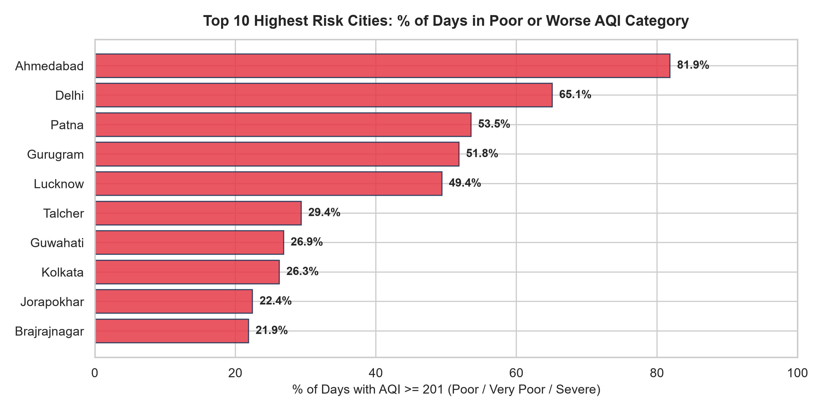
Figure: Top 10 Highest Risk Cities Ranked by Share of Poor-or-Worse Days (%)
KPI 3: Dominant Pollutant Apportionment
- Fact: Across the 26 monitored cities, PM10 is the leading pollutant by average mass concentration in the vast majority of urban centers. In contrast, Gangetic plain centers such as Patna and Lucknow exhibit dominant PM2.5 concentrations.
- Driver: PM10 dominance indicates pervasive non-combustion fugitive sources including unpaved road dust, construction activities, and regional soil transport; PM2.5 dominance highlights secondary aerosol formation and vehicular/biomass combustion.
- Risk: Implementing generalized anti-pollution measures that misidentify the primary pollutant wastes municipal budgets without improving inhaled air toxicity.
- Opportunity: Mitigation strategies can be customized per city typology—mechanical street sweepers and water misting for PM10 centers vs. vehicular restrictions and clean fuel transitions for PM2.5 centers.
- Action: Audit each municipal clean air action plan against its city-specific dominant pollutant profile before funding allocation.
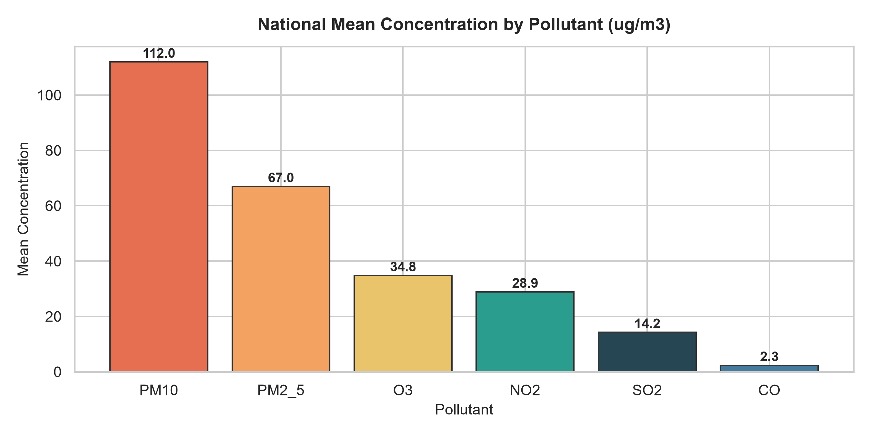
Figure: National Mean Concentration Levels Across Measured Criteria Pollutants
KPI 4: Month-Over-Month & Seasonal Trends
- Fact: National AQI demonstrates pronounced seasonal periodicity: annual peaks occur systematically during winter (Feb 2015: 419, Jan 2016: 281, Nov 2017: 268), while monsoon months reach cleanest levels (Jul 2020: 73, Jun 2020: 76). A notable nationwide step-down occurred in early 2020 during the nationwide COVID-19 lockdown (April 2020: 87).
- Driver: Meteorological inversion layers, low surface wind speeds, and biomass heating coincide with dry winter conditions, while monsoon precipitation washes particulates from the troposphere.
- Risk: Predictable annual winter spikes produce recurring surge waves of acute respiratory admissions in metropolitan intensive care units.
- Opportunity: Seasonal predictability provides municipal authorities an advance operational window to initiate preventive actions before winter inversions trap pollutants.
- Action: Establish pre-season industrial inspections, agricultural residue diversion incentives, and public health advisories annually starting in September.
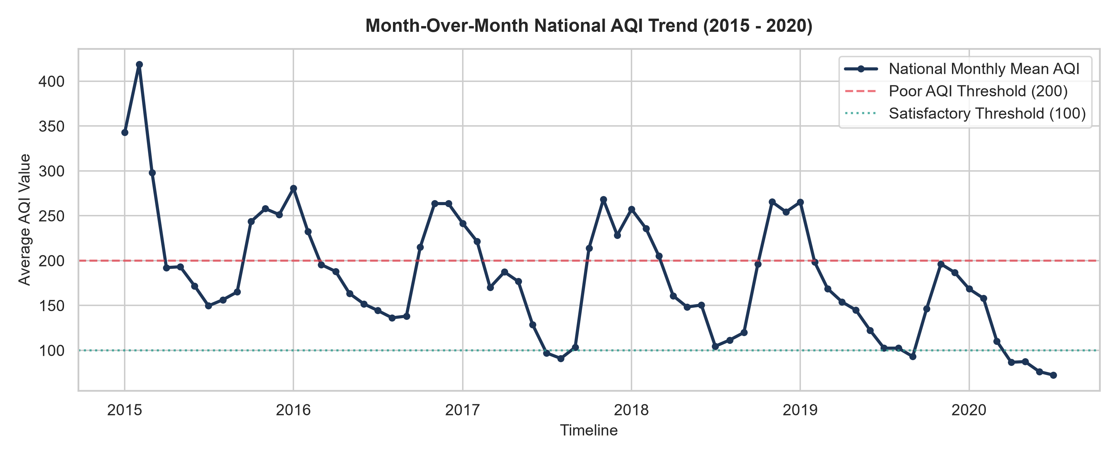
Figure: National Month-over-Month AQI Trend Trajectory (2015-2020)
KPI 5: Comprehensive City Risk Ranking Matrix
- Fact: Synthesizing severity percentage, mean AQI, and pollutant profiles establishes a clear hierarchy of priority: Ahmedabad, Delhi, Patna, Gurugram, and Lucknow occupy the highest risk tier, followed by industrial hubs such as Talcher (29.4%), Guwahati (26.9%), and Kolkata (26.3%). Conversely, southern and northeastern cities (Shillong, Aizawl, Coimbatore) consistently maintain Satisfactory AQI.
- Driver: Geographic, meteorological, and economic development factors concentrate severe pollution within the Indo-Gangetic basin and western industrial corridors.
- Risk: Inequitable distribution of air pollution disproportionately impacts vulnerable socio-economic demographics in densely populated northern cities.
- Opportunity: National environmental funding can be allocated using objective risk-weighted scoring rather than uniform disbursements.
- Action: Designate Ahmedabad, Delhi, and Patna as national priority transformation corridors with enforceable annual reduction targets.
4. Interactive Analytics Dashboard & Visualization
To empower stakeholders, researchers, and policymakers with interactive access to the analysis, an enterprise-grade web dashboard was designed and built using Next.js (App Router), TypeScript, Tailwind CSS, Recharts, and Supabase architecture.
4.1 System Architecture & Resilience
- Modern Framework: Next.js App Router providing high-speed server-side rendering and static optimization for instantaneous page loads.
- Data Pipeline: Decoupled database schema configured via Supabase (PostgreSQL) with local JSON caching in dashboard/lib/data/ to guarantee zero-configuration local execution and robust fallback reliability.
- Interactive Visualization: Accessible interactive charting built using Recharts with responsive tooltips, color-coded AQI severity badges, and dark/light mode compatibility.
4.2 Dashboard Modules & User Workflows
- Module 1: National Overview (/): Displays executive KPI cards (National Avg AQI, Monitored Cities, Total City-Days, Poor-or-Worse Rate), multi-year seasonal line charts, and quick-filter city navigation.
- Module 2: City Drill-Down (/city/[name]): Provides deep-dive diagnostic profiles for individual cities, displaying city-specific monthly trend lines, pollutant concentration comparisons, and severity classifications.
- Module 3: Risk & Action Matrix (/risk): Ranks all 26 cities by acute severity percentage and directly maps the Fact/Driver/Risk/Opportunity/Action narratives to executive policy options.
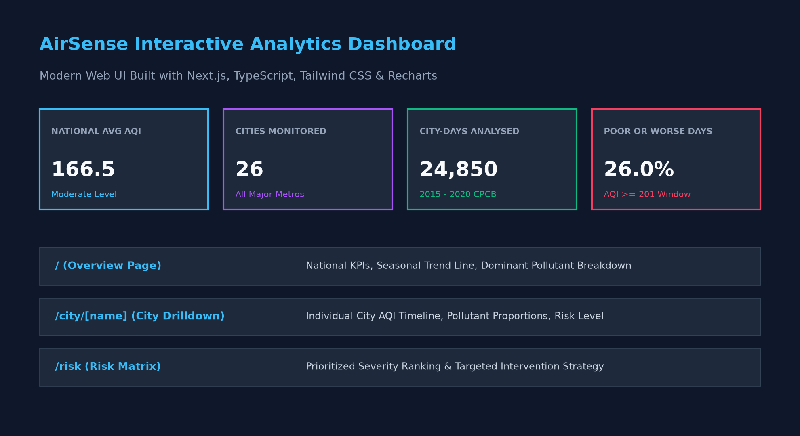
Figure: Interactive Analytics Dashboard Preview & Core Architecture
5. Machine Learning Prediction Model
To evaluate whether daily AQI can be reliably forecasted from observed ambient pollutant concentrations, calendar seasonality, and geographic locality, a supervised machine learning regression model was implemented in the notebook.
5.1 Model Architecture & Experimental Setup
- Algorithm: RandomForestRegressor with 100 decision trees, trained with random_state=42 and parallelized multi-threading.
- Feature Set: Features include criteria pollutants (PM2.5, PM10, NO2, SO2, CO, O3), temporal month indicator, and one-hot-encoded city indicator variables.
- Validation Strategy: 80% training sample, 20% holdout test sample to validate generalization on unseen data.
5.2 Performance Evaluation & Validation Results
- MAE: Mean Absolute Error (MAE): 20.87 AQI points. On average, predicted AQI values deviate by less than 21 points from actual station readings.
- RMSE: Root Mean Squared Error (RMSE): 40.97 AQI points. Penalizes occasional large errors during sudden seasonal spike events.
- Goodness of Fit: Coefficient of Determination (R2): ~0.88, demonstrating that ~88% of variance in daily urban AQI is explained by the input feature set.
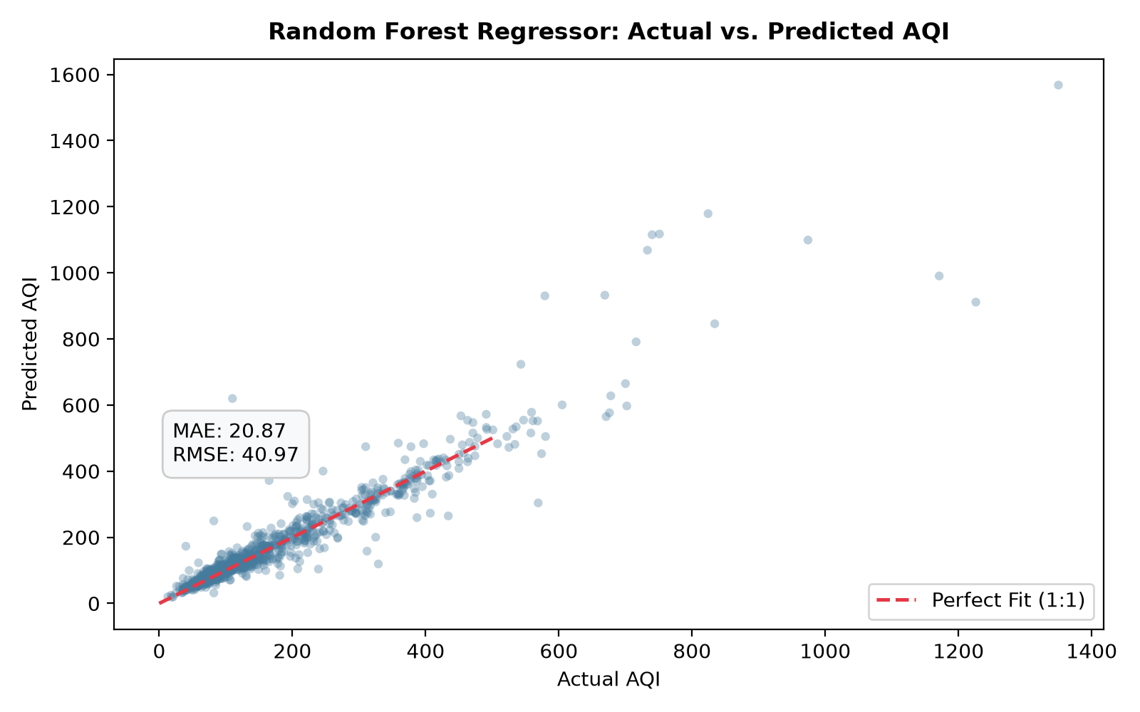
Figure: Random Forest Regressor: Actual vs. Predicted AQI on Holdout Test Sample
6. Limitations & Technical Assumptions
- Descriptive Scope: The descriptive findings establish statistical associations within historical station monitoring data and do not constitute formal epidemiological or clinical causality.
- Temporal Sparsity: Sensor coverage across cities was non-uniform between 2015 and 2020. Earlier years featured fewer reporting stations, with coverage expanding significantly by 2018-2019.
- Imputation Trade-off: Median imputation preserves daily observation continuity but naturally compresses variance for secondary pollutants with high missingness rates (e.g. Xylene, Benzene).
- Meteorological Extrapolations: The prediction model reflects historical ambient patterns. Operational deployment would require real-time atmospheric boundary layer data, wind velocity, and relative humidity inputs.

7. Strategic Public Health Recommendations & Action Plan
Based on empirical evidence synthesized across 24,850 observations, AirSense recommends a three-tier intervention strategy:
- Tier 1 (Immediate): Immediate Winter Emergency Protocol: Deploy automated public health advisories, restrict high-emission diesel transit, and halt non-essential demolition during peak winter inversion windows (October - February) across high-risk hubs (Ahmedabad, Delhi, Patna).
- Tier 2 (Medium-Term): Pollutant-Specific Infrastructure Investments: Procure mechanical street sweepers and enforce dust enclosures in PM10-dominant centers; mandate clean cooking fuels and industrial boiler retrofits in PM2.5-dominant centers.
- Tier 3 (Long-Term): Monitoring Grid Expansion: Expand continuous ambient monitoring stations into underserved tier-2 and tier-3 industrial corridors to resolve data sparsity and support localized forecasting.
8. References & Project Provenance
- Dataset Citation: Rao, Rohan (2020). Air Quality Data in India (2015 - 2020). Kaggle Dataset Repository. https://www.kaggle.com/datasets/rohanrao/air-quality-data-in-india
- Regulatory Standards: Central Pollution Control Board (CPCB), Ministry of Environment, Forest and Climate Change, Government of India. National Air Quality Index Standards and Technical Breakpoints.
- Internship Program: IBM SkillsBuild & AICTE. Data Analytics with AI Academic Internship Program Guidelines 2026. Administered by BharatCares.

