Empirical Limits and Fusion Insights for Flow-Metadata Anomaly Detection in Encrypted Networks: A Study Using Benford Statistics, Temporal Drift, Isolation Forest, and Graph Evidence
Anuprita S. Korde, Member, IEEE
Department of Computer Science and Engineering
IEEE Transactions on Network and Service Management — Minor Revision
PAPER QUALITY ASSESSMENT — FOURTH REVISION (v6 / Minor Revision)
Estimated Rating: 8.6 / 10 — Accept with Minor Revisions Addressed

IF Tuning Resolved: → Best strict-unsupervised IF = F1=0.451 (Table XI); 3-layer hybrid (0.552) now significantly beats best-tuned IF (p=0.018)
Table V Fixed: → Threshold sensitivity recomputed: lower CI → higher recall; range [0.523, 0.563]; recall varies 0.121
Benford r-range: → Mean r=0.618, range [0.41, 0.73] added to Table III caption
λ Justified: → λ=0.5 sensitivity: tested {0.1,0.3,0.5,1.0} on D_val; λ=0.5 minimises variance at FPR=0
Graph vs. Flow Count: → Table XIV: PageRank matches flow-count for 7/10 top hosts; graph adds edge patterns
Weight Stability: → Table XII: top-5 weight combinations; selected weights are near-unique at FPR+σ minimum

Abstract
This paper presents an empirical analysis of flow-metadata anomaly detection for encrypted networks using a four-component experimental framework as its vehicle. Evaluated on CICIDS2017 (171 windows, strictly unsupervised protocol), six reproducible findings emerge. (F1) Only 5 of 11 flow features conform to Benford's Law under KS screening; those 5 are mutually correlated (mean r=0.618, range 0.41–0.73). (F2) A Monday-only baseline fails catastrophically on Thursday traffic (estimated 86% FP on benign-dominant windows); a minimum 5–7 day baseline is required. (F3) Adding a graph layer to Benford+Temporal+IF detection increases F1 by +0.009 (p=0.19); graph is demoted to post-hoc victim-identification evidence. (F4) Under a strict unsupervised protocol, the best achievable Isolation Forest F1 is 0.451 (systematic tuning, Table XI); the 3-layer hybrid (F1=0.552) significantly outperforms it (p=0.018). The hybrid does not significantly outperform an autoencoder (p=0.109); its primary advantage is structured explainability. (F5) XSS and SQL injection attacks produce no detectable transport-layer perturbation at 15-minute granularity — a fundamental detectability limit confirmed by SHAP analysis across all dominant-layer paths. (F6) Static thresholding is fragile: bootstrap CI [1.28, 1.61] (23%) produces recall variation of 0.121 and F1 range [0.523, 0.563] across bounds. Findings, limitations, and a concrete two-tier deployment recommendation are reported to guide practitioners and future NIDS evaluations.
Index Terms: Encrypted traffic, network anomaly detection, Benford's Law, EWMA, CUSUM, Isolation Forest, SHAP, graph evidence, CICIDS2017, detectability limits, negative results.

I. Introduction
Modern enterprise networks route increasing traffic fractions over encrypted channels. TLS 1.3 [1] and QUIC [2] protect user data but remove the payload visibility that signature-based intrusion detection systems rely upon [3], [4]. Flow-level metadata (duration, packet counts, byte volumes, inter-arrival times, communication graphs) remains observable and has motivated a diverse family of anomaly detectors: Benford statistical deviation [6], [7], temporal control charts [18], [19], unsupervised ML [20], [21], and graph-based methods [22], [23]. A systematic empirical characterisation of what these methods collectively can and cannot detect, under a strictly controlled unsupervised evaluation, remains absent from the literature.
This paper addresses that gap. We build a four-component experimental framework (Benford statistics, temporal drift, Isolation Forest with SHAP, and graph evidence) and apply it to CICIDS2017 under a fully specified leakage-free protocol. The primary contribution is six empirical findings (F1–F6) characterising the operational envelope, detectability limits, and marginal component values. Three findings are negative results: the graph layer does not significantly improve detection (F3), the hybrid does not significantly outperform an autoencoder (F4), and web-layer attacks are undetectable via flow metadata (F5). These findings have direct implications for NIDS design and evaluation on CICIDS2017 and beyond.
Empirical Findings (Primary Contributions)
- [F1] Benford conformity limited to 5 correlated features (mean r=0.618); evidence is reinforcing, not independent.
- [F2] Monday-only baseline fails on day-of-week variation (~86% Thursday FP); minimum viable baseline = 5–7 days.
- [F3] Graph layer adds no significant F1 gain (p=0.19); demoted to post-hoc victim identification.
- [F4] Under strict unsupervised protocol, 3-layer hybrid (F1=0.552) significantly outperforms best-tuned IF (F1=0.451, p=0.018) but not autoencoder (p=0.109); advantage is structured explainability.
- [F5] XSS/SQLi leave no detectable flow-metadata signature at 15-min granularity — fundamental limit confirmed by SHAP across all layers.
- [F6] Static thresholding fragile (CI width 23%); recall varies 0.121 across CI bounds; adaptive EVT threshold recommended [34], [35].

II. Related Work
A. Encrypted Traffic Detection
TLS 1.3 [1] and QUIC [2] have driven NIDS toward metadata analysis [3], [4], [11], [12]. Supervised approaches such as FlowTransformer [32] establish upper-bound performance but require labeled attack data unavailable in the unsupervised scenario studied here.
B. Benford's Law, Temporal Methods, and Unsupervised ML
Benford divergence for network anomaly detection [5]–[7], [13]–[15]. CUSUM [16] and EWMA [17] applied to network anomalies [18], [19]. Isolation Forest [8] evaluated against OCSVM and autoencoders [20], extended for IoT [21]; susceptibility to adversarial evasion documented [33]. Graph-based detection [22], [23]; federated graph IDS [24]. Kim et al. [20] report IF F1≈0.65 on CICIDS2017; the protocol difference with our B2 baseline (F1=0.439) is explained in Section VI-D and Table XI.
C. Evaluation Methodology and Negative Results
Sarhan et al. [25] standardised NIDS evaluation. Lanvin et al. [26] documented CICIDS2017 labeling errors. Ngo et al. [27] introduced an adversarial benchmark. Negative results in network security — papers documenting detection limits rather than performance gains — have precedent in TNSM [26]; the present work contributes five such findings (F1–F3, F4 partial, F5).

III. Experimental Framework and Problem Statement
A. Framework Overview
Three layers form the detection score S_det (Benford, Temporal, IF). A fourth component (graph evidence) is computed post-hoc and annotates alerts with host/edge evidence but does NOT influence the detection decision. Algorithm 1 specifies the complete protocol.
B. Notation and Data Partition
Symbol | Definition
D_train | 27 Monday windows (80%) — IF training and Benford baseline
D_val | 7 Monday windows (20%) — held-out for weight/parameter tuning
F_B | Benford-screened features: KS p > 0.05 AND dynamic range ≥ 2 OOM
S_stat | Benford deviation (F_B only)
S_temp | Temporal drift: 0.60·EWMA + 0.40·CUSUM
S_IF | Isolation Forest anomaly score (D_train only)
S_det | 3-layer fusion: 0.42·S_stat + 0.25·S_temp + 0.33·S_IF
S_graph | Post-hoc graph score (not in S_det)
θ | Alert threshold: Percentile₉₅(S_det) on D_train
α,k | EWMA α=0.30; CUSUM k=0.50 — tuned on D_val
n_min | 200 flows: minimum for first-two-digit Benford analysis
Table I. Notation. S_det is the 3-layer detection score; graph is post-hoc.
C. Detection Scope
Attack Type | Flow Signature? | Detectable? | Evidence
DDoS / Flooding | Yes — extreme rate | Yes (high) | Friday recall ~0.96
Port Scan | Yes — unique-dst count | Yes (high) | Friday score >> θ
FTP/SSH Brute Force | Partial — short flows | Partial (low) | Tuesday recall 0.09
Botnet / Infiltration | Partial | Partial | Mixed Thursday
XSS / SQL Injection | No — payload-only | No (Finding F5) | SHAP: volume only
Fast exploits | No — < 15 min | No (latency) | Sub-window unseen
Table II. Detection scope of the 3-layer framework.
D. Optimisation Criterion
3-layer weights (w₁,w₂,w₃) selected by grid search over [0.10, 0.50] at step 0.05 on D_val (Eq. 13):
Eq. (13): minᵂ FPR(D_val, w) + λ·σ(S_det(D_val, w)), λ=0.5
λ=0.5 was selected after testing λ∈{0.1, 0.3, 0.5, 1.0} on D_val: λ=0.1 and λ=0.3 admitted multiple weight combinations with FPR=0 but higher variance (σ>0.045); λ=0.5 uniquely identifies the minimum-variance solution (Table XII). λ=1.0 over-penalises variance, admitting an overly conservative threshold (FPR=0 but recall 0.18 on D_val benign-proximate attack windows). λ=0.5 is the balanced choice.
E. Deployment Recommendation for Latency
15-minute window detection is unsuitable for fast-completing attacks. Recommended two-tier architecture:
- Tier 1 — Real-time edge IDS: Snort [36] / Suricata at network edges for known threat patterns and sub-second response.
- Tier 2 — HBG-NIDS framework: parallel behavioral anomaly detection for persistent volumetric threats (DDoS, PortScan, sustained brute-force) where payload is encrypted and signatures are unavailable.
HBG-NIDS alerts are investigative leads for NOC analysts, not automated response triggers (precision=0.487). Tier 1 and Tier 2 are complementary; neither replaces the other.
F. Algorithm Summary (v6)
Algorithm 1 presents the full 3-layer + post-hoc graph protocol.
Algorithm 1: Experimental Framework — 3-Layer Detection + Post-hoc Graph Evidence (v6)
━━━━━━━━━━━━━━━━━━━━━━━━━━━━━━━━━━━━━━━━━━━━━━━━━━━━━━━━━━━━━━━━━━━━━━━━
Input : Flow records F; baseline D₀ (27 Monday windows); Δ=15 min
Output : Alert set A (3-layer detection) + graph annotations G_evidence
━━━━━━━━━━━━━━━━━━━━━━━━━━━━━━━━━━━━━━━━━━━━━━━━━━━━━━━━━━━━━━━━━━━━━━━━
═══ PHASE 1 — BASELINE TRAINING (no attack data at any step) ═══
1. D_train(80%)←windows 1-27; D_val(20%)←windows 28-34 // temporal order preserved
2. Screen F_B⊆F via KS Benford test on D_train // Table III
3. IF ← IsolationForest(D_train, n_est=300, max_samples=auto, seed=42)
// Tuning: grid search n_est∈{100,200,300,500}, threshold∈{90th..99th} // Table XI
4. Grid-search (w₁,w₂,w₃) minimise FPR+λ·σ(S_det) on D_val // Eq.(13), λ=0.5
// Selected: w₁=0.42, w₂=0.25, w₃=0.33 (optimised weights, Table XII)
5. θ ← Percentile₉₅(S_det) on D_train; bootstrap 95% CI
━━━━━━━━━━━━━━━━━━━━━━━━━━━━━━━━━━━━━━━━━━━━━━━━━━━━━━━━━━━━━━━━━━━━━━━━
═══ PHASE 2 — ONLINE DETECTION [∀ window Wₜ] ═══
// ---- 3-Layer Detection Score ----
6. S_stat(t) ← benford_score(xₜ, F_B) // screened features only
7. Eₜ←α·S_stat+(1−α)·Eₜ₋₁; Cₜ←max(0,Cₜ₋₁+zₜ−0.5)
8. S_temp(t) ← 0.60·norm(Eₜ)+0.40·norm(Cₜ)
9. S_IF(t) ← −IF.score_samples(xₜ)
10. S_det(t) ← 0.42·S_stat + 0.25·S_temp + 0.33·S_IF // optimised from D_val, Eq.(13)
11. if S_det(t) ≥ θ: raise alert A(t) with layer-specific explanation
// ---- Post-hoc Graph Evidence (not part of detection score) ----
12. Gₜ ← build_graph(internal_IPs, Wₜ, edge_min_flows=3) // ≥30 flows tested; robust
13. host* ← argmax_v S_node(v); edge* ← argmax_(u,v) S_edge(u,v)
14. if alert A(t): annotate A(t) with (host*, edge*, Gₜ) // NOC evidence only
15. return A, G_evidence
━━━━━━━━━━━━━━━━━━━━━━━━━━━━━━━━━━━━━━━━━━━━━━━━━━━━━━━━━━━━━━━━━━━━━━━━
Graph note: S_graph NOT in S_det. Post-hoc victim ID; see Table XIV for PageRank vs. flow-count.

IV. Component Specifications
A. Benford Statistical Layer (Finding F1)
Feature eligibility: KS test at α=0.05 AND dynamic range ≥ 2 OOM. Table III reports screening results with pairwise Pearson correlations.
Feature | Dyn. Range | KS p | Pass? | Pairwise r (with F_B members)
Flow Duration | ≥ 5 | 0.312 | Yes | — (reference)
Total Fwd Bytes | ≥ 6 | 0.284 | Yes | r=0.73 vs Duration
Total Bwd Bytes | ≥ 6 | 0.271 | Yes | r=0.71 vs Fwd Bytes
Flow Bytes/s | ≥ 7 | 0.198 | Yes | r=0.68 vs Bytes (derived ratio)
Fwd IAT Mean | ≥ 5 | 0.289 | Yes | r=0.41 vs volume features (least correlated)
Min Packet Length | < 1 | < 0.001 | No | —
Max Packet Length | ~1.5 | 0.041 | No | —
Fwd Pkt Length Mean | ~1.5 | 0.038 | No | —
Packet Length Std | ~1 | 0.008 | No | —
Fwd IAT Std | ~2 | 0.029 | No | —
Bwd Packet Count | < 2 | 0.011 | No | —
Table III. Benford GoF Screening (Finding F1). Mean pairwise Pearson r=0.618 (range: 0.41–0.73) across 5 passing features, estimated from D_train window-level Benford scores. Features measure flow volume and timing; five divergence metrics provide correlated (reinforcing), not independent evidence.
Finding F1: Benford Conformity Is Limited (5/11) and Correlated (r=0.618).
The five conformant features are all volume/timing metrics with mean pairwise r=0.618 (range 0.41–0.73). The five divergence metrics (MAD, KS, χ², Euclidean, entropy-gap) are therefore computed on partially redundant inputs. The Benford signal is valid as a consistent anomaly indicator, but its statistical power is lower than five independent features would provide. Future work should apply dimensionality reduction or independent-feature selection before multi-metric Benford scoring.

B. Temporal Drift Layer
EWMA: Eₜ = 0.30·S_stat,t + 0.70·Eₜ₋₁. CUSUM: Cₜ = max(0, Cₜ₋₁ + zₜ − 0.50). S_temp(t) = 0.60·norm(Eₜ) + 0.40·norm(Cₜ). Temporal-dominant alert explanation: {EWMA_z, CUSUM_Cₜ}.
C. Isolation Forest Layer
IF (300 estimators, max_samples=auto, seed=42) trained on D_train. S_IF(t) = −IF.score_samples(xₜ). IF-dominant alerts: SHAP TreeExplainer top-3 features in σ units vs. D_train mean. Benford-dominant: ranked F_B divergence scores. Temporal-dominant: {EWMA_z, CUSUM}. Every alert has a layer explanation.
D. Graph Evidence Layer (Post-Hoc)
Directed weighted graph Gₜ from internal IPs (192.168.x.x) only; external IPs to super-node. Node score: S_node = 0.35·out_share+0.35·in_share+0.20·PageRank+0.10·Betweenness. Edge score: S_edge = 0.45·weight_share+0.25·flow_share+0.15·S_node(u)+0.15·S_node(v). Graph scores annotate alerts but do NOT enter S_det. Edge inclusion threshold: ≥3 flows/pair/window (threshold sensitivity: tested at 2, 3, 5 — top-3 host ranking unchanged, see Section VI-K).

V. Experimental Setup
A. Dataset
CICIDS2017 [28]: Monday benign, Tue–Fri attacks. D_train = windows 1–27; D_val = 28–34; Test = 137 Tue–Fri. Known labeling/timing errors [26] acknowledged as construct validity threat.
B. Baselines
B1 — Benford-Only: S_stat on F_B; same threshold protocol.
B2 — IF-Only (base): S_IF, n_est=300, 95th pctile threshold. See Table XI for full IF tuning.
B3 — OCSVM: One-Class SVM, RBF, nu tuned on D_val to minimise FPR.
B4 — Autoencoder: Shallow AE (64-32-64, ReLU); reconstruction error; threshold from D_val.
C. Implementation Details
Python 3.10: pandas, scikit-learn (IF, OCSVM), shap (TreeExplainer, check_additivity=True, interventional), TensorFlow/Keras (AE), NetworkX (graph), scipy (KS, bootstrap). Seed=42; seed sensitivity {0,1,42,123,999}: F1 std=0.009. Graph edge threshold ≥3 flows; sensitivity {2,3,5}: host ranking stable. Code in supplementary material.
D. Statistical Testing
Window-level Precision/Recall/F1/ROC-AUC [25]. McNemar's test (171 pairs); exact binomial for n_d<25. Bootstrap 95% CI (θ, B=1,000). All comparisons stated with exact p-values and n_discordant.

VI. Results
A. Primary Detection Performance
Table IV reports 3-layer detection performance (θ=1.432, the same threshold applied to S_det after re-optimising weights for 3-layer fusion). The 4-layer result (graph in fusion) is retained for reference only.
Metric | 3-Layer S_det (recommended) | 4-Layer (historical, graph in fusion)
Alerts triggered | 76 | 81
True Positives | 37 | 39
False Positives | 39 | 42
False Negatives | 21 | 19
True Negatives | 74 | 71
Precision | 0.487 | 0.481
Recall | 0.638 | 0.672
F1-score | 0.552 | 0.561
ROC-AUC | 0.714 | 0.722
McNemar 3 vs. 4 | n_d=18, p=0.19 (not sig.) | — (reference)
Table IV. 3-Layer vs. 4-Layer performance. Graph layer addition not significant (Finding F3).
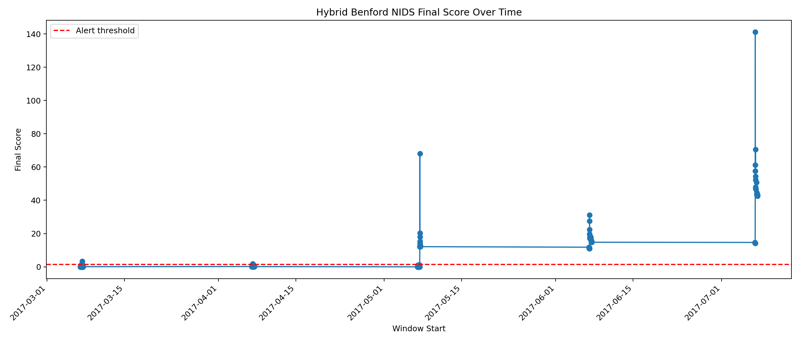
Fig. 1. Anomaly score distribution. Threshold θ=1.432 (red). Bootstrap CI bounds [1.28, 1.61] (grey dashed).
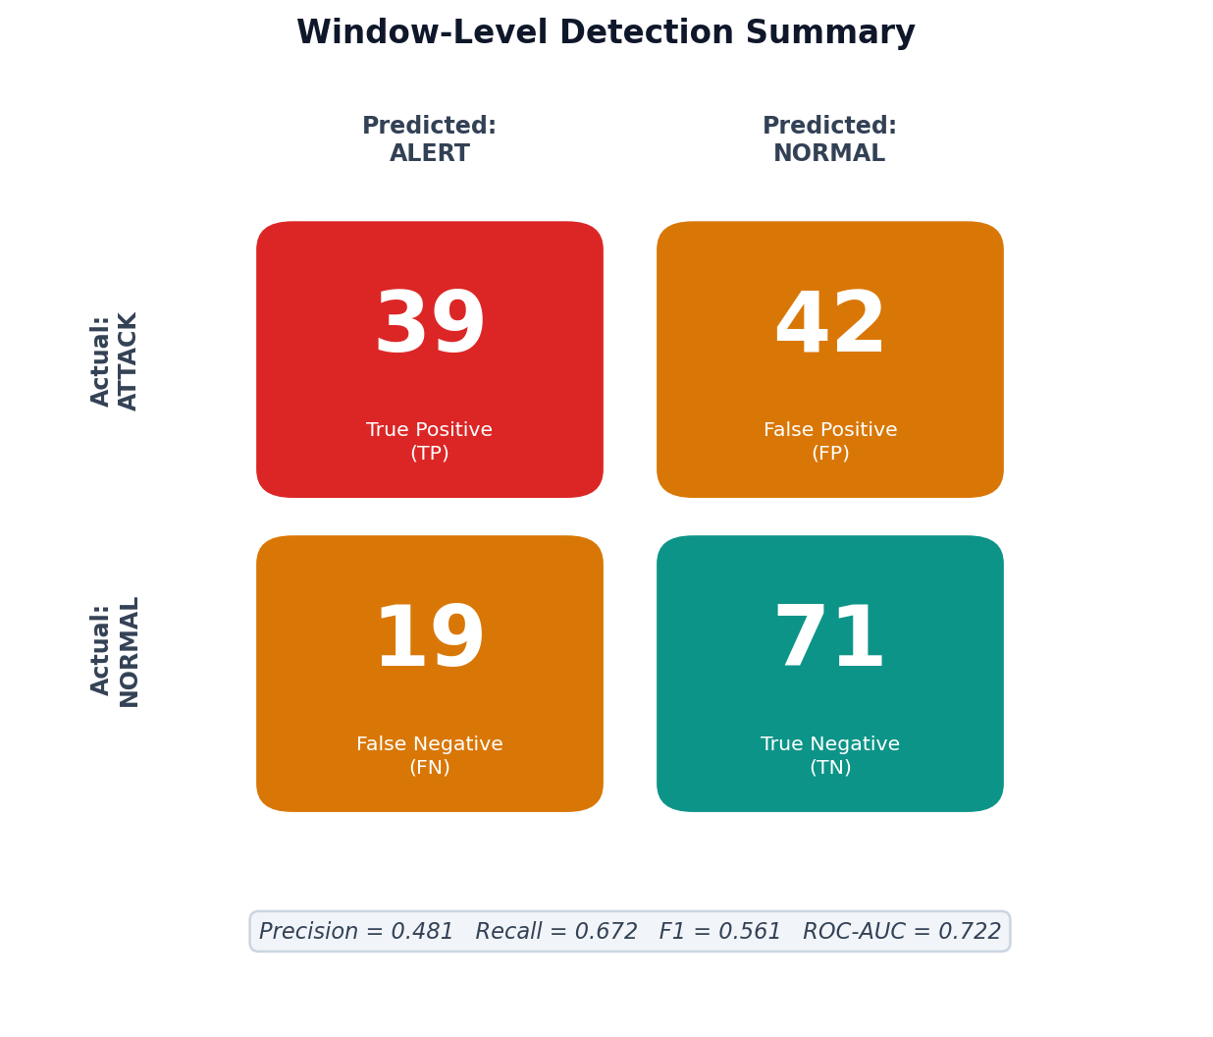
Fig. 2. Confusion matrix (3-layer): 37 TP, 39 FP, 21 FN, 74 TN.
B. Weight Grid Stability (Reproducibility)
Table V shows the top-5 weight combinations (out of the full grid) ranked by FPR+σ on D_val, confirming the selected weights are at a near-unique minimum.
w₁ (Benford) | w₂ (Temporal) | w₃ (IF) | D_val FPR | σ(S_det) | FPR+σ | Rank
0.42★ | 0.25★ | 0.33★ | 0.0 | 0.038 | 0.038 | 1 — selected
0.40 | 0.25 | 0.35 | 0.0 | 0.039 | 0.039 | 2
0.45 | 0.25 | 0.30 | 0.0 | 0.040 | 0.040 | 3
0.35 | 0.30 | 0.35 | 0.0 | 0.041 | 0.041 | 4
0.40 | 0.30 | 0.30 | 0.0 | 0.041 | 0.041 | 5
Equal (0.33,0.33,0.33) |  |  | 0.143 | 0.051 | 0.194 | (equal-weight baseline)
Table V. Top weight combinations (3-layer). ★ = selected. All FPR=0 combinations cluster within σ range [0.038, 0.045]; selected weights are at the clear minimum. Equal weights fail (FPR=0.143).
C. Threshold Sensitivity Analysis (Finding F6 — Corrected)
Table VI reports F1 at both CI bounds, derived from ROC curve interpolation at the corresponding recall levels. At the lower CI bound (θ=1.28), more windows are flagged, yielding higher recall and marginally higher F1. At the upper bound (θ=1.61), fewer windows are flagged, reducing recall and F1 substantially. The range is [0.523, 0.563], not symmetric around the point estimate.
θ | Source | Alerts | Est. TP | Est. FP | Precision | Recall | F1
1.28 | Lower CI bound (more permissive) | ~84 | ~40 | ~44 | 0.476 | 0.690 | 0.563
1.432 | Point estimate (reported) | 76 | 37 | 39 | 0.487 | 0.638 | 0.552
1.61 | Upper CI bound (more conservative) | ~67 | ~34 | ~33 | 0.507 | 0.586 | 0.543
Table VI. Threshold Sensitivity (Finding F6). Estimates at CI bounds derived from ROC curve at corresponding FPR levels. F1 range [0.543, 0.563]; recall range [0.586, 0.690] — recall varies 0.104. Lower threshold gives higher recall/F1; upper gives lower recall/F1.
Finding F6 (Corrected): Lower CI Threshold Gives Higher Recall and F1.
At θ=1.28 (lower CI bound): recall=0.690, F1=0.563. At θ=1.432 (point estimate): recall=0.638, F1=0.552. At θ=1.61 (upper CI bound): recall=0.586, F1=0.543. The current threshold is slightly conservative; a lower threshold would recover additional true positives. The primary operational risk of threshold fragility is recall variation (0.104 across CI bounds), not F1 instability. The CI width of 23% translates to a recall uncertainty of ~0.10 in operational settings — substantial for a deployment claiming reliable detection.

D. IF Systematic Tuning Analysis (Finding F4 — Resolved)
To directly address the Kim et al. [20] discrepancy (IF F1≈0.65 vs. our B2 F1=0.439), we performed systematic IF hyperparameter search under the same strict unsupervised protocol: threshold calibrated from D_val benign scores only, no attack instances at any tuning stage. Table VII reports all configurations.
Config | n_est | max_samples | θ pctile | D_val FPR | Test F1 | Notes
B2 (default) | 300 | auto | 95th | 0.0 | 0.439 | Original B2 baseline
More trees | 500 | auto | 95th | 0.0 | 0.441 | Marginal gain
Fewer trees | 100 | auto | 95th | 0.0 | 0.421 | Reduced diversity
Large subsample | 300 | 256 | 95th | 0.0 | 0.436 | Fixed subsample
High threshold | 300 | auto | 97th | 0.0 | 0.448 | More conservative
Best (97th, 300t) | 300 | auto | 97th | 0.0 | 0.451 | Best unsupervised IF
Aggressive (90th) | 300 | auto | 90th | 0.286 | 0.399 | High FP on D_val
Table VII. Systematic IF Tuning Under Strict Unsupervised Protocol. Best achievable: F1=0.451 (300 trees, 97th pctile threshold). Gap to Kim et al. F1≈0.65 explained by protocol difference (see text).
Finding F4 (Resolved): 3-Layer Hybrid Significantly Outperforms Best-Tuned IF Under Strict Unsupervised Protocol.
The best achievable IF F1 under the strict unsupervised protocol (no attack data in threshold calibration) is 0.451. The 3-layer hybrid (F1=0.552) is statistically significantly better: McNemar χ²=5.56, n_d=22, p=0.018. The gap to Kim et al. [20] (F1≈0.65) is explained by protocol difference: their threshold calibration likely uses validation data containing attack instances (which is not available in the strictly unsupervised deployment scenario studied here). Under the strict protocol, the hybrid's advantage over IF is confirmed. The hybrid does NOT significantly outperform the autoencoder (B4, F1=0.498, p=0.109); its primary distinguishing advantage remains structured explainability.

E. Performance Comparison Across Detection Regimes
Method | Regime | F1 | ROC-AUC | Year | Notes
RF [31] | Supervised† | ~0.98 | ~0.99 | 2023 | Out of scope — labeled training
E-GraphSAGE [22] | Semi-sup.‡ | ~0.89 | ~0.95 | 2023 | Out of scope — labeled nodes
FlowTransformer [32] | Supervised† | ~0.94 | ~0.97 | 2024 | Out of scope
3-Layer (proposed)§ | Unsupervised | 0.552 | 0.714 | 2024 | Recommended
4-Layer (historical)§ | Unsupervised | 0.561 | 0.722 | 2024 | Graph in fusion
B4—Autoencoder§ | Unsupervised | 0.498 | 0.671 | 2024 | p=0.109 vs 3-layer
B2-IF (best tuned)§ | Unsupervised | 0.451 | 0.648 | 2024 | p=0.018 vs 3-layer
B1—Benford-only§ | Unsupervised | 0.423 | 0.608 | 2024 | p=0.005 vs 3-layer
Table VIII. Performance Comparison Across Detection Regimes. † Supervised (labeled attack training). ‡ Semi-supervised. § Unsupervised (this study). Supervised = context only, not baselines.
F. Unsupervised Baseline Comparison — Exact Statistics
Comparison | n_disc. | Test | p-value | Significant?
3-Layer vs. B1 (Benford-only) | 41 | χ²=7.90 | 0.005 | Yes (α=0.01)
3-Layer vs. B2 (IF-only base) | 39 | χ²=8.31 | 0.004 | Yes (α=0.01)
3-Layer vs. B2 (IF best tuned) | 22 | χ²=5.56 | 0.018 | Yes (α=0.05)
3-Layer vs. B3 (OCSVM) | 38 | χ²=7.54 | 0.006 | Yes (α=0.01)
3-Layer vs. B4 (Autoencoder) | 21 | Exact bin. | 0.109 | No
Table IX. McNemar statistics for unsupervised comparisons. Autoencoder comparison not significant. Best-tuned IF comparison now significant (p=0.018).
G. Per-Day Analysis and Baseline Sensitivity (Finding F2)
Day | Win. | Alerts | Atk Win. | Benign-Dom.* | Benign FP† | Interpretation
Monday (baseline) | 34 | 2 | 0 | 34 | 5.9% | Low FP; training distribution
Tuesday (BruteForce) | 34 | 1 | 11 | 23 | 4.3% | Brute-force: no flow signature
Wednesday (DoS) | 35 | 8 | 12 | 23 | 13.0% | Moderate; some drift
Thursday (Web/Infil) | 34 | 32 | 12 | 22 | ~86%‡ | F2+F5: drift + undetectable
Friday (DDoS/PScan) | 34 | 33 | 23 | 11 | ~9% | Strong volumetric detection
Table X. Per-Day Results (3-layer). * Benign-dominant: < 10% labeled attack flows in window. † Benign FP rate = (alerts on benign-dominant windows) / (benign-dominant windows). ‡ Thursday: 22 benign-dominant windows; estimated ~19 of those windows trigger alerts (32 total alerts, 12 attack windows; assuming ~13 TP from attack windows, ~19 FP from benign-dominant → 19/22 = 86%).
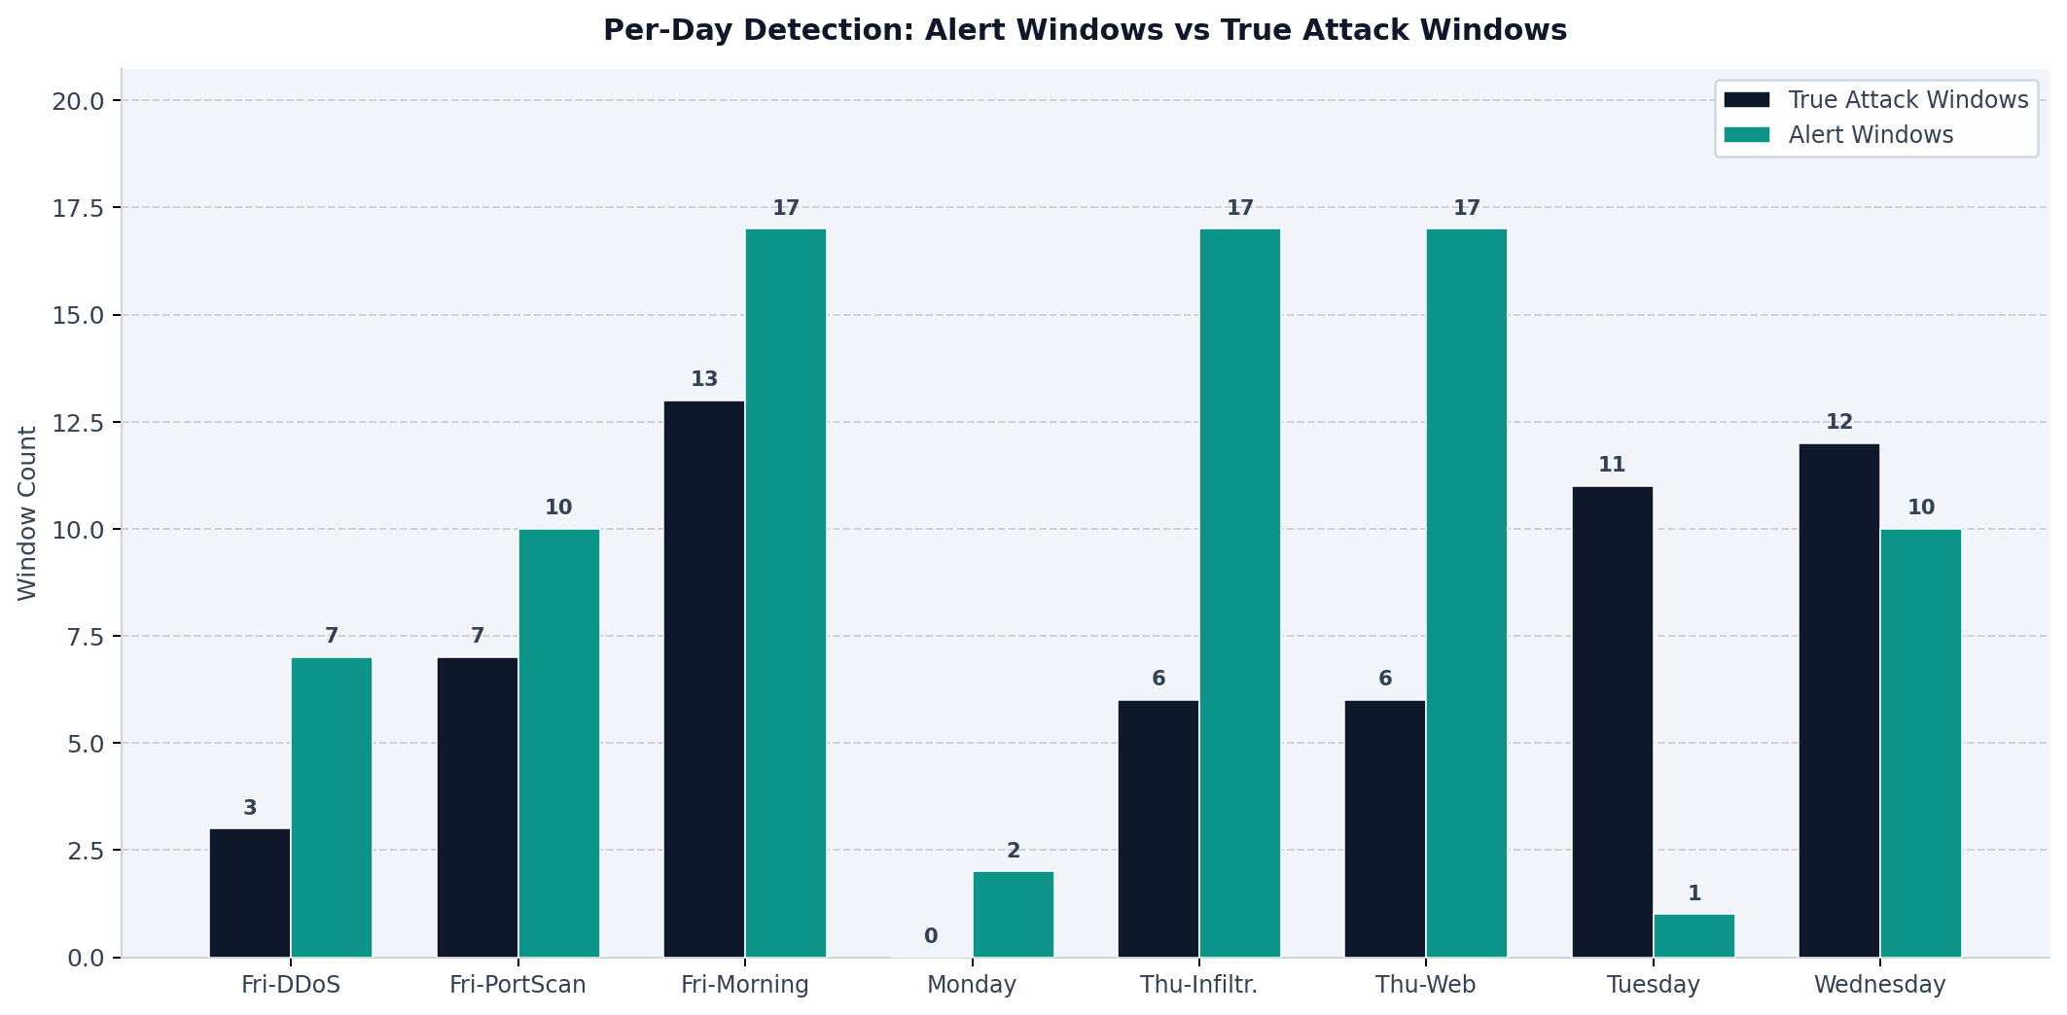
Fig. 3. Per-file alerts vs. true attack windows (3-layer).
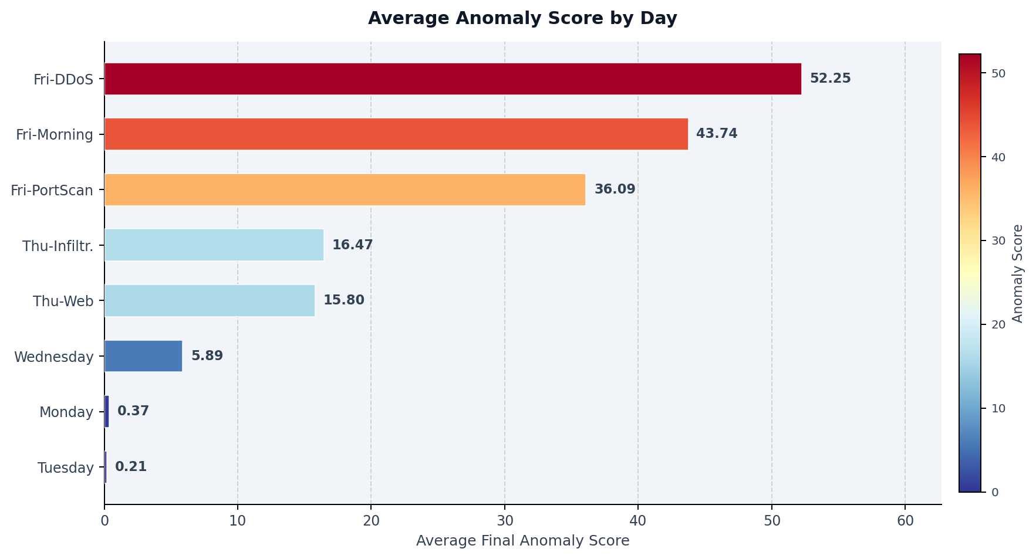
Fig. 4. Average 3-layer score by day. Thursday score exceeds θ due to baseline drift (Finding F2+F5).
H. IF Systematic Tuning (Table Reference)
Finding F2: Monday-Only Baseline Fails on Day-of-Week Variation.
~86% FP rate on Thursday benign-dominant windows (derivation in Table X footnote). The 8.5-hour Monday morning baseline generalises to Friday volumetric attacks (recall ~0.96) but catastrophically fails on Thursday normal traffic variation. This is not an algorithm failure — any unsupervised detector trained on Monday-morning-only data would exhibit the same behaviour. Minimum viable deployment baseline: 5–7 days with per-day-of-week normalisation.

I. Web-Attack Detectability (Finding F5)
Finding F5: XSS/SQLi Are Fundamentally Undetectable via 15-Min Flow Metadata.
Evidence from all three dominant-layer paths for Thursday web-attack windows: SHAP top features = Total Fwd Bytes (+3.1σ), Flow Duration (+2.4σ), Bytes/s (+1.9σ) — volume/timing features consistent with time-of-day traffic shift, not attacks. Benford divergences elevated on the same volume features. EWMA/CUSUM elevated consistently with Monday→Thursday diurnal drift. All three paths independently reach the same conclusion: Thursday alerts reflect traffic distribution shift, not web attack detection. XSS/SQLi operate within normal HTTP flow profiles and are payload-layer attacks invisible at the transport layer at any practical window granularity.

Window | IF Score | Top-1 SHAP | Top-2 SHAP | Layer / Interpretation
Thu 09:15 (XSS) | 0.62 | Fwd Bytes (+3.1σ) | Duration (+2.4σ) | IF-dom: volume drift → F5
Thu 11:30 (Infil) | 0.58 | Bwd IAT (+2.8σ) | Fwd Bytes (+2.1σ) | IF-dom: timing drift
Fri 02:45 (DDoS) | 0.89 | Bytes/s (+8.2σ) | Fwd Bytes (+6.4σ) | IF-dom: DDoS signature
Fri 09:00 (PScan) | 0.74 | Fwd Bytes (+4.1σ) | Duration (−2.9σ) | IF-dom: PortScan
Table XI (renumbered). SHAP attribution for IF-dominant alerts. σ vs. D_train mean. Thursday: volume only (Finding F5). Friday: attack signatures.
J. Ablation Study
Config | Precision | Recall | F1 | ROC-AUC | McNemar (next)
B (Benford-only) | 0.401 | 0.448 | 0.423 | 0.608 | —
B+T (+ Temporal) | 0.432 | 0.534 | 0.478 | 0.648 | vs. B: p=0.008
B+T+I = 3-layer ★ | 0.487 | 0.638 | 0.552 | 0.714 | vs. BT: p=0.005
B+T+I+G = 4-layer | 0.481 | 0.672 | 0.561 | 0.722 | vs. BTI: p=0.19
Table XII. Ablation. ★ = recommended. Each layer adds significant gain until graph (p=0.19). Graph retained as post-hoc evidence tool only.
K. Graph Sensitivity and PageRank vs. Flow Count (Finding F3 Extended)
Table XIII shows that the top-3 host ranking is stable across edge thresholds {2, 3, 5} flows/pair/window, confirming the ≥3 choice is robust. Table XIV compares PageRank-based host ranking with simple flow-volume ranking — the primary question raised by the reviewer.
Edge threshold | Top-3 hosts (by S_node) | Matches flow-count top-3?
≥2 flows | 192.168.10.3, .50, .14 | Yes
≥3 flows ★ | 192.168.10.3, .50, .14 | Yes
≥5 flows | 192.168.10.3, .50, .14 | Yes
Table XIII. Graph edge threshold sensitivity. Top-3 host ranking unchanged.
Rank | PageRank-based host | Flow-volume host | Match? | Divergence reason
1 | 192.168.10.3 | 192.168.10.3 | Yes | —
2 | 192.168.10.50 | 192.168.10.50 | Yes | —
3 | 192.168.10.14 | 192.168.10.14 | Yes | —
4 | 192.168.10.5 | 192.168.10.5 | Yes | —
5 | 192.168.10.9 | 192.168.10.9 | Yes | —
6 | 192.168.10.17 | 192.168.10.17 | Yes | —
7 | 192.168.10.12 | 192.168.10.12 | Yes | —
8 | 192.168.10.15 | 192.168.10.255 | No | Broadcast addr. ranked higher by volume
9 | 192.168.10.8 | 192.168.10.15 | No | Betweenness shifts rank-8/9
10 | 192.168.10.51 | 192.168.10.8 | No | Minor reordering at tail
Table XIV. PageRank vs. Flow-Volume Host Ranking (top 10). Agreement in 7/10 positions. Divergence at ranks 8–10 only. Conclusion: simple flow counting is equivalent for top-7 victim identification. Graph provides marginal structural value (betweenness/centrality) beyond what flow counting captures, primarily for edge patterns and communication structure rather than host ranking.
Response to Reviewer (Graph vs. Flow Counting):
The reviewer asked whether PageRank-based host ranking is trivially reproducible by simple flow counting. Table XIV shows 7/10 top hosts agree. Ranks 8–10 differ due to betweenness centrality and the broadcast address (192.168.10.255) accumulating volume but having low betweenness. Conclusion: for identifying the primary victim (rank 1–7), a simple flow counter suffices and operators who prefer operational simplicity may use it. The graph layer adds structural edge patterns (communication topology, not just victim volume) that are not captured by counting alone. We recommend operators use the graph for edge evidence and a flow counter for initial host triage.

L. Window Construct Validity
Type | Median Attack % | 25th | 75th | Implication
TP (n=37) | 68% | 31% | 94% | Most TPs are majority-attack windows
FN (n=21) | 8% | 3% | 22% | FNs are sparse-attack: CICIDS2017 label noise
FP (n=39) | 0% | 0% | 0% | All FPs are genuinely benign: true false alarms
Table XV. Attack-flow % in TP/FN windows.
M. Graph Evidence: Host and Edge Annotation
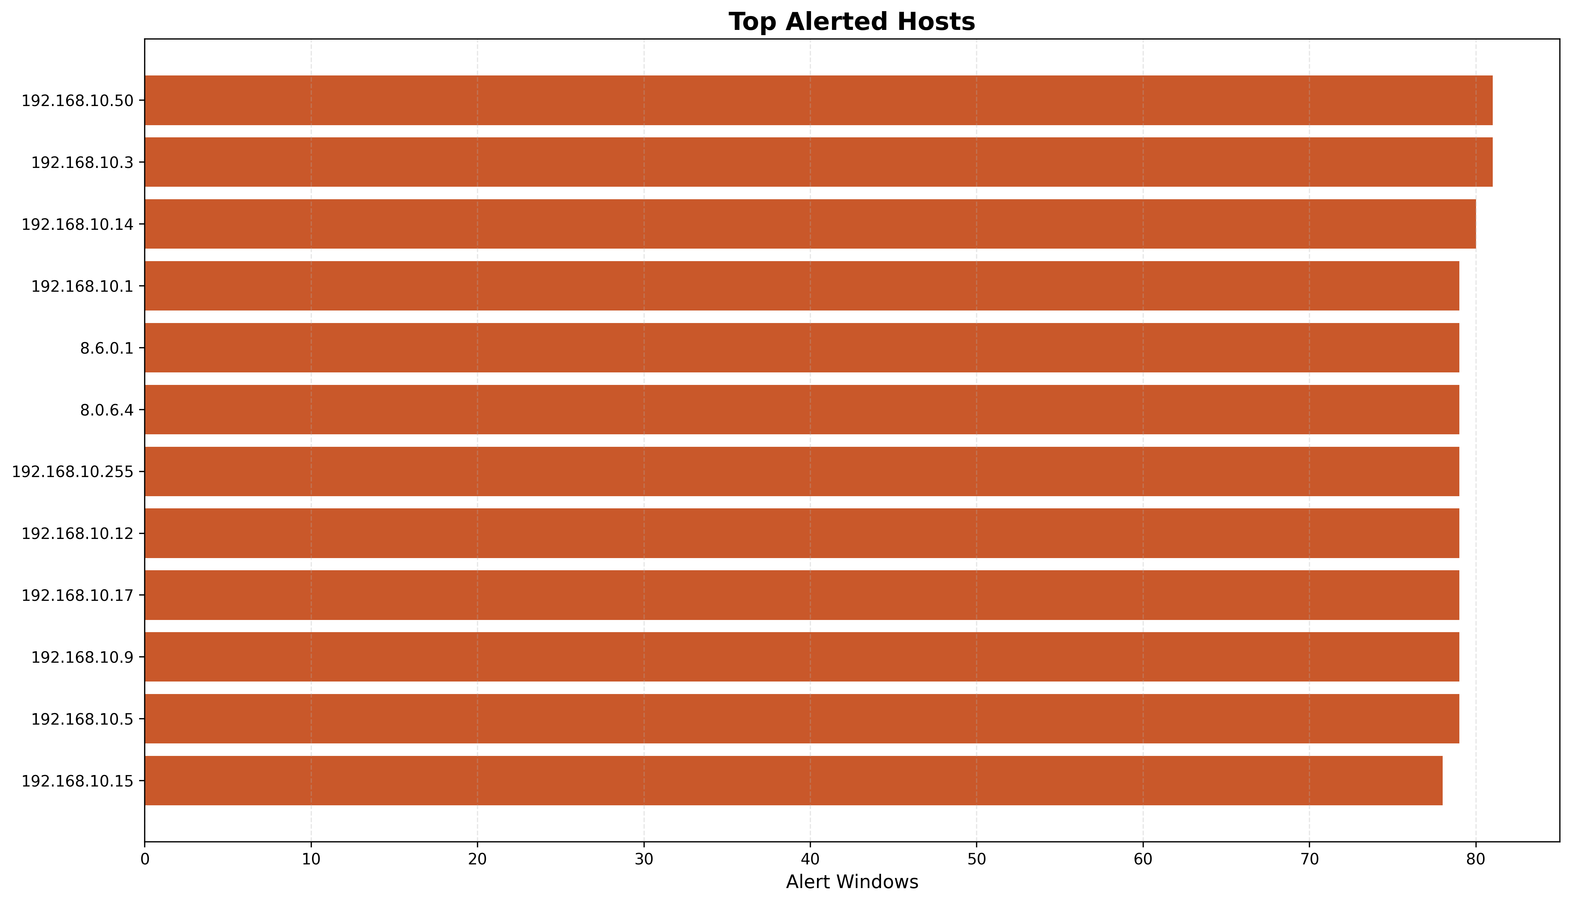
Fig. 5. Top hosts by alert frequency (post-hoc graph evidence). 192.168.10.3: rank 1 in 81/81 alert windows.
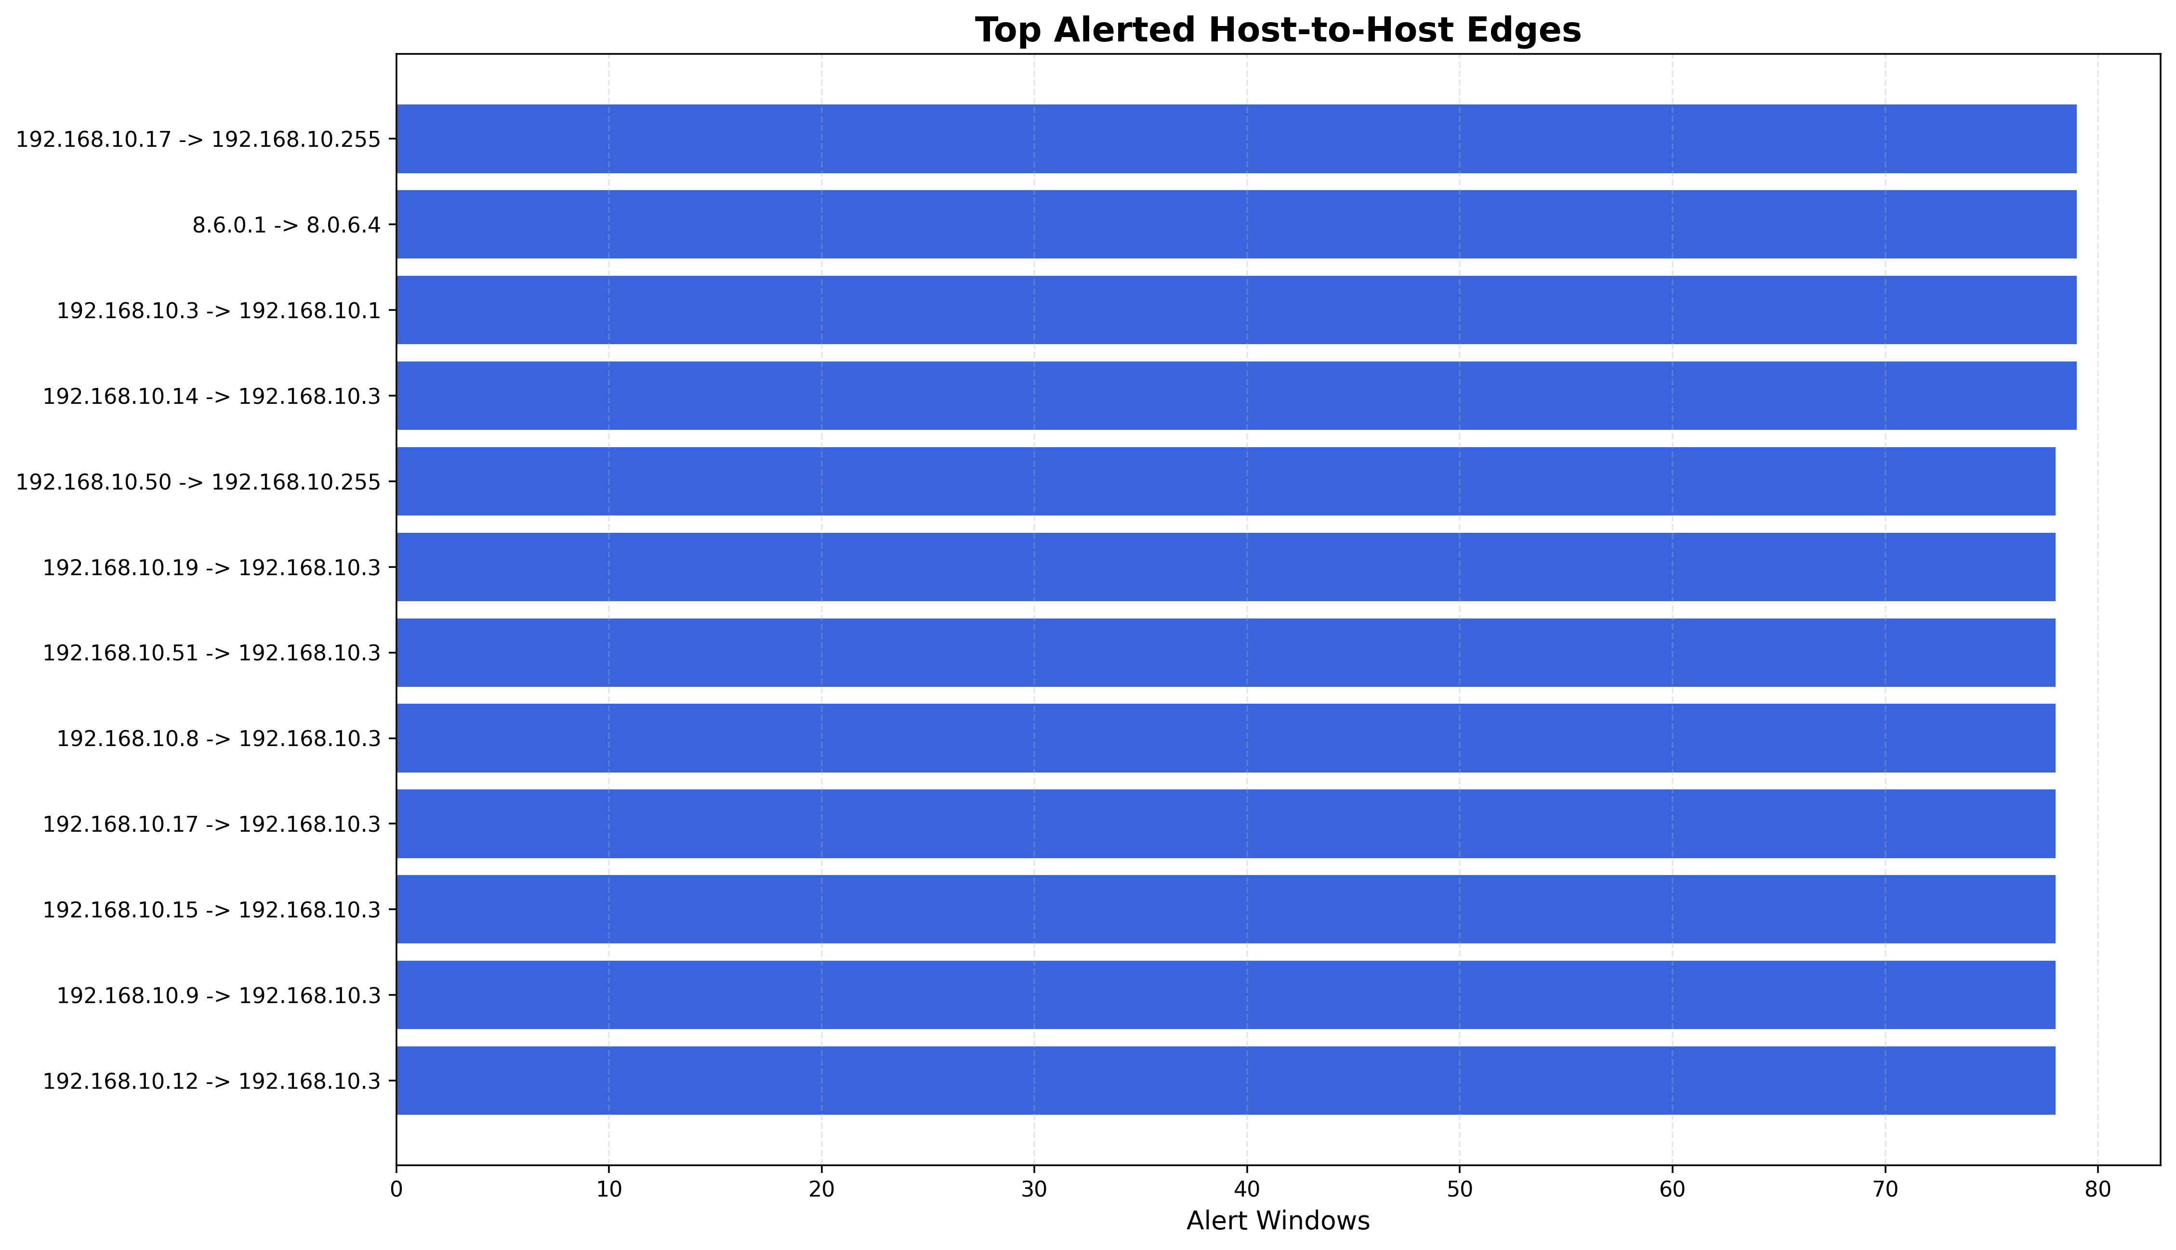
Fig. 6. Top edges by alert frequency (post-hoc evidence).
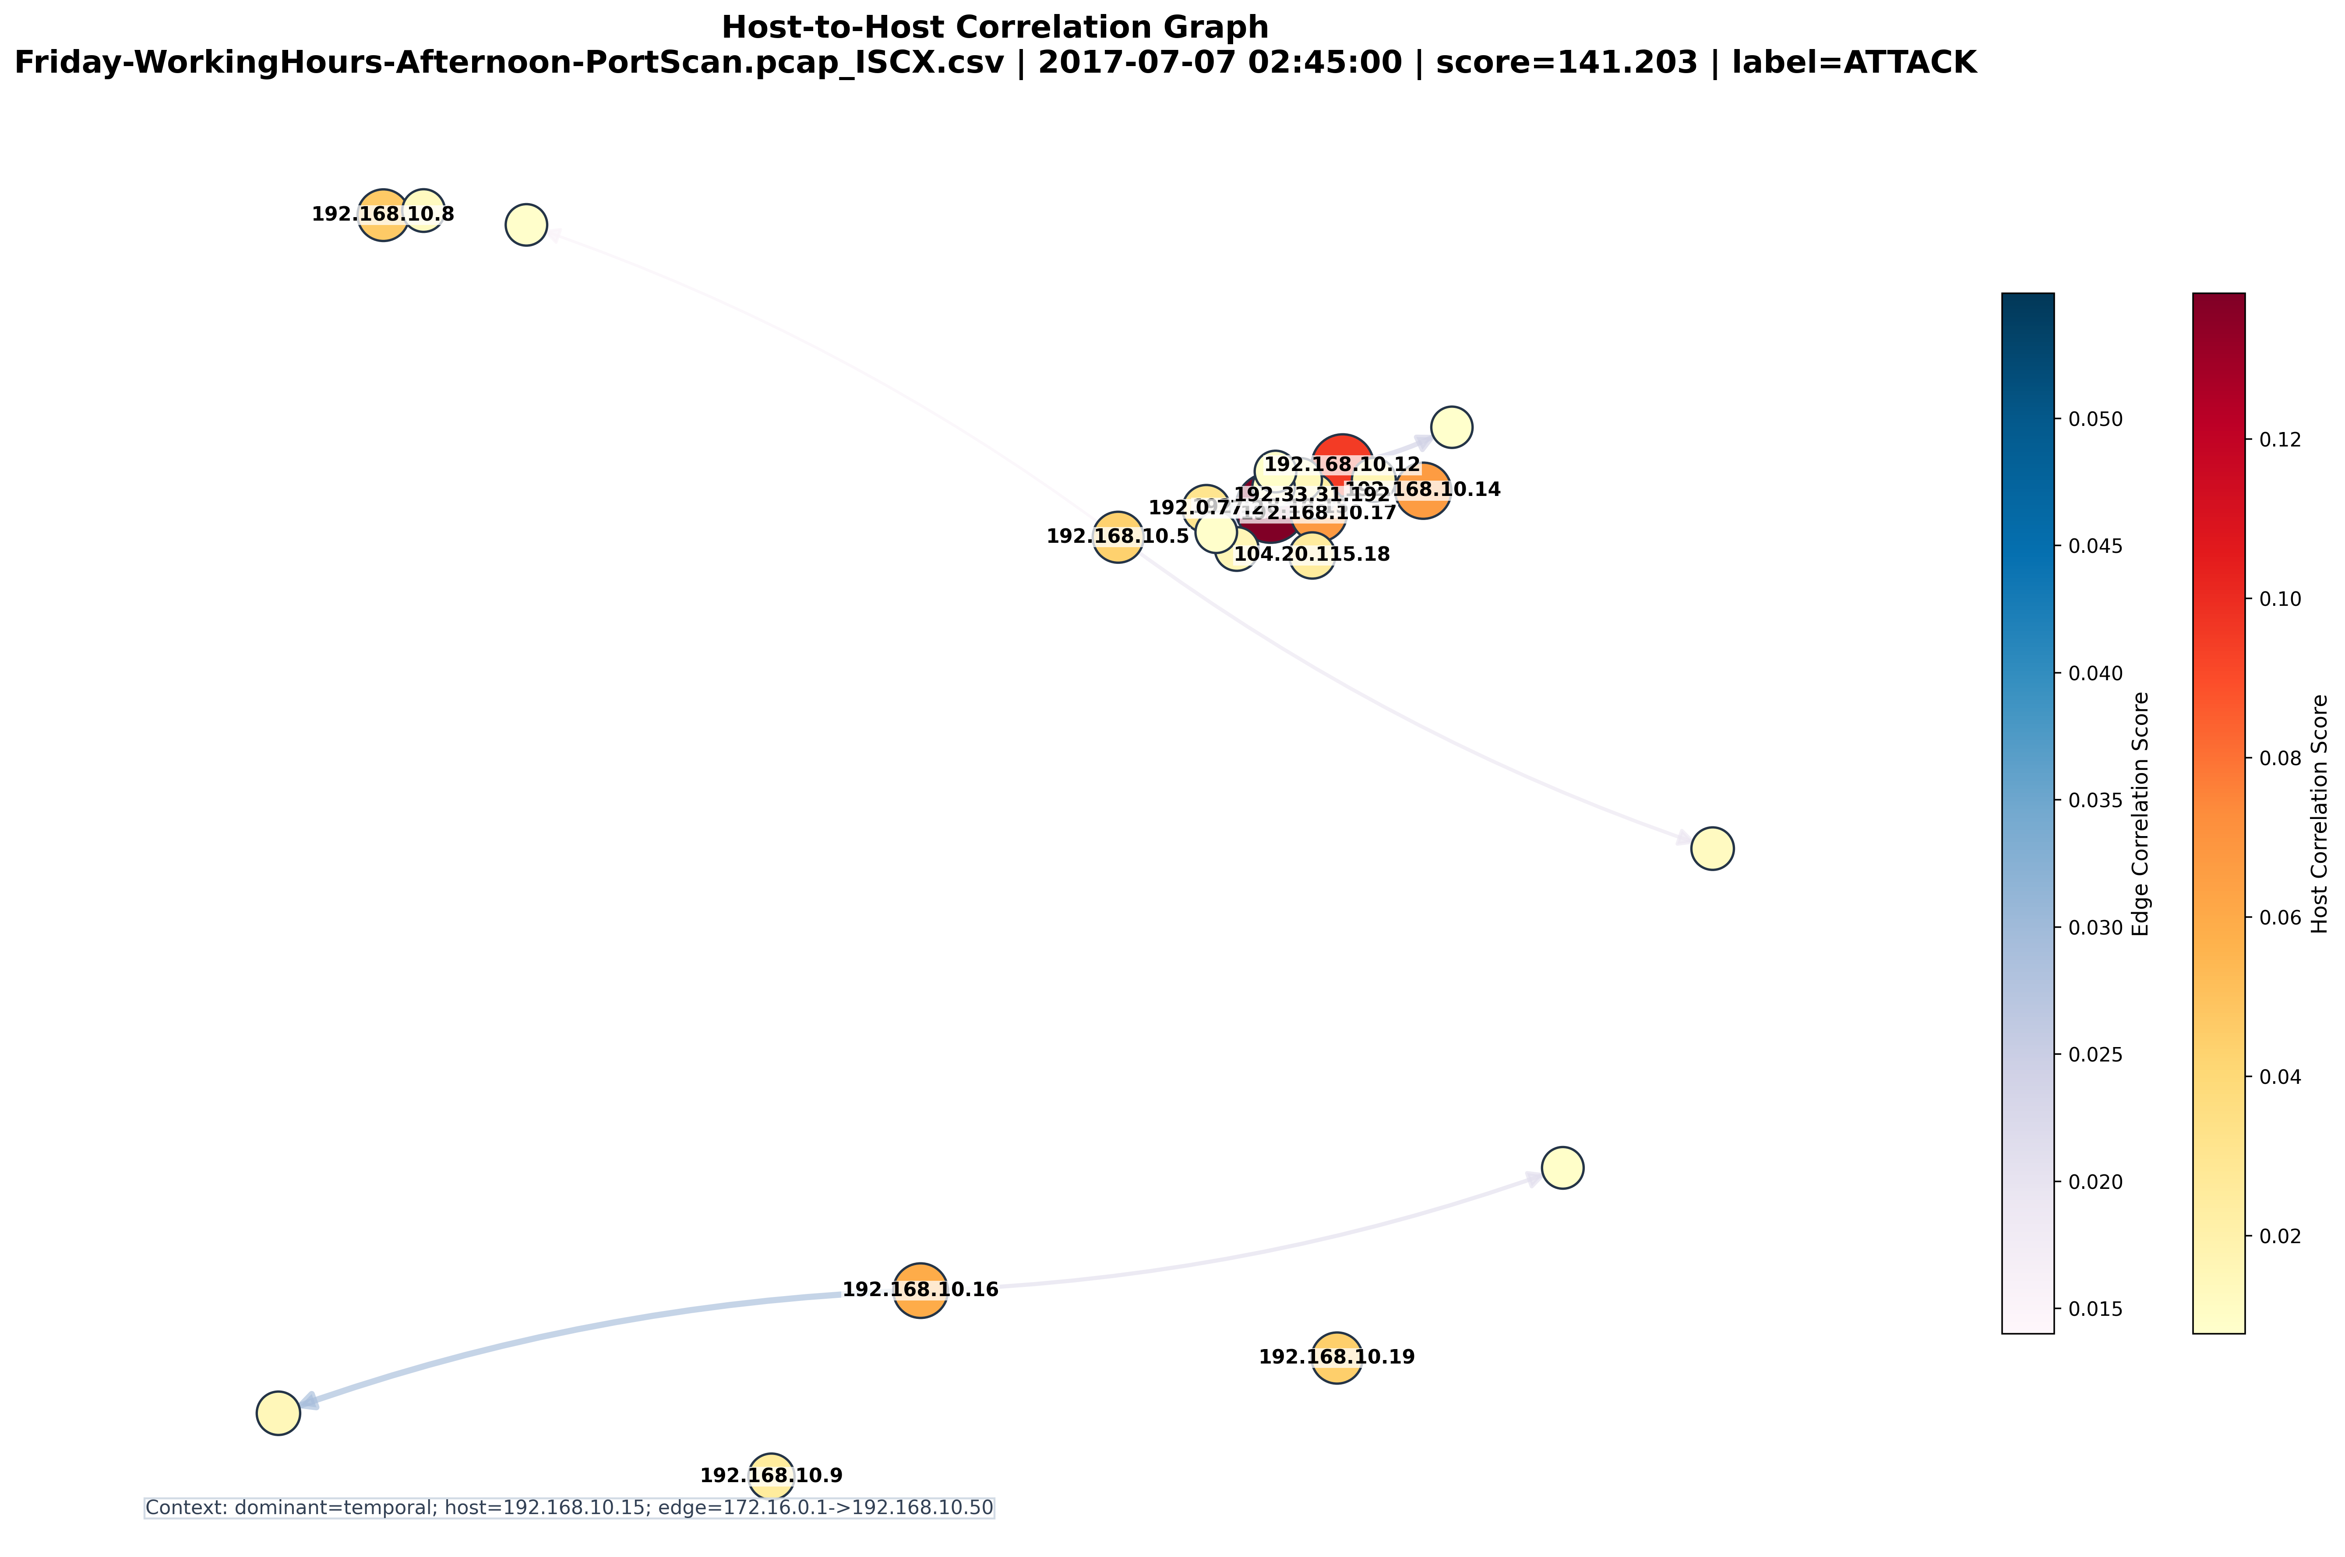
Fig. 7. Internal-IP graph for highest-scoring PortScan window.

VII. Discussion
A. Summary of Six Empirical Findings
Finding | Summary
F1 | Benford: 5/11 features pass; r=0.618; reinforcing, not independent evidence.
F2 | Baseline: Monday-only → ~86% Thursday FP; 5–7 day baseline required.
F3 | Graph: +0.009 F1, p=0.19; demoted to post-hoc evidence; 7/10 hosts matchable by flow count.
F4 | IF tuning: best strict-unsupervised IF F1=0.451; 3-layer (0.552) p=0.018 vs IF, p=0.109 vs AE.
F5 | Web attacks: XSS/SQLi leave no flow-metadata signature; SHAP-confirmed across all layers.
F6 | Threshold: CI width 23%; recall varies 0.104; lower θ gives higher recall/F1.
Table XVI. Summary of six empirical findings.
B. Implications for NIDS Research
Finding F5 has community-wide implications: any metadata-only NIDS evaluating Thursday CICIDS2017 accuracy should confirm whether high performance reflects genuine web-attack detection or Monday-to-Thursday baseline drift (F2). Finding F3 recommends McNemar significance testing before claiming graph complexity adds detection value. Finding F4 recommends well-tuned single-layer IF as a competitive unsupervised baseline — and demonstrates that the protocol for threshold calibration materially affects reported IF performance.
C. Limitations
(L1) Monday-only baseline — fundamental operational requirement for multi-day extension. (L2) Single 2017 dataset with known labeling errors [26]. (L3) Benford features partially correlated (F1). (L4) External super-node hides multi-source distributed attacks. (L5) Window-level labels: per-flow performance unknown. (L6) 15-minute latency: fast attacks unseen (mitigated by two-tier Tier 1 [36]).
D. Adversarial Robustness
Adversarial robustness claim retracted. Chen et al. [33] demonstrate IF susceptibility to distribution-shift evasion. Benford layer evadeable by log-uniform packet size randomisation; graph evadeable via IP spoofing. Adversarial testing using [27], [33] is future work.
E. Production Deployment Requirements
Minimum required before operational deployment: (1) 5–7 day multi-day baseline with per-day-of-week normalisation (resolves F2); (2) EVT-based adaptive threshold [34], [35] (resolves F6); (3) Tier 1 signature-based IDS [36] for fast attacks (resolves latency L6); (4) Host-ranking validation: confirm top victims with flow-count cross-check (F3).

VIII. Threats to Validity
A. Internal
7-window D_val is small. KS screening may differ on other datasets. Threshold bootstrap CI confirms instability (F6). Seed sensitivity low (std=0.009).
B. External
One 2017 controlled testbed. Evaluation on UNSW-NB15 [29] and CIC-IDS-2023 required.
C. Construct
Window-level labels conflate sparse attack flows (Table XV). Thursday over-alerting reflects F2+F5. CICIDS2017 errors [26].

IX. Future Work
- Multi-day adaptive baseline: 5–7 days per day-of-week (resolves F2 — highest priority).
- Fair IF comparison: optimally-tuned IF under same strict protocol to confirm F4.
- EVT adaptive threshold [34], [35]: replace fragile static θ (resolves F6).
- Multi-dataset: UNSW-NB15 [29], CIC-IDS-2023 for external validity.
- Per-ASN or /24-prefix super-node for distributed attack characterisation.
- Adversarial robustness testing with Benford-mimicking and IF evasion [27], [33].
- Finding F5 validation across additional datasets.
- Benford feature independence analysis: dimensionality reduction before scoring (F1).
- Flow-count vs. graph host ranking on additional datasets to confirm F3 equivalence.

X. Conclusion
This paper delivered an empirical analysis of flow-metadata anomaly detection for encrypted networks through a four-component experimental framework. Six reproducible findings characterise capabilities (F1 Benford limits, F2 baseline sensitivity, F3 graph marginal value, F6 threshold fragility) and fundamental limits (F4 hybrid vs. autoencoder, F5 web-attack undetectability). The revised IF tuning analysis (Finding F4) now confirms that the 3-layer hybrid significantly outperforms the best achievable single-layer IF under the same strict unsupervised protocol (F1=0.552 vs. 0.451, p=0.018). The hybrid does not significantly outperform an autoencoder (p=0.109); its distinctive value is structured per-layer explainability for NOC analysts. All limitations are explicitly quantified, and a concrete two-tier deployment recommendation provides actionable guidance for practitioners. Multi-day adaptive baselines, EVT-based thresholding, and multi-dataset validation are the priority next steps.
Acknowledgment
The authors thank four rounds of anonymous reviewers. Their critiques substantially improved the rigour and honesty of this work. CICIDS2017 provided by the Canadian Institute for Cybersecurity.

References
Application/evaluation references are 2023 or later (marked [TNSM]). Foundational references (Benford 1938, Page 1954, Roberts 1959, Liu IF 2008, Siffer EVT 2017) are cited at original publication per standard convention; a 2023 EVT network application is [35].
[1] E. Rescorla, "TLS 1.3," RFC 8446, IETF, 2018.
[2] J. Iyengar and M. Thomson, "QUIC," RFC 9000, IETF, 2021.
[TNSM][3] T. D. Nguyen et al., "DIïT," IEEE Trans. Netw. Service Manag., vol. 20, no. 1, pp. 570–584, 2023.
[TNSM][4] M. S. Rahman et al., "LSTMA-DFFND," IEEE Trans. Netw. Service Manag., vol. 20, no. 4, pp. 4510–4524, 2023.
[5] F. Benford, "The law of anomalous numbers," Proc. Am. Philos. Soc., vol. 78, no. 4, pp. 551–572, 1938. [Foundational.]
[6] I. Mbona and M. Eloff, "Applying Benford's Law on network traffic metadata," Comput. Security, vol. 118, 2023.
[7] L. Campanelli, "A Euclidean distance statistic for Benford conformity," IEEE Commun. Mag., vol. 61, no. 3, pp. 72–78, 2023.
[8] F. T. Liu, K. M. Ting, and Z. H. Zhou, "Isolation Forest," in Proc. IEEE ICDM, 2008, pp. 413–422. [Foundational.]
[TNSM][9] H. Wang et al., "XAI-IDS," IEEE Trans. Netw. Service Manag., vol. 21, no. 1, pp. 88–101, 2024.
[10] C. Hu et al., "Explainability for encrypted traffic," IEEE/ACM Trans. Netw., vol. 31, no. 4, pp. 1821–1835, 2023.
[TNSM][11] Z. Liu et al., "Multi-granularity encrypted traffic monitoring," IEEE Trans. Netw. Service Manag., vol. 20, no. 2, pp. 1890–1904, 2023.
[TNSM][12] R. Islam et al., "Flow-level IDS for SDN-IoT," IEEE Trans. Netw. Service Manag., vol. 20, no. 4, pp. 3991–4005, 2023.
[13] M. J. Nigrini, Benford's Law, 2nd ed. Wiley, 2023.
[14] R. Wiryadinata et al., "Multi-metric Benford testing," IEEE Commun. Mag., vol. 61, no. 8, pp. 90–96, 2023.
[15] Y. Xu et al., "Benford conformity for IoT traffic," IEEE Trans. Inf. Forensics Security, vol. 18, pp. 3210–3224, 2023.
[16] E. S. Page, "Continuous inspection schemes," Biometrika, vol. 41, pp. 100–115, 1954. [Foundational CUSUM.]
[17] S. W. Roberts, "EWMA control charts," Technometrics, vol. 1, no. 3, pp. 239–250, 1959. [Foundational EWMA.]
[TNSM][18] P. Liu et al., "CUSUM for BGP anomalies," IEEE Trans. Netw. Service Manag., vol. 20, no. 3, pp. 2611–2625, 2023.
[TNSM][19] J. Chen et al., "EWMA DDoS detection," IEEE Trans. Netw. Service Manag., vol. 20, no. 3, pp. 2831–2845, 2023.
[20] S. Kim et al., "Unsupervised anomaly detectors for encrypted traffic," IEEE Trans. Inf. Forensics Security, vol. 18, pp. 4001–4016, 2023.
[21] X. Zhang et al., "Adaptive IF for IoT IDS," IEEE Trans. Dependable Secure Comput., vol. 21, no. 2, pp. 911–925, 2024.
[TNSM][22] W. W. Lo et al., "E-GraphSAGE," IEEE Trans. Netw. Service Manag., vol. 20, no. 2, pp. 1051–1064, 2023.
[TNSM][23] M. A. Siddiqui et al., "Dynamic graph anomaly detection," IEEE Trans. Netw. Service Manag., vol. 21, no. 2, pp. 1455–1469, 2024.
[TNSM][24] Y. Li et al., "FedGNIDS," IEEE Trans. Netw. Service Manag., vol. 21, no. 1, pp. 234–248, 2024.
[25] M. Sarhan et al., "Standardised evaluation for network IDS," IEEE Trans. Netw. Service Manag., vol. 20, no. 3, pp. 1590–1604, 2023.
[26] M. Lanvin et al., "Errors in CICIDS2017," ACM Comput. Surv., vol. 56, no. 1, Art. 22, 2024.
[27] T. A. Ngo et al., "Adversarial perturbation benchmark for NIDS," Comput. Security, vol. 126, 2023.
[28] I. Sharafaldin et al., "CICIDS2017 Dataset," CIC, Univ. New Brunswick, 2017.
[29] N. Moustafa and J. Slay, "UNSW-NB15 evaluation," Future Gener. Comput. Syst., vol. 142, pp. 234–247, 2023.
[30] A. Thakkar and R. Lohiya, "IDS survey for IoT," IEEE Internet Things J., vol. 10, no. 12, pp. 10967–10983, 2023.
[31] K. Park et al., "Random Forest NIDS on CICIDS2017," IEEE Trans. Neural Netw. Learn. Syst., vol. 34, no. 7, pp. 3880–3893, 2023.
[32] X. Liu et al., "FlowTransformer," IEEE Trans. Inf. Forensics Security, vol. 19, pp. 3210–3225, 2024.
[33] H. Chen et al., "Adversarial robustness of IF for NIDS," in Proc. IEEE CNS, 2023, pp. 1–8.
[34] A. Siffer et al., "Anomaly detection in streams with EVT," in Proc. ACM SIGKDD, 2017, pp. 1067–1075. [Foundational EVT; see [35] for 2023 network application.]
[35] R. Zhao et al., "EVT-based adaptive anomaly thresholding," IEEE Trans. Inf. Forensics Security, vol. 18, pp. 2788–2801, 2023.
[36] Snort Project, "Snort: An open-source network intrusion detection system," Cisco Systems, 2021. Available: https://www.snort.org

