**Steps to setup the School Managment System**

1. Creation of Entity Relationship Diagram

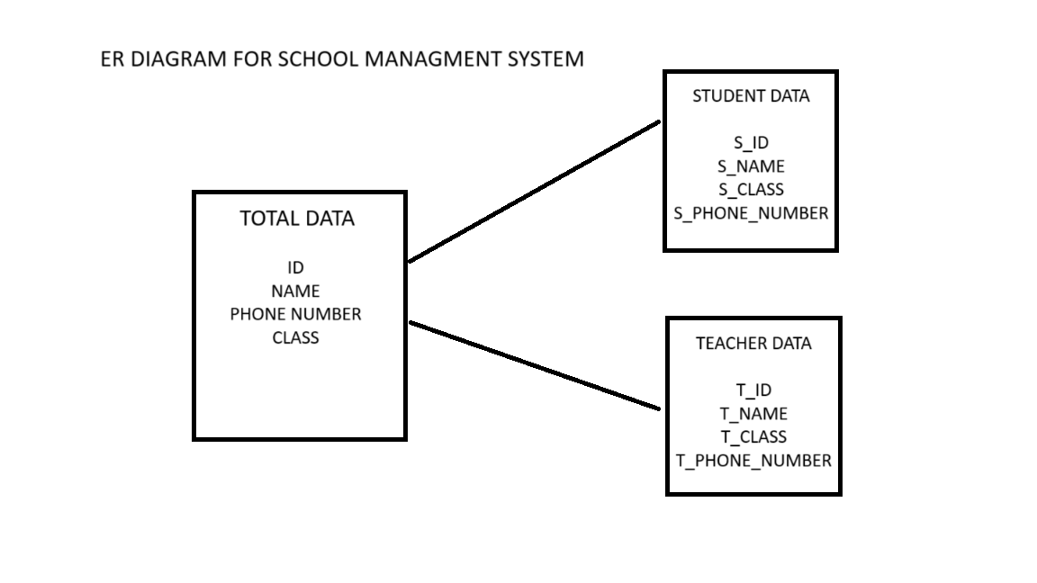

1. Creation of database School management system

Queries :

create database school_managment;

1. Creation of all tables according to ER Diagram

Queries

* For total data

create table total_data(

i_d int,

name varchar(15),

phone_number int,

class char(5));

* For student data

create table student_data(

s_id int,

s_name varchar(15),

s_phone_number int,

s_class char(5));

* For Teacher data

create table student_data(

s_id int,

s_name varchar(15),

s_phone_number int,

s_class char(5));

1. Inserting data into each table

* For total_data

insert into total_data(i_d,name,phone_number,class)

values

(1001,'darsh',24651,'TA'),

(0005,'sanju',55864,'SA'),

(1010,'rekha',01145,'TB'),

(0001,'renjith',11752,'SB');

* For student_data

insert into total_data(i_d,name,phone_number,class)

values

(1001,'darsh',24651,'TA'),

(0005,'sanju',55864,'SA'),

(1010,'rekha',01145,'TB'),

(0001,'renjith',11752,'SB');

* For teacher data

insert into teacher_data(t_id,t_name,t_phone_number,t_class)

values

(1007,'sangeeth',24871,'TA'),

(1005,'shahna',45864,'TA'),

(1010,'renju',04545,'TB'),

(1087,'rajini',194452,'TB');

1. Selecting data from tables

* From total_data

SELECT * from total_data;

* From student_data

select s_id from student_data;

* From teacher_data

select * from teacher_data

1. Updating data of all tables

* For total_data

update total_data set class='SC' where i_d=1010;

* For student_data

update student_data set s_class='SC' where s_id=87;

* For teacher data

update teacher_data set t_class='TC' where T_id=1005;

1. Delete rows from tables

* from total_data

delete from total_data where i_d=1001;

* from student data

delete from student_data where s_id=001;

* from teacher data

delete from teacher_data where t_id=1001;

1. Copying data from csv file

* For total_data

Copy total_data(i_d,name,phone_number,class)

Path ‘C:\Users\ASUS\Desktop\total_data’

Delimiter ‘,’

Csv header

* For student_data

Copy total_data(s_id,s_name,s_phone_number,s_class)

Path ‘C:\Users\ASUS\Desktop\student_data’

Delimiter ‘,’

Csv header

* For teacher_data

Copy total_data(t_id,t_name,t_phone_number,t_class)

Path ‘C:\Users\ASUS\Desktop\teacher_data’

Delimiter ‘,’

Csv header