CISC 863 Quiz -1  
Submitted by: Sagar Kukreja

1. Beta Prior Distribution

Initially we assume coin to be fair and hence we take a and b to be same and hence, we get a peak at 0.5

Beta(2,2)

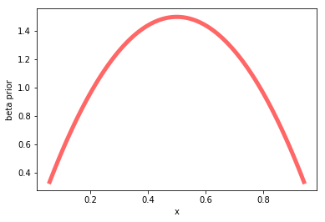

Beta (2, 0.5)

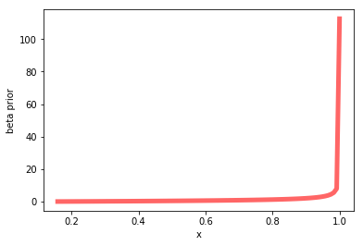

Beta(8,4)

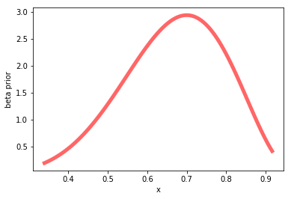

1. Bernoulli Likelihood

Ber(‘HHTHH’|θ)

But when we calculate the distribution from N= 5 trials , we observe that the coin is biased and hence the peak favors occurrence of head.

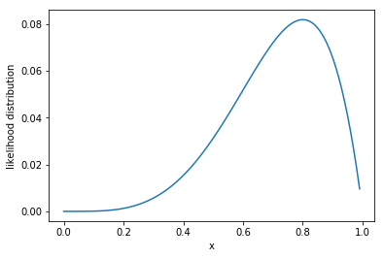

Ber(‘HHTTT’|θ)

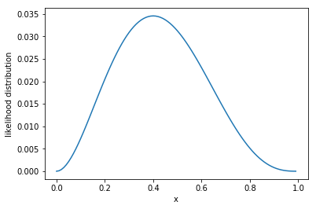

1. Posterior for beta prior is posterior only , hence,

For posterior, we sum up NH + FH and NT + FT, which now gives the peak at around 0.7.

FH = 2, NH = 4

FT = 2, NH = 1

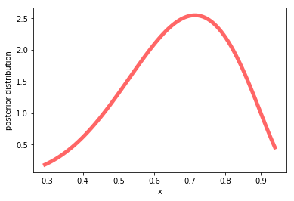

FH = 2, NH = 4

FT = 0.5, NH = 1

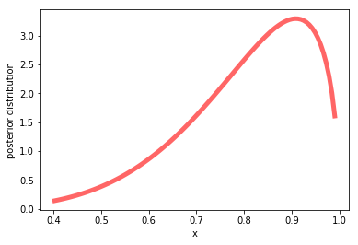

FH = 8, NH = 4

FT = 4, NH = 1

