CISC 863 Quiz -2  
Submitted by: Sagar Kukreja

1. Prior Distribution

Initially we plot the prior distribution on parameter µ, with µ0 = 0 and variance = 6

N(0,6)

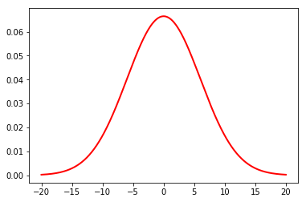

1. Gaussian Likelihood

We plot the gaussian distribution with of observed data now with mean = mean of data and variance = 100

Mean = 2.938



1. Posterior for Gaussian,

We calculate the mean and variance for posterior and plot the distribution,

Mean = 2.58

Var = 4.39

