NAME: SAGAR LADLA

ROLL: 2024HT01123

SUBJECT: EMBEDDED SYSTEM DESIGN

LAB ASSIGNMENT 2

ANS 1
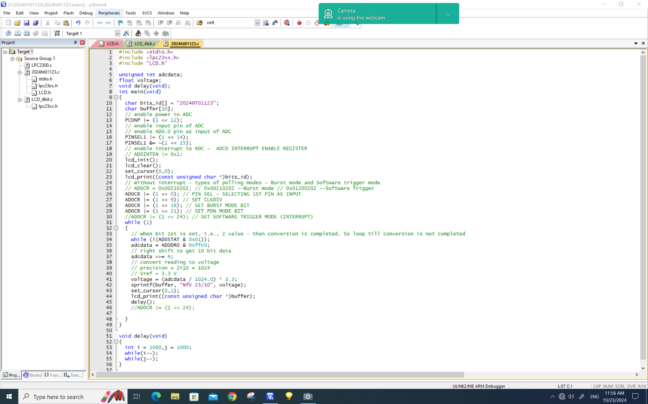
CODE WITH HIGH PRECISION VOLTAGE MEASURE:

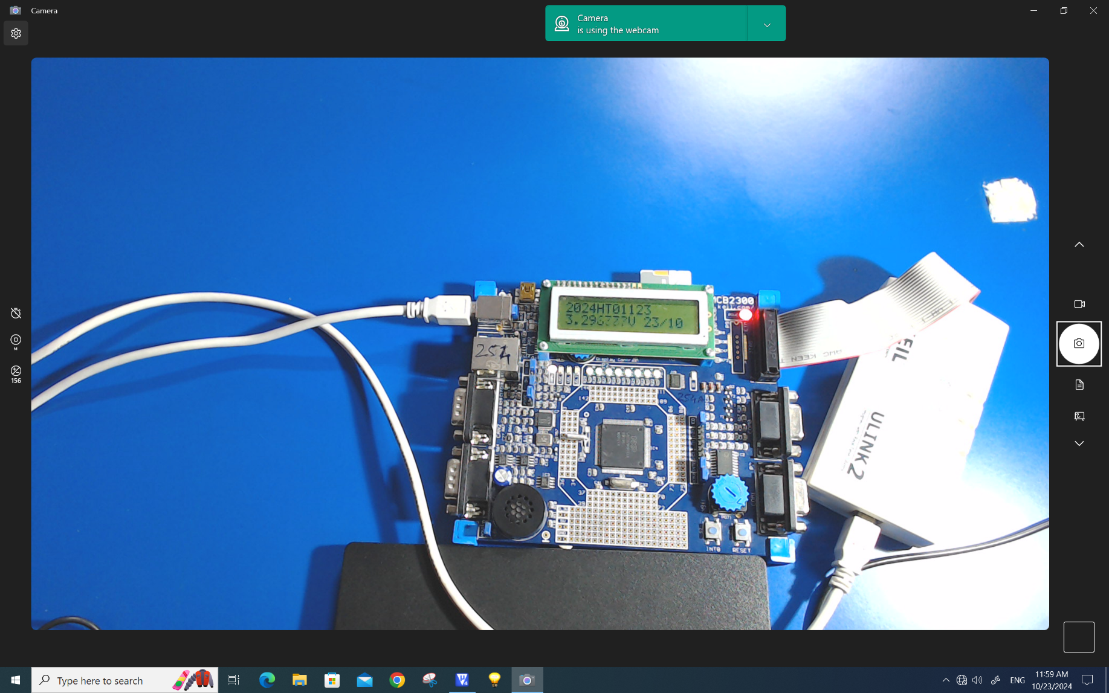
OUTPUT WITH HIGH PRECISION VOLTAGE MEASURE:

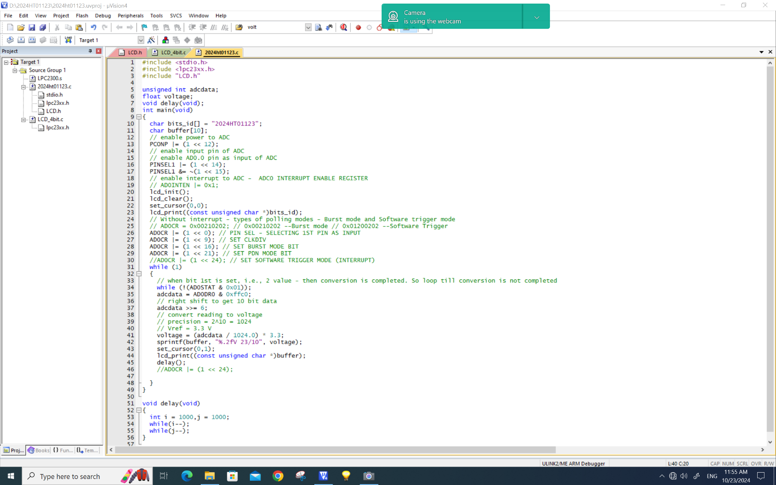
CODE WITH FIXED POINT VALUE:

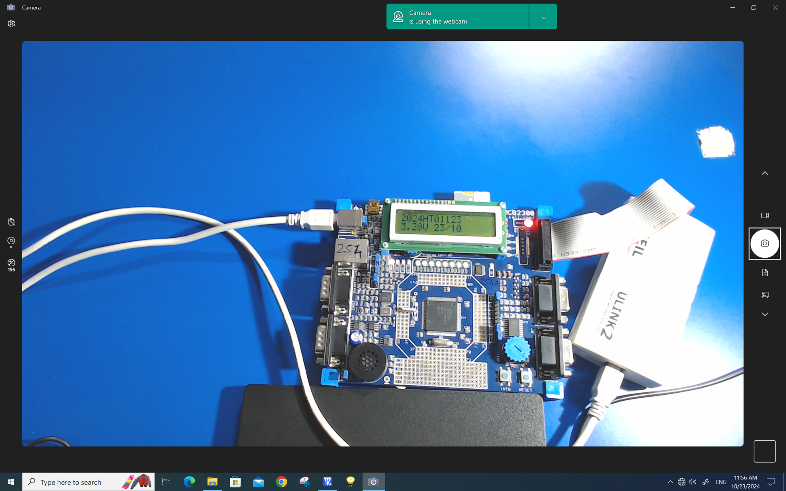
OUTPUT WITH FIXED POINT VALUE:

ANS 2:
- Smallest change in input voltage detected by LPC2378 ADC (Resolution),
  - R = V_{ref} / 2^{n}
  - R = 3.3 V / 2¹⁰
  - R = 3.3 V / 1024
  - R = 0.0032226563 V or R = 3.2226563 mV
- Operating f_{max} of LPC2378 ADC = 4.5 Mhz
- Steps to program timer for 2 second delay:
  - Reset timer0 initially to deactivate counting.
    - T0TCR=(1<<1);
  - Load calculated values in the Prescaler register T0PR and Match register T0MR0
    - T0MR0=599999
    - T0PR = 10
  - Initialize T0PC and T0TC registers.
    - T0PC=0;
    - T0TC=0;
  - Select operations using match registers when match is encountered.
    - T0MCR=(1<<0) | (1<<2);
  - Start the Timer by enabling it through T0TCR register.
    - T0TCR=(1<<0);
  - Wait till the interrupt and then clear the flag by writing T0IR register.
    - while(!(T0IR&(1<<0)));
    - T0IR=(1<<0);

CCLK = 48 MHz (given)
So, by using default ¼ divider, we will the PCLK = 48 MHz/4 = 12 MHz
Therefore, count:
= (PCLK / Desired frequency) - 1
= (12,000,000 / 20) – 1
= 6,00,000 – 1
Count = 5,99,999
T0MR0=5,99,999 is count which gives 0.2 seconds delay. To make the delay for 2 seconds we have to multiply it with 10, which we set in T0PR (prescaler) register.

Full code of LCD-ADC CODE:
#include <stdio.h>
#include <lpc23xx.h>
#include "LCD.h"

unsigned int adcdata;
float voltage;
void delay(void);
int main(void)
{
char bits_id[] = "2024HT01123";
char buffer[10];
// enable power to ADC
PCONP |= (1 << 12);
// enable input pin of ADC
// enable AD0.0 pin as input of ADC
PINSEL1 |= (1 << 14);
PINSEL1 &= ~(1 << 15);
// enable interrupt to ADC - ADC0 INTERRUPT ENABLE REGISTER
// AD0INTEN |= 0x1;
lcd_init();
lcd_clear();
set_cursor(0,0);
lcd_print((const unsigned char *)bits_id);
// Without interrupt - types of polling modes - Burst mode and Software trigger mode
// AD0CR = 0x00210202; // 0x00210202 --Burst mode // 0x01200202 --Software Trigger
AD0CR |= (1 << 0); // PIN SEL - SELECTING 1ST PIN AS INPUT
AD0CR |= (1 << 9); // SET CLKDIV
AD0CR |= (1 << 16); // SET BURST MODE BIT
AD0CR |= (1 << 21); // SET PDN MODE BIT
//AD0CR |= (1 << 24); // SET SOFTWARE TRIGGER MODE (INTERRUPT)
while (1)
{
// when bit 1st is set, i.e., 2 value - then conversion is completed. So loop till conversion is not completed
while (!(AD0STAT & 0x01));
adcdata = AD0DR0 & 0xffc0;
// right shift to get 10 bit data
adcdata >>= 6;
// convert reading to voltage
// precision = 2^10 = 1024
// Vref = 3.3 V
voltage = (adcdata / 1024.0) * 3.3;
sprintf(buffer, "%.2fV 23/10", voltage);
set_cursor(0,1);
lcd_print((const unsigned char *)buffer);
delay();
//AD0CR |= (1 << 24);

}
}

void delay(void)
{
int i = 1000,j = 1000;
while(i--);
while(j--);
}

