**Assignment 7**

Team

Abhitej Date (1001113870)

Rasika Dhanurkar (1001110582)

Sagar Lakhia (1001123182)

We successfully deployed an application which allows the user to upload an image and then add comments to it. The user is also able to register as well as sign in.

Below are screenshots for better understanding:

Login Screen:

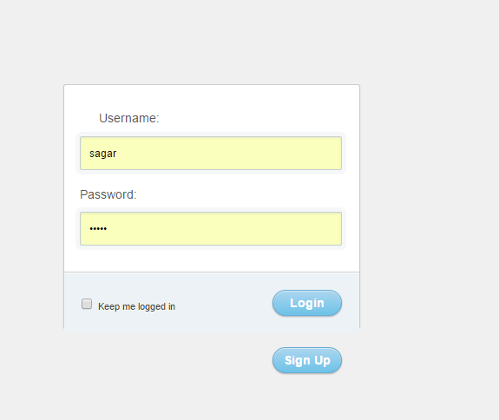

Creating a thread along with a picture and on the centre shows the list of threads already created.

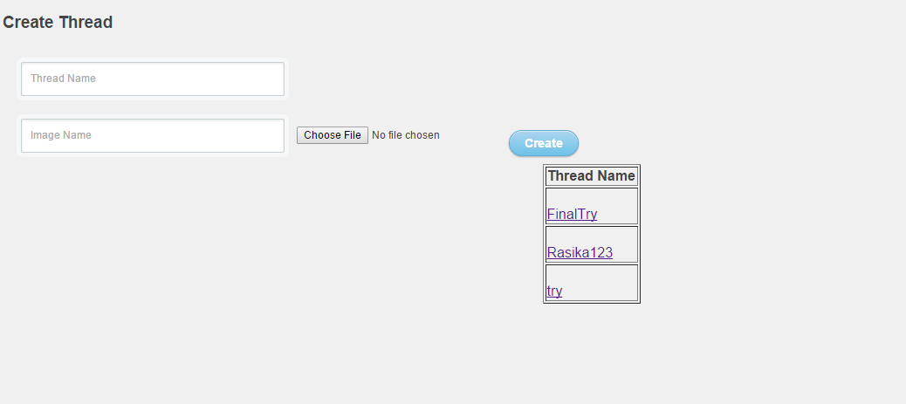

Creating a thread

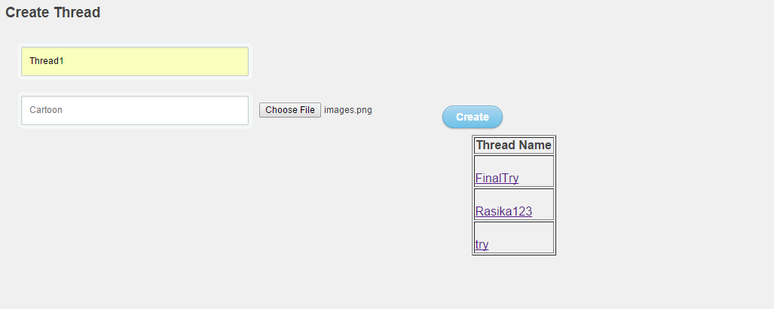

Thread gets created

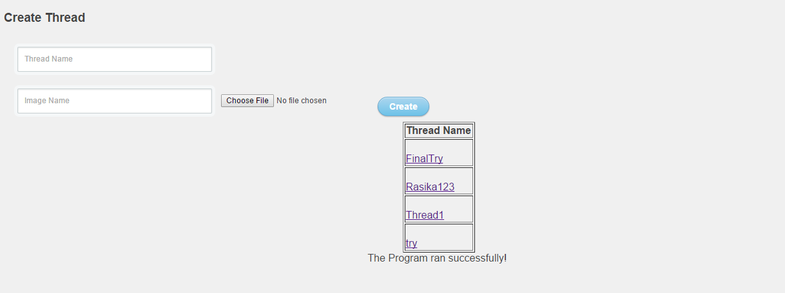

Now we can see the thread as:

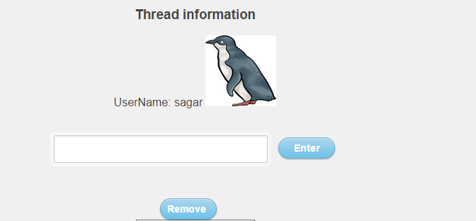

Remove removes the thread, Next we will add the comment

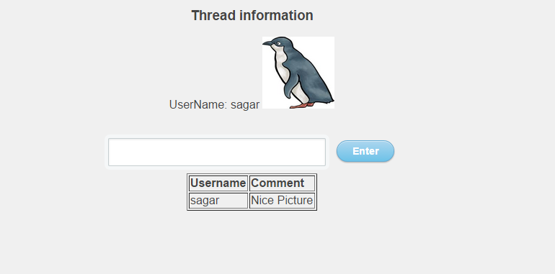

Now other user logs in:

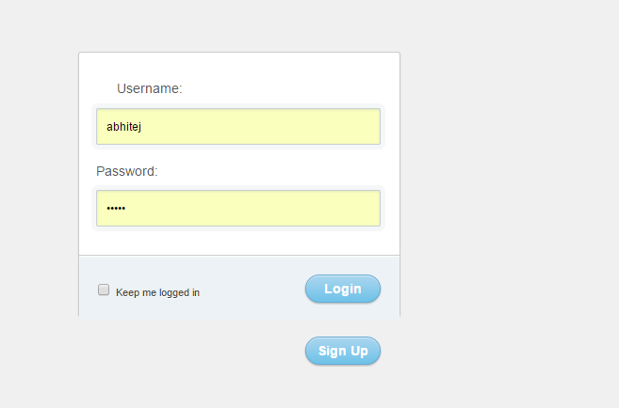

He looks at the available threads:

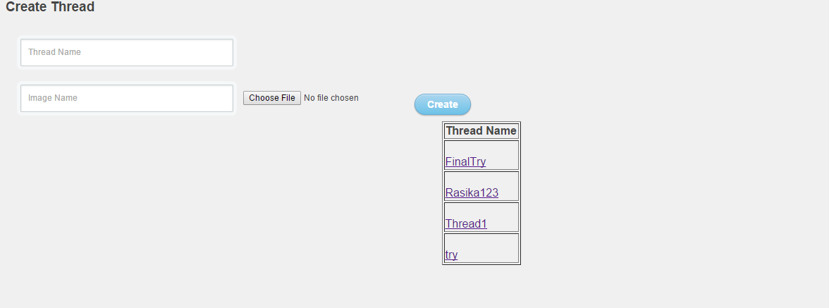

And then finally he makes a comment:

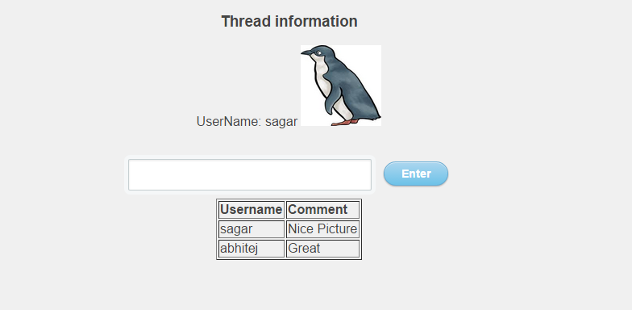

References:

[1] <https://cloud.google.com/storage/docs/access-control>

[2] <https://cloud.google.com/appengine/docs/python/googlecloudstorageclient/migrate>