ASSIGNMENT 2

Team Members

Abhitej Date (1001113870)  
Sagar Lakhia (1001123182)

Q Write the code necessary to determine the number of earthquakes for each week, for magnitudes   
 2, 3, 4, and 5 (or greater)

We were told that we can upload the csv file by any means but all the other functions should be done using Google App Engine. So we have used function from our first assignment to upload file to the bucket. In below image you can see time taken to upload CSV file

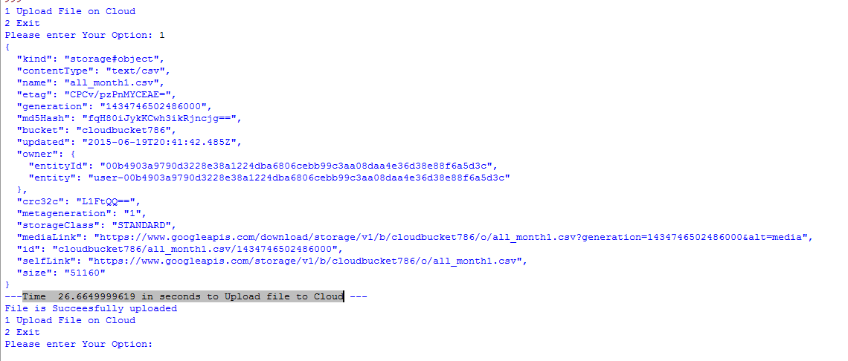

We stored all_months.csv, which approximately contains 8000 Records of earthquakes.

We referred the GCS Main demo application to learn how to read the file from cloud.

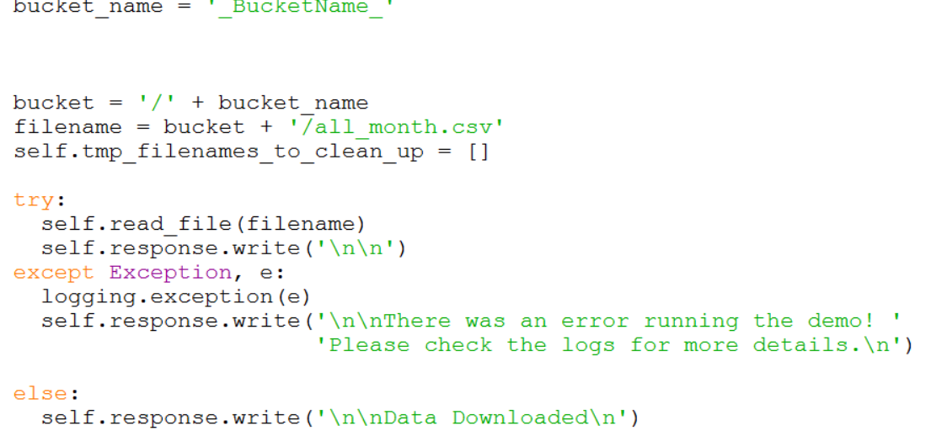

Next in order to display data on the html page we used jinja2 environment, we defined variables in our python code and then we passed our variables to be rendered on our html page.

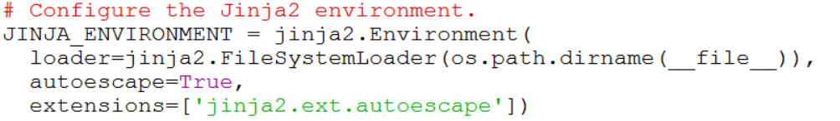

We connected to our database on the cloud and we created a table with the fields that we required using the following code:

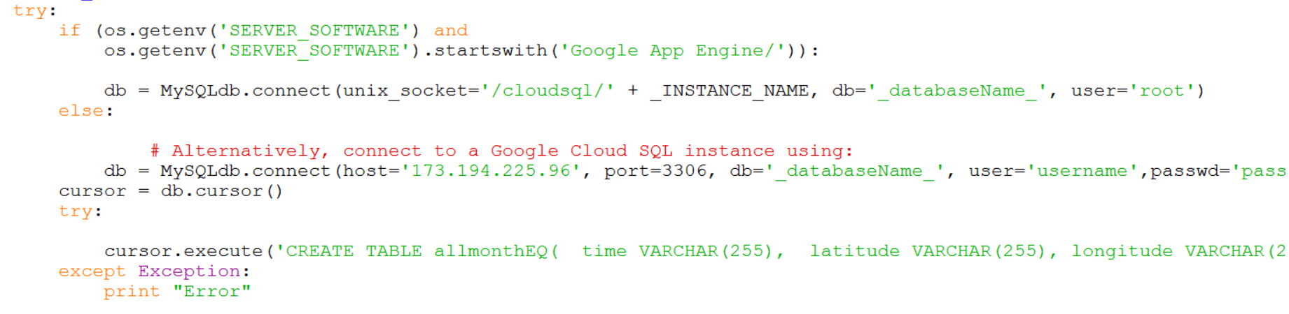

Then we read our file from Google cloud and then we inserted the data to the table we created above

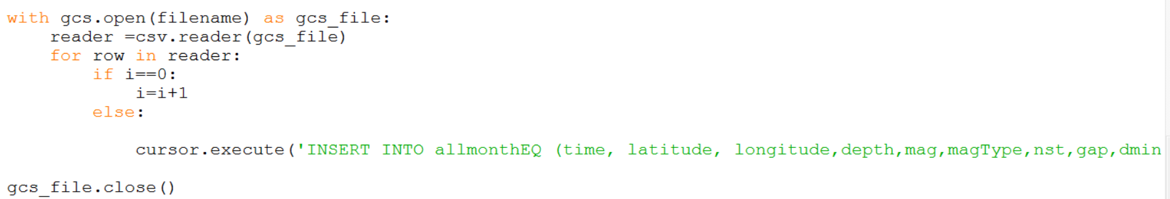

And then we filter the data that we stored in the queries to display the results that we achieved and we set those variables to the html page using jinja2

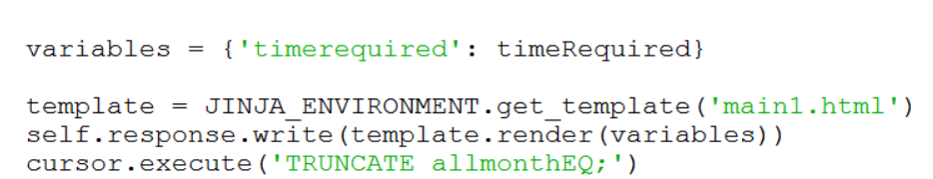

The HTML file that we created looks something like this:

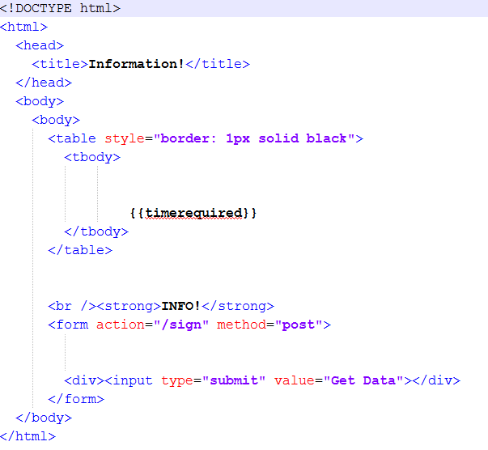

Screenshots of the Results:

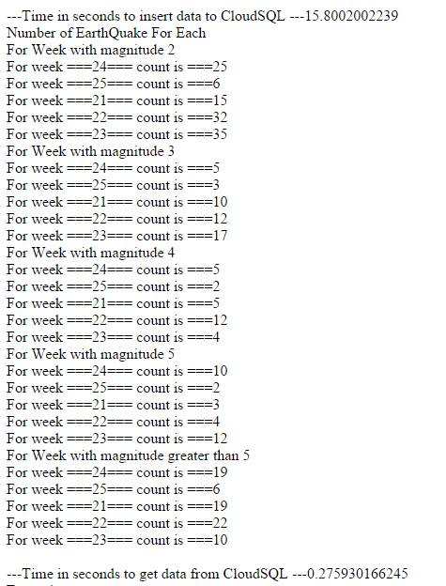

We have mentioned the time it took to enter the data into the database, the time it takes to run the query and the count of the earthquakes with magnitude we were asked for.