ASSIGNMENT 3

Team of 2

Team Members

Abhitej Date (1001113870)  
Sagar Lakhia (1001123182)

Q To create an interface where user can enter Magnitude of the earthquake and he can view the number of earthquakes along with the populated list.

Since we now already have our dataset ready and connected. Now it’s time to make it User interactive.

We provided a Number box, where user will enter the magnitude, we will search the data for that magnitude and display the results. Also user can enter location in second box, we will search the data for that location and display the results.

Now our HTML file looks like this:

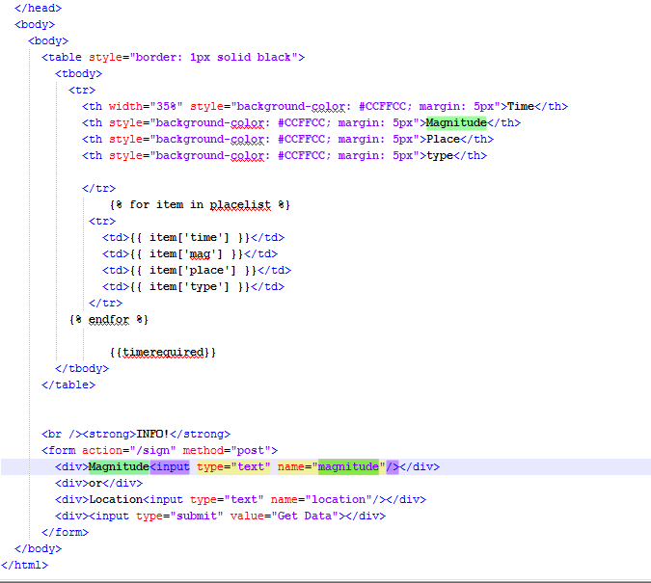

Which runs as follows:

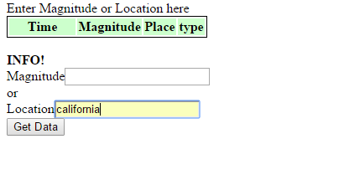

When you enter the data and click on “Get Data”

You get the results

For magnitude

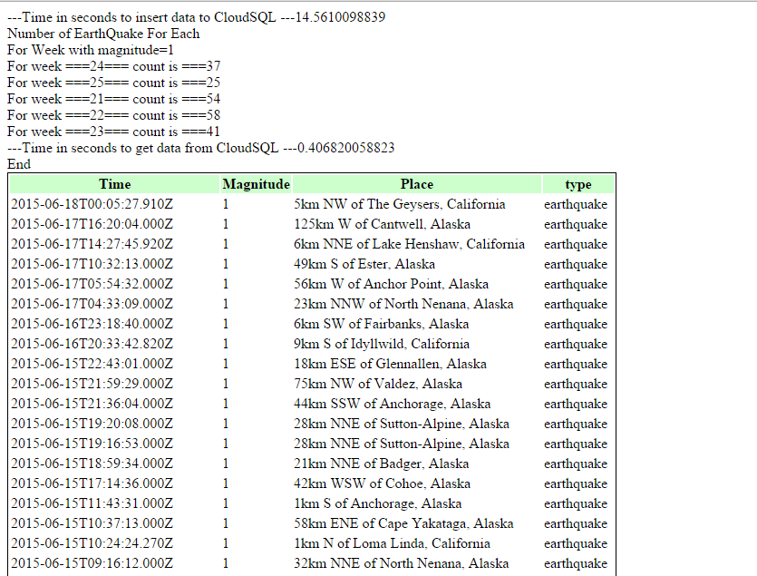

For Location

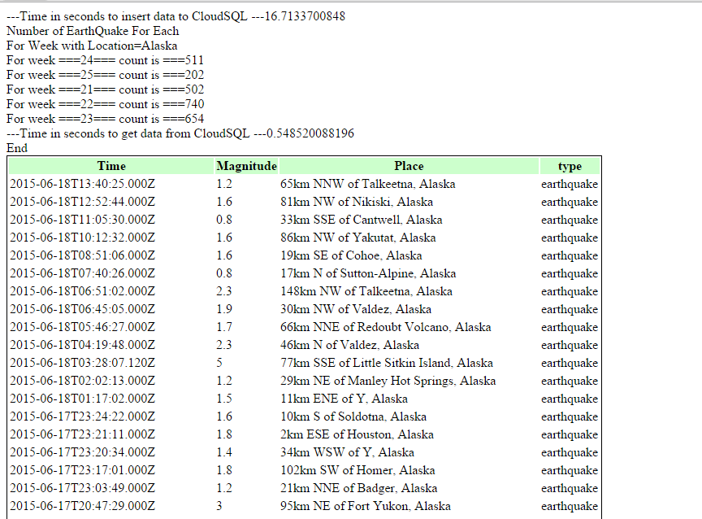

We have mentioned the time it took to enter data and the time to run the query.

We displayed the data using Jinja2.