Assignment-9

Visualization(Cloud)

Abhitej Date (1001113870)

Rasika Dhanurkar (1001110582)

Sagar Lakhia (1001123182)

We used Flask Framework in python along with ec2 to host our application in order to achieve our goal of visualizing data.

Note: We used three different datasets to visualize different graphs.

Below are some screenshots:

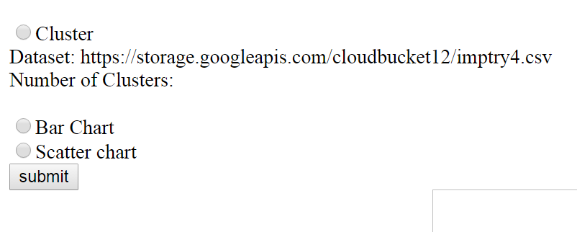

When you click on cluster, a text box pops up which asks the user to pass the number of clusters he wants.

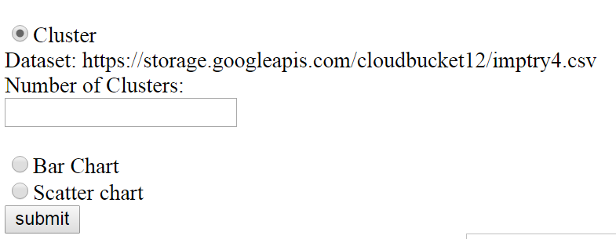

On clicking the submit button, the result gets displayed.

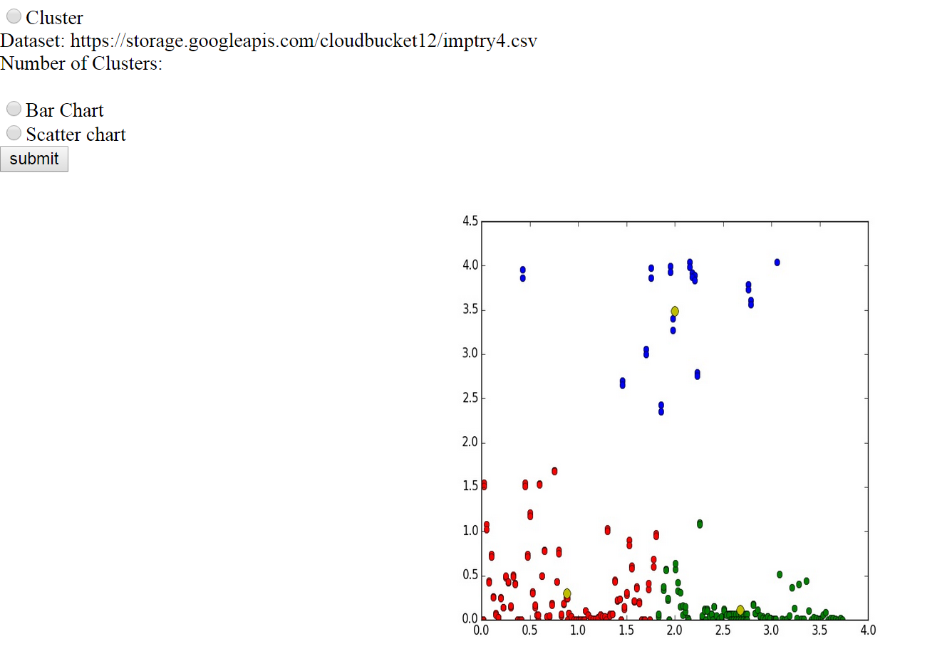

When the user selects bar chart, a bar chart is displayed as shown below.

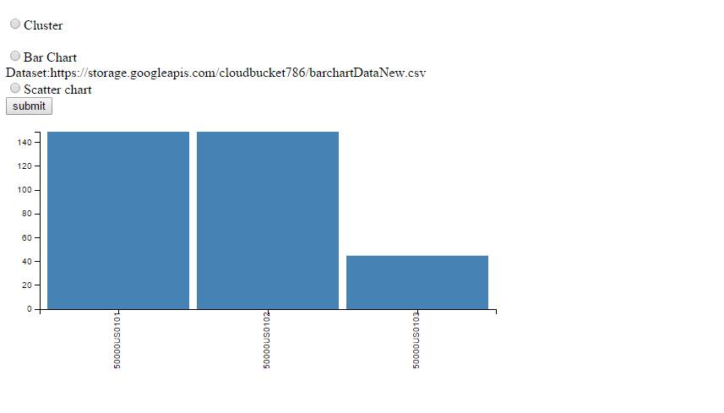

When the user clicks on scatter chart, a scatter chart is displayed as shown below.

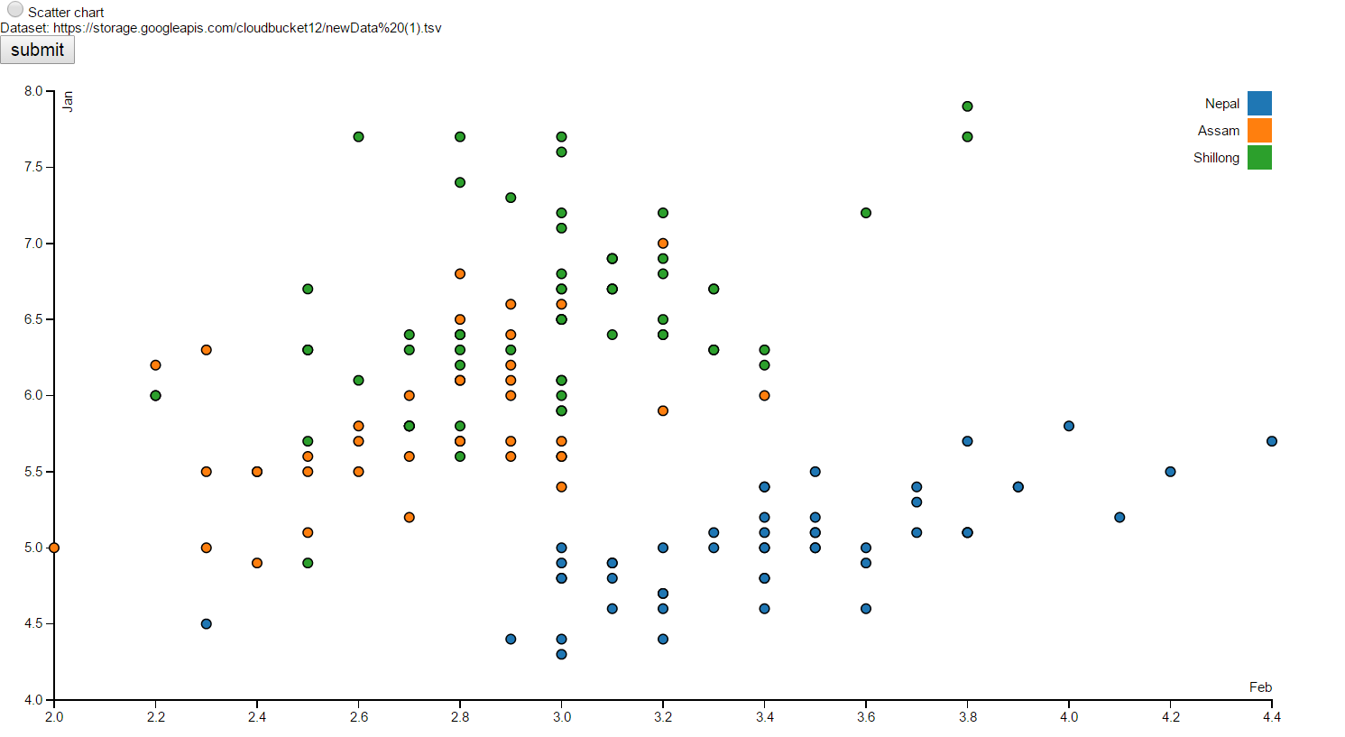

References:

1] <https://gist.github.com/d3noob>  
2] [www.stackoverflow.com](http://www.stackoverflow.com)  
3] <http://glowingpython.blogspot.com/2012/04/k-means-clustering-with-scipy.html>