GET All Tasks  
  
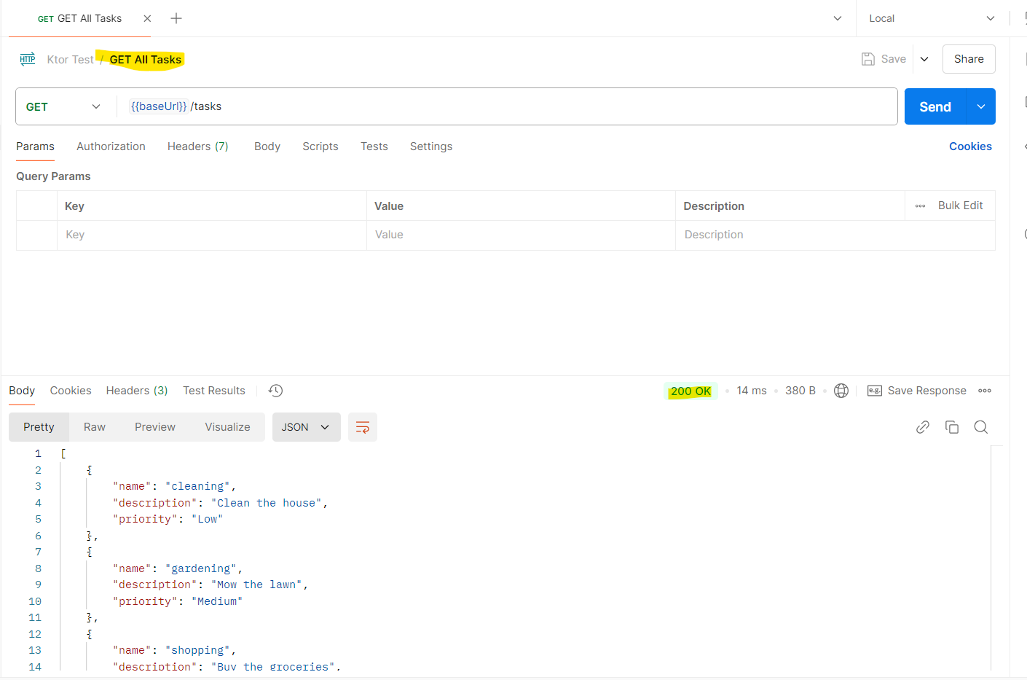  
  
GET Task By Name  
  
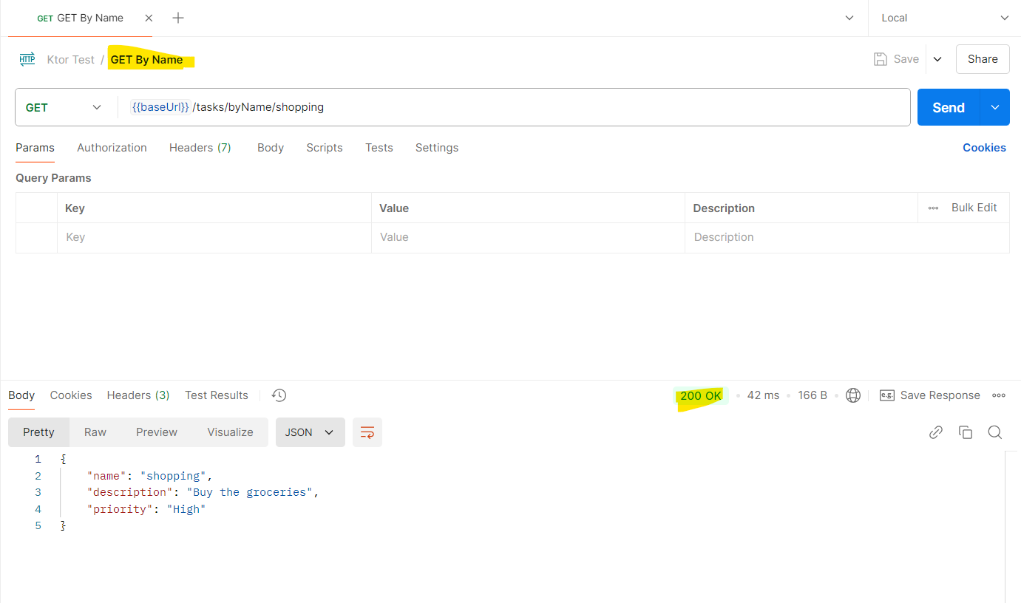  
  
  
  
  
  
GET Task By Prioroty  
  
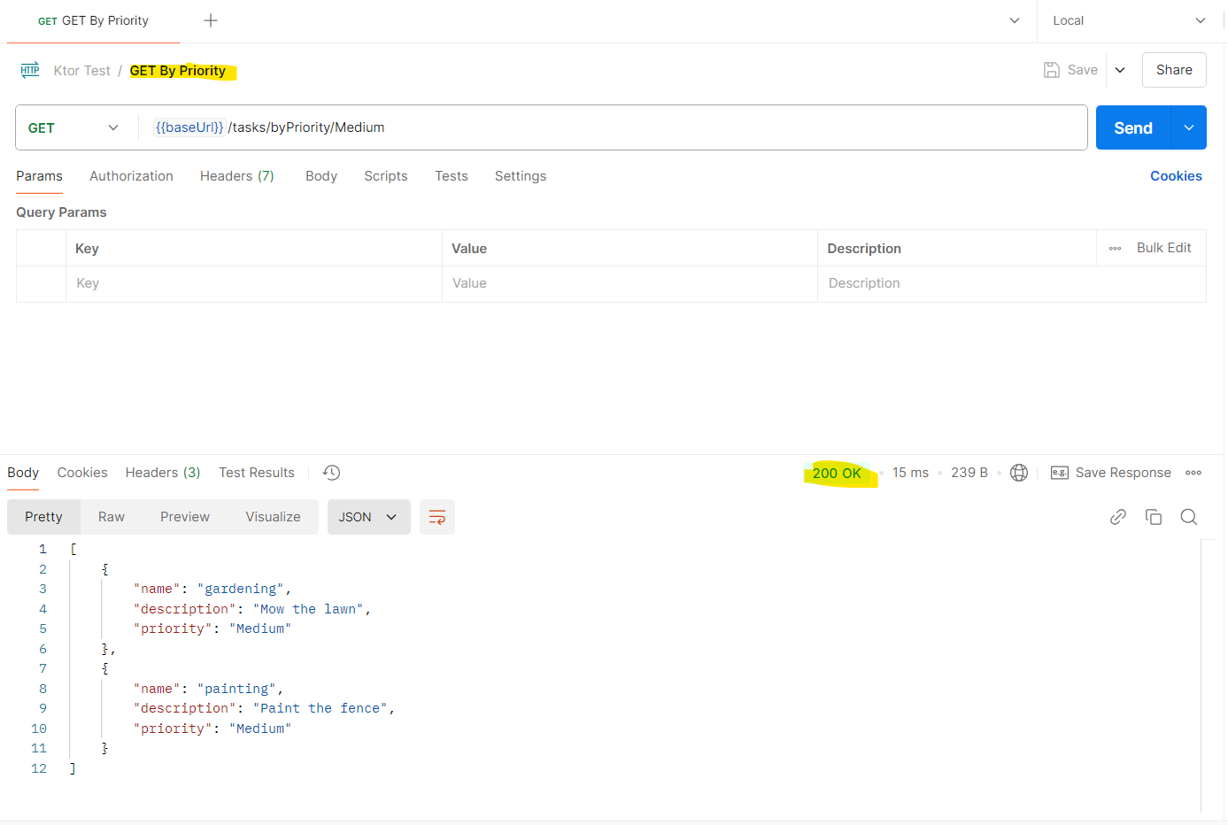  
  
POST New Task  
  
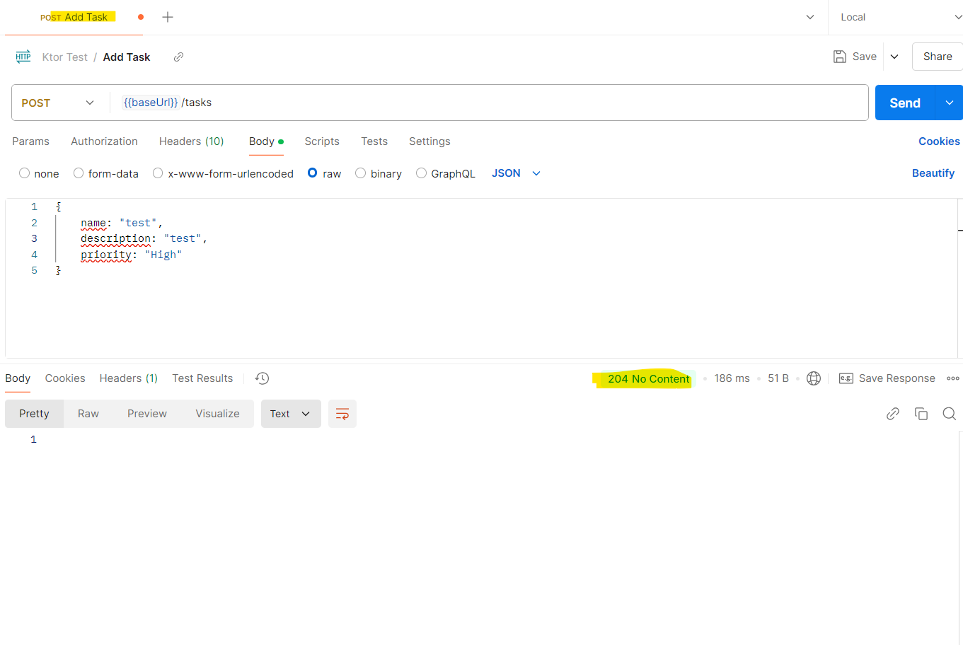  
  
DELETE Task  
  
