**Practical No: 1**

**Aim: Design UI based applications using basic Windows forms Controls.**

1. **Temperature Conversion**

**Code:**

**WebFrom1.asp**

<%@ Page Language="C#" AutoEventWireup="true" CodeBehind="WebForm1.aspx.cs" Inherits="Practical_8.WebForm1" %>

<!DOCTYPE html>

<html xmlns="http://www.w3.org/1999/xhtml">

<head runat="server">

<title></title>

<style type="text/css">

.auto-style1 {width: 100%;}

.auto-style2 {width: 159px;}

.auto-style3 {width: 159px;text-align: center;}

</style>

</head>

<body>

<form id="form1" runat="server">

<div>

<table class="auto-style1">

<tr>

<td class="auto-style2">Tempreature Conversion</td>

<td></td>

</tr>

<tr>

<td class="auto-style3">Enter Value</td>

<td>

<asp:TextBox ID="TextBox1" runat="server"></asp:TextBox>

</td>

</tr>

<tr>

<td class="auto-style2">

<asp:Button ID="Button1" runat="server" OnClick="Button1_Click" Text="C to F" />

<asp:Button ID="Button2" runat="server" OnClick="Button2_Click" Text="F to C" Width="75px" />

</td>

<td>

<asp:Button ID="Button3" runat="server" OnClick="Button3_Click" Text="Reset" />

</td>

</tr>

</table>

</div>

<asp:Label ID="Label1" runat="server"></asp:Label>

<br />

<asp:Label ID="Label2" runat="server"></asp:Label>

</form>

</body>

</html>

**WebFrom1.aspx.cs**

using System;

using System.Collections.Generic;

using System.Linq;

using System.Web;

using System.Web.UI;

using System.Web.UI.WebControls;

namespace Practical_8

{

public partial class WebForm1 : System.Web.UI.Page

{

protected void Page_Load(object sender, EventArgs e)

{

}

protected void Button1_Click(object sender, EventArgs e)

{

double c, f; c = int.Parse(TextBox1.Text);

f = c * 9 / 5 + 32;

Label1.Text = string.Format("Temperature in Fahrenheit is(°F) : " + f);

}

protected void Button2_Click(object sender, EventArgs e)

{

{

double c, f; f = int.Parse(TextBox1.Text);

c = (f - 32) * 5 / 9;

Label2.Text = string.Format("Temperature in Celsius is(°C) : " + c);

}

}

protected void Button3_Click(object sender, EventArgs e)

{

TextBox1.Text = "";

Label1.Text = "";

Label2.Text = "";

}

}

}

**Output:**

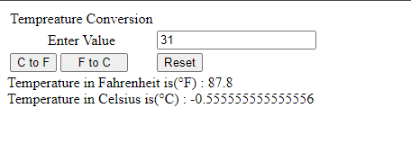

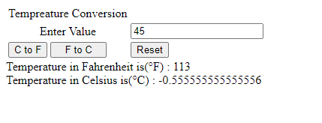

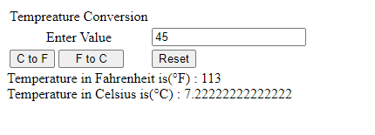

**ii.Simple Interest**

**Code:**

**WindowForm1.aspx.cs**

using System;

usingSystem.Collections.Generic;

usingSystem.ComponentModel;

usingSystem.Data;

usingSystem.Drawing;

usingSystem.Linq;

usingSystem.Text;

usingSystem.Threading.Tasks;

usingSystem.Windows.Forms;

namespaceCalculateInterest

{

classMyInterest

{

public Double SI, CI;

public Double P, R;

publicint N;

public Double Principal

{

get { return P; }

set { P = value; }

}

publicintNumOfYears

{

get { return N; }

set { N = value; }

}

public Double ROI

{

get { return R; }

set { R = value; }

}

public void calculateSI()

{

SI = (Principal * NumOfYears * ROI) / 100;

}

public void calculateCI()

{

CI = 1;

for (inti = 1; i<= NumOfYears; i++)

{

CI = CI * (1 + (ROI / 100));

}

CI = CI * Principal;

}

}

public partial class Form1 : Form

{

MyInterest m = new MyInterest();

void display(Boolean flag)

{

textBox4.Text = " Principal Amount : Rs." + m.Principal +"\r\n";

textBox4.Text += " Number of Years: " + m.NumOfYears +"\r\n";

textBox4.Text += " Rate of Interest: Rs." + m.ROI + "%";

if (flag)

{

textBox4.Text += "Simple Interest : Rs. " + m.SI.ToString();

}

else

{

textBox4.Text += "Compound Interest : Rs. " +

m.CI.ToString();

}

}

void setup()

{

m.Principal = Convert.ToDouble(textBox1.Text);

m.NumOfYears = Convert.ToInt32(textBox2.Text);

m.ROI = Convert.ToDouble(textBox3.Text);

}

public Form1()

{

InitializeComponent();

}

private void Form1_Load(object sender, EventArgs e)

{

}

private void button1_Click(object sender, EventArgs e)

{

setup();

m.calculateSI();

display(true);

}

private void button2_Click(object sender, EventArgs e)

{

setup();

m.calculateCI();

display(false);

}

}

}

**Output:**

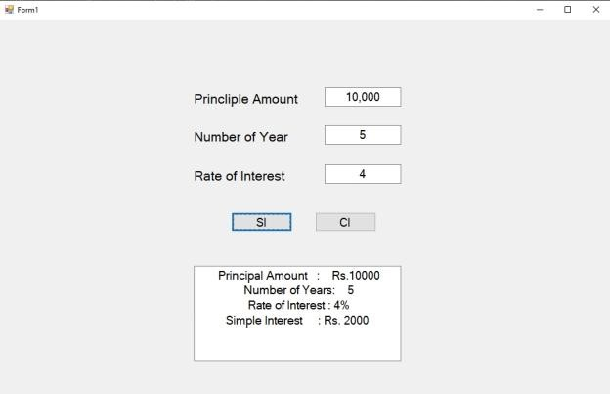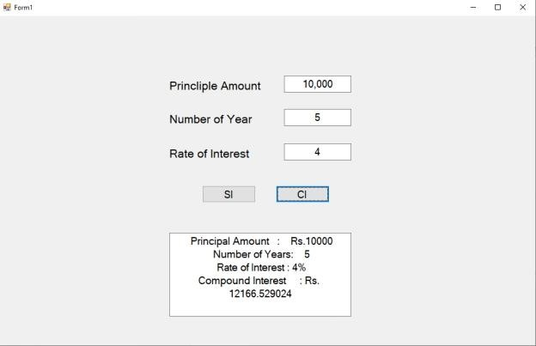

1. **MDI Parent Form**

**Code:**

**Form1 design**

namespace ClassProgram

{

partial class Form1

{

/// <summary>

/// Required designer variable.

/// </summary>

private System.ComponentModel.IContainer components = null;

/// <summary>

/// Clean up any resources being used.

/// </summary>

/// <param name="disposing">true if managed resources should be disposed; otherwise, false.</param>

protected override void Dispose(bool disposing)

{

if (disposing && (components != null))

{

components.Dispose();

}

base.Dispose(disposing);

}

#region Windows Form Designer generated code

/// <summary>

/// Required method for Designer support - do not modify

/// the contents of this method with the code editor.

/// </summary>

private void InitializeComponent()

{

this.textBox1 = new System.Windows.Forms.TextBox();

this.textBox2 = new System.Windows.Forms.TextBox();

this.textBox3 = new System.Windows.Forms.TextBox();

this.textBox4 = new System.Windows.Forms.TextBox();

this.button1 = new System.Windows.Forms.Button();

this.button2 = new System.Windows.Forms.Button();

this.SuspendLayout();

//

// textBox1

//

this.textBox1.Location = new System.Drawing.Point(444, 48);

this.textBox1.Name = "textBox1";

this.textBox1.Size = new System.Drawing.Size(100, 20);

this.textBox1.TabIndex = 0;

//

// textBox2

//

this.textBox2.Location = new System.Drawing.Point(444, 90);

this.textBox2.Name = "textBox2";

this.textBox2.Size = new System.Drawing.Size(100, 20);

this.textBox2.TabIndex = 1;

//

// textBox3

//

this.textBox3.Location = new System.Drawing.Point(444, 135);

this.textBox3.Name = "textBox3";

this.textBox3.Size = new System.Drawing.Size(100, 20);

this.textBox3.TabIndex = 2;

//

// textBox4

//

this.textBox4.Location = new System.Drawing.Point(301, 229);

this.textBox4.Multiline = true;

this.textBox4.Name = "textBox4";

this.textBox4.Size = new System.Drawing.Size(278, 92);

this.textBox4.TabIndex = 3;

//

// button1

//

this.button1.Location = new System.Drawing.Point(240, 178);

this.button1.Name = "button1";

this.button1.Size = new System.Drawing.Size(75, 23);

this.button1.TabIndex = 4;

this.button1.Text = "button1";

this.button1.UseVisualStyleBackColor = true;

this.button1.Click += new System.EventHandler(this.button1_Click);

//

// button2

//

this.button2.Location = new System.Drawing.Point(429, 178);

this.button2.Name = "button2";

this.button2.Size = new System.Drawing.Size(75, 23);

this.button2.TabIndex = 5;

this.button2.Text = "button2";

this.button2.UseVisualStyleBackColor = true;

this.button2.Click += new System.EventHandler(this.button2_Click);

//

// Form1

//

this.AutoScaleDimensions = new System.Drawing.SizeF(6F, 13F);

this.AutoScaleMode = System.Windows.Forms.AutoScaleMode.Font;

this.ClientSize = new System.Drawing.Size(800, 450);

this.Controls.Add(this.button2);

this.Controls.Add(this.button1);

this.Controls.Add(this.textBox4);

this.Controls.Add(this.textBox3);

this.Controls.Add(this.textBox2);

this.Controls.Add(this.textBox1);

this.Name = "Form1";

this.Text = "Form1";

this.Load += new System.EventHandler(this.Form1_Load);

this.ResumeLayout(false);

this.PerformLayout();

}

#endregion

private System.Windows.Forms.TextBox textBox1;

private System.Windows.Forms.TextBox textBox2;

private System.Windows.Forms.TextBox textBox3;

private System.Windows.Forms.TextBox textBox4;

private System.Windows.Forms.Button button1;

private System.Windows.Forms.Button button2;

}

}

**Program.cs**

using System;

using System.Collections.Generic;

using System.Linq;

using System.Threading.Tasks;

using System.Windows.Forms;

namespace ClassProgram

{

internal static class Program

{

/// <summary>

/// The main entry point for the application.

/// </summary>

[STAThread]

static void Main()

{

Application.EnableVisualStyles();

Application.SetCompatibleTextRenderingDefault(false);

Application.Run(new MDIParent1());

}

}

}

**Class**

namespace ClassProgram

{

partial class MDIParent1

{

/// <summary>

/// Required designer variable.

/// </summary>

private System.ComponentModel.IContainer components = null;

/// <summary>

/// Clean up any resources being used.

/// </summary>

/// <param name="disposing">true if managed resources should be disposed; otherwise, false.</param>

protected override void Dispose(bool disposing)

{

if (disposing && (components != null))

{

components.Dispose();

}

base.Dispose(disposing);

}

#region Windows Form Designer generated code

/// <summary>

/// Required method for Designer support - do not modify

/// the contents of this method with the code editor.

/// </summary>

private void InitializeComponent()

{

this.components = new System.ComponentModel.Container();

this.statusStrip = new System.Windows.Forms.StatusStrip();

this.toolStripStatusLabel = new System.Windows.Forms.ToolStripStatusLabel();

this.toolTip = new System.Windows.Forms.ToolTip(this.components);

this.menuStrip1 = new System.Windows.Forms.MenuStrip();

this.menuToolStripMenuItem = new System.Windows.Forms.ToolStripMenuItem();

this.classesToolStripMenuItem = new System.Windows.Forms.ToolStripMenuItem();

this.temperatureToolStripMenuItem = new System.Windows.Forms.ToolStripMenuItem();

this.uIControlsToolStripMenuItem = new System.Windows.Forms.ToolStripMenuItem();

this.statusStrip.SuspendLayout();

this.menuStrip1.SuspendLayout();

this.SuspendLayout();

//

// statusStrip

//

this.statusStrip.Items.AddRange(new System.Windows.Forms.ToolStripItem[] {

this.toolStripStatusLabel});

this.statusStrip.Location = new System.Drawing.Point(0, 431);

this.statusStrip.Name = "statusStrip";

this.statusStrip.Size = new System.Drawing.Size(632, 22);

this.statusStrip.TabIndex = 2;

this.statusStrip.Text = "StatusStrip";

//

// toolStripStatusLabel

//

this.toolStripStatusLabel.Name = "toolStripStatusLabel";

this.toolStripStatusLabel.Size = new System.Drawing.Size(39, 17);

this.toolStripStatusLabel.Text = "Status";

//

// menuStrip1

//

this.menuStrip1.Items.AddRange(new System.Windows.Forms.ToolStripItem[] {

this.menuToolStripMenuItem});

this.menuStrip1.Location = new System.Drawing.Point(0, 0);

this.menuStrip1.Name = "menuStrip1";

this.menuStrip1.Size = new System.Drawing.Size(632, 24);

this.menuStrip1.TabIndex = 4;

this.menuStrip1.Text = "menuStrip1";

//

// menuToolStripMenuItem

//

this.menuToolStripMenuItem.DropDownItems.AddRange(new System.Windows.Forms.ToolStripItem[] {

this.classesToolStripMenuItem,

this.temperatureToolStripMenuItem,

this.uIControlsToolStripMenuItem});

this.menuToolStripMenuItem.Name = "menuToolStripMenuItem";

this.menuToolStripMenuItem.Size = new System.Drawing.Size(50, 20);

this.menuToolStripMenuItem.Text = "Menu";

//

// classesToolStripMenuItem

//

this.classesToolStripMenuItem.Name = "classesToolStripMenuItem";

this.classesToolStripMenuItem.Size = new System.Drawing.Size(180, 22);

this.classesToolStripMenuItem.Text = "Classes";

this.classesToolStripMenuItem.Click += new System.EventHandler(this.classesToolStripMenuItem_Click);

//

// temperatureToolStripMenuItem

//

this.temperatureToolStripMenuItem.Name = "temperatureToolStripMenuItem";

this.temperatureToolStripMenuItem.Size = new System.Drawing.Size(180, 22);

this.temperatureToolStripMenuItem.Text = "Temperature";

//

// uIControlsToolStripMenuItem

//

this.uIControlsToolStripMenuItem.Name = "uIControlsToolStripMenuItem";

this.uIControlsToolStripMenuItem.Size = new System.Drawing.Size(180, 22);

this.uIControlsToolStripMenuItem.Text = "UIControls";

//

// MDIParent1

//

this.AutoScaleDimensions = new System.Drawing.SizeF(6F, 13F);

this.AutoScaleMode = System.Windows.Forms.AutoScaleMode.Font;

this.ClientSize = new System.Drawing.Size(632, 453);

this.Controls.Add(this.statusStrip);

this.Controls.Add(this.menuStrip1);

this.IsMdiContainer = true;

this.Name = "MDIParent1";

this.Text = "MDIParent1";

this.statusStrip.ResumeLayout(false);

this.statusStrip.PerformLayout();

this.menuStrip1.ResumeLayout(false);

this.menuStrip1.PerformLayout();

this.ResumeLayout(false);

this.PerformLayout();

}

#endregion

private System.Windows.Forms.StatusStrip statusStrip;

private System.Windows.Forms.ToolStripStatusLabel toolStripStatusLabel;

private System.Windows.Forms.ToolTip toolTip;

private System.Windows.Forms.MenuStrip menuStrip1;

private System.Windows.Forms.ToolStripMenuItem menuToolStripMenuItem;

private System.Windows.Forms.ToolStripMenuItem classesToolStripMenuItem;

private System.Windows.Forms.ToolStripMenuItem temperatureToolStripMenuItem;

private System.Windows.Forms.ToolStripMenuItem uIControlsToolStripMenuItem;

}

}

**MDIparent.cs**

using System;

using System.Collections.Generic;

using System.ComponentModel;

using System.Data;

using System.Drawing;

using System.Linq;

using System.Text;

using System.Threading.Tasks;

using System.Windows.Forms;

namespace ClassProgram

{

public partial class MDIParent1 : Form

{

private int childFormNumber = 0;

public MDIParent1()

{

InitializeComponent();

}

private void ShowNewForm(object sender, EventArgs e)

{

Form childForm = new Form();

childForm.MdiParent = this;

childForm.Text = "Window " + childFormNumber++;

childForm.Show();

}

private void OpenFile(object sender, EventArgs e)

{

OpenFileDialog openFileDialog = new OpenFileDialog();

openFileDialog.InitialDirectory = Environment.GetFolderPath(Environment.SpecialFolder.Personal);

openFileDialog.Filter = "Text Files (*.txt)|*.txt|All Files (*.*)|*.*";

if (openFileDialog.ShowDialog(this) == DialogResult.OK)

{

string FileName = openFileDialog.FileName;

}

}

private void SaveAsToolStripMenuItem_Click(object sender, EventArgs e)

{

SaveFileDialog saveFileDialog = new SaveFileDialog();

saveFileDialog.InitialDirectory = Environment.GetFolderPath(Environment.SpecialFolder.Personal);

saveFileDialog.Filter = "Text Files (*.txt)|*.txt|All Files (*.*)|*.*";

if (saveFileDialog.ShowDialog(this) == DialogResult.OK)

{

string FileName = saveFileDialog.FileName;

}

}

private void ExitToolsStripMenuItem_Click(object sender, EventArgs e)

{

this.Close();

}

private void CutToolStripMenuItem_Click(object sender, EventArgs e)

{

}

private void CopyToolStripMenuItem_Click(object sender, EventArgs e)

{

}

private void PasteToolStripMenuItem_Click(object sender, EventArgs e)

{

}

private void ToolBarToolStripMenuItem_Click(object sender, EventArgs e)

{

//toolStrip.Visible = toolBarToolStripMenuItem.Checked;

}

private void StatusBarToolStripMenuItem_Click(object sender, EventArgs e)

{

//statusStrip.Visible = statusBarToolStripMenuItem.Checked;

}

private void CascadeToolStripMenuItem_Click(object sender, EventArgs e)

{

LayoutMdi(MdiLayout.Cascade);

}

private void TileVerticalToolStripMenuItem_Click(object sender, EventArgs e)

{

LayoutMdi(MdiLayout.TileVertical);

}

private void TileHorizontalToolStripMenuItem_Click(object sender, EventArgs e)

{

LayoutMdi(MdiLayout.TileHorizontal);

}

private void ArrangeIconsToolStripMenuItem_Click(object sender, EventArgs e)

{

LayoutMdi(MdiLayout.ArrangeIcons);

}

private void CloseAllToolStripMenuItem_Click(object sender, EventArgs e)

{

foreach (Form childForm in MdiChildren)

{

childForm.Close();

}

}

private void classesToolStripMenuItem_Click(object sender, EventArgs e)

{

Form chfrm = new Form1();

chfrm.MdiParent = this;

chfrm.Show();

}

}

}

**Output:**

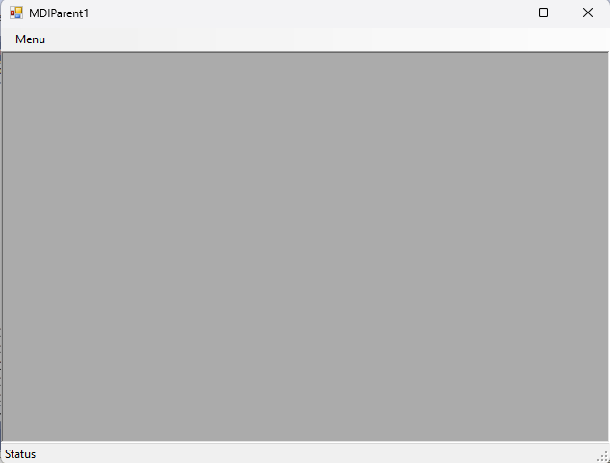

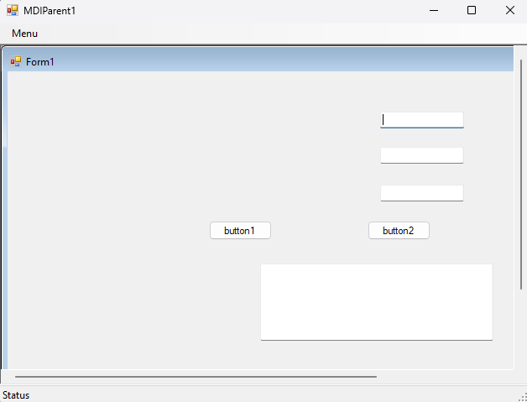

1. **Applications using Classes and Objects.**

**Code:**

**Form1.cs**

using System; usingSystem.Collections.Generic; usingSystem.ComponentModel; usingSystem.Data; usingSystem.Drawing; usingSystem.Linq; usingSystem.Text; usingSystem.Threading.Tasks; usingSystem.Windows.Forms;

using System.IO;

namespace Practical_6

{

public partial class Form1 : Form

{

public Form1()

{

InitializeComponent();

}

private void textBox2_TextChanged(object sender, EventArgs e)

{

}

private void button1_Click(object sender, EventArgs e)

{

{

string path = textBox1.Text;

StreamReader stream = new StreamReader(path);

string filedata = stream.ReadToEnd();

textBox2.Text = filedata.ToString();

stream.Close();

}

}

private void button2_Click(object sender, EventArgs e)

{

String str = textBox2.Text;

Char c =Convert.ToChar(textBox3.Text);

var count = str.Count(x => x == c);

label2.Text = "Letter "+c+" has occurred " + count.ToString() + " times.";

}

}

}

**Output:**

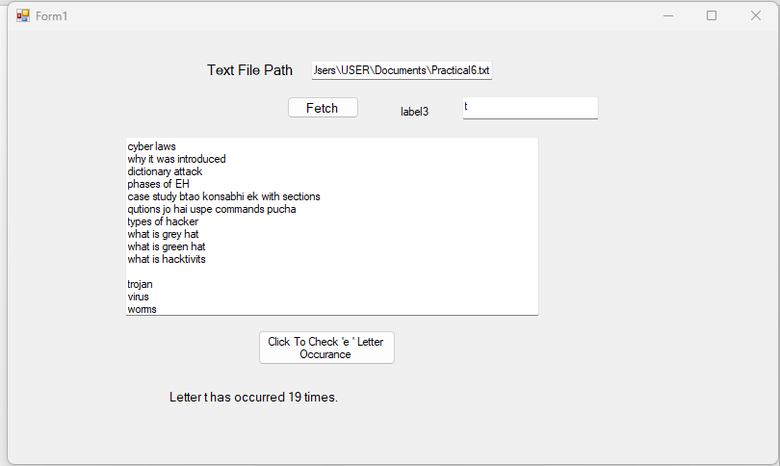

**Practical No: 2**

**Design a WebForm showing Personal Information**

**Code:**

**Webform1.aspx**

<%@ Page Language="C#" AutoEventWireup="true" CodeBehind="WebForm1.aspx.cs" Inherits="Practical_7.WebForm1" %>

<!DOCTYPE html>

<html xmlns="http://www.w3.org/1999/xhtml">

<head runat="server">

<title></title>

<style type="text/css">

.auto-style1 {

height: 28px;

}

.auto-style2 {

height: 28px;

width: 244px;

}

.auto-style3 {

width: 244px;

}

.auto-style4 {

width: 244px;

height: 32px;

}

.auto-style5 {

height: 32px;

}

</style>

</head>

<body style="height: 674px">

<form id="form1" runat="server">

<div>

</div>

<asp:Label ID="Label1" runat="server" Text="PERSONAL INFORMATION"></asp:Label>

<table style="width: 100%; height: 249px;">

<tr>

<td class="auto-style2">StudentID :</td>

<td class="auto-style1">

<asp:TextBox ID="TextBox1" runat="server" Width="270px"></asp:TextBox>

</td>

</tr>

<tr>

<td class="auto-style4">StudentName :</td>

<td class="auto-style5">

<asp:TextBox ID="TextBox2" runat="server" Width="269px"></asp:TextBox>

</td>

</tr>

<tr>

<td class="auto-style4">CourseName :</td>

<td class="auto-style5">

<asp:DropDownList ID="DropDownList1" runat="server">

<asp:ListItem>MCA</asp:ListItem>

<asp:ListItem>MMS</asp:ListItem>

<asp:ListItem>MBA</asp:ListItem>

</asp:DropDownList>

</td>

</tr>

<tr>

<td class="auto-style3">DateofBirth :</td>

<td>

<asp:Calendar ID="Calendar1" runat="server"></asp:Calendar>

</td>

</tr>

<tr>

<td class="auto-style3">MobileNumber :</td>

<td>

<asp:TextBox ID="TextBox3" runat="server" Width="250px"></asp:TextBox>

</td>

</tr>

<tr>

<td class="auto-style3">

<asp:Button ID="Button1" runat="server" Text="Submit" OnClick="Button1_Click" />

</td>

<td>

<asp:Button ID="Button2" runat="server" Text="Reset" OnClick="Button2_Click" />

</td>

</tr>

<tr>

<td>

<asp:Label ID="Label2" runat="server" Text="Label"></asp:Label>

</td>

<td>&nbsp;</td>

</tr>

<tr>

<td>

<asp:Label ID="Label3" runat="server" Text="Label"></asp:Label>

</td>

<td>&nbsp;</td>

</tr>

<tr>

<td>

<asp:Label ID="Label4" runat="server" Text="Label"></asp:Label>

</td>

<td>&nbsp;</td>

</tr>

<tr>

<td>

<asp:Label ID="Label5" runat="server" Text="Label"></asp:Label>

</td>

<td>&nbsp;</td>

</tr>

<tr>

<td>

<asp:Label ID="Label6" runat="server" Text="Label"></asp:Label>

</td>

<td>&nbsp;</td>

</tr>

</table>

</form>

</body>

</html>

**Webfrom1.aspx.cs**

using System;

using System.Collections.Generic;

using System.Linq;

using System.Web;

using System.Web.UI;

using System.Web.UI.WebControls;

namespace Practical_7

{

public partial class WebForm1 : System.Web.UI.Page

{

protected void Page_Load(object sender, EventArgs e)

{

}

protected void Button1_Click(object sender, EventArgs e)

{

Label2.Text = "Student Id:" + TextBox1.Text;

Label3.Text = "Student Name:" + TextBox2.Text;

Label4.Text = "Course Name:" + DropDownList1.Text;

Label5.Text = "Date of Birth:" + Calendar1.SelectedDate.ToLongDateString();

Label6.Text = "MobileNumber:" + TextBox3.Text;

}

protected void Button2_Click(object sender, EventArgs e)

{

Label2.Text = "";

Label3.Text = "";

Label4.Text = "";

Label5.Text = "";

Label6.Text = "";

TextBox1.Text = "";

TextBox2.Text = "";

DropDownList1.Text = "";

Calendar1.SelectedDate.ToLongDateString();

TextBox3.Text = "";

}

}

}

**Output:**

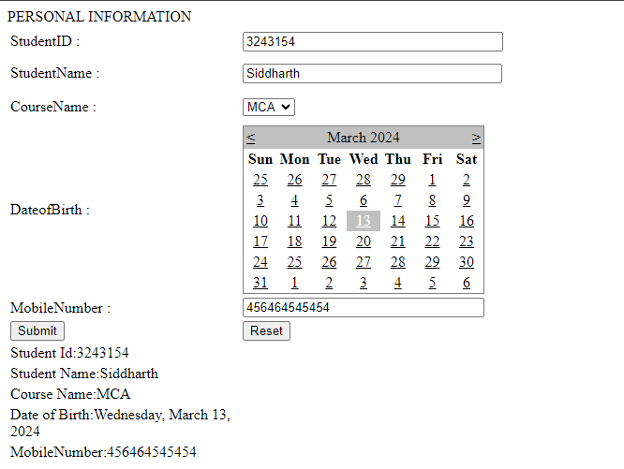

**Practical No: 3**

**Design Applications using Inheritance and Abstract Classes**

**i. Single Inheritance**

**Code:**

**single.aspx**

<%@PageLanguage="C#"AutoEventWireup="true"CodeBehind="single.aspx.cs"Inherits="p rac2b.single"%>

<!DOCTYPEhtml>

<htmlxmlns="http://www.w3.org/1999/xhtml">

<headrunat="server">

<title></title>

<styletype="text/css">

.auto-style1 {width: 100%;}

.auto-style2 {width: 124px;}

</style>

</head>

<body>

<formid="form1"runat="server">

<tableclass="auto-style1">

<tr>

<tdclass="auto-style2">Single Inheritance</td>

<td>&nbsp;</td>

</tr>

<tr>

<tdclass="auto-style2">Enter Number :</td>

<td>

<asp:TextBoxID="TextBox1"runat="server"></asp:TextBox>

</td>

</tr>

<tr>

<tdclass="auto-style2">

<asp:ButtonID="Button1"runat="server"OnClick="Button1_Click"Text= "Button"/>

</td>

<td>&nbsp;</td>

</tr>

</table>

<asp:LabelID="Label1"runat="server"></asp:Label>

<br/>

<asp:LabelID="Label2"runat="server"></asp:Label> </form>

</body>

</html>

**Single.aspx.cs**

using System;

using System.Collections.Generic;

using System.Linq;

using System.Web;

using System.Web.UI;

using System.Web.UI.WebControls;

namespace practical7

{ publicpartialclasssingle : System.Web.UI.Page

{ protectedvoid Page_Load(object sender, EventArgs e)

{

}

protectedvoid Button1_Click(object sender, EventArgs e)

{

B s = new B();

int n = int.Parse(TextBox1.Text); int x = s.sqr(n); int y = s.cub(n);

Label1.Text = string.Format("The Square of number is : " + x.ToString());

Label2.Text = string.Format("The Cube of number is : " + y.ToString());

} publicclassA

{ publicint sqr(int val1)

{ return val1 * val1;

}

}

publicclassB : A

{ publicint cub(int val1)

{ int v1 = sqr(val1); return v1 * val1;

}

}

}

}

**Output:**

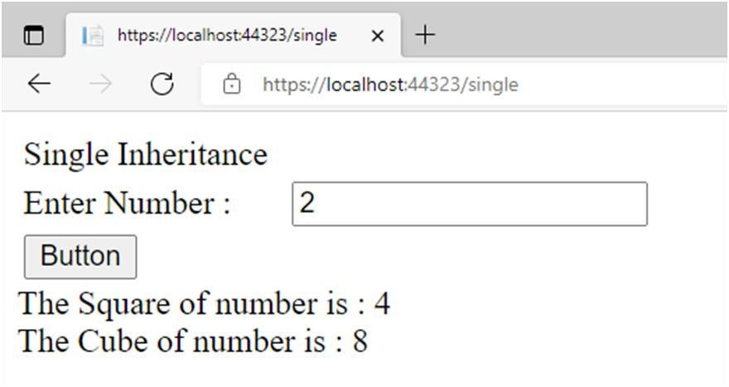

**ii. Multilevel Inheritance**

**Code:**

**Mulrilevel.aspx**

<%@PageLanguage="C#"AutoEventWireup="true"CodeBehind="Multilevel.aspx.cs"Inherit s="prac2b.Multilevel"%>

<!DOCTYPEhtml>

<htmlxmlns="http://www.w3.org/1999/xhtml">

<headrunat="server">

<title></title>

</head>

<body>

<formid="form1"runat="server">

<div>

<strong>Multilevel Inheritance</strong><br/>

Enter Number :&nbsp;

<asp:TextBoxID="TextBox1"runat="server"></asp:TextBox>

<br/>

<asp:ButtonID="Button1"runat="server"OnClick="Button1_Click"Text=

"Submit"/>

<br/>

<asp:LabelID="Label1"runat="server"></asp:Label> <br/>

<asp:LabelID="Label2"runat="server"></asp:Label> <br/>

<asp:LabelID="Label3"runat="server"></asp:Label> </div>

</form>

</body>

</html>

**Mulrilevel.aspx.cs**

using System;

using System.Collections.Generic;

using System.Linq;

using System.Web;

using System.Web.UI;

using System.Web.UI.WebControls;

namespace prac2b

{ publicpartialclassMultilevel : System.Web.UI.Page

{ protectedvoid Page_Load(object sender, EventArgs e)

{

} protectedvoid Button1_Click(object sender, EventArgs e)

{

C s = new C();

int n = int.Parse(TextBox1.Text); int x = s.sqr(n);

int y = s.cub(n); int z = s.sqr(n) + s.cub(n);

Label1.Text = string.Format("The Square of number is : " + x.ToString());

Label2.Text = string.Format("The Cube of number is : " + y.ToString());

Label3.Text = string.Format("The Sum of square and cube of number is : " + z.ToString());

} publicclassA

{ publicint sqr(int val1)

{ return val1 * val1;

}

} publicclassB : A

{ publicint cub(int val1)

{ int v1 = sqr(val1); return v1 * val1;

}

}

publicclassC : B

{ publicint add(int val1, int a, int v1)

{ a = val1 + v1; return a;

}

}

}

}

**Output :**

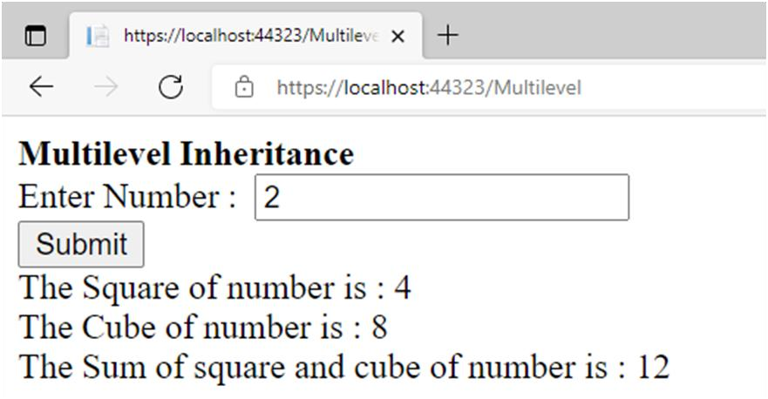

**iii.Hierarchical Inheritance**

**Code:**

**Hierarchical.aspx**

<%@PageLanguage="C#"AutoEventWireup="true"CodeBehind="Hierarchical.aspx.cs"Inhe rits="prac2b.WebForm2"%>

<!DOCTYPEhtml>

<htmlxmlns="http://www.w3.org/1999/xhtml">

<headrunat="server">

<title></title>

</head>

<body>

<formid="form1"runat="server">

<div>

<spanstyle="font-size:12.0pt;mso-bidi-font-size:11.0pt;line-height:103%;fontfamily:&quot;Times New Roman&quot;,serif;mso-fareast-fontfamily:&quot;Times New Roman&quot;;color:black; mso-ansi-language:EN-IN;mso-fareast-language:EN-IN;mso-bidilanguage:EN-IN">

<bstyle="mso-bidi-font-weight:normal">Hierarchical Inheritance<br/>

</b><spanstyle="mso-bidi-font-weight:normal">Enter value of A :&nbsp;

<asp:TextBoxID="TextBox1"runat="server"></asp:TextBox>

<br/>

Enter value of B :&nbsp;

<asp:TextBoxID="TextBox2"runat="server"></asp:TextBox>

<br/>

<asp:ButtonID="Button1"runat="server"Text="Result"/>

</span></span><spanstyle="mso-bidi-font-weight:normal">

<br/>

<asp:LabelID="Label1"runat="server"></asp:Label>

<br/>

<asp:LabelID="Label2"runat="server"></asp:Label> </span>

</div>

</form>

</body>

</html>

**Hierarchical.aspx.cs**

using System;

using System.Collections.Generic;

using System.Linq;

using System.Web;

using System.Web.UI;

using System.Web.UI.WebControls;

namespace prac2b

{ publicpartialclassWebForm2 : System.Web.UI.Page

{ publicclassA

{ publicint a; publicint b;

} publicclassB : A

{ publicint add(int val1, int val2)

{ a = val1; b = val2; return a + b;

}

} publicclassC : A

{ publicint sub(int val1, int val2)

{ a = val1; b = val2; return a - b;

}

}

protectedvoid Page_Load(object sender, EventArgs e)

{

} protectedvoid Button1_Click(object sender, EventArgs e)

{

1. s1 = new B();
2. s2 = new C();

int m = int.Parse(TextBox1.Text); int n = int.Parse(TextBox2.Text); int x = s1.add(m, n); int y = s2.sub(m, n);

Label1.Text = string.Format("Addition of A and B is : " + x.ToString());

Label2.Text = string.Format("Subtraction of A and B is : " + y.ToString()); }

}

}

**Output:**

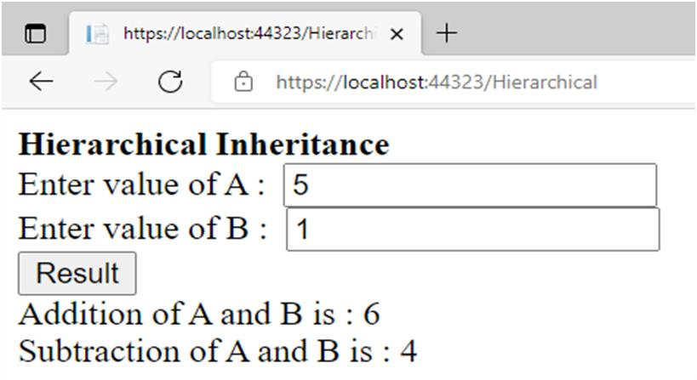

**Practical No: 4**

**Design a Web Application for an Organization with Registration forms and advanced controls.**

**Code:**

using System;

using System.Collections.Generic;

using System.Linq;

using System.Web;

using System.Web.UI;

using System.Web.UI.WebControls;

namespace Practical_4

{

public partial class WebForm1 : System.Web.UI.Page

{

protected void Page_Load(object sender, EventArgs e)

{

}

protected void Button1_Click(object sender, EventArgs e)

{

string name = TextBox1.Text;

int age = Convert.ToInt32(TextBox2.Text);

decimal basic = Convert.ToDecimal(TextBox3.Text);

decimal ta = Convert.ToDecimal(TextBox4.Text);

decimal da = Convert.ToDecimal(TextBox5.Text);

decimal hra = Convert.ToDecimal(TextBox6.Text);

decimal pf = Convert.ToDecimal(TextBox7.Text);

decimal professionalTax = Convert.ToDecimal(TextBox8.Text);

decimal GrossSalary = basic + ta + da + hra;//calculate gross salary

decimal deduction = pf + professionalTax;//calculate net salary after deduction

decimal netSalary = GrossSalary - deduction;

Label12.Text = GrossSalary.ToString("F2");//display result

Label13.Text = netSalary.ToString("F2");

}

}

}

**Output:**

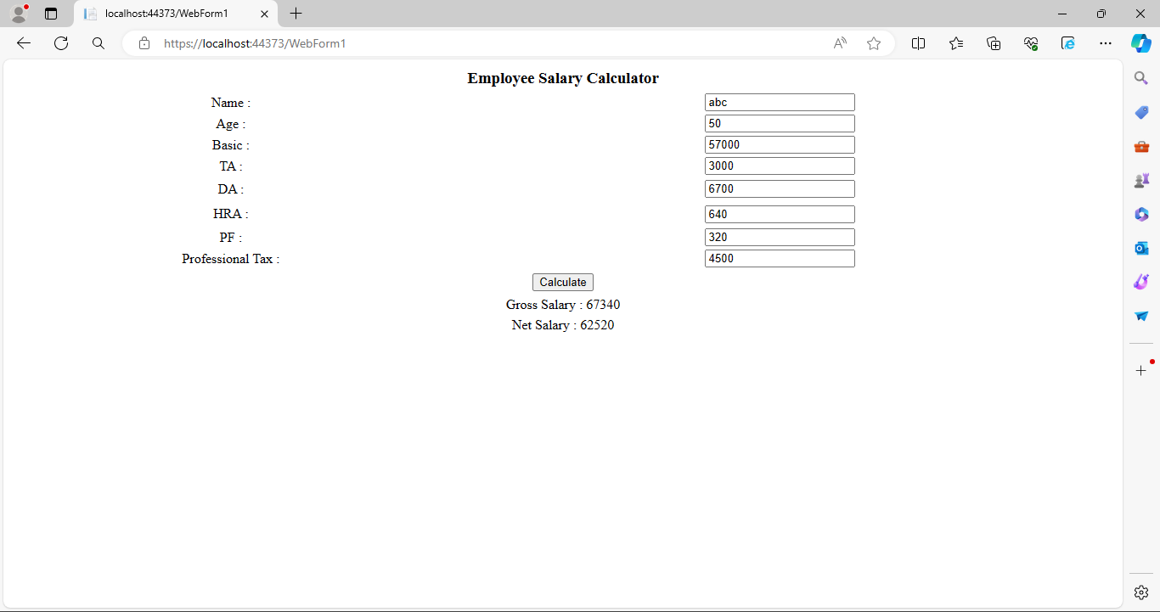

**Practical No: 5**

**Create website using master page concept.**

**Code:**

**MasterPage.Master**

<%@ Master Language="C#" AutoEventWireup="true" CodeBehind="Master Page.Master.cs" Inherits="Master.Site1" %>

<!DOCTYPE html>

<html>

<head runat="server">

<title></title>

<asp:ContentPlaceHolder ID="head" runat="server">

</asp:ContentPlaceHolder>

</head>

<body><form id="form1" runat="server">

<div>

<asp:ContentPlaceHolder ID="ContentPlaceHolder1" runat="server">

</asp:ContentPlaceHolder>

<h1>

**Welcome to NCRD Sterling**

</h1>

<p>

<asp:Button ID="Button1" runat="server" PostBackUrl="~/Home.aspx" Text="Home" />

<asp:Button ID="Button2" runat="server" PostBackUrl="~/Aboutus.aspx" Text="About Us" />

<asp:Button ID="Button3" runat="server" PostBackUrl="~/Create_account.aspx" Text="Create Account" />

<asp:Button ID="Button4" runat="server" PostBackUrl="~/Login.aspx" Text="Login" />

<asp:Button ID="Button5" runat="server" PostBackUrl="~/Contactus.aspx" Text="Contact Us" />

</p>

<div id="footer">

Your Footer Content

</div>

<style>

#footer{position:absolute;bottom:0;width:100%;height:60px;background:#6cf;text-align:center;}

</style>

</div>

</form>

</body>

</html>

**Home.aspx**

<%@ Page Title="" Language="C#" MasterPageFile="Master Page.Master" AutoEventWireup="true" CodeBehind="Home.aspx.cs" Inherits="Master.WebForm2" %>

<asp:Content ID="Content1" ContentPlaceHolderID="head" runat="server">

<p>

HEY! This is NCRD Home Page!!

</p>

<p>

Glad you visited here :)

</p>

</asp:Content>

**Aboutus.aspx**

<%@ Page Title="" Language="C#" MasterPageFile="Master Page.Master" AutoEventWireup="true" CodeBehind="Aboutus.aspx.cs" Inherits="Master.WebForm3" %>

<asp:Content ID="Content1" ContentPlaceHolderID="head" runat="server">

<p>WELCOME TO NCRD. We HAVE A GREAT ROASTER

FOR DOING BEST IN OUR INSTITUITE!</p>

</asp:Content>

**Create_account.aspx**

<%@ Page Title="" Language="C#" MasterPageFile="Master Page.Master" AutoEventWireup="true" CodeBehind="Create_account.aspx.cs" Inherits="Master.WebForm4" %>

<asp:Content ID="Content1" ContentPlaceHolderID="head" runat="server">

</asp:Content>

<asp:Content ID="Content2" ContentPlaceHolderID="ContentPlaceHolder1" runat="server">

<p>

IGN:<asp:TextBox ID="TextBox1" runat="server"></asp:TextBox>

</p>

<p>

IGN ID:<asp:TextBox ID="TextBox2" runat="server"></asp:TextBox>

</p>

<p>

Password:<asp:TextBox ID="TextBox3" runat="server" TextMode="Password"></asp:TextBox>

</p>

<p>

<asp:Button ID="Button7" runat="server" Text="Submit"></asp:Button>

</p>

<p>

<asp:Label ID="Label1" runat="server"></asp:Label>

</p>

</asp:Content>

**Login.aspx**

<%@ Page Title="" Language="C#" MasterPageFile="Master Page.Master" AutoEventWireup="true" CodeBehind="Login.aspx.cs" Inherits="Master.WebForm5" %>

<asp:Content ID="Content1" ContentPlaceHolderID="head" runat="server">

</asp:Content>

<asp:Content ID="Content2" ContentPlaceHolderID="ContentPlaceHolder1" runat="server">

<p>Login :</p>

<p>

Username :<asp:TextBox ID="TextBox1" runat="server"></asp:TextBox>

</p>

<p>

Password :<asp:TextBox ID="TextBox2" runat="server"></asp:TextBox>

</p>

<p>

<asp:CheckBox ID="CheckBox1" runat="server" Text="Remeber me next time" />

</p>

<p>

<asp:Button ID="Button6" runat="server" Text="Login" OnClientClick = "return confirm('Ok i Will remember?');" />

</p>

</asp:Content>

**Contactus.aspx**

<%@ Page Title="" Language="C#" MasterPageFile="Master Page.Master" AutoEventWireup="true"

CodeBehind="Contactus.aspx.cs" Inherits="Master.WebForm6" %>

<asp:Content ID="Content1" ContentPlaceHolderID="head" runat="server">

<h3>Our Contact page.</h3>

<address>

PANVEL<br />

NEW PANVEL,NAVI-MUMBAI 410206<br />

<abbr title="Phone">Phone:</abbr>

123-456-789

</address>

FYMCA

Roll No: 007

<address>

<strong>Support:</strong><a href="https://discord.gg/6Tnynq6Y">

support@ncrdsims.edu.in</a><br />

</address>

</asp:Content>

**Output:**

**Home**

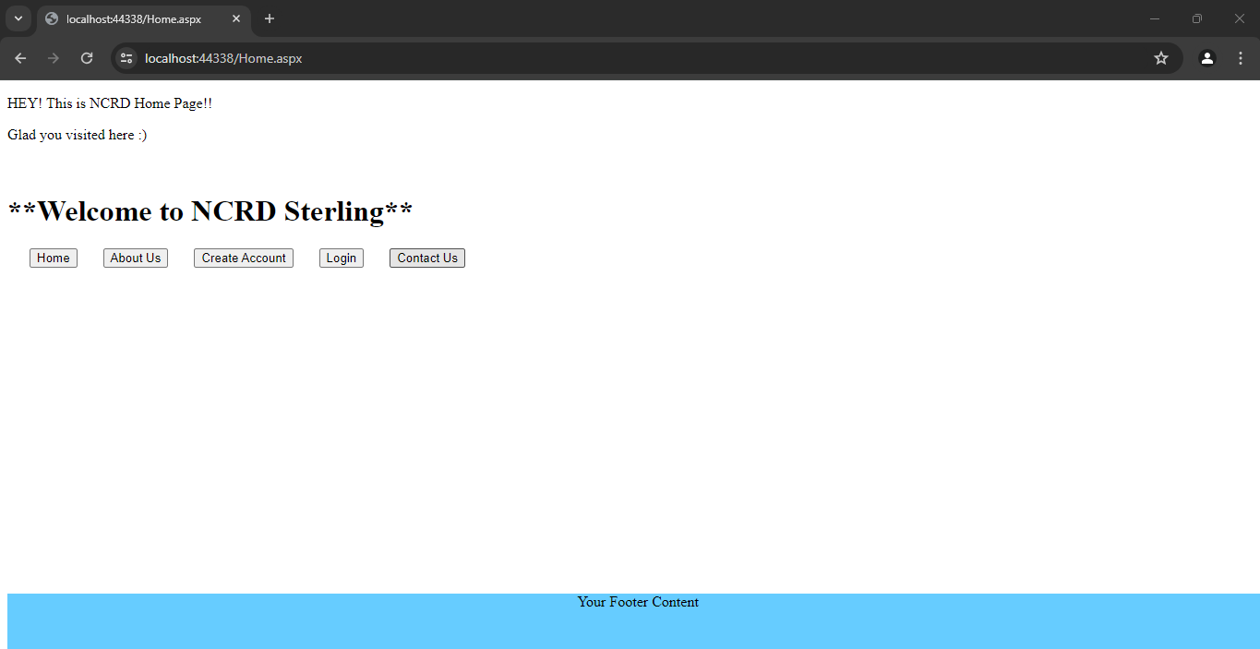

**Aboutus**

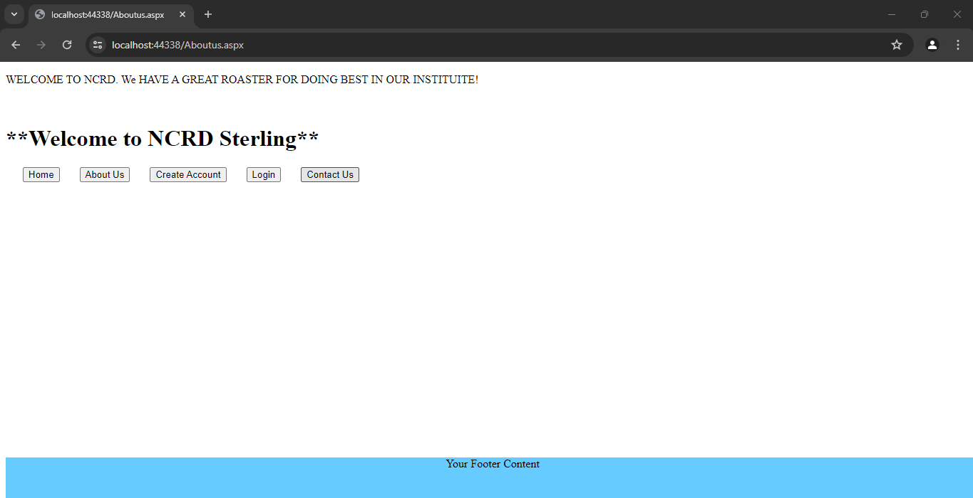

**Createaccount**

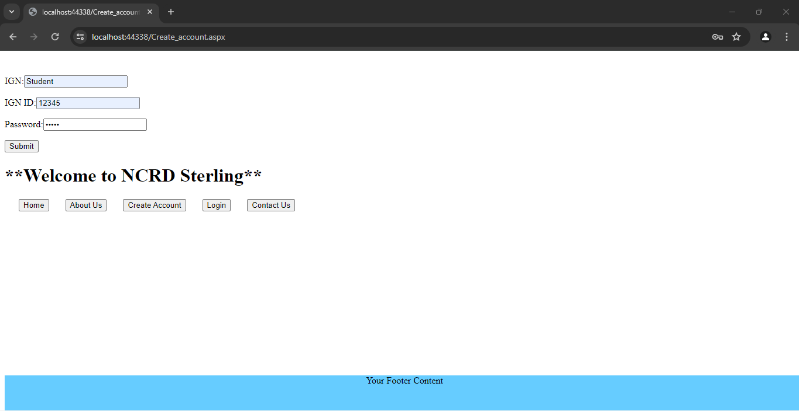

**Login**

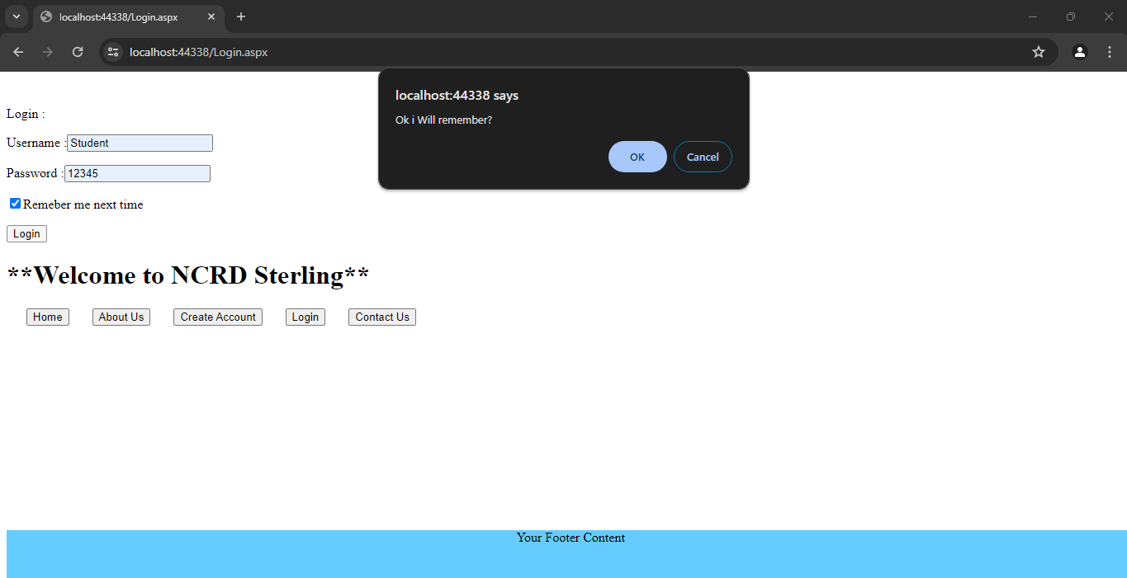

**Contact**

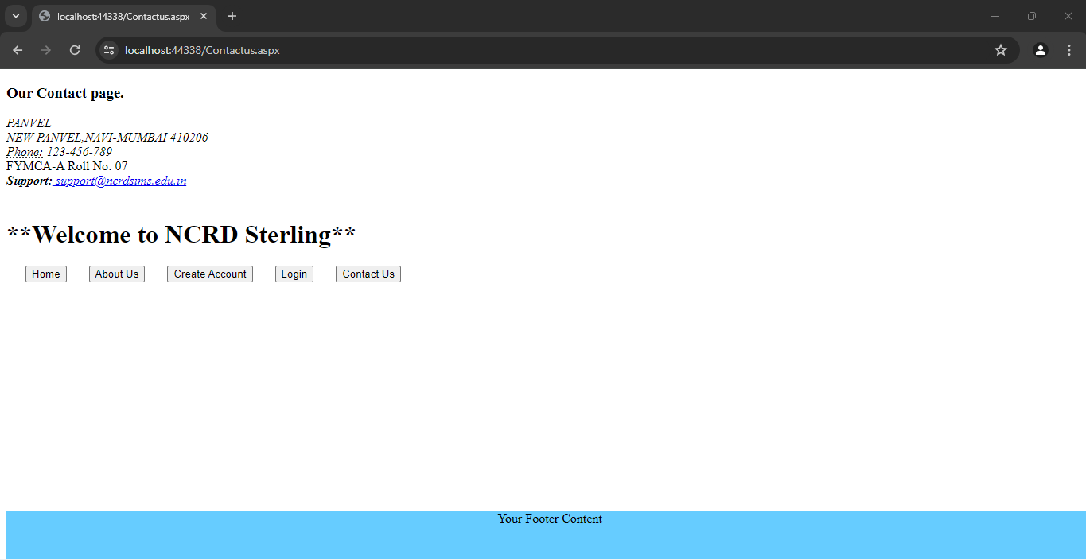

**Practical No: 6**

**Build an angular web application.**

**Code:**

**HTML**

<!DOCTYPE html>

<html lang="en">

<head>

<meta charset="UTF-8">

<meta http-equiv="X-UA-Compatible" content="IE=edge">

<meta name="viewport" content="width=device-width, initial-scale=1.0">

<title>Document</title>

<scriptsrc="angular.min.js"></script>

</head>

<body ng-app="">

<h1 style="text-align: center"> AREA AND PERIMETER OF RECTANGLE</h1>

Length : <input type="number" ng-model="num1">

Breath : <input type="number" ng-model="num2">

<P><strong>Area of Rectangle :</strong>**{{**num1*num2**}}**</P>

<P><strong>Perimeter of Rectangle :</strong>**{{**num1+num2+num1+num2**}}**</P> </body>

</html>

**Output:**

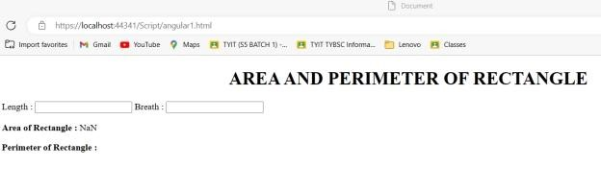

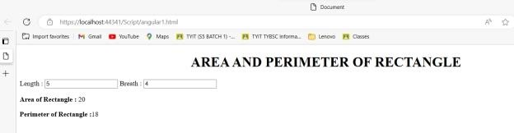

**Practical No: 7**

**Design a webpage to demonstrate a connection oriented architecture.**

**Code:**

**WebForm1.aspx**

<%@ Page Language="C#" AutoEventWireup="true" CodeBehind="WebForm1.aspx.cs" Inherits="Practical_15.WebForm1" %>

<!DOCTYPE html>

<html xmlns="http://www.w3.org/1999/xhtml">

<head runat="server">

<title></title>

<style type="text/css">

.auto-style1 {

height: 335px;

}

</style>

</head>

<body>

<form id="form1" runat="server">

<div class="auto-style1">

<asp:GridView ID="GridView1" runat="server" Height="157px" Width="254px">

</asp:GridView>

<asp:SqlDataSource ID="SqlDataSource1" runat="server" ConnectionString="<%$ ConnectionStrings:ConnectionString %>" ProviderName="<%$ ConnectionStrings:ConnectionString.ProviderName %>" SelectCommand="SELECT * FROM [employee]"></asp:SqlDataSource>

<asp:Button ID="Button2" runat="server" OnClick="Button2_Click" Text="Connected" />

<asp:Button ID="Button1" runat="server" Text="Disconnected" OnClick="Button1_Click" />

</div>

</form>

</body>

</html>

**WebForm1.aspx.cs**

using System;

using System.Collections.Generic;

using System.Data.SqlClient;

using System.Data;

using System.Linq;

using System.Web;

using System.Web.UI;

using System.Web.UI.WebControls;

namespace Practical_15

{

public partial class WebForm1 : System.Web.UI.Page

{

String StrSQL = "";

String StrConnection = "";

protected void Page_Load(object sender, EventArgs e)

{

StrSQL = "SELECT * FROM employee";

StrConnection = "Data Source=(LocalDB)\\MSSQLLocalDB;AttachDbFilename=|DataDirectory|\\Database1.mdf;Integrated Security=True";

}

protected void Button2_Click(object sender, EventArgs e)

{

using (SqlConnection objConn = new SqlConnection(StrConnection))

{

SqlCommand Objcmd = new SqlCommand(StrSQL, objConn);

Objcmd.CommandType = CommandType.Text;

objConn.Open();

SqlDataReader objDr = Objcmd.ExecuteReader();

GridView1.DataSource = objDr;

GridView1.DataBind();

objConn.Close();

}

}

protected void Button1_Click(object sender, EventArgs e)

{

SqlDataAdapter objDa = new SqlDataAdapter();

DataSet objDs = new DataSet();

using (SqlConnection objConn = new SqlConnection(StrConnection))

{

SqlCommand Objcmd = new SqlCommand(StrSQL, objConn);

Objcmd.CommandType = CommandType.Text;

objDa.SelectCommand = Objcmd;

objDa.Fill(objDs, "employee");

GridView1.DataSource = objDs.Tables[0];

GridView1.DataBind();

}

}

}

}

**Output:**

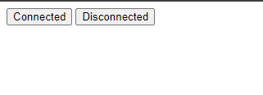

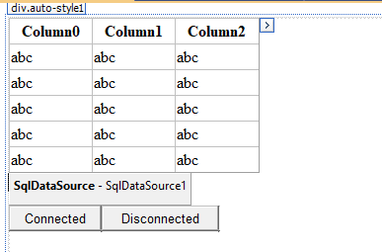

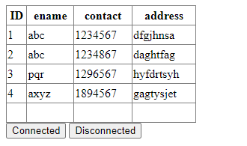

**Practical No: 8**

**Design a webpage to demonstrate a disconnected architecture.**

**Code:**

**WebForm1.aspx**

<%@ Page Language="C#" AutoEventWireup="true" CodeBehind="WebForm1.aspx.cs" Inherits="Practical_15.WebForm1" %>

<!DOCTYPE html>

<html xmlns="http://www.w3.org/1999/xhtml">

<head runat="server">

<title></title>

<style type="text/css">

.auto-style1 {

height: 335px;

}

</style>

</head>

<body>

<form id="form1" runat="server">

<div class="auto-style1">

<asp:GridView ID="GridView1" runat="server" Height="157px" Width="254px">

</asp:GridView>

<asp:SqlDataSource ID="SqlDataSource1" runat="server" ConnectionString="<%$ ConnectionStrings:ConnectionString %>" ProviderName="<%$ ConnectionStrings:ConnectionString.ProviderName %>" SelectCommand="SELECT * FROM [employee]"></asp:SqlDataSource>

<asp:Button ID="Button2" runat="server" OnClick="Button2_Click" Text="Connected" />

<asp:Button ID="Button1" runat="server" Text="Disconnected" OnClick="Button1_Click" />

</div>

</form>

</body>

</html>

**WebForm1.aspx.cs**

using System;

using System.Collections.Generic;

using System.Data.SqlClient;

using System.Data;

using System.Linq;

using System.Web;

using System.Web.UI;

using System.Web.UI.WebControls;

namespace Practical_15

{

public partial class WebForm1 : System.Web.UI.Page

{

String StrSQL = "";

String StrConnection = "";

protected void Page_Load(object sender, EventArgs e)

{

StrSQL = "SELECT * FROM employee";

StrConnection = "Data Source=(LocalDB)\\MSSQLLocalDB;AttachDbFilename=|DataDirectory|\\Database1.mdf;Integrated Security=True";

}

protected void Button2_Click(object sender, EventArgs e)

{

using (SqlConnection objConn = new SqlConnection(StrConnection))

{

SqlCommand Objcmd = new SqlCommand(StrSQL, objConn);

Objcmd.CommandType = CommandType.Text;

objConn.Open();

SqlDataReader objDr = Objcmd.ExecuteReader();

GridView1.DataSource = objDr;

GridView1.DataBind();

objConn.Close();

}

}

protected void Button1_Click(object sender, EventArgs e)

{

SqlDataAdapter objDa = new SqlDataAdapter();

DataSet objDs = new DataSet();

using (SqlConnection objConn = new SqlConnection(StrConnection))

{

SqlCommand Objcmd = new SqlCommand(StrSQL, objConn);

Objcmd.CommandType = CommandType.Text;

objDa.SelectCommand = Objcmd;

objDa.Fill(objDs, "employee");

GridView1.DataSource = objDs.Tables[0];

GridView1.DataBind();

}

}

}

}

**Output:**







**Practical No: 9**

**Create a webpage that demonstrates the use of data bound controls of ASP.NET.**

**Code:**

**WebForm1.aspx**

<%@ Page Language="C#" AutoEventWireup="true" CodeBehind="WebForm1.aspx.cs" Inherits="Practical_16.WebForm1" %>

<!DOCTYPE html>

<html xmlns="http://www.w3.org/1999/xhtml">

<head runat="server">

<title></title>

<style type="text/css">

.auto-style1 {

width: 56%;

height: 78px;

}

.auto-style3 {

width: 112px;

}

.auto-style4 {

width: 181px;

}

</style>

</head>

<body>

<form id="form1" runat="server">

<div>

<table class="auto-style1">

<tr>

<td colspan="2" align="center">Employee</td>

</tr>

<tr>

<td class="auto-style3">

<asp:Label ID="Label1" runat="server" Text="Employee Id"></asp:Label>

</td>

<td class="auto-style4">

<asp:TextBox ID="TextBox1" runat="server" Width="209px"></asp:TextBox>

</td>

</tr>

<tr>

<td class="auto-style3">

<asp:Label ID="Label2" runat="server" Text="Employee Name"></asp:Label>

</td>

<td class="auto-style4">

<asp:TextBox ID="TextBox2" runat="server" Width="209px"></asp:TextBox>

</td>

</tr>

<tr>

<td class="auto-style3">

<asp:Label ID="Label3" runat="server" Text="Employee City"></asp:Label>

</td>

<td class="auto-style4">

<asp:TextBox ID="TextBox3" runat="server" Width="209px"></asp:TextBox>

</td>

</tr>

<tr>

<td></td>

<td>

<asp:Button ID="Button1" runat="server" Text="Insert" OnClick="Button1_Click" Width="76px" />

<asp:Button ID="Button2" runat="server" Text="Delete" OnClick="Button2_Click" />

</td>

</tr>

</table>

</div>

<asp:GridView ID="GridView1" runat="server" AutoGenerateColumns="False" DataKeyNames="Empid" DataSourceID="SqlDataSource1" OnSelectedIndexChanged="GridView1_SelectedIndexChanged" Width="301px">

<Columns>

<asp:BoundField DataField="Empid" HeaderText="Empid" ReadOnly="True" SortExpression="Empid" />

<asp:BoundField DataField="Empname" HeaderText="Empname" SortExpression="Empname" />

<asp:BoundField DataField="Empcity" HeaderText="Empcity" SortExpression="Empcity" />

</Columns>

</asp:GridView>

<asp:SqlDataSource ID="SqlDataSource1" runat="server" ConnectionString="<%$ ConnectionStrings:ConnectionString %>" ProviderName="<%$ ConnectionStrings:ConnectionString.ProviderName %>" SelectCommand="SELECT * FROM [Emp]"></asp:SqlDataSource>

</form>

</body>

</html>

**WebFrom1.aspx.cs**

using System;

using System.Collections.Generic;

using System.Linq;

using System.Web;

using System.Web.UI;

using System.Web.UI.WebControls;

using System.Data;

using System.Data.SqlClient;

using System.Drawing;

using System.Net;

using System.Reflection.Emit;

using System.Security.Policy;

using System.Web.Services.Description;

using System.Xml.Linq;

using System.Security.Cryptography;

namespace Practical_16

{

public partial class WebForm1 : System.Web.UI.Page

{

SqlConnection con = new SqlConnection("Data Source = (LocalDB)\\MSSQLLocalDB; AttachDbFilename=|DataDirectory|\\Database1.mdf;Integrated Security = True");

protected void Page_Load(object sender, EventArgs e)

{

}

protected void Button1_Click(object sender, EventArgs e)

{

string connectionString = "Data Source=(LocalDB)\\MSSQLLocalDB;AttachDbFilename=|DataDirectory|\\Database1.mdf;Integrated Security=True";

SqlConnection con = new SqlConnection(connectionString);

con.Open();

string Empid = TextBox1.Text;

string Empname = TextBox2.Text;

string Empcity = TextBox3.Text;

string query = "Insert into Emp(Empid,Empname,Empcity) values('" + Empid + "','" + Empname + "','" + Empcity + "')";

SqlCommand cmd = new SqlCommand(query, con);

cmd.ExecuteNonQuery();

con.Close();

ScriptManager.RegisterStartupScript(this, this.GetType(), "alert", "alert('Record inserted') ;", true);

}

protected void GridView1_SelectedIndexChanged(object sender, EventArgs e)

{

}

protected void Button2_Click(object sender, EventArgs e)

{

}

}

}

**Output:**

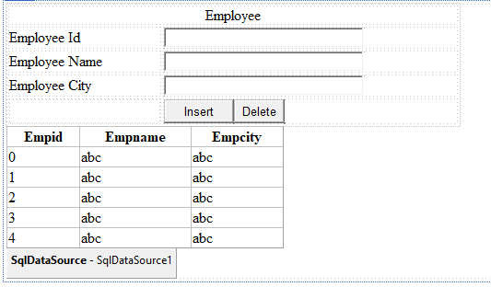

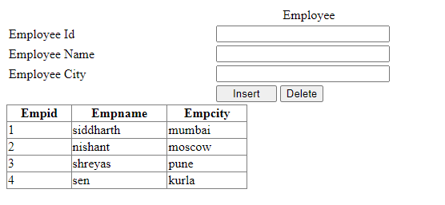

**Practical No: 10**

**Design a webpage to demonstrate the working of a simple store procedure.**

**Code:**

**WebFrom.apsx**

<%@ Page Language="C#" AutoEventWireup="true" CodeBehind="WebForm1.aspx.cs" Inherits="Practical_16.WebForm1" %>

<!DOCTYPE html>

<html xmlns="http://www.w3.org/1999/xhtml">

<head runat="server">

<title></title>

<style type="text/css">

.auto-style1 {

width: 56%;

height: 78px;

}

.auto-style3 {

width: 112px;

}

.auto-style4 {

width: 181px;

}

</style>

</head>

<body>

<form id="form1" runat="server">

<div>

<table class="auto-style1">

<tr>

<td colspan="2" align="center">Employee</td>

</tr>

<tr>

<td class="auto-style3">

<asp:Label ID="Label1" runat="server" Text="Employee Id"></asp:Label>

</td>

<td class="auto-style4">

<asp:TextBox ID="TextBox1" runat="server" Width="209px"></asp:TextBox>

</td>

</tr>

<tr>

<td class="auto-style3">

<asp:Label ID="Label2" runat="server" Text="Employee Name"></asp:Label>

</td>

<td class="auto-style4">

<asp:TextBox ID="TextBox2" runat="server" Width="209px"></asp:TextBox>

</td>

</tr>

<tr>

<td class="auto-style3">

<asp:Label ID="Label3" runat="server" Text="Employee City"></asp:Label>

</td>

<td class="auto-style4">

<asp:TextBox ID="TextBox3" runat="server" Width="209px"></asp:TextBox>

</td>

</tr>

<tr>

<td></td>

<td>

<asp:Button ID="Button1" runat="server" Text="Insert" OnClick="Button1_Click" Width="76px" />

<asp:Button ID="Button2" runat="server" Text="Delete" OnClick="Button2_Click" Width="60px" />

</td>

</tr>

</table>

</div>

<asp:GridView ID="GridView1" runat="server" AutoGenerateColumns="False" DataKeyNames="Empid" DataSourceID="SqlDataSource1" OnSelectedIndexChanged="GridView1_SelectedIndexChanged" Width="301px">

<Columns>

<asp:BoundField DataField="Empid" HeaderText="Empid" ReadOnly="True" SortExpression="Empid" />

<asp:BoundField DataField="Empname" HeaderText="Empname" SortExpression="Empname" />

<asp:BoundField DataField="Empcity" HeaderText="Empcity" SortExpression="Empcity" />

</Columns>

</asp:GridView>

<asp:SqlDataSource ID="SqlDataSource1" runat="server" ConnectionString="<%$ ConnectionStrings:EmpConnectionString %>" ProviderName="<%$ ConnectionStrings:EmpConnectionString.ProviderName %>" SelectCommand="SELECT * FROM [Emp1]"></asp:SqlDataSource>

</form>

</body>

</html>

**WebForm1.aspx.cs**

using System;

using System.Collections.Generic;

using System.Linq;

using System.Web;

using System.Web.UI;

using System.Web.UI.WebControls;

using System.Data;

using System.Data.SqlClient;

using System.Drawing;

using System.Net;

using System.Reflection.Emit;

using System.Security.Policy;

using System.Web.Services.Description;

using System.Xml.Linq;

using System.Security.Cryptography;

namespace Practical_16

{

public partial class WebForm1 : System.Web.UI.Page

{

string StrSql = "";

// SqlConnection con = new SqlConnection("Data Source = (LocalDB)\\MSSQLLocalDB; AttachDbFilename=|DataDirectory|\\Database1.mdf;Integrated Security = True");

//SqlConnection con = new SqlConnection("Data Source=.\SQLEXPRESS;Initial Catalog=emp;Integrated Security=True");

SqlConnection con = new SqlConnection("Data Source=DESKTOP-3GH50V5\\SQLEXPRESS;Initial Catalog=Emp;Integrated Security=True");

protected void Page_Load(object sender, EventArgs e)

{

}

protected void Button1_Click(object sender, EventArgs e)

{

StrSql = "SELECT * from Emp1";

string connectionString = "Data Source=DESKTOP-3GH50V5\\SQLEXPRESS;Initial Catalog=Emp;Integrated Security=True";

SqlConnection con = new SqlConnection(connectionString);

con.Open();

string Empid = TextBox1.Text;

string Empname = TextBox2.Text;

string Empcity = TextBox3.Text;

string query = "Insert into Emp1(Empid,Empname,Empcity) values('" + Empid + "','" + Empname + "','" + Empcity + "')";

SqlCommand cmd = new SqlCommand(query, con);

cmd.ExecuteNonQuery();

con.Close();

ScriptManager.RegisterStartupScript(this, this.GetType(), "alert", "alert('Record inserted') ;", true);

}

protected void GridView1_SelectedIndexChanged(object sender, EventArgs e)

{

}

protected void Button2_Click(object sender, EventArgs e)

{

}

}

}

**SQL Query** :

create database Emp;

use Emp;

create table Emp1

(

[Empid] INT NOT NULL,

[Empname] CHAR (50) NULL,

[Empcity] VARCHAR (50) NULL,

CONSTRAINT [PK_Emp] PRIMARY KEY CLUSTERED ([Empid] ASC)

);

SELECT TOP (1000) [Empid]

,[Empname]

,[Empcity]

FROM [Emp].[dbo].[Emp1]

create proc insertionEmp @Empid int, @Empname char(50), @Empcity varchar(50)

as begin

insert into Emp1 values(@Empid, @Empname, @Empcity);

end

exec insertionEmp 6, 'manav','asangaon'

select * from Emp1;

CREATE PROCEDURE GetAllEmployee

AS

BEGIN

Select ROW_NUMBER()over(order by EmpId desc) as SrNo,

EmpId,

EmpName,

EmpCity

from Employee

END

GO

CREATE PROCEDURE AddEmployee

@EmpName varchar(50) = null,

@EmpCity varchar(50)= null

AS

BEGIN

insert into Employee

(EmpName,EmpCity)

values

(

@EmpName,

@EmpCity

)

End

GO

CREATE PROCEDURE DeleteEmployee

@EmpId int

AS

BEGIN

Delete from Employee where EmpId=@EmpId;

End

GO

CREATE PROCEDURE UpdateEmployee

@EmpId int = null,

@EmpName varchar(50)= null,

@EmpCity varchar(50)= null

AS

BEGIN

if exists(select top(1)1 from Employee Where EmpId = @EmpId )

begin

update Employee set

EmpName = @EmpName,

EmpCity = @EmpCity

where EmpId = @EmpId

End

END

GO

**Output:**

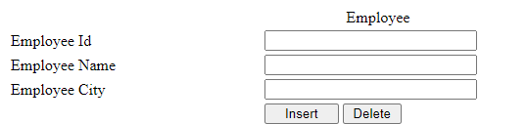

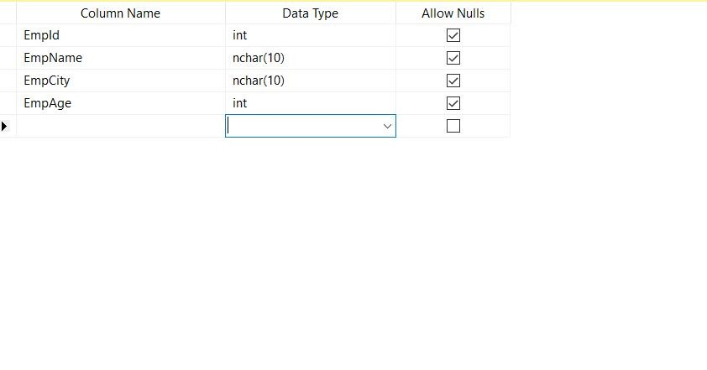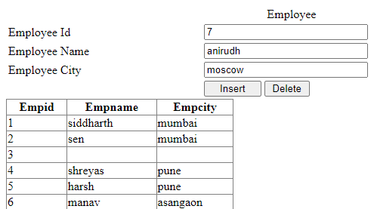

**Practical No: 11**

**Design a webpage to demonstrate the working of parameterized stored procedure.**

**Code:**

**MYSQL**

use practical_63;

create table author

(author_id integer primary key, authorName varchar(30), email varchar(25), gender varchar(6));

create table book

(BookId integer not null unique, ISBN integer primary key, book_name varchar(30)not null,

author integer, ed_num integer, price integer, pages integer,

foreign key(author) references author(author_id) on delete cascade);

**Inserting values into them:**

insert into author values (1, "Kraig Muller", "Wordnewton@gmail.com", "Male");

insert into author values (2, "Karrie Nicolette", "karrie23@gmail.com", "Female");

insert into book values (1,001, "Glimpses of the past", 1, 1,650,396);

insert into book values (2,002, "Beyond The Horizons of Venus", 1, 1,650,396);

insert into book values (3,003, "Ultrasonic Aquaculture", 2, 1,799,500);

insert into book values (4,004, "Cryogenic Engines", 2, 1, 499, 330);

DELIMITER $$

create procedure display_book()

BEGIN

select * from book;

END $$

call display_book();

**Procedure with IN parameter:**

DELIMITER $$

create procedure update_price(IN temp_ISBN varchar(10), IN new_price integer)

BEGIN

update book set price=new_price where ISBN=temp_ISBN;

END$$

call update_price(001,750);

**Procedure with OUT parameter:**

DELIMITER $$

create procedure disp_max(OUT highestprice integer)

BEGIN

select max(price) into highestprice from book;

END$$

call disp_max(@M);

select @M;

**Output:**

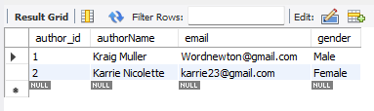

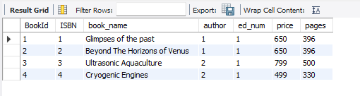

**Procedure with In parameter:**

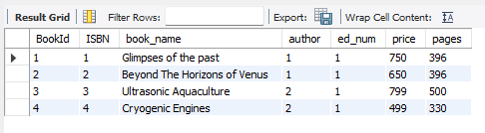

**Procedure with OUT parameter:**

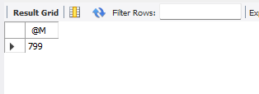

**Practical No: 12**

**Build websites to demonstrate the working of entity framework in dot net.**

**Code:**

**Student.cs**

using System;

using System.Collections.Generic;

using System.Linq;

using System.Web;

namespace Practical_18_mvc.Models

{

public class Student

{

public int Id { get; set; }

public string Name { get; set; }

public string Email { get; set; }

public string Course { get; set; }

public string Contact { get; set; }

}

}

**RecordContex.cs**

using System;

using System.Collections.Generic;

using System.Linq;

using System.Web;

using Practical_18_mvc.Models;

using System.Data.Entity;

using System.Data.Entity.ModelConfiguration.Conventions;

namespace Practical_18_mvc.Models

{

public class RecordContext:DbContext

{

public RecordContext() : base("RecordContext")

        {

        }

        public DbSet<Student>Students { get; set; }

protected override void OnModelCreating(DbModelBuilder modelBuilder)

{

modelBuilder.Conventions.Remove <PluralizingTableNameConvention>();

}

}

}

**Configuration.cs**

namespace Practical_18_mvc.Migrations

{

using Practical_18_mvc.Models;

using System;

using System.Collections.Generic;

using System.Data.Entity;

using System.Data.Entity.Migrations;

using System.Linq;

internal sealed class Configuration : DbMigrationsConfiguration<Practical_18_mvc.Models.RecordContext>

{

public Configuration()

{

AutomaticMigrationsEnabled = false;

}

protected override void Seed(Practical_18_mvc.Models.RecordContext context)

{

// This method will be called after migrating to the latest version.

// You can use the DbSet<T>.AddOrUpdate() helper extension method

// to avoid creating duplicate seed data.

var students = new List<Student>

{

new Student{Name="Mohan",Email="Samuai@example.com",Course="Java Technology", Contact="+25-258628"},

new Student{Name="Rohan",Email="Sam@example.com",Course=".NET Technology", Contact="+25-258694"},

new Student{Name="John",Email="Max@example.com",Course="Java Technology", Contact="+25-258999"},

new Student{Name="Saba",Email="saba@example.com",Course="Linux Administration", Contact="+25-258111"},

};

students.ForEach(s => context.Students.Add(s));

context.SaveChanges();

}

}

}

**202405090911327_initial.cs**

namespace Practical_18_mvc.Migrations

{

using System;

using System.Data.Entity.Migrations;

public partial class initial : DbMigration

{

public override void Up()

{

CreateTable(

"dbo.Student",

c => new

{

Id = c.Int(nullable: false, identity: true),

Name = c.String(),

Email = c.String(),

Course = c.String(),

Contact = c.String(),

})

.PrimaryKey(t => t.Id);

}

public override void Down()

{

DropTable("dbo.Student");

}

}

}

**Index.cshtml**

@model IEnumerable<Practical_18_mvc.Models.Student>

@{

ViewBag.Title = "Index";

}

<h2>Index</h2>

<p>

@Html.ActionLink("Create New", "Create")

</p>

<table class="table">

<tr>

<th>

@Html.DisplayNameFor(model => model.Name)

</th>

<th>

@Html.DisplayNameFor(model => model.Email)

</th>

<th>

@Html.DisplayNameFor(model => model.Course)

</th>

<th>

@Html.DisplayNameFor(model => model.Contact)

</th>

<th></th>

</tr>

@foreach (var item in Model) {

<tr>

<td>

@Html.DisplayFor(modelItem => item.Name)

</td>

<td>

@Html.DisplayFor(modelItem => item.Email)

</td>

<td>

@Html.DisplayFor(modelItem => item.Course)

</td>

<td>

@Html.DisplayFor(modelItem => item.Contact)

</td>

<td>

@Html.ActionLink("Edit", "Edit", new { id=item.Id }) |

@Html.ActionLink("Details", "Details", new { id=item.Id }) |

@Html.ActionLink("Delete", "Delete", new { id=item.Id })

</td>

</tr>

}

</table>

**Output:**

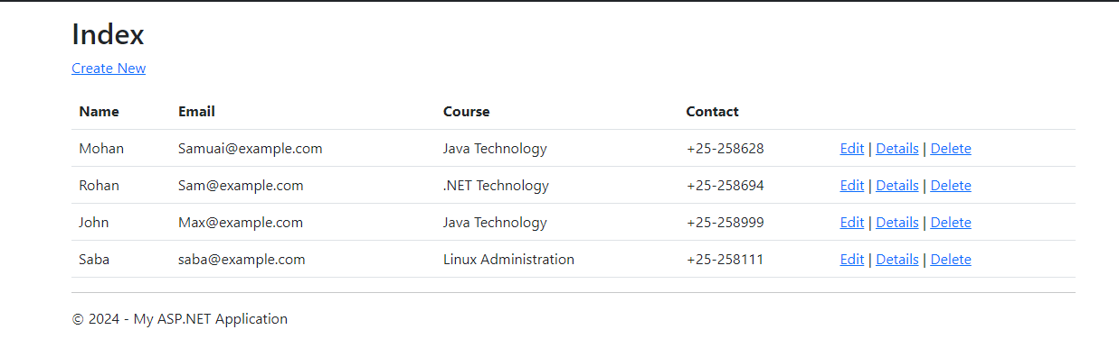

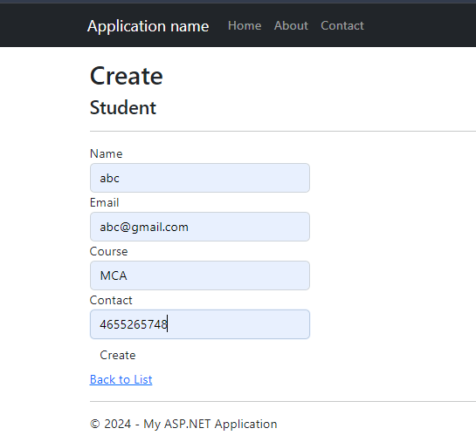

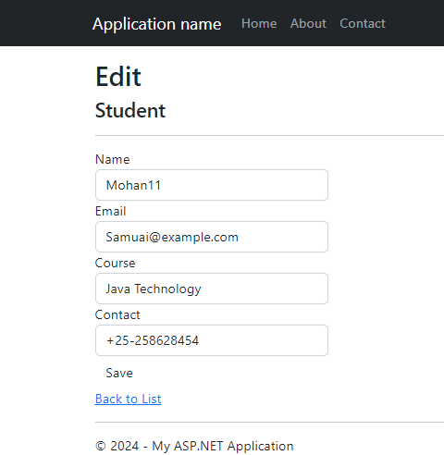

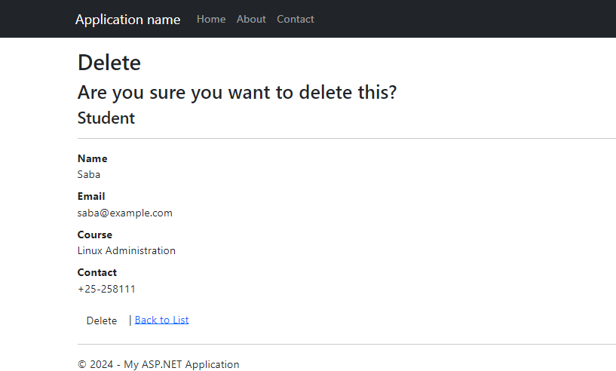

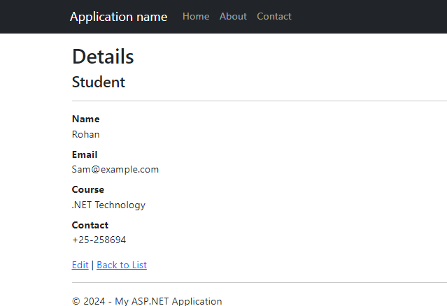

**Practical No: 13**

**Design Web Applications using Client Side Session Management**

1. **Hidden Field:**

**Code:**

**WebForm1.aspx**

<%@ Page Language="C#" AutoEventWireup="true" CodeBehind="WebForm2.aspx.cs" Inherits="Hidden_Field.WebForm2" %>

<!DOCTYPE html>

<html xmlns="http://www.w3.org/1999/xhtml">

<head runat="server">

<title></title>

</head>

<body>

<form id="form1" runat="server">

<div>

<asp:Label ID="Label1" runat="server" Text="Name"></asp:Label>

<asp:TextBox ID="TextBox1" runat="server"></asp:TextBox>

<br />

<asp:Label ID="Label2" runat="server" Text="Age:"></asp:Label>

<asp:TextBox ID="TextBox2" runat="server"></asp:TextBox>

<br />

<br />

<asp:Label ID="Label3" runat="server" Text="Branch:"></asp:Label>

<asp:TextBox ID="TextBox3" runat="server"></asp:TextBox>

<br />

<br />

<asp:Button ID="Button2" runat="server" OnClick="Button2_Click"

Text="Button"/>

<br />

<br />

<asp:Label ID="Label4" runat="server" Text="Label"></asp:Label>

&nbsp;&nbsp;&nbsp;&nbsp;&nbsp;

<asp:Label ID="Label5" runat="server" Text="Label"></asp:Label>

&nbsp;&nbsp;&nbsp;&nbsp;&nbsp;&nbsp;

<asp:Label ID="Label6" runat="server" Text="Label"></asp:Label>

<br />

<asp:HiddenField ID="HiddenField1" runat="server" />

<asp:HiddenField ID="HiddenField2" runat="server" />

<asp:HiddenField ID="HiddenField3" runat="server" /> <br />

</div>

</form>

</body>

</html>

**WebForm1.aspx.cs**

using System;

using System.Collections.Generic; using System.Linq;

using System.Web;

using System.Web.UI;

using System.Web.UI.WebControls;

namespace Hidden_Field

{ public partial class WebForm1 : System.Web.UI.Page

{ protected void Page_Load(object sender, EventArgs e)

{

String value1 = Request.Form["HiddenField1"];

String value2 = Request.Form["HiddenField2"];

String value3 = Request.Form["HiddenField3"];

Label4.Text = value1;

Label5.Text = value2;

Label6.Text = value3; }

protected void Button2_Click(object sender, EventArgs e)

{

HiddenField1.Value = TextBox1.Text;

HiddenField2.Value = TextBox2.Text;

HiddenField3.Value = TextBox3.Text;

Response.Write(HiddenField1.Value);

Response.Write(HiddenField2.Value);

Response.Write(HiddenField3.Value);

}

}

}

**Output:**

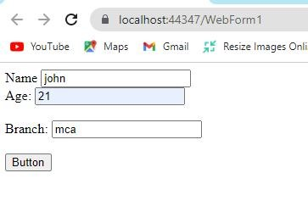

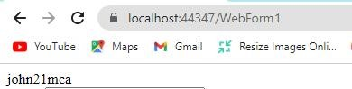

1. **Cookies:**

**Code:**

**WebForm3.aspx**

<%@ Page Language="C#" AutoEventWireup="true" CodeBehind="WebForm3.aspx.cs" Inherits="Hidden_Field.WebForm3" %>

<!DOCTYPE html>

<html xmlns="http://www.w3.org/1999/xhtml">

<head runat="server">

<title></title> </head>

<body>

<form id="form1" runat="server">

<div>

<asp:Label ID="Label1" runat="server" Text="Name:"></asp:Label>

<asp:TextBox ID="TextBox1" runat="server"></asp:TextBox>

<br />

<br />

<asp:Label ID="Label2" runat="server" Text="Age:"></asp:Label>

<asp:TextBox ID="TextBox2" runat="server"></asp:TextBox>

<br />

<br />

<asp:Label ID="Label3" runat="server" Text="Branch:"></asp:Label>

<asp:TextBox ID="TextBox3" runat="server"></asp:TextBox>

<br />

<br />

<asp:Button ID="Button1" runat="server" OnClick="Button1_Click"

Text="Submit" style="height: 26px"

/>

</div>

</form>

</body>

</html>

**WebForm3.aspx.cs**

using System;

using System.Collections.Generic; using System.Linq;

using System.Web;

using System.Web.UI;

using System.Web.UI.WebControls;

namespace Hidden_Field

{ public partial class WebForm3 : System.Web.UI.Page

{ protected void Page_Load(object sender, EventArgs e)

{

}

protected void Button1_Click(object sender, EventArgs e)

{

HttpCookie cookie = new HttpCookie("userinformation"); cookie["Name"] = TextBox1.Text; cookie["Age"] = TextBox2.Text; cookie["Branch"] = TextBox3.Text; Response.Cookies.Add(cookie);

Response.Redirect("WebForm4.aspx");

}

}

}

**WebForm4.aspx**

<%@ Page Language="C#" AutoEventWireup="true" CodeBehind="WebForm4.aspx.cs" Inherits="Hidden_Field.WebForm4" %>

<!DOCTYPE html>

<html xmlns="http://www.w3.org/1999/xhtml">

<head runat="server">

<title></title>

</head>

<body>

<form id="form1" runat="server">

<div>

<asp:Label ID="Label1" runat="server" Text="Label"></asp:Label>

<br />

<br />

<asp:Label ID="Label2" runat="server" Text="Label"></asp:Label>

<br />

<br />

<asp:Label ID="Label3" runat="server" Text="Label"></asp:Label> </div>

</form>

</body>

</html>

**WebForm4.aspx.cs**

using System;

using System.Collections.Generic; using System.Linq;

using System.Web;

using System.Web.UI;

using System.Web.UI.WebControls;

namespace Hidden_Field

{ publicpartialclassWebForm4 : System.Web.UI.Page {

protectedvoid Page_Load(object sender, EventArgs e)

{

HttpCookie cookie1 = Request.Cookies["userinformation"];

Label1.Text = cookie1["Name"];

Label2.Text = cookie1["Age"];

Label3.Text = cookie1["Branch"];

}

}

}

**Output:**

**Before Submitting:**

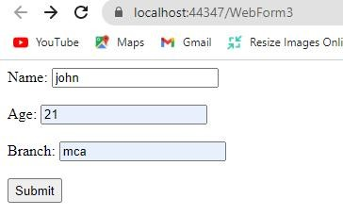

**After Submitting:**

**Cookies Generated**

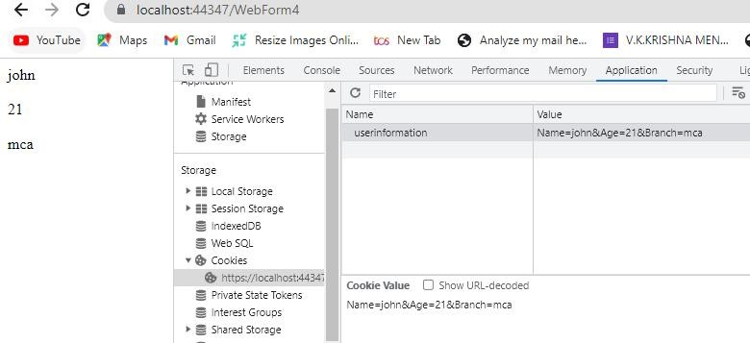

1. **Query Strings:**

**Code:**

**WebForm5.aspx**

<%@ Page Language="C#" AutoEventWireup="true" CodeBehind="WebForm5.aspx.cs" Inherits="Hidden_Field.WebForm5" %>

<!DOCTYPE html>

<html xmlns="http://www.w3.org/1999/xhtml">

<head runat="server">

<title></title>

</head>

<body>

<form id="form1" runat="server">

<div>

<asp:Label ID="Label1" runat="server" Text="Name:"></asp:Label>

<asp:TextBox ID="TextBox1" runat="server"></asp:TextBox>

<br />

<br />

<asp:Label ID="Label2" runat="server" Text="Age:"></asp:Label>

<asp:TextBox ID="TextBox2" runat="server"></asp:TextBox>

<br />

<br />

<asp:Label ID="Label3" runat="server" Text="Branch:"></asp:Label>

<asp:TextBox ID="TextBox3" runat="server"></asp:TextBox>

<br />

<br />

<asp:Button ID="Button1" runat="server" OnClick="Button1_Click" Text="Submit"/>

</div>

</form>

</body>

</html>

**WebForm5.aspx.cs**

using System;

using System.Collections.Generic; using System.Linq;

using System.Web;

using System.Web.UI;

using System.Web.UI.WebControls;

namespace Hidden_Field

{ public partial class WebForm5 : System.Web.UI.Page

{ protected void Page_Load(object sender, EventArgs e)

{

}

protected void Button1_Click(object sender, EventArgs e)

{

Response.Redirect("WebForm6.aspx?Name=" + TextBox1.Text + "&Age="

+TextBox2.Text + "&Branch=" + TextBox3.Text); }

}

}

**WebForm6.aspx.cs**

using System.Web;

using System.Web.UI;

using System.Web.UI.WebControls;

namespace Hidden_Field

{ public partial class WebForm6 : System.Web.UI.Page

{ protected void Page_Load(object sender, EventArgs e)

{

String Name = Request.QueryString["Name"]; int Age = int.Parse(Request.QueryString["Age"]);

String Branch = Request.QueryString["Branch"];

Response.Write("Name: " + Name + "</br> Age: " + Age + "</br> Branch: " +Branch);

}

}

}

**Output:**

**Before Submitting:**

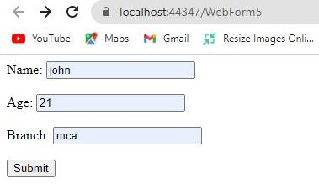

**After Submitting:**

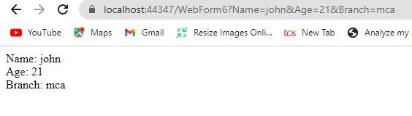

1. **ViewState:**

**Code:**

**ViewState.aspx**

<%@ Page Language="C#" AutoEventWireup="true" CodeBehind="viewstate.aspx.cs" Inherits="Hidden_Field.viewstate" %>

<!DOCTYPE html>

<html xmlns="http://www.w3.org/1999/xhtml">

<head runat="server">

<title></title>

</head>

<body>

<form id="form1" runat="server">

<div>

<asp:Label ID="Label1" runat="server" Text="Name:"></asp:Label>

<asp:TextBox ID="TextBox1" runat="server"></asp:TextBox>

<br />

<br />

<asp:Label ID="Label2" runat="server" Text="Age:"></asp:Label>

<asp:TextBox ID="TextBox2" runat="server"></asp:TextBox>

<br />

<br />

<asp:Label ID="Label3" runat="server" Text="Branch:"></asp:Label>

<asp:TextBox ID="TextBox3" runat="server"></asp:TextBox>

<br />

<br />

<asp:Label ID="Label4" runat="server"></asp:Label>

<br />

<br />

<asp:Button ID="Button1" runat="server" OnClick="Button1_Click"

Text="Button"

/>

</div>

</form>

</body>

</html>

**ViewState.aspx.cs**

using System;

using System.Collections.Generic;

using System.Linq;

using System.Web;

using System.Web.UI;

using System.Web.UI.WebControls;

namespace Hidden_Field

{ public partial class viewstate : System.Web.UI.Page

{ protected void Page_Load(object sender, EventArgs e)

{

}

protected void Button1_Click(object sender, EventArgs e)

{

ViewState["Name"] = TextBox1.Text;

ViewState["Age"] = TextBox2.Text;

ViewState["Branch"] = TextBox3.Text;

Label4.Text += "{ " + (String)ViewState["Name"] + ", " +

(String)ViewState["Age"] + ", " + (String)ViewState["Branch"] + " }"; }

}

}

**Output:**

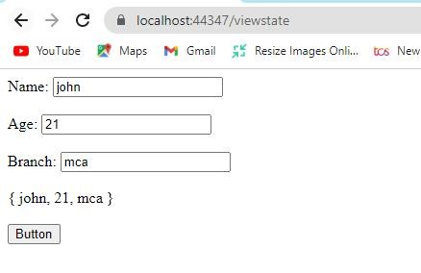

**Practical No: 14**

**Design Web Applications using Server Side Session Management Techniques.**

1. **Session State:**

**Code:**

**WebForm1.aspx**

<%@ Page Language="C#" AutoEventWireup="true" CodeBehind="WebForm1.aspx.cs" Inherits="Server.WebForm1" %>

<!DOCTYPE html>

<html xmlns="http://www.w3.org/1999/xhtml">

<head runat="server">

<title></title>

</head>

<body>

<form id="form1" runat="server">

<div>

<asp:Label ID="Label1" runat="server" Text="Name:"></asp:Label>

<asp:TextBox ID="TextBox1" runat="server"></asp:TextBox>

<br />

<br />

<asp:Label ID="Label2" runat="server" Text="Age:"></asp:Label>

<asp:TextBox ID="TextBox2" runat="server"></asp:TextBox>

<br />

<br />

<asp:Label ID="Label3" runat="server" Text="Branch:"></asp:Label>

<asp:TextBox ID="TextBox3" runat="server"></asp:TextBox>

<br />

<br />

<asp:Button ID="Button1" runat="server" OnClick="Button1_Click"

Text="Submit"

/>

</div>

</form>

</body>

</html>

**WebForm1.aspx.cs**

using System;

usingSystem.Collections.Generic; usingSystem.Linq; usingSystem.Web; usingSystem.Web.UI; usingSystem.Web.UI.WebControls; namespace Server

{ public partial class WebForm1 : System.Web.UI.Page

{ protected void Page_Load(object sender, EventArgs e)

{

}

protected void Button1_Click(object sender, EventArgs e)

{

Session["Name"] = TextBox1.Text;

Session["Age"] = TextBox2.Text;

Session["Branch"] = TextBox3.Text;

Response.Redirect("WebForm2.aspx");

}

}

}

**WebForm2.aspx**

<%@ Page Language="C#" AutoEventWireup="true" CodeBehind="WebForm2.aspx.cs" Inherits="Server.WebForm2" %>

<!DOCTYPE html>

<html xmlns="http://www.w3.org/1999/xhtml">

<head runat="server">

<title></title>

</head>

<body>

<form id="form1" runat="server">

<div>

<asp:Label ID="Label1" runat="server"></asp:Label>

<br />

<br />

<asp:Label ID="Label2" runat="server"></asp:Label>

<br />

<br />

<asp:Label ID="Label3" runat="server"></asp:Label> </div>

</form>

</body>

</html>

**WebForm2.aspx.cs**

using System;

usingSystem.Collections.Generic; usingSystem.Linq; usingSystem.Web; usingSystem.Web.UI; usingSystem.Web.UI.WebControls;

namespace Server

{ public partial class WebForm2 : System.Web.UI.Page

{ protected void Page_Load(object sender, EventArgs e)

{ if (Session["Name"] != null || Session["Branch"] != null || Session["Age"] !=null)

{

Label1.Text = "Name: " + Session["Name"].ToString();

Label2.Text = "Age: " + Session["Age"].ToString();

Label3.Text = "Branch: " + Session["Branch"].ToString(); }

}

}

}

**Output:**

**Before Submitting:**

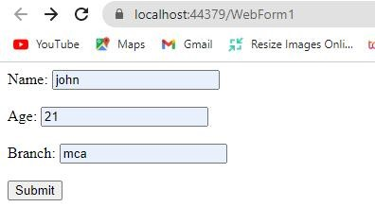

**After Submitting:**

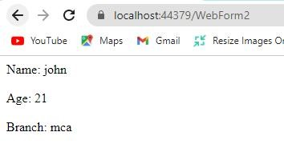

1. **Application State:**

**Code:**

**WebForm3.aspx:**

<%@PageLanguage="C#"AutoEventWireup="true"CodeBehind="WebForm3.aspx.cs"Inheri ts="Server.WebForm3"%>

<!DOCTYPEhtml>

<htmlxmlns="http://www.w3.org/1999/xhtml">

<headrunat="server">

<title></title>

</head>

<body>

<form id="form1"runat="server"> 6

<div>

<asp:LabelID="Label1"runat="server"Text="Name:"></asp:Label>

<asp:TextBoxID="TextBox1"runat="server"></asp:TextBox>

<br/>

<br/>

<asp:LabelID="Label2"runat="server"Text="Age:"></asp:Label>

<asp:TextBoxID="TextBox2"runat="server"></asp:TextBox>

<br/>

<br/>

<asp:LabelID="Label3"runat="server"Text="Branch"></asp:Label>

<asp:TextBoxID="TextBox3"runat="server"></asp:TextBox>

<br/>

<br/>

<asp:ButtonID="Button1"runat="server"OnClick="Button1_Click"Text= "Submit"/>

</div>

</form>

</body>

</html>

**WebForm3.aspx.cs**

using System;

usingSystem.Collections.Generic; usingSystem.Linq; usingSystem.Web; usingSystem.Web.UI; usingSystem.Web.UI.WebControls;

namespace Server

{ publicpartialclassWebForm3 : System.Web.UI.Page

{ protectedvoidPage_Load(object sender, EventArgs e) {

}

protectedvoid Button1_Click(object sender, EventArgs e)

{

Application["Name"] = TextBox1.Text;

Application["Age"] = TextBox2.Text;

Application["Branch"] = TextBox3.Text;

Response.Redirect("WebForm2.aspx");

}

}

}

**WebForm4.aspx**

<%@PageLanguage="C#"AutoEventWireup="true"CodeBehind="WebForm4.aspx.cs"Inheri ts="Server.WebForm4"%>

<!DOCTYPEhtml>

<htmlxmlns="http://www.w3.org/1999/xhtml">

<headrunat="server">

<title></title>

</head>

<body>

<form id="form1"runat="server">

<div>

<asp:LabelID="Label1"runat="server"></asp:Label>

<br/>

<br/>

<asp:LabelID="Label2"runat="server"></asp:Label>

<br/>

<br/>

<asp:LabelID="Label3"runat="server"></asp:Label> </div>

</form>

</body>

</html>

**WebForm4.aspx.cs:**

using System;

usingSystem.Collections.Generic; usingSystem.Linq; usingSystem.Web; usingSystem.Web.UI; usingSystem.Web.UI.WebControls;

namespace Server

{ publicpartialclassWebForm4 : System.Web.UI.Page {

protectedvoidPage_Load(object sender, EventArgs e)

{

Label1.Text = "Name: " + Application["Name"].ToString();

Label2.Text = "Age: " + Application["Age"].ToString();

Label3.Text = "Branch: " + Application["Branch"].ToString(); }

}

}

**Output:**

**Before Submitting:**

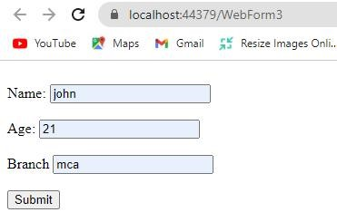

**After Submitting:**

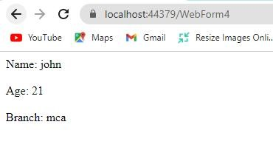

**Practical No: 15**

**Design Web Application to produce and Consume a web Service.**

**Code:**

using System;

using System.Collections.Generic;

using System.Linq;

using System.Web;

using System.Web.Services;

namespace Practical_21

{

/// <summary>

/// Summary description for WebService1

/// </summary>

[WebService(Namespace = "http://tempuri.org/")]

[WebServiceBinding(ConformsTo = WsiProfiles.BasicProfile1_1)]

[System.ComponentModel.ToolboxItem(false)]

// To allow this Web Service to be called from script, using ASP.NET AJAX, uncomment the following line.

// [System.Web.Script.Services.ScriptService]

public class WebService1 : System.Web.Services.WebService

{

[WebMethod]

public string HelloWorld()

{

return "Hello World";

}

[WebMethod]

public double addition(double a, double b)

{ return a + b; }

[WebMethod]

public double subtraction(double a, double b)

{ return a - b; }

[WebMethod]

public double multiplication(double a, double b)

{ return a * b; }

[WebMethod]

public double division(double a, double b)

{ return a / b; }

}

}

**Output:**

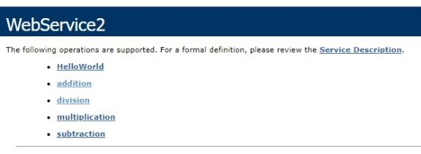

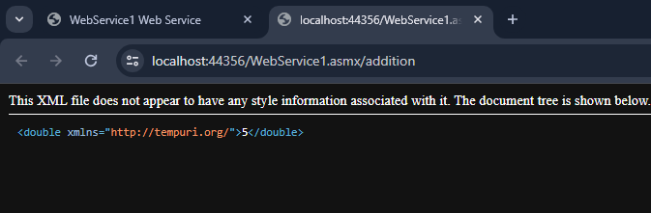

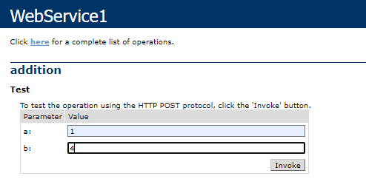

**Practical No: 16**

**Design Web Application to produce and Consume a WCF Service.**

**Code:**

**WebForm1.aspx.cs**

using System;

usingSystem.Collections.Generic; usingSystem.Linq; usingSystem.Web; usingSystem.Web.UI; usingSystem.Web.UI.WebControls;

namespace WCF {

public partial class WebForm1 : System.Web.UI.Page

{ protected void Page_Load(object sender, EventArgs e)

{

} protected void Button1_Click(object sender, EventArgs e)

{

ServiceReference1.WebService2SoapClient obj = new ServiceReference1.WebService2SoapClient(); double a = Convert.ToDouble(TextBox1.Text); double b = Convert.ToDouble(TextBox2.Text); doubleans = obj.addition(a, b);

Label3.Text = "Result:" + ans.ToString();

} protected void Button2_Click(object sender, EventArgs e) {

ServiceReference1.WebService2SoapClient obj = new ServiceReference1.WebService2SoapClient(); double a = Convert.ToDouble(TextBox1.Text); double b = Convert.ToDouble(TextBox2.Text); doubleans = obj.subtraction(a, b);

Label3.Text = "Result:" + ans.ToString();

} protected void Button3_Click(object sender, EventArgs e)

{

ServiceReference1.WebService2SoapClient obj = new ServiceReference1.WebService2SoapClient(); double a = Convert.ToDouble(TextBox1.Text); double b = Convert.ToDouble(TextBox2.Text); doubleans = obj.multiplication(a, b);

Label3.Text = "Result:" + ans.ToString();

} protected void Button4_Click(object sender, EventArgs e)

{

ServiceReference1.WebService2SoapClient obj = new ServiceReference1.WebService2SoapClient(); double a = Convert.ToDouble(TextBox1.Text); double b = Convert.ToDouble(TextBox2.Text); doubleans = obj.division(a, b);

Label3.Text = "Result:" + ans.ToString();

}

}

}

**Output:**

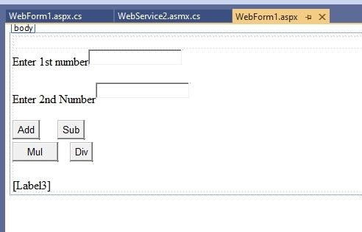

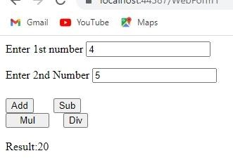

**Practical No: 17**

**Design MVC based Web applications.**

**Code:**

**Class**

using System;

using System.Collections.Generic;

using System.Linq;

using System.Web;

namespace Practical_22.Models

{

public class Class1

{

public string Name { get; set; }

public string Address { get; set; }

public int Age { get; set;}

}

}

**Index**

@{

ViewBag.Title = "Home Page";

}

<h2>Employee Details</h2>

<table style="font-family:Arial">

<tr>

<td>

<b>Employee Name</b>

</td>

<td>

<b>@Model.Name</b>

</td>

</tr>

<tr>

<td>

<b>Employee Age</b>

</td>

<td>

<b>@Model.Age</b>

</td>

</tr>

<tr>

<td><b>Employee Address:</b></td>

<td>@Model.Address</td>

</tr>

</table>

**HomeController**

using Practical_22.Models;

using System;

using System.Collections.Generic;

using System.Linq;

using System.Net.Sockets;

using System.Web;

using System.Web.Mvc;

namespace Practical_22.Controllers

{

public class HomeController : Controller

{

public ActionResult Index()

{

Class1 emp = new Class1()

{

Address = "Seawoods, Navi mumbai",

Name = "Ram",

Age = 22

};

return View(emp);

}

public ActionResult About()

{

ViewBag.Message = "Your application description page.";

return View();

}

public ActionResult Contact()

{

ViewBag.Message = "Your contact page.";

return View();

}

}

}

**Output:**

