**Experiment No. 1: Program to blink Arduino onboard LED.**

**Aim:** Write a program to blink Arduino onboard LED, to interface external LED with Arduino, and write a program to turn ON LED for 1 sec after every 2 seconds.

**Components Used:**  Arduino Kit, LED, Resistor, Jumping wire

**Circuit Diagram:**

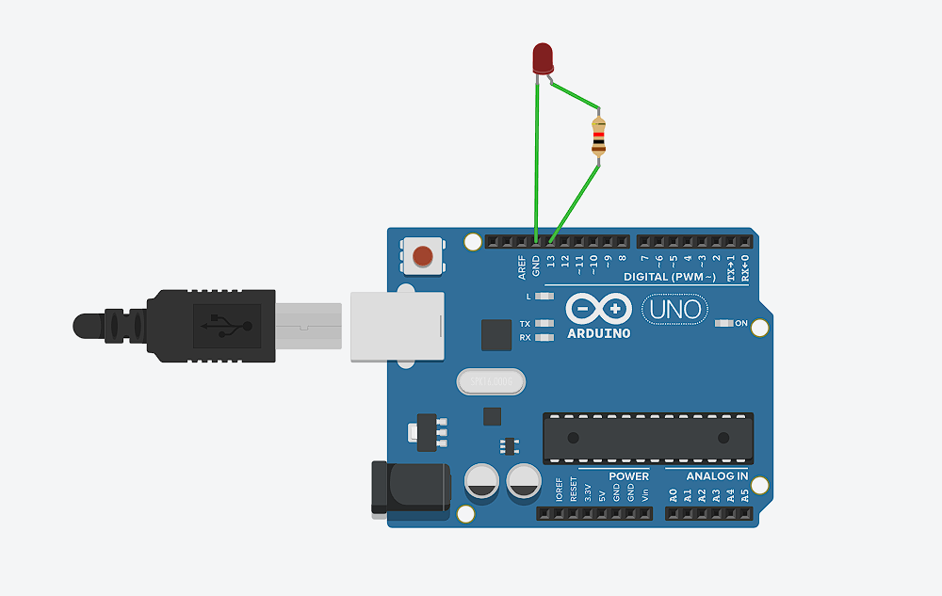

**Code:**

void setup ()

{

pinMode (13, OUTPUT);

}

void loop ()

{

digitalWrite (13, HIGH);

delay (1000); // Wait for 1000 millisecond(s)

digitalWrite (13, LOW);

delay (2000); // Wait for 2000 millisecond(s)

}

**Output:**

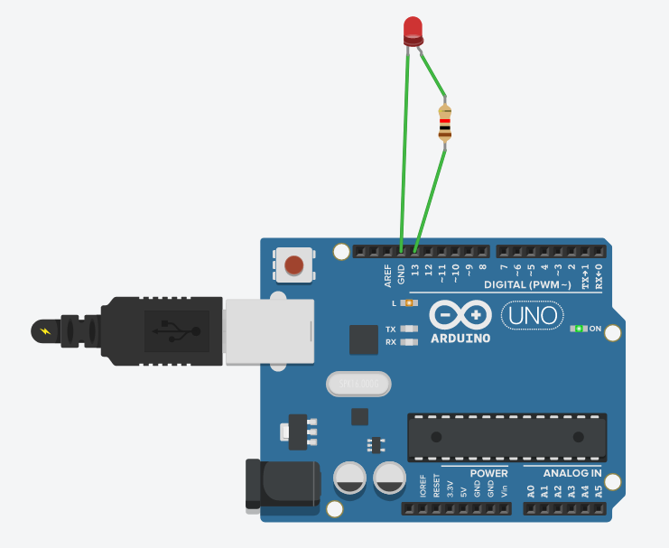

**Experiment No. 2: Program to blink 2 Arduino onboard LEDs using 2 resistors**.

**Aim:** Program to blink Arduino onboard two LED and two resistors to interface external LED with Arduino and write a program to turn ON LED for 1 sec after every 2 seconds.

**Components Used:**  Arduino Kit, 2 LEDs, 2 Resistors, Jumping wire

**Circuit Diagram:**

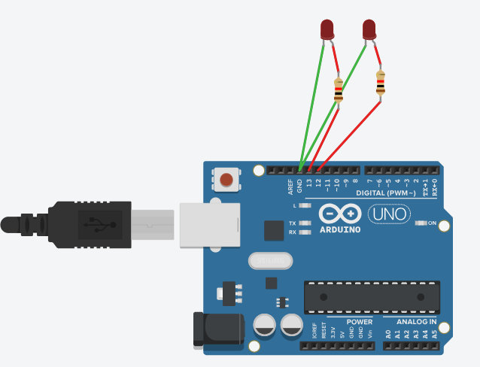

**Code:**

Simultaneous blinking

void setup ()

{

pinMode (13, OUTPUT);

pinMode (12, OUTPUT);

}

void loop ()

{

digitalWrite (13, HIGH);

digitalWrite (12, HIGH);

delay (1000); // Wait for 1000 millisecond(s)

digitalWrite (13, LOW);

digitalWrite (12, LOW);

delay (2000); // Wait for 2000 millisecond(s)

 }

**Code:** Alternative blinking

void setup ()

{

pinMode (13, OUTPUT);

pinMode (12, OUTPUT);

}

void loop ()

{

digitalWrite (13, HIGH);

delay (1000); // Wait for 1000 millisecond(s)

digitalWrite (13, LOW);

delay (2000); // Wait for 2000 millisecond(s)

digitalWrite (12, HIGH);

delay (1000);

digitalWrite (12, LOW);

delay (2000);

}

**Output:**

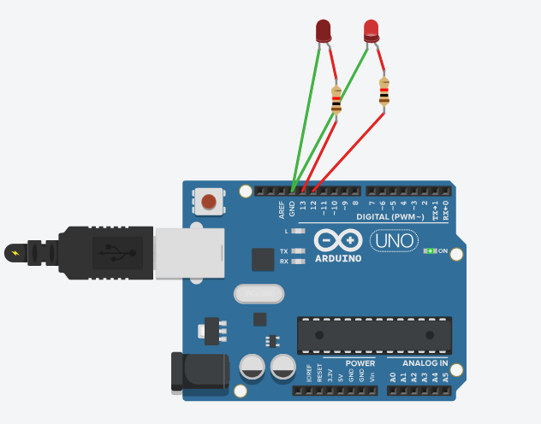

**Experiment No. 3: Program to blink 2 Arduino onboard LEDs using single resistors**.

**Aim:** Program to blink Arduino onboard two LED and one resistor to interface external LED with Arduino and write a program to turn ON LED for 1 sec after every 2 seconds.

**Components Used:**  Arduino Kit, 2 LEDs, 1 Resistor, Jumping wire

**Circuit Diagram:**

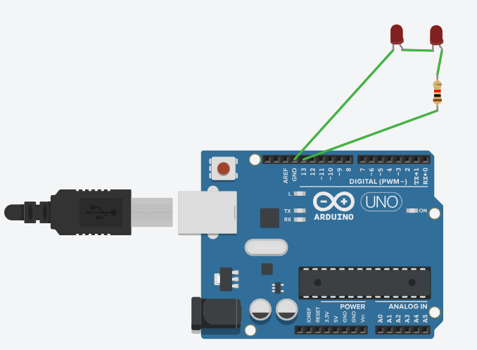

**Code:**

void setup ()

{

pinMode (12, OUTPUT);

}

void loop ()

{

digitalWrite (12, HIGH);

delay (1000); // Wait for 1000 millisecond(s)

digitalWrite (12, LOW);

delay (2000); // Wait for 2000 millisecond(s)

}

**Output:**

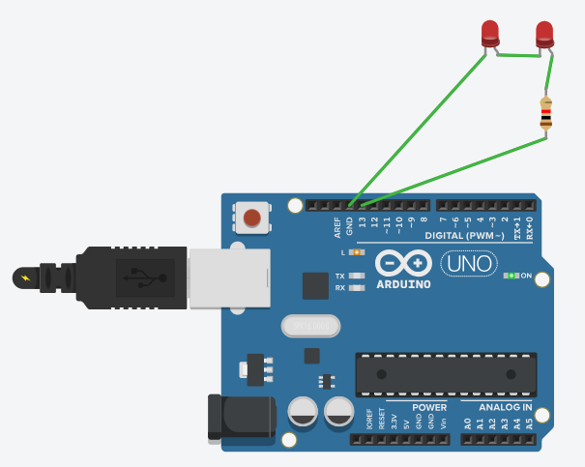

**Experiment No. 4: To interface 5 LED‟s with Arduino and to blink 6 LEDs, one at a time, in a back & forth formation.**

**Aim:** To interface 5 LED‟s with Arduino and write a program to blink 6 LEDs, one at a time, in a back-and-forth formation.

**Components Used:**  Arduino Kit, 5 LEDs, 5 Resistors, Jumping wire

**Circuit Diagram:**

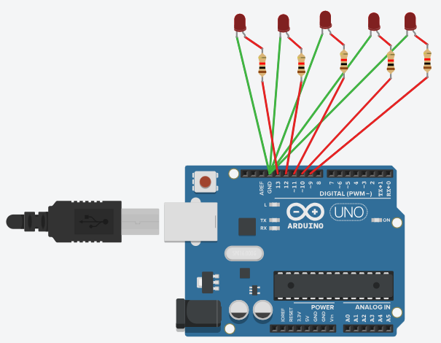

**Code:**

void setup ()

{

pinMode (5, OUTPUT);

pinMode (7, OUTPUT);

pinMode (11, OUTPUT);

pinMode (12, OUTPUT);

pinMode (13, OUTPUT);

}

void loop ()

{

digitalWrite (13, HIGH);

delay (1000);

digitalWrite (13, LOW);

digitalWrite (12, HIGH);

delay (1000);

digitalWrite (12, LOW);

digitalWrite (11, HIGH);

delay (1000);

digitalWrite (11, LOW);

digitalWrite (7, HIGH);

delay (1000);

digitalWrite (7, LOW);

digitalWrite (5, HIGH);

delay (1000);

digitalWrite (5, LOW);

}

**Output:**

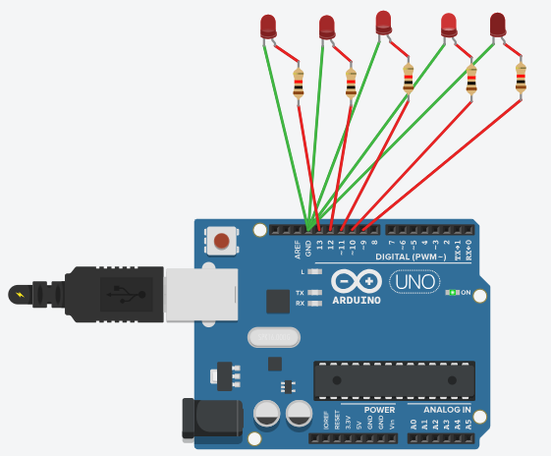

**Experiment No. 5: To interface Push button with Arduino and to turn ON LED when push button is pressed.**

**Aim:** To interface Push button with Arduino and write a program to turn ON LED when push button is pressed.

**Components Used:**  Arduino Kit, 1 LED, 1 Resistor, 1 Push Button, Breadboard, Jumping wire

**Circuit Diagram:**

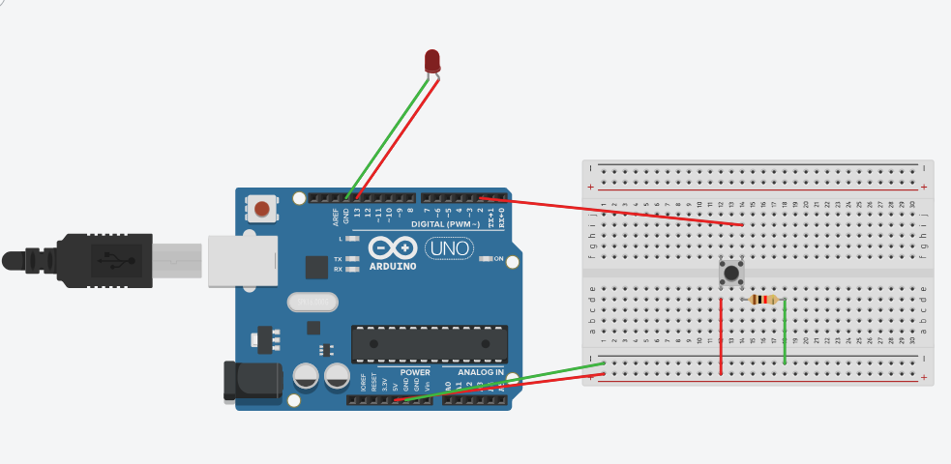

**Code:**

void setup ()

{

pinMode (2, OUTPUT);

pinMode (13, OUTPUT);

}

void loop ()

{

   if (digitalRead (2) ==1)

  {

digitalWrite (13, HIGH);

  }

  else

  {

digitalWrite (13, LOW);

  }

}

**Output:**

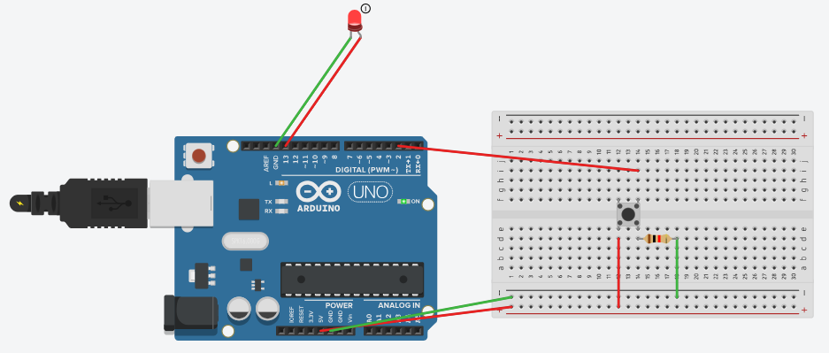

**Experiment No. 6: To blink 1 led and buzz 1 buzzer after pushing a button.**

**Aim:** To interface Push button, Speaker/buzzer with Arduino and write a program to turn ON LED and generate a note or tone when push button is pressed.

**Components Used:**  Arduino Kit, 1 LED, 1 Resistor, 1 Push Button, 1 Buzzer, Breadboard, Jumping wire

**Circuit Diagram:**

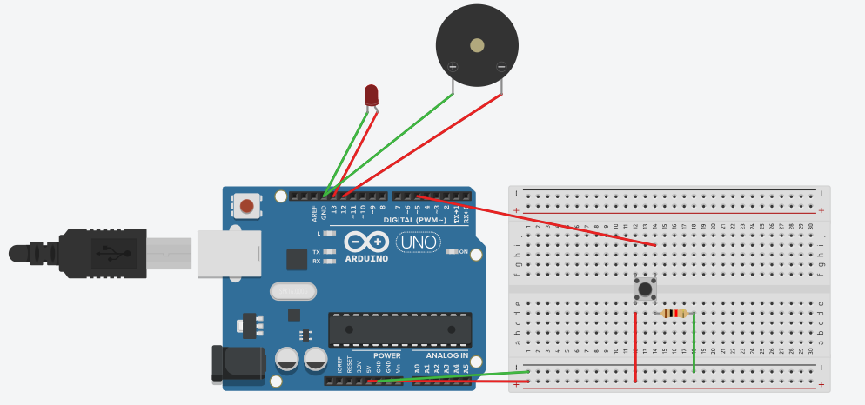

**Code:**

void setup ()

{

pinMode (13, OUTPUT);

pinMode (12, OUTPUT);

}

void loop ()

{

   if (digitalRead (5) ==1)

  {

digitalWrite (13, HIGH);

digitalWrite (12, HIGH);

  }

else {

digitalWrite (13, LOW);

digitalWrite (12, LOW);

  }

}

**Output:**

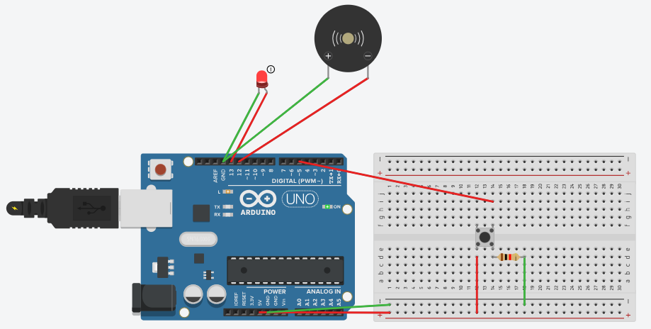

**Experiment No. 7: To blink 1 led and buzz 1 buzzer after pushing a button and Another led and same buzzer after pushing 2nd button.**

**Aim:** To interface 2 Push buttons, a Speaker with Arduino and write a program to turn ON LED and generate 2 different tones on two button keyboards.

**Components Used:** Arduino Kit, 2 LEDs, 2 Resistors, 2 Push Button, 1 Buzzer, Breadboard, Jumping wire

**Circuit Diagram:**

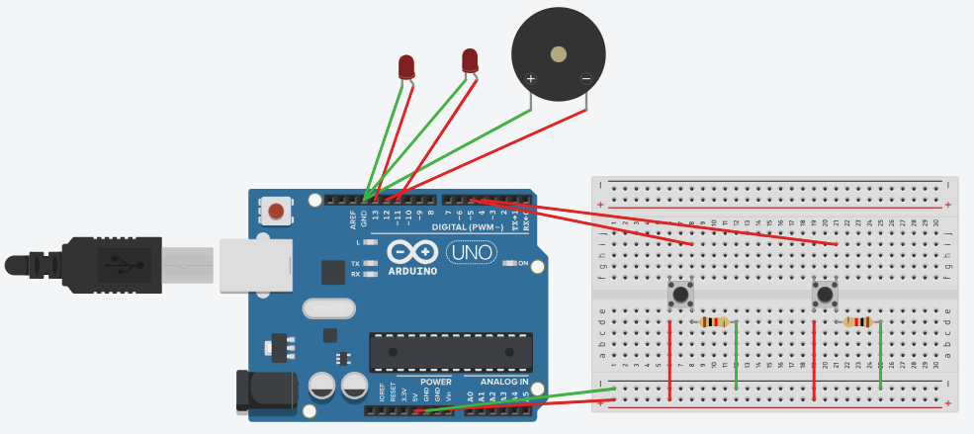

**Code:**

void setup ()

{

pinMode (13, OUTPUT);

pinMode (12, OUTPUT);

pinMode (11, OUTPUT);

}

void loop ()

{

   if (digitalRead (5) ==1)

{

digitalWrite (13, HIGH);

digitalWrite (12, HIGH);

 }

  if (digitalRead (2) ==1)

{

digitalWrite (11, HIGH);

digitalWrite (12, HIGH);

 }

  else

{

digitalWrite (13, LOW);

digitalWrite (12, LOW);

digitalWrite (11, LOW);

  }

}

**Output:**

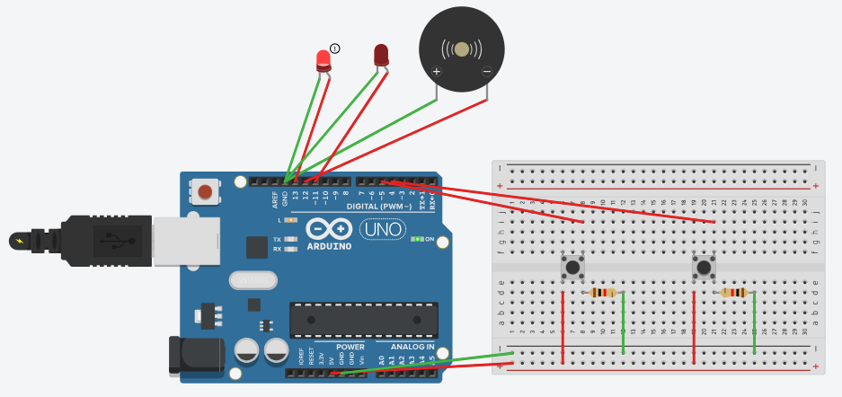

**Experiment No. 8: To blink all segments of SSD to print numbers from 1-9**

**Aim:** To interface Seven Segment Display (SSD) with Arduino and write a program to print numbers from 1 to 9 on SSD.

**Components Used:**  Arduino Kit, 1 SSD, 2 Resistors, Breadboard, Jumping wire

**Circuit Diagram:**

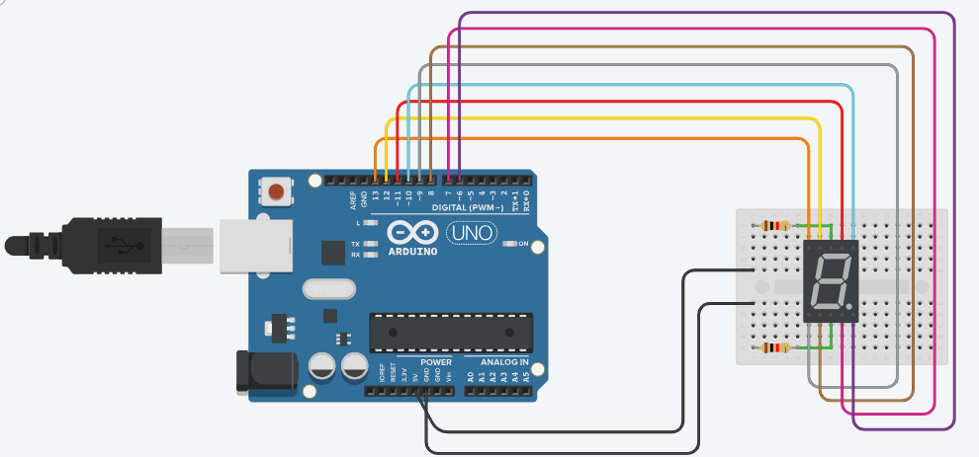

**Code:**

unsigned const int A = 13;

unsigned const int B = 12;

unsigned const int C = 11;

unsigned const int D = 10;

unsigned const int E = 9;

unsigned const int F = 8;

unsigned const int G = 7;

unsigned const int H = 6;

void setup ()

{

pinMode (A, OUTPUT);

pinMode (B, OUTPUT);

pinMode (C, OUTPUT);

pinMode (D, OUTPUT);

pinMode (E, OUTPUT);

pinMode (F, OUTPUT);

pinMode (G, OUTPUT);

pinMode (H, OUTPUT);

}

void zero ()

{

digitalWrite (A, LOW);

digitalWrite (B, HIGH);

digitalWrite (C, HIGH);

digitalWrite (D, HIGH);

digitalWrite (E, HIGH);

digitalWrite (F, HIGH);

digitalWrite (G, HIGH);

digitalWrite (H, LOW);

}

void one ()

{

digitalWrite (A, LOW);

digitalWrite (B, LOW);

digitalWrite (C, LOW);

digitalWrite (D, HIGH);

digitalWrite (E, LOW);

digitalWrite (F, LOW);

digitalWrite (G, HIGH);

digitalWrite (H, LOW);

}

void two()

{

digitalWrite (A, HIGH);

digitalWrite (B, LOW);

digitalWrite (C, HIGH);

digitalWrite (D, HIGH);

digitalWrite (E, HIGH);

digitalWrite (F, HIGH);

digitalWrite (G, LOW);

digitalWrite (H, LOW);

}

void three()

{

digitalWrite (A, HIGH);

digitalWrite (B, LOW);

digitalWrite (C, HIGH);

digitalWrite (D, HIGH);

digitalWrite (E, LOW);

digitalWrite (F, HIGH);

digitalWrite (G, HIGH);

digitalWrite (H, LOW);

}

void four()

{

digitalWrite (A, HIGH);

digitalWrite (B, HIGH);

digitalWrite (C, LOW);

digitalWrite (D, HIGH);

digitalWrite (E, LOW);

digitalWrite (F, LOW);

digitalWrite (G, HIGH);

digitalWrite (H, LOW);

}

void five()

{

digitalWrite (A, HIGH);

digitalWrite (B, HIGH);

digitalWrite (C, HIGH);

digitalWrite (D, LOW);

digitalWrite (E, LOW);

digitalWrite (F, HIGH);

digitalWrite (G, HIGH);

digitalWrite (H, LOW);

}

void six()

{

digitalWrite (A, HIGH);

digitalWrite (B, HIGH);

digitalWrite (C, HIGH);

digitalWrite (D, LOW);

digitalWrite (E, HIGH);

digitalWrite (F, HIGH);

digitalWrite (G, HIGH);

digitalWrite (H, LOW);

}

void seven()

{

digitalWrite (A, LOW);

digitalWrite (B, LOW);

digitalWrite (C, HIGH);

digitalWrite (D, HIGH);

digitalWrite (E, LOW);

digitalWrite (F, LOW);

digitalWrite (G, HIGH);

digitalWrite (H, LOW);

}

void eight()

{

digitalWrite (A, HIGH);

digitalWrite (B, HIGH);

digitalWrite (C, HIGH);

digitalWrite (D, HIGH);

digitalWrite (E, HIGH);

digitalWrite (F, HIGH);

digitalWrite (G, HIGH);

digitalWrite (H, LOW);

}

void nine()

{

digitalWrite (A, HIGH);

digitalWrite (B, HIGH);

digitalWrite (C, HIGH);

digitalWrite (D, HIGH);

digitalWrite (E, LOW);

digitalWrite (F, HIGH);

digitalWrite (G, HIGH);

digitalWrite (H, LOW);

}

// Start

void loop(void)

{

zero ();

delay (1000);

one ();

delay (1000);

two ();

delay (1000);

three ();

delay (1000);

four ();

delay (1000);

five ();

delay (1000);

six ();

delay (1000);

seven ();

delay (1000);

eight ();

delay (1000);

nine ();

delay (1000);

}

**Output:**

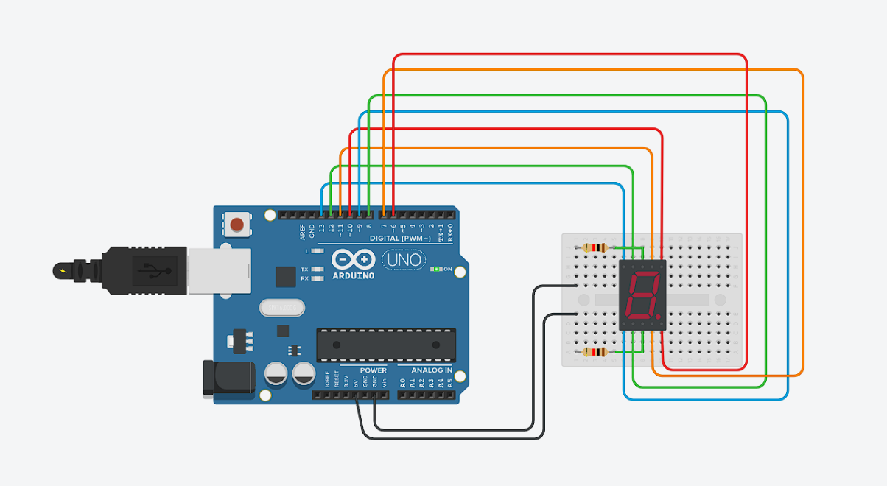

**Experiment No. 9: Program to interface LCD with Arduino and to display messages**

**Aim:** To interface LCD with Arduino and write a program to display message on LCD.

**Components Used:**  Arduino Kit, 1 LCD, 1 Resistor, Breadboard, Jumping wire

**Circuit Diagram:**

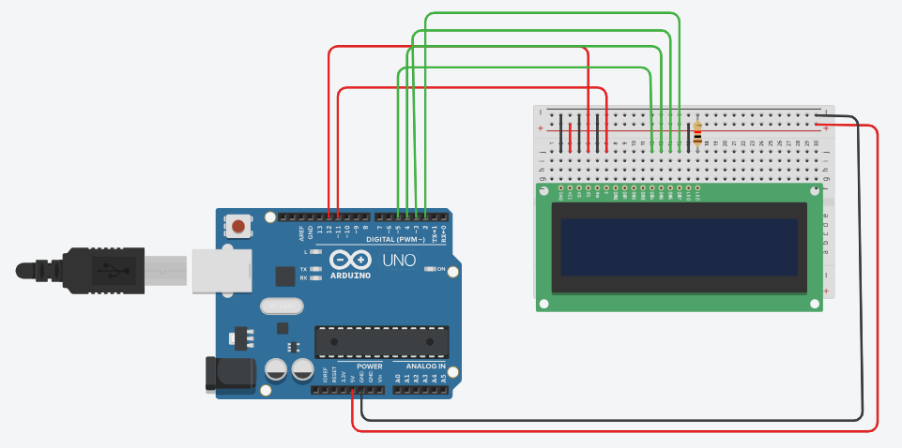

**Code:**

#include <LiquidCrystal.h>

const int rs = 12, en = 11, d4 = 5, d5 = 4, d6 = 3, d7 = 2;

LiquidCrystal lcd (rs, en, d4, d5, d6, d7);

void setup ()

{

lcd.begin (16, 2);

lcd.print ("Hello Sagar");

}

void loop ()

{

lcd.setCursor (0, 1);

lcd.print (millis () / 1000);

}

**Output:**

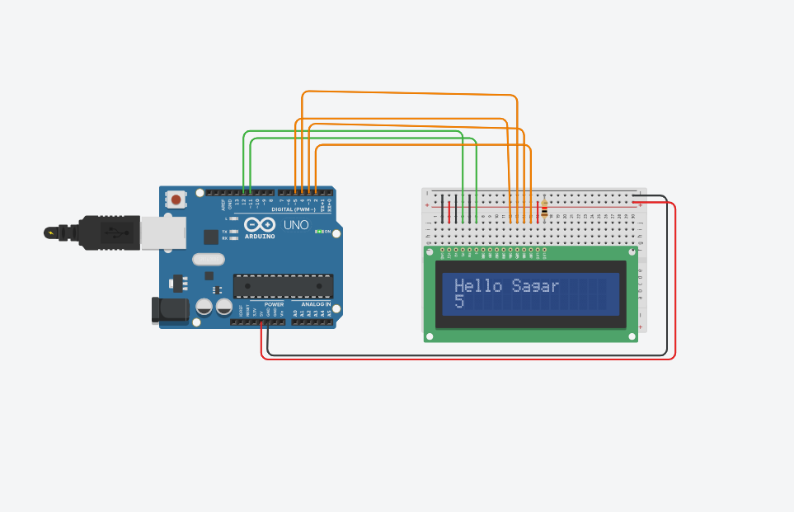

**Experiment No.10: Program to interface LCD and potentiometer with Arduino and to display messages**

**Aim:** To interface LCD, potentiometer with Arduino and write a program to display message on LCD.

**Components Used:**  Arduino Kit, 1 LCD, 1 Resistor, 1 Potentiometer, Breadboard, Jumping wire

**Circuit Diagram:**

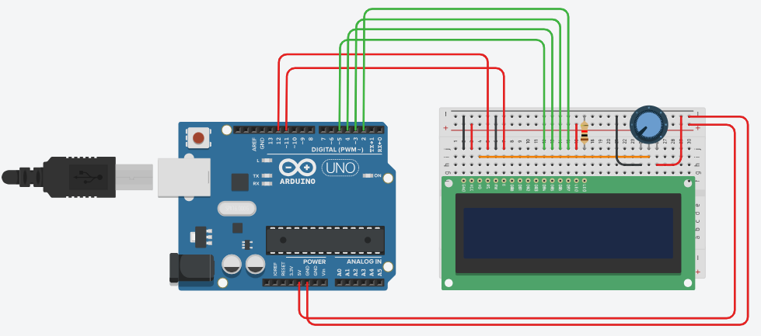

**Code:**

#include<LiquidCrystal.h>

LiquidCrystal lcd (12, 11, 5, 4, 3, 2);

void setup ()

{

lcd.begin (16, 2);

}

void loop ()

{

lcd.setCursor (0,0);

lcd.print ("Hello");

lcd.setCursor (2,1);

lcd.print ("Sagar");

}

**Output:**

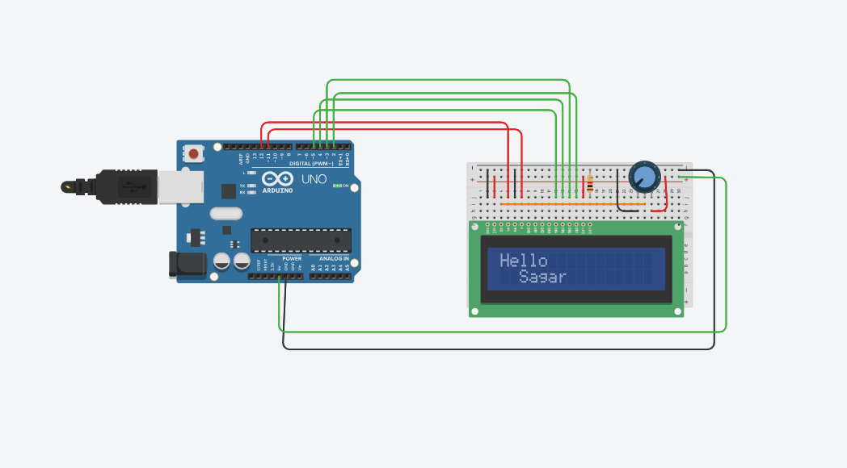

**Experiment No.11: Program to interface LCD, push button, potentiometer with Arduino and to display a message**

**Aim:** To interface LCD, push button, potentiometer with Arduino and write a program to display message on LCD when push button is pressed.

**Components Used:**  Arduino Kit, 1 LCD, 2 Resistors, 1 Potentiometer, 1 Push Button, Breadboard,

Jumping wire

**Circuit design:**

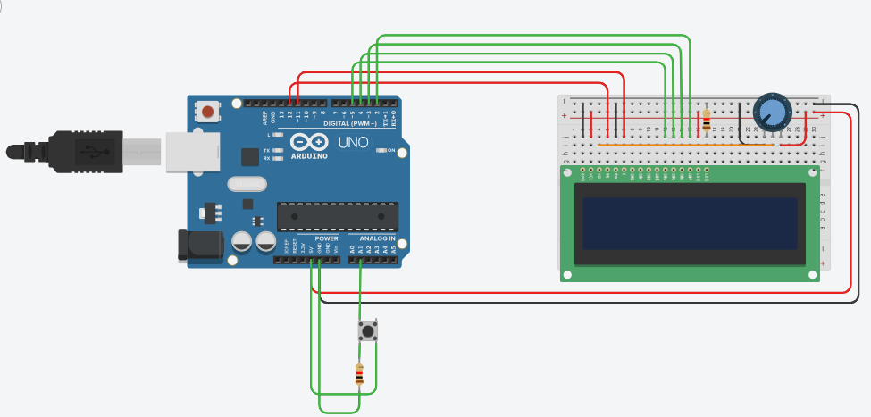

**Code:**

#include<LiquidCrystal.h>

LiquidCrystal lcd (12, 11, 5, 4, 3, 2);

void setup ()

{

lcd.begin (16, 2);

pinMode (A1, INPUT);

}

void loop ()

{

lcd.setCursor (0,1);

  if (digitalRead (A1) ==HIGH)

  {

lcd.print ("Hello Sagar");

  }

}

**Output:**

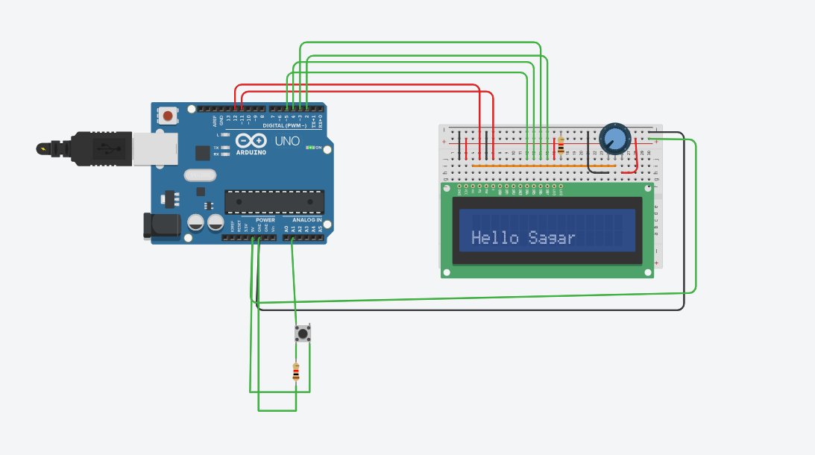

**Experiment No.12: Program to interface LCD, push button, potentiometer with Arduino and to display no. of times push button is pressed**

**Name of the Program:** To interface LCD, push button, potentiometer with Arduino and write a program to display the no. of times (count) the push button is pressed on LCD.

**Components Used:**  Arduino Kit, 1 LCD, 2 Resistors, 1 Potentiometer, 1 Push Button, Breadboard,

Jumping wire

**Circuit design:**

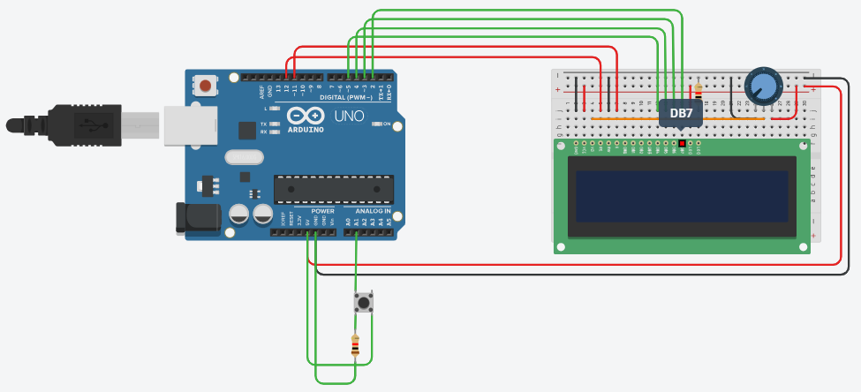

**Code: -**

#include <LiquidCrystal.h>

int val;

int count=0;

int press;

int Y;

const int rs = 12, en = 11, d4 = 5, d5 = 4, d6 = 3, d7 = 2;

LiquidCrystal lcd (rs, en, d4, d5, d6, d7);

void setup ()

{

lcd.begin (16, 2);

pinMode (A1, INPUT);

}

void loop ()

{

val=digitalRead(A1);

  if (val== HIGH)

{

    press=count++;

    Y=1*press+1; //y= mx +b

delay (250);

  }

lcd.setCursor (0, 0);

lcd.print ("Click");

lcd.setCursor (0, 1);

lcd.print(Y);

}

**Output:**

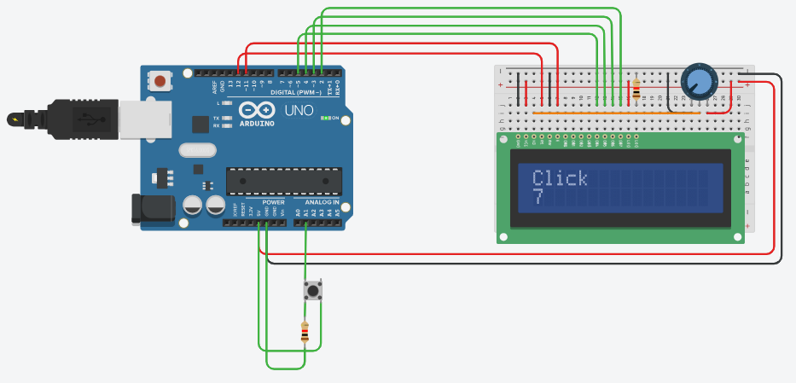

**Experiment No.13: Program to interface LED and Photoresistor (LDR) with Arduino to increase and decrease the brightness of the LED**

**Aim:** To interface LED, Photo resistor (LDR) with Arduino and write a program to increase and decrease the brightness of the LED based on the amount of light

**Components Used :** Arduino kit, 1 LED, 2 Resistors, 1 Photoresistor, Breadboard, Jumping wire

**Circuit design:**

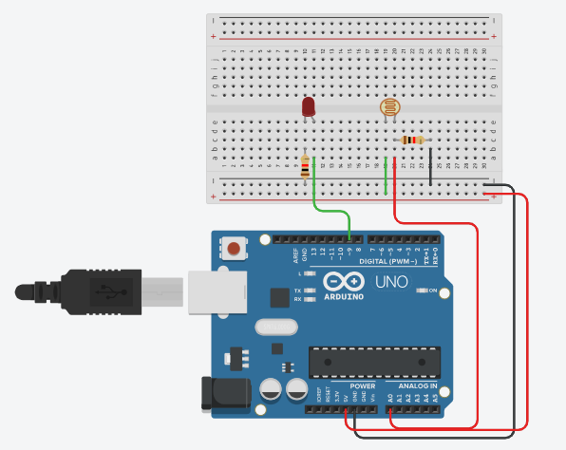

**Code:**

int photosensor = 0;

void setup ()

{

pinMode (A0, INPUT);

Serial.begin (9600);

pinMode (9, OUTPUT);

}

void loop ()

{

photosensor = analogRead (A0);

Serial.println (photosensor);

analogWrite (9, map (photosensor, 0, 1023, 0, 255));

delay (1000);

}

**Output:**

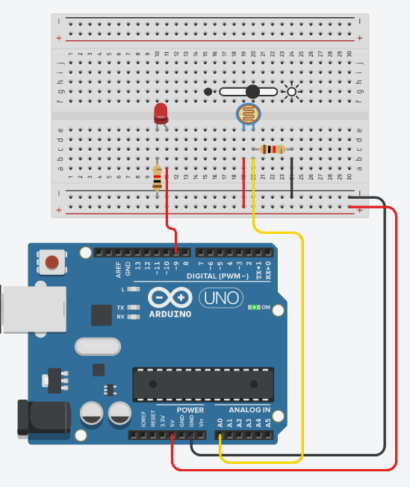

**Experiment No.14: Program to interface DHT11 sensor with Arduino to display temperature and humidity data**

**Aim:** To interface *DHT11* sensor with Arduino and write a program to display temperature and humidity data on serial monitor.

**Components Used:** Arduino kit, 1 DHT11 sensor, Jumping wire

**Circuit design:**

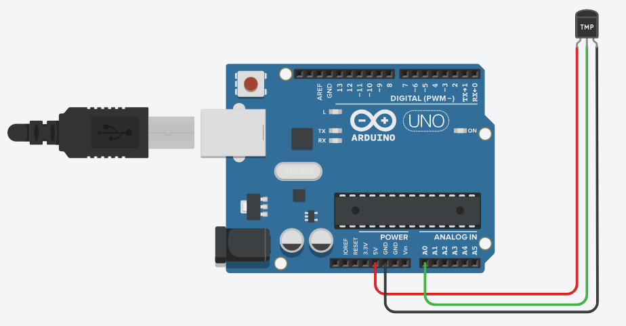

**Code:**

void setup ()

{

Serial.begin(9600);

}

void loop ()

{

  int sensorValue= analogRead(A0);

//serial.println (sensorValue);

  float volt=(sensorValue/1023.0) *4.9;

//serial.println(volt);

Delay (2000);

  float tempC= (volt -0.5) *100;//celcius

Serial.println(tempC);

Delay (2000);

}

**Output:**

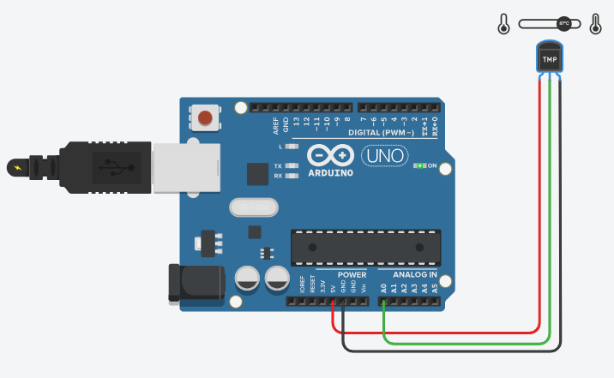

**Experiment No.15: Program to interface PIR/ Ultrasonic sensor with Arduino depending on motion detection/sound detection.**

**Aim:** To interface PIR/ Ultrasonic sensor with Arduino and write a program to turn on and off LED depending on motion detection/sound detection.

# **Components Used:** Arduino kit, 1 Ultrasonic sensor, 1 LED, 1 Resistor, Breadboard, Jumping Wires.

# **Circuit design:**

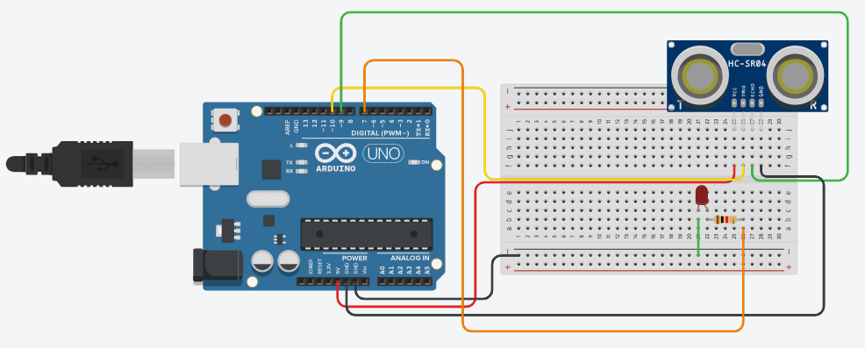

**Code:**

void setup ()

{

Serial.begin(9600);

pinMode (10, OUTPUT);

pinMode (7, OUTPUT);

pinMode (9, INPUT);

digitalWrite (10, HIGH);

}

void loop ()

{

While (digitalRead (9) == HIGH)

{

digitalWrite (7, LOW);

delay (3000);

digitalWrite (7, HIGH);

delay (2000);

}

}

**Output:**

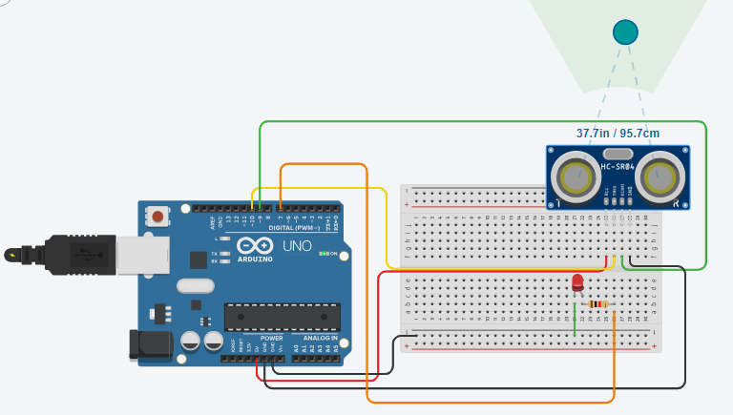

**Experiment No.16: Program to interface servo motor/DC motor with Arduino to sweep a servo back and forth**

**Aim:** To interface servo motor/DC motor with Arduino and write a program to sweep a servo back and forth through its full range of motion/ to control a DC motor.

**Components Used:** Arduino kit, 1 Micro Servo Motor, Jumping wire

**Circuit design:**

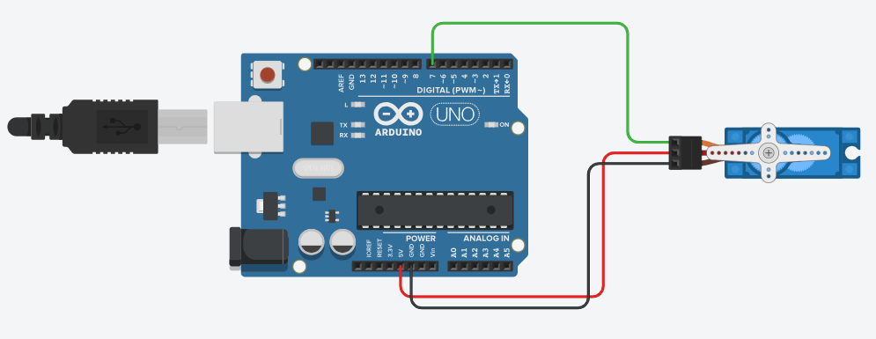

**Code:**

#include<Servo.h>

Servo myservo;

void setup ()

{

myservo.attach (7);

}

void loop ()

{

for (int ang=0; ang<180; ang++)

{

myservo.write (ang);

delay (50);

  }

for (int ang=180; ang>0; ang--)

{

myservo.write (ang);

delay (50);

  }

}

**Output:**

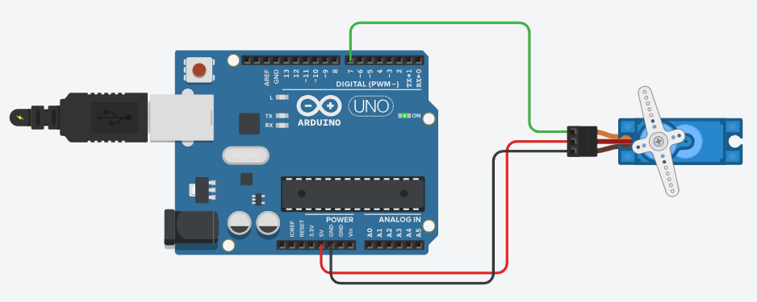

**Experiment No.17: Program to interface DC motor with Arduino to control speed of a DC motor**

**Aim:** To interface DC motor with Arduino and write a program to control Speed of a DC motor.

**Components Used:** Arduino kit,1 NPN Transistor, 1 Potentiometer, 1 9-Volt Battery, 1 Resistor, 1 DC Motor, Jumping wire.

**Circuit design:**

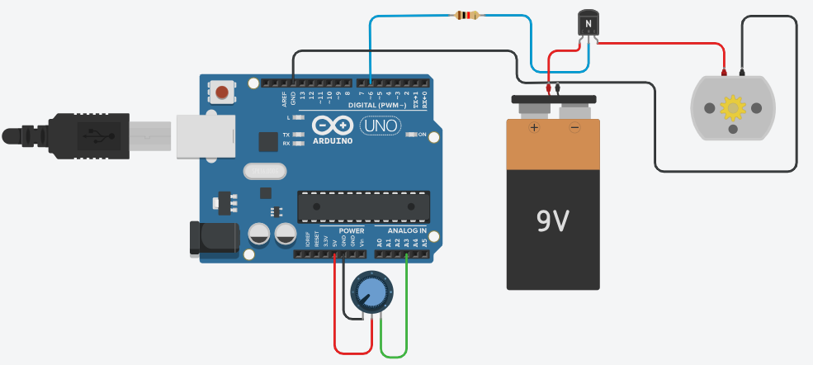

**Code:**

const int poten = A3;

int var;

void setup ()

{

Serial.begin (9600);

pinMode (6, OUTPUT);

}

void loop ()

{

var = analogRead(poten);

analogWrite (6, var);

Serial.println(var);

}

**Output:**

