**EXPERIMENT NO. 1**

**Q. Introduction to UI life cycle and UI tools.**

**UI Life Cycle:**

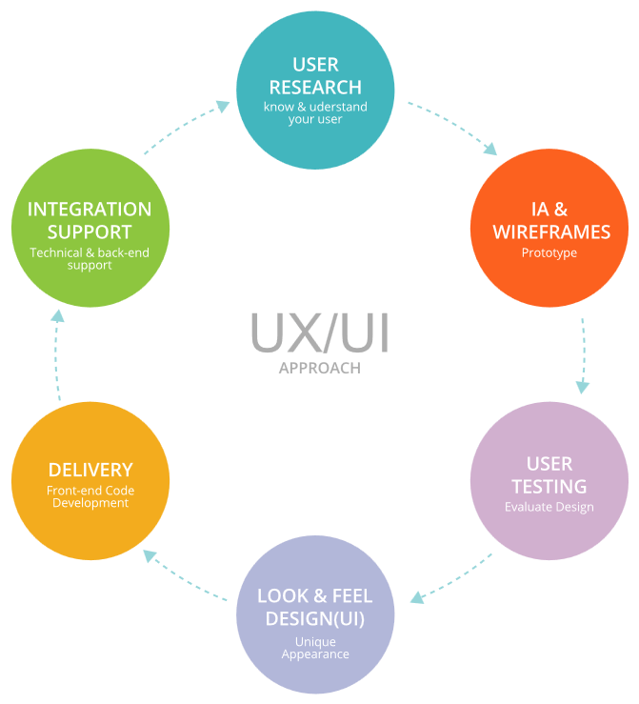

**UI Tools:**

**1. In Vision:**

In Vision is a web-based prototyping tool popular with both UX and UI designers alike.  You can upload static design files and quickly turn them into high-fidelity, interactive prototypes.

**2. Sketch:**

The digital design app that every UI pro needs: is Sketch. This is a vector-based tool, so you can easily resize anything that you draw without losing sharpness.

**3. Figma:**

Discover the very first in-browser interface design tool, Figma. With powerful editing tools and loads of handy features, Figma is a one-stop shop for designing, prototyping, and gathering feedback. UI designers especially can take advantage of the constraints feature, which adapts your designs when the screen size changes. With the components feature, it’s also extremely easy to reuse elements across your designs.

**4. Flinto:**

Flinto is an interactive prototyping app for Mac that offers pretty much everything you need to bring your designs to life. Design micro-interactions and screen transitions, add video layers simply by dragging video or GIF files straight into your designs, incorporate UI sound effects and customizable scrolling*—*the list goes on.

**5. Adobe XD:**

Adobe XD is a vector-based tool for designing and prototyping user experiences for web,  mobile, and even voice! If you’re already familiar with the Adobe Creative Cloud suite, you’ll feel right at home in Adobe XD—an extremely versatile tool that offers a whole host of features for designing, prototyping, sharing, collaborating, and creating a complete design system. XD natively supports Windows 10 and macOS and is also available as a mobile app for both Android and iOS.

**EXPERIMENT NO. 2**

**Q. Project Proposal and Requirement Gathering (Introduction of Project).**

**Project Name: Footwear App**

A footwear app is a mobile application designed to facilitate the buying and selling of shoes, sandals, sneakers, boots, and other types of footwear. These apps offer users a convenient platform to browse through a wide range of footwear options, make purchases, track orders, and manage their accounts, all from the comfort of their smartphones or tablets. Typically, footwear apps integrate features such as product search, filtering, sizing guides, secure payment gateways, and personalized recommendations to enhance the user experience.

**MOTTO: “Step into Style, Step into Convenience”**

**Advantages:**

1. **Convenience:** One of the primary advantages of footwear apps is the convenience they offer to users. Customers can shop for their favorite shoes anytime, anywhere, without the need to visit physical stores. This convenience is particularly beneficial for busy individuals who may not have the time to shop in-store.
2. **Wide Selection:** Footwear apps often feature a vast selection of shoes from various brands, styles, and price ranges. This allows users to explore a broader range of options and find the perfect pair to suit their preferences and budget.
3. **Personalization:** Many footwear apps leverage user data and preferences to provide personalized recommendations and suggestions. By analyzing past purchases, browsing history, and user profiles, these apps can offer tailored product recommendations that are more likely to resonate with individual users.
4. **Ease of Comparison:** Footwear apps make it easy for users to compare prices, styles, and features across different brands and products. This transparency empowers users to make informed purchasing decisions and ensures that they get the best value for their money.
5. **Concierge Services:** Some footwear apps offer additional services such as virtual fitting assistance, style advice, and customization options. These value-added services enhance the overall shopping experience and help users make confident purchasing decisions.

**Disadvantages:**

1. **Limited Sensory Experience:** Unlike shopping in physical stores, where customers can touch, feel, and try on shoes before making a purchase, footwear apps offer a more limited sensory experience. Users cannot physically inspect the shoes or assess their comfort and fit until after they've made a purchase, which may lead to dissatisfaction or returns.
2. **Shipping Delays and Costs:** While footwear apps offer the convenience of online shopping, users may encounter delays in shipping and delivery, especially during peak seasons or unforeseen circumstances. Additionally, shipping costs can sometimes add to the overall expense of purchasing shoes online, particularly for international orders.
3. **Sizing Challenges:** One of the significant challenges of buying shoes online is ensuring the correct size and fit. Despite sizing guides and recommendations provided by footwear apps, users may still encounter issues with sizing consistency across different brands and styles. This can result in returns and exchanges, leading to inconvenience for both users and retailers.
4. **Security Concerns:** Like any e-commerce platform, footwear apps are susceptible to security risks such as data breaches, identity theft, and fraudulent transactions. Users may be hesitant to provide sensitive information such as credit card details and personal data, especially if they have concerns about the app's security measures.
5. **Lack of Physical Interaction:** For some users, the absence of face-to-face interaction with sales associates and the inability to physically try on shoes may detract from the overall shopping experience. This lack of human interaction can make it challenging to address specific questions or concerns about product details, materials, or sizing.

**EXPERIMENT NO. 3**

**Q. Logo Designing.**

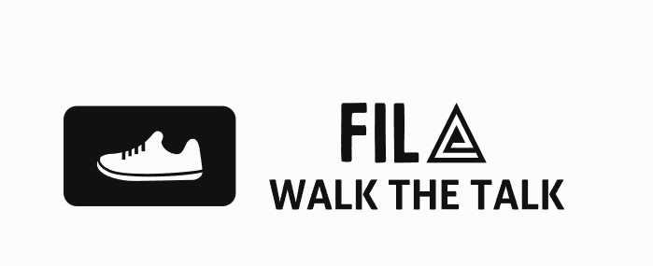

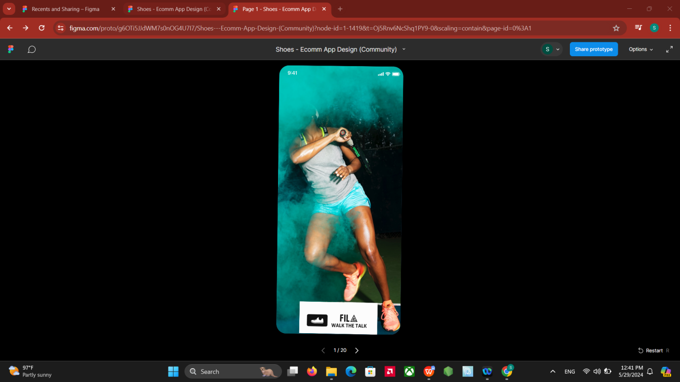

**EXPERIMENT NO. 4**

**Q. Problem Statement: System Concept Statement**.

**Problem Statement:**

The footwear market in India has been drawing a prominent spotlight in the fashion and style industry and is expanding significantly.

* Consumers are increasingly expecting better service, instant product availability, and fast delivery — whether this is in-store or online.
* There will always be a challenge to provide an in-store-like experience on an e-commerce platform. For example, users will not be in a position to try different shoes before buying them.
* The color of the shoes shown on the site might differ from the actual shade of color.
* Threat of availability of low-cost footwear from other countries.

**EXPERIMENT NO. 5**

**Q. Design a user persona.**

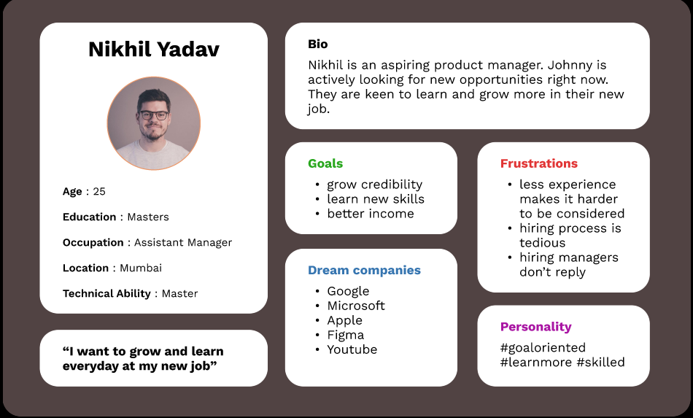

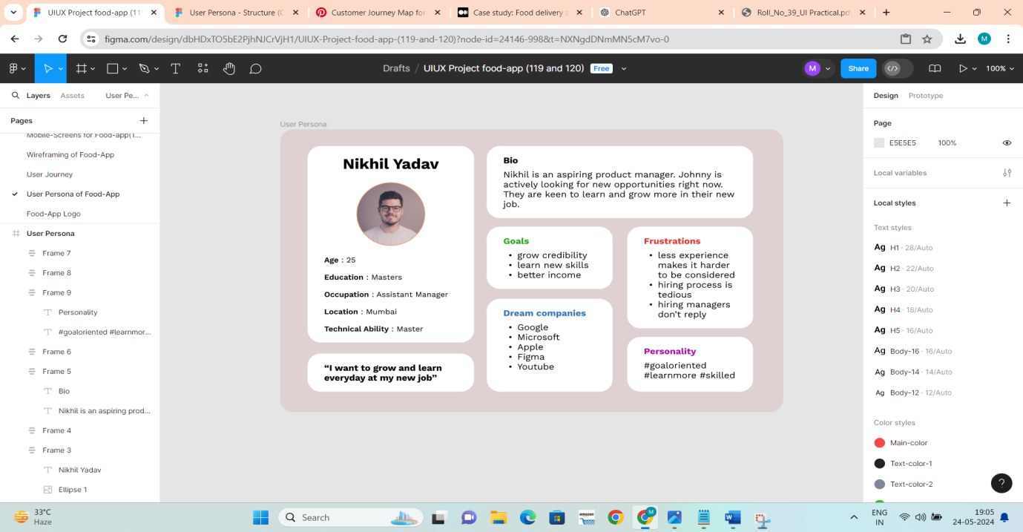

**EXPERIMENT NO. 6**

**Q. Design a Customer Journey Map.**

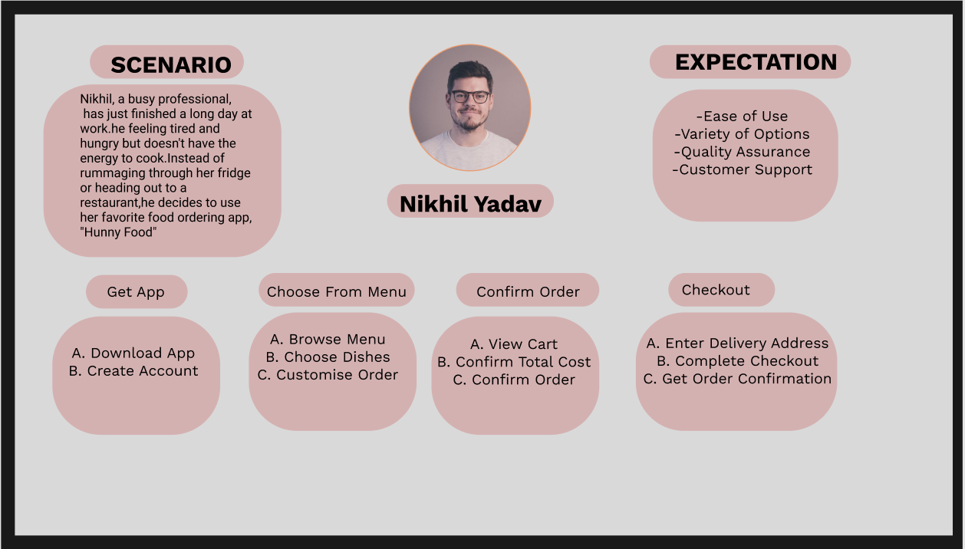

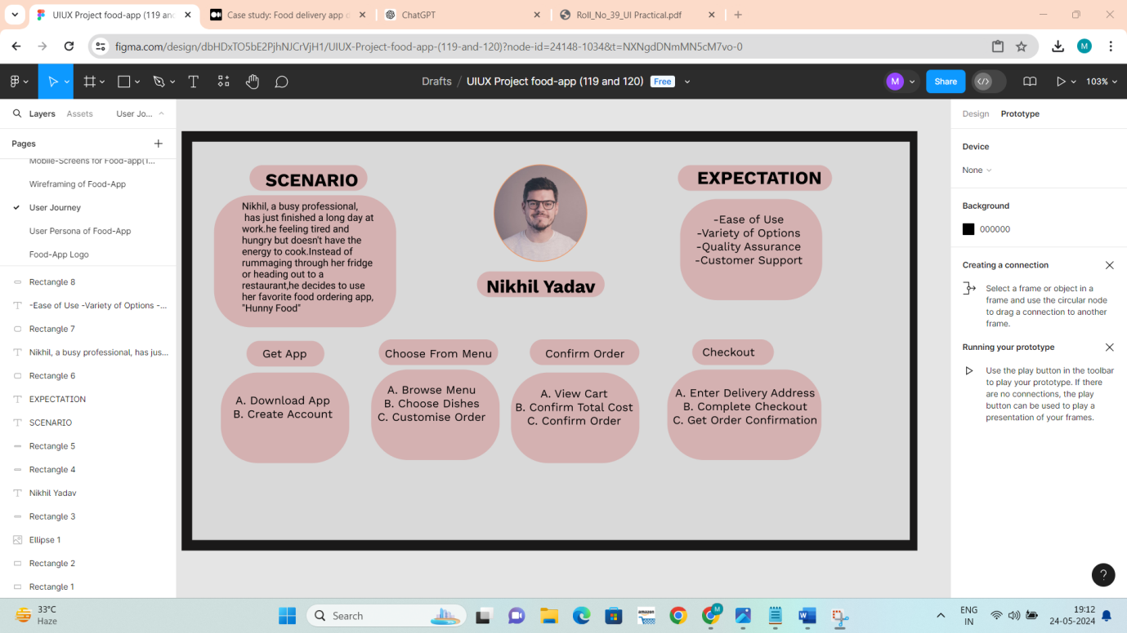

**EXPERIMENT NO. 7**

**Q. ER (Entity Relationship) Diagram.**

ER Diagram stands for Entity Relationship Diagram, also known as ERD is a diagram that displays the relationship of entity sets stored in a database. In other words, ER diagrams help to explain the logical structure of databases. ER diagrams are created based on three basic concepts: entities, attributes, and relationships.

ER Diagrams contain different symbols that use rectangles to represent entities, ovals to define attributes, and diamond shapes to represent relationships.

ER Model stands for Entity Relationship Model is a high-level conceptual data model diagram. ER model helps to systematically analyze data requirements to produce a well-designed database. The ER Model represents real-world entities and the relationships between them. Creating an ER Model in DBMS is considered a best practice before implementing your database.

**Some E-R model notations are:**

**1. Entity: An** entity is a thing or object that can be distinguished.

Ex: a person is an entity as every person is distinguishable.

**2. Attribute:** each entity has a set of attributes.

Ex: entity person has attributes like name age address gender etc

**3. Relationship: A** relationship is an association among several entities example an inquiry relationship is there between the customer entity and the Railway entity.

**Some notation of the E-R model are:**

1. **Rectangle:** It represents the entity set.

2. **Ellipse:** It represents attributes.

3. **Diamond:** It represents the relationship among entity sets.

4. **Line:** The line lies between the attribute entity and entity to the relationship.

**E-R DIAGRAM:**

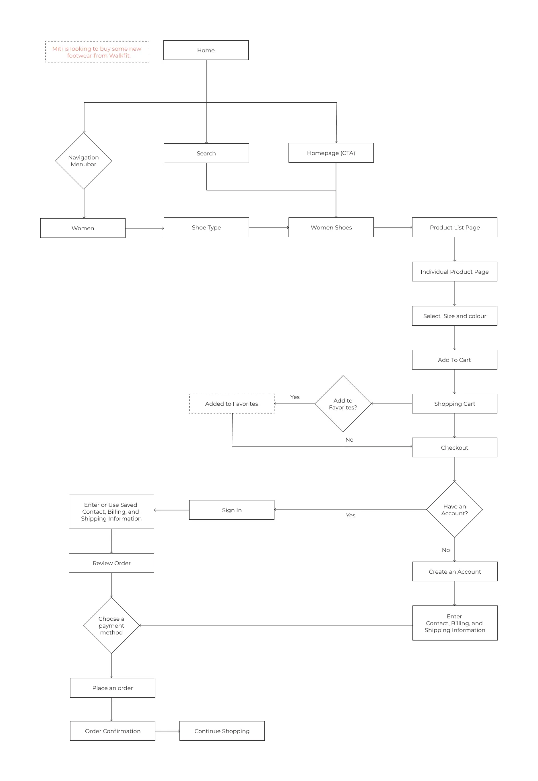

**EXPERIMENT NO. 8**

**Q. Creation of scenario – Story Board.**

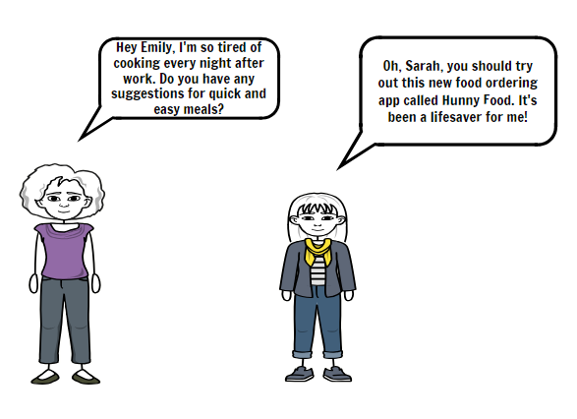

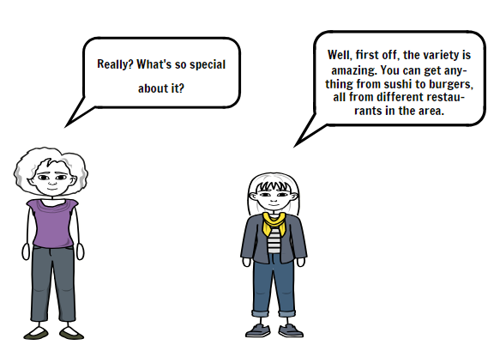

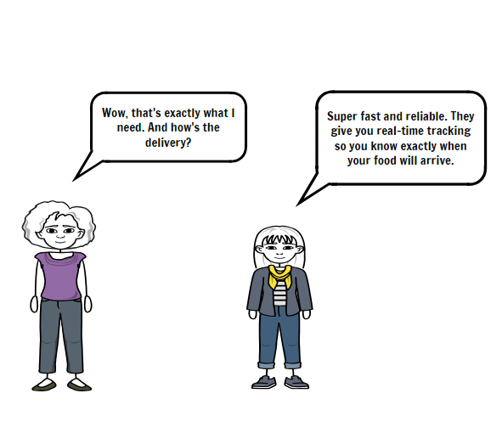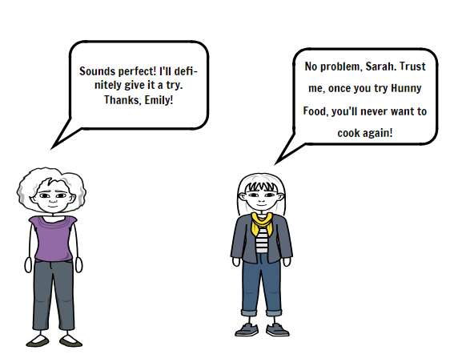

**EXPERIMENT NO. 9**

**Q. Create Wireframing:**

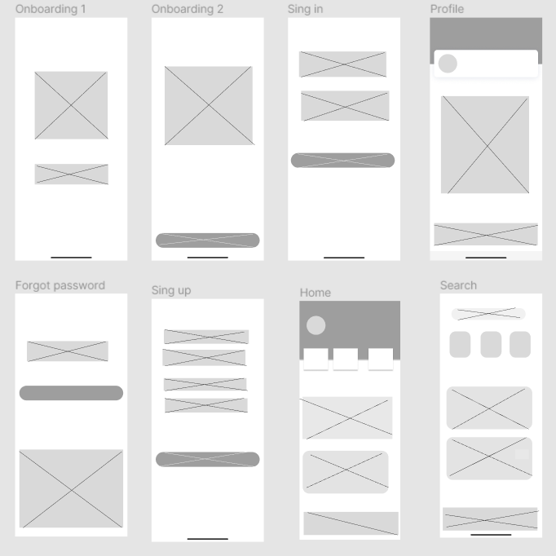

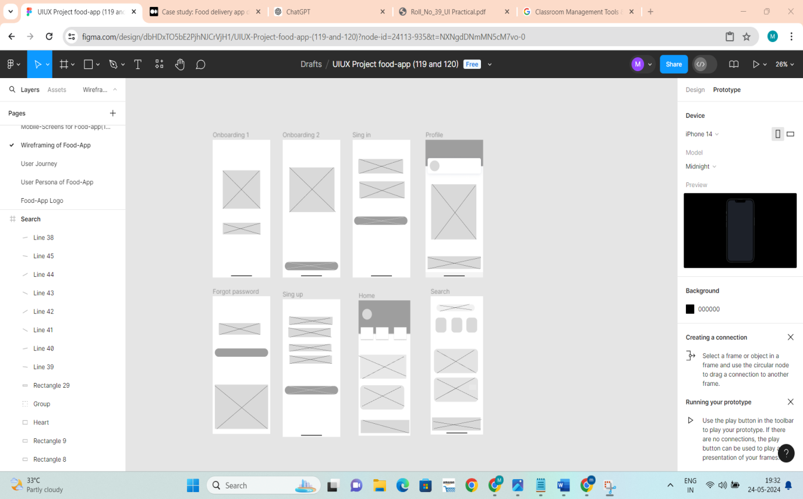

**EXPERIMENT NO. 10**

**Q. Create Prototyping:**

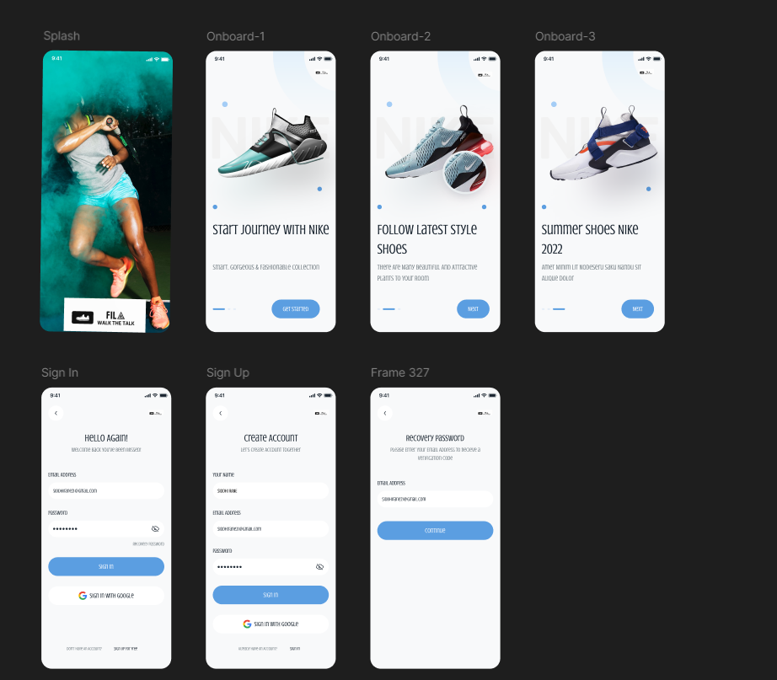

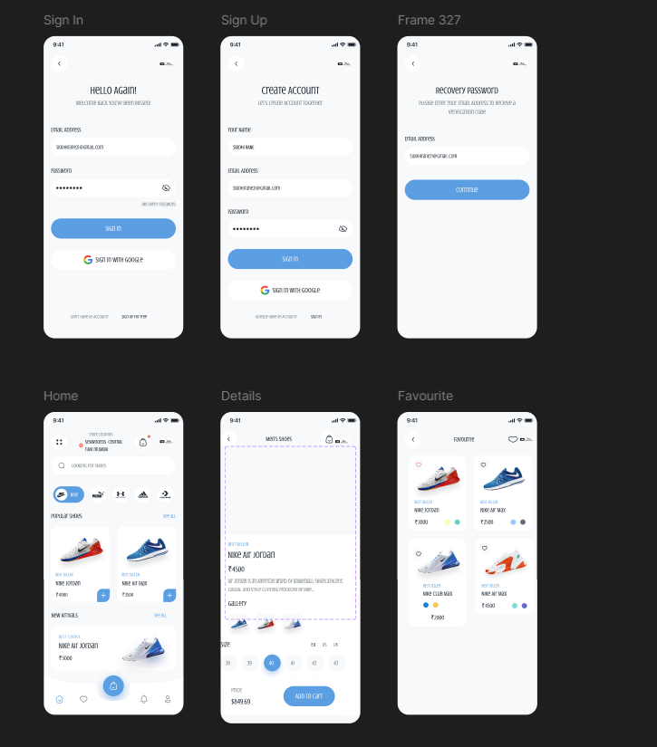

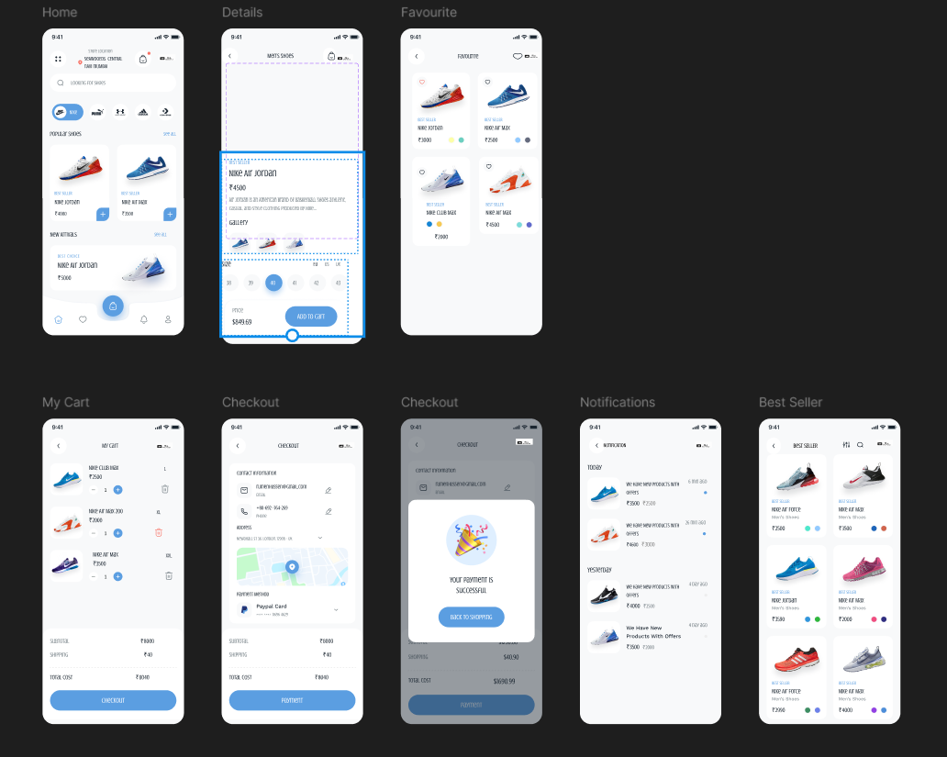

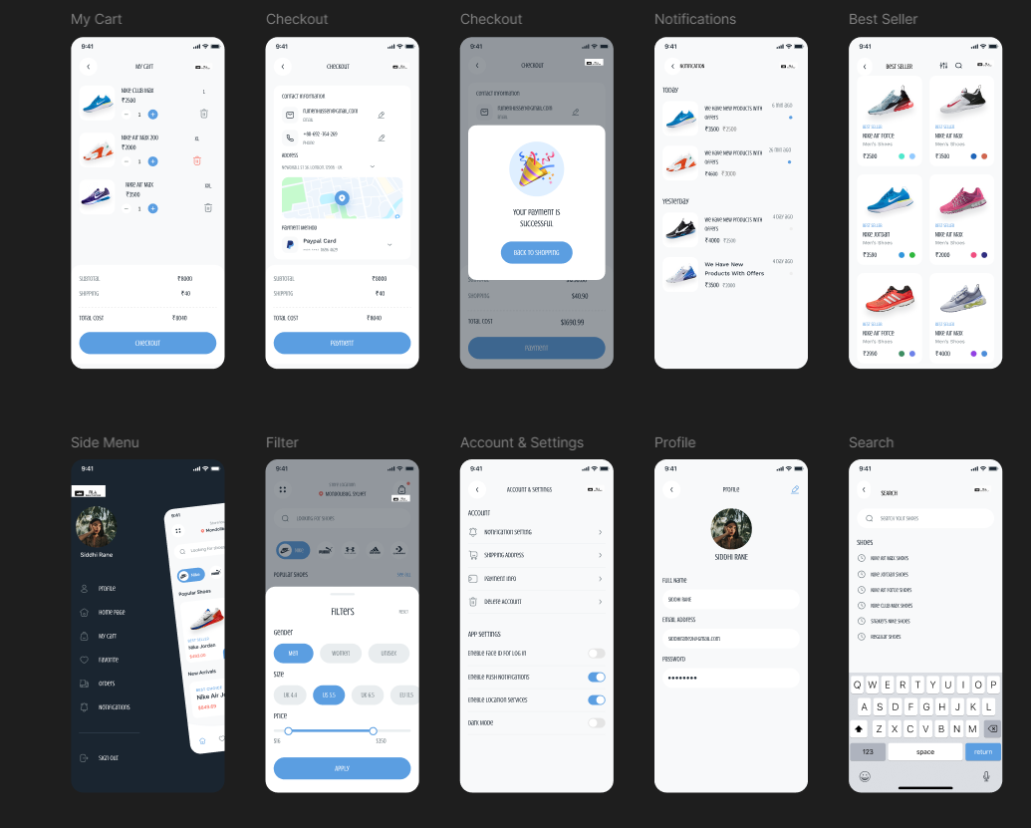

**EXPERIMENT NO. 11**

**Q. Usability Evaluation of the Design. Testing of User Interface from third party (Test scripts).**

Testing is the process of executing a program to find errors. To make our software perform well it should be error-free. If testing is done successfully it will remove all the errors from the software.

**Types of Testing:**

**1. Unit Testing:**

It focuses on the smallest unit of software design. In this, we test an individual unit or group of interrelated units. It is often done by the programmer by using sample input and observing its corresponding outputs.

**2. Integration Testing:**

The objective is to take unit-tested components and build a program structure that has been dictated by design. Integration testing is testing in which a group of components is combined to produce output.

**3. Regression Testing:**

Every time a new module is added leads to changes in the program. This type of testing makes sure that the whole component works properly even after adding components to the complete program.

**4. Smoke Testing:**

This test is done to make sure that the software under testing is ready or stable for further testing. It is called a smoke test as the testing of an initial pass is done to check if it did not catch fire or smoke in the initial switch-on.

**5. Alpha Testing:**

This is a type of validation testing. It is a type of *acceptance testing* that is done before the product is released to customers. It is typically done by QA people.

**6. Beta Testing:**

The beta test is conducted at one or more customer sites by the end-user of the software. This version is released for a limited number of users for testing in a real-time environment

**7. System Testing:**

This software is tested such that it works fine for the different operating systems. It is covered under the black box testing technique. In this, we just focus on the required input and output without focusing on internal work.

**8. Stress Testing:**

In this, we give unfavorable conditions to the system and check how it performs in those conditions.

**9. Performance Testing:**

It is designed to test the run-time performance of software within the context of an integrated system.

**10. Acceptance Testing:**

Acceptance testing is done by the customers to check whether the delivered products perform the desired tasks or not, as stated in the requirements.

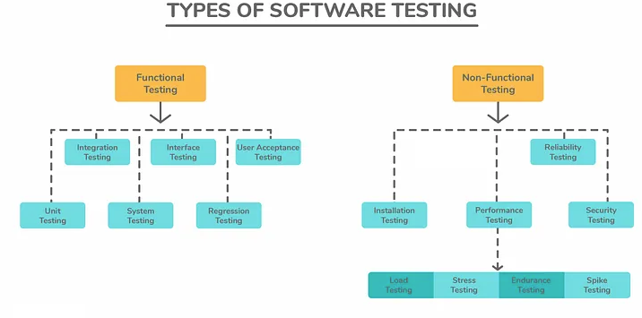

| **Test Case ID** | **Test Case Description** | **Test Steps** | **Expected Result** | **Pass/Fail** |
| --- | --- | --- | --- | --- |
| TC001 | User Registration | 1. Navigate to registration page 2. Enter valid user details  3. Submit form | The user is successfully registered and redirected to the home page | Pass |
| TC002 | User Login | 1. Navigate to the login page  2. Enter valid credentials  3. Click the login button | The user is successfully logged in and redirected to the home page | Pass |
| TC003 | Search Functionality | 1. Enter the search query in the search bar  2. Click the search button | Relevant footwear items are displayed based on the search query | Pass |
| TC004 | Product Details Display | 1. Click on a footwear product  2. View product details and description | Product details and descriptions are accurately displayed | Pass |
| TC005 | Add to Cart Functionality | 1. Click on the "Add to Cart" button for a product.  2. View cart | Selected product is added to the cart and is visible in the cart | Pass |
| TC006 | Cart Management (Edit, Remove Items) | 1. Navigate to the cart  2. Edit quantity or remove items from the cart | Changes to the cart (editing quantity or removing items) are reflected | Pass |
| TC007 | Checkout Process | 1. Proceed to checkout from the cart page  2. Enter shipping and payment details  3. Confirm | The user completes the checkout process | Pass |
| TC008 | Payment Processing | 1. Enter valid payment information  2. Click on the "Submit Payment" button | Payment is processed successfully and the order is confirmed | Pass |
| TC009 | Order History | 1. Navigate to the order history page  2. View past orders | User can view a list of their past orders | Pass |
| TC010 | User Profile Management | 1. Navigate to the user profile page  2. Edit personal information  3. Save changes | Changes to user profile information are saved successfully | Pass |
| TC011 | Wishlist Functionality | 1. Add a product to the Wishlist  2. View wishlist | The product is added to the wishlist and is visible on the wishlist | Pass |
| TC012 | Share Product Functionality | 1. Share a product via email or social media | The product link is successfully shared with the selected platform | Pass |

**EXPERIMENT NO. 12**

# Q. 10 Questions to be asked to future user

1. What are your primary goals or objectives for using this product/service?
2. How would you describe your current challenges or pain points?
3. What specific features or functionalities are you hoping to see in this product/service?
4. Have you used similar products/services in the past? If so, what did you like/dislike about them?
5. What is your preferred method of communication or interaction with this product/service?
6. Are there any specific deadlines or time constraints we should be aware of?
7. What resources or support do you anticipate needing to fully utilize this product/service?
8. How do you envision this product/service fitting into your daily workflow or routine?
9. What criteria will you use to evaluate the success or effectiveness of this product/service?
10. Is there anything else you'd like to share about your expectations or requirements?