Introduction

Purpose:

The purpose of this document is to provide a detailed architectural overview of RemediX, a comprehensive telehealth platform designed to bridge the gap between patients and healthcare providers through instant, secure, and user-friendly remote consultations. This document serves as a definitive guide for developers, project managers, and stakeholders to understand the system's design, functionality, and technical implementation.

Scope:

- The system allows patients and doctors to register, authenticate, and manage their profiles securely.
- Patients can enter basic personal details and select the medical specialty required for consultation.
- The application supports online payment processing that must be completed before the consultation begins.
- It ensures secure handling, storage, and retrieval of Protected Health Information (PHI) with proper authentication and authorization mechanisms.
- The platform provides real-time communication features, including chat and information sharing during live consultations.
- An integrated transcription service converts consultation audio into text to overcome challenges related to dialect and accent differences.
- The system maintains a history of consultations for future reference by authorized users.

Overview of Features:

This document covers the end-to-end system architecture, including the responsive frontend interface, robust backend API, database schema, and integration with critical external services for video conferencing and payments.

Objectives:

To ensure the design meets all project requirements, including secure user authentication, real-time video consultations, efficient consultation scheduling, and reliable data management.

Figma Link -
https://www.figma.com/design/tGX972tlQjajcQiLt0XLLf/Codia-AI-Design--Screenshot-to-Editable-Figma-Design--Community-?node-id=0-1&p=f

Video URL -
https://drive.google.com/file/d/1gIRYJPQlwEiCsp6ofjlFly6ynsgSplsx/view?usp=sharing

System Overview

1. Architecture Diagram:

- High-Level Components:

  - Client-Side (Front-End): A modern Single Page Application (SPA) built with React and Vite, providing an interactive user interface.

  - Server-Side (Back-End): A scalable Node.js server using Express.js to handle API requests, business logic, and third-party integrations.

  - Database: MongoDB serves as the primary data store, managing complex relationships between patients, doctors, and consultations.

  - External Services:

    - Square: Handles secure payment processing for consultation fees.
    - VideoSDK: Powers the real-time video and audio communication infrastructure.
    - Cloudinary: Manages media storage for profile pictures and prescription documents.
    - Nodemailer: Facilitates email notifications for account verification and appointment updates.

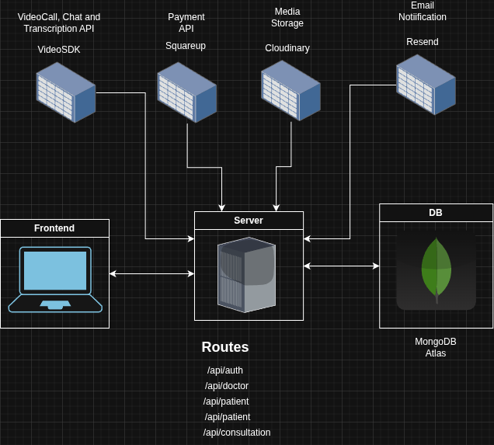

Fig 1 - High Level Architecture Diagram

2. Technology Stack:

Front-End:
- React: Utilized for building dynamic, component-based user interfaces.

- TypeScript: Ensures type safety and code reliability across the application.

- Tailwind CSS: Provides a utility-first approach for rapid, responsive styling.

- Vite: Delivers a fast development environment and optimized production builds.
Back-End:

- Node.js & Express.js: The core runtime and framework for building the RESTful API.

- Zod: Used for rigorous runtime request validation and schema definition.

- NodeMailer: To send emails directly from the code when consultations are booked or rescheduled.

- Database:
  - MongoDB & Mongoose: A NoSQL database with an Object Data Modeling (ODM) library for flexible data management.

3. Front-End Architecture

UI/UX Design:

- Components:

  - Consultation Scheduler: A sophisticated interface allowing patients to filter doctors by specialty, view availability, and book specific time slots.

  - Consultation Interface (Room): A dedicated video conferencing environment powered by VideoSDK, featuring controls for audio, video, and screen sharing.

  - Role-Based Dashboards: Distinct dashboard views for Doctors (managing shifts, viewing upcoming appointments) and Patients (booking history, finding doctors).

  - Secure Payment Form: Integrated directly into the booking flow using Square Web Payments SDK to capture transaction details securely.

- Features:

  - Instant Health Consultation: Seamlessly connects patients with available doctors via high-quality video calls. The frontend handles the complexity of meeting initialization and token management.
  - Dynamic Scheduling: Real-time availability checking ensures patients only book valid slots, preventing double-booking.

  - Profile Management: Users can update personal details and upload profile images, which are processed and stored via Cloudinary.

  - Patient Information Capture: Forms collect user data such as name, contact details, and medical history. The information is sent to the back-end for processing and storage.

  - Chat Integration: Real-time chat functionality is implemented using VideoSDK API. Messages are sent and received in real-time during consultations.

  - Transcription Integration: Real-time chat functionality is implemented using VideoSDK API.

- Security Measures:

  - JWT Authentication: Secure session management using JSON Web Tokens, automatically attached to API requests via Axios interceptors.

  - Protected Routes: Client-side routing guards sensitive pages (Dashboards, Consultation Rooms) against unauthorized access.

  - Environment Configuration: Sensitive keys and API URLs are strictly managed through environment variables.

4. Back-End Architecture

API Design:

- Endpoints:
  - /api/auth: Handles user registration, login, and token generation.

  - /api/profile: Manages user profile data and file uploads.

  - /api/doctor: Exposes doctor availability, shift management, and specialty filtering.

  - /api/patient: Handles patient-specific data retrieval.

  - /api/consultation: The core endpoint for creating bookings, processing payments, and managing consultation status.

- Data Handling:

  - Request Validation: All incoming requests are validated against strict Zod schemas to ensure data integrity before processing.

  - Global Error Handling: A centralized middleware captures and formats errors, ensuring consistent API responses.

- Business Logic:

  - Consultation Scheduling: Complex logic calculates available time slots based on doctor shifts and existing bookings.

  - Payment Processing: Verifies transactions with Square before confirming appointments, ensuring financial security.

  - Slot Availability: Prevents patients from booking or rescheduling to conflicting slots.

- Authentication & Authorization:

  - User Authentication: Implements secure password hashing (Bcrypt) and JWT issuance for stateless authentication.

  - Authorization: Middleware verifies user roles (Doctor vs. Patient) to enforce access control policies on specific endpoints.

- Security Measures:

  - CORS: Configured to allow requests only from trusted frontend origins.

  - Input Sanitization: Rigorous validation prevents injection attacks and ensures clean data entry.

5. Database Design

Schema Design:

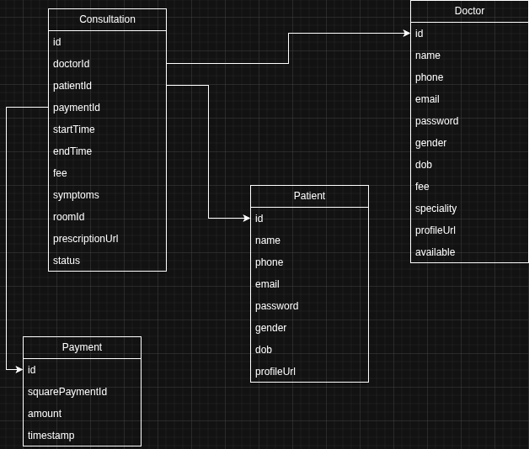

- Consultation:

  - Stores comprehensive details: doctorId, patientId, paymentId, startTime, endTime, fee, symptoms, roomId, prescriptionUrl, and status (pending/completed).

  - Acts as the central record linking the financial, medical, and scheduling aspects of a visit.

- Doctor:

  - Contains professional details: name, email, specialty, fee, profileUrl, and available status.

  - Shifts: A nested schema defining working hours (dayOfWeek, startTime, endTime, slotDuration) to drive the scheduling engine.

- Patient:
  - Stores personal information: name, email, phone, gender, dob, and profileUrl.

  - Designed to be extensible for future medical history records.

- Payment
  - Stores information about payments successfully processed by Square

Data Access:

- Mongoose Models: Strongly typed models (ConsultationModel , DoctorModel, PatientModel) provide an interface for CRUD operations.

- Repositories: The application likely employs a repository pattern (suggested by the folder structure) to abstract database logic from controllers, promoting cleaner code and easier testing.

Figma Link -
https://www.figma.com/design/tGX972tlQjajcQiLt0XLLf/Codia-AI-Design--Screenshot-to-Editable-Figma-Design--Community-?node-id=0-1&p=f

Video URL -
https://drive.google.com/file/d/1gIRYJPQlwEiCsp6ofjlFly6ynsgSplsx/view?usp=sharing

