**Assignment No:- 10**

**Assignment Name:-Create a website in ASP.NET containing Ad Rotator and calendar control.**

**Name:-CHIRAG ASHOK MAHAJAN.**

**Roll No:-59**

**_________________________________________________________________________________**

* **Default.aspx :-**

<%@ Page Language="C#" AutoEventWireup="true" CodeFile="Default.aspx.cs" Inherits="_Default" %>

<!DOCTYPE html>

<html xmlns="http://www.w3.org/1999/xhtml">

<head runat="server">

<title></title>

</head>

<body>

<form id="form1" runat="server">

<div>

<asp:Label ID="Label1" runat="server" Font-Bold="True" Font-Size="X-Large" Text="AdRotator :"></asp:Label>

<br />

<asp:AdRotator ID="AdRotator1" runat="server" AdvertisementFile="~/XMLFile.xml" OnAdCreated="AdRotator1_AdCreated" />

<br />

<br />

<asp:Label ID="Label2" runat="server" Font-Bold="True" Font-Size="X-Large" Text="Calendar : "></asp:Label>

<asp:Calendar ID="Calendar1" runat="server" BackColor="White" BorderColor="Black" BorderStyle="Solid" CellSpacing="1" Font-Names="Verdana" Font-Size="9pt" ForeColor="Black" Height="250px" NextPrevFormat="ShortMonth" Width="330px">

<DayHeaderStyle Font-Bold="True" Font-Size="8pt" ForeColor="#333333" Height="8pt" />

<DayStyle BackColor="#CCCCCC" />

<NextPrevStyle Font-Bold="True" Font-Size="8pt" ForeColor="White" />

<OtherMonthDayStyle ForeColor="#999999" />

<SelectedDayStyle BackColor="#333399" ForeColor="White" />

<TitleStyle BackColor="#333399" BorderStyle="Solid" Font-Bold="True" Font-Size="12pt" ForeColor="White" Height="12pt" />

<TodayDayStyle BackColor="#999999" ForeColor="White" />

</asp:Calendar>

</div>

</form>

</body>

</html>

**Design Page :-**

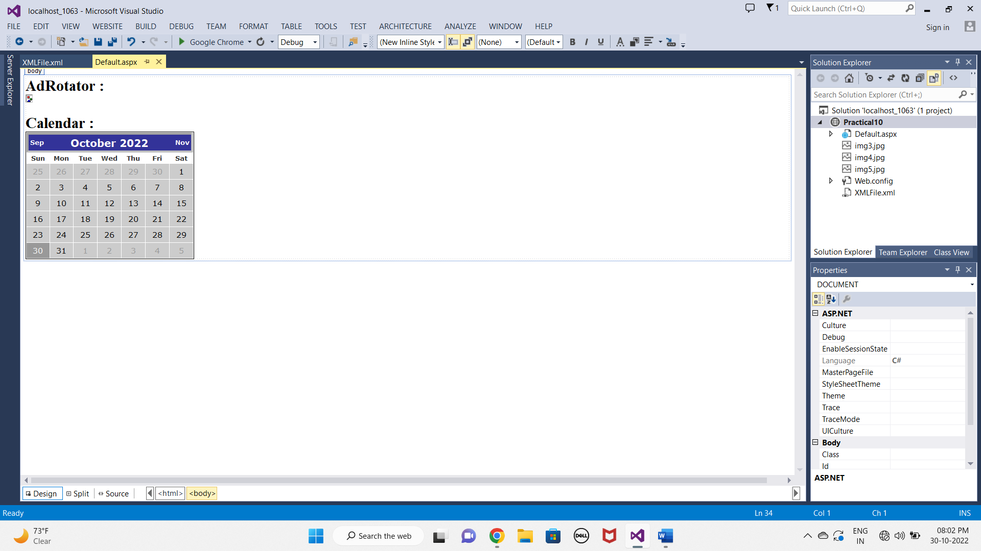

**XMLFile.xml :-**

<?xml version="1.0" encoding="utf-8" ?>

<Advertisements>

<Ad>

<ImageUrl>img4.jpg</ImageUrl>

<NavigateUrl>http://122345purva.com</NavigateUrl>

<AlternateText>davil</AlternateText>

<Impressions>20</Impressions>

<Keyword>Meera</Keyword>

</Ad>

<Ad>

<ImageUrl>img5.jpg</ImageUrl>

<NavigateUrl>http://23456purva.com</NavigateUrl>

<AlternateText>alfa</AlternateText>

<Impressions>30</Impressions>

<Keyword>Academy</Keyword>

</Ad>

<Ad>

<ImageUrl>img3.jpg</ImageUrl>

<NavigateUrl>http://1888purva.com</NavigateUrl>

<AlternateText>god</AlternateText>

<Impressions>50</Impressions>

<Keyword>Academy</Keyword>

</Ad>

</Advertisements>

**OUTPUT :-**

