**Assignment No:- 14**

**Assignment Name:- Create an ASP.Net webpage to demonstrate LINQ to SQL object and perform different operations on it.**

**Name:-CHIRAG ASHOK MAHAJAN.**

**Roll No:- 59.**

**___________________________________________________________________________________**

* **Add Project : -**

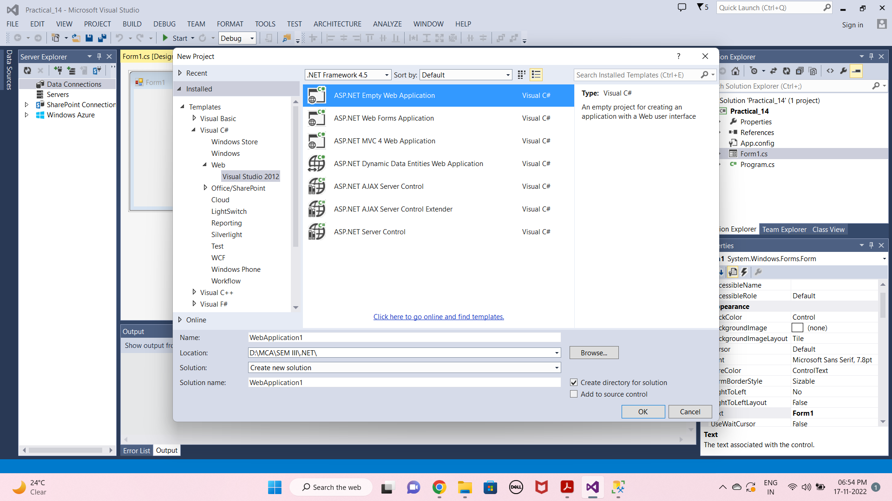

* **Add LINQ to SQL Class File :-**

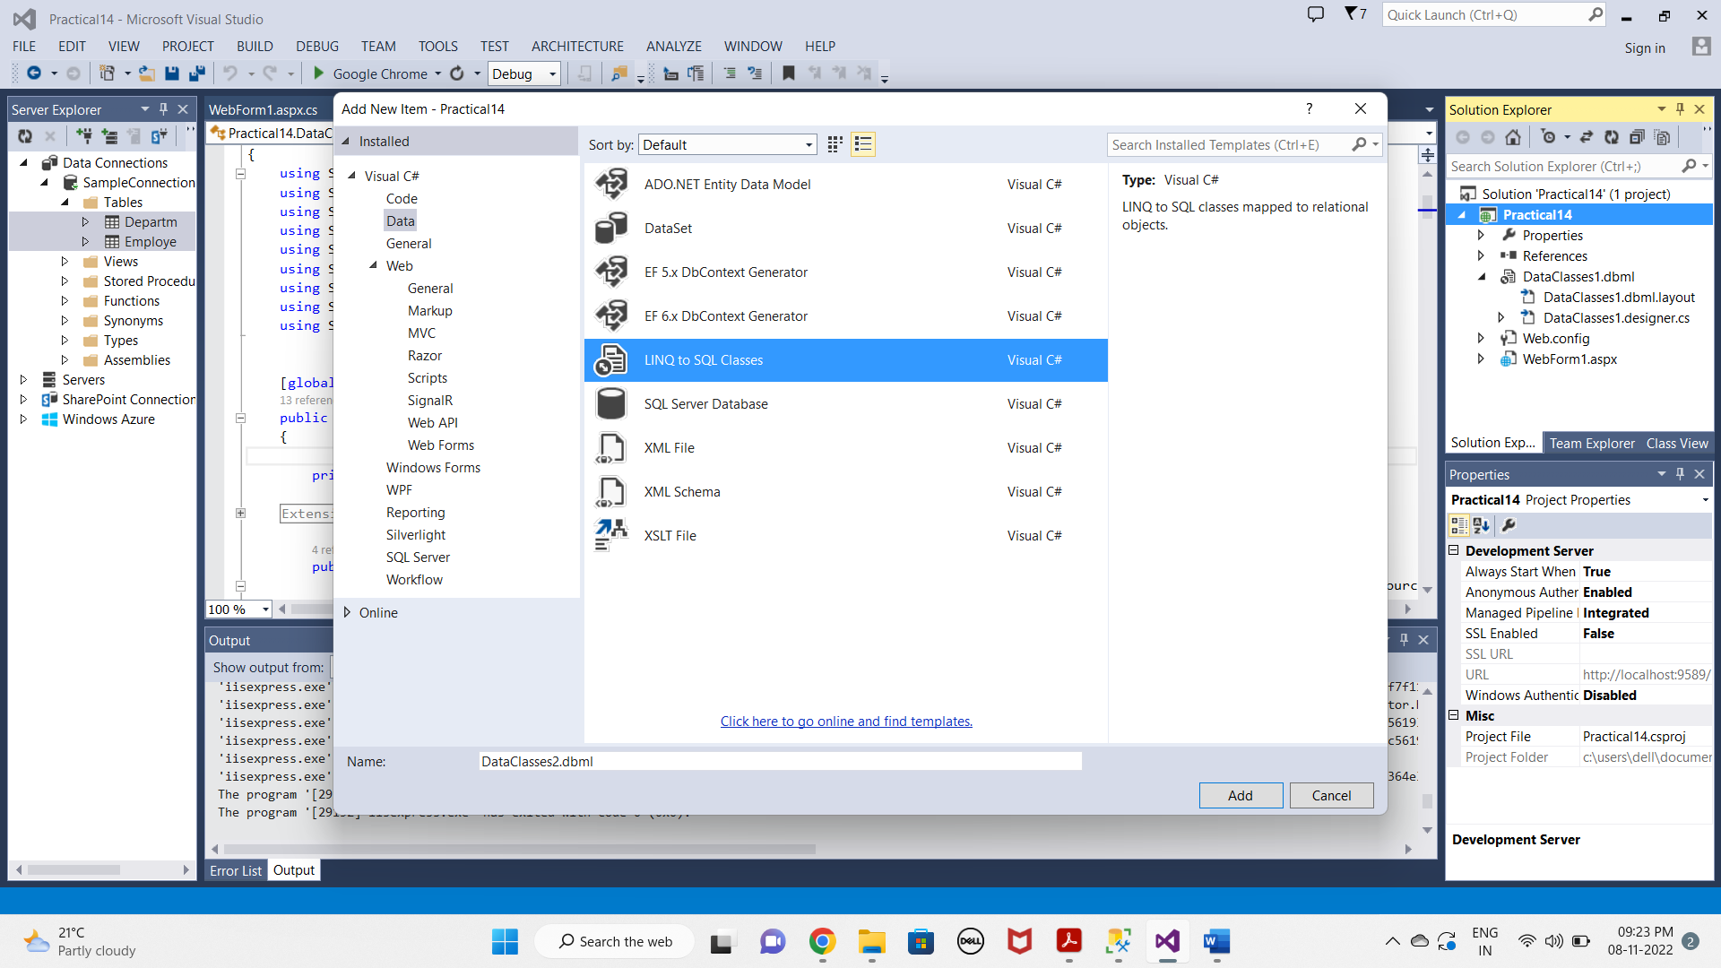

* **DATABASE :-**
  + **First Table :-**

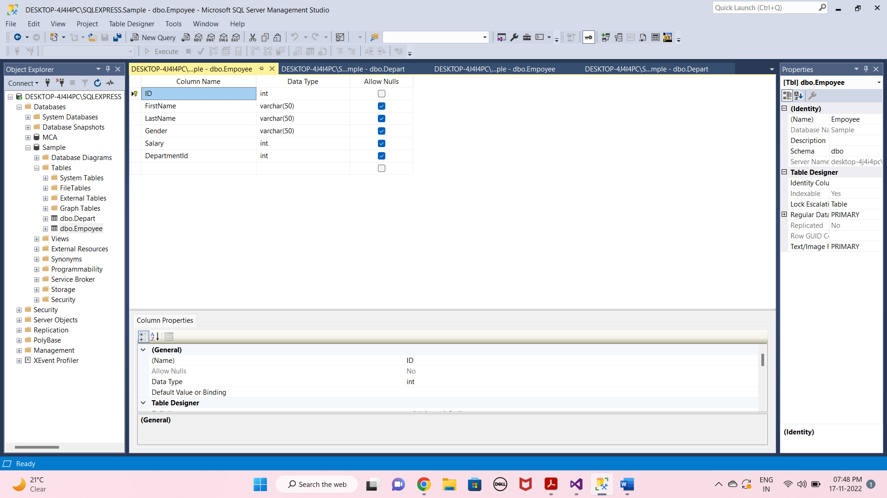

* **Second Table :-**

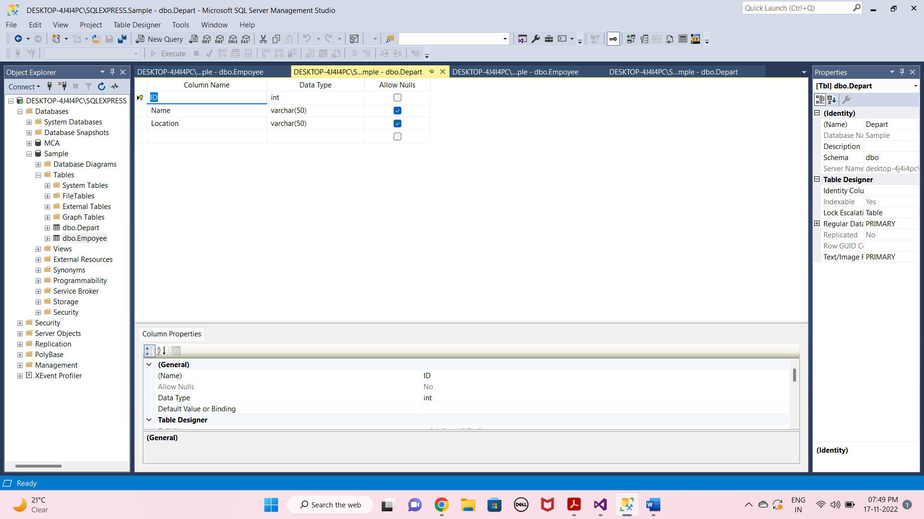

* **Add Connection :-**

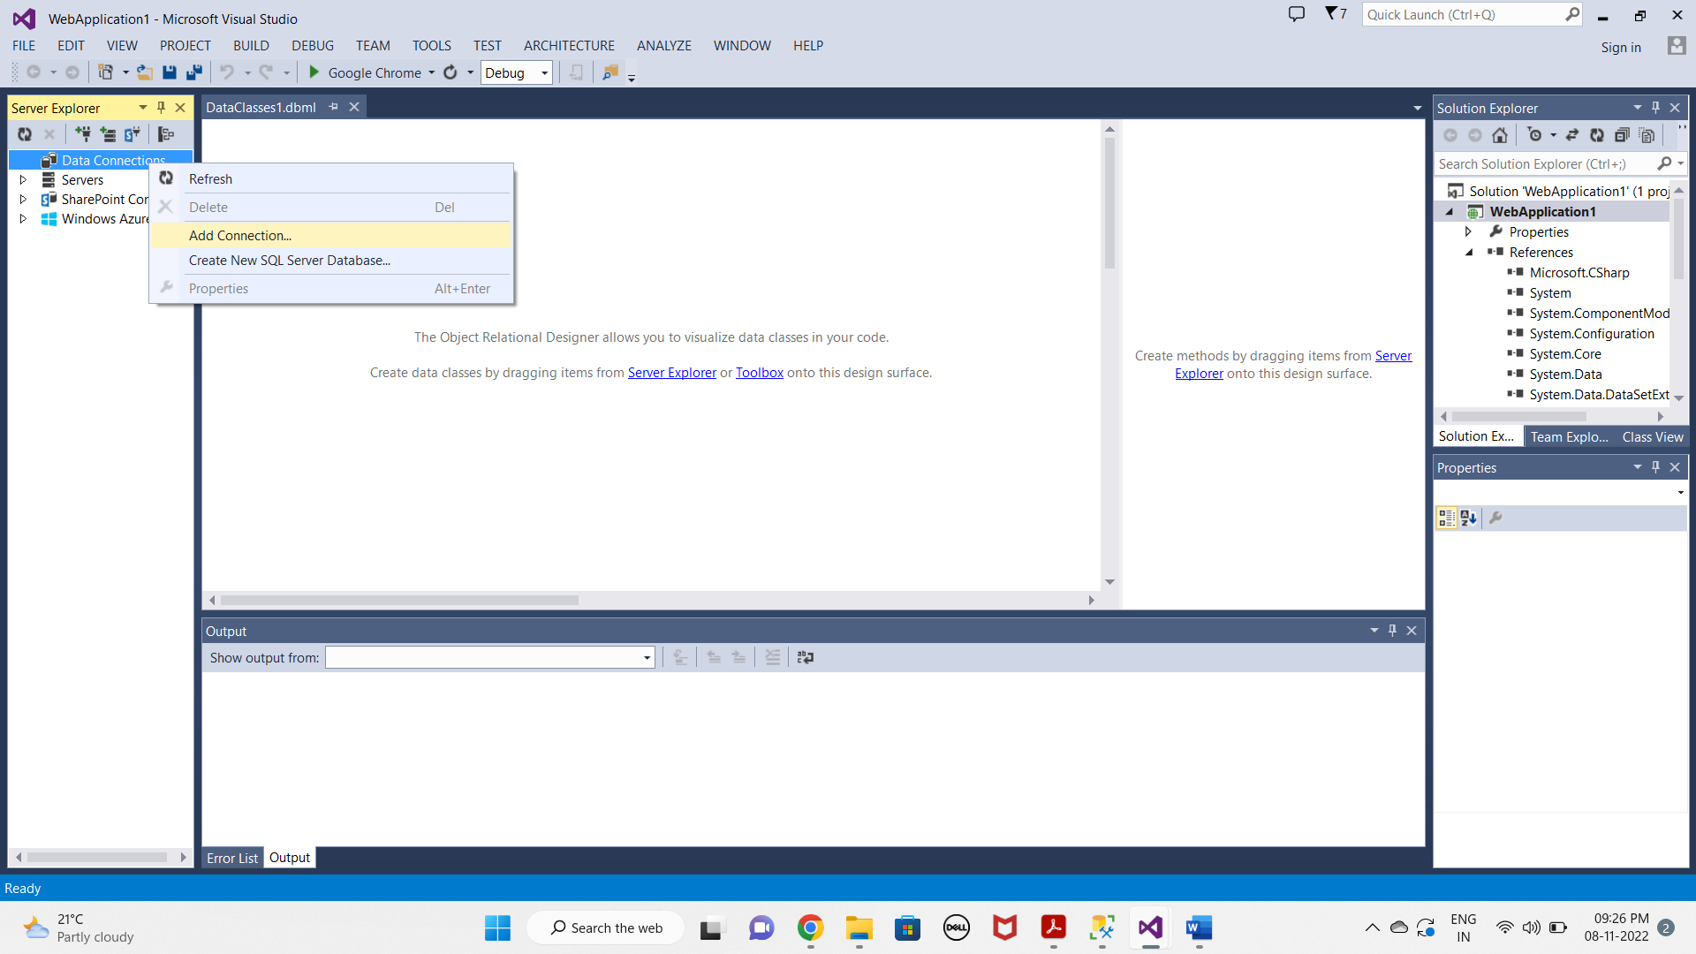

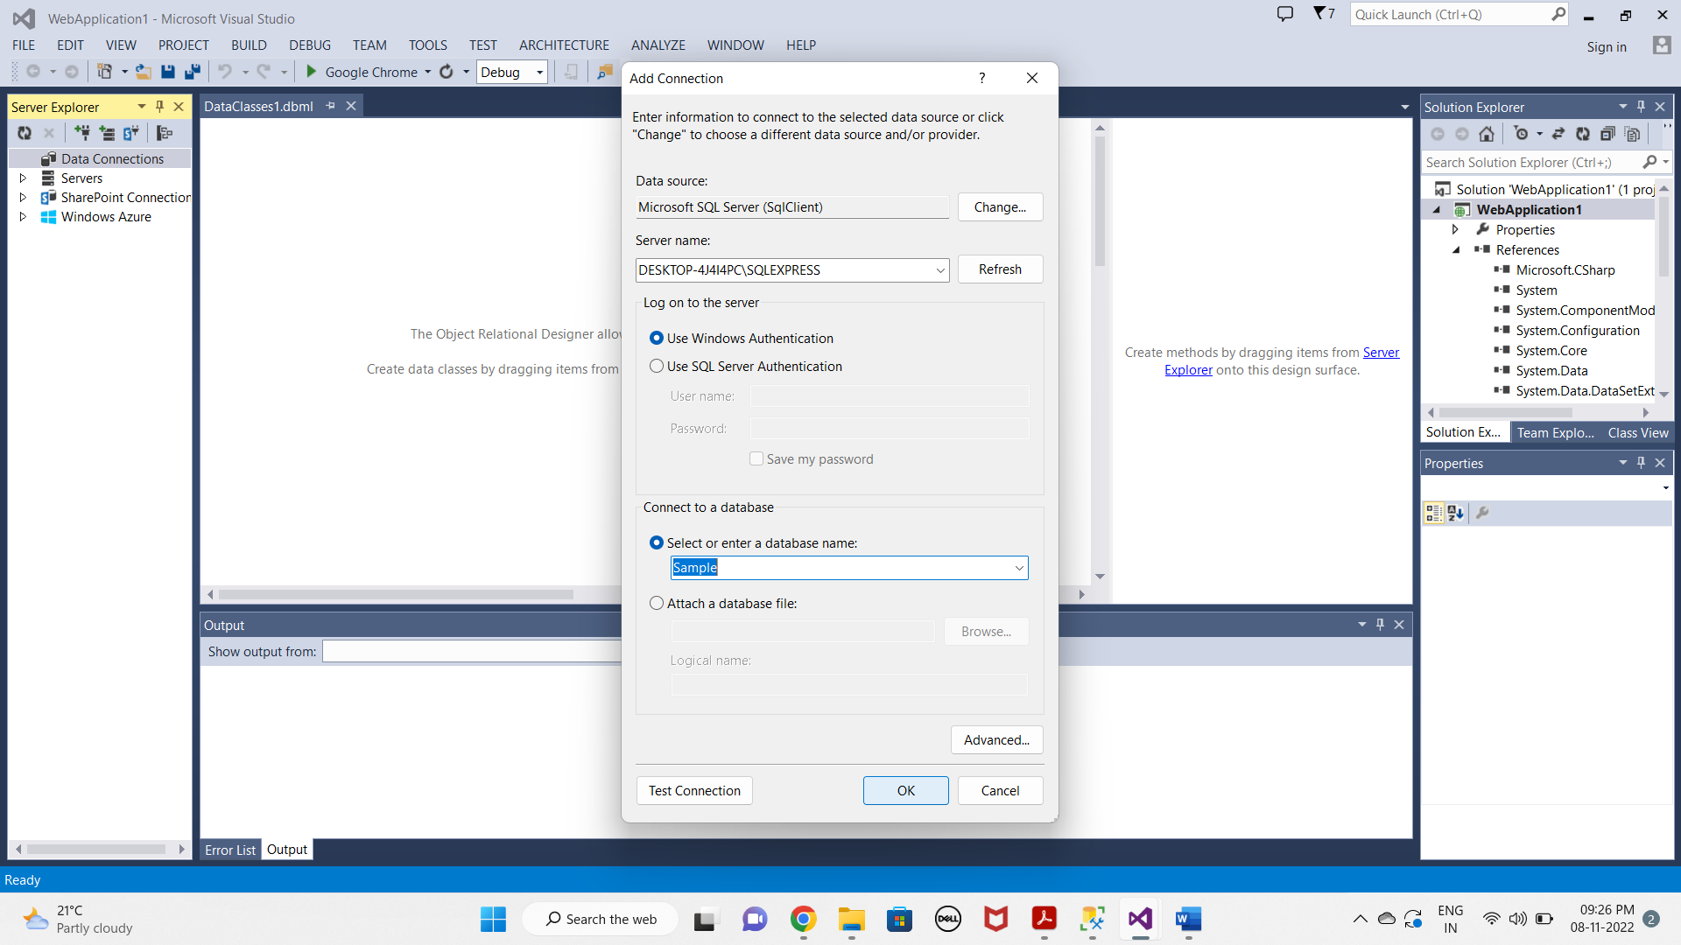

* **Add Table on DataClass1.dblm File :-**

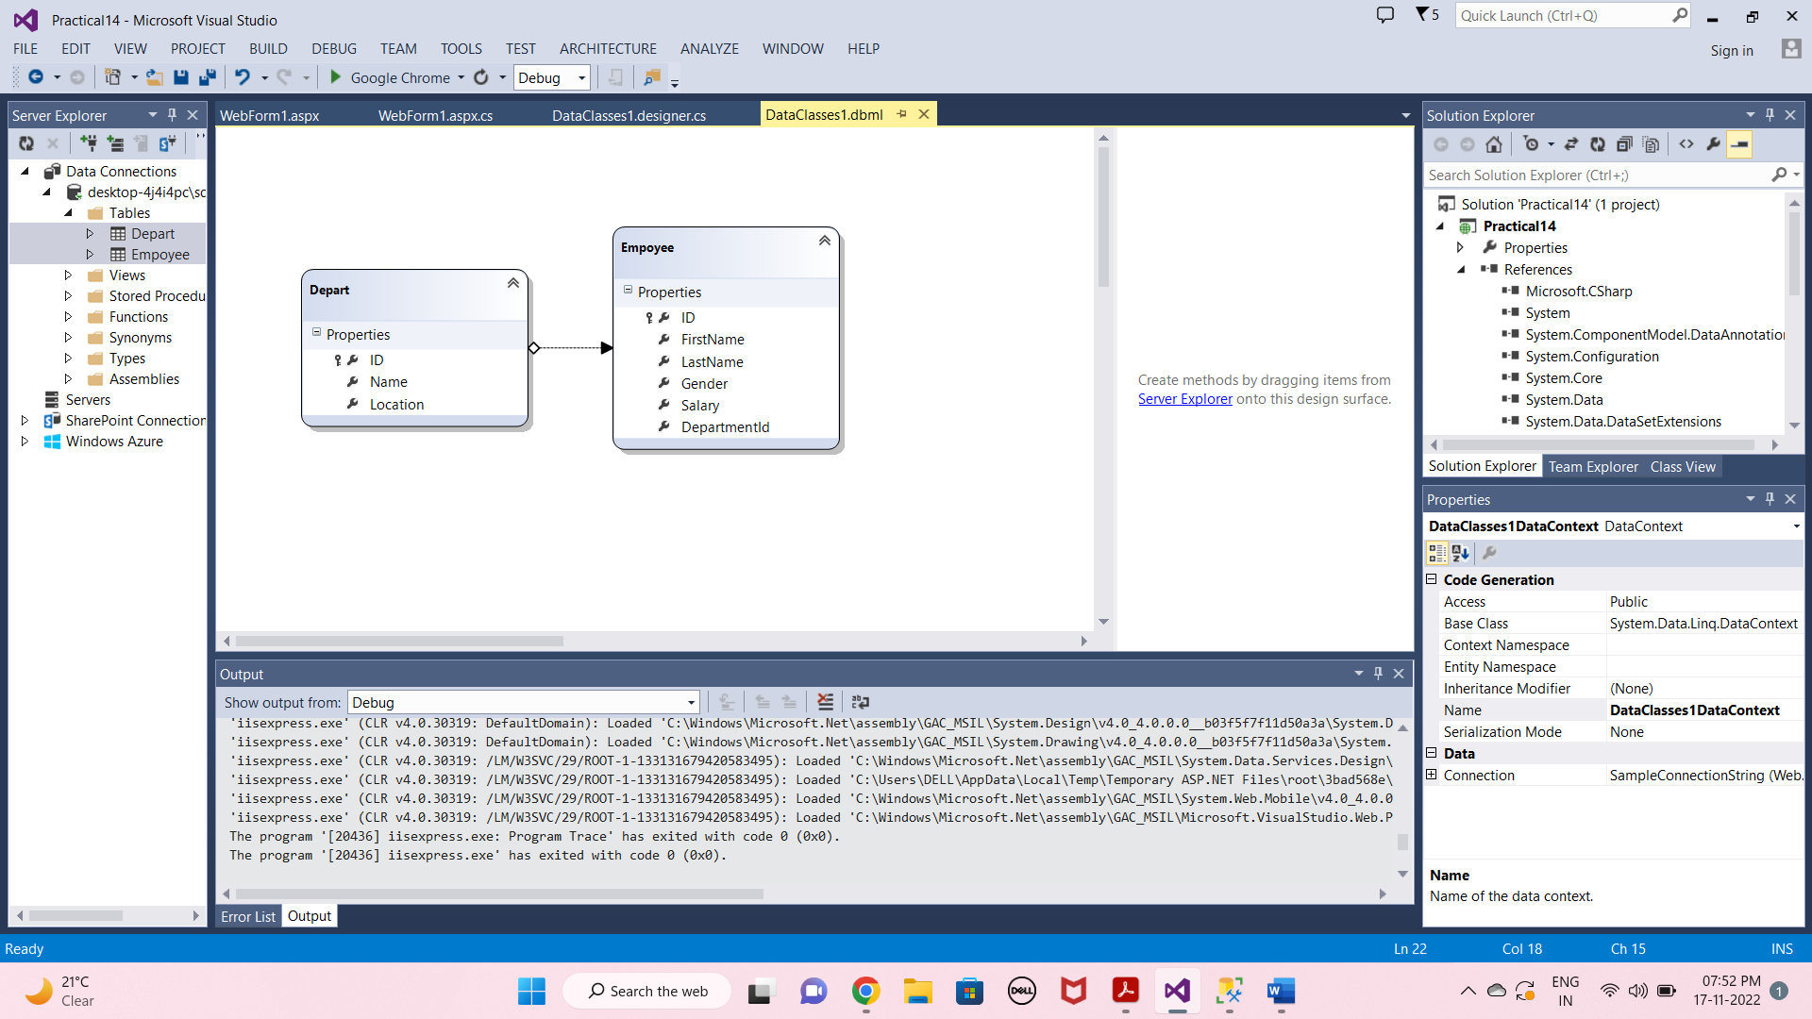

* **WebForm1.aspx Page :-**

<%@ Page Language="C#" AutoEventWireup="true" CodeBehind="WebForm1.aspx.cs" Inherits="Practical14.WebForm1" %>

<!DOCTYPE html>

<html xmlns="http://www.w3.org/1999/xhtml">

<head runat="server">

<title></title>

</head>

<body>

<form id="form1" runat="server">

<div>

<asp:GridView ID="GridView1" runat="server" CellPadding="4" ForeColor="#333333" GridLines="None" Height="261px" Width="402px" >

<AlternatingRowStyle BackColor="White" />

<FooterStyle BackColor="#990000" Font-Bold="True" ForeColor="White" />

<HeaderStyle BackColor="#990000" Font-Bold="True" ForeColor="White" />

<PagerStyle BackColor="#FFCC66" ForeColor="#333333" HorizontalAlign="Center" />

<RowStyle BackColor="#FFFBD6" ForeColor="#333333" />

<SelectedRowStyle BackColor="#FFCC66" Font-Bold="True" ForeColor="Navy" />

<SortedAscendingCellStyle BackColor="#FDF5AC" />

<SortedAscendingHeaderStyle BackColor="#4D0000" />

<SortedDescendingCellStyle BackColor="#FCF6C0" />

<SortedDescendingHeaderStyle BackColor="#820000" />

</asp:GridView>

<br />

<br />

<asp:Button ID="Button1" runat="server" Font-Bold="True" Font-Size="Large" OnClick="Button1_Click" Text="Get Data" />

&nbsp;&nbsp;&nbsp;

<asp:Button ID="Button2" runat="server" Font-Bold="True" Font-Size="Large" OnClick="Button2_Click" Text="Insert" />

&nbsp;&nbsp;&nbsp;

<asp:Button ID="Button3" runat="server" Font-Bold="True" Font-Size="Large" OnClick="Button3_Click" Text="Update" />

&nbsp;&nbsp;&nbsp;

<asp:Button ID="Button4" runat="server" Font-Bold="True" Font-Size="Large" OnClick="Button4_Click" Text="Delete" />

</div>

</form>

</body>

</html>

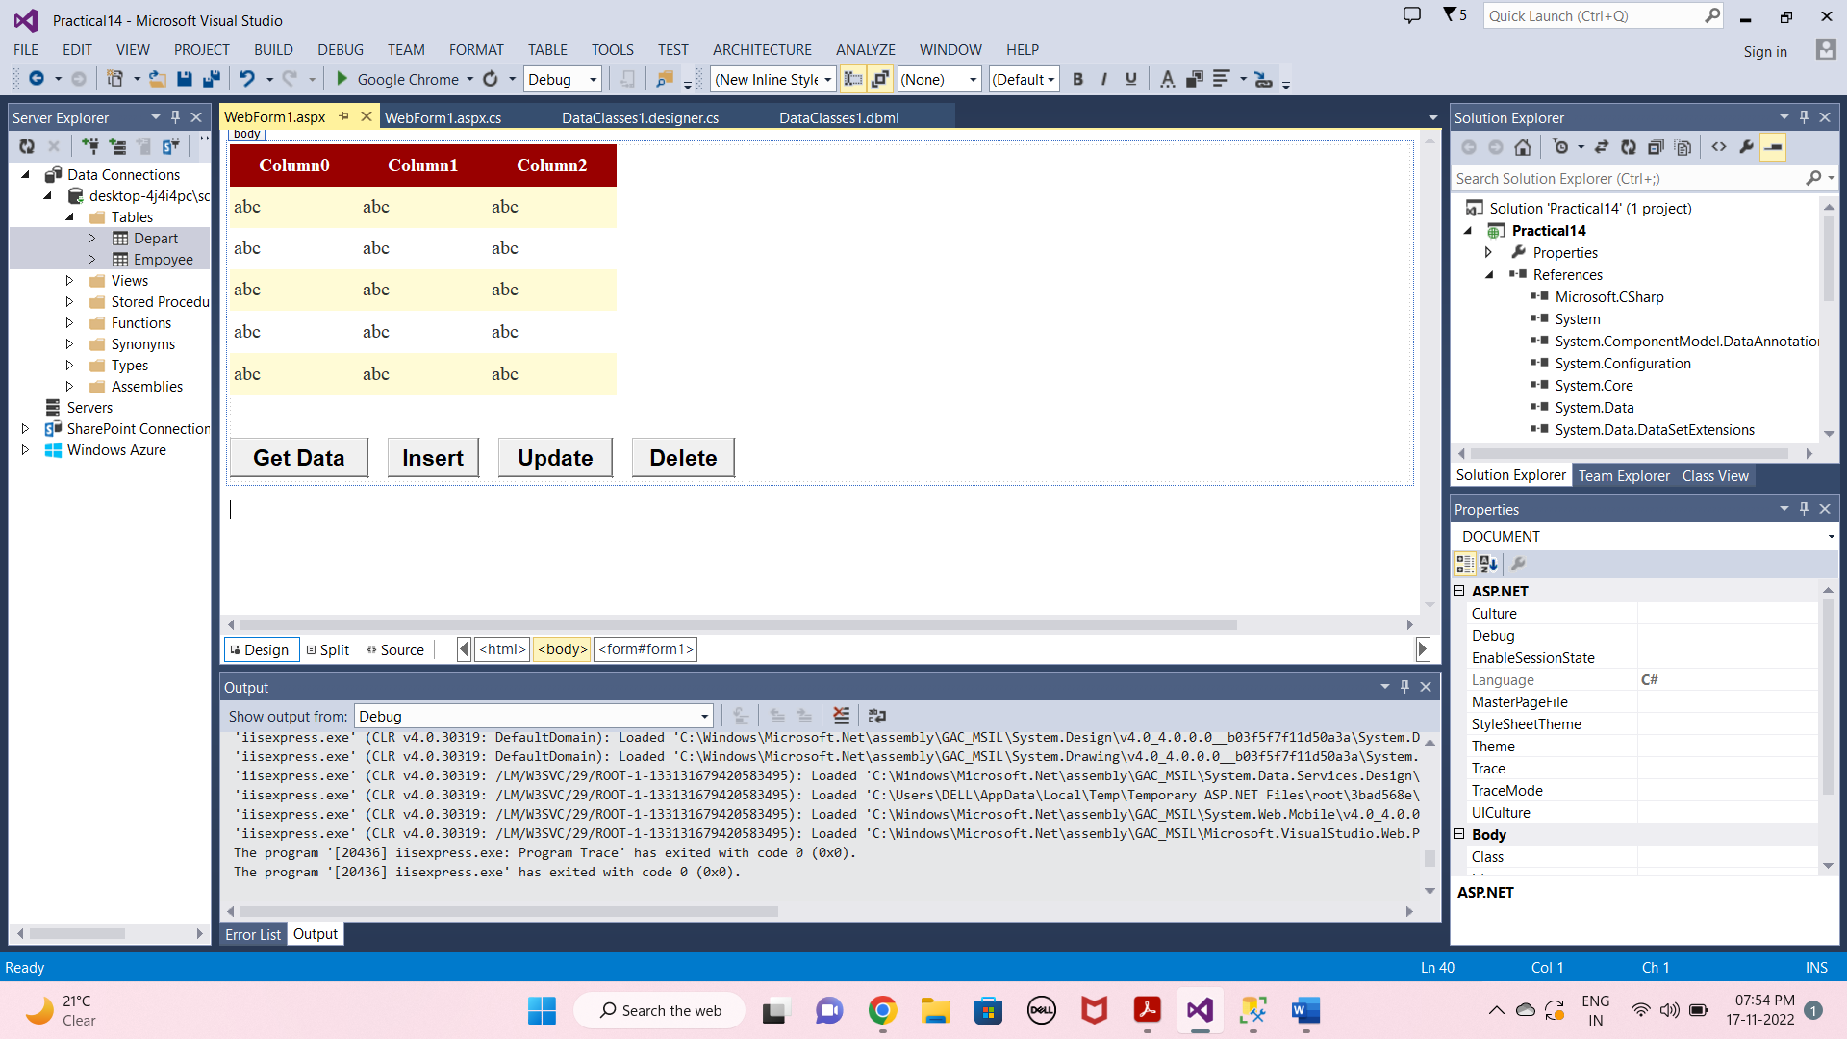

* **WebForm1.aspx.cs Page :-**

using System;

using System.Collections.Generic;

using System.Linq;

using System.Web;

using System.Web.UI;

using System.Web.UI.WebControls;

namespace Practical14

{

public partial class WebForm1 : System.Web.UI.Page

{

protected void Page_Load(object sender, EventArgs e)

{

}

private void GetData()

{

DataClasses1DataContext dbContext = new DataClasses1DataContext();

GridView1.DataSource = dbContext.Empoyees;

GridView1.DataBind();

}

protected void Button1_Click(object sender, EventArgs e)

{

GetData();

}

protected void Button2_Click(object sender, EventArgs e)

{

using (DataClasses1DataContext dbContext = new DataClasses1DataContext())

{

Empoyee newEmployee = new Empoyee

{

ID = 12,

FirstName = "Purva",

LastName = "Warke",

Gender = "FeMale",

Salary = 69000,

DepartmentId = 2

};

dbContext.Empoyees.InsertOnSubmit(newEmployee);

dbContext.SubmitChanges();

}

}

protected void Button3_Click(object sender, EventArgs e)

{

using (DataClasses1DataContext dbContext = new DataClasses1DataContext())

{

Empoyee employee = dbContext.Empoyees.SingleOrDefault(x=>x.ID==12);

employee.Salary = 75000;

dbContext.SubmitChanges();

}

}

protected void Button4_Click(object sender, EventArgs e)

{

using (DataClasses1DataContext dbContext = new DataClasses1DataContext())

{

Empoyee employee = dbContext.Empoyees.SingleOrDefault(x=>x.ID==12);

dbContext.Empoyees.DeleteOnSubmit(employee);

dbContext.SubmitChanges();

}

}

}

}

**OUTPUT :-**

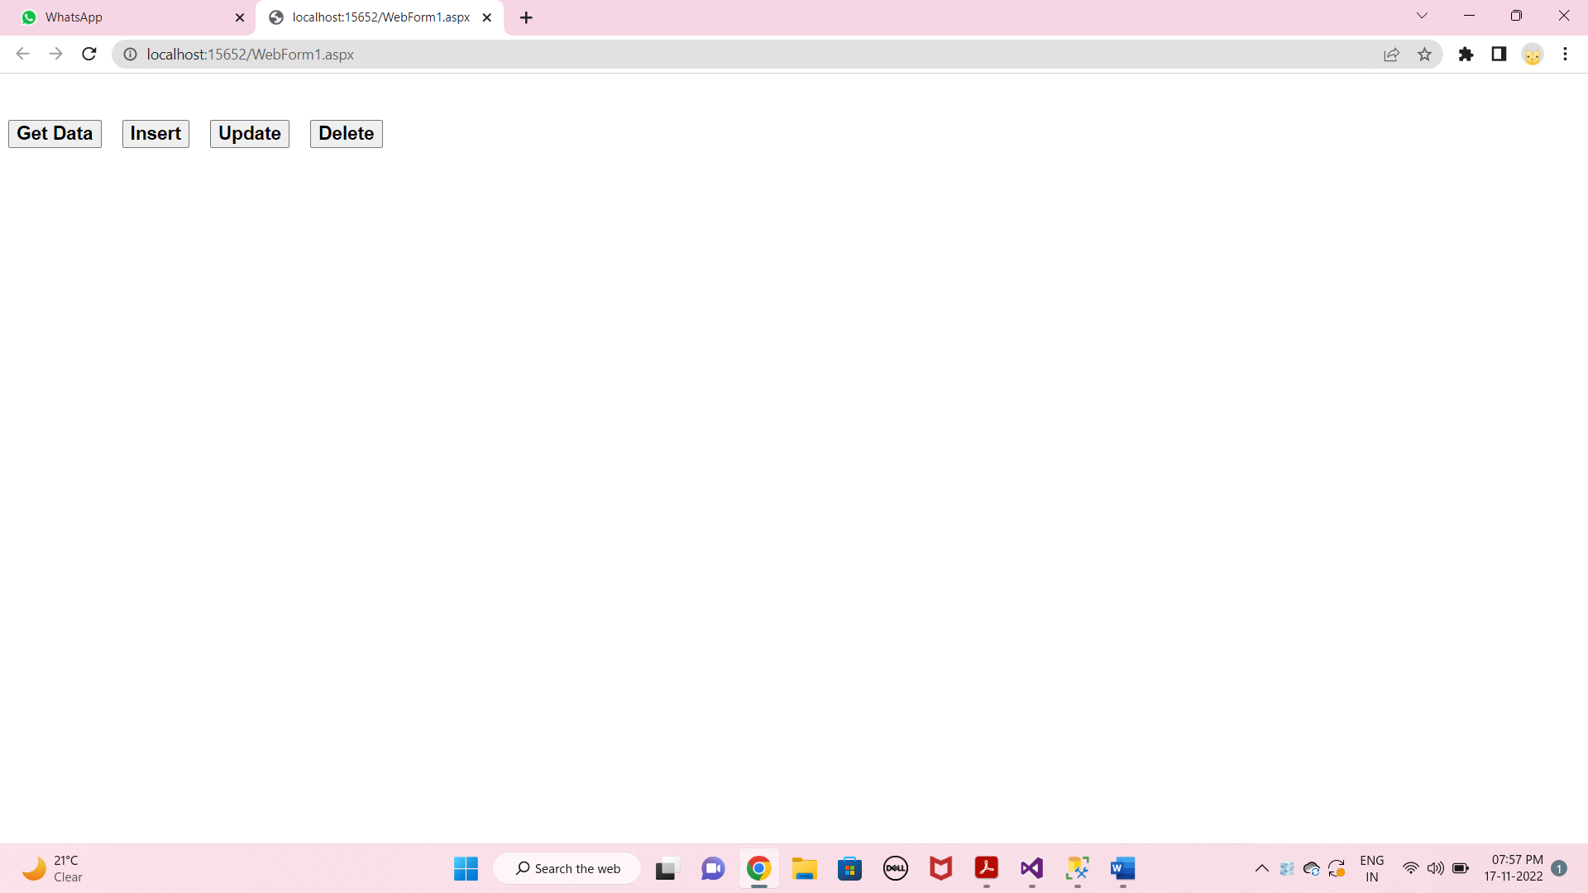

* **GetData :-**

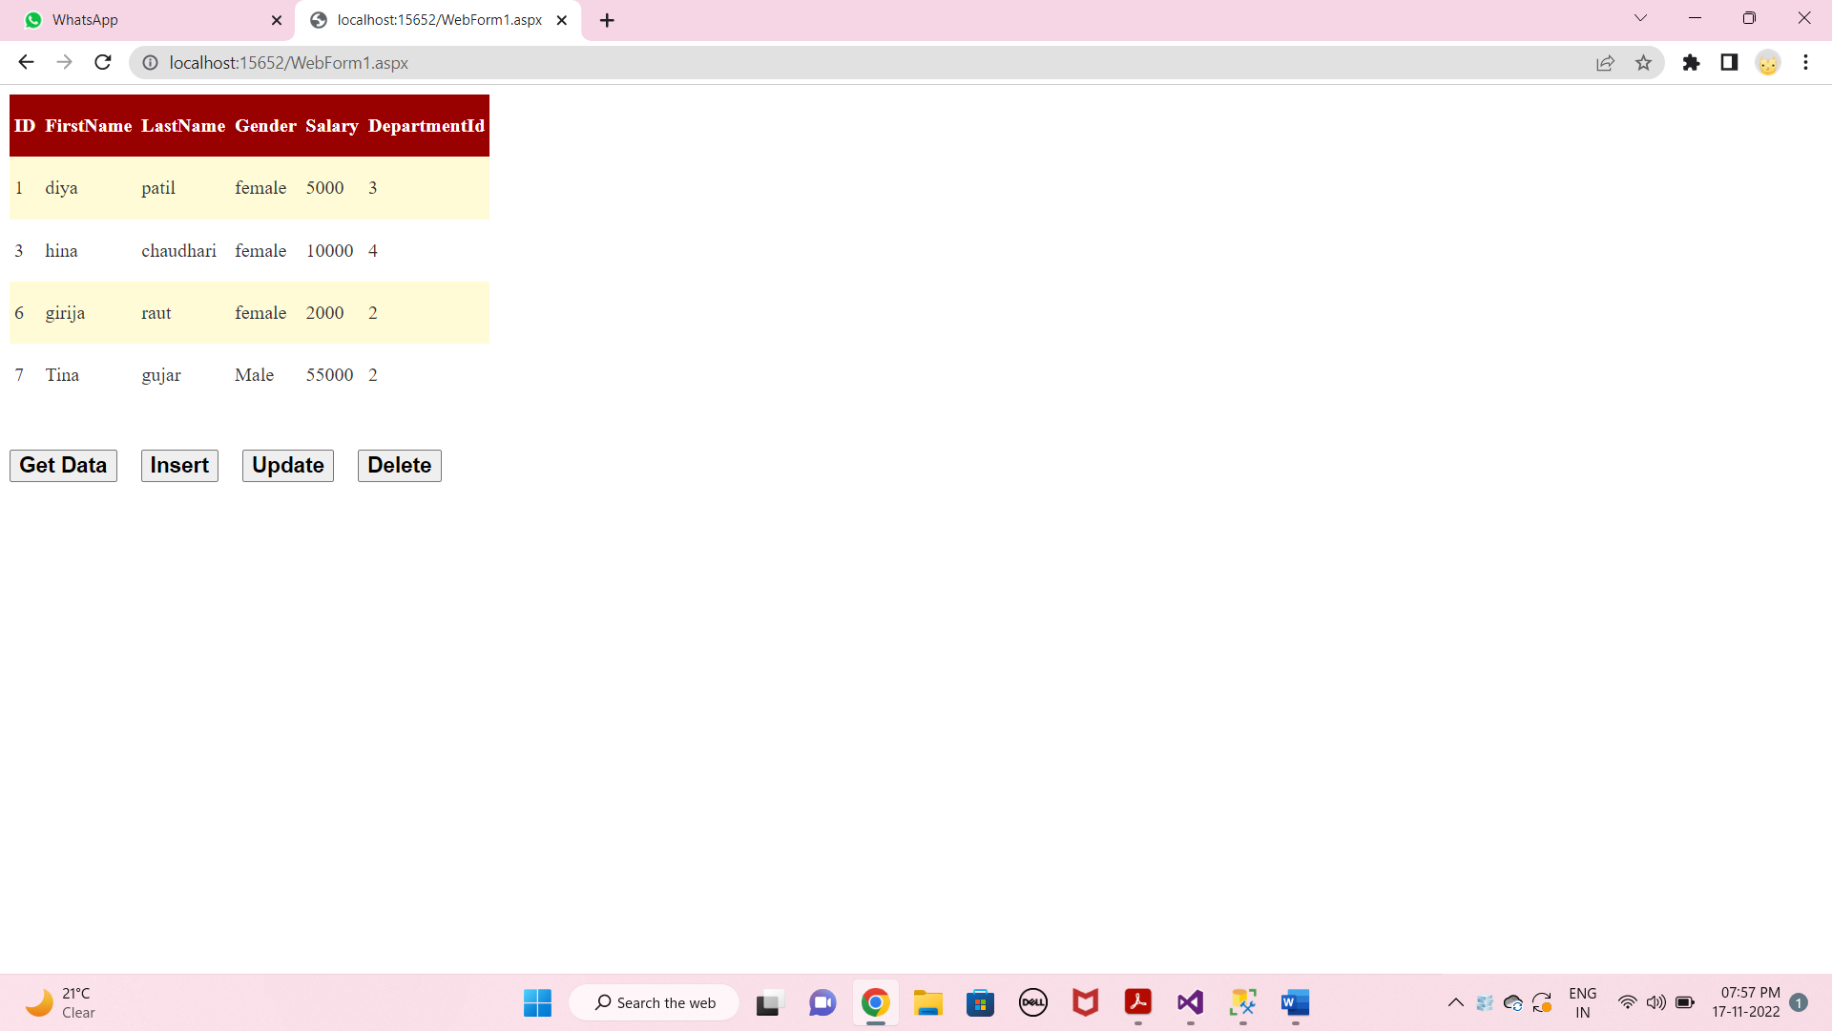

* **Insert :-**

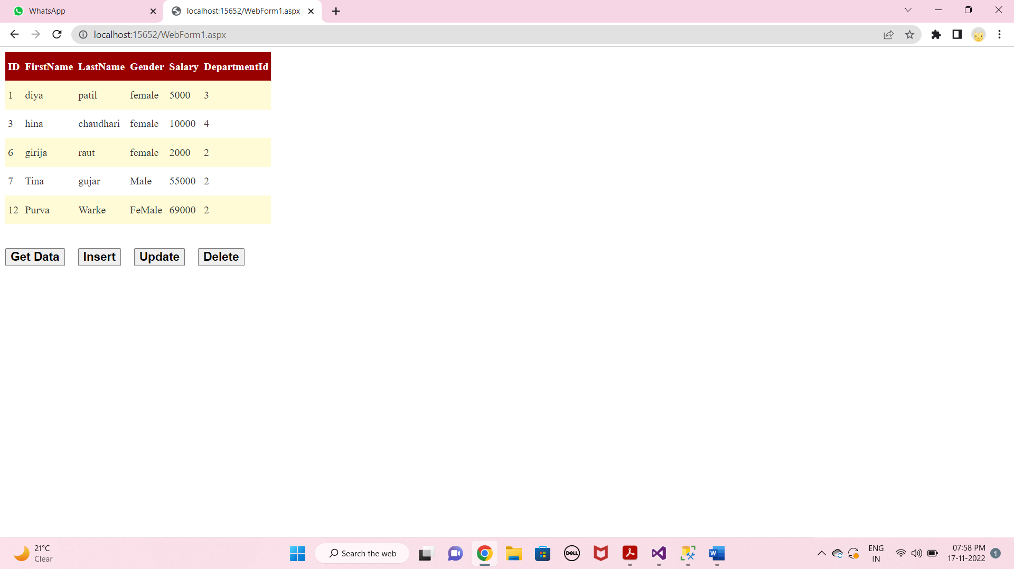

* **Update :-**

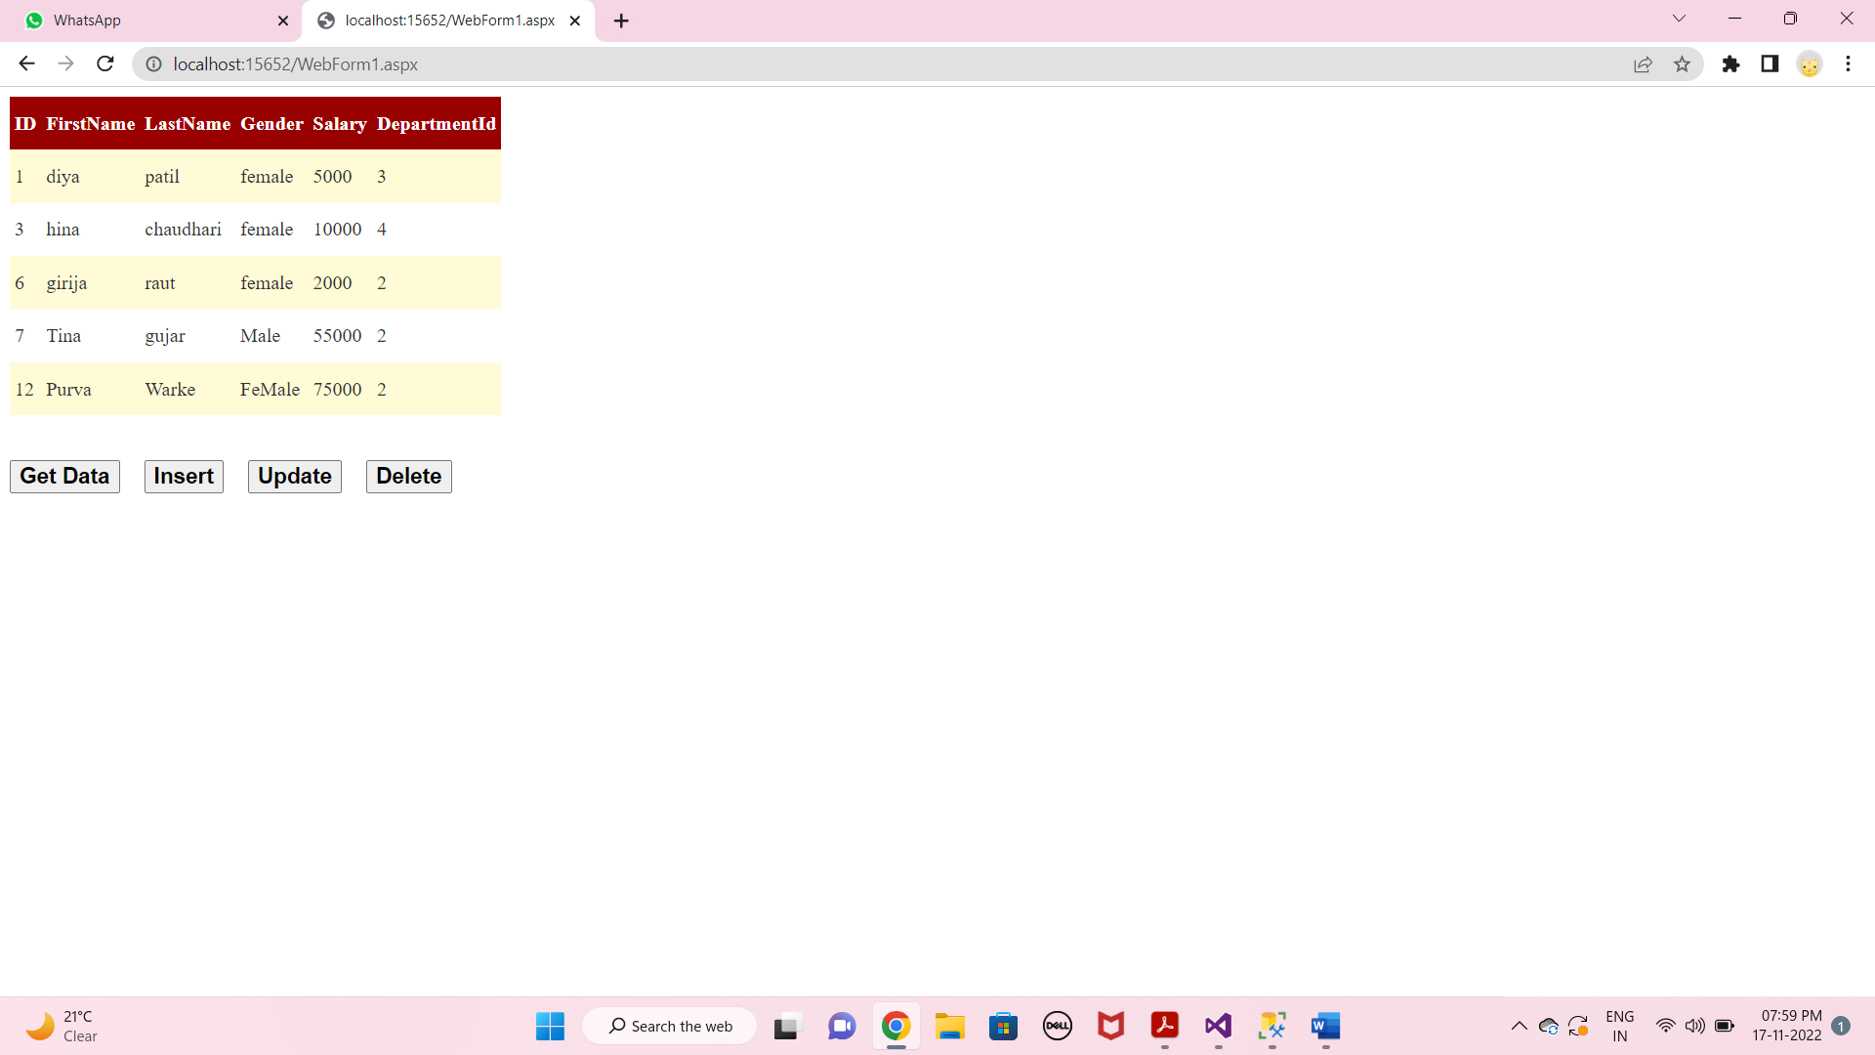

* **Delete :-**

