**Assignment No:- 16**

**Assignment Name:- Create an ASP.NET web form having dropdown list bounded through array list. Display user text with appropriate selected value.**

**Name:- CHIRAG ASHOK MAHAJAN.**

**Roll No:- 59.**

**______________________________________________________________________________**

* **Default.aspx Page :-**

<%@ Page Language="C#" AutoEventWireup="true" CodeFile="Default.aspx.cs" Inherits="_Default" %>

<!DOCTYPE html>

<html xmlns="http://www.w3.org/1999/xhtml">

<head runat="server">

<title></title>

</head>

<body>

<form id="form1" runat="server">

<div>

<p style="box-sizing: inherit; margin: 0px 0px 26px; padding: 0px; color: rgb(34, 34, 34); font-family: Roboto, sans-serif; font-size: 16px; font-style: normal; font-variant-ligatures: normal; font-variant-caps: normal; font-weight: 300; letter-spacing: normal; orphans: 2; text-align: start; text-indent: 0px; text-transform: none; white-space: normal; widows: 2; word-spacing: 0px; -webkit-text-stroke-width: 0px; background-color: rgb(255, 255, 255); text-decoration-thickness: initial; text-decoration-style: initial; text-decoration-color: initial;">

A big city has a lot on offer for you to make your life a pleasant experience. However, as you know, good things never come easy, so, to reap the perks of city life, you have to make sure to work hard at the same pace as it runs. Hence, people work like a machine to fulfill their dreams and be successful.</p>

<p style="box-sizing: inherit; margin: 0px 0px 26px; padding: 0px; color: rgb(34, 34, 34); font-family: Roboto, sans-serif; font-size: 16px; font-style: normal; font-variant-ligatures: normal; font-variant-caps: normal; font-weight: 300; letter-spacing: normal; orphans: 2; text-align: start; text-indent: 0px; text-transform: none; white-space: normal; widows: 2; word-spacing: 0px; -webkit-text-stroke-width: 0px; background-color: rgb(255, 255, 255); text-decoration-thickness: initial; text-decoration-style: initial; text-decoration-color: initial;">

Moreover, people experience a lot of competition in big cities to achieve their life’s goal. Whether a business owner or an employee both struggle to be at par and earn more fame as well as money. They all have to match the pace of life to let the ends meet. A good life in a big city is almost impossible unless you are well settled. Also, you will hardly get any free and peaceful time in such cities as you have to hustle consistently.</p>

<p style="box-sizing: inherit; margin: 0px 0px 26px; padding: 0px; color: rgb(34, 34, 34); font-family: Roboto, sans-serif; font-size: 16px; font-style: normal; font-variant-ligatures: normal; font-variant-caps: normal; font-weight: 300; letter-spacing: normal; orphans: 2; text-align: start; text-indent: 0px; text-transform: none; white-space: normal; widows: 2; word-spacing: 0px; -webkit-text-stroke-width: 0px; background-color: rgb(255, 255, 255); text-decoration-thickness: initial; text-decoration-style: initial; text-decoration-color: initial;">

You will see there is a great rush of traffic at peak hours of the morning as well as evening. It is not easy to shop around in the markets because they are bustling with the crowd always. The parks are full, and the metro is congested. These thickly populated cities even go through housing problems, which is even increasing every passing day. All this seldom gives the residents of the big city any peaceful moment.</p>

<br />

<asp:Label ID="Label2" runat="server" Font-Bold="True" Font-Size="X-Large" Text="Select Your City : "></asp:Label>

<asp:DropDownList ID="DropDownList1" runat="server" Font-Size="X-Large">

</asp:DropDownList>

<br />

<br />

<asp:Button ID="Button1" runat="server" Font-Bold="True" Font-Size="Large" OnClick="Button1_Click" Text="Choices " />

&nbsp;&nbsp;&nbsp;

<asp:Button ID="Button2" runat="server" Font-Bold="True" Font-Size="Large" OnClick="Button2_Click" Text="Display" />

<br />

<br />

</div>

<asp:Label ID="Label1" runat="server" Font-Bold="True" Font-Size="Medium"></asp:Label>

</form>

</body>

</html>

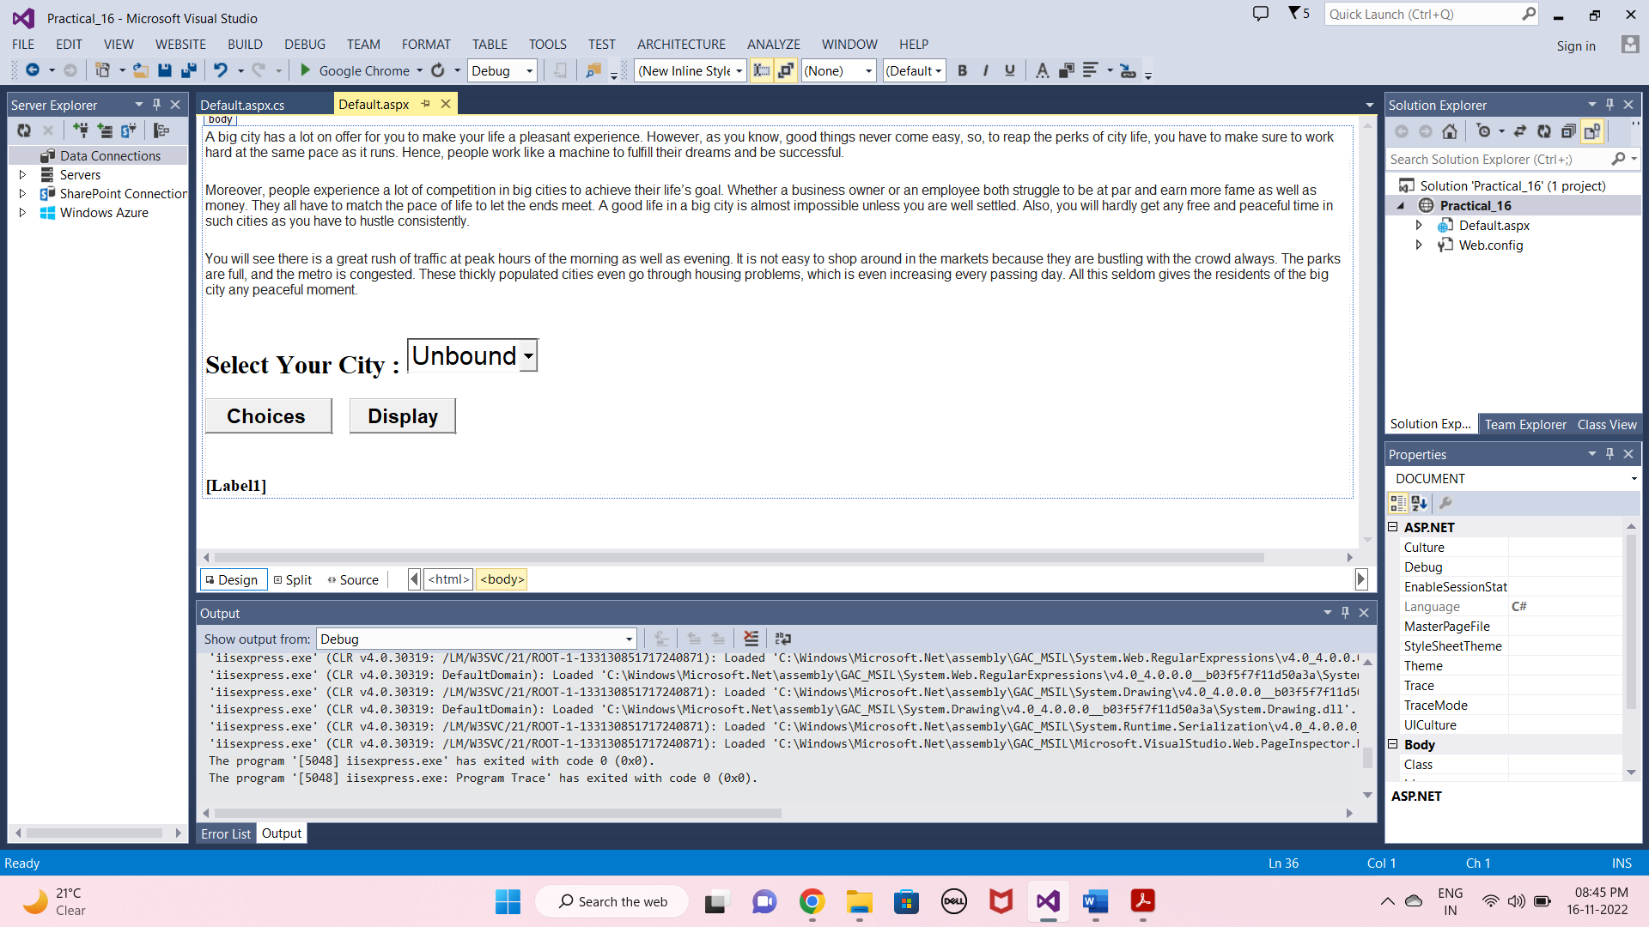

* **Default.aspx.cs Page :-**

using System;

using System.Collections.Generic;

using System.Linq;

using System.Web;

using System.Web.UI;

using System.Web.UI.WebControls;

using System.Collections;

public partial class _Default : System.Web.UI.Page

{

private ArrayList getdata()

{

ArrayList obj = new ArrayList();

obj.Add("Nashik");

obj.Add("Pune");

obj.Add("Jalgaon");

obj.Add("Dhule");

obj.Add("Surat");

obj.Add("Mumbai");

obj.Add("Kolhapur");

obj.Add("Akola");

obj.Add("Delhi");

return obj;

}

protected void Page_Load(object sender, EventArgs e)

{

}

protected void Button1_Click(object sender, EventArgs e)

{

ArrayList a = getdata();

DropDownList1.DataSource = a;

DropDownList1.DataBind();

}

protected void Button2_Click(object sender, EventArgs e)

{

Label1.Text = " Your City is : "+DropDownList1.SelectedValue.ToString();

}

}

**OUTPUT :-**

