**Assignment No:- 3**

**Assignment Name:- Create an ASP.Net webpage to demonstrate Databinding to GridView Control using DataAdapter .**

**Name:- CHIRAG ASHOK MAHAJAN.**

**Roll No:- 59.**

**______________________________________________________________________________**

* **Login.aspx Page :**

<%@ Page Language="C#" AutoEventWireup="true" CodeFile="Login.aspx.cs" Inherits="Login" %>

<!DOCTYPE html>

<html xmlns="http://www.w3.org/1999/xhtml">

<head runat="server">

<title></title>

<style type="text/css">

.auto-style1 {

width: 100%;

}

.auto-style2 {

width: 105px;

}

</style>

</head>

<body style="height: 348px; width: 409px">

<form id="form1" runat="server">

<table align="center" class="auto-style1">

<tr>

<td colspan="2">

<asp:Label ID="Label1" runat="server" Font-Bold="True" Font-Size="XX-Large" ForeColor="#3333CC" Text="Login Form !!"></asp:Label>

</td>

</tr>

<tr>

<td class="auto-style2">&nbsp;</td>

<td>&nbsp;</td>

</tr>

<tr>

<td class="auto-style2">

<asp:Label ID="Label2" runat="server" Text="User Name : "></asp:Label>

</td>

<td>

<asp:TextBox ID="TextBox1" runat="server" OnTextChanged="TextBox1_TextChanged"></asp:TextBox>

</td>

</tr>

<tr>

<td class="auto-style2">

<asp:Label ID="Label3" runat="server" Text="Password : "></asp:Label>

</td>

<td>

<asp:TextBox ID="TextBox2" runat="server" TextMode="Password"></asp:TextBox>

</td>

</tr>

<tr>

<td class="auto-style2">&nbsp;</td>

<td>&nbsp;</td>

</tr>

<tr>

<td class="auto-style2">

<asp:Button ID="Button1" runat="server" Font-Bold="True" OnClick="Button1_Click" Text="Login" Width="90px" />

</td>

<td>

<asp:Button ID="Button2" runat="server" Font-Bold="True" OnClick="Button2_Click" Text="Show" Width="99px" />

</td>

</tr>

<tr>

<td class="auto-style2">&nbsp;</td>

<td>&nbsp;</td>

</tr>

<tr>

<td class="auto-style2"></td>

<td>&nbsp;</td>

</tr>

</table>

<asp:Label ID="Label4" runat="server"></asp:Label>

<br />

<asp:GridView ID="GridView1" runat="server">

</asp:GridView>

</form>

</body>

</html>

**Login.aspx.cs Page :**

using System;

using System.Collections.Generic;

using System.Linq;

using System.Web;

using System.Web.UI;

using System.Web.UI.WebControls;

using System.Data.SqlClient;

using System.Data;

public partial class Login : System.Web.UI.Page

{

string str = "server=DESKTOP-4J4I4PC\\SQLEXPRESS; initial catalog=MCA; trusted_connection=true";

protected void Page_Load(object sender, EventArgs e)

{

}

protected void Button1_Click(object sender, EventArgs e)

{

SqlConnection con = new SqlConnection(str);

con.Open();

string a="insert into Login Values('"+ TextBox1.Text+"','"+TextBox2.Text+"')";

SqlCommand cmd = new SqlCommand(a, con);

cmd.ExecuteNonQuery();

TextBox1.Text = "";

con.Close();

}

protected void Button2_Click(object sender, EventArgs e)

{

Label4.Text = "User's Login Information ";

SqlConnection con = new SqlConnection(str);

string q = "select * from Login";

SqlDataAdapter da = new SqlDataAdapter(q, con);

DataTable dt = new DataTable();

da.Fill(dt);

GridView1.DataSource = dt;

GridView1.DataBind();

}

protected void TextBox1_TextChanged(object sender, EventArgs e)

{

}

}

**Design Page :**

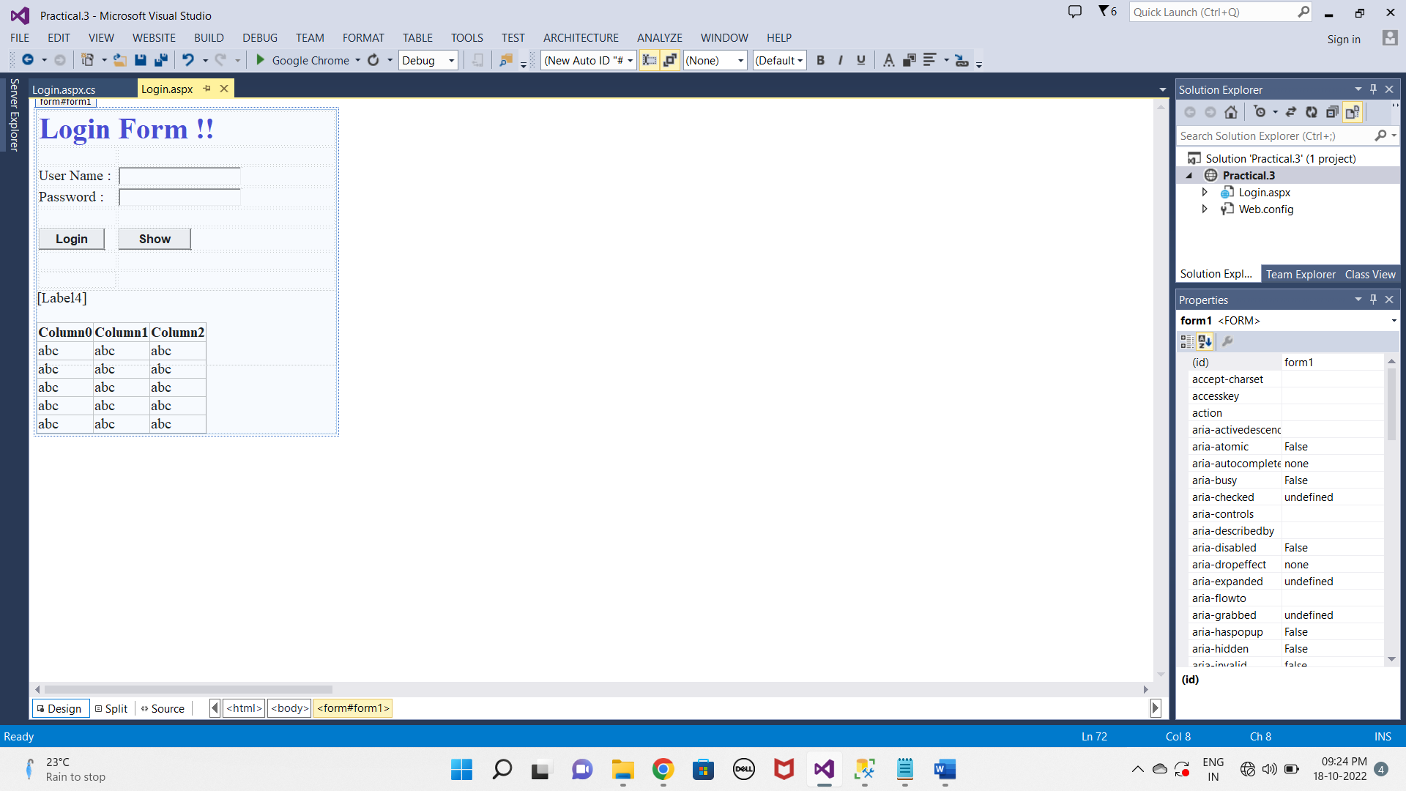

**OUTPUT :**

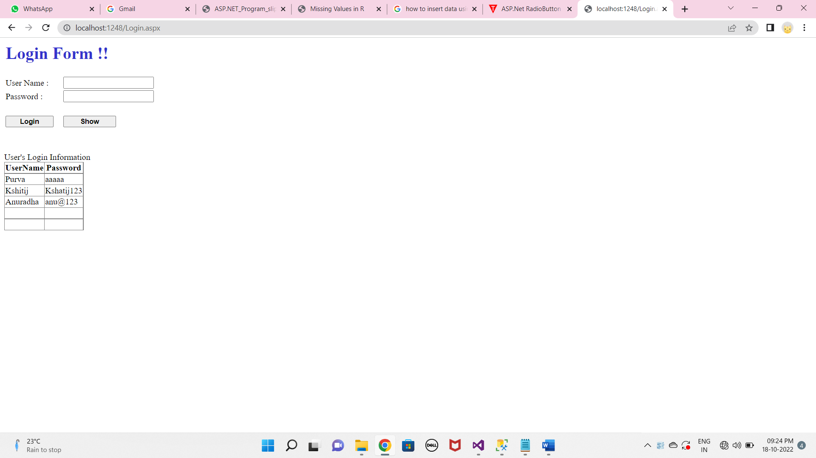

**Database :**

