**Assignment No:- 5**

**Assignment Name:- Create a web Service having simple calculator operations (add, subtract, multiply) and use the service in ASP.Net application.**

**Name:- CHIRAG ASHOK MAHAJAN.**

**Roll No:- 59.**

**________________________________________________________________________________**

* **WebService.cs :**

using System;

using System.Collections.Generic;

using System.Linq;

using System.Web;

using System.Web.Services;

/// <summary>

/// Summary description for WebService

/// </summary>

[WebService(Namespace = "http://tempuri.org/")]

[WebServiceBinding(ConformsTo = WsiProfiles.BasicProfile1_1)]

// To allow this Web Service to be called from script, using ASP.NET AJAX, uncomment the following line.

// [System.Web.Script.Services.ScriptService]

public class WebService : System.Web.Services.WebService {

public WebService () {

//Uncomment the following line if using designed components

//InitializeComponent();

}

[WebMethod]

public int Add(int x, int y)

{

return x + y;

}

[WebMethod]

public int Sub(int x, int y)

{

return x - y;

}

[WebMethod]

public int Mul(int x, int y)

{

return x * y;

}

[WebMethod]

public int Div(int x, int y)

{

return x / y;

}

}

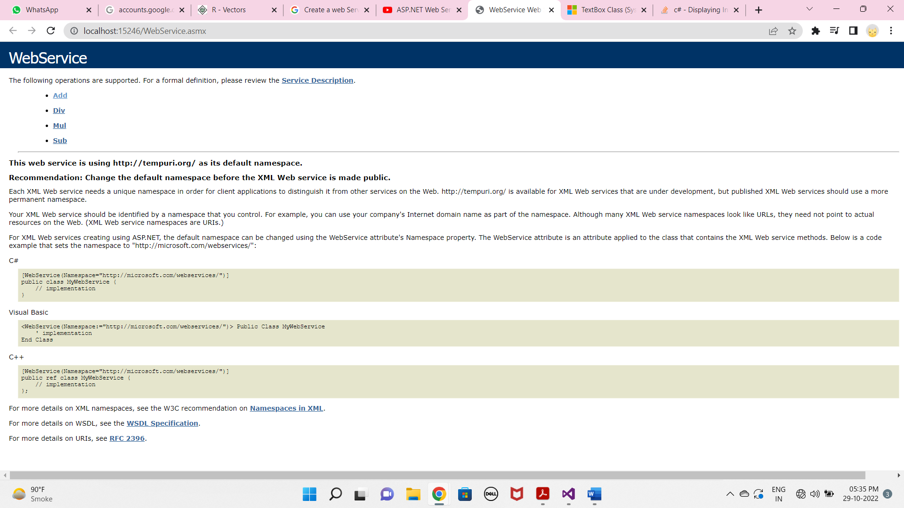

* **WebForm1.aspx :**

<%@ Page Language="C#" AutoEventWireup="true" CodeBehind="WebForm1.aspx.cs" Inherits="WebApplication1.WebForm1" %>

<!DOCTYPE html>

<html xmlns="http://www.w3.org/1999/xhtml">

<head runat="server">

<title></title>

</head>

<body>

<form id="form1" runat="server">

<div>

</div>

<asp:Label ID="Label1" runat="server" Font-Bold="True" Font-Size="Large" Text="Enter First Number : "></asp:Label>

<asp:TextBox ID="TextBox1" runat="server"></asp:TextBox>

<p>

<asp:Label ID="Label2" runat="server" Font-Bold="True" Font-Size="Large" Text="Enter Second Number : "></asp:Label>

<asp:TextBox ID="TextBox2" runat="server"></asp:TextBox>

</p>

<p>

<asp:Label ID="Label3" runat="server" Font-Bold="True" Font-Size="Large" Text="Result : "></asp:Label>

<asp:TextBox ID="TextBox3" runat="server"></asp:TextBox>

</p>

<asp:Button ID="Button1" runat="server" Font-Bold="True" OnClick="Button1_Click" Text="Addition" />

&nbsp;&nbsp;&nbsp;

<asp:Button ID="Button2" runat="server" Font-Bold="True" OnClick="Button2_Click" Text="Subtraction" />

&nbsp;&nbsp;&nbsp;

<asp:Button ID="Button3" runat="server" Font-Bold="True" OnClick="Button3_Click" Text="Multiplication" />

&nbsp;&nbsp;&nbsp;&nbsp;

<asp:Button ID="Button4" runat="server" Font-Bold="True" OnClick="Button4_Click" Text="Division" />

</form>

</body>

</html>

* **Add WebServices :**

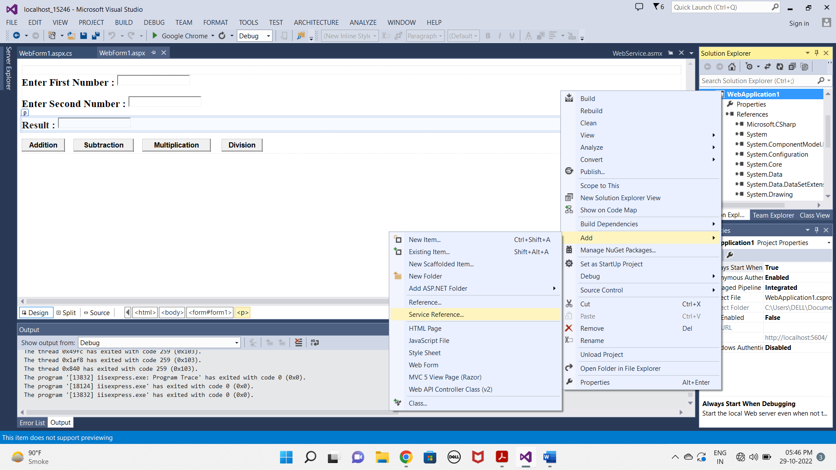

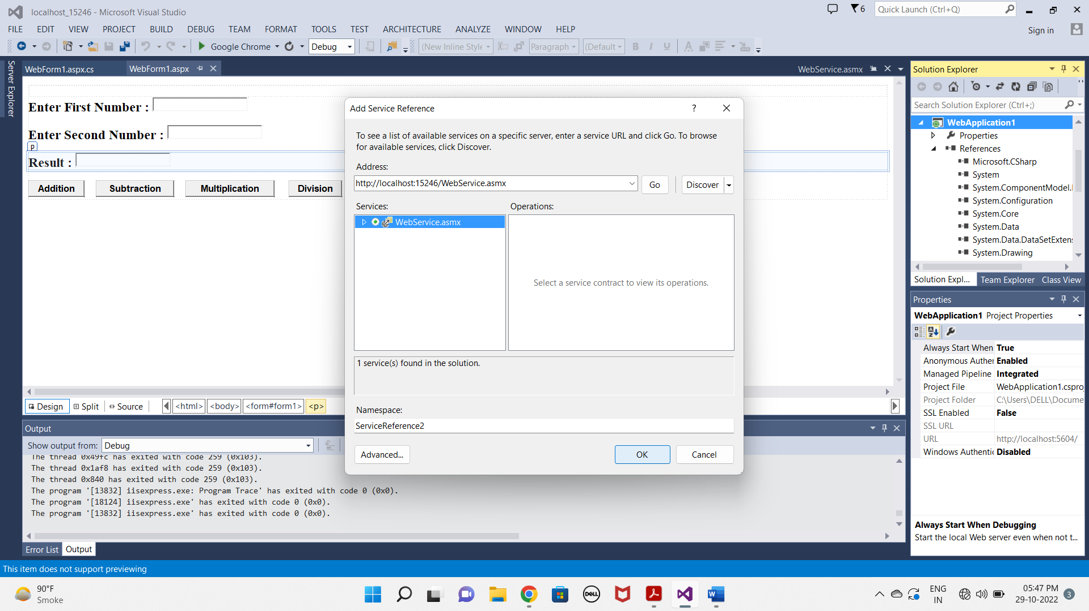

* **WebForm1.aspx.cs :**

using System;

using System.Collections.Generic;

using System.Linq;

using System.Web;

using System.Web.UI;

using System.Web.UI.WebControls;

using WebApplication1.ServiceReference1;

namespace WebApplication1

{

public partial class WebForm1 : System.Web.UI.Page

{

WebServiceSoapClient obj;

protected void Page_Load(object sender, EventArgs e)

{

obj = new WebServiceSoapClient();

}

protected void Button1_Click(object sender, EventArgs e)

{

int a = Convert.ToInt32(TextBox1.Text);

int b = Convert.ToInt32(TextBox2.Text);

int ans = obj.Add(a, b);

TextBox3.Text = ans.ToString();

}

protected void Button2_Click(object sender, EventArgs e)

{

int a = Convert.ToInt32(TextBox1.Text);

int b = Convert.ToInt32(TextBox2.Text);

int ans = obj.Sub(a, b);

TextBox3.Text = ans.ToString();

}

protected void Button3_Click(object sender, EventArgs e)

{

int a = Convert.ToInt32(TextBox1.Text);

int b = Convert.ToInt32(TextBox2.Text);

int ans = obj.Mul(a, b);

TextBox3.Text = ans.ToString();

}

protected void Button4_Click(object sender, EventArgs e)

{

int a = Convert.ToInt32(TextBox1.Text);

int b = Convert.ToInt32(TextBox2.Text);

int ans = obj.Div(a, b);

TextBox3.Text = ans.ToString();

}

}

}

**OUTPUT**:

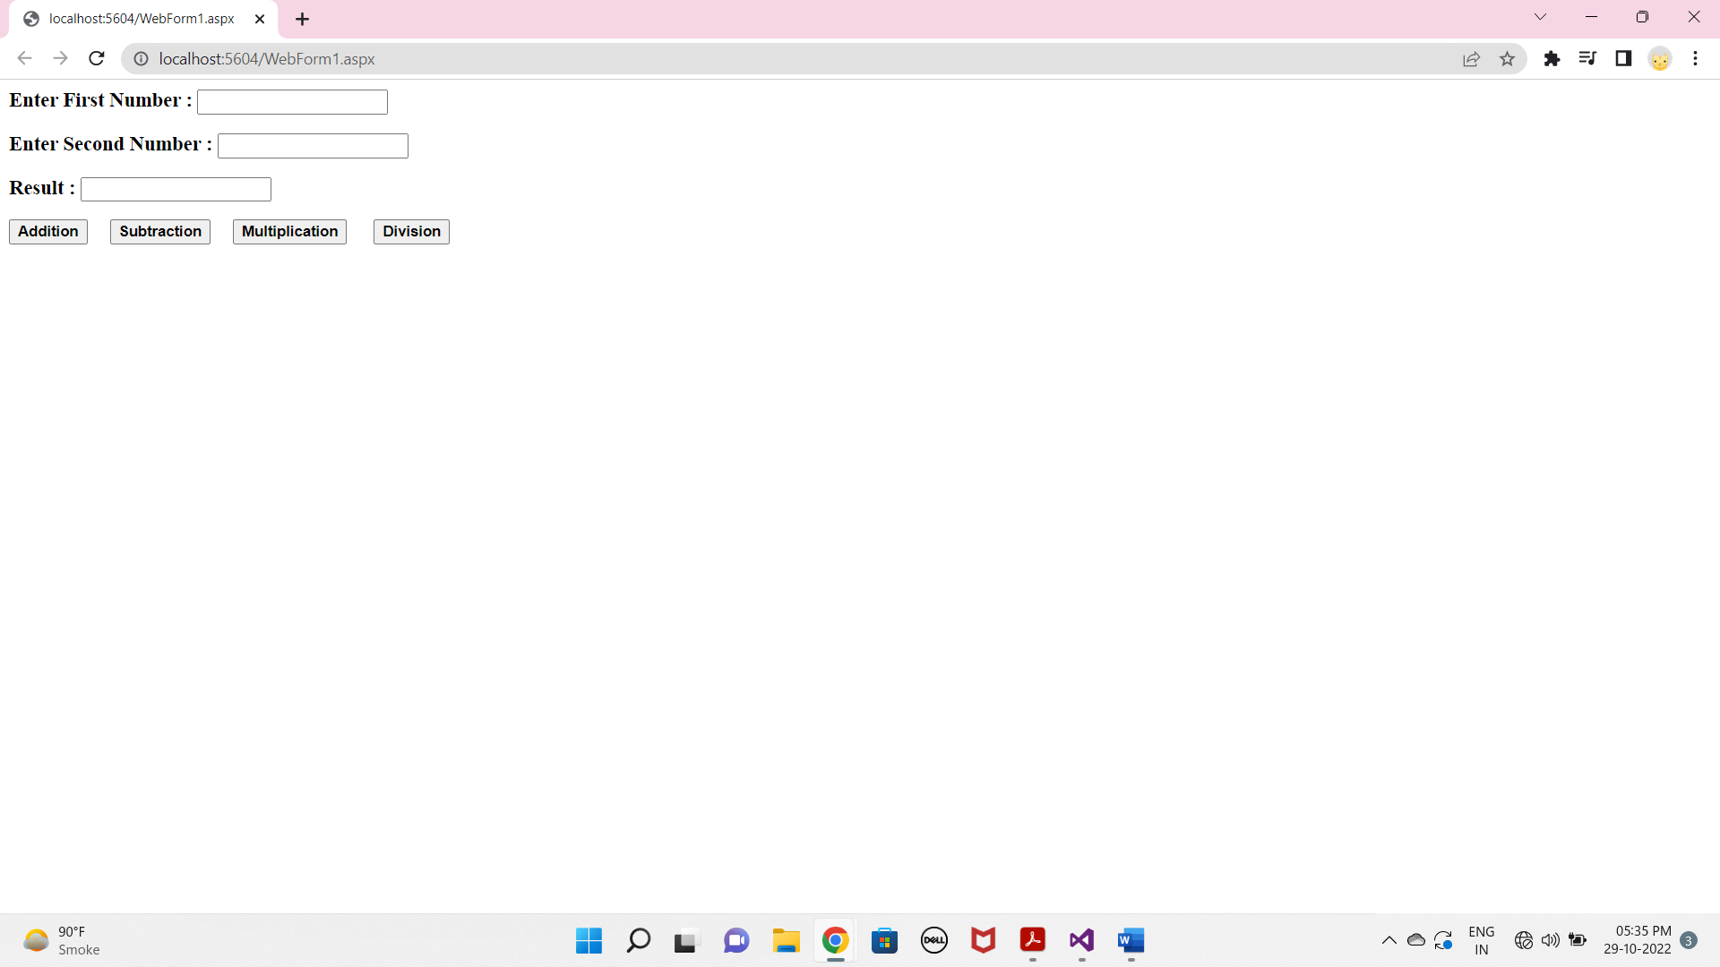

**Addition :**

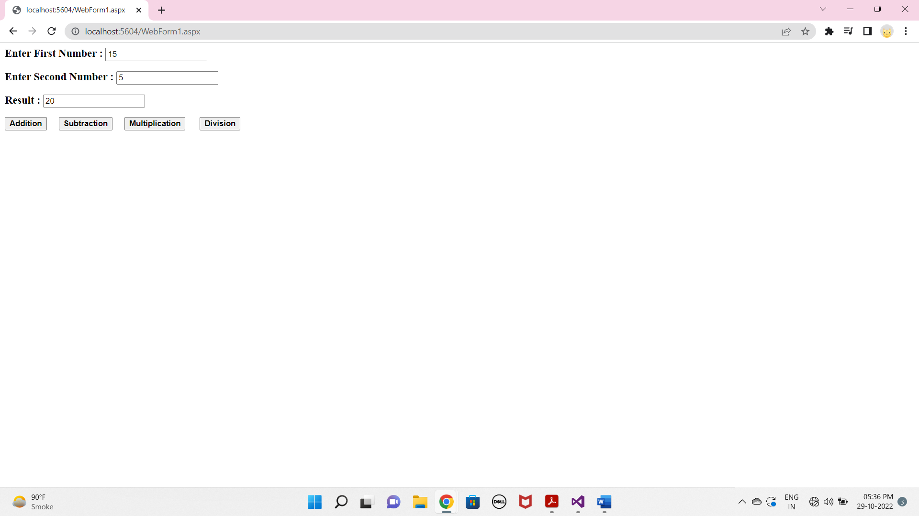

**Subtraction :**

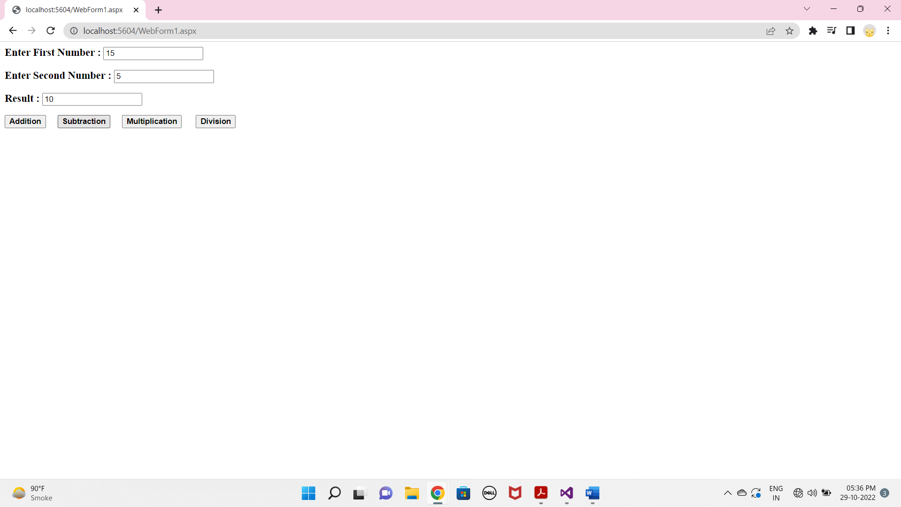

**Multiplication :**

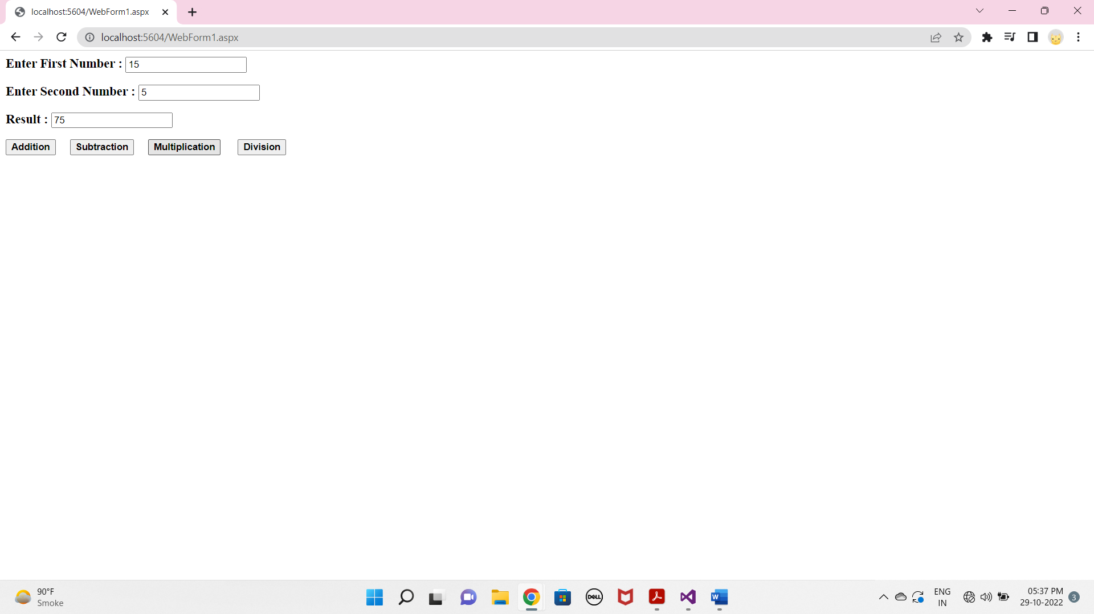

**Division :**

