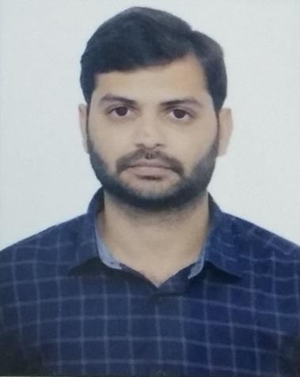

SAGAR N

**Address** : Palya(V),Chaldiganahalli(P),Srinivaspura(T),Kolar(D),Karnataka-563126

**Mobile** : +91 7899917200

**Email** [: sagarnreddy98@gmail.com](mailto:sagarnreddy98@gmail.com)

**Objective:**

Looking for a position where I can contribute significantly by inculcation of knowledge and skills that provide ample opportunities to grow professionally.

# Academic Credentials:

|  |  |  |  |  |
| --- | --- | --- | --- | --- |
| **Education** | **Institution** | **Board/University** | **Year of Passing** | **Percentage** |
| Engineerin g | CMR Institute of Technology | VTU | 2020 | 70.7% |
| P.U.C | Sahyadri PU College | Karnataka State Board | 2016 | 83.16% |
| 10th Standard | Sri Byraveshwara Vidyanikethana | Karnataka State Board | 2014 | 92.48% |

**Profesional Skill: Software Skills**

* Solid Edge ST9
* SeeNC mill and turn
* CAPS mill and turn

**Projects:**

**Project Name :** Vapor Smoothening of 3D printed parts

**Project Name :** Ultrasonic distance measurement with intelligent braking system

**Personal Profile:**

Name : SAGAR N

Father’s name : NARAYANAREDDY R

D.O.B : 07th November 1998

Sex : Male

Languages known : English, Kannada, Telugu, Hindi Interests : Music, Playing

**Declaration:**

I hereby confirm that all the information stated above is true and to the best of my knowledge. You are kindly requested to consider my candidature for the suitable position in your valued organization.

Place:

Date: Sagar N