1. Read a CSV file with data in multiple columns and compute mean, median mode of each of the columns.

code:

import pandas as pd

df = pd.read_csv('/content/drive/MyDrive/Untitled spreadsheet - Sheet1.csv') statistics_per_column = df.agg(['mean', 'median', lambda x: x.mode().iloc[0]]) print("Statistics for each column:")

print(statistics_per_column)

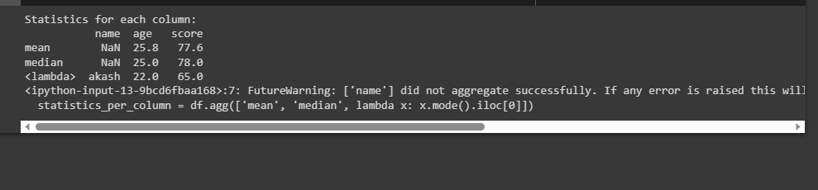output:

Plot each of the columns with different colors (check what kind of graph is suitable ) Code:

import matplotlib.pyplot as plt import random

# Student names

students = ['Akash', 'Sudarshan', 'Om', 'Sameer', 'Avaneesh']

# Example marks for each student

history_marks = [random.randint(60, 100) for _ in range(5)] math_marks = [random.randint(60, 100) for _ in range(5)] chemistry_marks = [random.randint(60, 100) for _ in range(5)]

# Create a new figure plt.figure()

# Plot each student's marks with different colors

plt.plot(students, history_marks, marker='o', color='blue', label='History Marks') plt.plot(students, math_marks, marker='o', color='green', label='Math Marks') plt.plot(students, chemistry_marks, marker='o', color='red', label='Chemistry Marks')

# Add labels and title plt.xlabel('Students') plt.ylabel('Marks')

plt.title('Comparison of Student Marks')

plt.xticks(rotation=45) # Rotate student names for better visibility

# Add legend plt.legend()

# Show the plot

plt.tight_layout() # Adjust layout for better spacing plt.show()

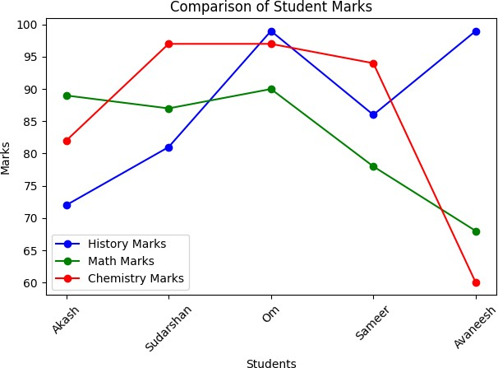

Create a game (like lottery/ rock paper/scissors) and write a python code to record how many times the computer won and the user won in an excel file. Plot the graph showing the success rate of user and computer with different colors

import random import pandas as pd

import matplotlib.pyplot as plt

gamelist = ['rock', 'paper', 'scissors'] comp_wins = 0

user_wins = 0

total_games = 0 results = []

while True:

comp = random.choice(gamelist) print(comp)

userinput = input("Enter one of the following: rock, scissors, paper (or 'exit' to stop): ")

if userinput == 'exit': break

if userinput in gamelist: total_games += 1

if comp == userinput: result = "Tie"

elif (comp == 'rock' and userinput == 'scissors') or \ (comp == 'paper' and userinput == 'rock') or \ (comp == 'scissors' and userinput == 'paper'): comp_wins += 1

result = "Computer wins" else:

user_wins += 1 result = "User wins"

results.append(result) else:

print("Enter a valid input")

# Write results to Excel data = {'Results': results} df = pd.DataFrame(data)

df.to_excel('game_results.xlsx', index=False)

# Calculate success rates

user_success_rate = (user_wins / total_games) * 100 comp_success_rate = (comp_wins / total_games) * 100

# Plot the success rates labels = ['User', 'Computer']

success_rates = [user_success_rate, comp_success_rate] colors = ['blue', 'red']

plt.bar(labels, success_rates, color=colors) plt.xlabel('Players')

plt.ylabel('Success Rate (%)') plt.title('Game Success Rate') plt.ylim(0, 100)

plt.show()

print(f"User's success rate: {user_success_rate:.2f}%") print(f"Computer's success rate: {comp_success_rate:.2f}%")

