**Introduction:**

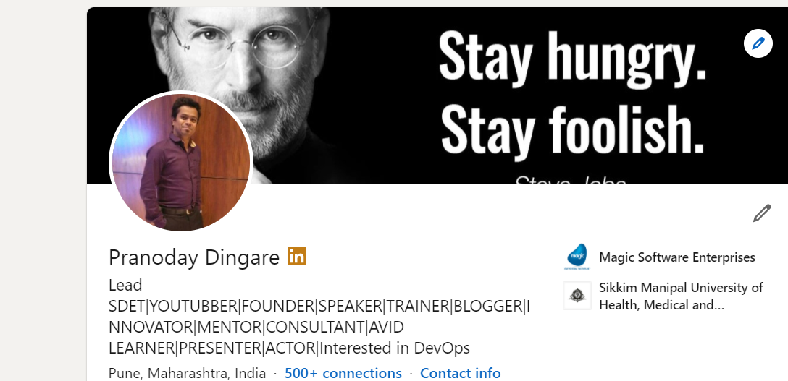

**Name**:Pranoday P Dingare

**Work Experience**:**More than 14 years experience in Software Quality Assurance**

**Worked for initial 4 years as Manual Tester**

**10+ years into TestAutomation as Individual Contributor**

**ISTQB Foundation,ISTQB Advanced(Test Analyst module),CSI Certified professional**

**Been part of various TestAutomation projects using tools like:**

TestComplete,UFT(Desktop App automation),Seeetest(Mobile Automation),Appium(Mobile Automation),Selenium,Protractor(WebApp automation)

**Been into trainings since last 9+ years.Conducted 100+ training programs and trained 2000+ professionals.**

**Have conducted various Retail & Corporate trainings on:**

ISTQB Workshops

**Automationtools**:Selenium,Appium,SeeTest,TestComplete,UFT,

Postman,Cypress etc.

**Scripting Languages:**Python,C#,Java,VBScript,TypeScript,JavaScript

**DevOps Tools:** Git,Maven,Nexus,Dockers etc.

**LinkedIn Profile:**

[**linkedin.com/in/trainerpranoday-dingare**](https://www.linkedin.com/in/trainerpranoday-dingare)

**Contact Details:**

**EmailID:**pranoday.dingare@gmail.com

**Mobile Number:**9822233115

**Youtube Channel(TrainerPranodayD):**

[**https://studio.youtube.com/channel/UCCrKkDLZlS3pLXd7N8tvl3w**](https://studio.youtube.com/channel/UCCrKkDLZlS3pLXd7N8tvl3w)