Download NodeJs

<https://nodejs.org/en/download/>

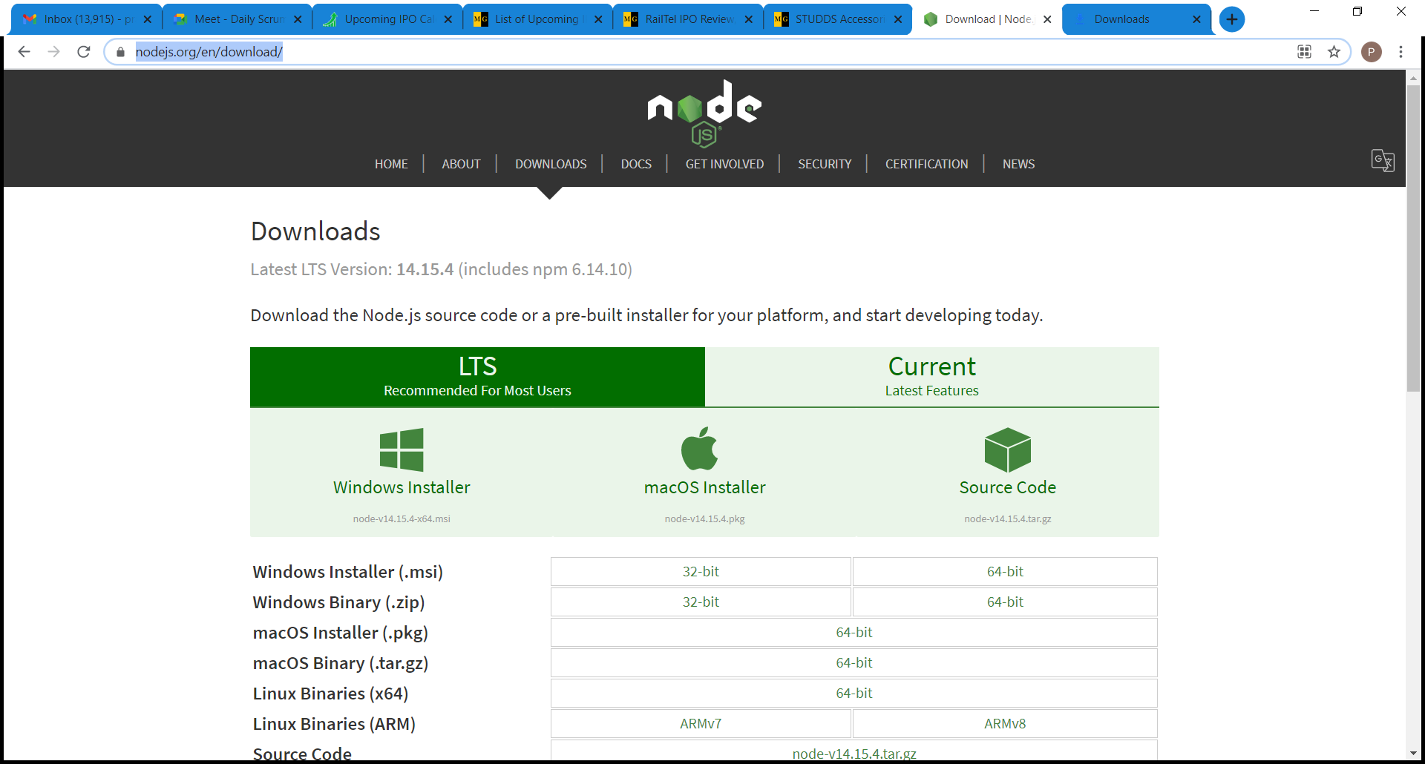

Install nodeJs by running downloaded .msi file

Install appium as a Node Package Module using command:

npm I –g appium

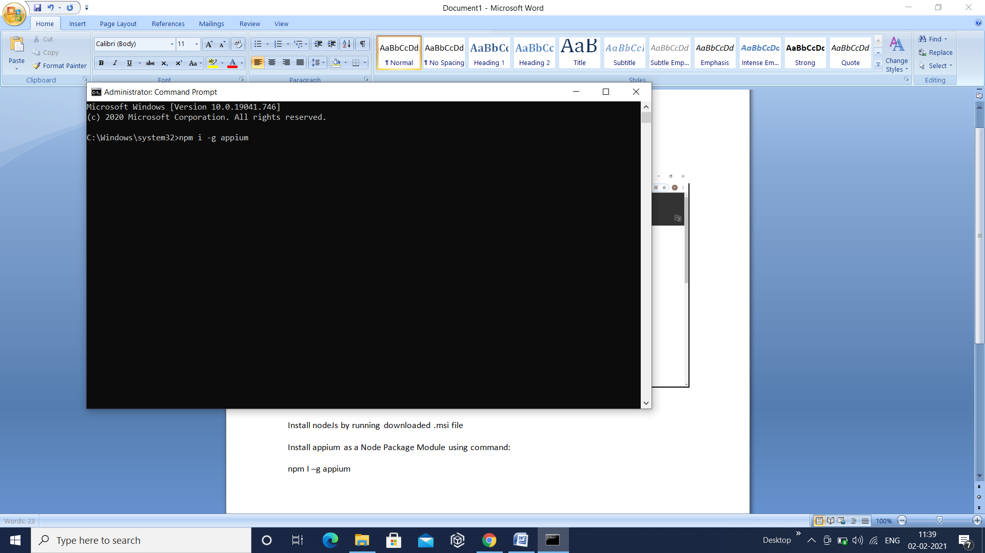

Download appium desktop using following link

**https://github.com/appium/appium-desktop/releases/tag/v1.19.1**

Click on link Appium-windows-1.19.1.exe to download setup exe

Download Eclipse using following link:

<https://www.eclipse.org/downloads/download.php?file=/oomph/epp/2020-12/R/eclipse-inst-jre-win64.exe>

**Choose Eclipse IDE for JAVA Developers option to download and install Eclipse**

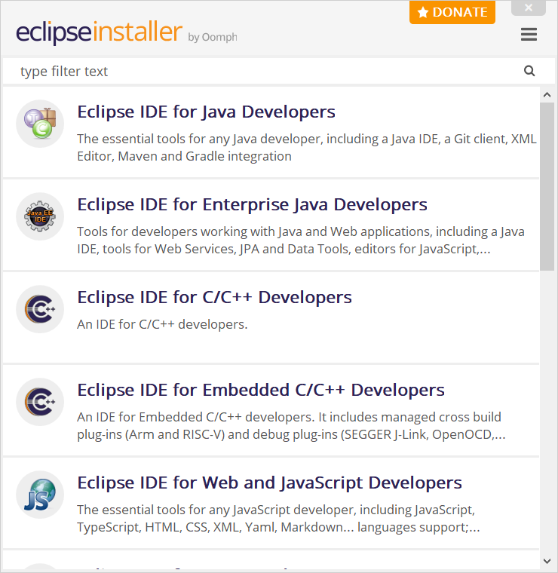

**Install TestNG :**

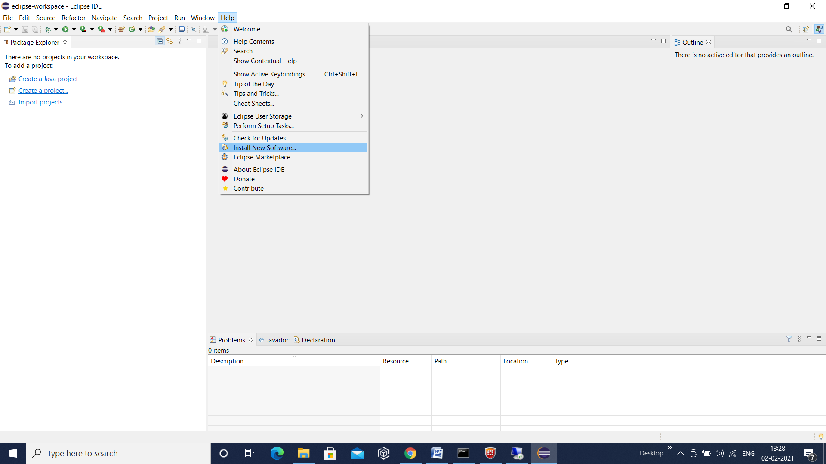

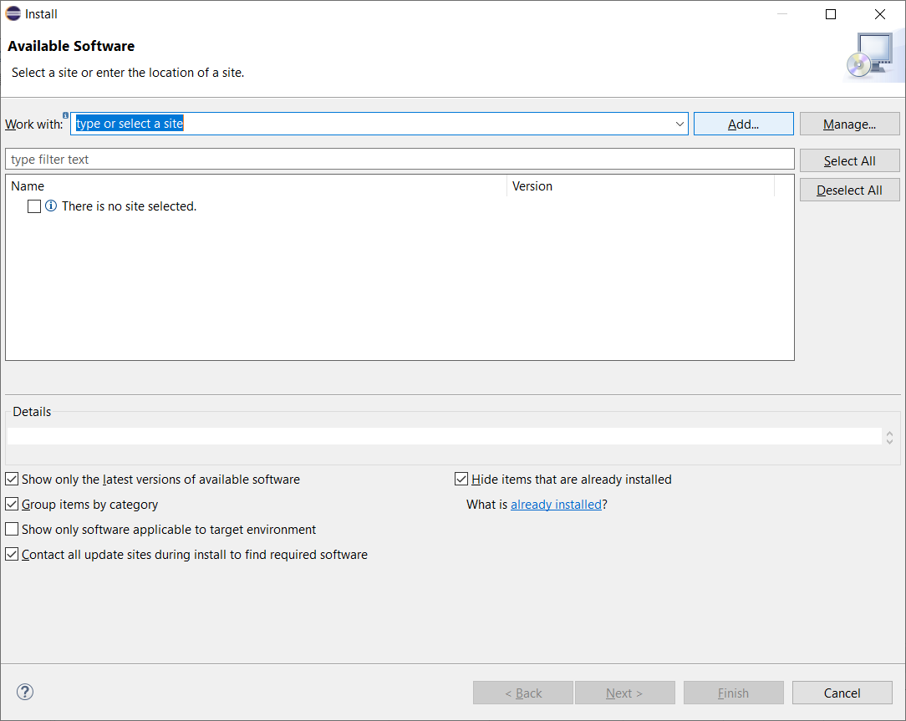

**https://dl.bintray.com/testng-team/testng-eclipse-release/**

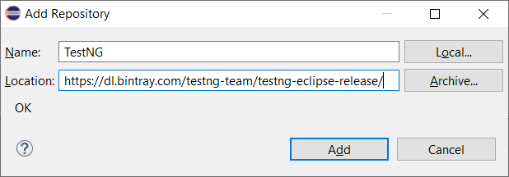

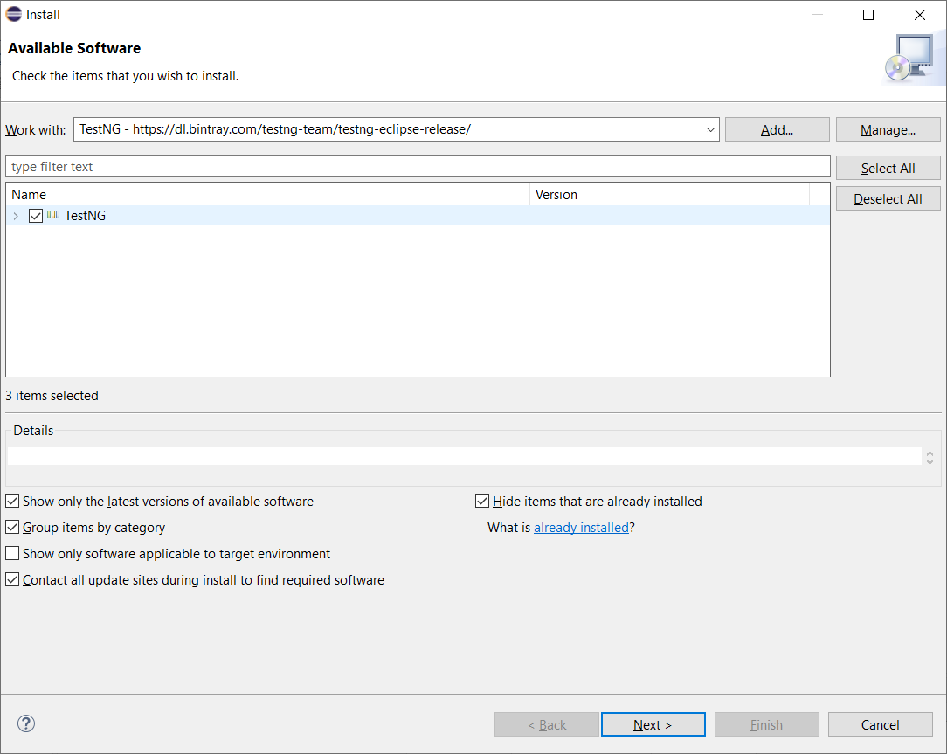

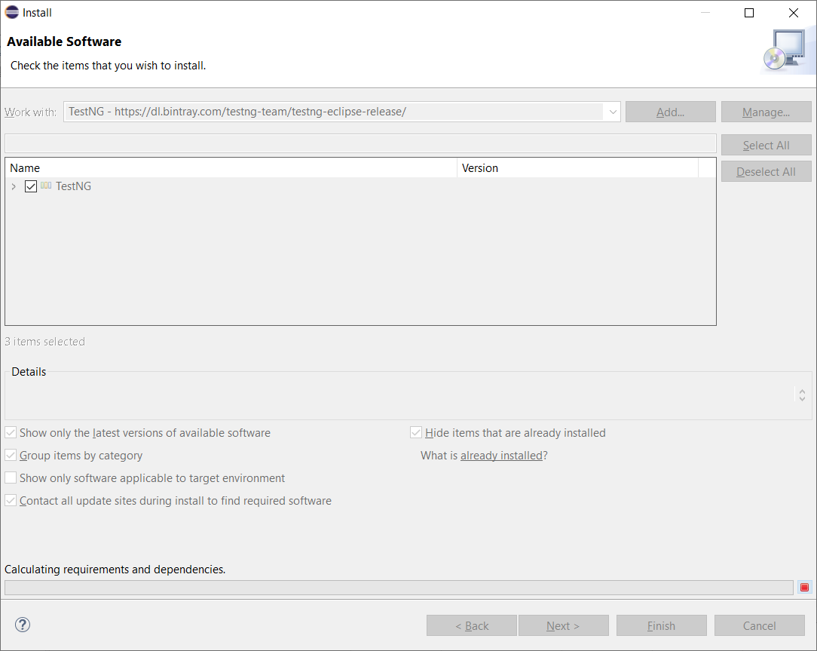

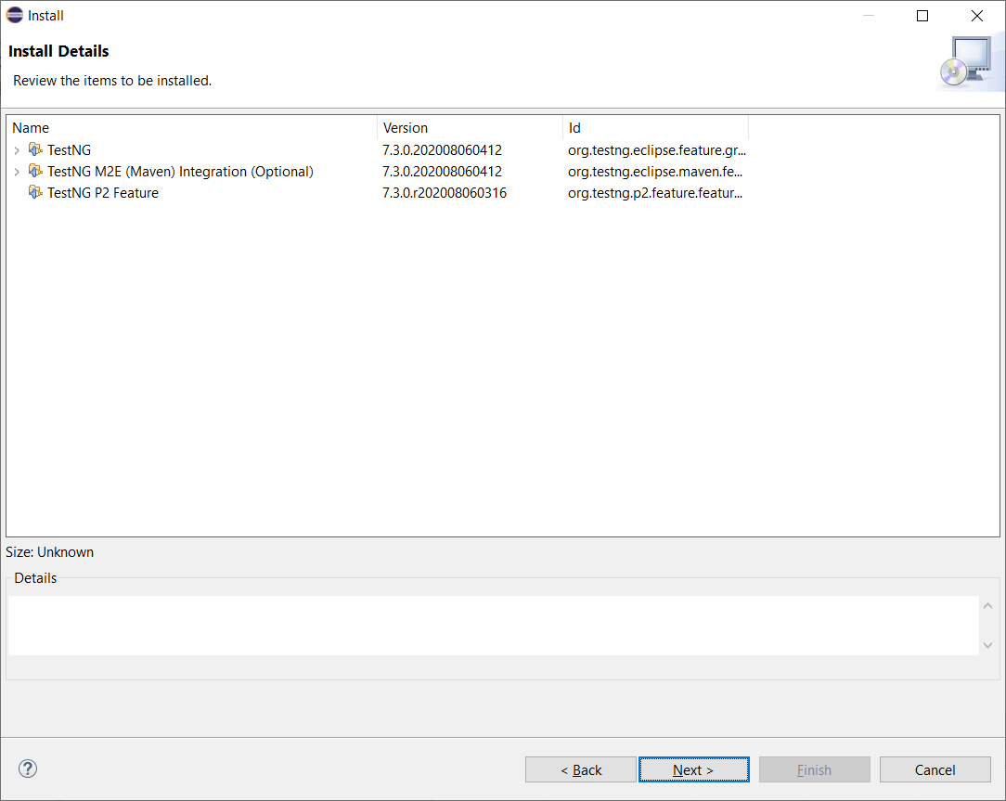

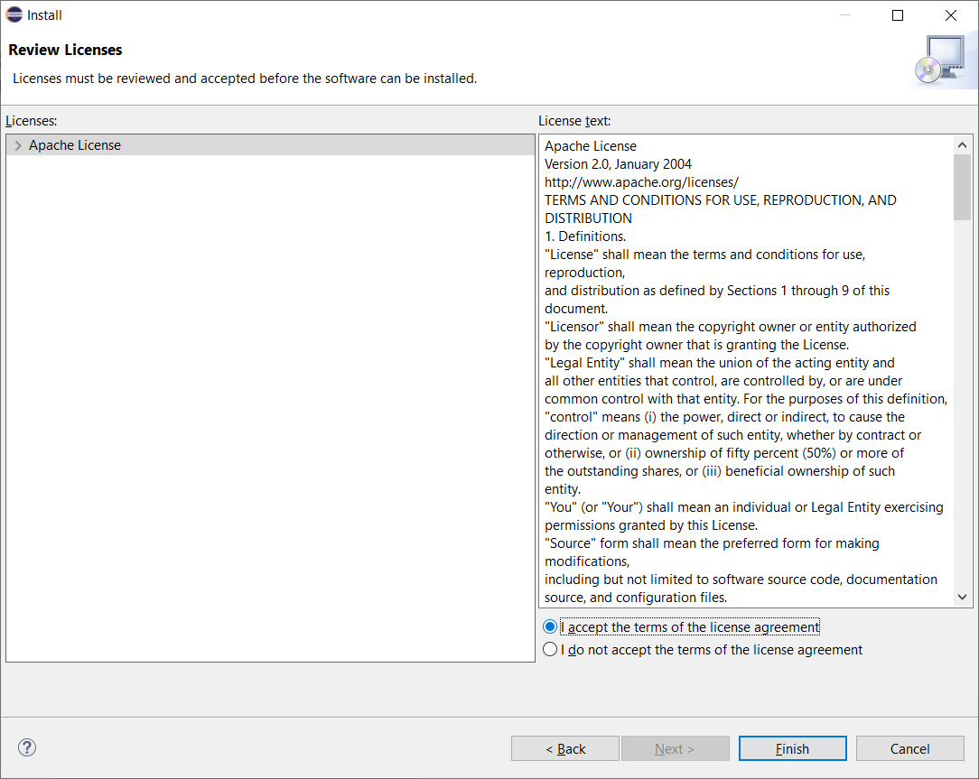

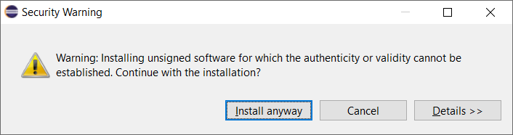

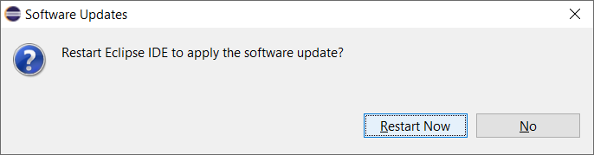

**Download Android SDK**

<https://developer.android.com/studio>

**Download Android Platform tools**

<https://developer.android.com/studio/releases/platform-tools>