Gatling Load Test Summary

Gatling Version: 3.9.5

Docker platform for Deployed Applications.  
Host vm(172.16.1.67) and Client vm(172.16.1.68) architecture. Specifications are ram of 23GB and 16 cpu cores.

# ASA Load Test (No Delay)

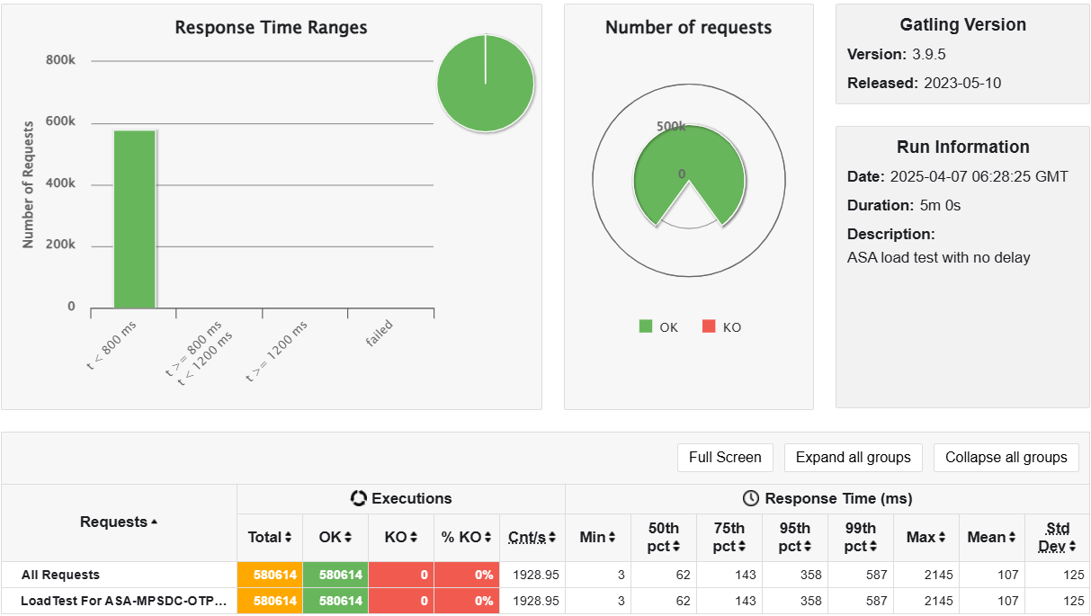

High-Level Summary  
Test Duration: 5 minutes  
  
Total Requests: 580,614  
  
Successful (OK): 580,614 (100%)  
Failures (KO): 0 (0%) ✅  
  
Test Description: ASA load test with no delay  
  
Request Rate:  
Requests per second: ~1929 req/s

# ASA Load Test (With Delay)

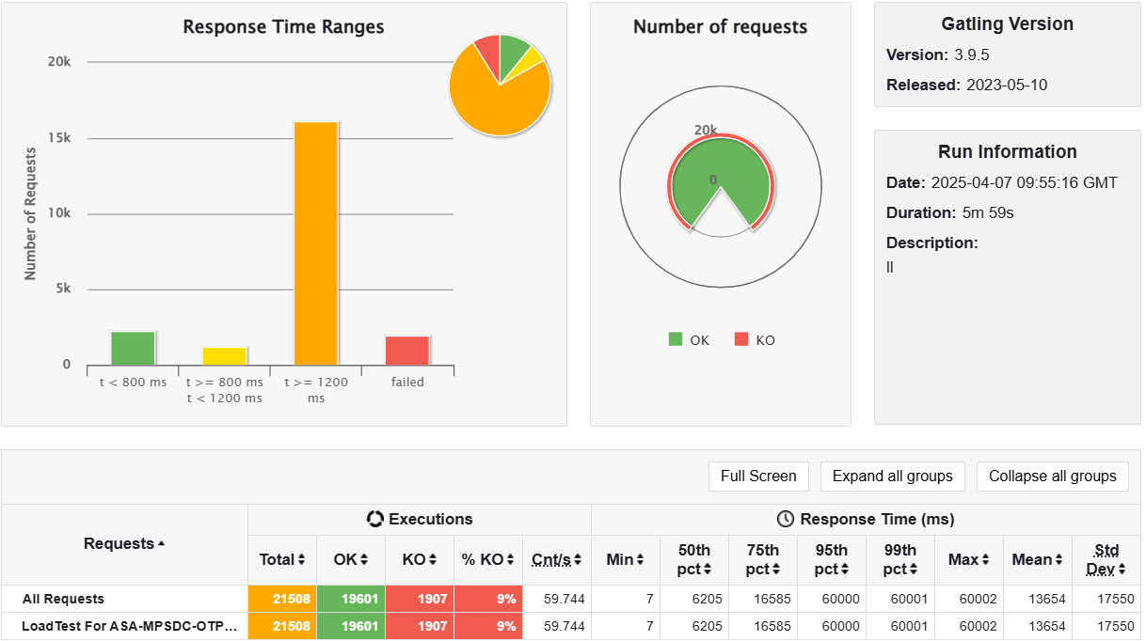

High-Level Summary  
Test Duration: 5 minutes 59 seconds  
  
Total Requests: 21,508  
  
Successful (OK): 19601 (91%)  
Failures (KO): 1907 (9%) ✅  
  
Test Description: ASA load test with delay of 3 Seconds in of container out of available 3 containers.  
  
Request Rate:  
Requests per second: ~60 req/s

# STUB Load Test

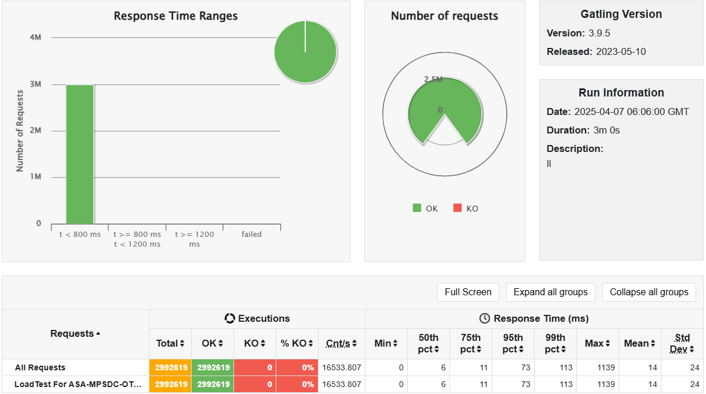

High-Level Summary  
Test Duration: 3 minutes  
  
Total Requests: 2,992,619  
  
Successful (OK): 2,992,619 (100%)  
Failures (KO): 0 (0%) ✅  
  
Test Description: Stub load test with No Delay  
  
Request Rate:  
Requests per second: ~16,534 req/s

# STUB Load Test (With Delay)

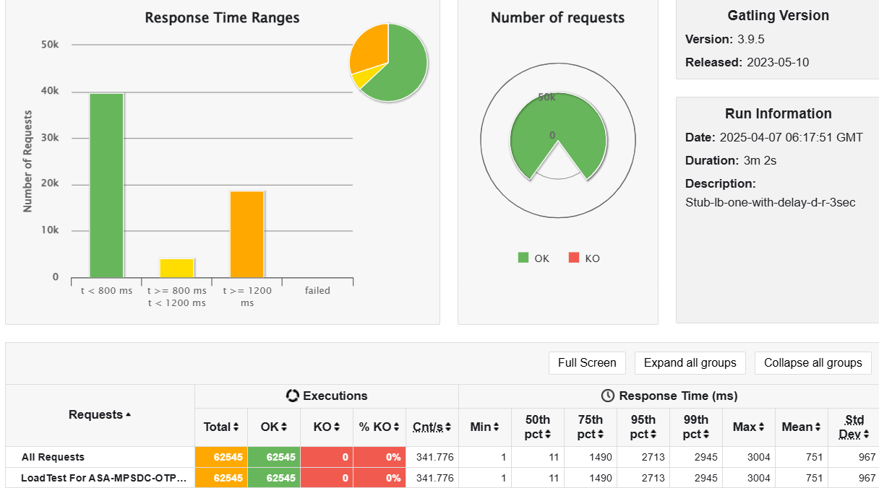

High-Level Summary  
Test Duration: 3 minutes 2 seconds  
  
Total Requests: 62,545  
  
Successful (OK): 62545 (100%)  
Failures (KO): 0 (0%) ✅  
  
Test Description: Stub load test with Delay of 3 second in one of container out of 3 containers  
  
Request Rate:  
Requests per second: ~342 req/s

# Infrastructure Information

