**Lab Sheet for JAVA Practical**

Prepared by- Sagar Neupane

Bsc CSIT 7th Sem

Submitted to – Mr. Ashok Chand

Lecturer of Banke Bageshwori College

Subject : Advance Java Programming

Qn.1 : Write a Java program to Print “Hello world”.

Solution:-

To print anything on console using java program we use the function called println() and to call that function we use the instance called System and out

So by combining all these we use the syntax :  
System.out.println();

To use the object System we need a static main method so that we can access it

Hence our code looks like this:

Class sagar

{

Public static void main(string[] args)

{

System.out.println(“Hello World”);

}

}

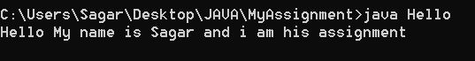

Qn2. Write a program to demonstrate one dimensional array.

Solution: Array are those container that stores same datatypes. Inside array we can have multiple values and they can be accessed uniquely by naming their index no. By default array index starts from zero.

Here is procedural example on how to create one dimensional array in java

class oneDimensionalArray

{

public static void main(string[] args)

{

int[] myarr = {1,2,3,4};

for(int i=0;i<4;i++)

{

System.out.println(myarr[i])

}

}

}

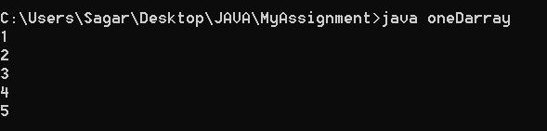

Qn 3 . Write a program to find the following:-

1. Prime number Checking
2. Sum of Digits
3. Prime Number Checking

import java.util.Scanner;

class PrimeNumber

{

public static void main(String args[])

{

Scanner sc = new Scanner(System.in);

System.out.println("Enter the Number ");

int mynum = sc.nextInt();

int count = 0;

for(int i=1;i<=mynum;i++)

{

if(mynum%i ==0)

{

count++;

}

}

if(count<=2)

{

System.out.println("The number is prime");

}

else

{

System.out.println("The Number is Composite");

}

}

}

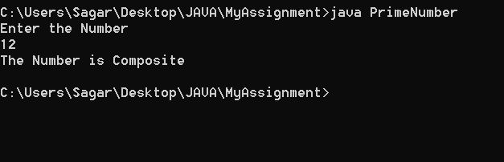

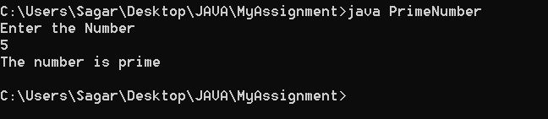

b. Sum of Digits in number

Solution:-

import java.util.Scanner;

class addDigits

{

public static void main(String args[])

{

Scanner sc = new Scanner(System.in);

System.out.print("Enter the Number whose digits you want to add:\t");

int myNum = sc.nextInt();

String sNum = String.valueOf(myNum);

int added = 0;

for(int i=0;i<sNum.length();i++)

{

int backNum = myNum%10;

added = added + backNum;

myNum = myNum /10;

}

System.out.println(added);

}

}

