**What is Software Configuration Management?**

In Software Engineering, **Software Configuration Management(SCM)** is a process to systematically manage, organize, and control the changes in the documents, codes, and other entities during the Software Development Life Cycle. The primary goal is to increase productivity with minimal mistakes. SCM is part of cross-disciplinary field of configuration management and it can accurately determine who made which revision.

## Why do we need Configuration management?

The primary reasons for Implementing Technical Software Configuration Management System are:

* There are multiple people working on software which is continually updating
* It may be a case where multiple version, branches, authors are involved in a software config project, and the team is geographically distributed and works concurrently
* Changes in user requirement, policy, budget, schedule need to be accommodated.
* Software should able to run on various machines and Operating Systems
* Helps to develop coordination among stakeholders
* SCM process is also beneficial to control the costs involved in making changes to a system

**Tasks in SCM process**

* Configuration Identification
* Baselines
* Change Control
* Configuration Status Accounting
* Configuration Audits and Reviews

**Configuration Identification:**

Configuration identification is a method of determining the scope of the software system. With the help of this step, you can manage or control something even if you don’t know what it is. It is a description that contains the CSCI type (Computer Software Configuration Item), a project identifier and version information.

**Activities during this process:**

* Identification of configuration Items like source code modules, test case, and requirements specification.
* Identification of each CSCI in the SCM repository, by using an object-oriented approach
* The process starts with basic objects which are grouped into aggregate objects. Details of what, why, when and by whom changes in the test are made
* Every object has its own features that identify its name that is explicit to all other objects
* List of resources required such as the document, the file, tools, etc.

Example:

Instead of naming a File login.php its should be named login_v1.2.php where v1.2 stands for the version number of the file

Instead of naming folder “Code” it should be named “Code_D” where D represents code should be backed up daily.

**Baseline:**

A baseline is a formally accepted version of a software configuration item. It is designated and fixed at a specific time while conducting the SCM process. It can only be changed through formal change control procedures.

**Activities during this process:**

* Facilitate construction of various versions of an application
* Defining and determining mechanisms for managing various versions of these work products
* The functional baseline corresponds to the reviewed system requirements
* Widely used baselines include functional, developmental, and product baselines

In simple words, baseline means ready for release.

**Change Control:**

Change control is a procedural method which ensures quality and consistency when changes are made in the configuration object. In this step, the change request is submitted to software configuration manager.

Activities during this process:

* Control ad-hoc change to build stable software development environment. Changes are committed to the repository
* The request will be checked based on the technical merit, possible side effects and overall impact on other configuration objects.
* It manages changes and making configuration items available during the software lifecycle

**Configuration Status Accounting:**

Configuration status accounting tracks each release during the SCM process. This stage involves tracking what each version has and the changes that lead to this version.

**Activities during this process:**

* Keeps a record of all the changes made to the previous baseline to reach a new baseline
* Identify all items to define the software configuration
* Monitor status of change requests
* Complete listing of all changes since the last baseline
* Allows tracking of progress to next baseline
* Allows to check previous releases/versions to be extracted for testing

**Configuration Audits and Reviews:**

Software Configuration audits verify that all the software product satisfies the baseline needs. It ensures that what is built is what is delivered.

**Activities during this process:**

* Configuration auditing is conducted by auditors by checking that defined processes are being followed and ensuring that the SCM goals are satisfied.
* To verify compliance with configuration control standards. auditing and reporting the changes made
* SCM audits also ensure that traceability is maintained during the process.
* Ensures that changes made to a baseline comply with the configuration status reports
* Validation of completeness and consistency

**Participant of SCM process:**

Following are the key participants in SCM

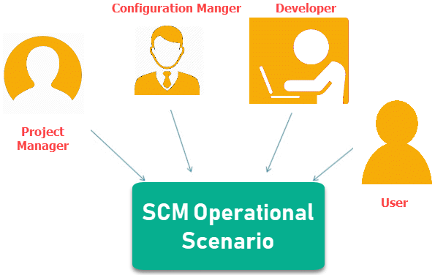

**1. Configuration Manager**

* Configuration Manager is the head who is Responsible for identifying configuration items.
* CM ensures team follows the SCM process
* He/She needs to approve or reject change requests

**2. Developer**

* The developer needs to change the code as per standard development activities or change requests. He is responsible for maintaining configuration of code.
* The developer should check the changes and resolves conflicts

**3. Auditor**

* The auditor is responsible for SCM audits and reviews.
* Need to ensure the consistency and completeness of release.

**4. Project Manager:**

* Ensure that the product is developed within a certain time frame
* Monitors the progress of development and recognizes issues in the SCM process
* Generate reports about the status of the software system
* Make sure that processes and policies are followed for creating, changing, and testing

**5. User**

The end user should understand the key SCM terms to ensure he has the latest version of the software