**Sqoop-Hive Integration**

**Project folder Structure:**

**Ots.sh:** One-time Load script. It creates RDBMS & HIVE schemas

It will load **1st day** data if Source files available in **Source** folder

**Daily-load.sh:** One-time Load script. It creates RDBMS & HIVE schemas

It will load **subsequent days** data if Source files available in **Source** folder.

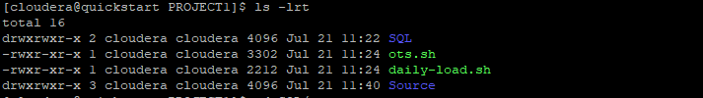

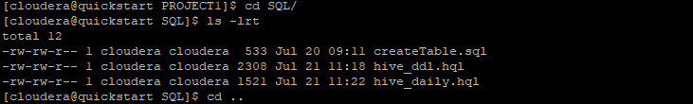

**Error Message If Source Files are not available for processing**

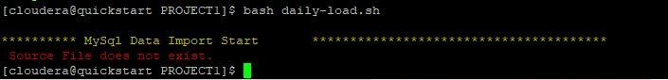

**1ST DAY Execution Results**

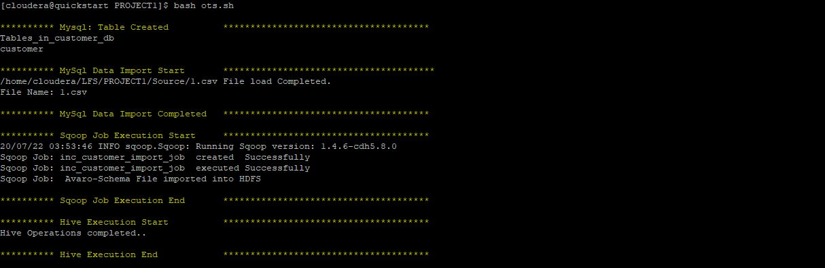

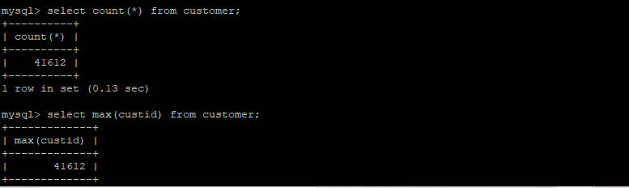



**2nd DAY Execution Results:**

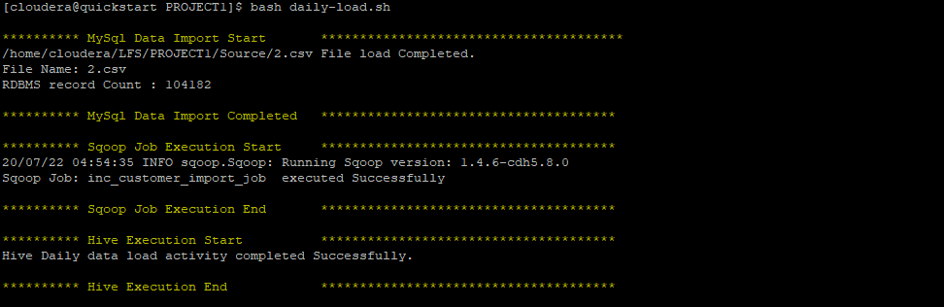

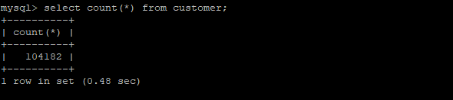

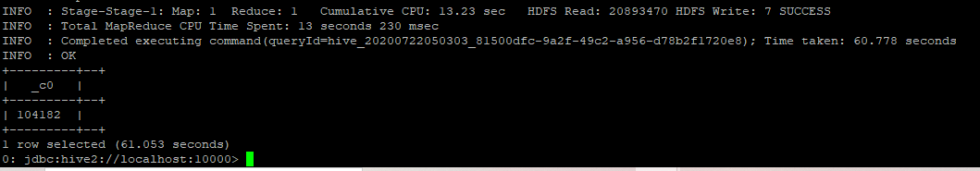

**Partitions of tbl_external_customer**

0: jdbc:hive2://localhost:10000> show partitions tbl_external_customer;

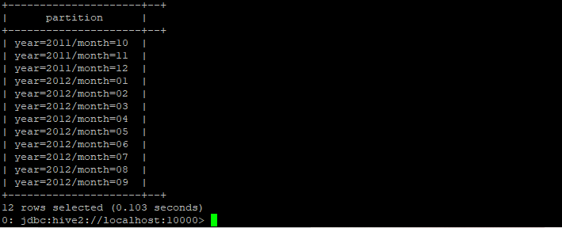

**Drop Manage Table from Hive Schema**

