**VoterChain**

**A** **decentralized** **voting** **system** **created** **with** **Blockchain,Node.js** **and** **React**

Sagar Ajay Parker

**What** **is** **blockchain?**

• A blockchain is a public ledger of information collected through a network that sits on top of the internet.

• The name blockchain is derived from the method that the technology uses to stores data into blocks which link to form a chain.

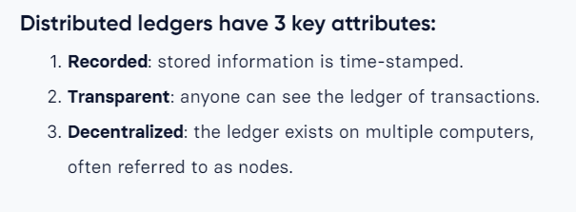• Once the data is recorded in a block it cannot be altered without having to change every block that came after it, making it impossible to do so without it being seen by the other participants on the network.

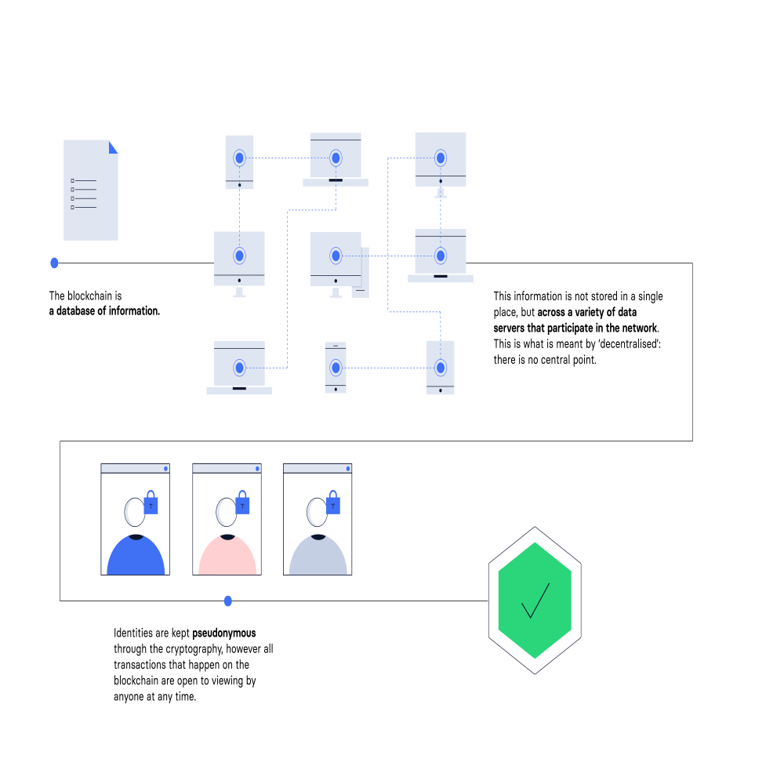

**Current voting system and issues related to EVM:**

Electronic Voting Machine (also known as EVM) is voting using

electronic means to either aid or take care of the chores of casting and

counting votes.

* Attacker with brief access to EVMs can tamper with votes and potentially change election outcomes.
* Dishonest election insiders or other criminals could alter election results by replacing parts of the machines with malicious look-alike parts.
* Attackers could use portable hardware devices to change the vote records stored in the machines.

**What** **is** **VoterChain** **?**

• VoterChain is a new form of voting system created by implementing blockchain.

• It is a distributed form of storing users votes using public blockchain technology.

• VoterChain allows voters to vote from anywhere in the world with a active internet connection and a registered phone number.

• A vote casted by a voter is stored as a block in the blockchain after being mined by public mining nodes in the VoterChain network.

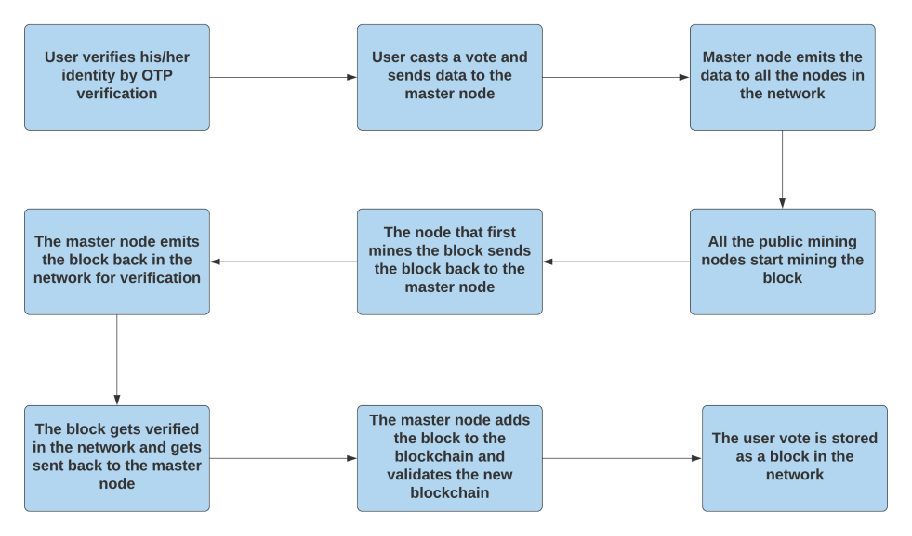**How** **VoterChain** **Works**

**Technologies** **used**

• **Front-end** : • **Back-end** : • **WebSocket** :

React Node.js Socket.io

• **Primary** **Language** : Javascript

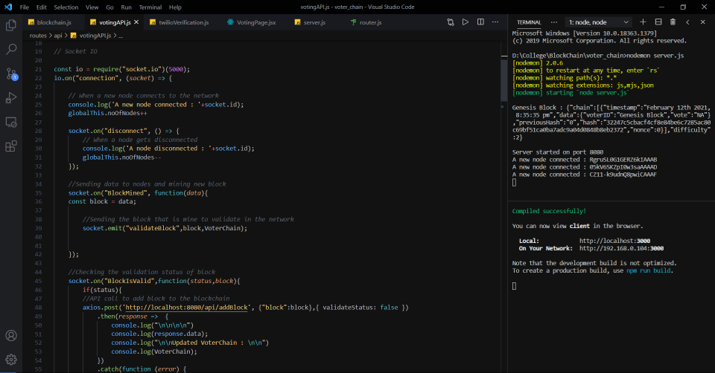**Master** **Node**

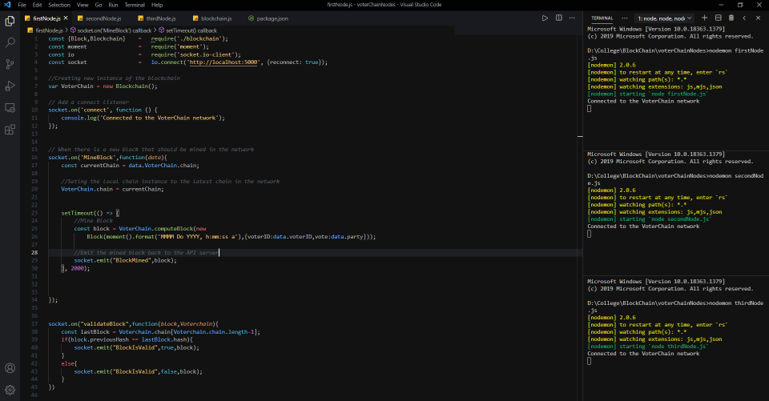**Mining** **Node**

**Code :**

**Blockchain**

const SHA256 = require('crypto-js/sha256');

const moment = require('moment');

class Block{

constructor(timestamp,data,previousHash = ""){

this.timestamp = timestamp;

this.data = data;

this.previousHash = previousHash;

this.hash = this.calculateHash();

this.nonce = 0;

}

calculateHash(){

return SHA256(this.timestamp + this.previousHash + this.nonce +JSON.stringify(this.data) ).toString();

}

//Proof of Work

mineBlock(difficulty){

while(this.hash.substring(0, difficulty) !== Array(difficulty + 1).join("0")){

this.nonce++;

this.hash = this.calculateHash();

}

console.log("Block mined : "+ this.hash);

}

}

class Blockchain{

constructor(){

this.chain = [this.createGenesisBlock()];

this.difficulty = 2;

}

createGenesisBlock(){

return new Block(moment().format('MMMM Do YYYY, h:mm:ss a'),{voterID:'Genesis Block',vote:'NA'}, "0");

}

getLatestBlock(){

return this.chain[this.chain.length -1];

}

computeBlock(newBlock){

newBlock.previousHash = this.getLatestBlock().hash;

newBlock.mineBlock(this.difficulty);

return newBlock;

}

addBlock(computedBlock){

this.chain.push(computedBlock);

}

isChainValid(){

for(let i = 1; i < this.chain.length; i++){

const currentBlock = this.chain[i];

const previousBlock = this.chain[i-1];

function calculateHash(){

return SHA256(currentBlock.timestamp + currentBlock.previousHash + currentBlock.nonce +JSON.stringify(currentBlock.data)).toString();

}

if(currentBlock.hash !== calculateHash()){

return false

}

if(currentBlock.previousHash !== previousBlock.hash){

return false;

}

}

return true;

}

}

module.exports.Block = Block;

module.exports.Blockchain = Blockchain;

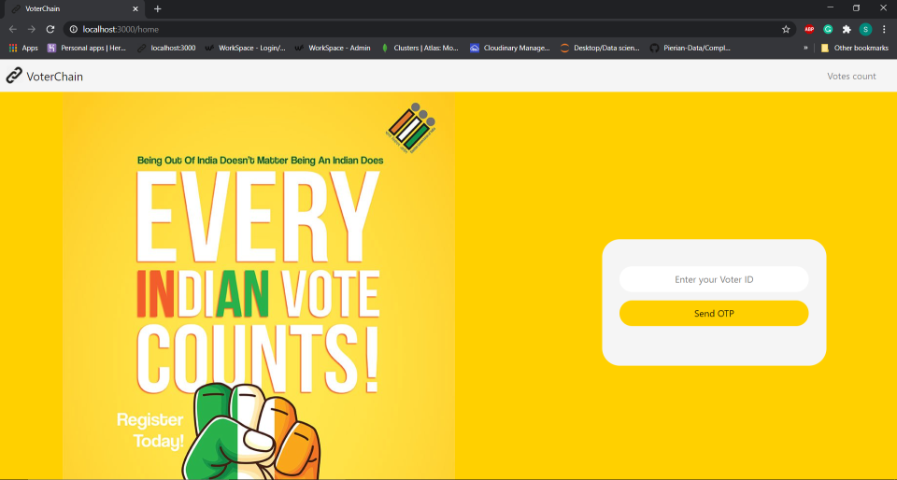**Output** **:** **Homescreen**

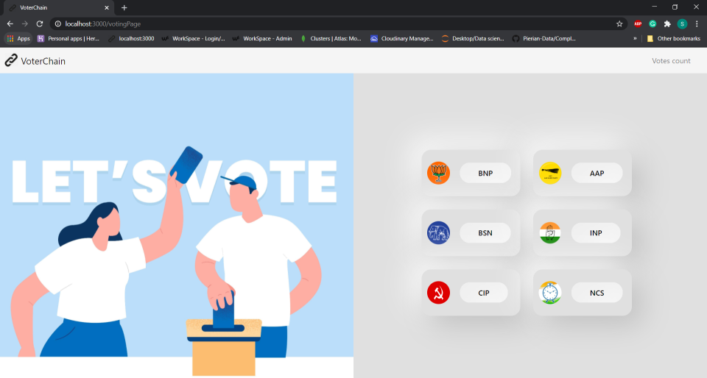**Output** **:** **Voting** **page**

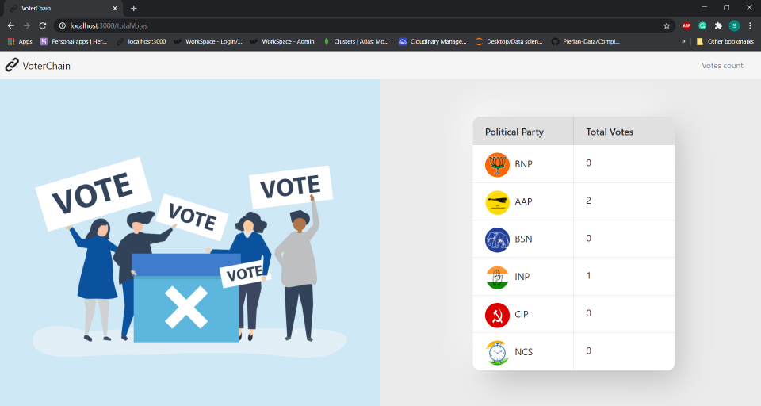**Output** **:** **Votes** **count** **page**

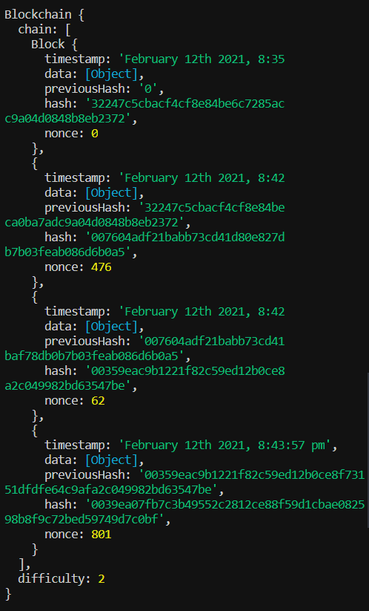**Output** **:** **Final** **Blockchain**

**Conclusion**

* VoterChain can help fix the current issue of EVM tampering with the help of blockchain technology.
* With the help of VoterChain users can vote from any part of the world with registered voters ID and a registered phone no which will lead to an increase in the voting turnout.
* VoterChain can help fix the issue of fake votes in the current EVM system.

**Bibliography :**

<https://www.investopedia.com/news/how-blockchain-technology-can-prevent-voter-fraud/>

<https://en.wikipedia.org/wiki/Blockchain>

<https://socket.io/>

<https://www.npmjs.com/package/axios>

**Thank** **you** **!**