Sentiment Analysis Assignment Submission
Program language: Python
The program accepts a text string and classifies it as Positive, Negative, or Neutral. It uses TextBlob automatically when available and a small fallback lexicon in environments where TextBlob is not installed.

Program Operations and Test Screenshots

Positive program run
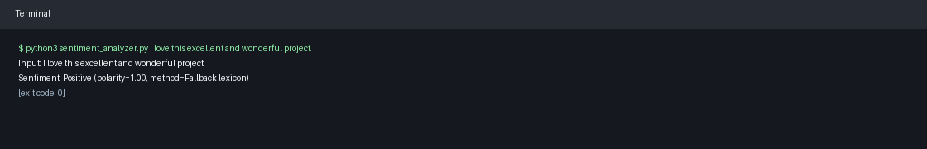

Negative program run
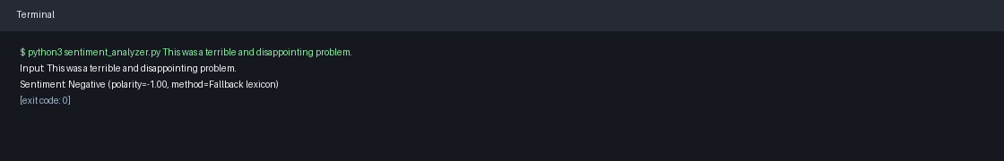

Neutral program run
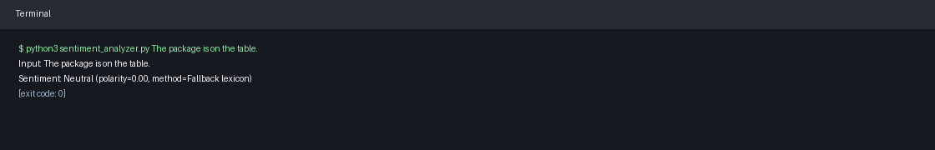

Unit tests
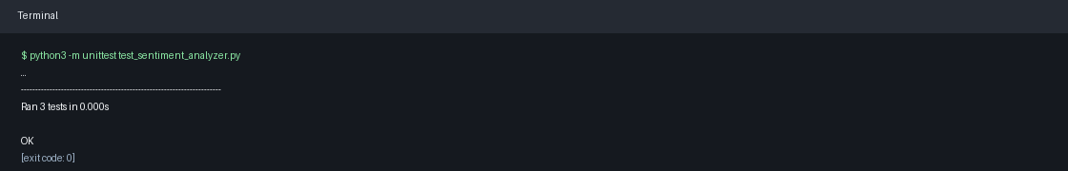

Dataset-style CSV evaluation
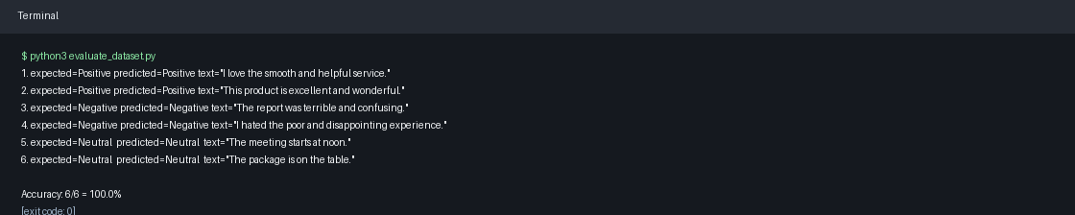

Testing Summary
The unit tests cover all three required sentiments: Positive, Negative, and Neutral. The sample CSV evaluation demonstrates dataset-style testing on six labeled examples.

Source Code: sentiment_analyzer.py
"""Simple sentiment analyzer for a text string.
The program uses TextBlob when it is installed. If TextBlob is unavailable,
it falls back to a small transparent word-score analyzer so the assignment can
still run in a clean Python environment.
"""
from __future__ import annotations
import argparse
import re
from dataclasses import dataclass
POSITIVE_WORDS = {
"amazing",
"awesome",
"beautiful",
"best",
"calm",
"delightful",
"enjoy",
"excellent",
"fantastic",
"good",
"great",
"happy",
"helpful",
"impressive",
"love",
"loved",
"nice",
"perfect",
"pleasant",
"positive",
"recommend",
"smooth",
"success",
"wonderful",
}
NEGATIVE_WORDS = {
"angry",
"awful",
"bad",
"broken",
"confusing",
"disappointing",
"dislike",
"fail",
"failed",
"hate",
"hated",
"horrible",
"negative",
"poor",
"problem",
"sad",
"terrible",
"unhappy",
"unpleasant",
"worst",
}
@dataclass(frozen=True)
class SentimentResult:
text: str
sentiment: str
polarity: float
method: str
def _fallback_polarity(text: str) -> float:
words = re.findall(r"[a-z']+", text.lower())
if not words:
return 0.0
positive_count = sum(word in POSITIVE_WORDS for word in words)
negative_count = sum(word in NEGATIVE_WORDS for word in words)
scored_words = positive_count + negative_count
if scored_words == 0:
return 0.0
return (positive_count - negative_count) / scored_words
def _classify_polarity(polarity: float) -> str:
if polarity > 0.05:
return "Positive"
if polarity < -0.05:
return "Negative"
return "Neutral"
def analyze_sentiment(text: str) -> SentimentResult:
"""Return Positive, Negative, or Neutral for the supplied text."""
try:
from textblob import TextBlob # type: ignore
polarity = float(TextBlob(text).sentiment.polarity)
method = "TextBlob"
except Exception:
polarity = _fallback_polarity(text)
method = "Fallback lexicon"
return SentimentResult(
text=text,
sentiment=_classify_polarity(polarity),
polarity=polarity,
method=method,
)
def build_message(result: SentimentResult) -> str:
return (
f'Sentiment: {result.sentiment} '
f'(polarity={result.polarity:.2f}, method={result.method})'
)
def main() -> None:
parser = argparse.ArgumentParser(
description="Classify a text string as Positive, Negative, or Neutral."
)
parser.add_argument("text", help="Text string to analyze")
args = parser.parse_args()
result = analyze_sentiment(args.text)
print(f"Input: {result.text}")
print(build_message(result))
if __name__ == "__main__":
main()

Source Code: test_sentiment_analyzer.py
import unittest
from sentiment_analyzer import analyze_sentiment, build_message
class SentimentAnalyzerTests(unittest.TestCase):
def test_positive_sentiment(self):
result = analyze_sentiment("I love this excellent and wonderful project.")
self.assertEqual(result.sentiment, "Positive")
self.assertIn("Sentiment: Positive", build_message(result))
def test_negative_sentiment(self):
result = analyze_sentiment("This was a terrible and disappointing problem.")
self.assertEqual(result.sentiment, "Negative")
self.assertIn("Sentiment: Negative", build_message(result))
def test_neutral_sentiment(self):
result = analyze_sentiment("The package is on the table.")
self.assertEqual(result.sentiment, "Neutral")
self.assertIn("Sentiment: Neutral", build_message(result))
if __name__ == "__main__":
unittest.main()

Source Code: evaluate_dataset.py
"""Evaluate the sentiment analyzer on a CSV dataset with text and label columns."""
from __future__ import annotations
import csv
from pathlib import Path
from sentiment_analyzer import analyze_sentiment
def evaluate(path: Path) -> tuple[int, int]:
correct = 0
total = 0
with path.open(newline="", encoding="utf-8") as handle:
reader = csv.DictReader(handle)
for row in reader:
expected = row["label"]
predicted = analyze_sentiment(row["text"]).sentiment
total += 1
correct += predicted == expected
print(
f'{total}. expected={expected:<8} predicted={predicted:<8} '
f'text="{row["text"]}"'
)
return correct, total
def main() -> None:
dataset_path = Path("sample_sentiment_dataset.csv")
correct, total = evaluate(dataset_path)
accuracy = correct / total if total else 0
print(f"\nAccuracy: {correct}/{total} = {accuracy:.1%}")
if __name__ == "__main__":
main()

Related ChatGPT Session History
User prompt:
1.Takes a text string as input
2.Outputs a message about the sentiment of the text string, whether it's "Positive", "Negative" or "Neutral". See also Sentiment Analysis
Include tests showing all the sentiments and submit a word document with screenshots of the program operations and tests.
Use any programming language you prefer
Include the entire related LLM (ChatGPT) session history in your submission for this assignment, including all the prompts you used.
Try Testing it on a sentiment dataset, e.g., https://www.kaggle.com/datasets/abhi8923shriv/sentiment-analysis-dataset
Hint: TextBlob
Assistant prompts/actions used in this session:
- Inspected the repository structure to choose a clean location for assignment files.
- Used the document-generation instructions because the requested deliverable is a Word document.
- Checked whether TextBlob was installed in the runtime. It was not available.
- Implemented a Python sentiment analyzer that uses TextBlob when installed and a fallback lexicon otherwise.
- Added unit tests covering Positive, Negative, and Neutral outputs.
- Added a small dataset-style CSV and evaluator to demonstrate batch sentiment testing without requiring Kaggle credentials.
- Ran all example program operations, unit tests, and dataset evaluation.
- Generated this Word document with screenshots of the program and tests.

