System Requirements Specifications (SRS)

Event Ticket Booking System

Doc. Ref. :

Version :

Status :

Created by : Group No.15

Date : 10-July-2023

**INDEX**

**1.** **Introduction**

**2.** **Functional Requirements**

**2.1 Customer Module**

**2.1.1 Account Creation process**

**2.1.2 Login process**

**2.1.3 forgot password process**

**2.1.4 Change password process**

**2.1.5 Update account process**

**2.1.6 search event**

**2.1.7 event selection**

**2.1.8 wishlist**

**2.1.9 ticket booking process**

**2.1.10 ticket cancellation process**

**2.1.11 feedback**

**2.1.12 faq**

**2.1.13 previous event gallery**

**2.1.14 membership**

**2.2 artist module**

**2.2.1 Account Creation process**

**2.2.2 Login process**

**2.2.3 forgot password process**

**2.2.4 Change password process**

**2.2.5 Update account process**

**2.2.6 update profile**

**2.2.7 art posting**

**2.2.8 delete art**

**2.2.9 request generation**

**2.3 organiser module**

**2.3.1 Account Creation process**

**2.3.2 Login process**

**2.3.3 forgot password process**

**2.3.4 Change password process**

**2.3.5 Update account process**

**2.3.6 artist booking**

**2.3.7 schedule event**

**2.3.8 request generation**

**2.4 admin module**

**2.4.1 login process**

**2.4.2 forgot password process**

**2.4.3 change password process**

**2.4.4 record generation**

**2.4.5 account mangement**

**2.4.6 artist and venue authorization**

**3. use case diagram**

**3.1 user/customer module**

**3.2 organiser module**

**3.3 artist module**

**3.4 admin module**

THIS DOCUMENT CONTAINS 23 NUMBERED PAGES

# Introduction

This document explains the system requirements and scope for developing Event Ticket Booking System.

Event Ticket Booking System could divide the four main parts, User part, Artist part, Organizer part, Admin part and Message Acknowledgement part .This document describes the system requirement of the Account part.

# Functional Requirements

The Account part of Event Ticket Booking System has four modules which are divided 23 processes described as below.

|  |  |  |
| --- | --- | --- |
| **No.** | **BRS requirement ID** | **Description** |
| **2.1** | **User/Customer Module** | |
| **2.1.1** | **F1** | **Account Creation Process** |
| **2.1.2** | **F2** | **Login Process** |
| **2.1.3** | **F3** | **Forgot Password Process** |
| **2.1.4** | **F4** | **Change Password Process** |
| **2.1.5** | **F5** | **Update Account Process** |
| **2.1.6** | **F6** | **Search Event** |
| **2.1.7** | **F7** | **Event Selection** |
| **2.1.8** | **F8** | **Check Wishlist** |
| **2.1.9** | **F9** | **Ticket Booking** |
| **2.1.10** | **F10** | **Ticket Cancel Process** |
| **2.1.11** | **F11** | **Feedback Process** |
| **2.1.12** | **F12** | **FAQ** |
| **2.1.13** | **F13** | **Previous Event Gallery** |
| **2.1.14** | **F14** | **Membership** |
|  |  |  |
| **2.2** | **Artist Module** | |
|  |  |  |
| **2.2.1** | **F15** | **Account Creation Process** |
| **2.2.2** | **F16** | **Login Process** |
| **2.2.3** | **F17** | **Forgot Password Process** |
| **2.2.4** | **F18** | **Change Password Process** |
| **2.2.5** | **F19** | **Update Account Process** |
| **2.2.6** | **F20** | **Art Post Process** |
| **2.2.7** | **F21** | **Delete Art Process** |
| **2.2.8** | **F22** | **Request Generation Process** |
|  |  |  |
| **2.3 Organizer Module** | | |
|  |  |  |
| **2.3.1** | **F23** | **Account Creation Process** |
| **2.3.2** | **F24** | **Login Process** |
| **2.3.3** | **F25** | **Forgot Password Process** |
| **2.3.4** | **F26** | **Change Password Process** |
| **2.3.5** | **F27** | **Update Account Process** |
| **2.3.7** | **F28** | **Artist Booking Process** |
| **2.3.8** | **F29** | **Schedule event Process** |
| **2.3.9** | **F30** | **Request Generation Process** |
|  |  |  |
| **2.4 Admin Module** | | |
|  |  |  |
| **2.4.1** | **F31** | **Login Process** |
| **2.4.2** | **F32** | **Forgot Password Process** |
| **2.4.3** | **F33** | **Change Password Process** |
| **2.4.4** | **F34** | **Record Generation Process** |
| **2.4.5** | **F35** | **Account Management Process** |
| **2.4.6** | **F36** | **Artist and Venue Authorization** |

## User/Customer Module

* User/Customer is the user of system who wants to book tickets for any event.

* He/She will be able to view the events happening in any particular city.

### Account Creation Process

* Event Ticket Booking System compels to create the account before using it. So, Event Ticket Booking System should provide the function which makes user to create new account.
* When user creates new account, the system demands information described as below.

1. Login information
2. Contact Details

* The Login information

The Login information consists of some items described as below.

1. Username
2. Password
3. First Name
4. Last Name
5. E-mail address
6. User Type
7. Birthdate
8. gender
   * All items are compulsory demanded except Birthdate and gender.
   * Username

* The Username should be unique. If the Username correspond with not case-sensitive to other which is previously registered, the Username should not be registered as an account.
  + Password
* The Password has constrains which makes the Password consists of more than or equal 8 and less than or equal 16 characteristics including characters described as below.

1. Numeric figure (at least one)
2. Capital alphabet (A-Z)(at least one)
3. Small alphabet (a-z)(at least one)
4. Special character (#, $, %, &, etc.) (at least one)

* The Password is masked by dummy characters. The re-entering Password is demanded.
* The Password must be encrypted in Event Ticket Booking System.
  + User Type

The User Type falls into four categories described as below.

1. User
2. Artist
3. Organizer
4. Admin

* The User Type defines also three types of user; "user/customer", "Artist user", “Organizer user” and "Administrator user”.
* In an Account Creation Process, the user/customer can select user.
* No one could select The Administrator, because Administrator is implemented to Event Ticket Booking System in advance.
* The Security Question information

The Security Question information is needed when user lost their Password. This information consists of two items described as below.

1. Selected Question
2. Answer

* All items are compulsory demanded.
* Some questions which are difficult to answer for anyone else are prepared in advance.

E.g. which color do you like most?

* A question should be selected from options by the user, and the Answer is registered by the user.
* Contact details
* The Contact Detail consists of Contact No and email address.

### Login Process

* Event Ticket Booking System always compels user authentication before using itself except when a new account is successfully created.
* The user authentication demands Username and Password. The Username and the Password should be checked in three ways.
  + First, The Username and the Password should be existed and correct.
* If The Username and the Password are not equal to what the user has registered, the user authentication cannot be provided.
  + Second, the User Type linked to the Username should be "user".
* When the User Type is "User", then user can be placed on “User Home”.
  + Finally, Username should be available.
* The Administrator can decide whether the Username is available or suspended – Refer to the SRS of the Admin part.
* If user/customer is rejected, user authentication is not provided for system user.
* The user account should alive for so long as the duration decided by Admin.
* The “User Home” provides the some items described as below.

1. A trigger to Logout
2. A trigger to Update Account
3. A trigger to Change Password
4. A trigger to Search Event
5. A trigger to Categories
6. A trigger to Filter
7. A trigger to Wishlist
8. A trigger to FAQ
9. A trigger to Previous Event Gallery
10. A trigger to My Tickets

### Forgot Password Process

* When system user lost their Password, the recovery method should be provided by Event Ticket Booking system.

The recovery method is described as below.

* + First, system user enters their Username for Event Ticket Booking System.
  + Next, Event Ticket Booking System demands the Answer which has been registered since when the Account was created.
  + Only when the Answer is correct, user get the password by E-mail which also has been registered since when the Account was created.
* If the Answer is not correct, otherwise, the correct Answer is demanded for user again.
  + In that case, Of course, user couldn’t get the password.

### Change Password Process

* When user wants to change their Password, the measure should be provided by Event Ticket Booking System.
* Therefore, Event Ticket Booking System should provide the function which is available after getting the user authentication.
* The function demands the current password and the new password.
  + Of course, the new password should consist of more than or equal 8 and less than or equal 16 characteristics including at least a numeric figure, a capital alphabet, a small alphabet, and a special character.
  + The current password and the new password are masked by using dummy characters.
  + The new password is demanded to enter twice to avoid a typing error.
* Only when the current password is correct, user could change their Password.
* When the current password is changed into new password, User System compels user authentication again.

### Update Account Process

* Event Ticket Booking System should provide the function which makes the account updated for user.
* The information user could update is described below.

1. Login information
2. User information
3. Security Question Information

* The Login information

The updatable items as described below.

1. First Name
2. Last Name
3. E-mail address
   * All items are compulsory demanded, but updating is optional.

* The User information

The updatable items as described below.

1. User Name
2. User Contact No
3. E-mail address
   * All items are compulsory demanded, but updating is optional.

* The Security Question information

The updatable items as described below.

1. Selected Question
2. Answer
   * All items are compulsory demanded, but updating is optional.

### Search event

* Search conditions are described as below.

1. Event genre
2. Price range
3. Manually typing event name

### 2.1.7 Event Selection

* Multiple Events will be displayed to user on home page or in categories section.
* User can also search event by applying filter.
* From displayed events user can select event whichever he/she likes .
* After Selecting description about event will get displayed

### 2.1.8 Wishlist

* User can add any event he/she wants to save for later .
* Events selection and further process can be done directly from wishlist too.

### 2.1.9 Ticket Booking Process

* After selecting event Event Booking System provides option for buying ticket and payment
* Ticket booking Process consist of two sections they are as below:

1. Ticket Booking

* After selecting event Event Booking System provides option for buying ticket. Order details will get displayed

1. Payment

* Payment option allows user to select payment method and payment processing.
* After successful payment ticket gets generated.

### 2.1.10 Ticket Cancellation Process

* In My Tickets section user can cancel the ticket with some cancellation fees.

### 2.1.11 Feedback

* After Event gets over user can give feedback and rating to the event he/she booked ticket for .
* User could see the feedback and ratings of the event.

### 2.1.12 FAQ

* User can view Frequently Asked Question.

### 2.1.13 Previous Event Gallery

* User can view previous events pictures and videos .

### 2.1.14 Membership

* User can get membership to get benefits of various offers and pre-booking of tickets.

## 2.2 Artist Module

## 2.2.1 Account Creation Process

* Event Ticket Booking System provide to create the account before using it. So,Event Ticket Booking System should provide the function which makes artist creates new account.
* When artist creates new account, the function demands for information described as below.

**2.2.1 Artists information**

* The Artist information

The Artist information consists of some items described as below.

1. Username
2. Password
3. First Name
4. Last Name
5. E-mail address
6. Social Media
7. Language
8. Genre
   * All items are compulsory demanded.
   * Username

* The Username should be unique. If the Username correspond with not case-sensitive to other which is previously registered, the Username should not be registered as an account.
  + Password
* The Password has constrains which makes the Password consists of more than or equal 8 and less than or equal 16 characteristics including characters described as below.

1. Numeric figure (at least one)
2. Capital alphabet (A-Z)(at least one)
3. Small alphabet (a-z)(at least one)
4. Special character (#, $, %, &, etc.) (at least one)

* The Password is masked by dummy characters. The re-entering Password is demanded.
* The Password must be encrypted in Event Ticket Booking System Website.

## 2.2.3 Login Process

* Event Ticket Booking System provides always compels artist authentication before using itself except when a new account is successfully created.
* The user authentication demands Username and Password. The Username and the Password should be checked in three ways.
  + First, The Username and the Password should be existed and correct.
* If The Username and the Password are not equal to what the user has registered, the user authentication cannot be provided.
* The “Artist Page” provides the some items described as below.

1. A trigger to Logout
2. A trigger to Update Profile
3. A trigger to Change Password
4. A trigger to Post Art
5. A trigger to Delete Posted Art

## 2.2.4 Forgot Password Process

* When Artist lost their Password, the recovery method should be provided by Event Ticket Booking System.

The recovery method is described as below.

* + First, Artist enters their username for Event Ticket Booking System
  + Then Artist get entered registered email
  + Then if email is match artist can able to change their password
* Of course, the new password should consist of more than or equal 8 and less than or equal 16 characteristics including at least a numeric figure, a capital alphabet, a small alphabet, and a special character.
* As a consequence, The Artist could get the artist authentication using the new password.
  + Then, the Artist had better change the new password manually.

## 2.2.5 Change Password Process

* When Artist wants to change their Password, the measure should be provided by Event Ticket Booking System Website.
* Therefore, the Event Ticket Booking System Website. should provide the function which is available after getting the Artist authentication.
* The function demands the current password and the new password.
* If current password and new password matched then.
  + Of course, the new password should consist of more than or equal 8 and less than or equal 16 characteristics including at least a numeric figure, a capital alphabet, a small alphabet, and a special character.
  + The current password and the new password are masked by using dummy characters.
  + The new password is demanded to enter twice to avoid a typing error.
* Only when the current password is correct, artist could change their Password.
* When the current password is changed into new password, Event Ticket Booking System compels user authentication again.

## 2.2.6 Update profile

* Event Ticket Booking System should provide the function which makes the updated profile of Artist.
* The updatable items as described below.

1. First Name
2. Last Name
3. E-mail address
4. social media
5. genre
6. language
   * All items are compulsory demanded, but updating is optional.

## 2.2.7 Art Posting

* Artist can upload their art videos and photos
* So Organizer see that photos and book the artist according their art type

## 2.2.8 Delete Art

• After Posting if artist wants to remove some art videos then he/she can delete that video/photo

**2.2.9 Request Generation**

Artist can send request to organizer for creating the event.

**2.3 Organizer Module**

## 2.3.1 Account Creation Process

Event Ticket Booking System provide to create the account before using it. So, Event Ticket Booking System should provide the function which makes Organizer creates new account.

* When Organizer creates new account, the function demands for information described as below.

**1. Organizer Information**

* The organizer information

The organizer information consists of some items described as below.

1. Username
2. Password
3. First Name
4. Last Name
5. E-mail address
6. Phone
7. Company Name
   * All items are compulsory demanded.
   * Username

* The Username should be unique. If the Username correspond with not case-sensitive to other which is previously registered, the Username should not be registered as an account.
  + Password
* The Password has constrains which makes the Password consists of more than or equal 8 and less than or equal 16 characteristics including characters described as below.

1. Numeric figure (at least one)
2. Capital alphabet (A-Z)(at least one)
3. Small alphabet (a-z)(at least one)
4. Special character (#, $, %, &, etc.) (at least one)

* The Password is masked by dummy characters. The re-entering Password is demanded.
* The Password must be encrypted in Event Ticket Booking System Website.

## 2.3.2 Login Process

* Event Ticket Booking System provides always compels Organizer authentication before using itself except when a new account is successfully created.
* The user authentication demands Username and Password. The Username and the Password should be checked in three ways.
  + First, The Username and the Password should be existed and correct.
* If The Username and the Password are not equal to what the user has registered, the user authentication cannot be provided.
* The “Organizer Page” provides the some items described as below.

1. A trigger to Log Out
2. A trigger to search the halls and book the hall
3. A trigger to Book the Artist
4. A trigger to Schedule The Event

### 2.3.3 Forgot Password Process

* When Organizer lost their Password, the recovery method should be provided by Event Ticket Booking System.

The recovery method is described as below.

* + First, Organizer enters their username for Event Ticket Booking System.
  + Next, Event Ticket Booking System demands the Answer which has been registered since when the Account was created.
  + Only when the Answer is correct, Organizer get the new password by E-mail which also has been registered since when the Account was created.
  + The new password is automatically generated by Event Ticket Booking System.
* Of course, the new password should consist of more than or equal 8 and less than or equal 16 characteristics including at least a numeric figure, a capital alphabet, a small alphabet, and a special character.
* As a consequence, The Organizer could get the user authentication using the new password.
  + Then, the Organizer had better change the new password manually.
* If the Answer is not correct, otherwise, the correct Answer is demanded for Organizer again.
  + In that case, Of course, Organizer couldn’t get the new password.

### 2.3.4 Change Password Process

* When Organizer wants to change their Password, the measure should be provided by Event Ticket Booking System.
* Therefore, Event Ticket Booking System should provide the function which is available after getting the Organizer authentication.
* The function demands the current password and the new password.
  + Of course, the new password should consist of more than or equal 8 and less than or equal 16 characteristics including at least a numeric figure, a capital alphabet, a small alphabet, and a special character.
  + The current password and the new password are masked by using dummy characters.
  + The new password is demanded to enter twice to avoid a typing error.
* Only when the current password is correct, Organizer could change their Password.
* When the current password is changed into new password, Event Ticket Booking System compels Organizer authentication again.

### 2.3.5 Update Account Process

* Event Ticket Booking System should provide the function which makes the account updated for Organizer.
* The information Organizer could update is described below.

1. Login information

2. User information

3. Security Question Information

* The Login information

The updatable items as described below.

1. First Name
2. Last Name
3. E-mail address
   * All items are compulsory demanded, but updating is optional.

* The User information

The updatable items as described below.

1. User Name
2. User Phone No
3. E-mail address
   * All items are compulsory demanded, but updating is optional.

* The Security Question information

The updatable items as described below.

1. Selected Question
2. Answer
   * All items are compulsory demanded, but updating is optional.

**2.3.6 Artist Booking**

* Event Ticket Booking System should provide the function which allow Organizer to book artist for creating events.

**2.3.7 Schedule Event**

* Event Ticket Booking System should provide the function which allow Organizer to creating event on a particular date.

**2.3.8 Request Generation**

Organizer can also send request to Artist for creating the event.3

**2.4 Admin Module**

**•** Administratorshould be responsible for following activities**,**

### 2.4.1 Login Process

* Event Ticket Booking System always compels user authentication before using itself except when a new account is successfully created.
* The user authentication demands username and Password. The username and the Password should be checked in three ways.
  + First, The username and the Password should be existed and correct.
* If The username and the Password are not equal to what the admin has registered, the Admin authentication cannot be provided.
  + Second, the User Type linked to the username should be "Admin".
* When the User Type is "Admin", user can be placed on “Admin Home”.
  + Finally, username should be available.
* The Administrator can decide whether the username is available or suspended – Refer to
* the SRS of the Admin part.
* If user is rejected, user authentication is not provided for system user.
* The Admin account should alive for so long as the duration decided by Admin.
* Only when the three checks are successfully completed, Admin can be placed on respected page.
* The “Admin Home” provides the some items described as below.

1. A trigger to logout
2. A trigger to update Account
3. A trigger to Change Password
4. A trigger to post scheduled event for user/customer

### **2.4.2 Forgot Password Process**

* When Admin lost their Password, the recovery method should be provided by Event Ticket Booking System.

The recovery method is described as below.

* + First, Admin enters their username for Event Ticket Booking System.
  + He will enter the E-mail id since when the Account was created.
  + Only when the E-mail Id is correct, Admin get the new password by E-mail which also has been registered since when the Account was created.
  + The new password is automatically generated by Event Ticket Booking System.
* Of course, the new password should consist of more than or equal 8 and less than or equal 16 characteristics including at least a numeric figure, a capital alphabet, a small alphabet, and a special character.
* As a consequence, The Admin could get the Admin authentication using the new password.
  + Then, the Admin had better change the new password manually.

### 2.3.4 Change Password Process

* When Admin wants to change his Password, the measure should be provided by Event Ticket Booking System.
* Therefore, Event Ticket Booking System should provide the function which is available after getting the Admin authentication.
* The function demands the current password and the new password.
  + Of course, the new password should consist of more than or equal 8 and less than or equal 16 characteristics including at least a numeric figure, a capital alphabet, a small alphabet, and a special character.
  + The current password and the new password are masked by using dummy characters.
  + The new password is demanded to enter twice to avoid a typing error.
* Only when the current password is correct, Admin could change his Password.
* When the current password is changed into new password, Event Ticket Booking System compels user authentication again.

**2.4.4 Record Generation**

• Admin should able to see all the records from any users.

• Daily report of enrolment to admin.

• Monthly report of enrolment as per the states to admin.

#### 2.4.5 Accounts Management

• Admin should able to manage all the accounts with following activities,

1. Enable accounts

2. Disable accounts

**2.4.6 Artist And Venue Authorization**

Admin will accept and reject the request sent by organizer for creating the events.

**3.Use Case Diagram:**

**3.1 User/Customer Module :**

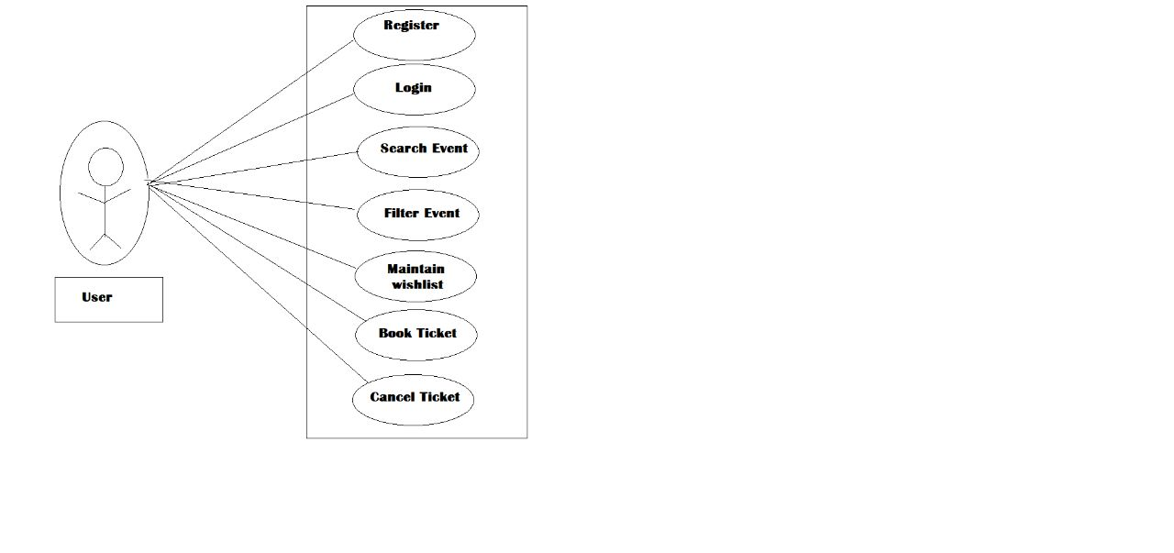

**3.2 Organiser Module:**

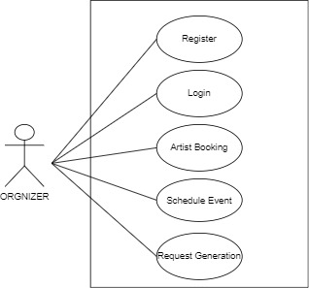

**3.3 Admin Module :**

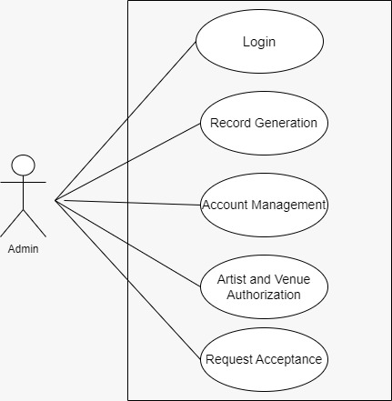

**3.4 Artist Module:**

