- On your local machine Install
- Install:
  - Terraform
  - AWS CLI
  - Azure CLI
1. Install Terraform on Windows

Step 1 — Download Terraform
- Go to: https://developer.hashicorp.com/terraform/downloads
- Under Windows, download:
64-bit Terraform ZIP

Step 2 — Extract Terraform
- Extract the ZIP file.
- Move terraform.exe to a folder such as:
C:\terraform\

Step 3 — Test installation
- Open PowerShell and run:
terraform -version
- You should see output like:
Terraform v1.x.x
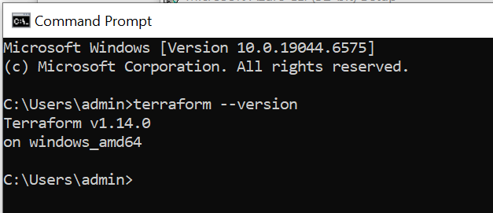
2. Install AWS CLI on Windows

Step 1 — Download AWS CLI
Download 64-bit Windows installer: https://awscli.amazonaws.com/AWSCLIV2.msi

Step 2 — Run Installer
- Double-click AWSCLIV2.msi
- Follow prompts → Finish

Step 3 — Verify installation
- Open PowerShell:
aws --version
- Expected output:
aws-cli/2.x.x Python/3.x

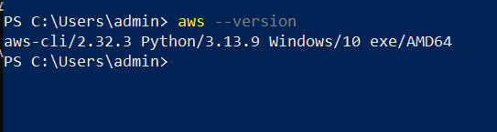

3. Install Azure CLI on Windows

Step 1 — Download Azure CLI
Go to: https://aka.ms/installazurecliwindows
This downloads AzureCLI.msi.

Step 2 — Run installer
Follow wizard → Install

Step 3 — Verify installation
- Open PowerShell:
az --version
- You should see:
azure-cli 2.x.x
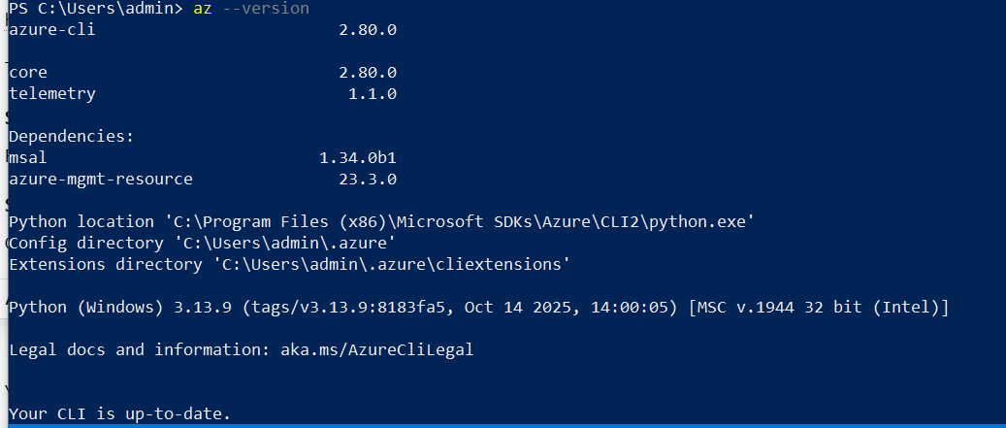

- On your local machine Install
Using Git Bash (Recommended for Terraform & SSH)

Step 1 — Open Git Bash
- Install Git for Windows: https://git-scm.com/download/win
- Then open Git Bash.

Step 2 — Run the same SSH keygen command

ssh-keygen -t rsa -b 4096 -C "multi-cloud-dr" -f ~/.ssh/mcdr_key

Your key files will be created at:
C:\Users\<YourUsername>\.ssh\mcdr_key
C:\Users\<YourUsername>\.ssh\mcdr_key.pub

- mcdr_key → private key
- mcdr_key.pub → public key

Step 3 — Verify keys
- In Git Bash:
ls ~/.ssh
- You should see:
mcdr_key mcdr_key.pub

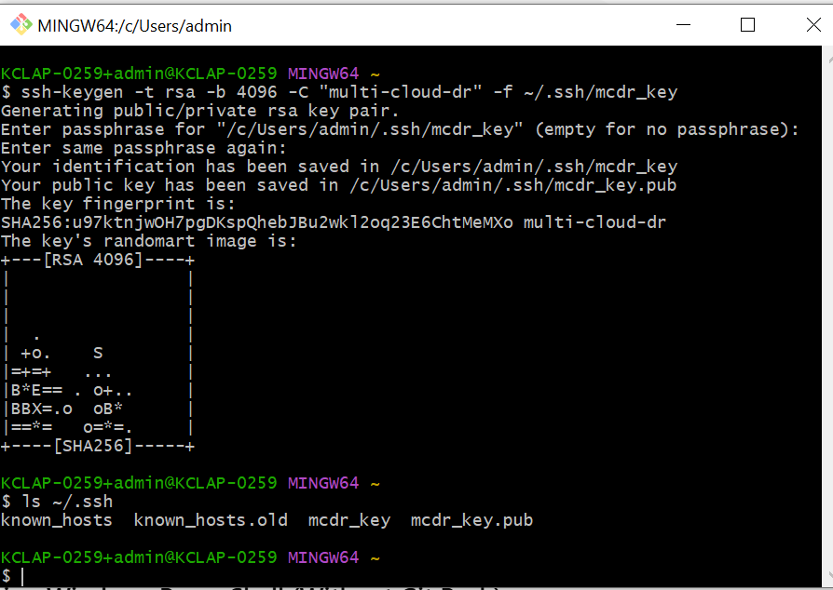

Task 1 – Infrastructure Provisioning (AWS & Azure)

1.1 AWS – VPC, Subnets, EC2 (App + Tools)

1.1.1 Create folder & files
mkdir -p project/aws
cd project/aws
Create variables.tf:
variable "aws_region" {
description = "AWS region"
type = string
default = "us-east-1"
}

variable "project_name" {
description = "Project name prefix"
type = string
default = "multi-cloud-dr"
}

variable "public_key_path" {
description = "Path to your SSH public key"
type = string
}
Create main.tf:
terraform {
required_version = ">= 1.3.0"

required_providers {
aws = {
source = "hashicorp/aws"
version = "~> 5.0"
}
}
}

provider "aws" {
region = var.aws_region
}

# VPC
resource "aws_vpc" "main" {
cidr_block = "10.0.0.0/16"
enable_dns_support = true
enable_dns_hostnames = true

tags = {
Name = "${var.project_name}-vpc"
}
}

# Internet Gateway
resource "aws_internet_gateway" "igw" {
vpc_id = aws_vpc.main.id

tags = {
Name = "${var.project_name}-igw"
}
}

# Public subnets
resource "aws_subnet" "public_1" {
vpc_id = aws_vpc.main.id
cidr_block = "10.0.1.0/24"
availability_zone = "${var.aws_region}a"
map_public_ip_on_launch = true
tags = {
Name = "${var.project_name}-public-1"
}
}

resource "aws_subnet" "public_2" {
vpc_id = aws_vpc.main.id
cidr_block = "10.0.2.0/24"
availability_zone = "${var.aws_region}b"
map_public_ip_on_launch = true
tags = {
Name = "${var.project_name}-public-2"
}
}

# Private subnets
resource "aws_subnet" "private_1" {
vpc_id = aws_vpc.main.id
cidr_block = "10.0.11.0/24"
availability_zone = "${var.aws_region}a"
tags = {
Name = "${var.project_name}-private-1"
}
}

resource "aws_subnet" "private_2" {
vpc_id = aws_vpc.main.id
cidr_block = "10.0.12.0/24"
availability_zone = "${var.aws_region}b"
tags = {
Name = "${var.project_name}-private-2"
}
}

# NAT
resource "aws_eip" "nat_eip" {
domain = "vpc"
tags = { Name = "${var.project_name}-nat-eip" }
}

resource "aws_nat_gateway" "nat" {
allocation_id = aws_eip.nat_eip.id
subnet_id = aws_subnet.public_1.id
depends_on = [aws_internet_gateway.igw]

tags = {
Name = "${var.project_name}-nat"
}
}

# Public route table
resource "aws_route_table" "public" {
vpc_id = aws_vpc.main.id

route {
cidr_block = "0.0.0.0/0"
gateway_id = aws_internet_gateway.igw.id
}

tags = {
Name = "${var.project_name}-public-rt"
}
}

resource "aws_route_table_association" "public_1" {
subnet_id = aws_subnet.public_1.id
route_table_id = aws_route_table.public.id
}

resource "aws_route_table_association" "public_2" {
subnet_id = aws_subnet.public_2.id
route_table_id = aws_route_table.public.id
}

# Private route table
resource "aws_route_table" "private" {
vpc_id = aws_vpc.main.id

route {
cidr_block = "0.0.0.0/0"
nat_gateway_id = aws_nat_gateway.nat.id
}

tags = {
Name = "${var.project_name}-private-rt"
}
}

resource "aws_route_table_association" "private_1" {
subnet_id = aws_subnet.private_1.id
route_table_id = aws_route_table.private.id
}

resource "aws_route_table_association" "private_2" {
subnet_id = aws_subnet.private_2.id
route_table_id = aws_route_table.private.id
}

# Security group
resource "aws_security_group" "web_sg" {
name = "${var.project_name}-web-sg"
description = "Allow SSH and HTTP"
vpc_id = aws_vpc.main.id

ingress {
description = "SSH"
from_port = 22
to_port = 22
protocol = "tcp"
cidr_blocks = ["0.0.0.0/0"]
}

ingress {
description = "HTTP"
from_port = 80
to_port = 80
protocol = "tcp"
cidr_blocks = ["0.0.0.0/0"]
}

egress {
from_port = 0
to_port = 0
protocol = "-1"
cidr_blocks = ["0.0.0.0/0"]
}

tags = {
Name = "${var.project_name}-web-sg"
}
}

# Key pair using your public key
resource "aws_key_pair" "default" {
key_name = "${var.project_name}-key"
public_key = file(var.public_key_path)
}

# App instance
resource "aws_instance" "app" {
ami = "ami-0ecb62995f68bb549"
instance_type = "t3.micro"
subnet_id = aws_subnet.public_1.id
vpc_security_group_ids = [aws_security_group.web_sg.id]
key_name = aws_key_pair.default.key_name
associate_public_ip_address = true

tags = {
Name = "${var.project_name}-app"
Role = "app"
}
}

# Tools instance
resource "aws_instance" "tools" {
ami = "ami-0ecb62995f68bb549"
instance_type = "t3.micro"
subnet_id = aws_subnet.public_2.id
vpc_security_group_ids = [aws_security_group.web_sg.id]
key_name = aws_key_pair.default.key_name
associate_public_ip_address = true

tags = {
Name = "${var.project_name}-tools"
Role = "tools"
}
}
Create outputs.tf:
output "app_public_ip" {
value = aws_instance.app.public_ip
description = "Public IP of the App Machine"
}

output "tools_public_ip" {
value = aws_instance.tools.public_ip
description = "Public IP of the Tools Machine"
}

1.1.2 Configure & Run Terraform
First Configure aws Login :

aws configure

Give Below Information :
AWS Access Key ID: <from CSV>
AWS Secret Access Key: <from CSV>
Default region name: us-east-1
Default output format: json

Run Terraform

cd project/aws
terraform init
terraform plan -var="public_key_path=$HOME/.ssh/mcdr_key.pub"
terraform apply -var="public_key_path=$HOME/.ssh/mcdr_key.pub"

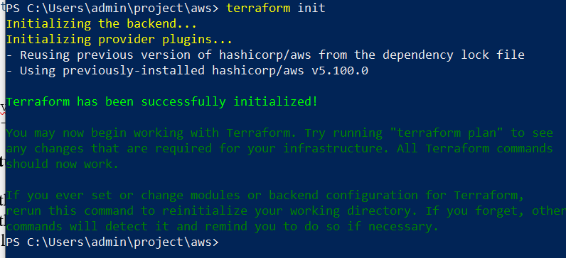
- Screenshots to capture:
- Terminal with terraform plan summary (AWS).
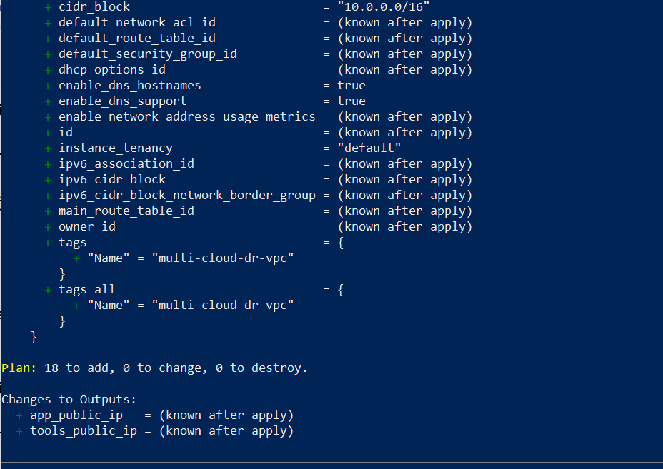

- Terminal with terraform apply success.
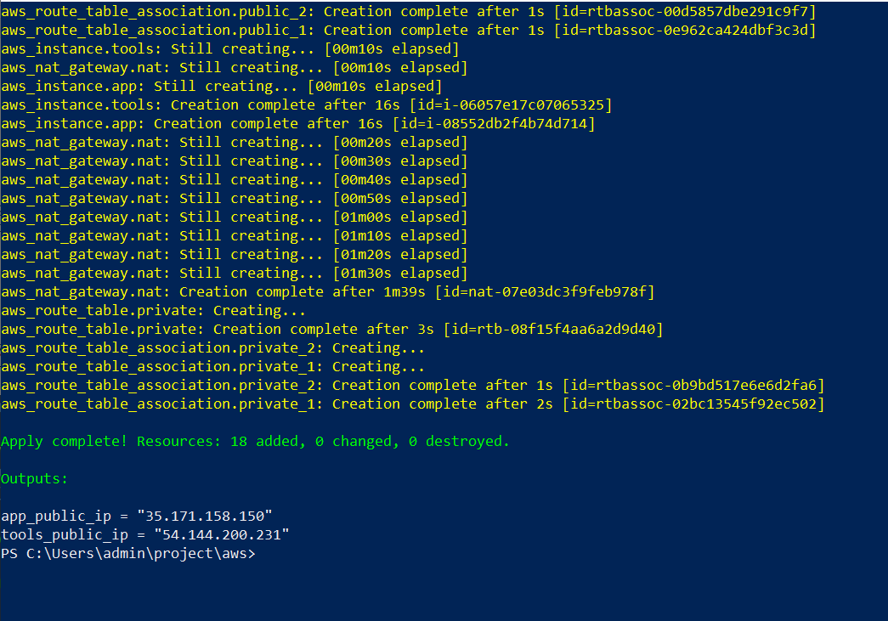
- AWS Console:
  - VPC details
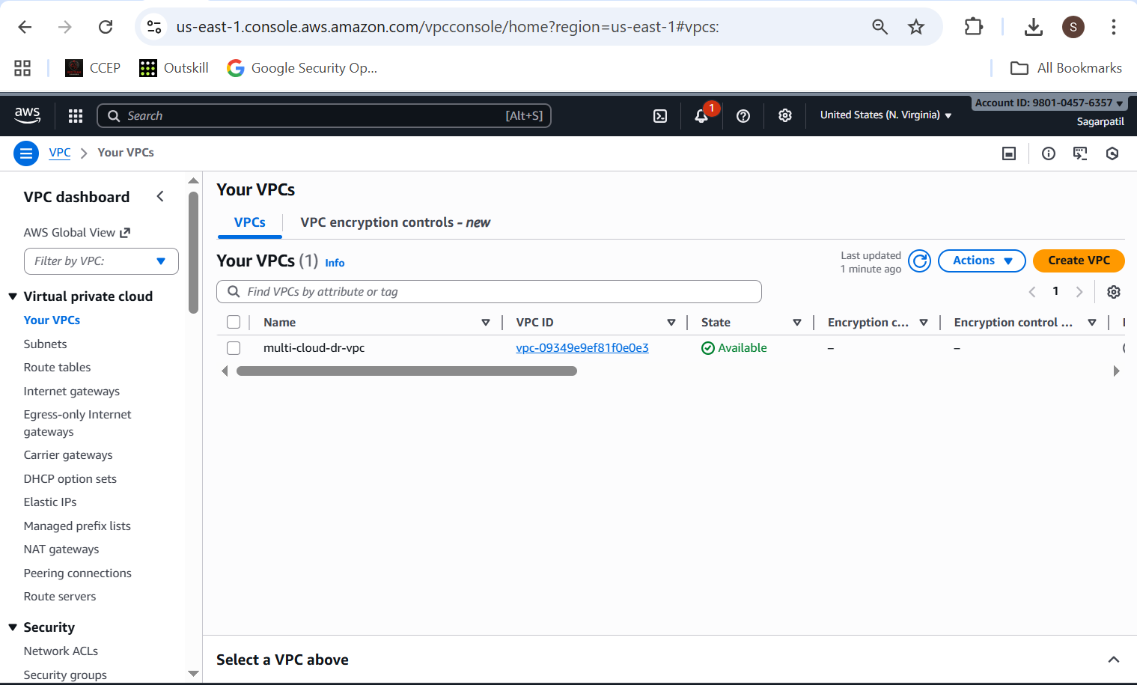
  - Subnets listing (2 public, 2 private)
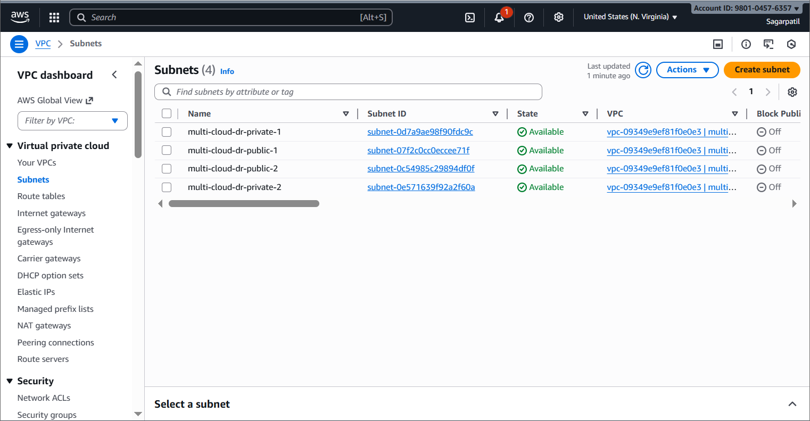
  - Route tables (public + private)
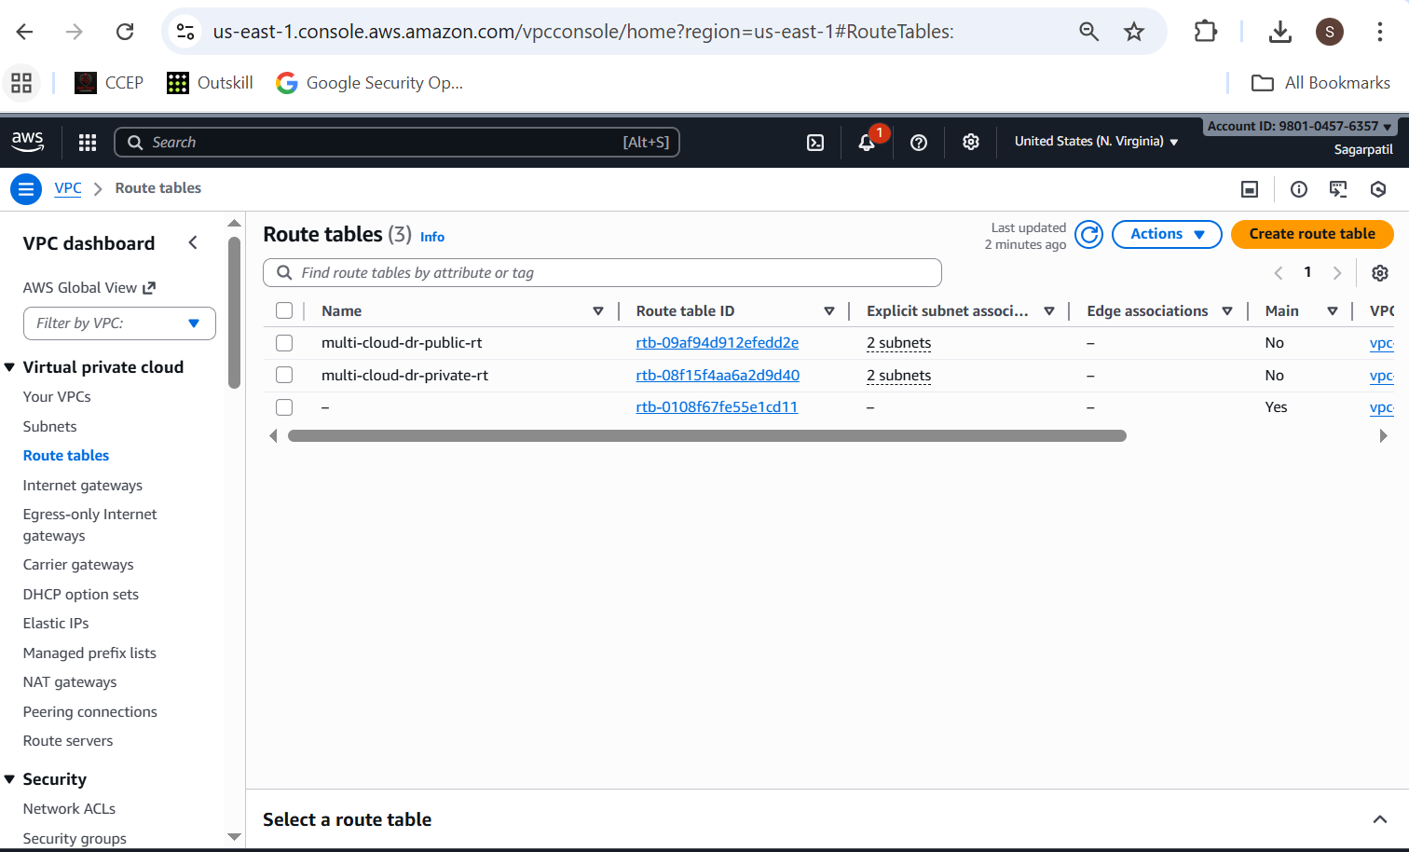

  - NAT gateway
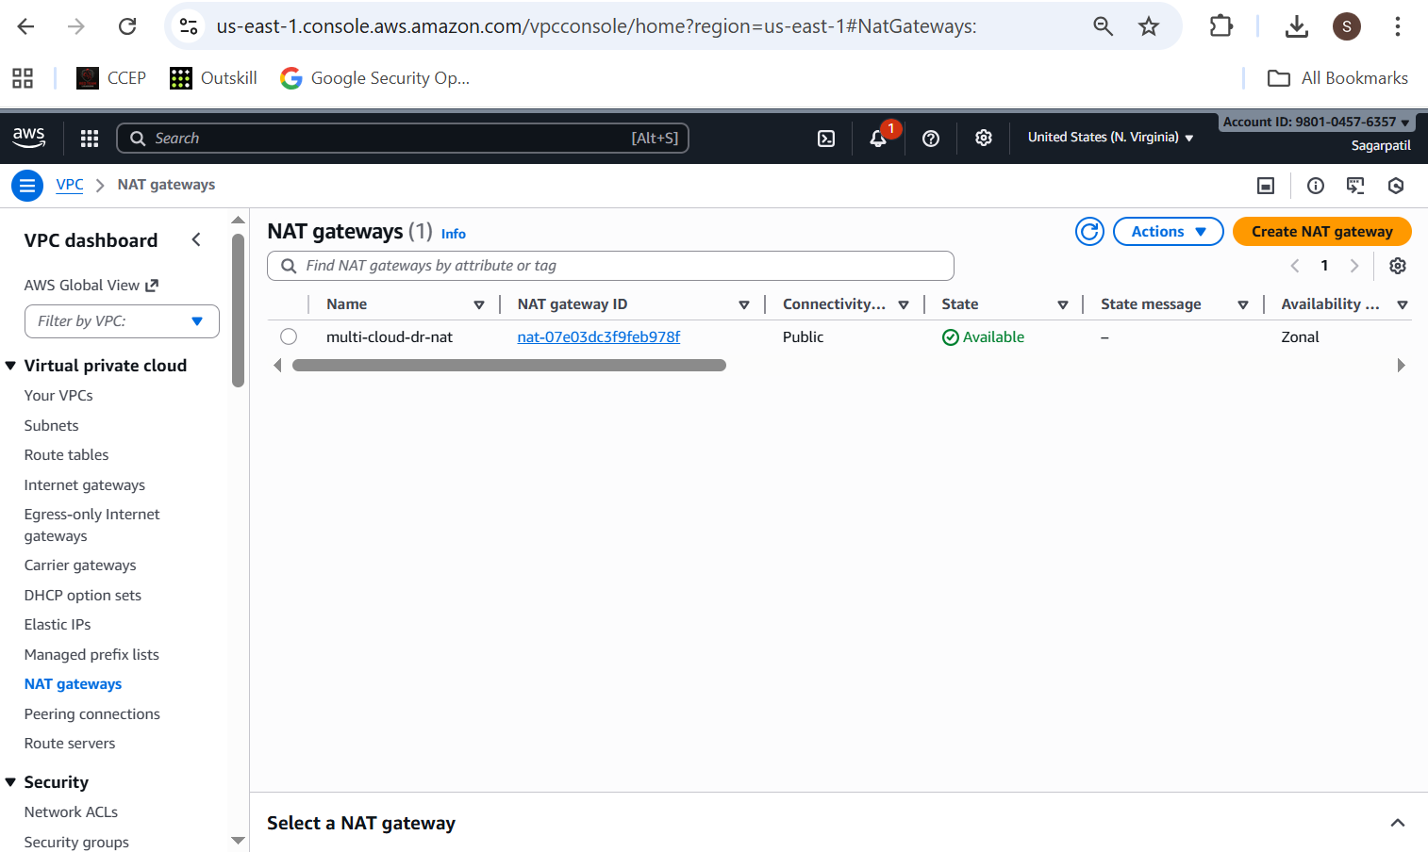
  - Security group inbound rules (22, 80)
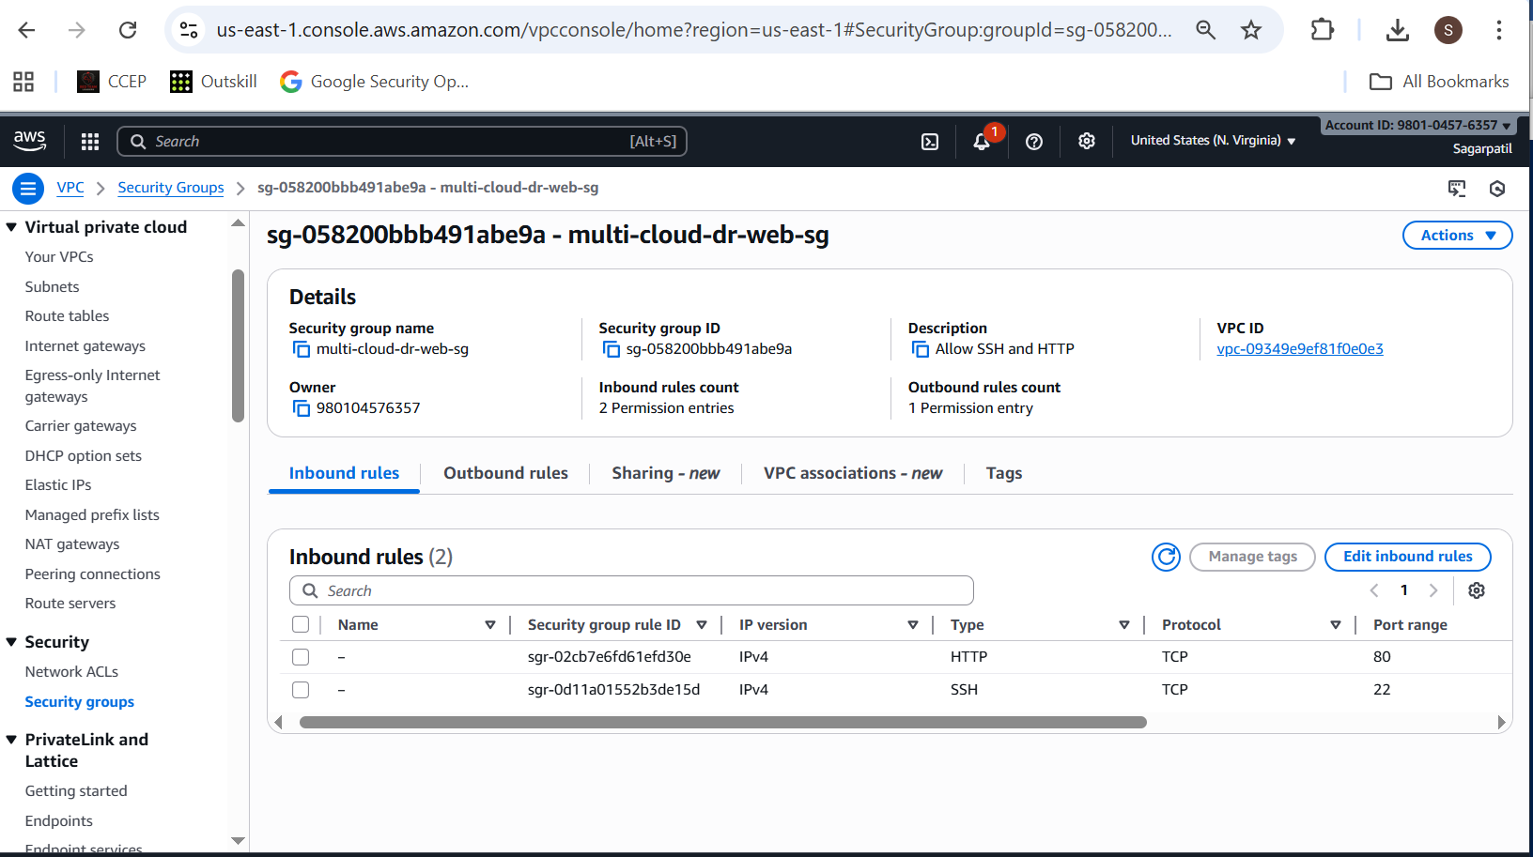

  - EC2 instances list showing App + Tools machines
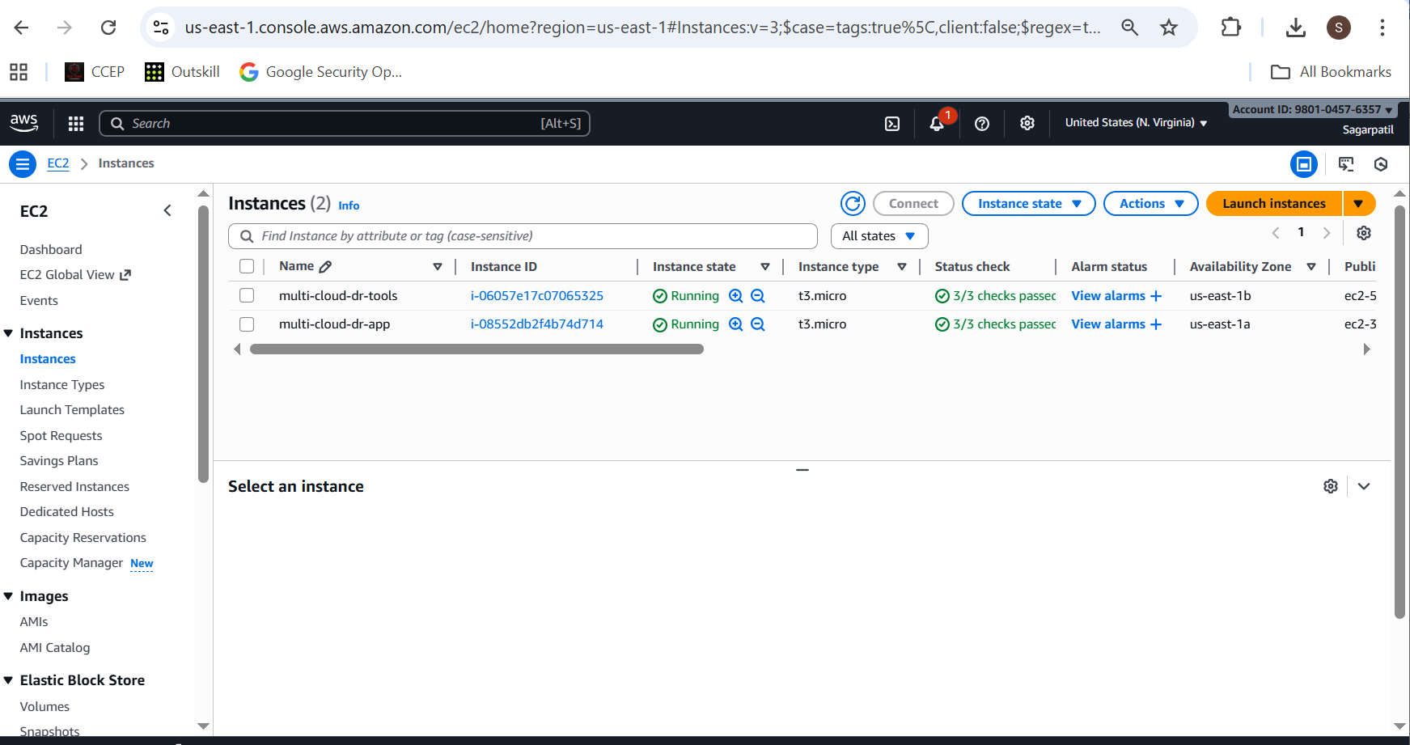
  - Internet Gateway
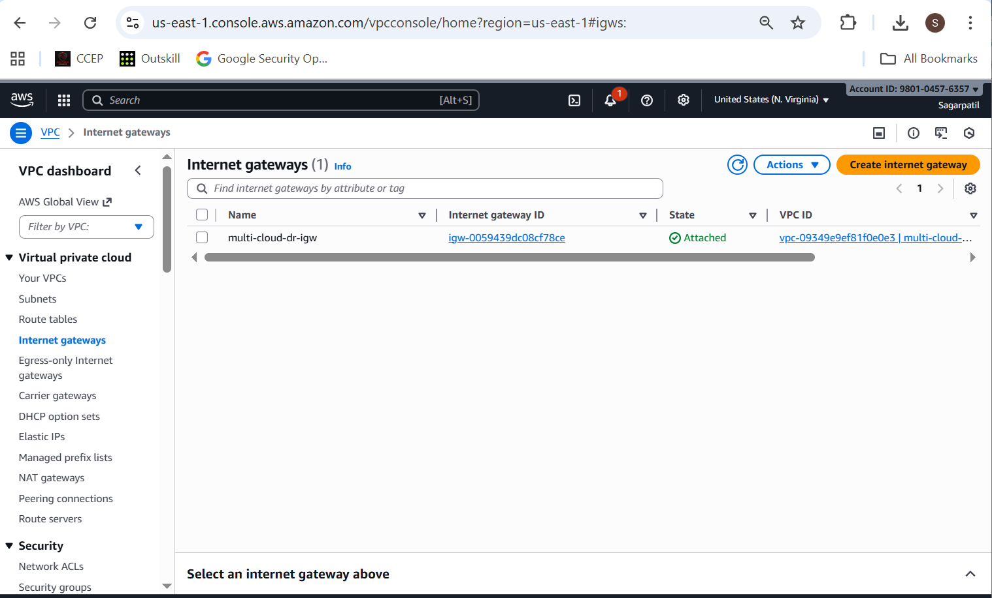

1.1.3 SSH test to EC2s
From local:
ssh -i ~/.ssh/mcdr_key ubuntu@<AWS_APP_PUBLIC_IP>
ssh -i ~/.ssh/mcdr_key ubuntu@<AWS_TOOLS_PUBLIC_IP>
Screenshot:
- Terminal showing successful SSH into both EC2s.
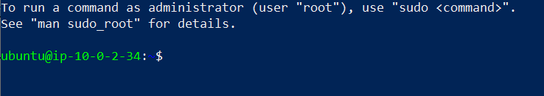
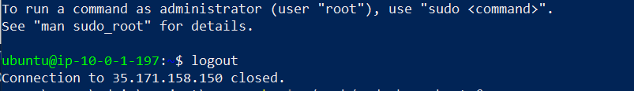

1.2 Azure – VNet, Subnet, NSG, VM

1.2.1 Create folder & files
cd project
mkdir -p azure
cd azure
variables.tf:
variable "azure_location" {
description = "Azure location"
type = string
default = "eastus"
}

variable "project_name" {
description = "Project name"
type = string
default = "multi-cloud-dr"
}

variable "admin_username" {
description = "Admin username for VM"
type = string
default = "azureuser"
}

variable "public_key_path" {
description = "Path to SSH public key"
type = string
}
main.tf:
terraform {
required_version = ">= 1.3.0"

required_providers {
azurerm = {
source = "hashicorp/azurerm"
version = "~> 4.0"
}
}
}

provider "azurerm" {
features {}
}

resource "azurerm_resource_group" "rg" {
name = "${var.project_name}-rg"
location = var.azure_location
}

resource "azurerm_virtual_network" "vnet" {
name = "${var.project_name}-vnet"
location = azurerm_resource_group.rg.location
resource_group_name = azurerm_resource_group.rg.name
address_space = ["10.10.0.0/16"]
}

resource "azurerm_subnet" "subnet_app" {
name = "${var.project_name}-subnet-app"
resource_group_name = azurerm_resource_group.rg.name
virtual_network_name = azurerm_virtual_network.vnet.name
address_prefixes = ["10.10.1.0/24"]
}

resource "azurerm_network_security_group" "nsg" {
name = "${var.project_name}-nsg"
location = azurerm_resource_group.rg.location
resource_group_name = azurerm_resource_group.rg.name

security_rule {
name = "SSH"
priority = 100
direction = "Inbound"
access = "Allow"
protocol = "Tcp"
source_port_range = "*"
destination_port_range = "22"
source_address_prefix = "*"
destination_address_prefix = "*"
}

security_rule {
name = "HTTP"
priority = 110
direction = "Inbound"
access = "Allow"
protocol = "Tcp"
source_port_range = "*"
destination_port_range = "80"
source_address_prefix = "*"
destination_address_prefix = "*"
}
}

resource "azurerm_subnet_network_security_group_association" "subnet_nsg_assoc" {
subnet_id = azurerm_subnet.subnet_app.id
network_security_group_id = azurerm_network_security_group.nsg.id
}

resource "azurerm_public_ip" "app_pip" {
name = "${var.project_name}-app-pip"
location = azurerm_resource_group.rg.location
resource_group_name = azurerm_resource_group.rg.name
allocation_method = "Static"
sku = "Basic"
}

resource "azurerm_network_interface" "app_nic" {
name = "${var.project_name}-app-nic"
location = azurerm_resource_group.rg.location
resource_group_name = azurerm_resource_group.rg.name

ip_configuration {
name = "internal"
subnet_id = azurerm_subnet.subnet_app.id
private_ip_address_allocation = "Dynamic"
public_ip_address_id = azurerm_public_ip.app_pip.id
}
}

resource "azurerm_linux_virtual_machine" "app_vm" {
name = "${var.project_name}-app-vm"
location = azurerm_resource_group.rg.location
resource_group_name = azurerm_resource_group.rg.name
size = "Standard_B1s"

admin_username = var.admin_username
disable_password_authentication = true

network_interface_ids = [azurerm_network_interface.app_nic.id]

admin_ssh_key {
username = var.admin_username
public_key = file(var.public_key_path)
}

os_disk {
name = "${var.project_name}-app-osdisk"
caching = "ReadWrite"
storage_account_type = "Standard_LRS"
}

source_image_reference {
publisher = "Canonical"
offer = "0001-com-ubuntu-server-jammy"
sku = "22_04-lts"
version = "latest"
}

computer_name = "appvm"

tags = {
Role = "app"
}
}
outputs.tf:
output "app_vm_public_ip" {
value = azurerm_public_ip.app_pip.ip_address
description = "Public IP of Azure App VM"
}

1.2.2 Run Terraform

az login # if not already logged in
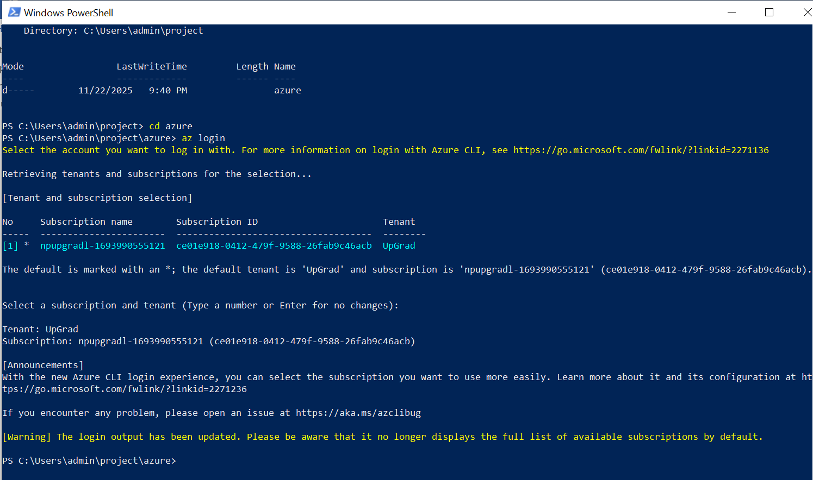
cd project/azure
terraform init

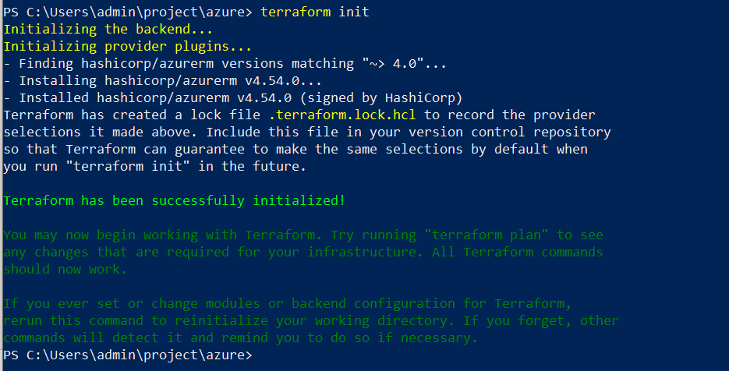

terraform plan -var="public_key_path=$HOME/.ssh/mcdr_key.pub"
terraform apply -var="public_key_path=$HOME/.ssh/mcdr_key.pub"
Screenshots:
- Terminal with plan and apply (Azure).
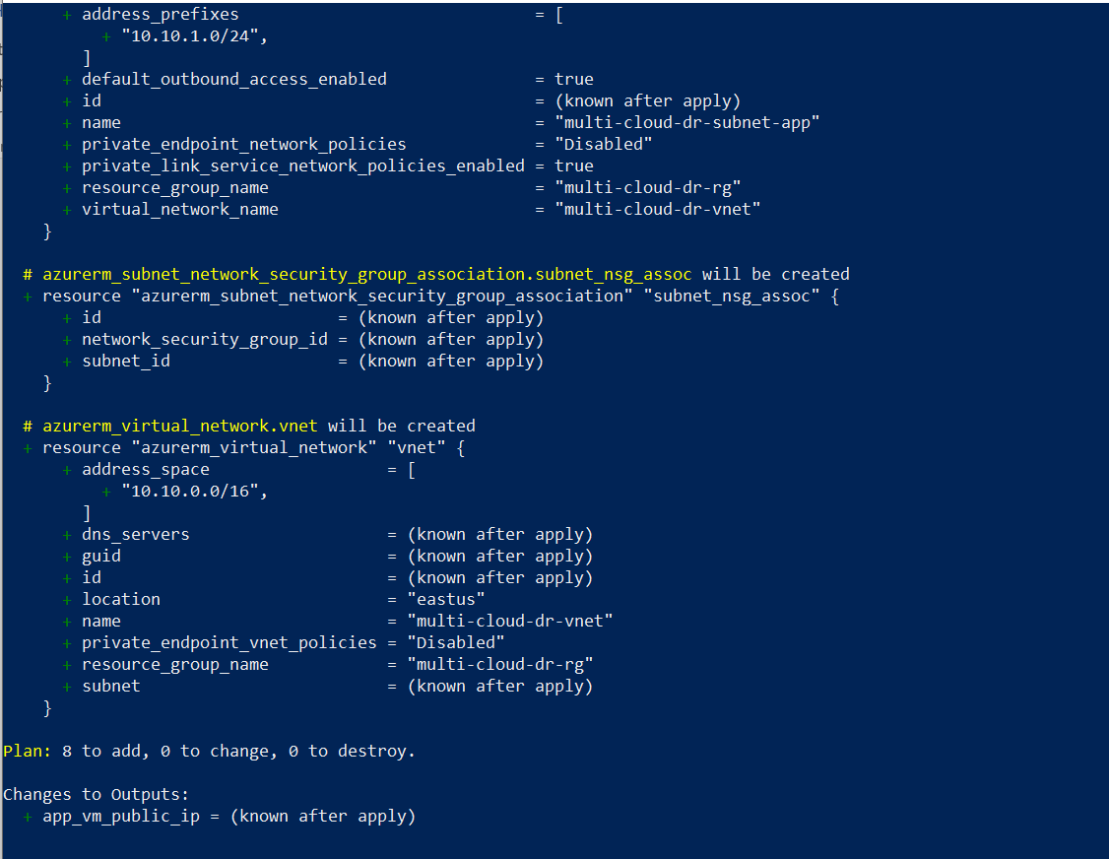
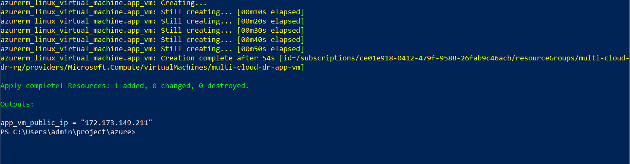
- Azure portal:
  - Resource group
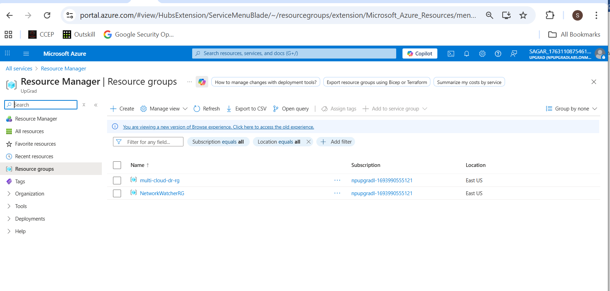
  - VNet + subnet
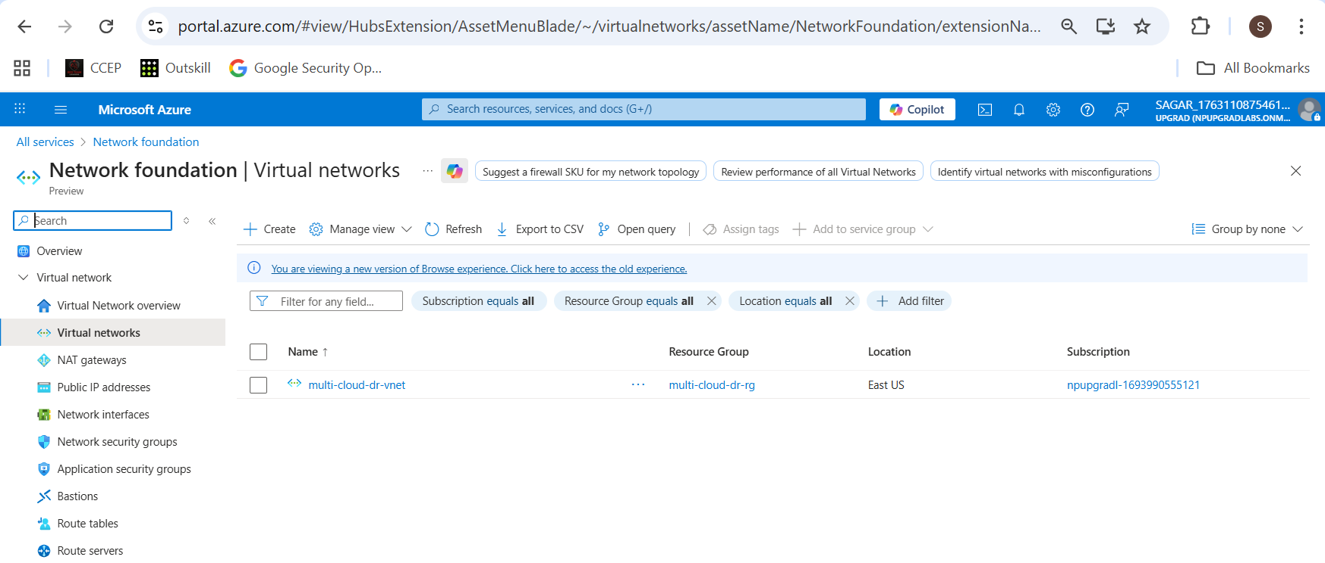
  - NSG inbound rules (22, 80)
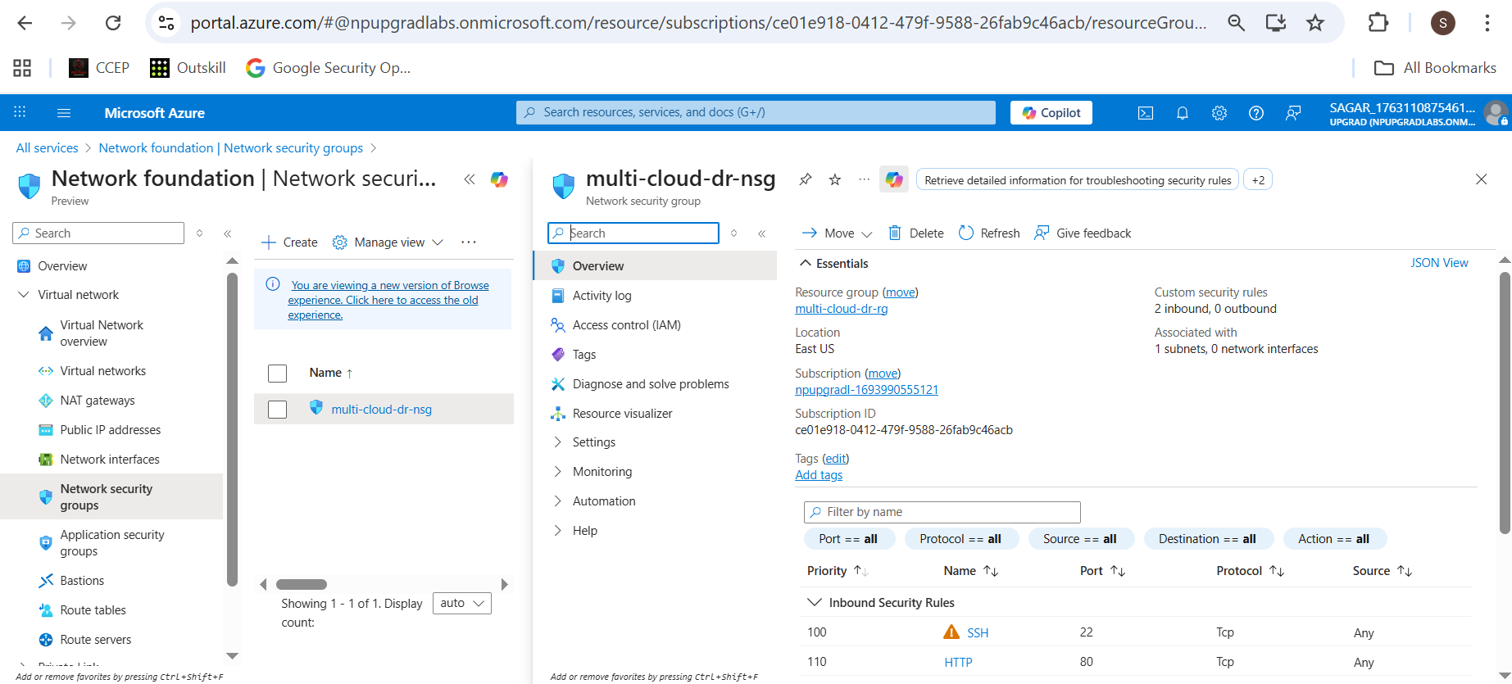
  - VM overview (running, public IP).
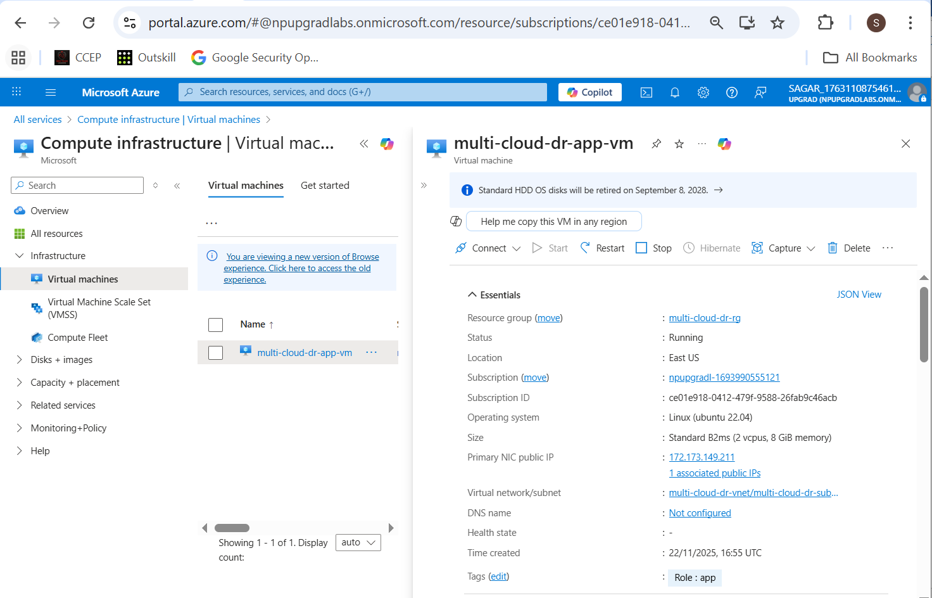

1.2.3 SSH test to Azure VM
ssh -i ~/.ssh/mcdr_key azureuser@<AZURE_APP_PUBLIC_IP>

Screenshot:
Terminal showing successful SSH login.
