Task 2 – Configuration Management (Ansible)
All Ansible work happens on the AWS Tools Machine.

2.1 Install Ansible on Tools Machine
- SSH to Tools Machine:
ssh -i ~/.ssh/mcdr_key ubuntu@<AWS_TOOLS_PUBLIC_IP>
- Install Ansible:
sudo apt update
sudo apt install -y ansible git
ansible --version
Screenshot:
ansible --version output.
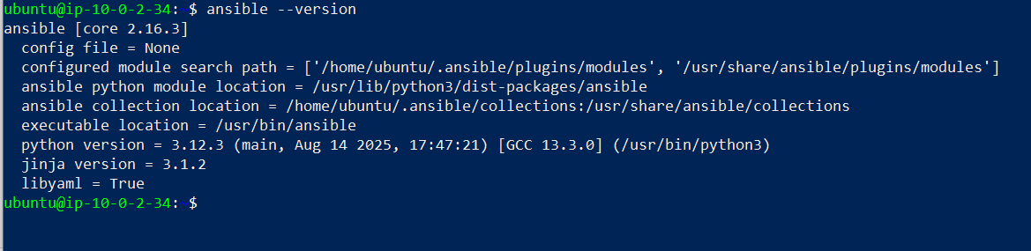

2.2 Copy SSH key to Tools Machine
On local machine:
scp -i C:\Users\admin\.ssh\mcdr_key C:\Users\admin\.ssh\mcdr_key ubuntu@<AWS_TOOLS_PUBLIC_IP>:/home/ubuntu/.ssh/

On Tools Machine:
chmod 600 ~/.ssh/mcdr_key

2.3 Create Ansible inventory
On Tools Machine:
mkdir -p ~/multi-cloud-ansible
cd ~/multi-cloud-ansible
vim inventory.ini
inventory.ini:
[aws_app]
aws_app ansible_host=<AWS_APP_PUBLIC_IP> ansible_user=ubuntu ansible_ssh_private_key_file=/home/ubuntu/.ssh/mcdr_key

[azure_app]
azure_app ansible_host=<AZURE_APP_PUBLIC_IP> ansible_user=azureuser ansible_ssh_private_key_file=/home/ubuntu/.ssh/mcdr_key

[all_app_servers:children]
aws_app
azure_app
Test connectivity:
ansible -i inventory.ini all_app_servers -m ping
Screenshot:
Ping output showing pong from both hosts.
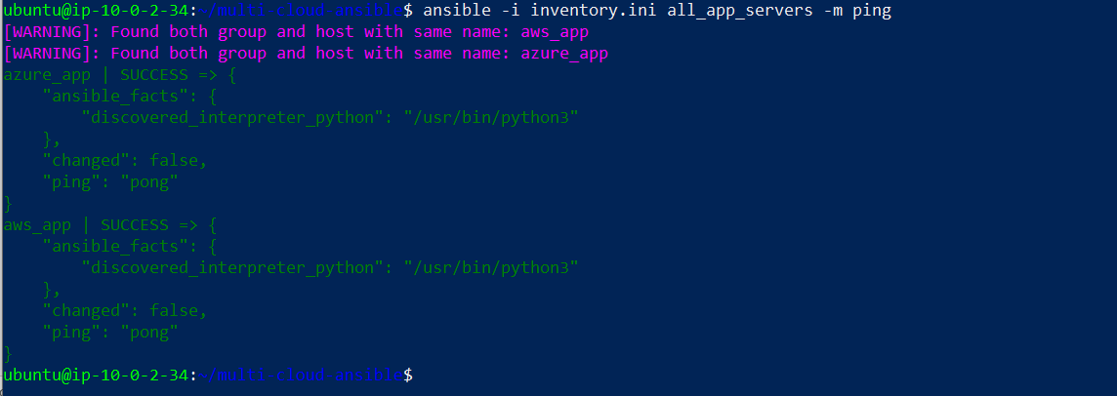

2.4 Ansible playbook to install & start Nginx
Create nginx_setup.yml:
---
- name: Install and configure Nginx on AWS and Azure app servers
hosts: all_app_servers
become: yes
vars:
nginx_pkg_name: nginx

tasks:
- name: Update APT cache
ansible.builtin.apt:
update_cache: yes
cache_valid_time: 3600

- name: Install Nginx
ansible.builtin.apt:
name: "{{ nginx_pkg_name }}"
state: present

- name: Ensure Nginx is enabled and started
ansible.builtin.service:
name: nginx
state: started
enabled: yes

- name: Check Nginx default page
ansible.builtin.command: curl -s http://localhost
register: nginx_page
changed_when: false

- name: Show first line of Nginx page
ansible.builtin.debug:
msg: "{{ nginx_page.stdout_lines | default([]) | first | default('no output') }}"
Run it:
ansible-playbook -i inventory.ini nginx_setup.yml

Screenshots:
- Playbook run showing success.
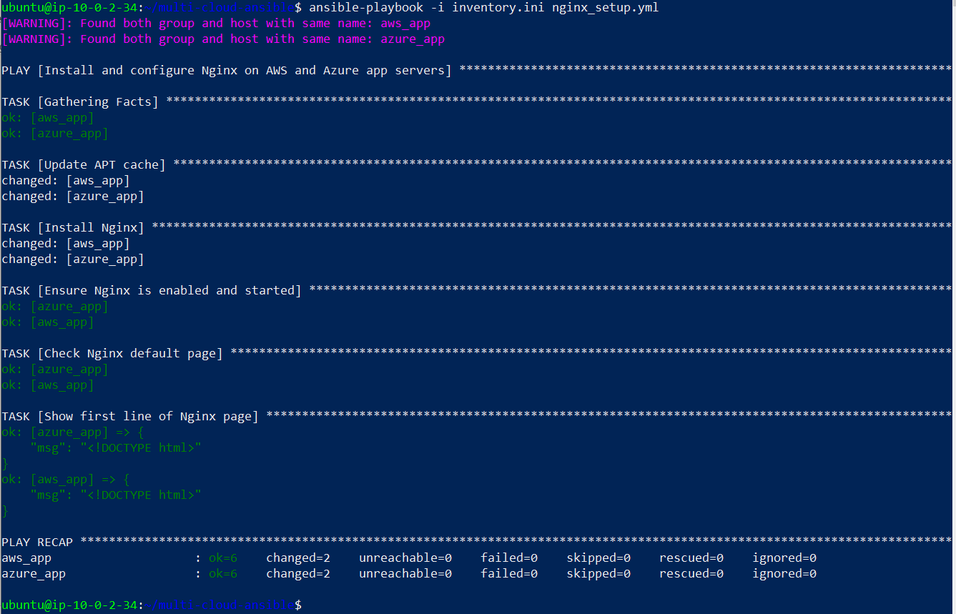
On each app server:
# On AWS app
systemctl status nginx
ls -l /var/www/html/

# On Azure app
systemctl status nginx
ls -l /var/www/html/

Screenshots:
- systemctl status nginx on AWS & Azure = active.

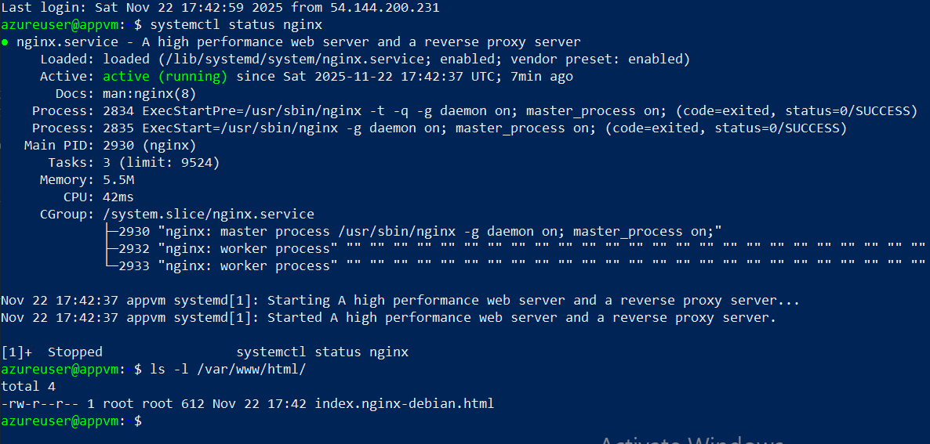
- /var/www/html listing.
