Task 3 – Application Deployment (Custom Nginx Pages)

3.1 Create custom html files on Tools Machine
From ~/multi-cloud-ansible:
cat > index-aws.html << 'EOF'
<!doctype html>
<html>
<head><title>Welcome to AWS</title></head>
<body>
<h1>Welcome to AWS</h1>
<p>This page is served from the AWS App Machine.</p>
</body>
</html>
EOF

cat > index-azure.html << 'EOF'
<!doctype html>
<html>
<head><title>Welcome to Azure</title></head>
<body>
<h1>Welcome to Azure</h1>
<p>This page is served from the Azure VM.</p>
</body>
</html>
EOF
Screenshot:
ls showing index-aws.html and index-azure.html.
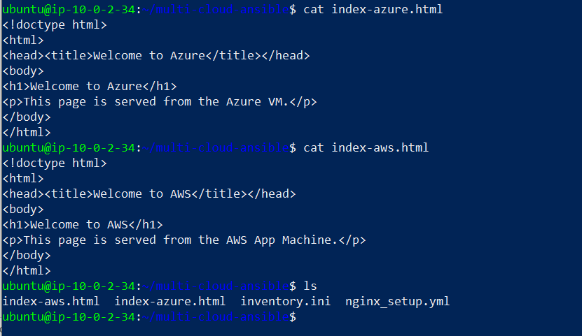

3.2 Add cloud flag to inventory
Edit inventory.ini:
[aws_app]
aws_app ansible_host=<AWS_APP_PUBLIC_IP> ansible_user=ubuntu ansible_ssh_private_key_file=/home/ubuntu/.ssh/mcdr_key cloud=aws

[azure_app]
azure_app ansible_host=<AZURE_APP_PUBLIC_IP> ansible_user=azureuser ansible_ssh_private_key_file=/home/ubuntu/.ssh/mcdr_key cloud=azure

[all_app_servers:children]
aws_app
azure_app

3.3 Deployment playbook
Create nginx_deploy.yml:
---
- name: Deploy custom index pages to AWS and Azure
hosts: all_app_servers
become: yes

tasks:
- name: Set index source based on cloud
ansible.builtin.set_fact:
custom_index_src: "index-{{ cloud }}.html"

- name: Copy custom index.html to web root
ansible.builtin.copy:
src: "{{ custom_index_src }}"
dest: /var/www/html/index.html
owner: www-data
group: www-data
mode: '0644'
notify: Restart nginx

- name: Ensure Nginx default site uses index.html
ansible.builtin.lineinfile:
path: /etc/nginx/sites-available/default
regexp: '^\s*index '
line: "\tindex index.html;"
backup: yes
notify: Restart nginx

- name: Check Nginx page from localhost
ansible.builtin.command: curl -s http://localhost
register: nginx_page
changed_when: false

- name: Assert correct welcome text
ansible.builtin.assert:
that:
- >
(cloud == 'aws' and 'Welcome to AWS' in nginx_page.stdout)
or
(cloud == 'azure' and 'Welcome to Azure' in nginx_page.stdout)
fail_msg: "Custom welcome text not correct on {{ inventory_hostname }}"
success_msg: "Custom welcome text correct on {{ inventory_hostname }}"

handlers:
- name: Restart nginx
ansible.builtin.service:
name: nginx
state: restarted
Run:
ansible-playbook -i inventory.ini nginx_deploy.yml
Screenshots:
- Playbook run showing copy + assert tasks success.
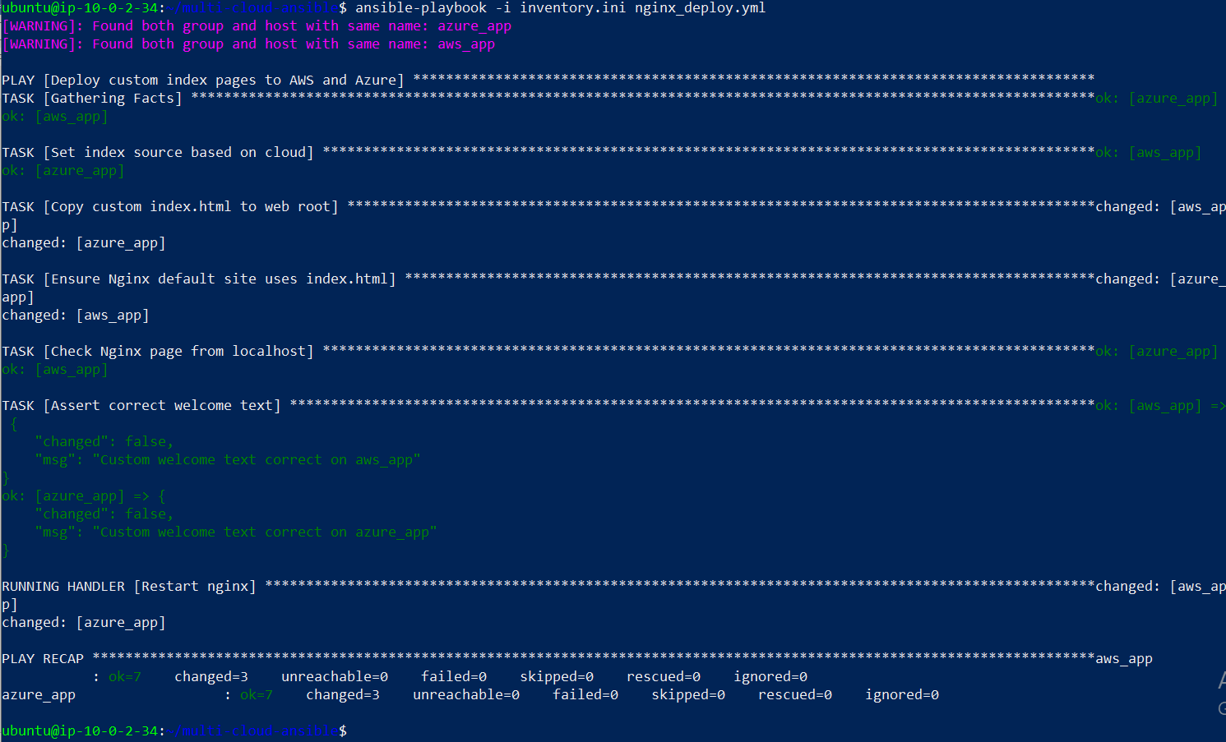
On AWS app:
cat /var/www/html/index.html

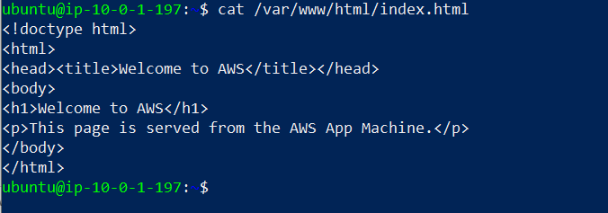
On Azure app: cat /var/www/html/index.html

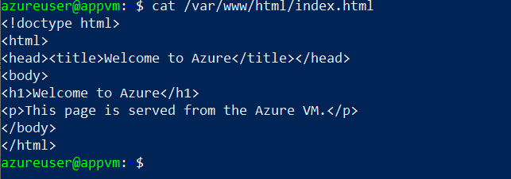
Screenshots:
- Each file content showing Welcome to AWS / Welcome to Azure.
Nginx config:
sudo cat /etc/nginx/sites-available/default | grep -i "index"
Screenshot:
Line showing index index.html;.
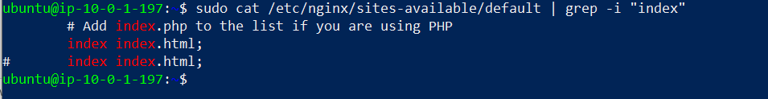
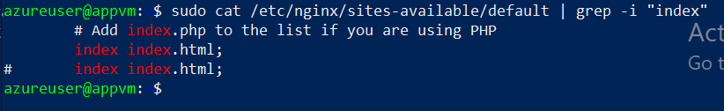

3.4 Browser verification
From your local machine:
- Open http://<AWS_APP_PUBLIC_IP> → Welcome to AWS
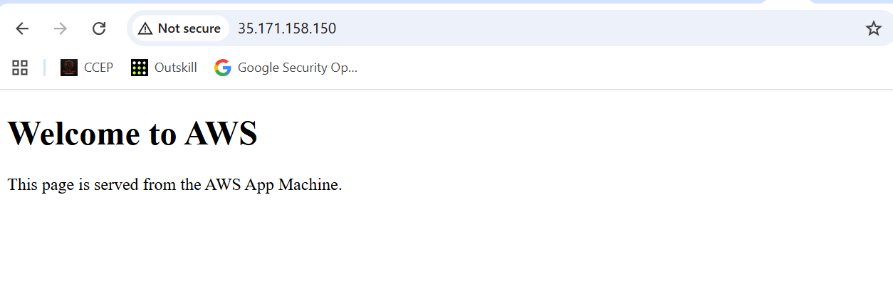
- Open http://<AZURE_APP_PUBLIC_IP> → Welcome to Azure
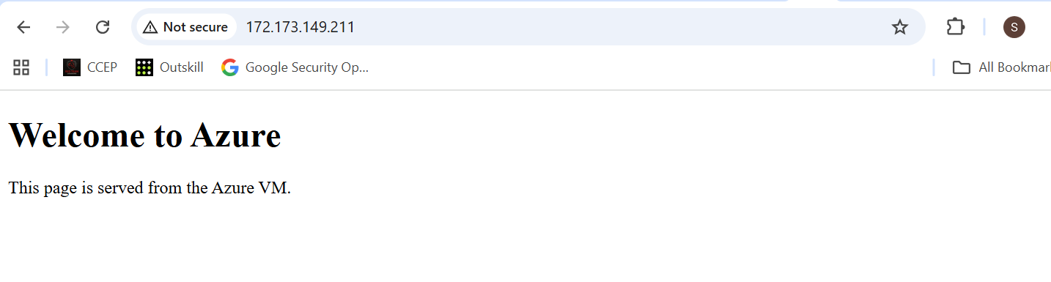
Screenshots: Browser for AWS page.
- Browser for Azure page.

