Task 4 – Jenkins Setup for Continuous Deployment

4.1 Install Jenkins on Tools Machine
On Tools Machine:
sudo apt update
sudo apt install -y openjdk-17-jdk
java -version
Add Jenkins repo & install:
curl -fsSL https://pkg.jenkins.io/debian-stable/jenkins.io-2023.key | sudo tee \
/usr/share/keyrings/jenkins-keyring.asc > /dev/null

echo deb [signed-by=/usr/share/keyrings/jenkins-keyring.asc] \
https://pkg.jenkins.io/debian-stable binary/ | sudo tee \
/etc/apt/sources.list.d/jenkins.list > /dev/null

sudo apt update
sudo apt install -y jenkins
sudo systemctl enable jenkins
sudo systemctl start jenkins
sudo systemctl status jenkins
Screenshot:
systemctl status jenkins = active.
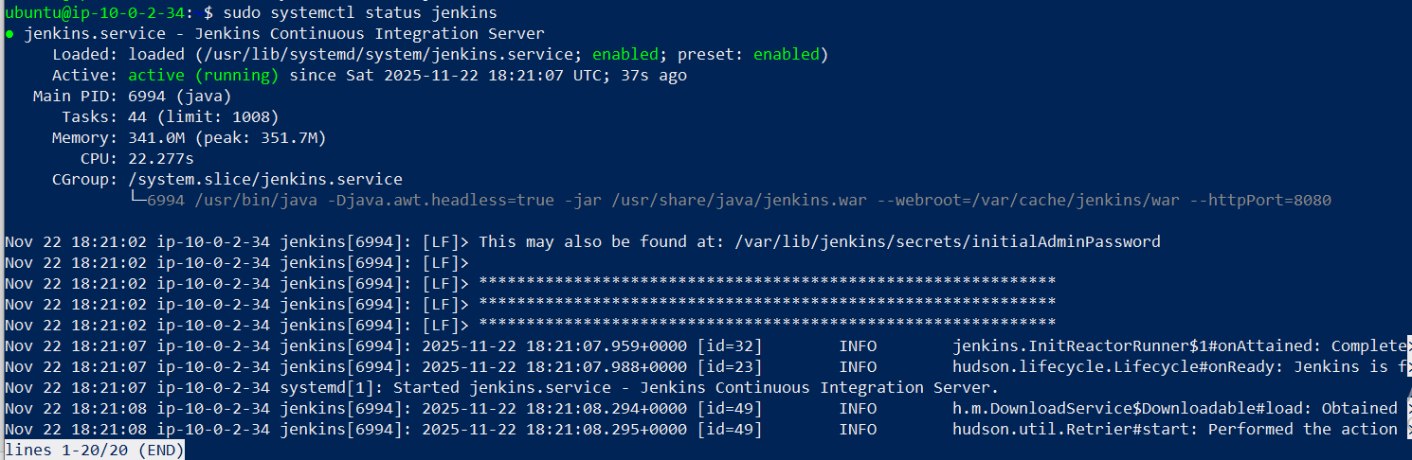
Update security group for Tools Machine to allow TCP 8080 from your IP.
Open from browser:
http://<AWS_TOOLS_PUBLIC_IP>:8080

Get initial password:
sudo cat /var/lib/jenkins/secrets/initialAdminPassword
Finish Jenkins setup and create admin user.
Screenshots:
- Jenkins first dashboard after setup.
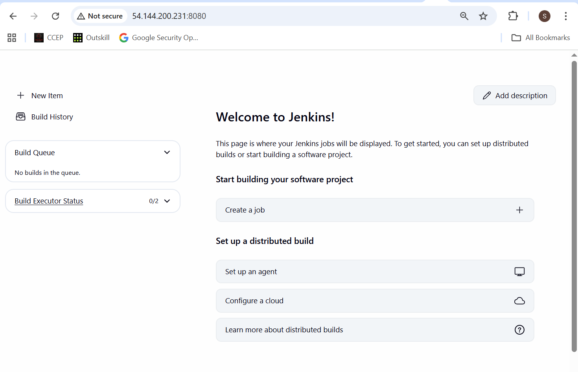

4.2 Prepare GitHub repo
Create a GitHub repo, e.g. multi-cloud-dr-cd containing:
- inventory.ini (same content but key path /var/lib/jenkins/.ssh/mcdr_key)
- nginx_deploy.yml
- index-aws.html
- index-azure.html
- Jenkinsfile
On Tools Machine, copy key for Jenkins:
sudo mkdir -p ~jenkins/.ssh
sudo cp /home/ubuntu/.ssh/mcdr_key ~jenkins/.ssh/
sudo chown -R jenkins:jenkins ~jenkins/.ssh
sudo chmod 700 ~jenkins/.ssh
sudo chmod 600 ~jenkins/.ssh/mcdr_key
In repo’s inventory.ini:
[aws_app]
aws_app ansible_host=<AWS_APP_PUBLIC_IP> ansible_user=ubuntu ansible_ssh_private_key_file=/var/lib/jenkins/.ssh/mcdr_key cloud=aws

[azure_app]
azure_app ansible_host=<AZURE_APP_PUBLIC_IP> ansible_user=azureuser ansible_ssh_private_key_file=/var/lib/jenkins/.ssh/mcdr_key cloud=azure

[all_app_servers:children]
aws_app
azure_app

4.3 Jenkinsfile
Create Jenkinsfile in repo:
pipeline {
agent any

environment {
ANSIBLE_FORCE_COLOR = 'true'
}

stages {
stage('Checkout') {
steps {
checkout scm
}
}

stage('Deploy via Ansible') {
steps {
sh '''
ansible-playbook -i inventory.ini nginx_deploy.yml
'''
}
}
}

post {
success {
echo 'Deployment successful.'
}
failure {
echo 'Deployment failed. Check logs.'
}
}
}
Push everything to GitHub.

4.4 Configure Jenkins job
In Jenkins UI:
- New Item → choose Pipeline.
- Name: multi-cloud-dr-cd.
- Under Pipeline:
  - Definition: Pipeline script from SCM
  - SCM: Git
  - Repo URL: https://github.com/sagarpatilbox/multi-cloud-dr-cd.git
  - Credentials: add if private
  - Script Path: Jenkinsfile
Save.
Screenshot:
Jenkins job config page.
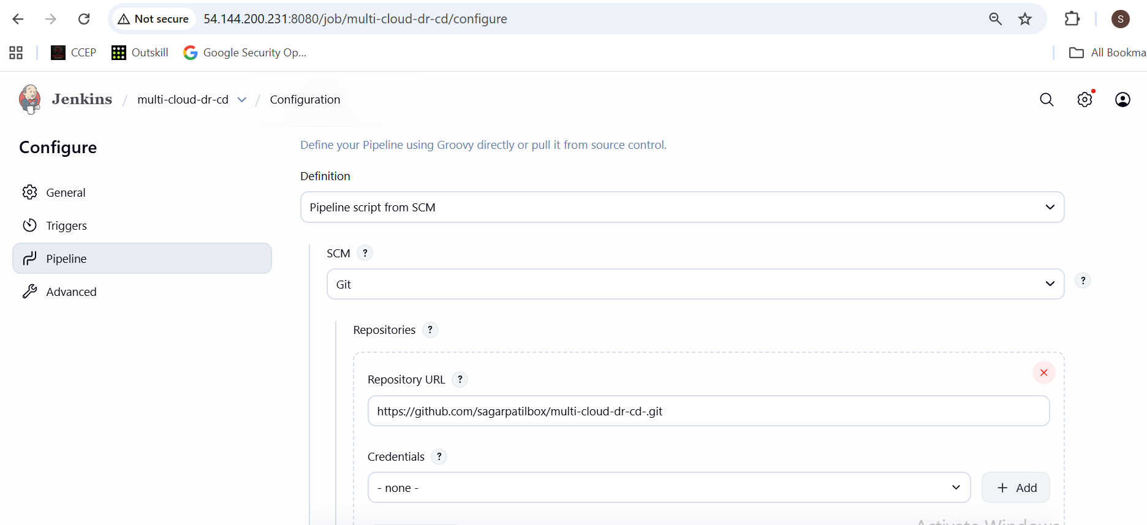

4.5 Run pipeline
Click Build Now.

Screenshots:
- Build
- Console output showing:
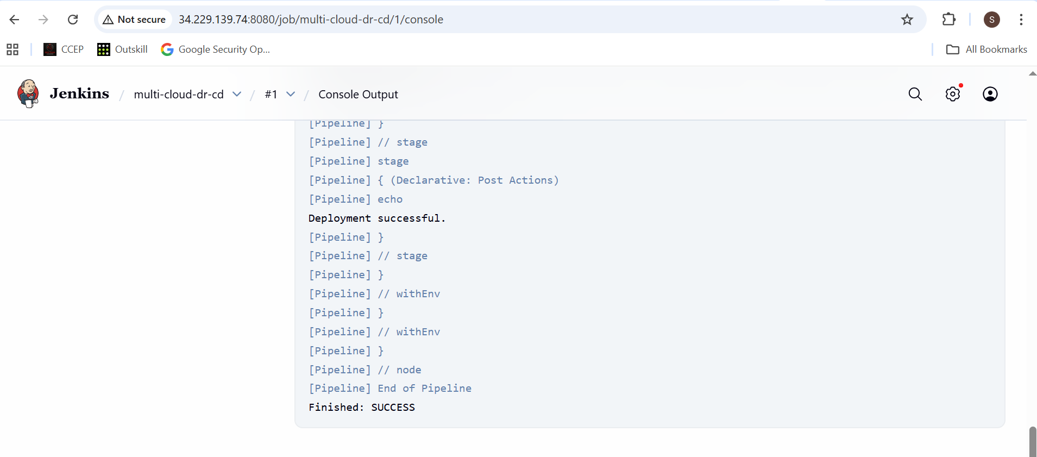
Now edit HTML in GitHub (e.g. add v2) → run/build again → check pages updated.
Screenshots:
- Before/after browser pages.
