Task 5 – Traffic Management Using AWS Route 53
I am Using My domain app.sagardevsecops.online

5.1 Create hosted zone
In AWS Console → Route 53 → Hosted zones → Create hosted zone:
- Domain name: sagardevsecops.online
- Type: Public hosted zone
Screenshot:
Hosted zone overview.
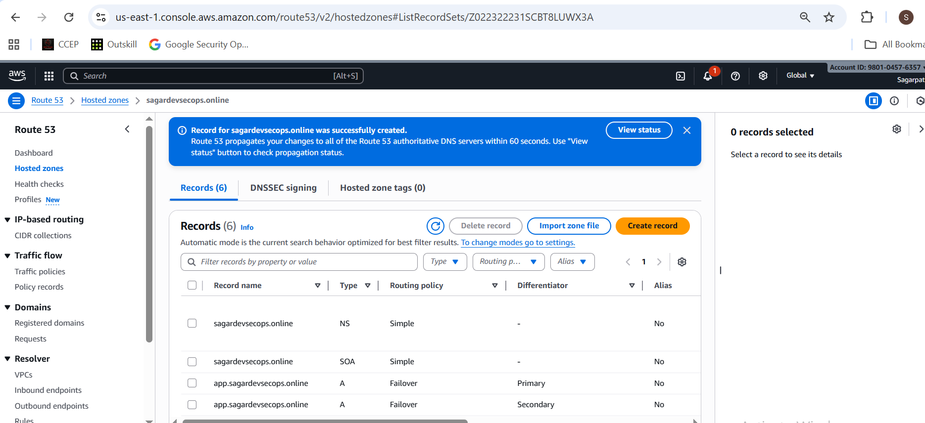

5.2 Create health check for AWS app
Route 53 → Health checks → Create health check:
- Name: aws-app-health
- Endpoint → IP address = <AWS_APP_PUBLIC_IP>
- Protocol: HTTP
- Port: 80
- Path: /

Screenshot:
Health check details (status OK when app running).
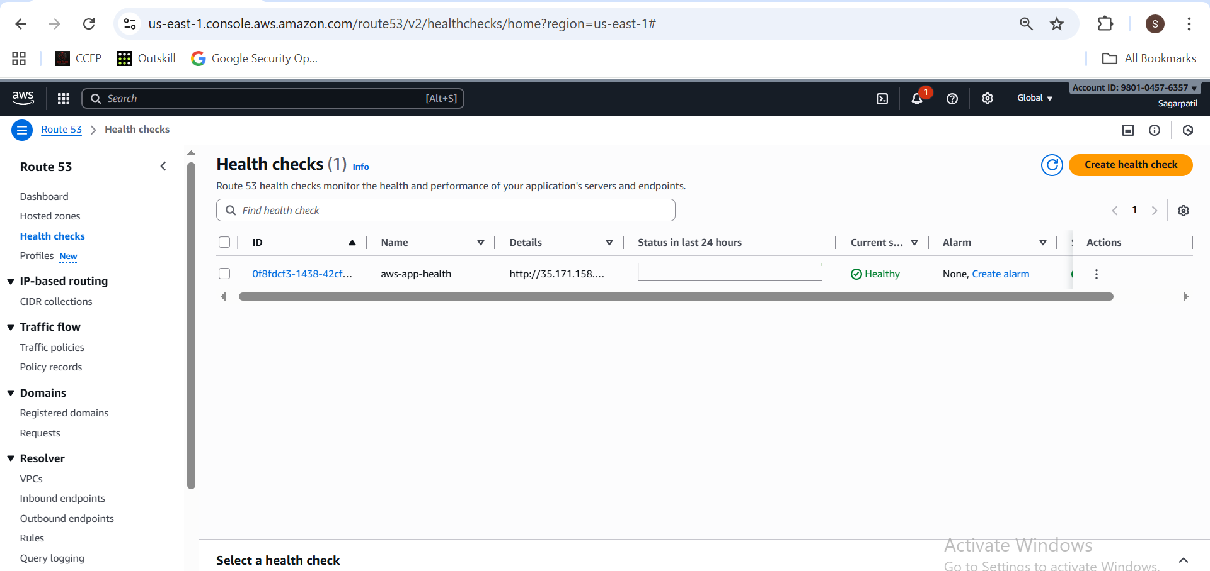

5.3 Create failover records
In hosted zone → Create record:
Primary record (AWS)
- Record name: app.sagardevsecops.online
- Type: A
- Routing policy: Failover
- Failover record type: Primary
- Value: <AWS_APP_PUBLIC_IP>
- Health check: aws-app-health
- Record ID: aws-primary
Secondary record (Azure)
- Record name: app.sagardevsecops.online
- Type: A
- Routing policy: Failover
- Failover record type: Secondary
- Value: <AZURE_APP_PUBLIC_IP>
- No health check
- Record ID: azure-secondary

Screenshots:
app.sagardevsecops.online
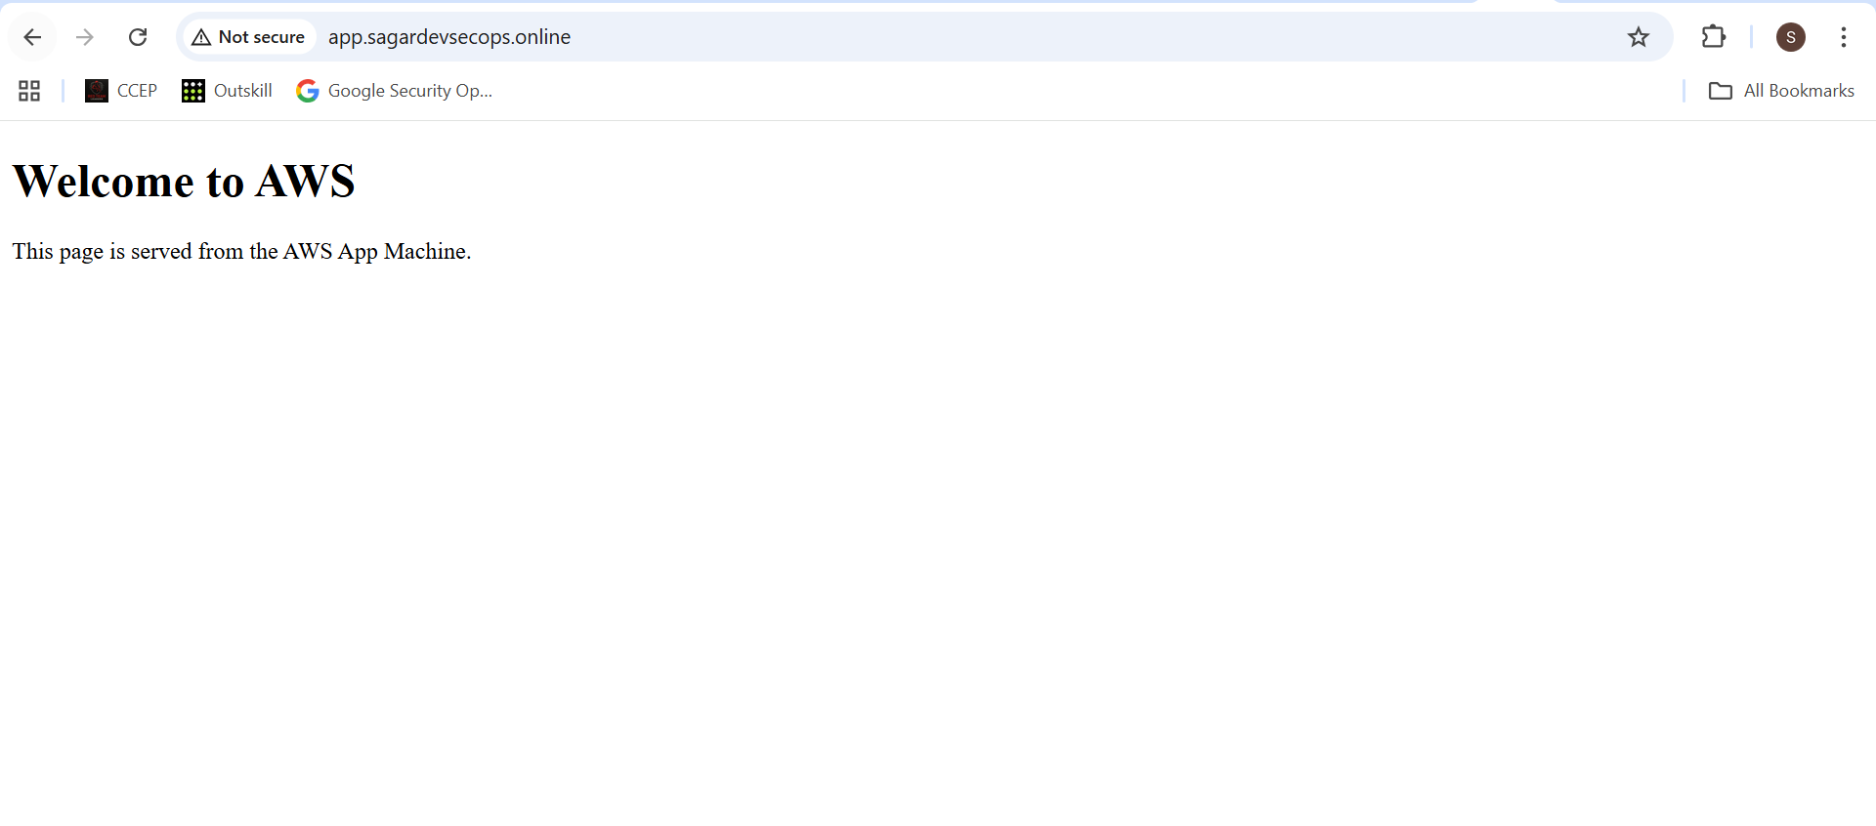

5.4 Test failover
- With AWS app running:
- curl http://app.sagardevsecops.online

Screenshot: Browser output.

- Stop AWS App instance in EC2 console.
  - Wait for health check to show Unhealthy.
Now you should see Welcome to Azure.
Screenshots:
  - EC2 instance state = stopped.
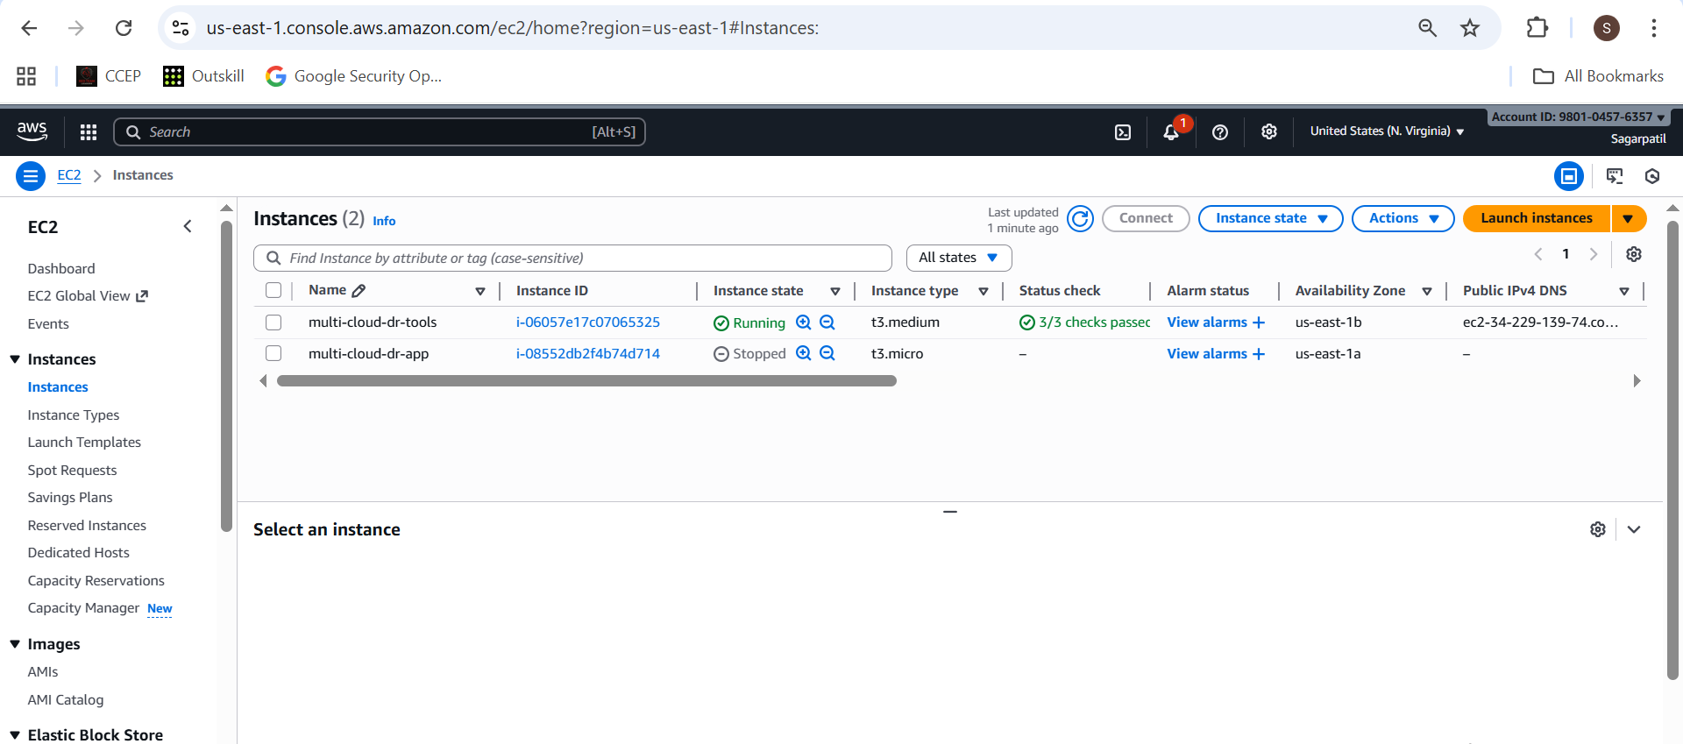
  - Health check status = Unhealthy.
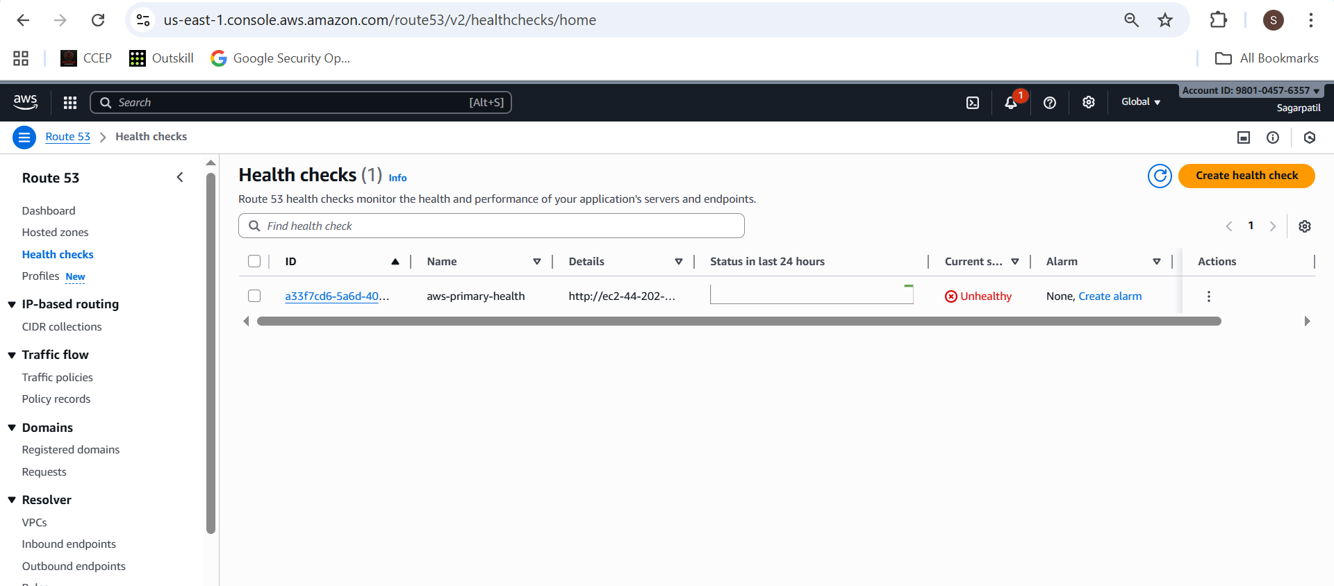

  - Browser showing Azure page via app.sagardevsecops.online.
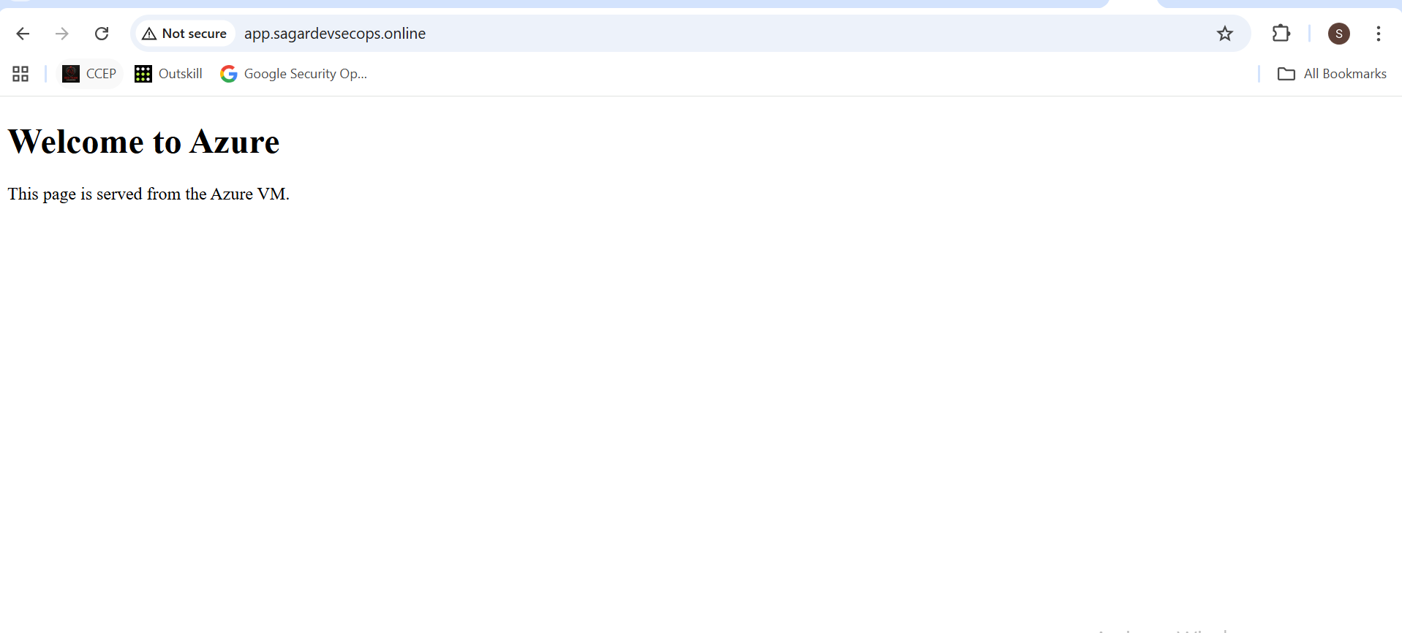
- Start AWS instance again, wait until health check is healthy, and re-test.
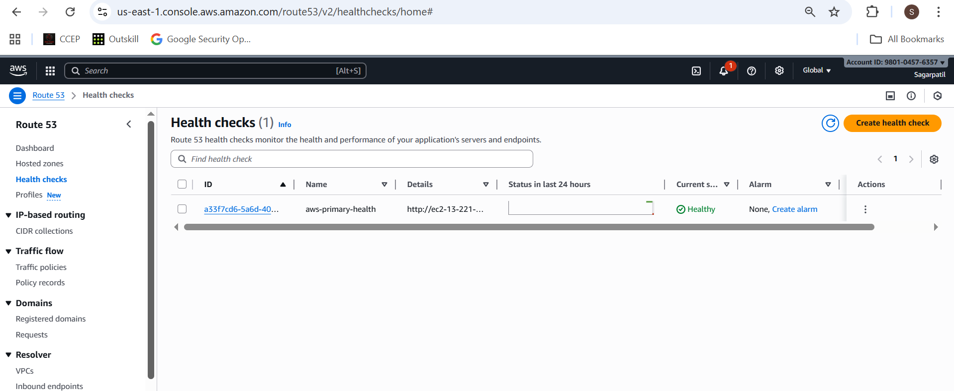

- Browser showing AWS page again.

