Two Faces of Food Insecurity in India: Hunger and Unhealthy Diets
Introduction
Food insecurity is often misunderstood as hunger alone. In reality, it has two very different faces—especially in India. While millions of people struggle to access enough food to meet basic needs, many others consume diets filled with highly processed, unsafe, and nutritionally poor foods. Both situations point to deeper problems within the food system.
This website explores the two sides of food insecurity in India: chronic hunger and malnutrition on one hand, and unhealthy diets and lifestyle diseases on the other. Through blogs, real-world examples, images, and videos, the platform highlights how economic inequality, changing food habits, climate shocks, and policy decisions shape what ends up on people’s plates. The goal is to create awareness, encourage informed choices, and spark conversations about building a food system that is safe, sustainable, and fair for everyone.
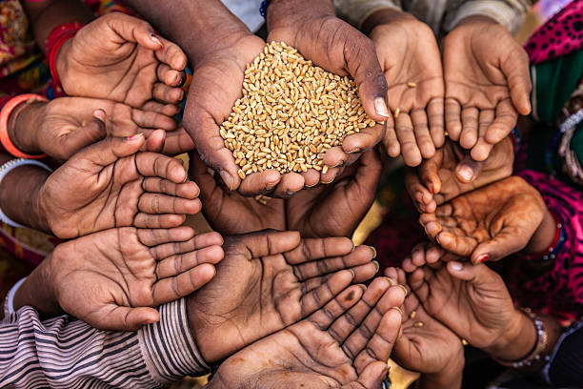
https://www.google.com/url?sa=i&url=https%3A%2F%2Ffrontline.thehindu.com%2Fsociety%2Findia-poverty-decline-real-or-illusion%2Farticle69814819.ece&psig=AOvVaw2KzvQu7BSJ1fBPYXDNRQBA&ust=1765783090807000&source=images&cd=vfe&opi=89978449&ved=0CBEQjRxqFwoTCNjxjOPEvJEDFQAAAAAdAAAAABAE
Recent Crises Exposing India’s Food System Fragility
COVID-19 Lockdown: When India’s Food System Froze Overnight
The COVID-19 lockdown was one of the biggest stress-tests India’s food system had ever faced — and it exposed just how delicate the whole structure really is. Almost overnight, millions of migrant workers found themselves unemployed, stranded, and unsure of where their next meal would come from. These were families who lived day to day, earning just enough to buy food, and suddenly they had nothing except uncertainty.
Across major cities, markets shut down, transportation stopped, and supply chains froze. Vegetables never left farms, milk was spilled on roadsides because distributors couldn’t reach cities, and essential food items became difficult to access. Children who depended on mid-day meals in government schools were suddenly cut off from their most reliable source of nutrition. Many urban poor families survived purely on ration rice and dal provided through the Public Distribution System (PDS).
This crisis revealed the hidden backbone of India’s food system — the informal workforce. They transport vegetables, work in mandis, load trucks, sell produce on carts, and run small kirana shops. When they stopped, everything stopped. The lockdown proved that food security is not just about having enough food in storage — it’s about distribution, movement, jobs, and accessibility.
More importantly, it raised questions about how prepared India is for emergencies. A country of 1.4 billion cannot depend entirely on last-minute decisions. Sustainable food security needs robust logistics, stronger safety nets, predictable support for migrant workers, and systems that won’t collapse the moment economic activity pauses. The pandemic was a harsh reminder: a food system is only as strong as the people and networks that keep it running every single day.
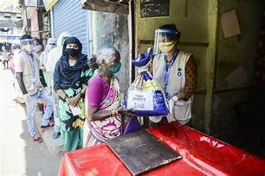
https://www.actionagainsthunger.org/app/uploads/2022/09/Food_Distribution_4_Maharashtra-scaled.webp
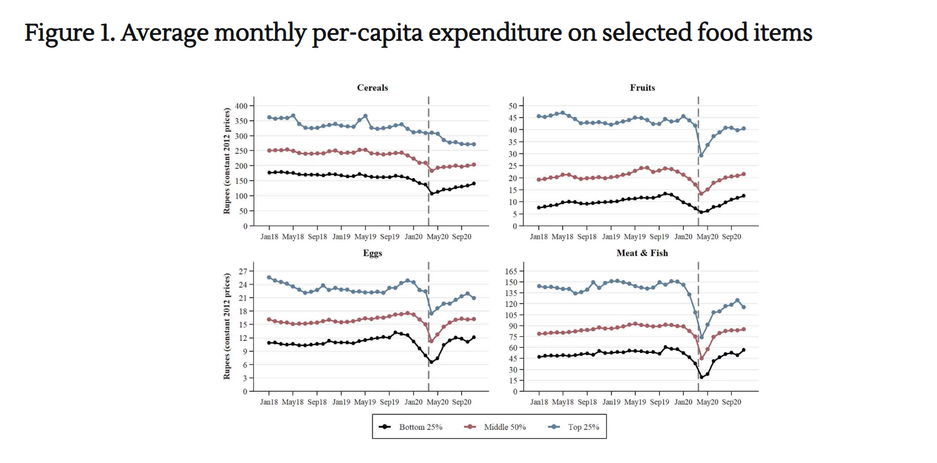
https://www.google.com/url?sa=i&url=https%3A%2F%2Fcovid-19-constitution.in%2Fanalyses%2Fthe-covid-19-crisis-and-peoples-right-to-fo&psig=AOvVaw3RVtYRKW1wckTe4-Gdegg8&ust=1765783215649000&source=images&cd=vfe&opi=89978449&ved=0CBEQjRxqFwoTCKj9gJ_FvJEDFQAAAAAdAAAAABAE

Tomato & Vegetable Price Shock (2022–2024): When Everyday Food Became a Luxury
Between 2022 and 2024, India saw one of its most dramatic vegetable price spikes ever — especially tomatoes. Prices didn’t just rise; they skyrocketed. In some cities, tomatoes touched ₹180–₹220 per kg, turning a basic kitchen ingredient into a luxury item. Households started cutting back, restaurants removed tomato-based dishes, and memes flooded the internet. But behind the humor lay a very real, unsettling reality: India’s vegetable supply chains are deeply vulnerable.
Why did this happen? The answer lies in climate extremes and unstable logistics. Heavy, unexpected rains destroyed crops in major tomato-growing states like Karnataka, Andhra Pradesh, and Maharashtra. Just when farmers replanted, heatwaves scorched the new crop. Repeated cycles of destruction meant that vegetables never reached full production, causing shortages.
But climate was only half the story. India's supply chain relies heavily on middlemen, outdated cold storage, and long-distance transportation. When production dropped, traders hoarded vegetables, expecting higher profits. Transport delays and fuel price increases added further pressure. The result? A perfect storm that made everyday vegetables unaffordable.
This crisis taught India a powerful lesson: food affordability is fragile. Small disruptions can snowball into massive price shocks. Building climate-resilient agriculture, modern cold-chain systems, and transparent pricing mechanisms is no longer optional — it’s essential.
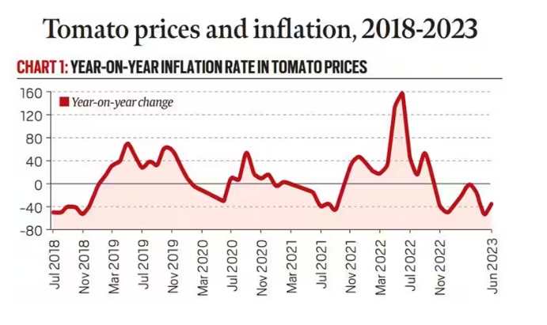
https://www.google.com/url?sa=i&url=https%3A%2F%2Fwww.drishtiias.com%2Fdaily-updates%2Fdaily-news-analysis%2Ftomatoes-price-volatility&psig=AOvVaw2ef2xxa1XdyIvEcUrJtaaw&ust=1765783246992000&source=images&cd=vfe&opi=89978449&ved=0CBEQjRxqFwoTCMiQzLHFvJEDFQAAAAAdAAAAABAE

Rice Export Ban & Panic Buying (2023–2024): One Policy, Millions of Kitchen Crises
In mid-2023, India suddenly announced a ban on the export of non-basmati white rice to control domestic inflation. Within hours, panic set in. Videos of people rushing to purchase 10–20 kg bags of rice flooded social media. Many shops ran out of stock temporarily, and prices surged despite government assurances. This wasn’t a crisis caused by shortage — it was a crisis of fear and uncertainty.
India is the world’s largest rice exporter, accounting for more than 40% of global supply. So when India pressed the pause button, markets around the world shook instantly. Countries in Africa and Asia that rely heavily on Indian rice faced price surges and supply disruptions.
Domestically, the ban exposed an important truth: households respond emotionally when it comes to staple foods. Even the slightest rumor or policy shift can cause widespread panic buying. It also highlighted how interconnected global markets are — a local decision triggered global consequences.
This episode underlined the importance of predictable policymaking, transparent communication, and stable food distribution systems. People need clarity, not surprises. Because when it comes to essential foods, fear spreads faster than facts.
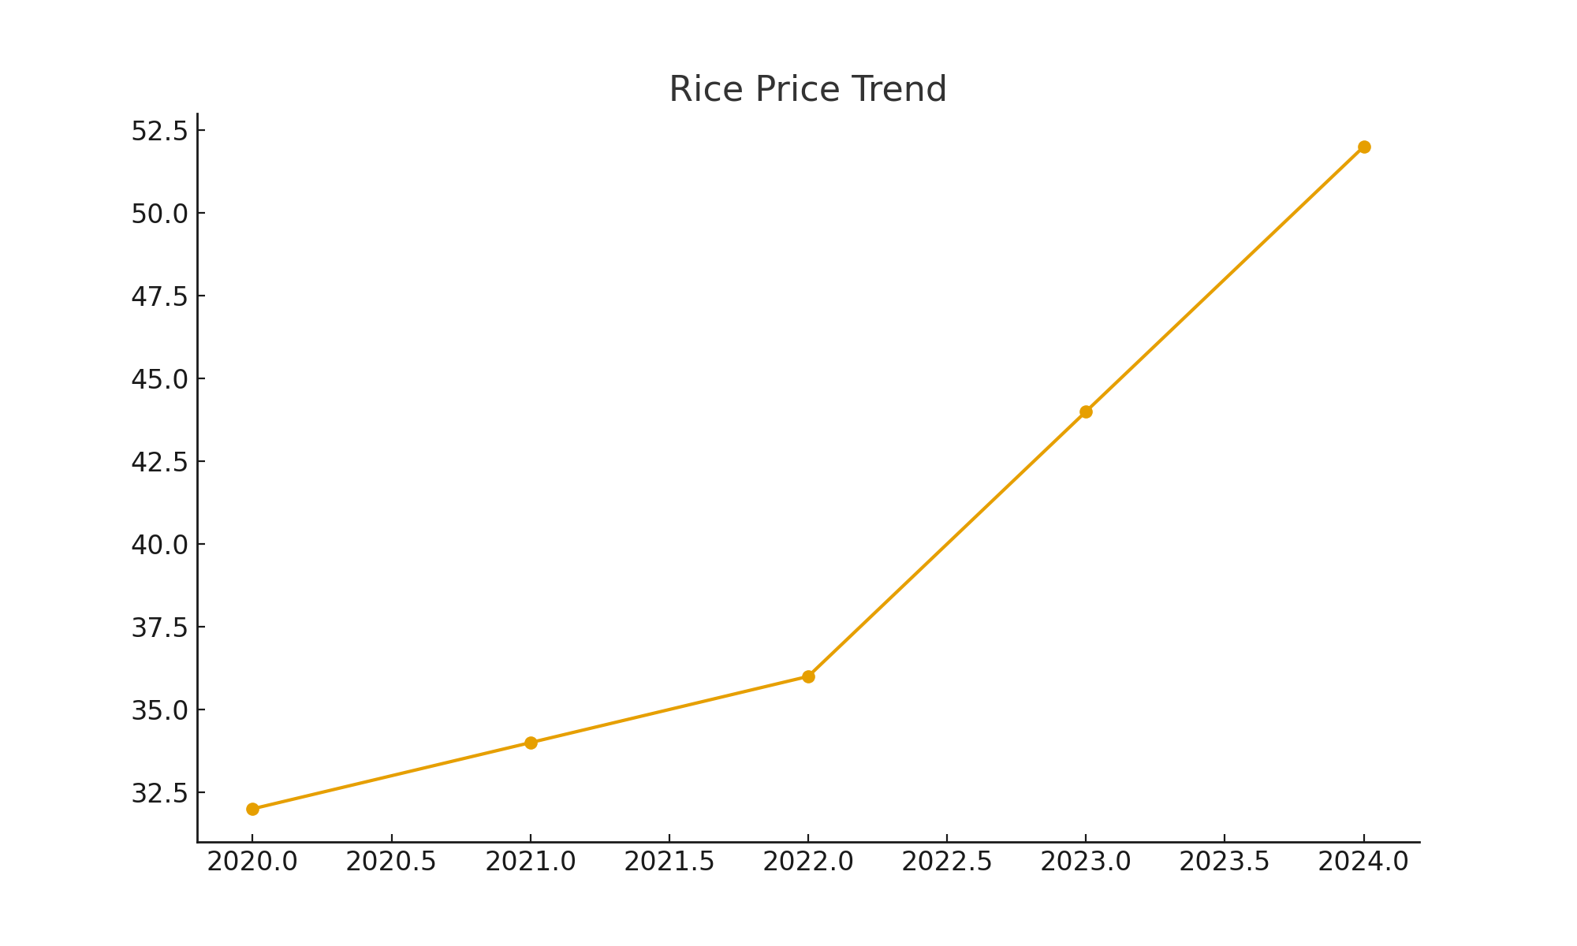

Pulses Price Spike (2015–2023): When Protein Became Unaffordable
Over nearly a decade, India repeatedly faced price spikes in pulses — especially tur, urad, and moong. These aren’t just any food items; for millions of Indian households, especially vegetarians, pulses are the primary and often only source of protein. When prices doubled or tripled, families were forced to cut back on essential nutrition.
The reasons behind the spikes were a mix of climate shocks, market manipulation, and heavy dependence on imports. Droughts in Maharashtra and Karnataka damaged kharif tur crops. Traders hoarded stock, worsening shortages. Imports from Myanmar, Canada, and East Africa couldn’t always fill the gap in time.
The real tragedy? Poor households had to settle for less nutritious meals. Protein deficiency increased, particularly among children and women. At the same time, middle-class families reluctantly paid higher prices, straining household budgets.
This long-running crisis showed the danger of relying too heavily on a few crops and pointed to the need for diversified farming, better storage, fair pricing, and support for pulse farmers.
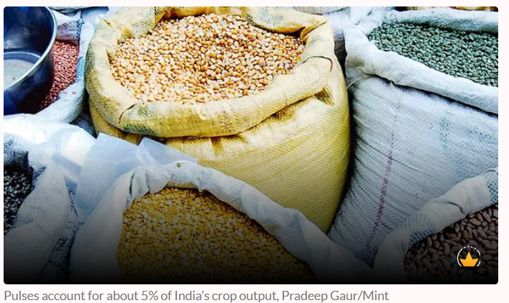
https://www.google.com/url?sa=i&url=https%3A%2F%2Fswarajyamag.com%2Feconomy%2Fsupplyco-economics-do-we-have-an-answer-to-keralas-food-inflation&psig=AOvVaw2Pp3uJSPpaFIJC_XQAAP3G&ust=1765783319693000&source=images&cd=vfe&opi=89978449&ved=0CBEQjRxqFwoTCNis0NHFvJEDFQAAAAAdAAAAABAE

North India Floods & Crop Loss (2023): Climate Chaos Hits the Food Bowl
In 2023, Punjab, Haryana, and Uttar Pradesh — the agricultural heart of India — faced severe flooding due to erratic monsoon patterns. Rivers overflowed, fields were submerged for weeks, and thousands of acres of paddy, maize, sugarcane, and vegetable crops were destroyed. Farmers faced heartbreaking losses, and consumers felt the impact almost immediately through rising prices.
Vegetables like beans, gourds, and leafy greens saw price spikes, while fodder shortages pushed up dairy costs. The floods showed how one climatic event can ripple across the entire food economy — from farmers to consumers.
This incident reinforced that climate change is not a distant threat; it’s already reshaping the stability of India’s food supply. Stronger flood management, climate-resilient seeds, and diversified cropping patterns are urgently needed.
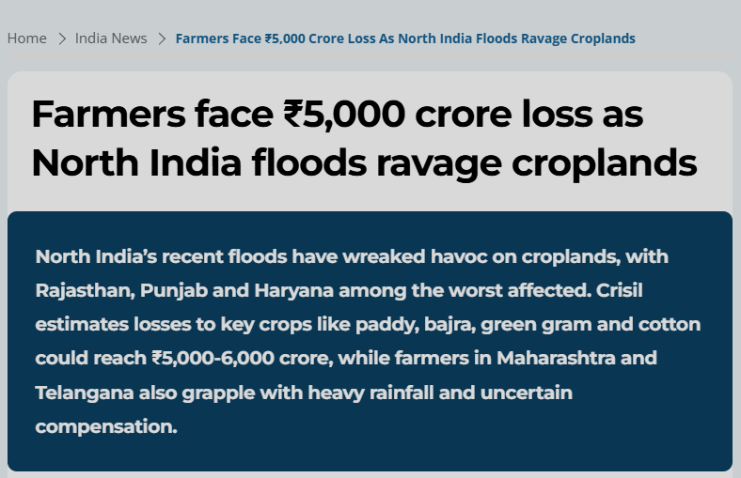

Wheat Production Decline Due to Heatwave (2022–2023): When Heat Burned India’s Bread Basket
In 2022, North India experienced the hottest March in over a century — and the timing couldn’t have been worse. Wheat crops were entering their grain-filling stage, when cooler temperatures are ideal. Instead, scorching heat shriveled the grains, reducing the yield by 10–15% in several regions. India, which had earlier announced it could “feed the world,” had to suddenly halt wheat exports.
This crisis highlighted the brutal reality of climate change: even a few extra degrees can threaten national food supplies. As wheat is India’s second-most important staple, any decline has a direct impact on PDS, household budgets, and overall food inflation.
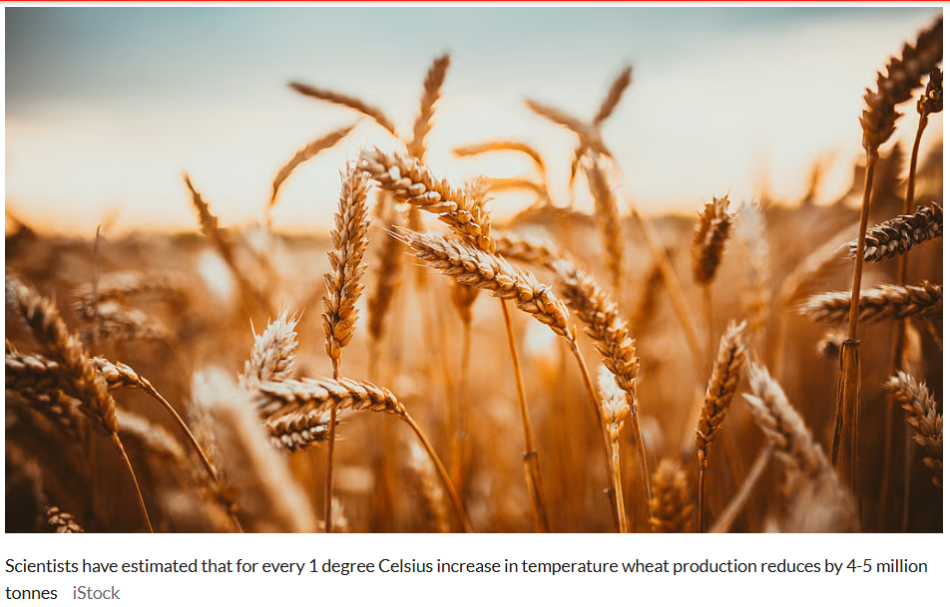
https://www.google.com/url?sa=i&url=https%3A%2F%2Fswachhindia.ndtv.com%2Ftoo-early-to-say-about-impact-of-high-temperatures-on-wheat-crop-union-agriculture-minister-74712%2F&psig=AOvVaw257q8WfJwxfomnupSiTt0-&ust=1765783360605000&source=images&cd=vfe&opi=89978449&ved=0CBEQjRxqFwoTCLiDxOTFvJEDFQAAAAAdAAAAABAS
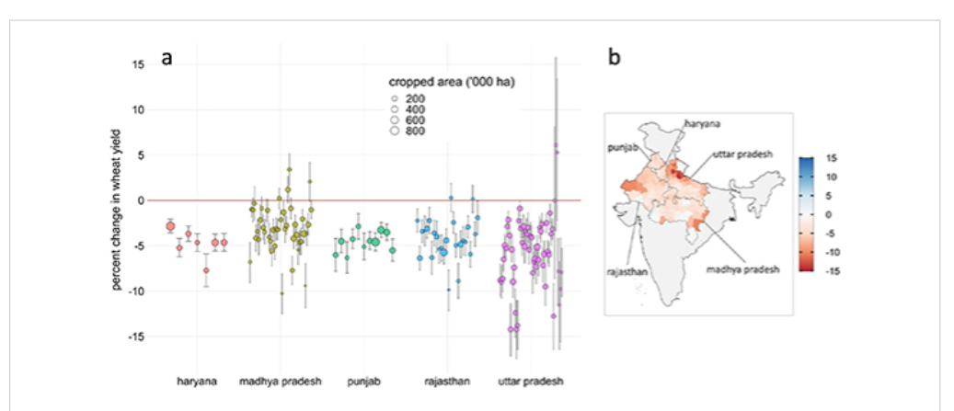
https://www.google.com/url?sa=i&url=https%3A%2F%2Fwww.researchgate.net%2Ffigure%2Fa-District-wise-wheat-yield-loss-percent-expected-in-2022-compared-to-a_fig3_373845850&psig=AOvVaw0-__w_cpaE-yglMq-Inomd&ust=1765783389972000&source=images&cd=vfe&opi=89978449&ved=0CBEQjRxqFwoTCOijivLFvJEDFQAAAAAdAAAAABAE

Irrigation & Water Scarcity Crisis in Punjab–Haryana (2023–2024): Food Security Begins With Water
Punjab and Haryana form India’s food backbone — but both states are running out of water. In 2023–2024, a severe irrigation crisis emerged as canal water dropped and groundwater declined below critical levels. Farmers struggled to transplant paddy on time, tube wells ran dry, and electricity consumption shot up as pumps strained to extract water from deeper levels.
The crisis revealed how water scarcity directly translates to food scarcity. Delayed paddy planting led to delayed harvesting, reduced yields, and increased vulnerability to pests. Vegetables and fodder also suffered, showing that the issue goes beyond just rice and wheat.
This incident was a clear warning: India’s food security depends on sustainable water management. Without urgent reforms in crop diversification, groundwater conservation, and irrigation planning, the country risks long-term agricultural decline.
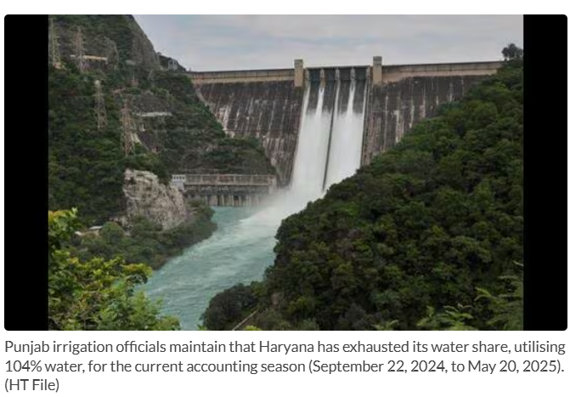
https://www.google.com/url?sa=i&url=https%3A%2F%2Fwww.hindustantimes.com%2Fcities%2Fchandigarh-news%2Fcentre-proposes-restructuring-of-bbmb-may-dilute-punjab-s-role-101760384847684.html&psig=AOvVaw1tc8Xfuq-AKGF2B-8DbDb5&ust=1765783408312000&source=images&cd=vfe&opi=89978449&ved=0CBEQjRxqFwoTCOCnt_rFvJEDFQAAAAAdAAAAABAE

What’s Really Happening on Our Plates
What these stories reveal is that food insecurity in India is no longer just about not having enough food — it is also about what kind of food people are eating. For low-income families, rising prices, unstable incomes, and gaps in the Public Distribution System (PDS) make it difficult to access fruits, vegetables, milk, eggs, and protein-rich foods. Many households depend on low-cost, low-nutrient meals, leading to child stunting, anemia among women, poor maternal health, and long-term physical and cognitive development issues.
At the same time, middle- and upper-class households face a different but equally serious problem. Diets increasingly dominated by ultra-processed foods, sugary drinks, deep-fried snacks, fast food, and adulterated products have led to rising obesity, diabetes, hypertension, and lifestyle-related diseases. Even with enough calories, nutrition quality is often poor.
Together, these realities show a troubling paradox: while some people struggle with hunger, others suffer from unhealthy diets. Both problems stem from the same roots — economic inequality, weak food safety regulation, changing food culture, and a food system that prioritizes profit and convenience over nutrition and health.

Why This Matters for India’s Future
The consequences of this dual crisis go far beyond individual households. Hunger and malnutrition weaken children’s learning ability, reduce productivity, and trap families in cycles of poverty. At the other end, diet-related diseases place a growing burden on healthcare systems and household finances, affecting long-term economic growth.
These challenges highlight the urgent need for stronger nutrition programs, better food safety enforcement, greater awareness about healthy eating, and support for sustainable, local food systems. Without coordinated action, India risks facing a future where food is available — but not affordable, safe, or nourishing for large sections of the population.

Final Thoughts
India’s food insecurity has two interconnected faces: hunger and malnutrition among the poor, and unhealthy, unsafe diets among the middle- and upper-class population. Both are symptoms of deeper structural issues within the food system. True food security cannot be achieved by addressing only one side of the problem. Ensuring safe, nutritious, affordable, and equitable food for everyone must be a national priority — not just for public health, but for India’s social and economic future.

🎥 Bonus
A bonus video has been added covering the first three crises discussed above.

