Terraform is an open-source infrastructure as a code (IAC) software tool created by HashiCorp. It enables users to define and provision a datacenter infrastructure using a high-level configuration language known as Hashicorp Configuration Language (HCL).

List of Infrastructure as a code software (IAC) tool

* Terraform Supports multiple cloud provider
* CloudFormation Supports only AWS (Owned by AWS)
* Ansible
* SaltStack
* Chef
* Puppet

Tools like Terraform and CloudFormation primarily used for Infrastructure Orchestration and they can do configuration management only for certain part.

Whereas, Ansible/Chef/Puppet are only designed for configuration management , and they can also orchestrate infra for certain part only.

Terraform Installation in Linux

wget <https://releases.hashicorp.com/terraform/0.12.24/terraform_0.12.24_linux_amd64.zip>

unzip terraform_0.12.24_linux_amd64.zip

mv terraform /bin/

terraform version

Some useful commands

Terraform init

Terraform plan

Terraform apply

Terraform destroy (To delete all terraform resources)

Terraform destroy -target <> (To destroy specific resource)

Terraform validate (To Check Configuration)

**Attributes**

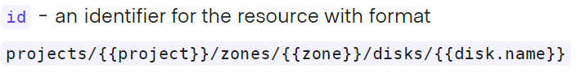

Example 🡪

id=projects/analysis-project-273210/zones/europe-west2-b/instances/terraform-machine2

id=projects/analysis-project-273210/zones/europe-west2-b/disks/disk1

**Linking GCP resources**

By “self_link”

Example 🡪

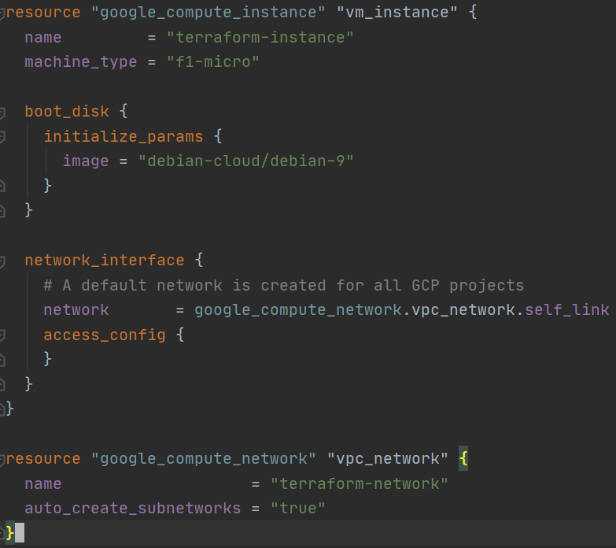

**Note: To use an existing resource from GCP in terraform script, user needs to use complete URL of the resource.**

For e.g. : Below is the code snippet for creating an instance group in an existing GCP network named default.

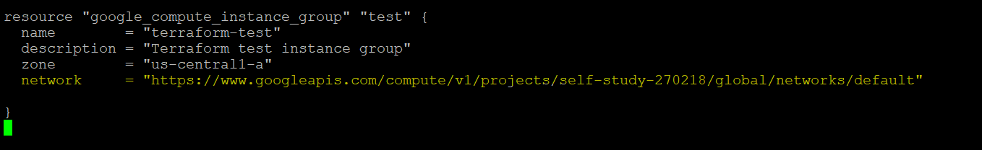

List of existing networks in GCP can be found by:

gcloud compute networks list --uri