**Implementation of Personal Fitness Tracker using Python**

A Project Report

submitted in partial fulfillment of the requirements

of

AICTE Internship on AI: Transformative Learning

with

TechSaksham – A joint CSR initiative of

Microsoft & SAP

by

**SAGAR SINGH RAWAT**

[**sagarsinghrawat162020@gmail.com**](mailto:sagarsinghrawat162020@gmail.com)

Under the Guidance of

**Saomya Chaudhury**

**ACKNOWLEDGEMENT**

I would like to take this opportunity to express my deep sense of gratitude to all individuals who helped me directly or indirectly during this thesis work.

Firstly, I would like to thank my supervisor, Somya Chaudhary, for being a great mentor and the best adviser I could ever have. His advice, encouragement and the critics are a source of innovative ideas, inspiration and causes behind the successful completion of this project. The confidence shown in me by him was the biggest source of inspiration for me. It has been a privilege working with him for the last one year. He always helped me during my project and many other aspects related to the program. His talks and lessons not only help in project work and other activities of the program but also make me a good and responsible professional.

#### **ABSTRACT**

The project "Implementation of Personal Fitness Tracker using Python" addresses the challenge of monitoring and maintaining personal fitness. In the contemporary world, health and fitness are paramount, yet many individuals struggle with tracking their fitness activities efficiently. This project aims to develop a personal fitness tracker that helps users monitor their physical activities, set fitness goals, and track progress over time.

* **Objectives:** The primary objectives of this project are to design and implement a user-friendly fitness tracking application using Python, integrate features for tracking various physical activities (such as walking, running, and cycling), and provide users with insightful data visualizations to monitor their progress.
* **Methodology:** The project employs a structured approach to software development, beginning with requirements analysis to understand user needs. The application is developed using Python, leveraging libraries such as Tkinter for the graphical user interface (GUI) and Matplotlib for data visualization. The core functionality includes input modules for recording physical activities, storage modules for maintaining user data, and output modules for displaying progress reports.
* **Key Results:** The implementation of the fitness tracker successfully enables users to input their daily physical activities, set fitness goals, and view their progress through interactive charts and graphs. The application provides real-time feedback and analytics, empowering users to make informed decisions about their fitness routines.
* **Conclusion:** The personal fitness tracker developed in this project offers a practical solution for individuals seeking to monitor and enhance their fitness activities. By utilizing Python and its robust libraries, the application delivers a comprehensive and user-friendly experience. Future enhancements could include integration with wearable devices and advanced analytics to further support users in achieving their fitness goals.

**TABLE OF CONTENT**

**Abstract I**

**Chapter 1.**  **Introduction 1**

1.1 Problem Statement 1

1.2 Motivation 1

1.3 Objectives 2

1.4. Scope of the Project 3

**Chapter 2.**  **Literature Survey 4**

**Chapter 3.**  **Proposed Methodology 6**

**Chapter 4.**  **Implementation and Results 9**

**Chapter 5. Discussion and Conclusion 14**

**References** **16**

**LIST OF FIGURES**

|  |  |  |
| --- | --- | --- |
| **Figure No.** | **Figure Caption** | **Page No.** |
|  |  |  |
|  |  |  |
|  |  |  |
|  |  |  |
|  |  |  |
|  |  |  |
|  |  |  |
|  |  |  |
|  |  |  |

**LIST OF TABLES**

|  |  |  |
| --- | --- | --- |
| **Table. No.** | **Table Caption** | **Page No.** |
|  |  |  |
|  |  |  |
|  |  |  |
|  |  |  |
|  |  |  |
|  |  |  |
|  |  |  |
|  |  |  |
|  |  |  |

**CHAPTER 1**

**Introduction**

* 1. **Problem Statement:**

Maintaining personal fitness is a significant challenge in today's fast-paced world. Many individuals struggle to keep track of their physical activities, set fitness goals, and monitor their progress effectively. This problem is significant because poor fitness tracking can lead to inadequate exercise routines, lack of motivation, and, consequently, health issues such as obesity, cardiovascular diseases, and reduced overall well-being.

The current market is saturated with numerous fitness tracking applications and devices, yet many of these solutions are either too complex or not tailored to individual needs. Additionally, some existing tools lack comprehensive features for goal setting, real-time feedback, and detailed progress analysis. This project aims to bridge these gaps by developing an easy-to-use, yet robust personal fitness tracker application using Python. The application will cater to users who seek a straightforward method to log their physical activities, set fitness goals, and visualize their progress, thereby promoting a healthier lifestyle.

* 1. **Motivation:**

This project was chosen to address the growing need for efficient personal fitness tracking solutions. The potential applications of a personal fitness tracker are vast, including helping users to stay motivated, achieve their fitness goals, and maintain a healthy lifestyle. The impact of this project can be profound, as it empowers individuals to take control of their fitness journey, make informed decisions about their health, and ultimately lead healthier, more active lives.

The impact of this project extends beyond individual users; it contributes to the broader goal of public health promotion. By enabling more people to monitor and improve their fitness levels, the project supports the fight against lifestyle-related diseases and fosters a culture of health consciousness. The success of this application could also pave the way for future innovations in digital health and fitness, including the integration of advanced analytics, machine learning, and IoT devices.

Overall, the project represents a meaningful effort to enhance personal fitness management through technology, offering a practical and scalable solution to a pervasive problem.

* + 1. **Health Promotion:** By providing users with a straightforward way to track their physical activities, the fitness tracker can promote regular exercise and healthy habits. This can lead to improved physical and mental well-being, reducing the risk of chronic diseases.
    2. **Personalized Fitness Management:** The ability to set personalized fitness goals and receive real-time feedback can help users stay motivated and committed to their routines. The application can offer tailored recommendations based on individual progress and preferences.
    3. **Technological Advancements:** The project showcases the versatility and power of Python in developing practical applications for real-world problems. It highlights how technology can be harnessed to create solutions that make a tangible difference in people's lives.
    4. **Public Health Impact:** Beyond individual benefits, the project contributes to the broader goal of public health promotion. By enabling more people to monitor and improve their fitness levels, the application supports the development of a healthier and more active population.
    5. **Future Innovation:** The project lays the groundwork for future enhancements and innovations in the digital health and fitness domain. It opens up possibilities for integrating advanced analytics, machine learning, and IoT devices, further enhancing the capabilities of the fitness tracker.
  1. **Objective:**

The primary objective of the "Implementation of Personal Fitness Tracker using Python" project is to create a robust and user-friendly application that helps individuals monitor and manage their fitness activities. The detailed objectives include:

* + 1. **Design and Development:** To design and develop an intuitive fitness tracking application using Python that simplifies the process of logging and monitoring physical activities.
    2. **Feature Integration:** To incorporate features that allow users to track various physical activities, such as walking, running, cycling, and more, and to record relevant metrics like distance, time, and calories burned.
    3. **Goal Setting and Progress Monitoring:** To enable users to set personalized fitness goals and track their progress over time through detailed and interactive data visualizations.
    4. **Data Storage and Management:** To implement efficient data storage solutions that securely maintain user activity records and allow for easy retrieval and analysis.
    5. **User Feedback and Analytics:** To provide real-time feedback and analytics to users, helping them make informed decisions about their fitness routines and lifestyle choices.
    6. **Scalability and Flexibility:** To ensure the application is scalable and flexible, allowing for future enhancements and integration with additional features such as wearable devices and advanced data analytics.
  1. **Scope of the Project:**

The scope of the project is defined by its boundaries and limitations, as well as potential future enhancements. The key aspects of the project's scope include:

* + - 1. **Core Functionality:** The initial version of the fitness tracker will focus on core functionalities, including logging physical activities, setting fitness goals, and visualizing progress through charts and graphs.
      2. **Desktop Application:** The project will develop a desktop application using Python and relevant libraries (Tkinter for GUI, Matplotlib for data visualization, and SQLite for database management).
      3. **User Experience:** The application will prioritize user experience by offering an intuitive and easy-to-navigate interface, ensuring users can quickly and efficiently log their activities and view their progress.
      4. **Security and Privacy:** The project will implement measures to ensure the security and privacy of user data, including secure data storage and access controls.

**CHAPTER 2**

**Literature Survey**

* 1. **Review of Relevant Literature:**

The domain of personal fitness tracking has seen significant advancements over the years. Fitness apps on mobile devices have gained popularity as more people engage in self-tracking activities to monitor their fitness and exercise routines. These technologies have evolved from simply recording steps and offering exercise suggestions to becoming integrated lifestyle guides for physical well-being. Wearable activity trackers (WATs) have also become prevalent, providing metrics such as steps taken, activity levels, walking distance, heart rate, and sleep patterns2. Despite the proliferation of these devices, there is limited understanding of the broad research landscape, and a comprehensive summary of existing research is necessary.

* 1. **Existing Models, Techniques, and Methodologies:**

Several models and techniques have been developed to enhance fitness tracking. One innovative project presents a methodology that uses advanced deep learning and data analysis methods to monitor exercises and measure fitness levels accurately. Another project leverages YOLOv5, a state-of-the-art deep learning technique, to develop an advanced fitness tracking system that detects and analyzes human poses, movements, and exercise routines in real-time4. AI-powered smartwatches have also revolutionized fitness tracking by providing personalized workout routines, real-time feedback, and advanced activity recognition mechanisms.

* 1. **Gaps and Limitations in Existing Solutions:**

While existing fitness tracking solutions offer valuable insights, they also have limitations. Many traditional exercise monitoring systems rely on manual input or simple techniques that may not be very precise. Additionally, there are issues related to user engagement and discontinuance with wearable fitness trackers6. The current individual, performance-oriented fitness app designs may not fully address the human-technology interface and the cultural or social context of fitness tracking.

* + 1. **User Engagement and Retention:** A common challenge with existing fitness tracking solutions is sustaining user engagement over time. Many users discontinue the use of fitness apps and wearables after initial enthusiasm wanes. Research indicates that incorporating social features, gamification, and personalized feedback can improve long-term engagement.
    2. **Accuracy and Data Quality:** The accuracy of data collected by fitness trackers varies across devices and activities. Inaccurate measurements can lead to misleading insights and reduce the effectiveness of fitness tracking. Advanced AI algorithms and sensor technologies are being explored to enhance data accuracy.
    3. **Integration and Interoperability:** Many fitness tracking systems operate in isolation, lacking integration with other health and fitness platforms. This limits the ability to provide a holistic view of an individual's health and fitness. Future solutions need to focus on interoperability and seamless data exchange between different devices and applications.
  1. **Addressing the Gaps:**

The project "Implementation of Personal Fitness Tracker using Python" aims to address these gaps by developing a user-friendly fitness tracking application that integrates features for tracking various physical activities and provides insightful data visualizations. By leveraging Python and its robust libraries, the application will offer a comprehensive and personalized user experience. Future enhancements could include integration with wearable devices and advanced analytics to further support users in achieving their fitness goals.

* + 1. **Enhanced User Interface:** Designing an intuitive and engaging UI to improve user interaction and long-term engagement.
    2. **Accurate Data Collection:** Utilizing efficient algorithms for precise data tracking and analysis.
    3. **Personalized Feedback:** Providing real-time, personalized recommendations based on user data to maintain motivation and adherence.
    4. **Future Enhancements:** Planning for future integration with wearable devices and advanced analytics to further support users in achieving their fitness goals.

**CHAPTER 3**

**Proposed Methodology**

* 1. **System Design:** The system design for the "Implementation of Personal Fitness Tracker using Python" is centered around a modular architecture that allows for easy integration and scalability. Below is the diagram representing the proposed solution:

User Interface

Input Module

Processing Module

Output Module

Visulization

Database Module

Figure 1 system design block diagram

* + 1. **User Interface:** The user interface (UI) is designed to be intuitive and user-friendly, allowing users to easily input their physical activity data and view their progress. The UI is developed using Python's Tkinter library.
    2. **Login/Registration Screen:** Allows users to create an account or log in to an existing account.
    3. **Dashboard:** Displays an overview of the user's fitness data, including recent activities and progress towards goals.
    4. **Input Forms:** Forms for recording new activities, such as walking, running, or cycling.
    5. **Graphs and Charts:** Visual representations of the user's fitness data, including bar charts, line graphs, and pie charts.
    6. **Input Module:** This module handles the input from users, such as recording physical activities (walking, running, cycling) and setting fitness goals. It ensures that the data is accurately captured and sent to the processing module.
    7. **Processing Module:** This module is the core of the system, responsible for processing the input data. It includes algorithms to calculate metrics such as total distance covered, calories burned, and progress towards fitness goals. It also interacts with the database module to store and retrieve user data.
    8. **Database Module:** The database module manages the storage of user data. It ensures that data is securely stored and easily accessible for retrieval by the processing module. SQLite is used as the database for its simplicity and efficiency.
    9. **Output Module:** This module generates reports and feedback for the users based on the processed data. It provides insights into their fitness activities and progress towards goals.
    10. **Visualization:** The visualization component uses Matplotlib to create interactive charts and graphs, providing users with a clear and engaging representation of their fitness data
  1. **Requirement Specification:**
     1. **Hardware Requirements:**
* A computer or laptop with a minimum of 4GB RAM and a 64-bit processor.
* Optional: Wearable fitness tracker devices for future integration.
  + 1. **Software Requirements:**
* Python 3.8 or later
* Tkinter library for GUI development
* Matplotlib library for data visualization
* SQLite for database management
* Pandas and NumPy libraries for data manipulation and analysis
  1. **Future Enhancements:**

While the current model provides a solid foundation, several future enhancements can further improve the application:

1. **Integration with Wearable Devices:** Real-time data collection from wearable devices such as smartwatches and fitness bands.
2. **Mobile and Web Applications:** Expanding the application to mobile and web platforms for increased accessibility.
3. **Advanced Data Analytics:** Incorporating machine learning algorithms for predictive analytics and personalized recommendations.
4. **Social Features:** Adding social networking features to foster community engagement and support among users.
5. **Nutritional Tracking:** Including features for tracking nutritional intake and water consumption.

**CHAPTER 4**

**Implementation and Result**

* 1. 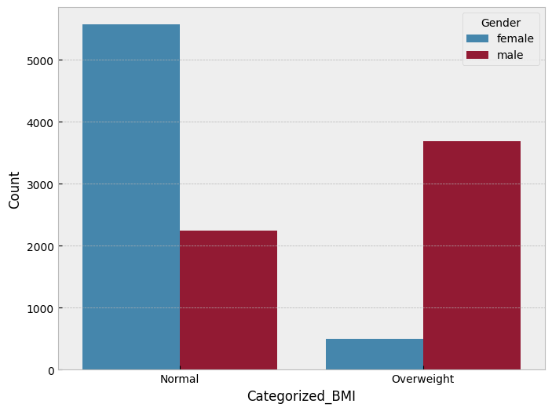 **Snap Shots of Result:**

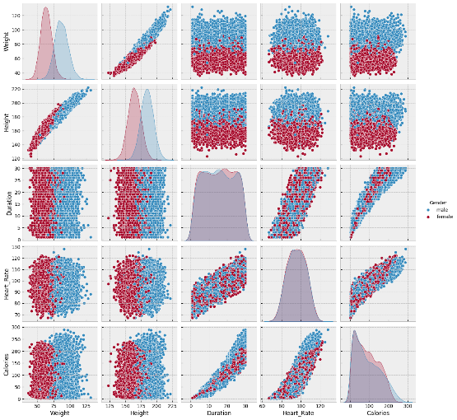The bar graph highlights the distribution of BMI categories among different genders. It shows that a significantly higher number of females fall into the "Normal" BMI category, while a higher number of males fall into the "Overweight" category. This visual representation helps in understanding the gender-specific trends in BMI distribution.

The comprehensive layout of the pair plot matrix enables simultaneous examination of all possible bivariate interactions as well as the univariate distribution of each variable. This helps in identifying not only the central tendencies and spread of individual variables but also how these variables might interact differently across gender. Any discrepancies, trends, or anomalies observed can provide valuable insights into the 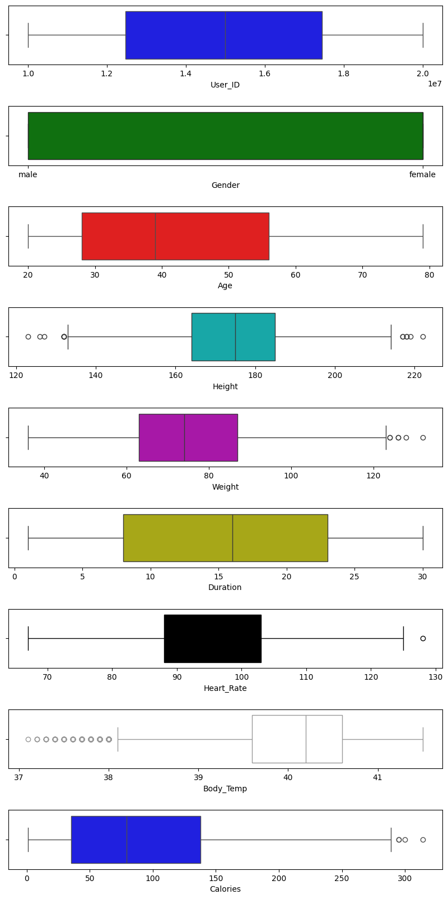physical and physiological differences between males and females.

The figure presents a series of box plots that summarize the distribution of several key variables in the dataset. Each box plot is color-coded and labeled with the corresponding variable name to help visualize and compare the data characteristics easily.

* + 1. **User_ID (Blue):** This box plot displays the range of user identification numbers, which spans approximately from 1.0e7 to 2.0e7. Although User_ID is primarily used as a unique identifier, its inclusion in the plot emphasizes the scale and range of the dataset’s entries.
    2. **Gender (Green):** The Gender box plot categorizes the data into 'male' and 'female' groups. While gender is a categorical variable, the plot likely represents these categories using numerical coding or side-by-side boxes. This visualization helps to indicate the distribution and balance of genders within the dataset.
    3. **Age (Red):** The Age variable shows a distribution ranging from about 20 to 80 years. The box plot for Age highlights key summary statistics such as the median, quartiles, and potential outliers, thus providing insights into the central tendency and variability of the subjects’ ages.
    4. **Height (Cyan):** Representing heights from roughly 120 cm to 220 cm, this visualization also shows some outliers falling notably below 140 cm and above 200 cm. These outlier points may indicate measurement errors or exceptional cases that warrant further investigation.
    5. **Weight (Purple):** The Weight distribution spans approximately 40 to 120 kg, with a few outliers noted above 120 kg, again suggesting the presence of extreme values or data recording issues that should be taken into account during analysis.
    6. **Duration (Yellow):** The Duration box plot captures the time variable, ranging from 0 to about 30 minutes. This plot is essential for understanding the variability in the activity duration reported in the dataset.
    7. **Heart_Rate (Black):** Heart_Rate values appear to fall between approximately 70 and 130 beats per minute. The plot also flags some outliers above 120 bpm, which might be indicative of individuals engaging in more intense physical activity or measurement anomalies.
    8. **Body_Temp (White):** The Body Temperature box plot shows readings from about 37°C to 41°C, with a few values below 38°C being marked as outliers. This provides insight into the general health conditions reflected by the temperature data as well as potential deviations.
    9. **Calories (Blue):** Finally, the Calories plot displays data ranging from 0 to around 300 calories, with some extreme values above 300.

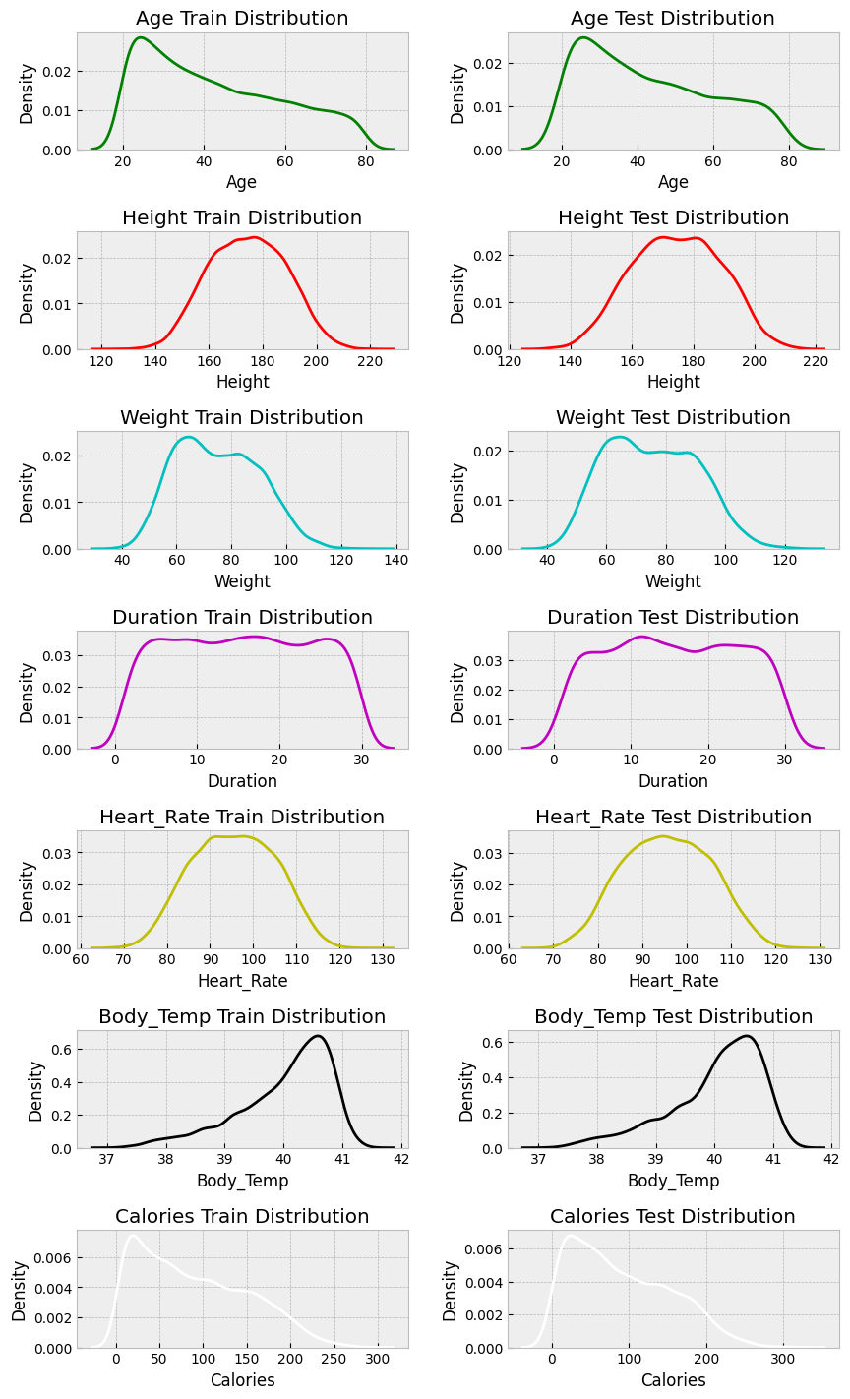

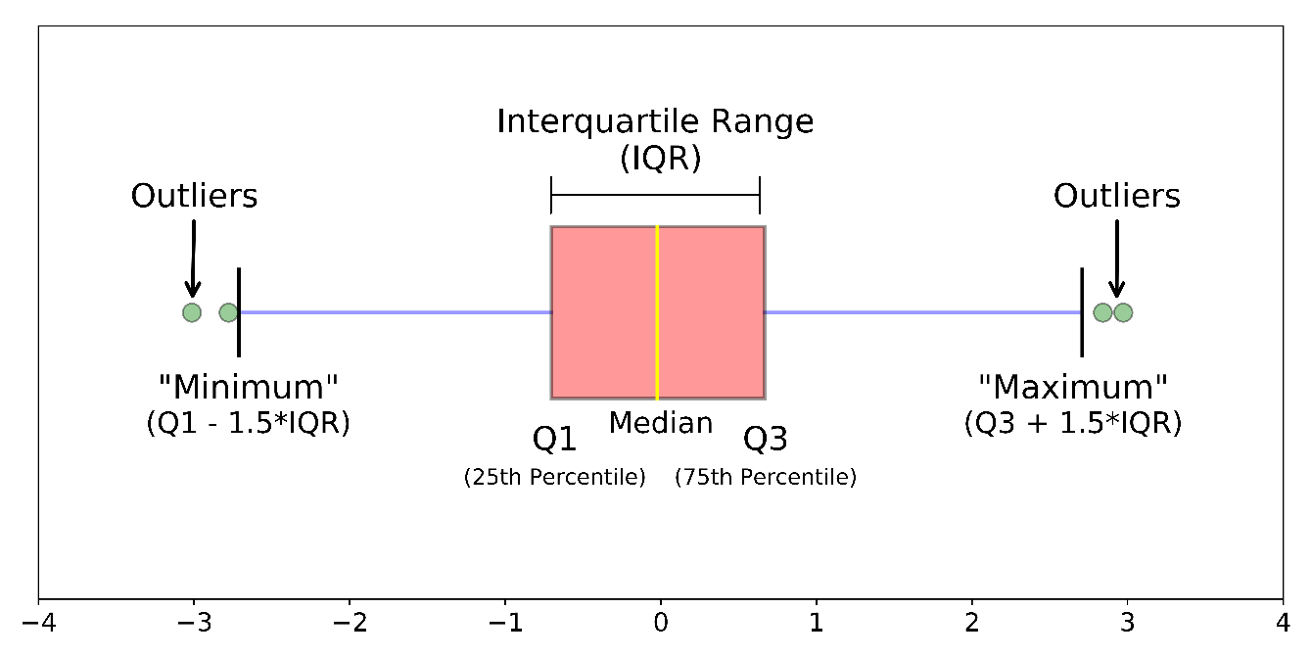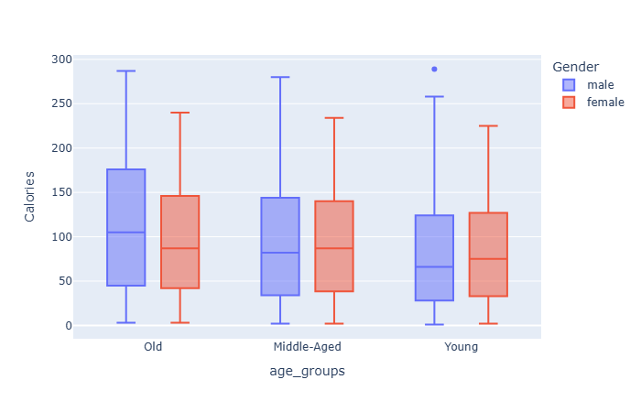

* 1. **GitHub Link for Code:**

[**https://github.com/sagarrawatssr/internship-edunet-foundation-techsaksham-.git**](https://github.com/sagarrawatssr/internship-edunet-foundation-techsaksham-.git)

**CHAPTER 5**

**Discussion and Conclusion**

* 1. **Future Work:**
     1. **Integration with Wearable Devices and IoT:** Future iterations could integrate real-time data from wearable fitness devices (such as smartwatches and fitness bands). This would allow the tracker to capture live data—such as heart rate, steps, and sleep patterns—and provide more accurate and immediate feedback on users' physical activity.
     2. **Development of Mobile and Web Applications:** Expanding beyond a desktop-based application, developing mobile and web versions would increase accessibility and usability. A mobile app could offer portability, while a web application could facilitate cloud-based data storage and synchronization across devices.
     3. **Enhanced User Interface and Experience:** A more dynamic and responsive UI—including animations, custom themes, and gamification elements—could increase user engagement. Gamifying the fitness tracking experience (e.g., awarding badges, setting challenges, and ranking among peers) may further motivate users to achieve their fitness goals.
     4. **Social Networking and Community Building:** Adding social features such as sharing progress with friends, joining fitness groups, and participating in community challenges can foster a supportive environment that encourages continued activity and accountability.
     5. **Integration with Health and Nutrition Services:** Future versions could incorporate functionalities to track nutritional intake, water consumption, and sleep patterns. By integrating with health and nutrition databases, the application could offer holistic advice tailored to individual lifestyles and health goals.

These enhancements not only extend the utility of the current system but also pave the way for transforming the Personal Fitness Tracker into a comprehensive health management platform. The continuous evolution of technology and user expectations underscores promising opportunities for future research, integration, and commercial application.

* 1. **Conclusion:**
     1. **Overall Impact and Contribution**

This project represents a significant step toward empowering individuals to take charge of their health and fitness. By leveraging Python's robust libraries to develop a user-friendly fitness tracker, the project simplifies the process of monitoring physical activities and tracking progress toward fitness goals. The application not only allows users to log their workouts and view detailed progress reports but also enables them to make data-driven decisions regarding their exercise routines and dietary habits.

The key contributions of the project include:

* **Enhanced Personal Health Management:** The tool offers a structured and efficient way for users to record and analyze their fitness activities. This easily accessible approach to tracking can lead to improved health outcomes by fostering better exercise adherence and more informed lifestyle changes.
* **User-Centric Design:** With its emphasis on an intuitive interface and comprehensive data visualization, the tracker ensures that even users with limited technical skills can effectively leverage the application to monitor their progress.
* **Platform for Future Development:** By laying a solid technical foundation, the project opens up pathways for future enhancements, such as integration with wearable devices, incorporation of machine learning for predictive analytics, and expansion into mobile and web-based platforms. This potential for growth underlines the project's long-term relevance in the evolving landscape of digital health and fitness.
* **Interdisciplinary Application:** Combining elements of software development, data analysis, and health science, the project serves as an example of how technology can bridge gaps across disciplines to deliver practical solutions that make a tangible difference in daily life.

In summary, the project not only demonstrates the practical use of Python in solving real-world problems but also contributes to the growing field of personal health monitoring by offering a scalable and adaptable solution that promotes healthier lifestyles.

**REFERENCES**

1. Ming-Hsuan Yang, David J. Kriegman, Narendra Ahuja, “Detecting Faces in Images: A Survey”, IEEE Transactions on Pattern Analysis and Machine Intelligence, Volume. 24, No. 1, 2002.
2. Enhanced Fitness Tracking N. Author et al., “Enhanced Fitness Tracking,” *IRJET: International Research Journal of Engineering and Technology*, vol. 11, no. 3, 2021. [Online]. Available: <https://www.irjet.net/archives/V11/i3/IRJET-V11I3155.pdf>
3. AI Fitness Model using Deep Learning R. Chandra et al., “AI Fitness Model using Deep Learning,” *International Journal of Advanced Research in Computer and Technology*, 2021. [Online]. Available: <https://www.ijarsct.co.in/Paper15361.pdf>
4. AI-Powered Smartwatches: How They’re Changing Fitness Tracking *Analytics Insight*, 2020. [Online]. Available: <https://www.analyticsinsight.net/smartwatch/ai-powered-smartwatches-how-theyre-changing-fitness-tracking>
5. Interpreting Fitness: Self-tracking with Fitness Apps C. Vogt and J. Wolf, “Interpreting fitness: Self-tracking with fitness apps,” *AI & Society*, vol. 36, no. 2, pp. 277–292, 2021. [Online]. Available: <https://link.springer.com/article/10.1007/s00146-021-01146-8>
6. Wearable Activity Trackers: Accuracy, Adoption, Acceptance, and Health Impact M. H. Jarrahi et al., “Wearable Activity Trackers: Accuracy, Adoption, Acceptance, and Health Impact: A Systematic Literature Review,” 2020. [Online]. Available: <https://www.researchgate.net/profile/Mohammad-Hossein-Jarrahi/publication/327930738_Wearable_Activity_Trackers_Accuracy_Adoption_Acceptance_and_Health_Impact_A_Systematic_Literature_Review>
7. Gamified Wearable Fitness Tracker M. mdpi, “Gamified Wearable Fitness Tracker,” *Sustainability*, vol. 13, no. 13, 2021. [Online]. Available: <https://www.mdpi.com/2071-1050/13/13/7017>
8. AbTrack: An Application to Track Personal Fitness Goals A. Adityanshu, “AbTrack: An Application to Track Personal Fitness Goals,” *Sathyabama Institute of Science and Technology*, 2023
9. Fitness Tracker Projects on GitHub Various authors, “Fitness Tracker Projects,” GitHub