URL Shortener (Infrastructure as Code) Project

**Cloud Computing**

**(SoSe22)**

**Supervisor: Prof. Dr. Sebastian Rieger**

Submitted by

Rohat Sagar Urif Sonu

rohat-sagar.urif-sonu@informatik.hs-fulda.de

**Matriculation Number:** 1394658

Nisha Devi

nisha.devi@informatik.hs-fulda.de

**Matriculation Number:** 1394632

Inspired from the famous system design interview questions, URL shortener, we decided to utilize our learning from the course of cloud computing to write infrastructure as a code for this application. For purpose of this course, we limited the functionality of the application to shorten the URL and keep track of opens. We used the terraform tool for writing infrastructure as code.

Our initial design was as follows

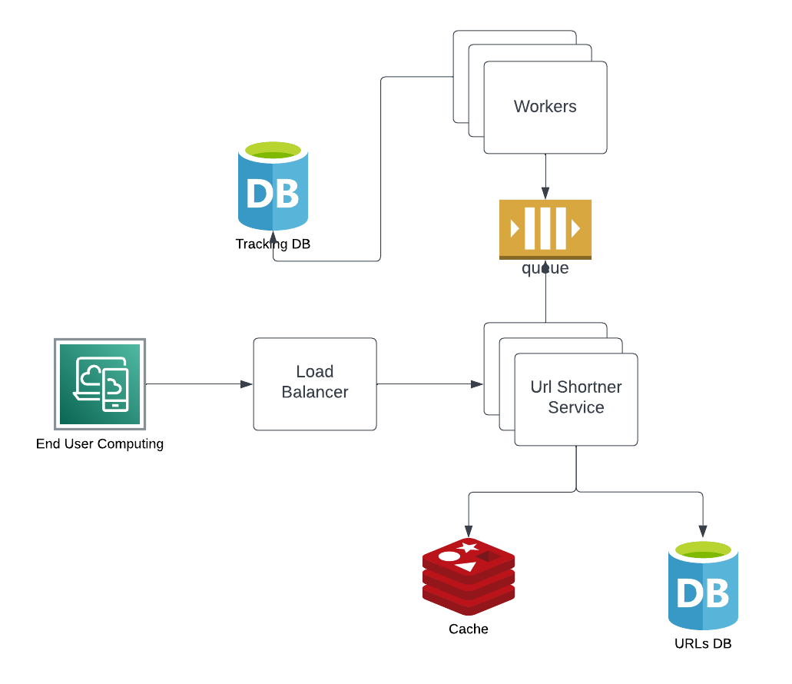

Unfortunately, learning the terraform and Azure cloud took most of the time and we were only able to implement following design and had to remove the tracking part from the design.

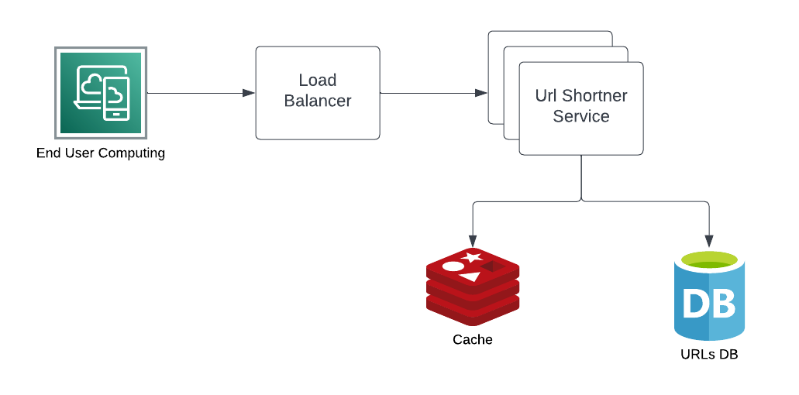

We have used following tech stack

|  |  |
| --- | --- |
| API | .NET 6 Minimal API |
| Database | Postgres |
| Cache | Redis |

These are the steps to test the project

1. First we need to build and push our application docker image to docker hub, we have already done that and it is available at <https://hub.docker.com/repository/docker/rohatsagar/cloudcomp15_sose22> but if you want to do it then please go to \url-shortener\src directory and run the following command "docker build -f Api/Dockerfile -t rohatsagar/cloudcomp15_sose22 .", once the image is built then you need to push it to docker hub and you can change the image name as per your repository also if the image name is changed then you need to update main terraform file.
2. Once the docker image is pushed then we need to apply main terraform file but before that make sure you have azure cli downloaded and logged in, if that is done then terraform should start creating the resources, please note that the process usually takes around 30 minutes.

The default value for number of instances is 5 but we can change it.