**LUCAS KANADE HOMEWORK 3**

Sagar Sachdev (sagarsac)

1.1 a)

Taking derivative w.r.t p:

* 1. b)

A is the steepest gradient of the images

b is the error image

* 1. c)

To minimize :

1.2

1.3

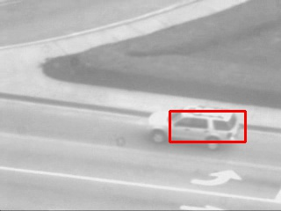testCarSequence.py Results:

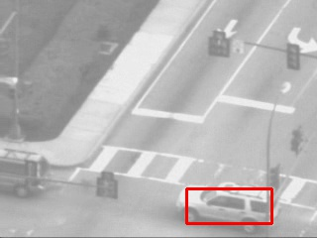 Frame 1 Frame 100 Frame 200

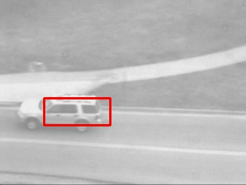

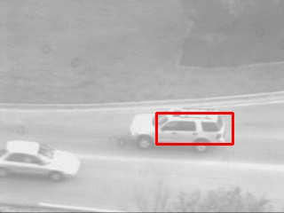

Frame 300 Frame 400

testGirlSequence.py Results:

Frame 1 Frame 20 Frame 40

Frame 60 Frame 80

1.4

testCarSequenceWithTemplateCorrection.py

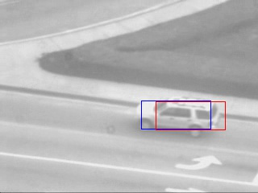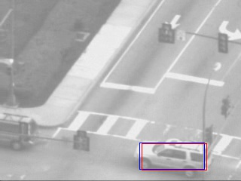 Frame 0 Frame 100 Frame 200

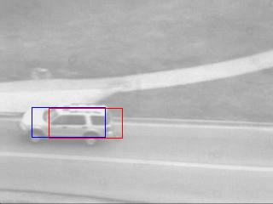

Frame 300 Frame 400

Frame 0 Frame 20 Frame 40

Frame 60 Frame 80

2.1

2.2

2.3

testAntSequence.py

Frame 30 Frame 60 Frame 90

Frame 120

testAerialSequence.py

Frame 30 Frame 60 Frame 90

Frame 120

3.1

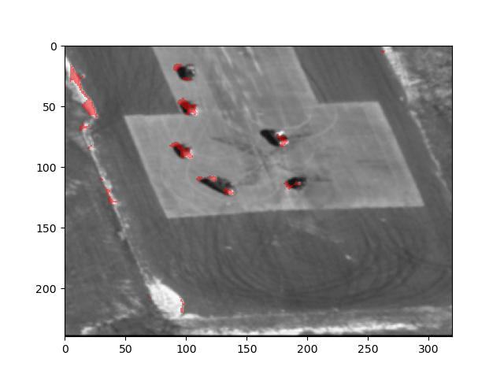testAerialSequence.py (Inverse Composition)

Frame 30 Frame 60 Frame 90

Frame 120

testAntSequence.py

Frame 30 Frame 60 Frame 90

Frame 120

**ACKNOWLEDGEMENTS:**

1. My research lab mate Bassam Bikdash helped with Lucas Kanade Affine warp calculation for A matrix
2. Resources for Plotting image on image:
   1. <https://matplotlib.org/3.5.1/api/_as_gen/matplotlib.pyplot.imshow.html>
   2. <https://matplotlib.org/stable/api/_as_gen/matplotlib.pyplot.plot.html>
   3. My research lab mate Bassam Bikdash

**ADDITIONAL HAND CALCS FOR REFERENCE:**

