**16720-B COMPUTER-VISION HOMEWORK**

Sagar Sachdev (sagarsac)

Q1.1

For

Therefore, proved.

Q1.2

Since the translation is in the x-axis, it can be reflected as:

Cross-product matrix can be written as:

Given that:

and:

We can compute the cross product, of the epipolar lines:

Hence the two epipolar lines are parallel.

1.3

Making omega the subject of the formula and treating this as a linear algebra problem, we get:

1.4

Therefore the fundamental matrix is a skew-symmetric matrix

Q2.2

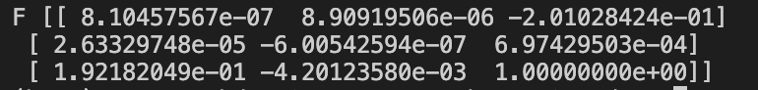

Q3.1

3.2

3.3

Q4.1

Q4.2

Q5.1

**NOTE:**

I think there is something incorrect in bundleAdjustment hence why I do not have an output.

**ACKNOWLEDGEMENTS:**

1. My friend from my lab Bassam Bikdash helped me (and served as office hours) for a bit of this assignment since I did not have access to the Office Hours due to personal circumstances highlighted to Prof Ramanan
2. <https://www.geeksforgeeks.org/how-to-generate-2-d-gaussian-array-using-numpy/> was used for Gaussian weighting portion of the epipolar correspondences