Game Design Document

Fill up the Following document

1. Write the title of your project.

THE TRAFFIC RACER

1. What is the goal of the game?

TO REACH THE FINISH LINE ON THE TRACK.

1. Write a brief story of your game?

THE PLAYER IS A THIEF WHO IS BEING CHASED BY POLICE

AND PLAYER HAS TO REACH THE SAFE AREA WHICH IS

MARKED AS FINISH LINE ON THE TRACK. THE PLAYER NEED TO PASS THE HUGE TRAFFIC WHICH COULD SLOW HIM DOWN AND DECREASES THE CHANCES OF ESCAPE.

1. Which are the playing characters of this game?

* Playing characters are the ones which respond to the user based on the input from the user
* Cars, monkeys, dinos, wizards etc, are the playing characters in the game.

|  |  |  |
| --- | --- | --- |
| Number | Character Name | What can this character do? |
| 1 | THE MAIN CAR | JUST CAN DRIVE ON THE TRACK |
| 2 |  |  |
| 3 |  |  |
| 4 |  |  |
| 5 |  |  |
| 6 |  |  |
| 7 |  |  |
| 8 |  |  |

1. Which are the Non Playing Characters of this game?

* Non Playing characters are the ones which don't have an action or a behaviour when the user interacts with the game.
* Hurdles, stones, bananas, coins, etc are non playing characters in the game.

|  |  |  |
| --- | --- | --- |
| Number | Character Name | What can this character do? |
| 1 | THE POLICE | CHASING THE PLAYER |
| 2 | THE TRAFFIC | SLOWING DOWN CAR SPEED SOMEHOW |
| 3 | BUNKERS | SLOWING CAR SPEED |
| 4 |  |  |
| 5 |  |  |
| 6 |  |  |
| 7 |  |  |
| 8 |  |  |

Draw your imagination of this game. What does this game look like?

* Draw the game either on your computer or on paper,
* Add images of scenes of the game to show each of the playing and non-playing characters at least once.

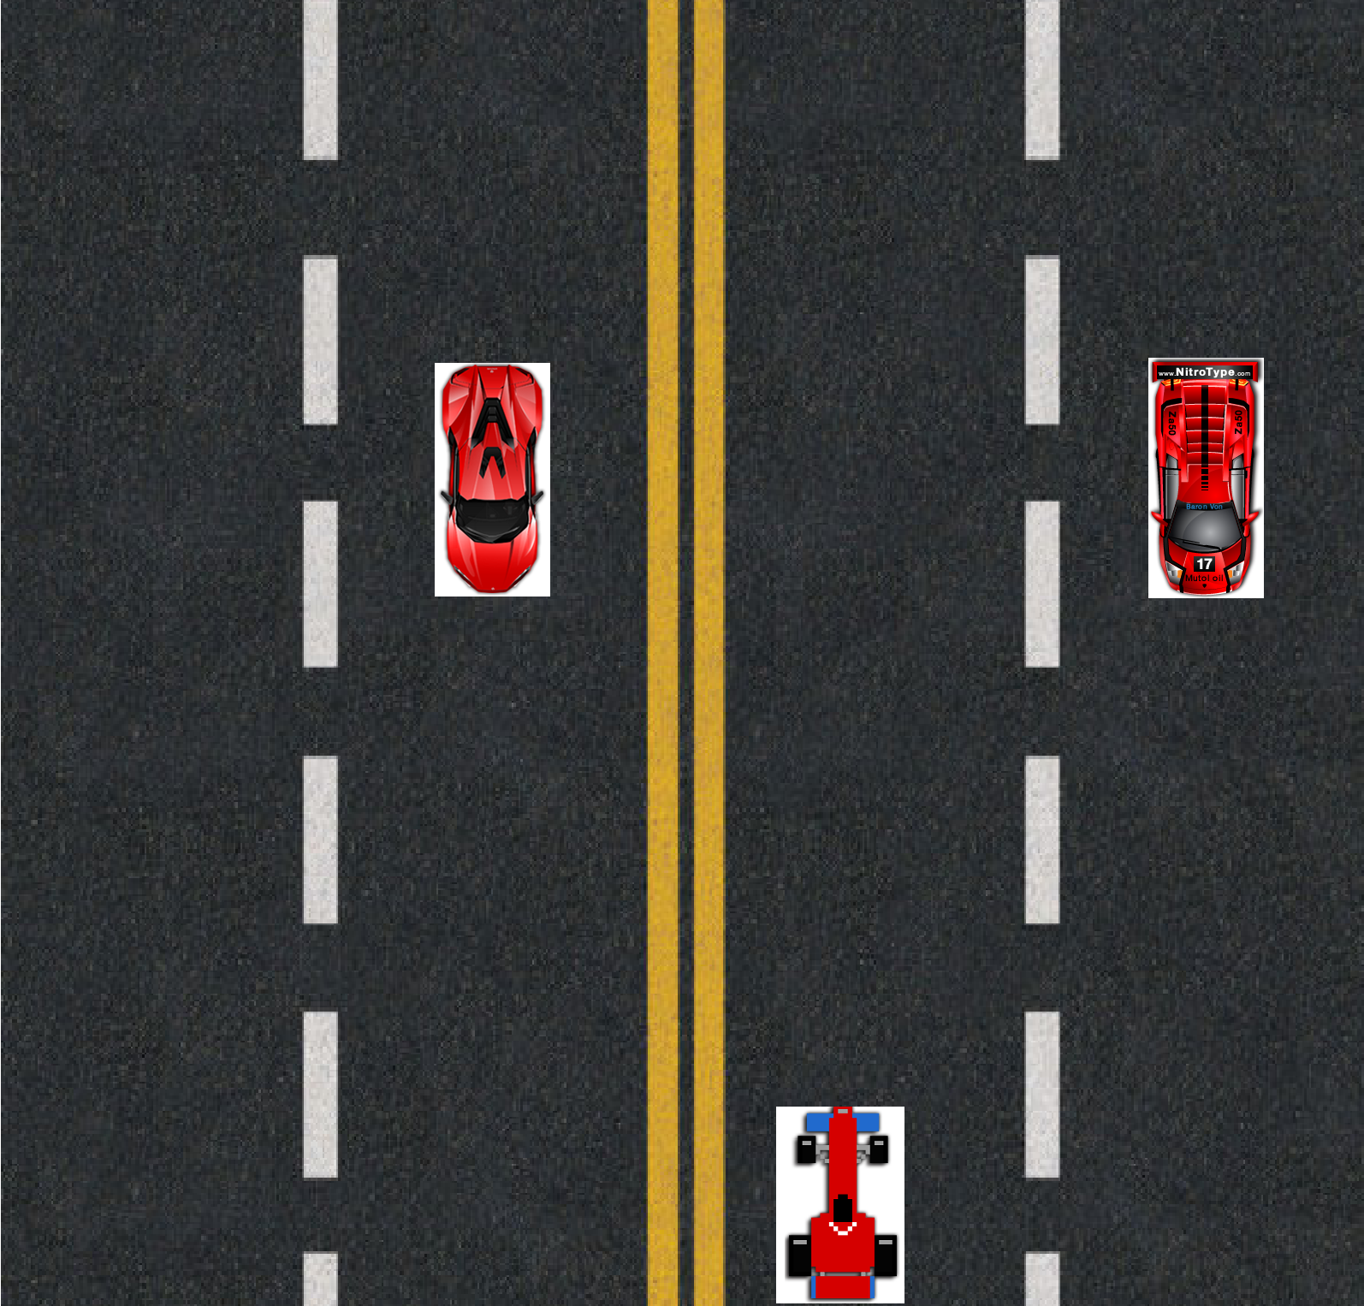

How do you plan to make your game engaging?

THE BACK TO BACK OBSTACLES AS TRAFFIC MIGHT KEEP THE USER OR THE PLAYER

ENGAGED BECAUSE LEAVING MIGHT TURN TO GAME OVER.