WEEK 3 - FINAL REPORT

Password Cracking - Project Module 1 & 2 Combined

Week | Week 3
Modules Covered | PM1 - Password Cracking with JTR (John The Ripper) + PM2 - Password Cracking with Networkwalks Tools
Student Name | Sagar Shah
Date | 23 September 2026
Training | Cybersecurity & Ethical Hacking - Networkwalks

Purpose of the Report
In this report, I will be highlighting the project modules that I completed for Week 3 and how I went about doing it by sharing screenshots, without adding too much detail. Detailed step-by-step procedures are already documented in separate reports:
- WK3-PM1.docx (Detailed report for Project Module 1 - JTR + Johnny)
- WK3-PM2.docx (Detailed report for Project Module 2 - Networkwalks Online Tools)
This final report provides a concise summary of both modules, tools used, process overview, key screenshots, and flags captured.

Project 1: Project Module 1 - Password Cracking with JTR
In Project Module 1, I was instructed to use JTR (John The Ripper) password cracker to gain access to the provided locked PDFs.

Tools Used
- JTR (John The Ripper) 1.9.0-jumbo-1 OMP [cygwin 64-bit x86_64 AVX2 AC]
- Johnny (GUI for JTR) - Graphical interface for JTR
- OnlineHashCrack PDF Hash Extractor / Networkwalks Hash Calculator for hash generation

The Process (Summary)
The first step was installation which was straightforward. I visited the official OpenWall website (https://www.openwall.com/john/) to download and install JTR (john-1.9.0-jumbo-1-win64). Next, I downloaded and installed Johnny, which is the GUI for JTR, from https://www.openwall.info/wiki/john/johnny. Then I needed to set it up because it isn't configured by default - I had to browse to C:/Users/futur/Downloads/john-1.9.0-jumbo-1-win64/run/john.exe in Johnny's Settings. Johnny detected it as 'Detected John the Ripper 1.9.0-jumbo-1 OMP'.
After setup, I used an online tool to generate hash for the PDF. After generating the hash, I saved it in a .txt file (hash1.txt) and used it as input for Johnny to crack the password. I clicked 'Open password file' -> selected hash file -> clicked 'Start new attack' -> password appeared in Password column with 100% cracked status. (Full details in WK3-PM1.docx document)

Key Screenshots - PM1
Lab Setup - Desktop and JTR Files:

Figure 1: Desktop showing Johnny installed, Downloads folder showing john-1.9.0-jumbo-1-win64 folder
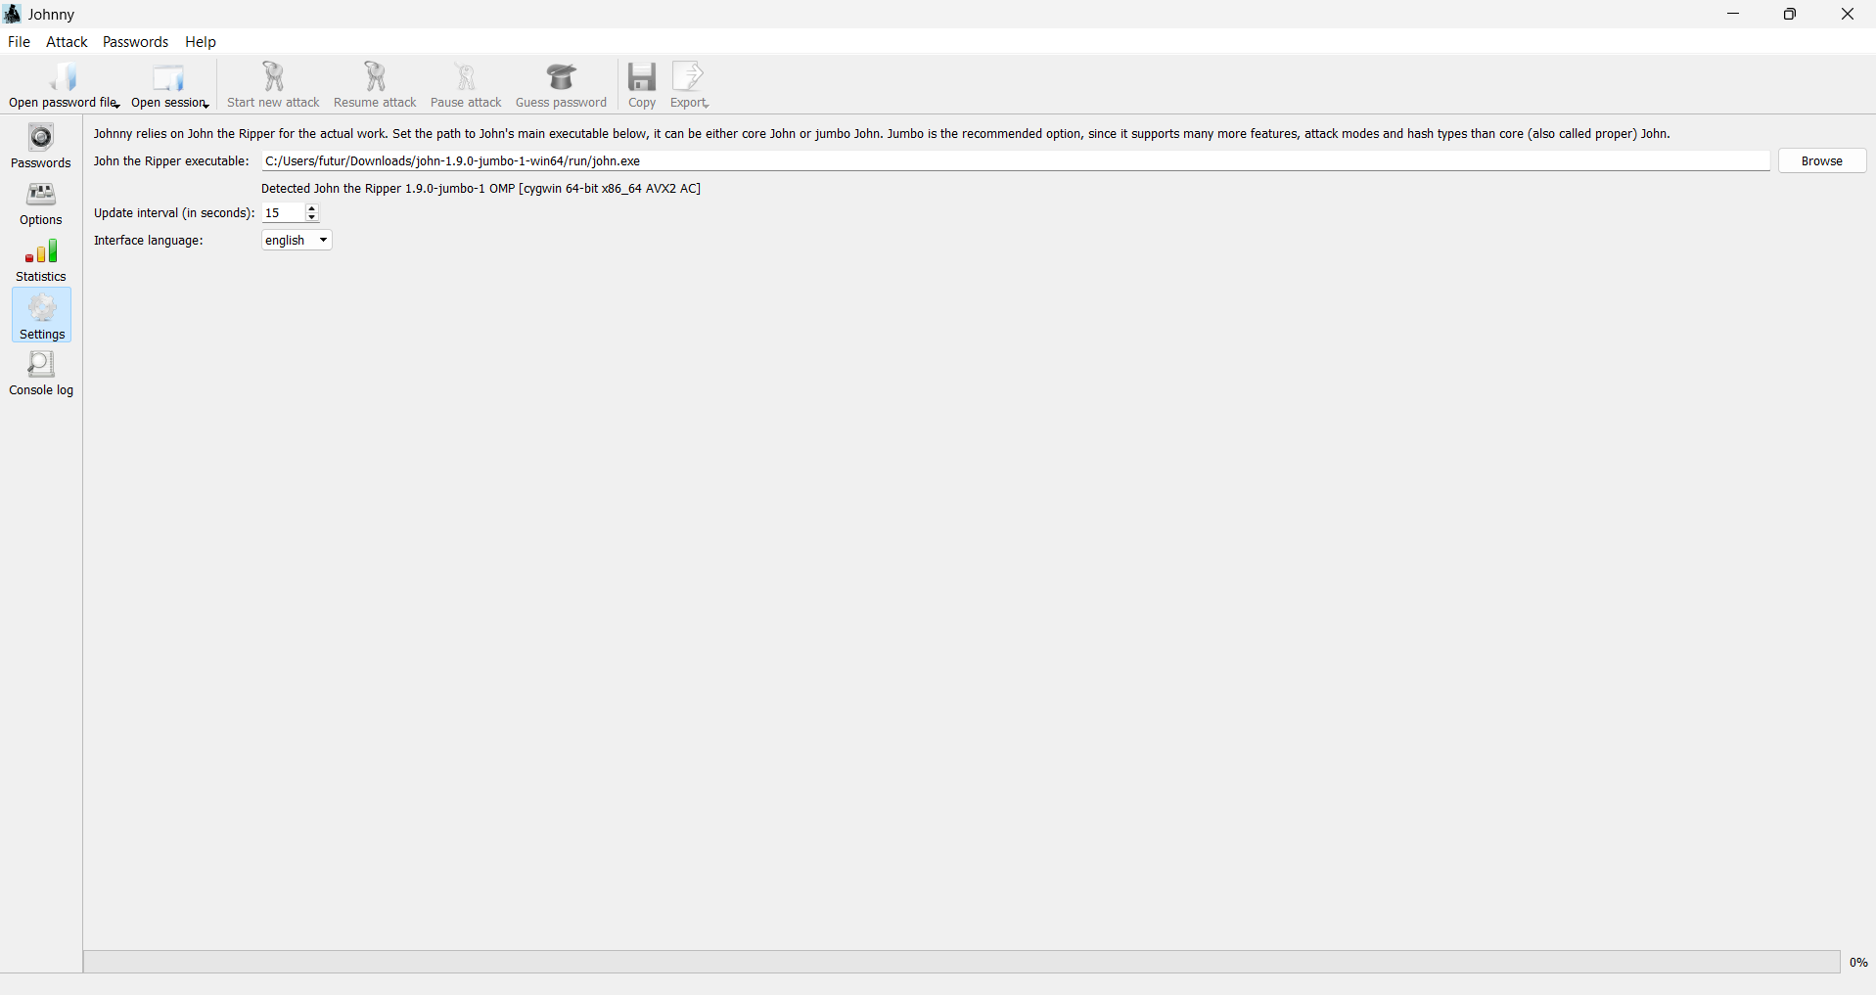
Figure 2: Johnny Settings - JTR executable configured successfully
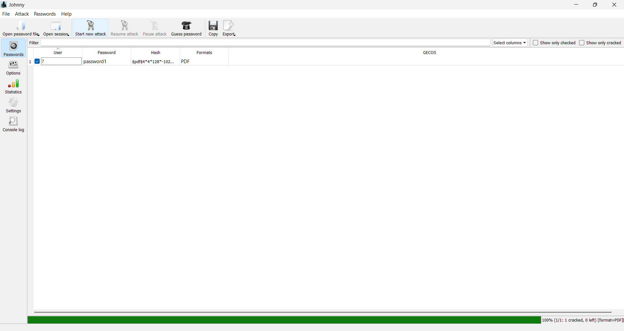
Figure 3: Johnny - Password cracked - 'password1' - Format: PDF - 100% (1/1: 1 cracked, 0 left)

Flags Captured - PM1
Note: For further details regarding this project refer to the WK3-PM1.docx detailed document.
Filename | Password | Flag
My Locked PDF1 / My-Locked-PDF1.pdf | good-luck / password1 | nw{cybersecurity_flag_captured_2608} / nw{networkwalks_flag1_jtr_270521_1}
My Locked PDF2 / My-Locked-PDF2.pdf | password1 | nw{networkwalks_persistence_jtr_270521}
My Locked PDF3 / My-Locked-PDF3.pdf | 1qaz2wsx | nw{networkwalks_flag_260821_1}

Detailed Flag List - PM1 (As per Johnny):
Filename | Password | Flag
My-Locked-PDF1 | password1 | nw{networkwalks_flag1_jtr_270521_1}
My-Locked-PDF2 | password1 | nw{networkwalks_persistence_jtr_270521}
My-Locked-PDF3 | 1qaz2wsx | nw{networkwalks_flag_260821_1}

Project 2: Project Module 2 - Password Cracking with Networkwalks Tools
In this project module 2, I needed to use the online Networkwalks tools in order to generate the hash and crack the password for the PDFs. For this purpose I used the hash-calculator and password-cracker web tools.

Tools Used
- Hash Calculator - https://networkwalks.com/hash-calculator/ (Generates MD5, SHA-1, SHA-256, etc. or extracts crackable hash from PDF)
- Password Cracker - https://networkwalks.com/password-cracker/ (Dictionary Attack Lab - JTR-like in browser)

Process (Summary)
The process was a lot simpler than using Johnny, since I didn't need to install or setup anything. All that was needed was to give input to the Hash Calculator to generate the hash and then provide that hash to the Password Cracker to crack the password for the PDF to gain access.
Steps:
1. Visited lab page: https://networkwalks.com/password-cracking-with-networkwalks-tools-project-task-lab/ and downloaded PDFs
2. Opened Hash Calculator, went to PDF tab, uploaded PDF (parsed locally - nothing uploaded to server)
3. Tool extracted $pdf$ hash (pdf2john/hashcat compatible format, R4 V4 128-bit)
4. Copied hash and pasted into Password Cracker tool
5. Used Built-in list (100 passwords) and clicked Start Cracking - live console shows Trying: daniel, hannah, etc.
6. Password cracked successfully shown in green
7. Opened locked PDF with cracked password and captured flag
(Full details in WK3-PM2.docx document)

Key Screenshots - PM2
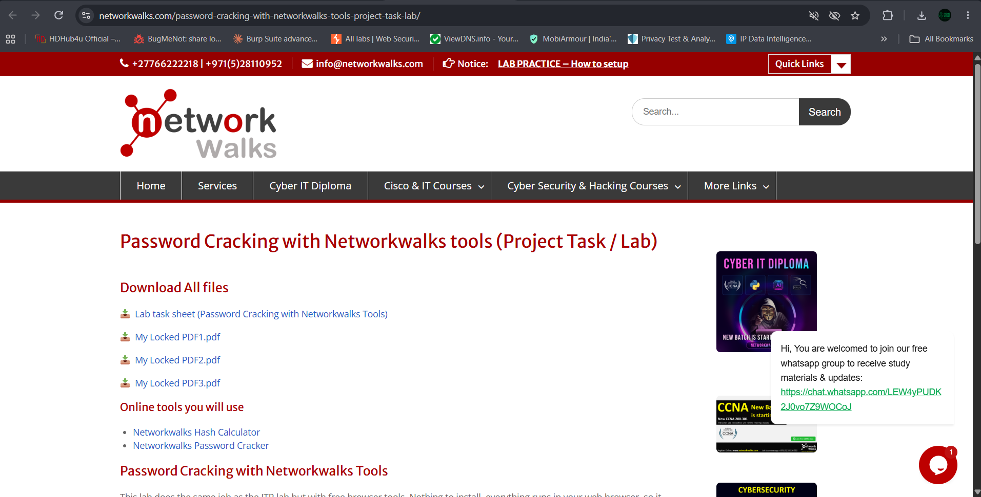
Figure 4: Lab page showing downloads and online tools links
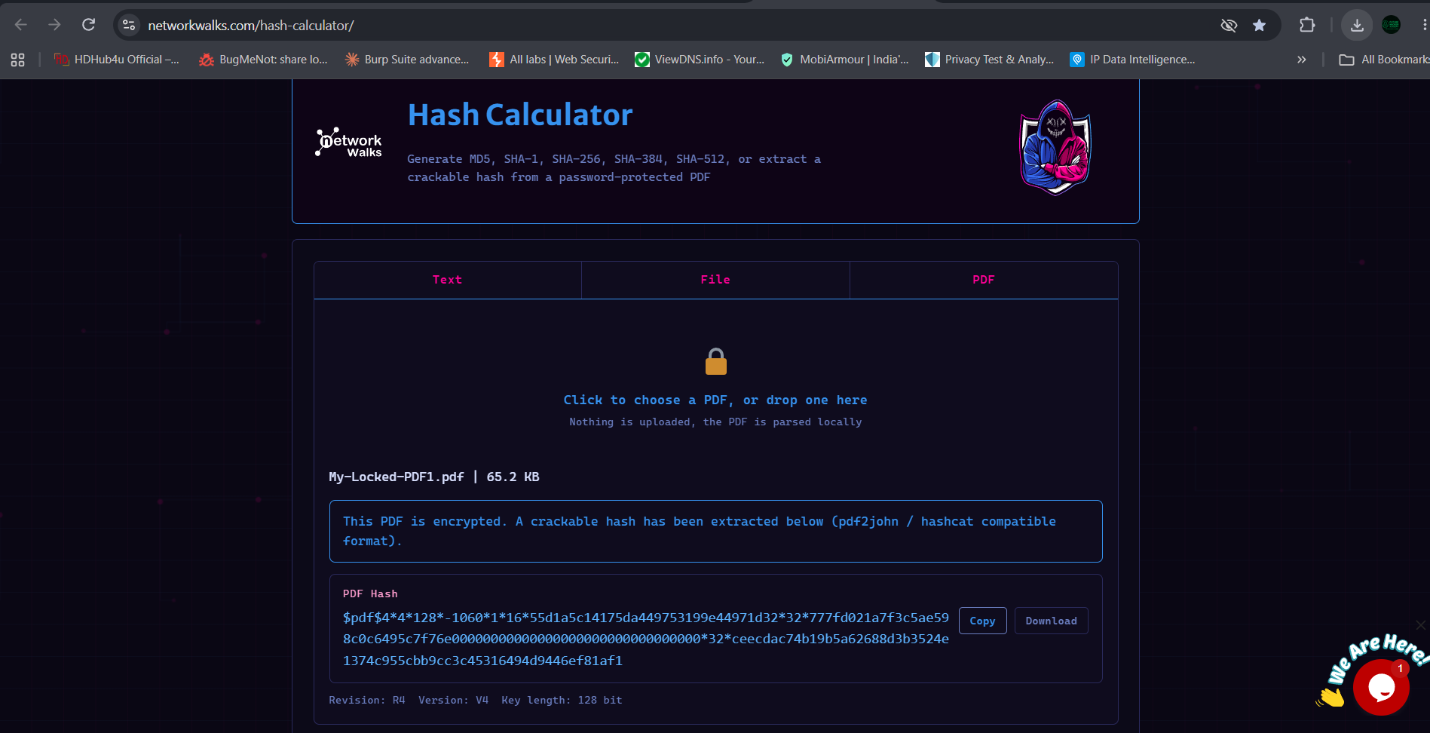
Figure 5: Hash Calculator - PDF1 hash extracted (65.2 KB) - $pdf$4*4*128*-1060*...
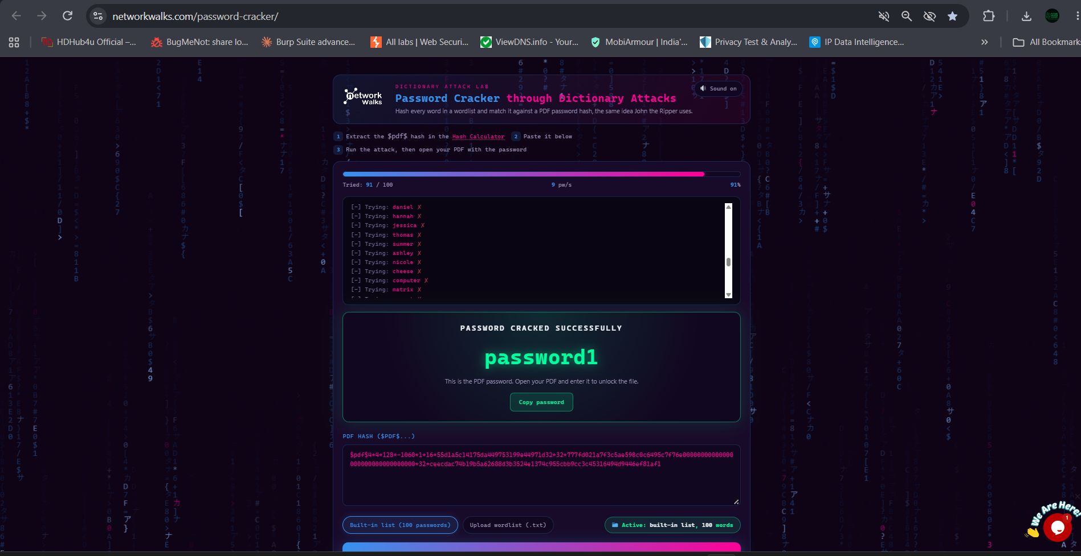
Figure 6: Password Cracker - Dictionary Attack - 91/100 tried - PASSWORD CRACKED SUCCESSFULLY: password1
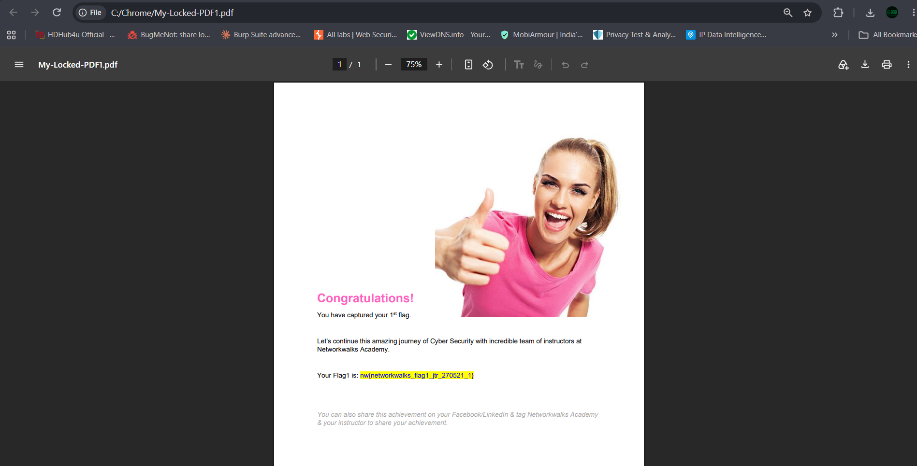
Figure 7: Flag captured - My-Locked-PDF1 opened - nw{networkwalks_flag1_jtr_270521_1}
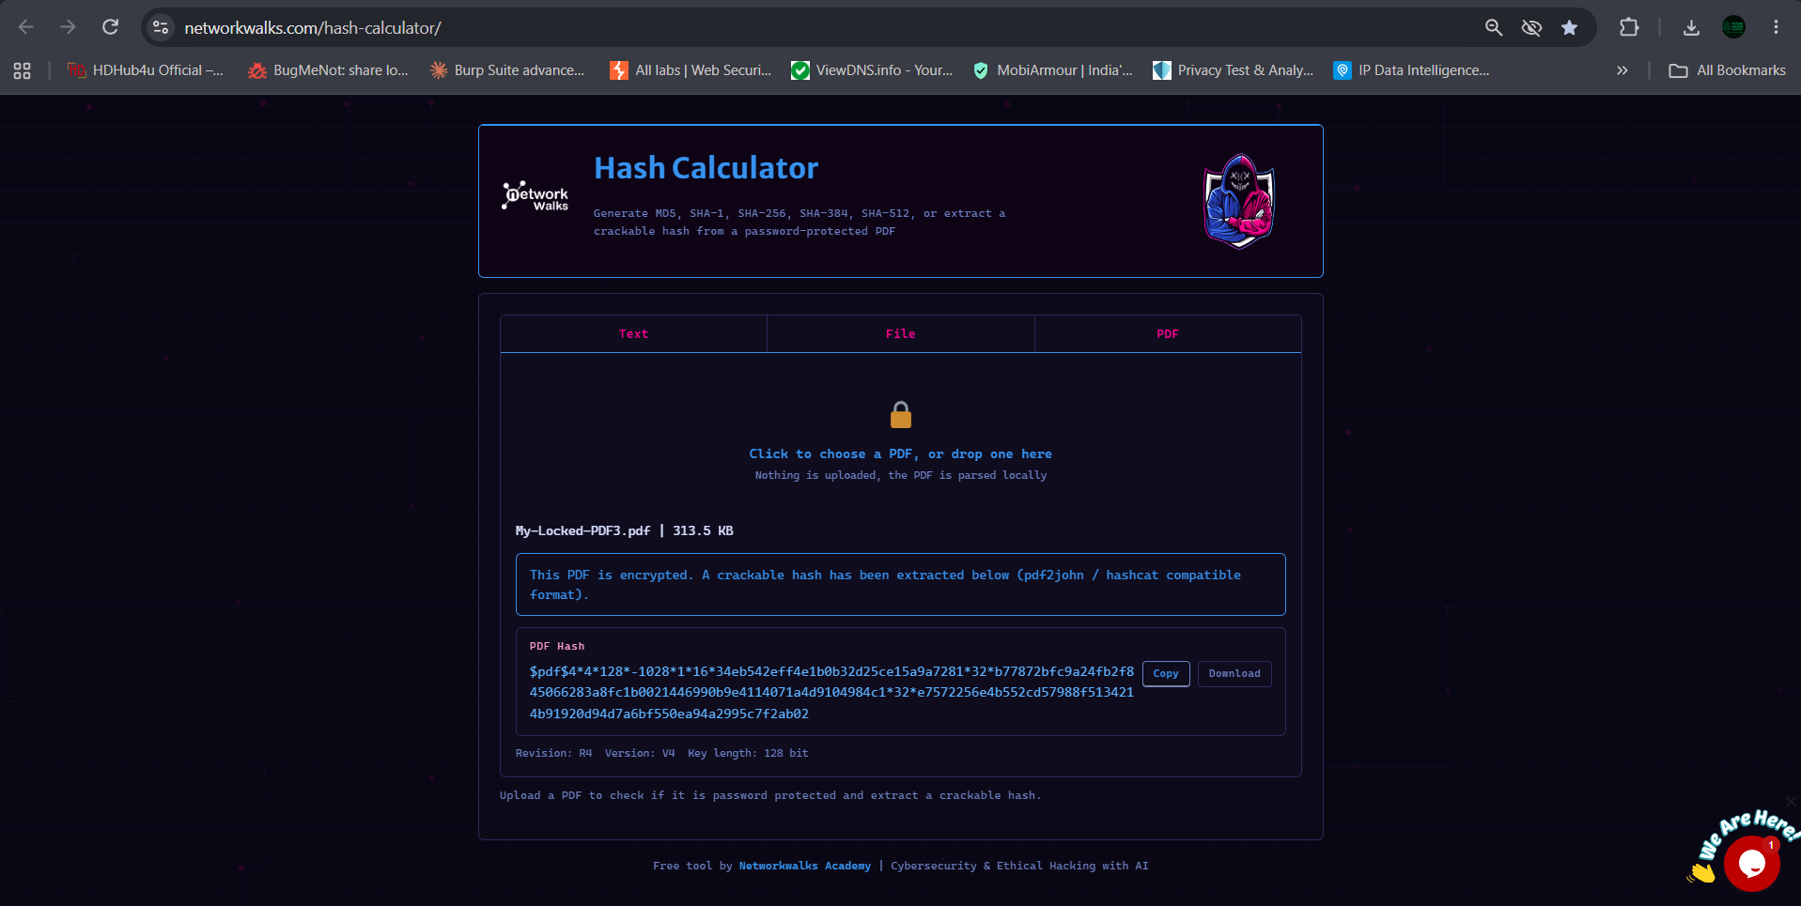
Figure 8: Hash Calculator - PDF3 (313.5 KB) hash extraction
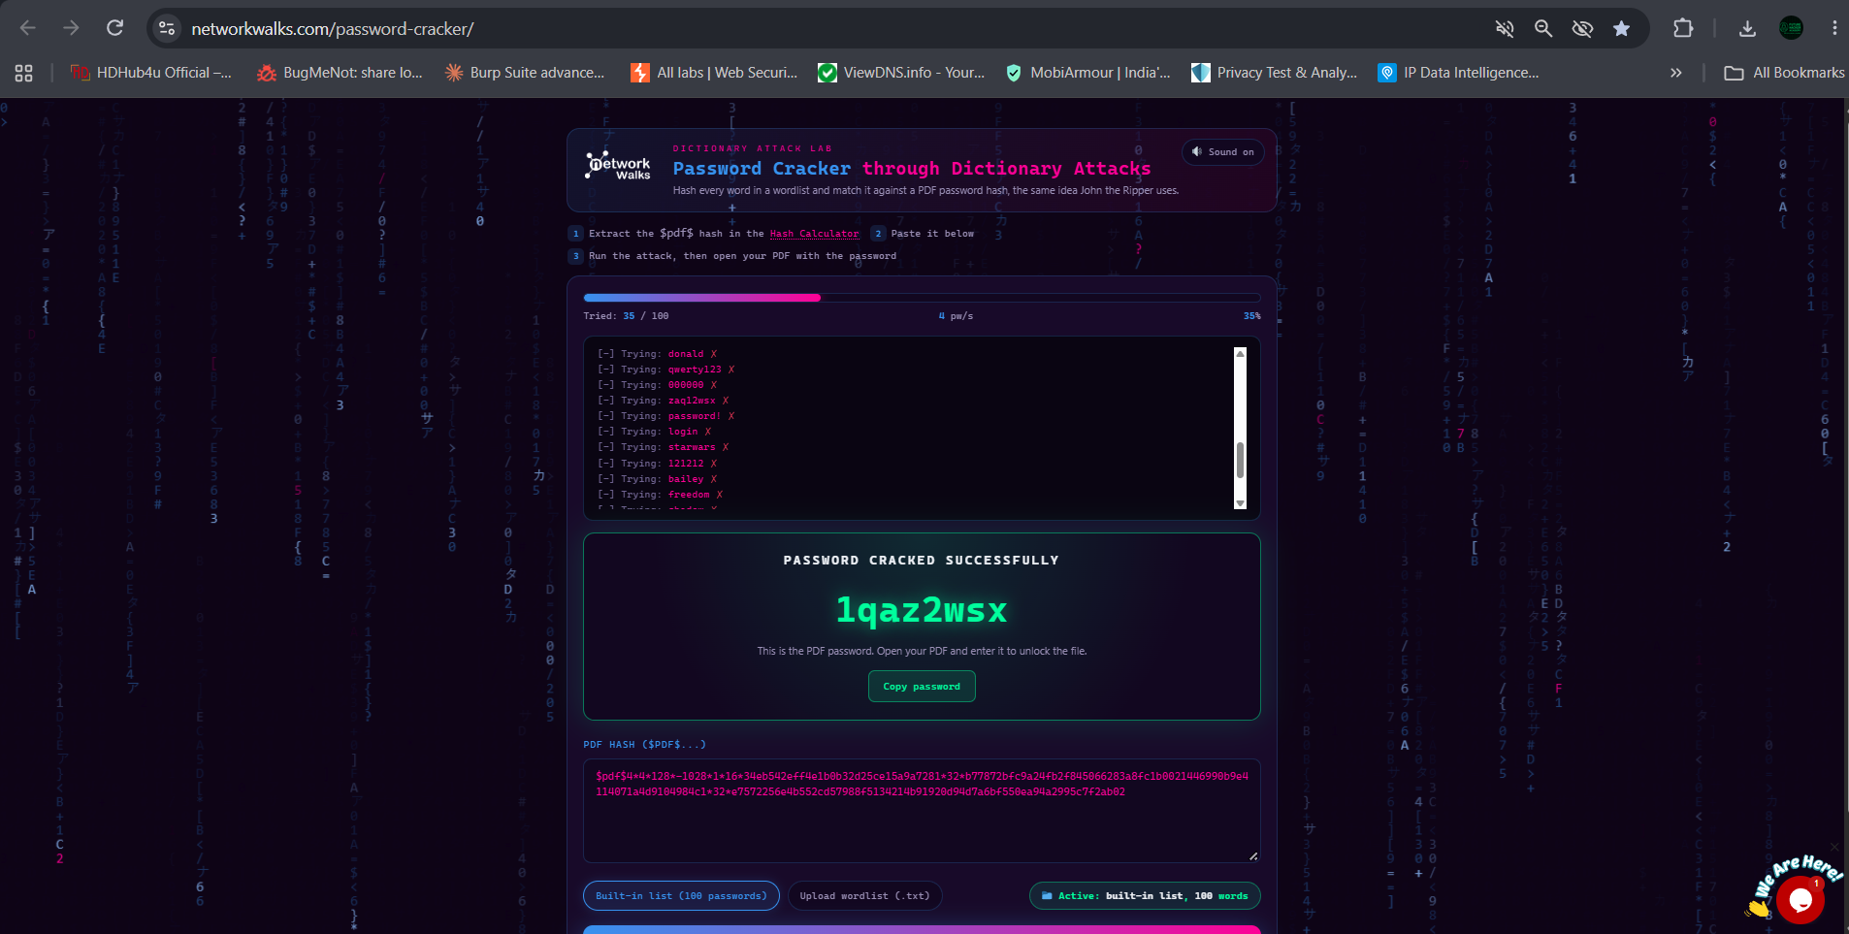
Figure 9: Password Cracker - PDF3 - Password: 1qaz2wsx (keyboard pattern)

Flags Captured - PM2
Note: For further details regarding this project refer to the WK3-PM2.docx document.
Filename | Password | Flag
My-Locked-PDF1 | password1 | nw{networkwalks_flag1_jtr_270521_1}
My-Locked-PDF2 | password1 | nw{networkwalks_persistence_jtr_270521}
My-Locked-PDF3 | 1qaz2wsx | nw{networkwalks_flag_260821_1}

Overall Summary - Week 3
Aspect | PM1 - JTR + Johnny | PM2 - NW Tools
Installation Required | Yes - JTR + Johnny GUI setup needed | No - Browser only
Method | Offline dictionary attack via Johnny | Online dictionary attack via website

Learning Comparison
PM1 taught me how real pentesters setup and use John the Ripper offline, understanding executable paths, hash file formats, and attack modes.
PM2 showed me how the same concept can be implemented online without installation, ideal for quick CTFs and browser-based labs. Both modules reinforced that weak passwords like 'password1' and '1qaz2wsx' are in common wordlists and can be cracked within seconds at 4-9 passwords/second speed.
Key takeaway: Strong passwords (12+ chars, mixed case, numbers, symbols) are essential. Also learned about PDF encryption R4 V4 128-bit and how pdf2john extracts hashes.

Conclusion
Week 3 successfully covered password cracking from both offline (JTR) and online (Networkwalks tools) perspectives. All 3 PDFs were cracked in both modules, and all flags were captured:
- nw{networkwalks_flag1_jtr_270521_1}
- nw{networkwalks_persistence_jtr_270521}
- nw{networkwalks_flag_260821_1}
- nw{cybersecurity_flag_captured_2608} (additional flag from PM1)
The experience gained in Week 3 provides a solid foundation for understanding password security, hash extraction, and dictionary attacks, which are crucial skills for ethical hacking and cybersecurity assessments.
Both detailed reports (WK3-PM1 and WK3-PM2) contain step-by-step screenshots and are attached along with this final summary report.

Submitted By:
Sagar Shah
Final Report - Week 3 (PM1 + PM2)
Password Cracking with JTR & Networkwalks Tools
Networkwalks Cybersecurity Training
Date: 23 September 2026

