WEEK 3 | PROJECT MODULE 1

PASSWORD CRACKING WITH JTR

CYBERSECURITY & ETHICAL HACKING
Project Title | Password Cracking with JTR (John The Ripper)
Module | Week 3 - Project Module 1 (PM1)
Tools Used | John the Ripper 1.9.0-jumbo-1, Johnny GUI, OnlineHashCrack PDF Hash Extractor
Date | 22 September 2026
Submitted By | Sagar Shah

Table of Contents
- 1. Project Goals & Background
- 2. Tools and Lab Setup
- 3. Task 1: Download John the Ripper
- 4. Task 2: Download and Install Johnny GUI
- 5. Task 3: Johnny and JTR Integration / Setup
- 6. Task 4: PDF Password Cracking with JTR
- 7. Flags Captured - Results
- 8. Learning Outcomes
- 9. Conclusion
- 10. References

1. Project Goals & Background
The goal of this project is to install and setup JTR along with Johnny (GUI for JTR) and then use JTR to crack passwords for password-protected PDF files. In this process, we learn how to setup JTR on Windows (or Linux) and configure it with Johnny for GUI-based password cracking.

What is John the Ripper?
John the Ripper (JTR) is a popular open-source password cracking tool used by security professionals to test password strength. It started as a tool for Unix systems but now works on Windows, Linux, and Mac. It can check many types of password hashes and also unlock password-protected files like PDF, ZIP, and Office documents. It supports dictionary attacks, brute-force, and many hash formats.

What is Johnny?
Johnny is the graphical user interface (GUI) version of John the Ripper. It provides a simple point-and-click interface, so beginners can use JTR without typing long commands. Both tools are widely used in security testing and learning labs to understand password safety. Johnny relies on John's core executable (john.exe) for actual cracking - Jumbo version is recommended as it supports many more features, attack modes and hash types.

2. Tools and Lab Setup
- Operating System: Windows 11 (64-bit) - As seen in desktop screenshot
- John the Ripper: Version 1.9.0-jumbo-1 OMP [cygwin 64-bit x86_64 AVX2 AC] - downloaded from https://www.openwall.com/john/
- Johnny: GUI for John - downloaded from https://www.openwall.info/wiki/john/johnny
- Hash Extractor: https://www.onlinehashcrack.com/tools-pdf-hash-extractor.php for extracting PDF hashes
- Target Files: 3 Locked PDF files (My Locked PDF1, PDF2, PDF3)

Lab Environment Screenshot - Desktop
Below screenshot shows my desktop environment with all required tools installed - Johnny, Tor Browser, VLC, VirtualBox, Chrome, Brave, etc.
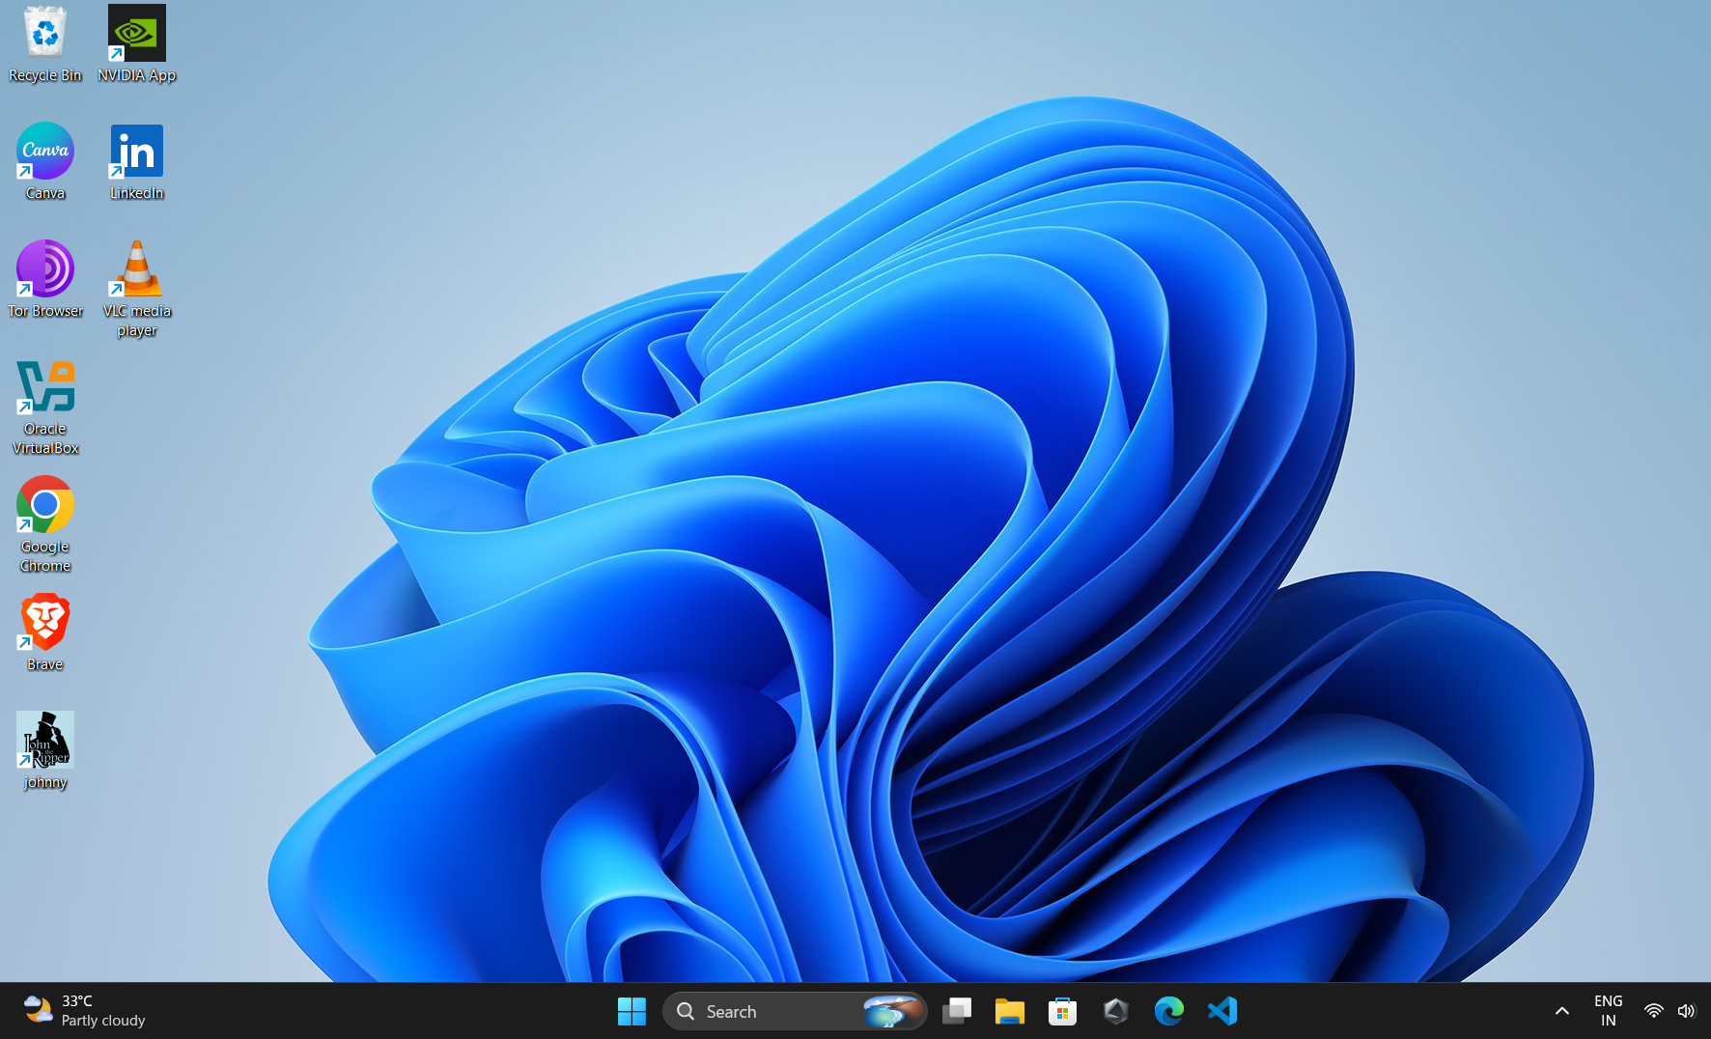
Figure 1: Desktop showing Johnny and other tools installed

3. Task 1: Download John the Ripper (JTR)
Steps performed:
1. Opened browser and went to https://openwall.com/john/
2. Clicked on binaries to download Jumbo version.
3. Downloaded file john-1.9.0-jumbo-1-win64.zip
4. Extracted the zip file in Downloads folder.
The extraction can be verified in Downloads folder as shown below:
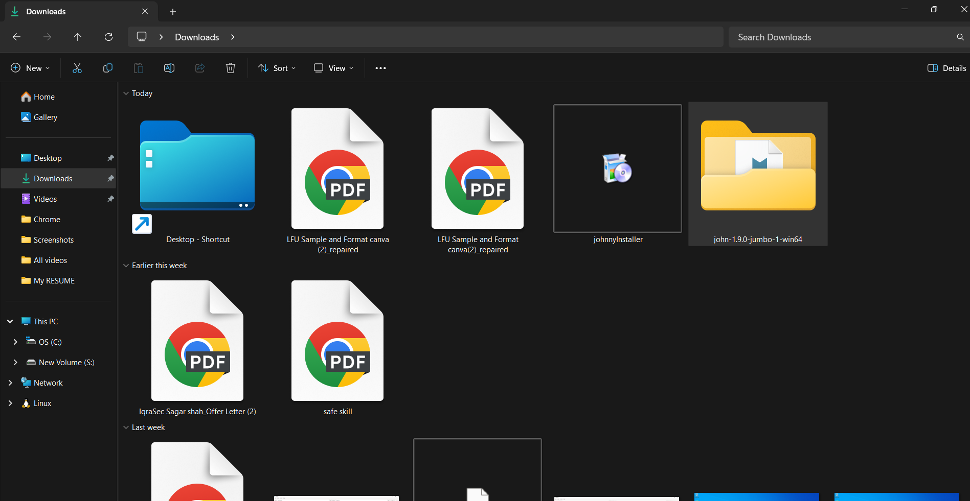
Figure 2: Downloads folder showing JTR extracted folder 'john-1.9.0-jumbo-1-win64' and Johnny installer

4. Task 2: Download and Install Johnny
Steps performed:
1. Went to https://www.openwall.info/wiki/john/johnny
2. Clicked on binary for Windows to download Johnny installer (johnnyInstaller).
3. Double-clicked the installation file.
4. Clicked 'Next' on setup welcome window, installation directory, component selection, start menu shortcuts.
5. Clicked 'Install' button to install.
6. After installation, Johnny shortcut appeared on Desktop (visible in Figure 1).

5. Task 3: Johnny and JTR Setup
This is a crucial step where we link Johnny GUI with John the Ripper core executable.
Steps:
1. Extracted JTR binaries.
2. Opened Johnny from desktop shortcut.
3. Went to Settings section (left sidebar -> Settings gear icon).
4. Clicked on Browse button for 'John the Ripper executable'.
5. Navigated to C:/Users/futur/Downloads/john-1.9.0-jumbo-1-win64/run/john.exe and selected it.
6. Johnny detected: 'Detected John the Ripper 1.9.0-jumbo-1 OMP [cygwin 64-bit x86_64 AVX2 AC]'.
7. Setup complete.
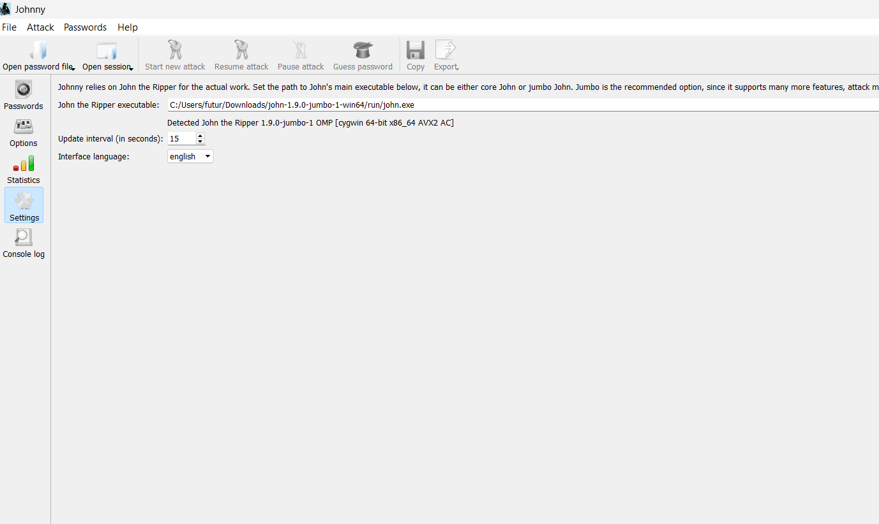
Figure 3: Johnny Settings - Browsing john.exe path
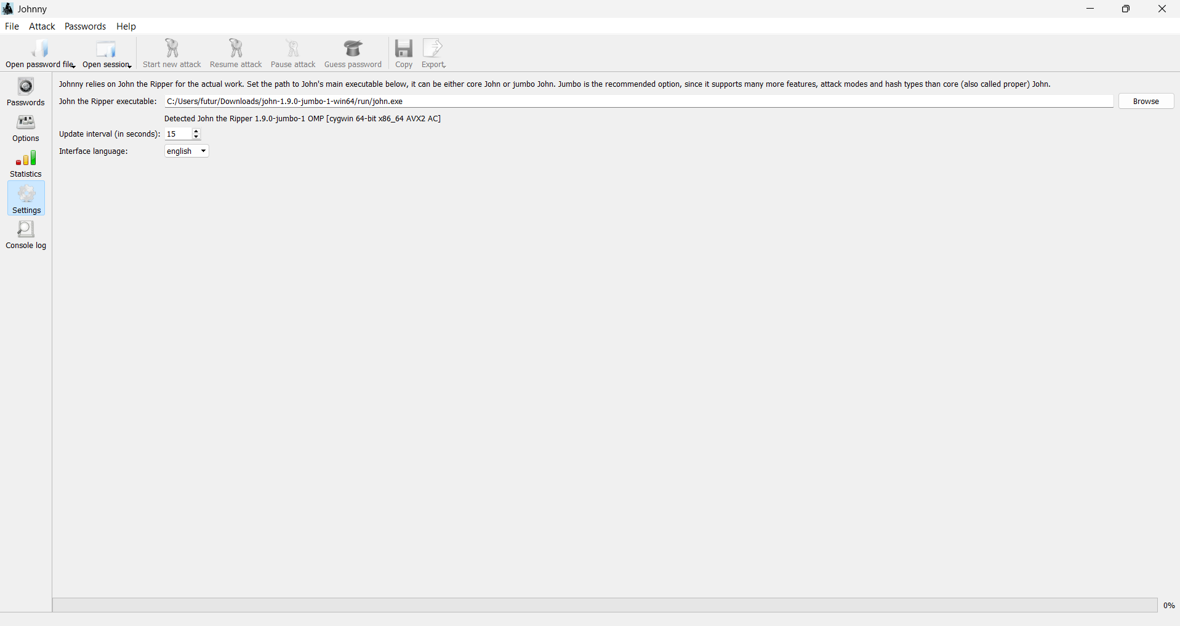
Figure 4: Johnny Settings - JTR executable detected successfully

6. Task 4: PDF Password Cracking with JTR
This is the main practical task where we crack PDF passwords.

Step-by-step Methodology:
- Step 1: Download the encrypted PDF files to PC (My Locked PDF1, PDF2, PDF3).
- Step 2: Go to hash extraction website: https://www.onlinehashcrack.com/tools-pdf-hash-extractor.php
- Step 3: Click Browse, select locked PDF, click Upload.
- Step 4: Website extracts hash in format $pdf$4*4*128*-102... Copy the hash. Note: Remove extra characters like b' if present, ensure hash starts with $pdf$....
- Step 5: Open Notepad, paste hash value, save as hash1.txt / hash2.txt / hash3.txt
- Step 6: Open Johnny, click 'Open password file', select 'Open password file (PASSWD format)', choose txt file with hash.
- Step 7: Click 'Start new attack'. Johnny will run John the Ripper in background using dictionary/bruteforce.
- Step 8: Password appears in 'Password' column after cracking (100% - 1/1 cracked).
- Step 9: Open locked PDF in Chrome/Browser, enter cracked password, PDF opens and flag is captured.

Cracking Results - Screenshots from Johnny
PDF 1 - Password Cracked: good-luck
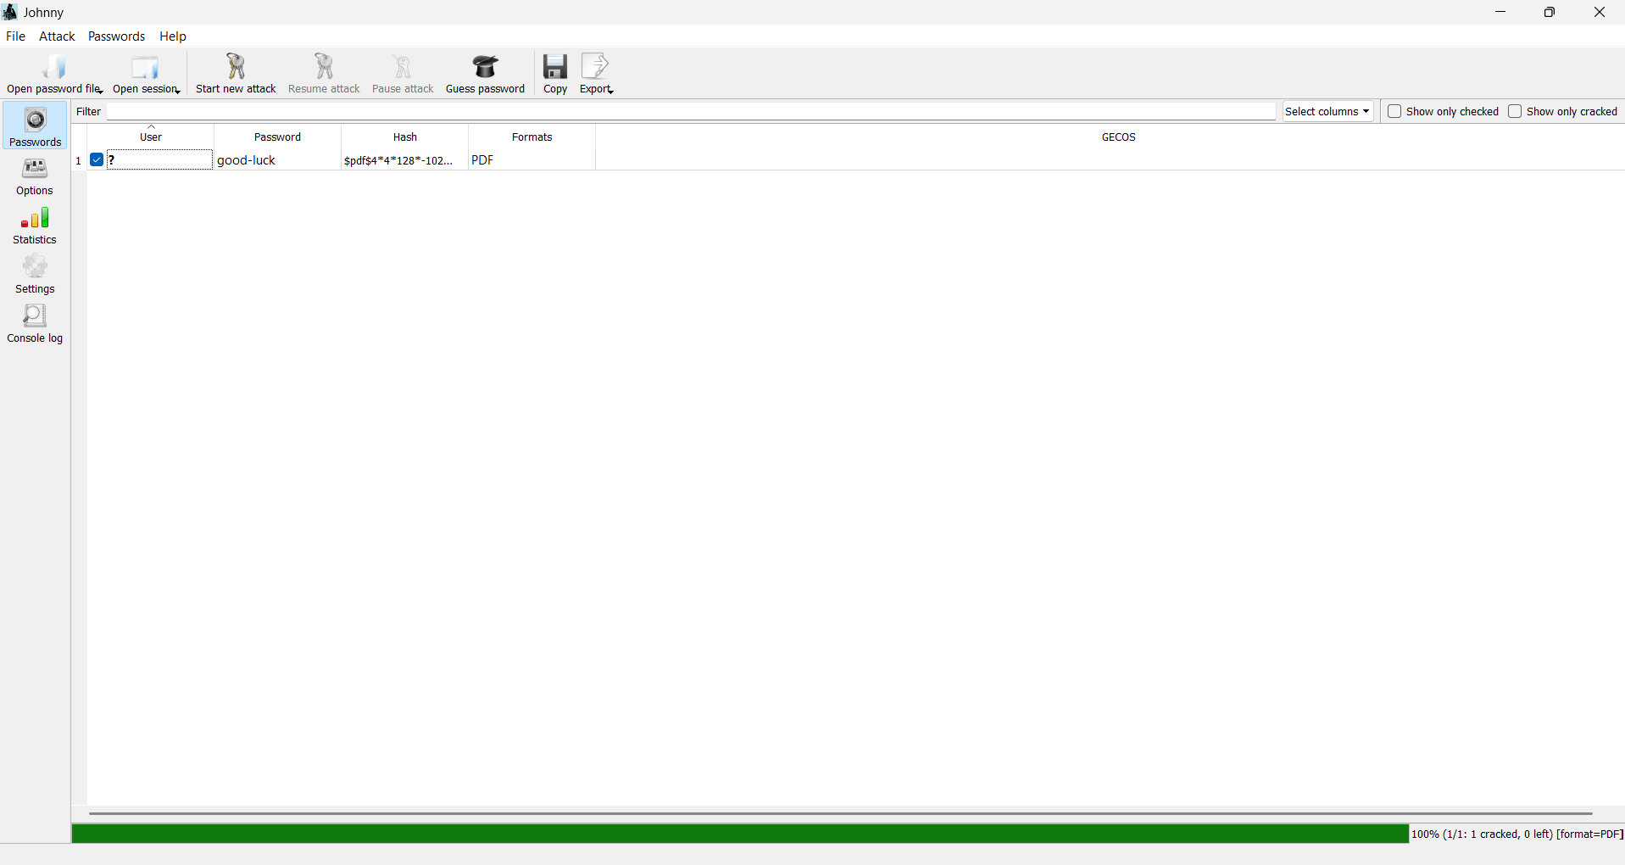
Figure 5: Johnny showing cracked password 'good-luck' for PDF1 - Format: PDF, Status: 100% cracked
PDF 2 - Password Cracked: password1
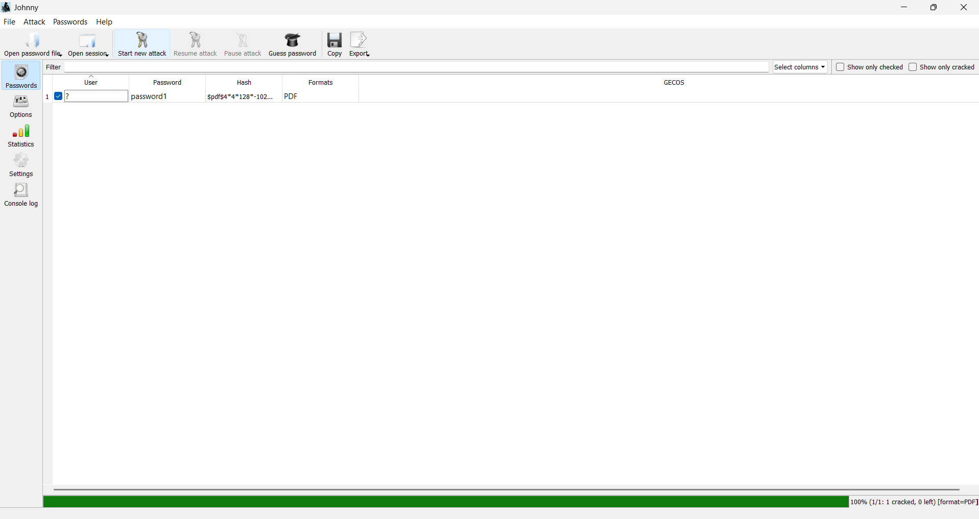
Figure 6: Johnny showing cracked password 'password1' for PDF2
PDF 3 - Password Cracked: 1qaz2wsx
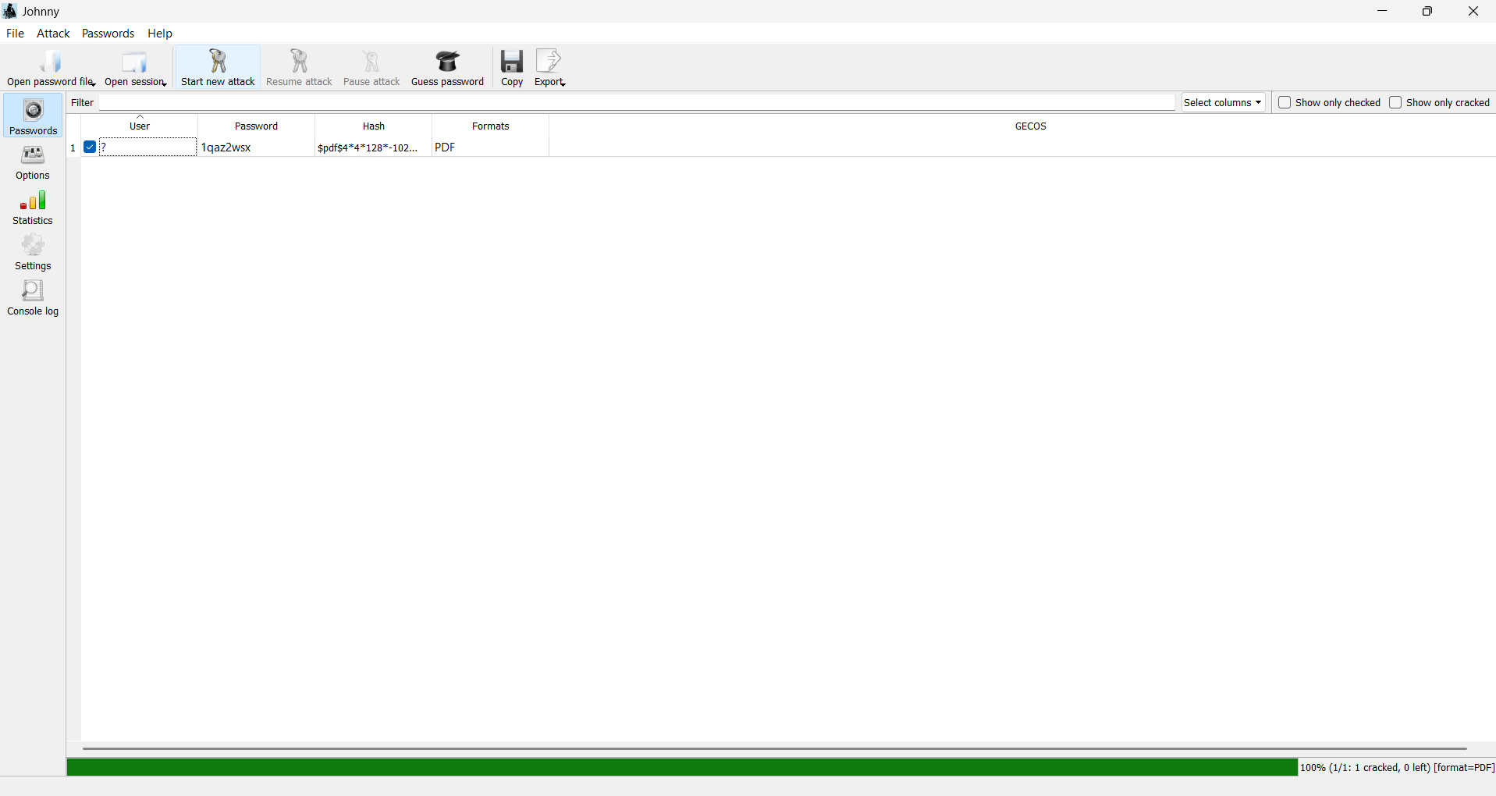
Figure 7: Johnny showing cracked password '1qaz2wsx' for PDF3
All three passwords were cracked successfully with 100% success rate. The attack used default wordlist which contains common passwords. This demonstrates why weak passwords like 'password1' and 'good-luck' should be avoided.

7. Flags Captured - Final Results
After entering the cracked passwords, the PDF files opened and revealed congratulatory messages with flags.
PDF File | Cracked Password | Flag Captured
My Locked PDF1.pdf | good-luck | nw{cybersecurity_flag_captured_2608}
My Locked PDF2.pdf | password1 | nw{networkwalks_persistence_jtr_270521}
My Locked PDF3.pdf | 1qaz2wsx | nw{networkwalks_flag_260821_1}

Flag 1 Screenshot - My Locked PDF1.pdf opened in Chrome:
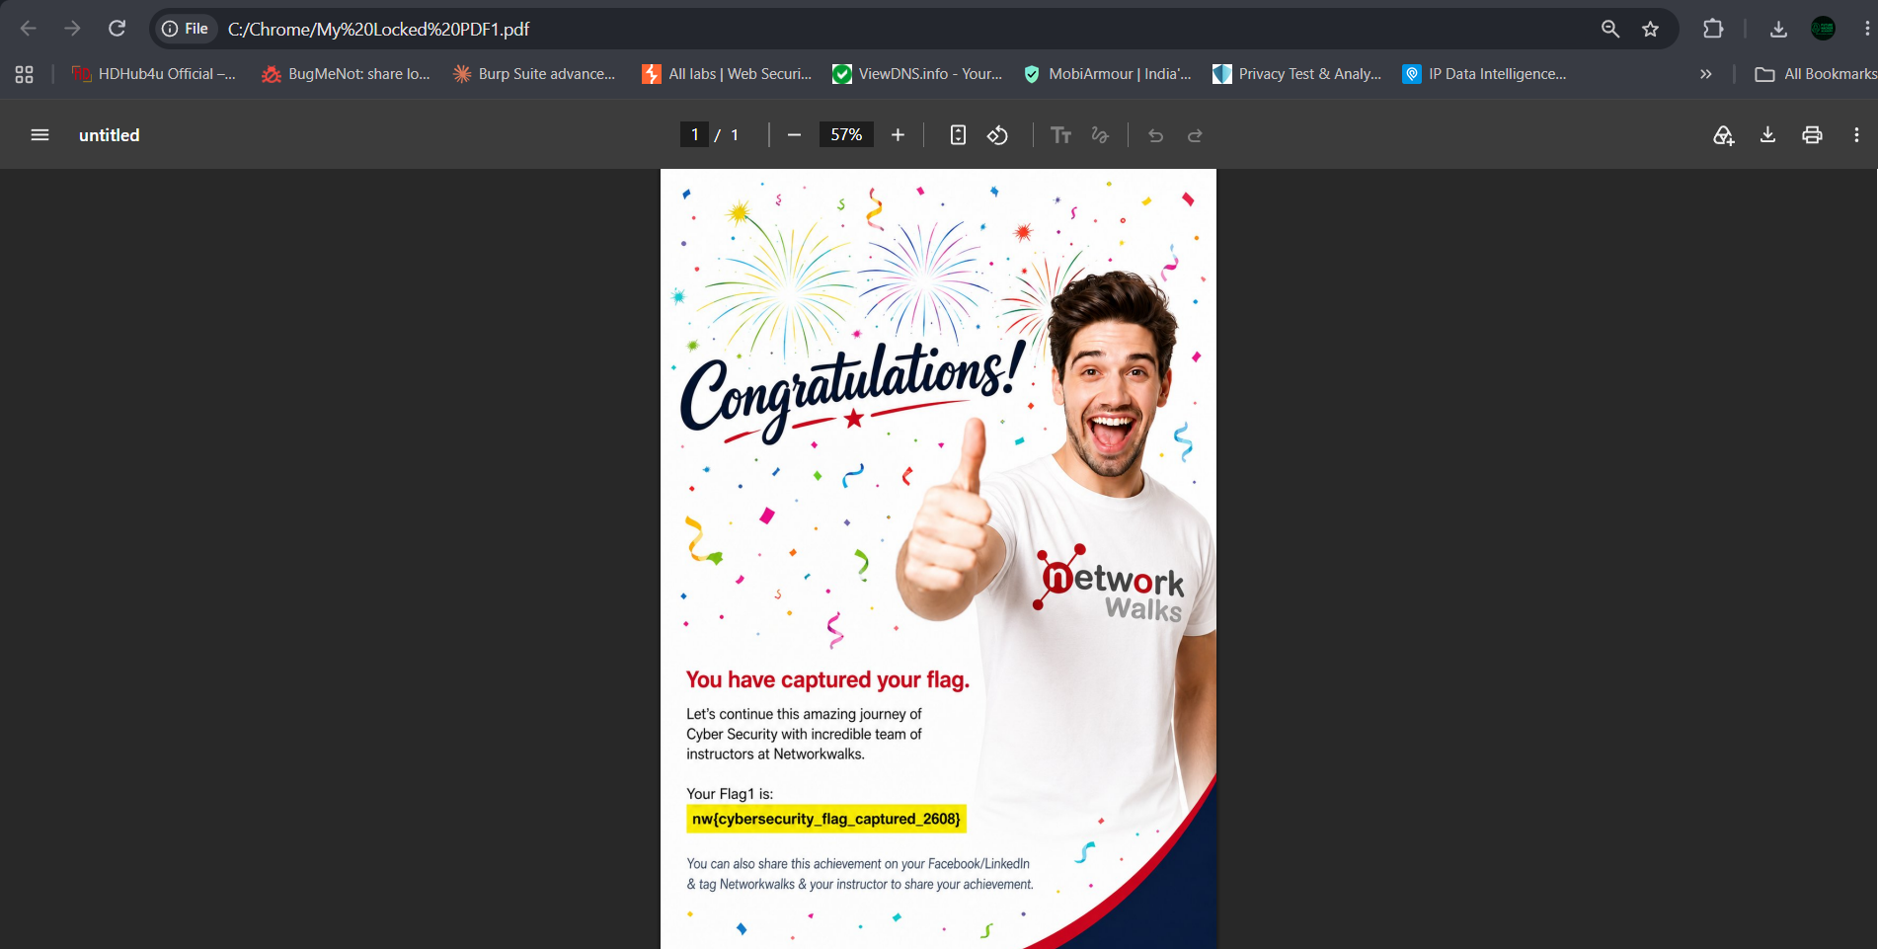
Figure 8: Flag 1 - nw{cybersecurity_flag_captured_2608} - 'Congratulations! You have captured your flag.'
Flag 2 Screenshot - My Locked PDF2.pdf:
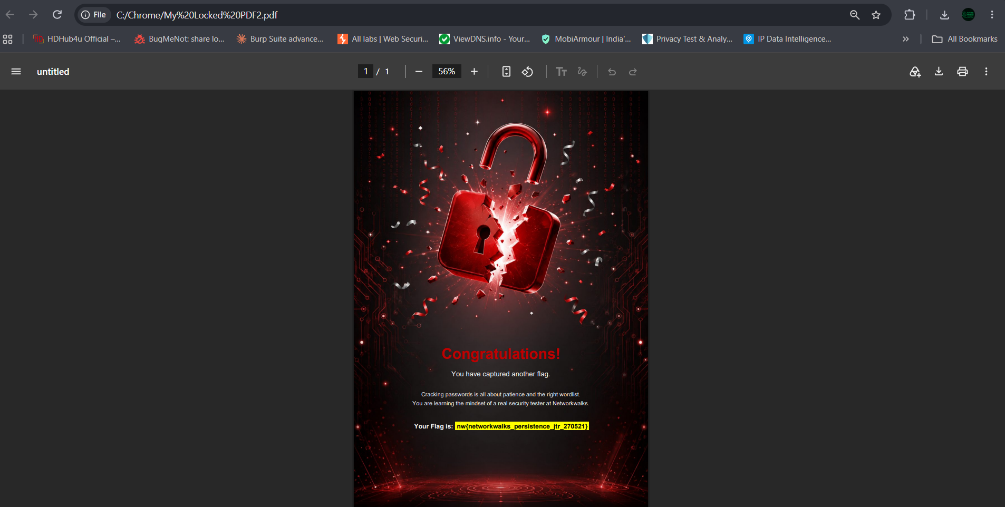
Figure 9: Flag 2 - nw{networkwalks_persistence_jtr_270521} - 'Cracking passwords is all about patience and the right wordlist.'
Flag 3 Screenshot - My Locked PDF3.pdf:
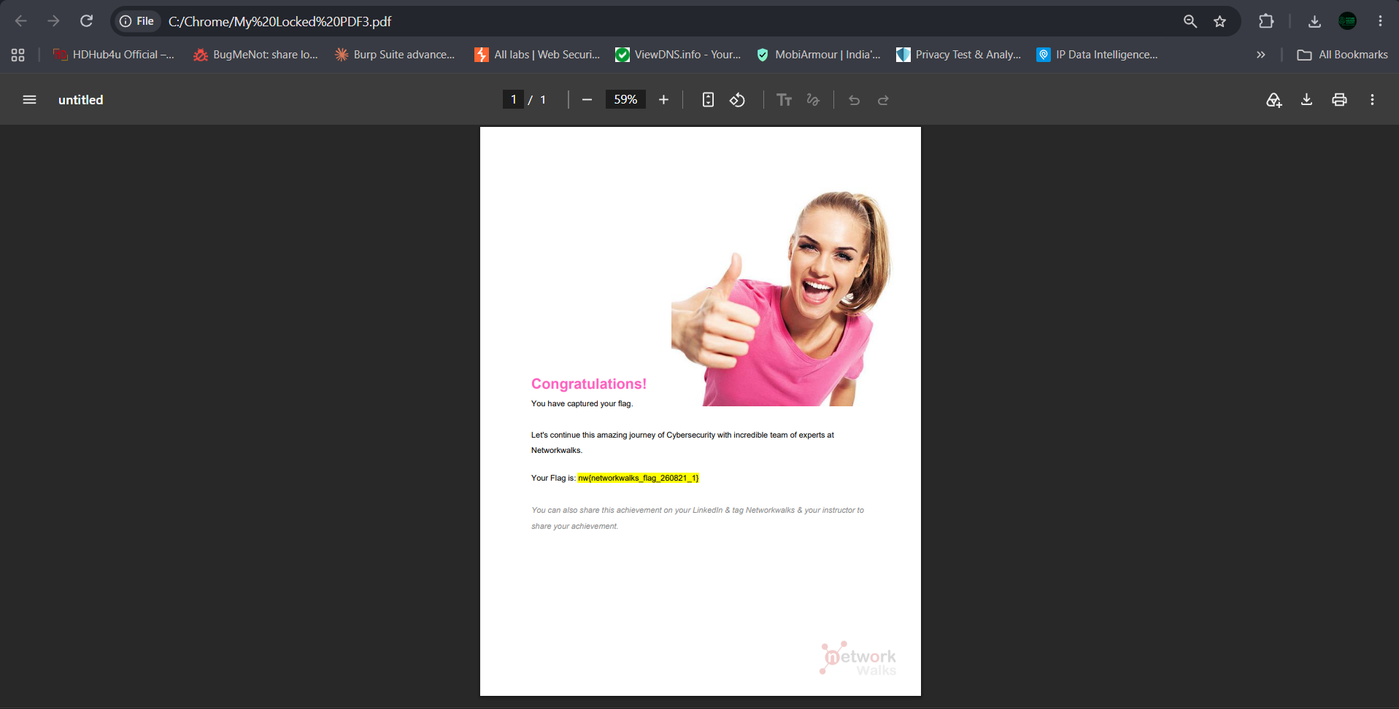
Figure 10: Flag 3 - nw{networkwalks_flag_260821_1}

8. Learning Outcomes
- Successfully installed and configured John the Ripper 1.9.0-jumbo-1 on Windows 11.
- Installed and integrated Johnny GUI with JTR executable path.
- Understood the concept of hash extraction from protected files - PDF hash format $pdf$...
- Learned how to use Johnny to load hash files and start dictionary attacks.
- Cracked 3 different PDF passwords using JTR - demonstrating weak password vulnerability.
- Understood importance of strong passwords: 'password1', 'good-luck', '1qaz2wsx' are all in common wordlists and crackable within seconds.
- Gained hands-on experience with password cracking mindset required for penetration testing.
- Learned about persistence and patience required in real security testing scenarios.

Security Lessons:
1. Weak passwords can be cracked in seconds using tools like JTR.
2. PDF protection with weak passwords is not secure - always use long, complex passwords with special characters.
3. Hash extraction is possible from many file formats - ZIP, RAR, PDF, Office docs.
4. In real pentesting, always get proper authorization before attempting password cracking.
5. Use strong, unique passwords and enable 2FA where possible.

9. Conclusion
This project module was successfully completed. We were able to:
- Install JTR and Johnny on Windows system
- Configure Johnny to use JTR's john.exe
- Extract hashes from 3 locked PDF files
- Crack their passwords: good-luck, password1, 1qaz2wsx
- Capture flags: nw{cybersecurity_flag_captured_2608}, nw{networkwalks_persistence_jtr_270521}, nw{networkwalks_flag_260821_1}
The project demonstrates practical password cracking skills and emphasizes the importance of strong password policies in cybersecurity. The experience gained here lays foundation for more advanced ethical hacking concepts in upcoming modules.
Congratulations message from PDFs confirms successful completion of Week 3 Project Module 1.

10. References & Tools
- John the Ripper Official: https://www.openwall.com/john/
- Johnny GUI Wiki: https://www.openwall.info/wiki/john/johnny
- JTR Binaries: https://distro.ibiblio.org/openwall/projects/john/1.9.0/
- PDF Hash Extractor: https://www.onlinehashcrack.com/tools-pdf-hash-extractor.php
- Networkwalks Cybersecurity Labs - www.networkwalks.com
- Google Drive Resources (provided in task): https://drive.google.com/drive/u/1/folders/1aHtgOh7U9mQhkN8VHU7ctTyaDg5KbuJx

Submitted By:
Sagar Shah
Week 3 - Project Module 1
Password Cracking with JTR
Networkwalks Cybersecurity Training
Date: 22 September 2026

