WEEK 3 | PROJECT MODULE 2

PASSWORD CRACKING WITH NETWORKWALKS TOOLS

Project Title | Password Cracking with Networkwalks Tools (Online Lab)
Module | Week 3 - Project Module 2 (PM2)
Tools Used | Networkwalks Hash Calculator, Networkwalks Password Cracker (Dictionary Attack Lab)
Submitted By | Sagar Shah
Date | 23 September 2026

Table of Contents
- 1. Project Goals & Background
- 2. Lab Overview & Tools
- 3. Task 1: Download Lab Files
- 4. Task 2: Calculate PDF Hash using Hash Calculator
- 5. Task 3: Crack Password using Password Cracker Tool
- 6. Task 4: Access PDF and Capture Flag
- 7. Complete Results - All 3 PDFs
- 8. Learning Outcomes
- 9. Conclusion
- 10. References

1. Project Goals & Background
The goal of this project is to use the Networkwalks online tools to crack the password of PDF files. Here we use the Networkwalks hashing and password cracking online tools directly in the browser without installing anything. This lab does the same job as the JTR lab but with free browser tools - nothing to install, everything runs in your web browser, so it is easy and fast.

What is Password Cracking?
Password cracking is the process of recovering a password from stored data or a protected file. Security professionals use it to test how strong a password is and to show why weak passwords are risky. If a password is short or common, it can be found quickly, which proves the need for strong passwords.
Many files like PDF, ZIP, and Office documents can be locked with a password. When a file is locked, its password is stored in the form of a hash. A hash is a scrambled value that represents the password. To recover the password, we first take out this hash from the file (pdf2john), and then run it through a cracking tool that tries different words until it finds a match.

Why Networkwalks Tools?
Networkwalks provides two free online tools:
1. Hash Calculator (https://networkwalks.com/hash-calculator/) - Generates MD5, SHA-1, SHA-256, SHA-384, SHA-512, or extracts a crackable hash from a password-protected PDF. The PDF is parsed locally, nothing is uploaded to server - secure.
2. Password Cracker (https://networkwalks.com/password-cracker/) - Dictionary Attack Lab that hashes every word in a wordlist and matches it against a PDF password hash, same idea John the Ripper uses.
Both tools run in any web browser, no installation needed, works on Windows and Kali Linux both.

2. Lab Overview & Tools
Lab URL: https://networkwalks.com/password-cracking-with-networkwalks-tools-project-task-lab/
This page contains:
- Lab task sheet (Password Cracking with Networkwalks Tools)
- My Locked PDF1.pdf, PDF2.pdf, PDF3.pdf
- Links to Hash Calculator and Password Cracker
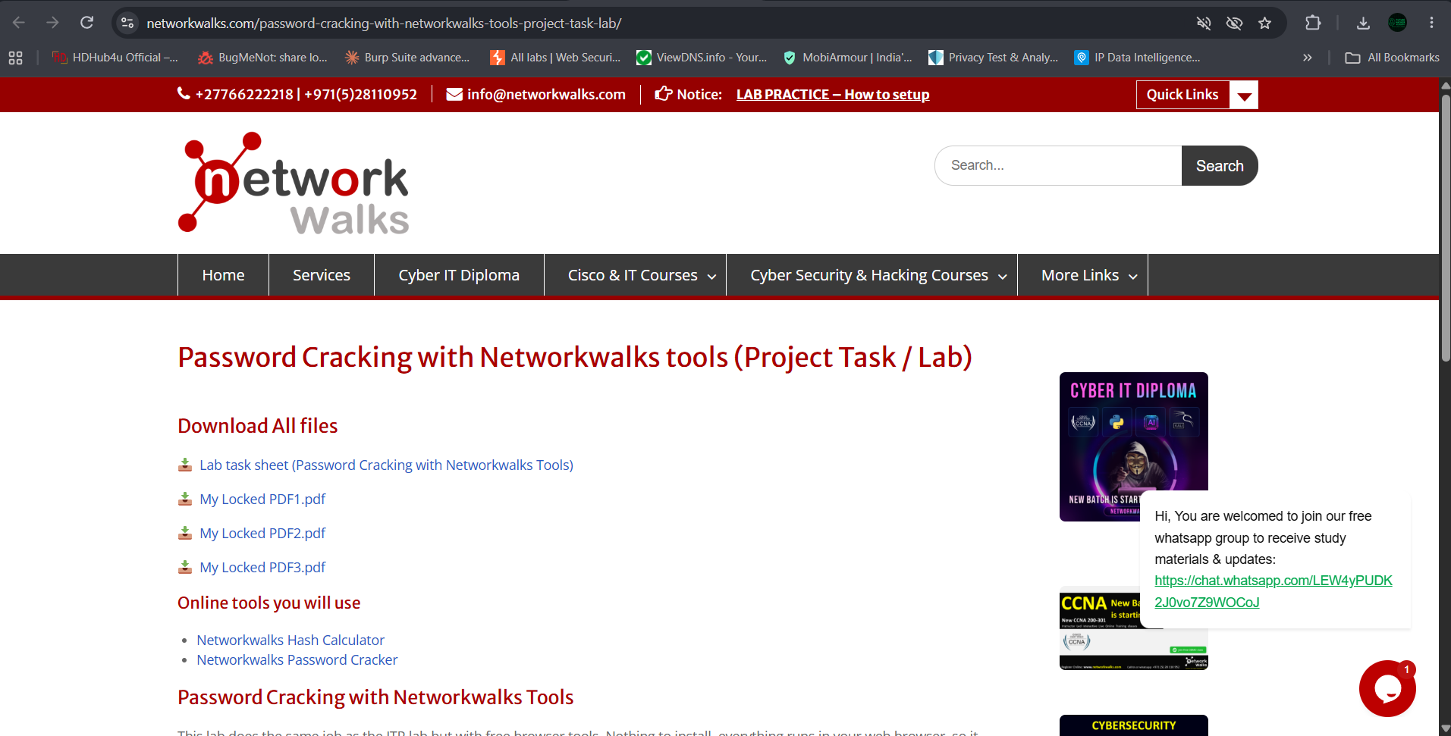
Figure 1: Networkwalks Lab Task Page showing download links for 3 locked PDFs and online tools

3. Task 1: Download Lab Files
Steps:
1. Visited https://networkwalks.com/password-cracking-with-networkwalks-tools-project-task-lab/
2. Downloaded My Locked PDF1.pdf, My Locked PDF2.pdf, My Locked PDF3.pdf to C:/Chrome/ folder (as seen in browser address bar)
3. Verified files are password protected - when opened in Chrome, they ask for password.

4. Task 2: Calculate PDF Hash using Networkwalks Hash Calculator
Tool: https://networkwalks.com/hash-calculator/
Steps:
1. Opened Hash Calculator tool
2. Went to PDF tab (3 tabs: Text, File, PDF)
3. Clicked on 'Click to choose a PDF, or drop one here' area
4. Selected My-Locked-PDF1.pdf - Tool shows 'Nothing is uploaded, the PDF is parsed locally' for privacy
5. Tool automatically detected encryption and extracted crackable hash in pdf2john / hashcat compatible format ($pdf$4*4*128*...)
6. Copied full hash and noted Revision: R4, Version: V4, Key length: 128 bit

PDF 1 Hash Extraction:
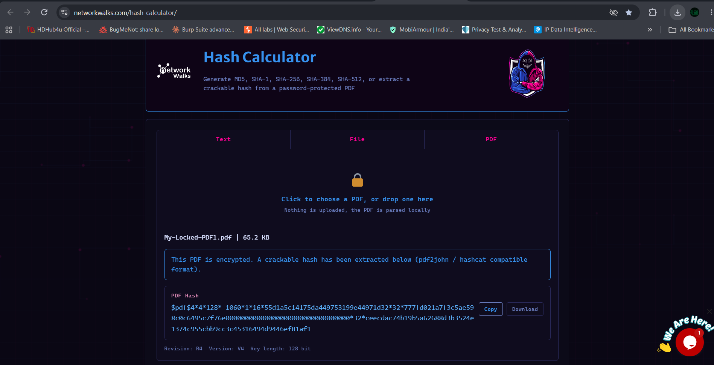
Figure 2: Hash Calculator - My-Locked-PDF1.pdf (65.2 KB) hash extracted: $pdf$4*4*128*-1060*1*16*55d1a5c... pdf2john compatible

PDF 2 Hash Extraction:
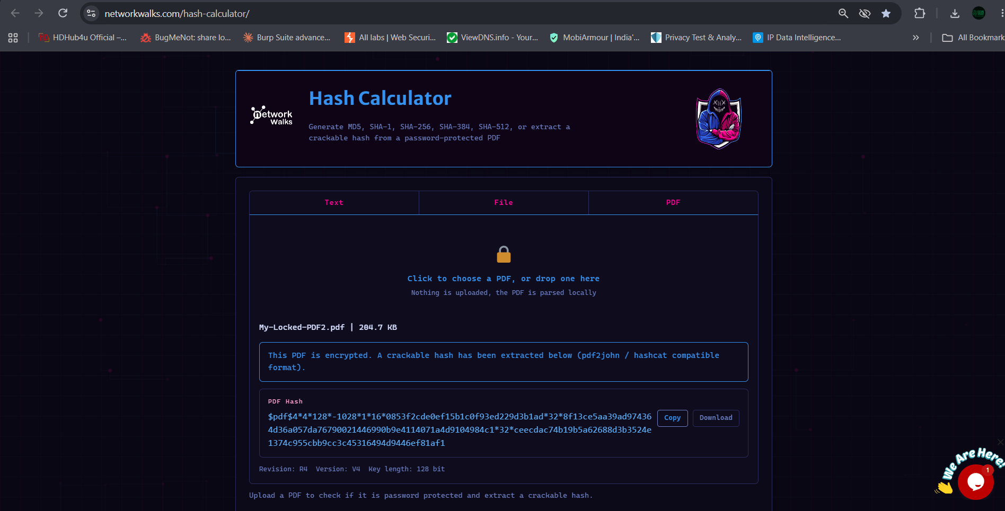
Figure 3: Hash Calculator - My-Locked-PDF2.pdf (204.7 KB) hash extracted - Revision R4, V4, 128 bit

PDF 3 Hash Extraction:
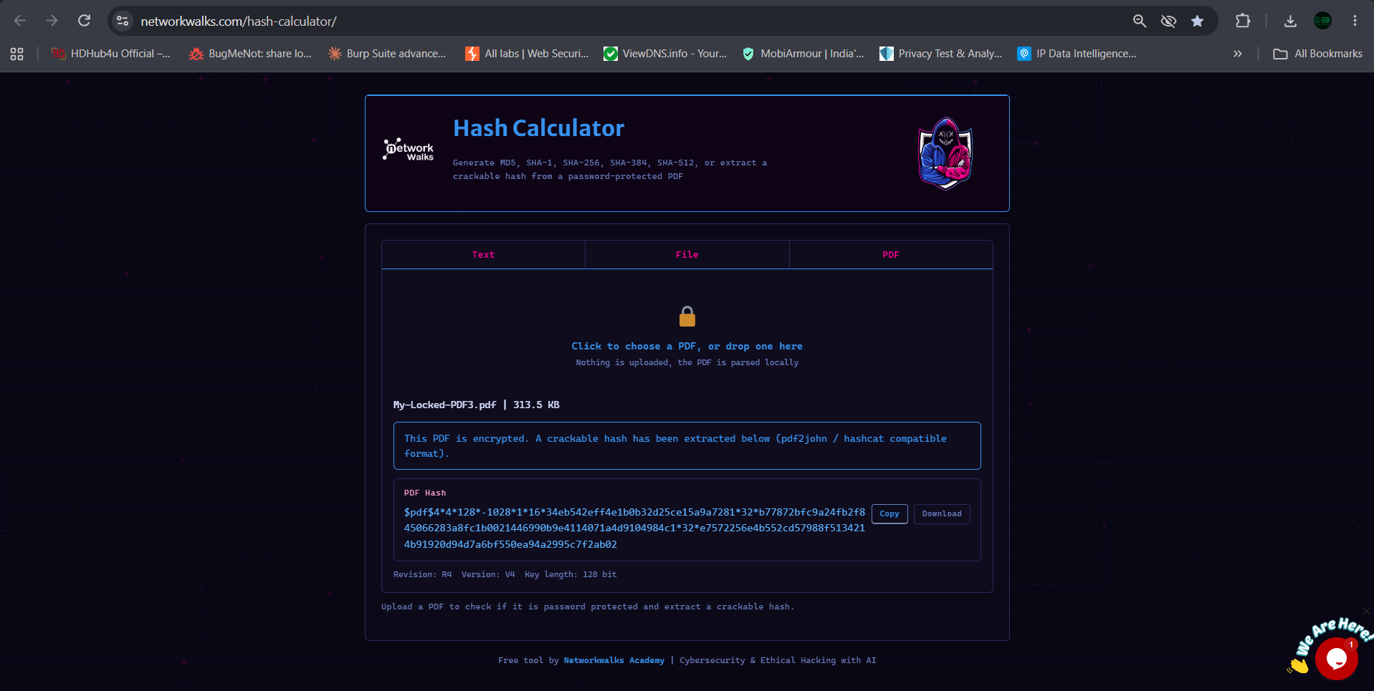
Figure 4: Hash Calculator - My-Locked-PDF3.pdf (313.5 KB) hash extracted
Note: Always copy the complete hash starting from $pdf$. Do not miss any part. The tool also provides Copy and Download buttons.

5. Task 3: Cracking the Password using Networkwalks Password Cracker
Tool: https://networkwalks.com/password-cracker/
This is a Dictionary Attack Lab that works like John the Ripper.
Steps:
1. Went to Password Cracker tool
2. Pasted the $pdf$ hash into 'PDF HASH' input box
3. Selected wordlist: Built-in list (100 passwords)
4. Clicked Start Cracking
5. Tool shows live progress: Tried: X / 100, speed: 9 pm/s, console like '[-] Trying: daniel X'
6. When found, shows 'PASSWORD CRACKED SUCCESSFULLY' in green

PDF 1 Cracking Result:
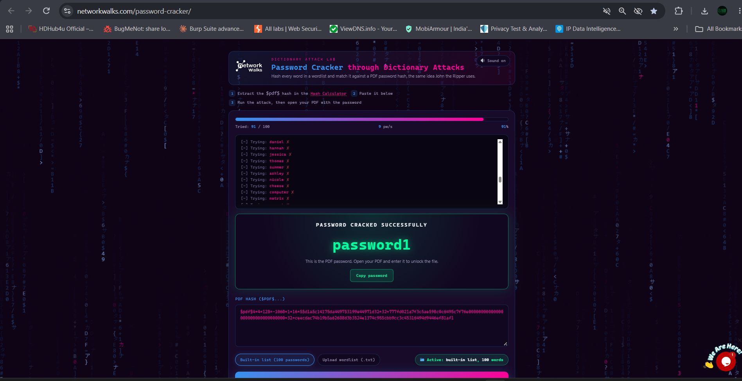
Figure 5: Password Cracker - PDF1 - Tried 91/100 words at 9 pm/s - Password Cracked Successfully: password1

PDF 2 Cracking Result:
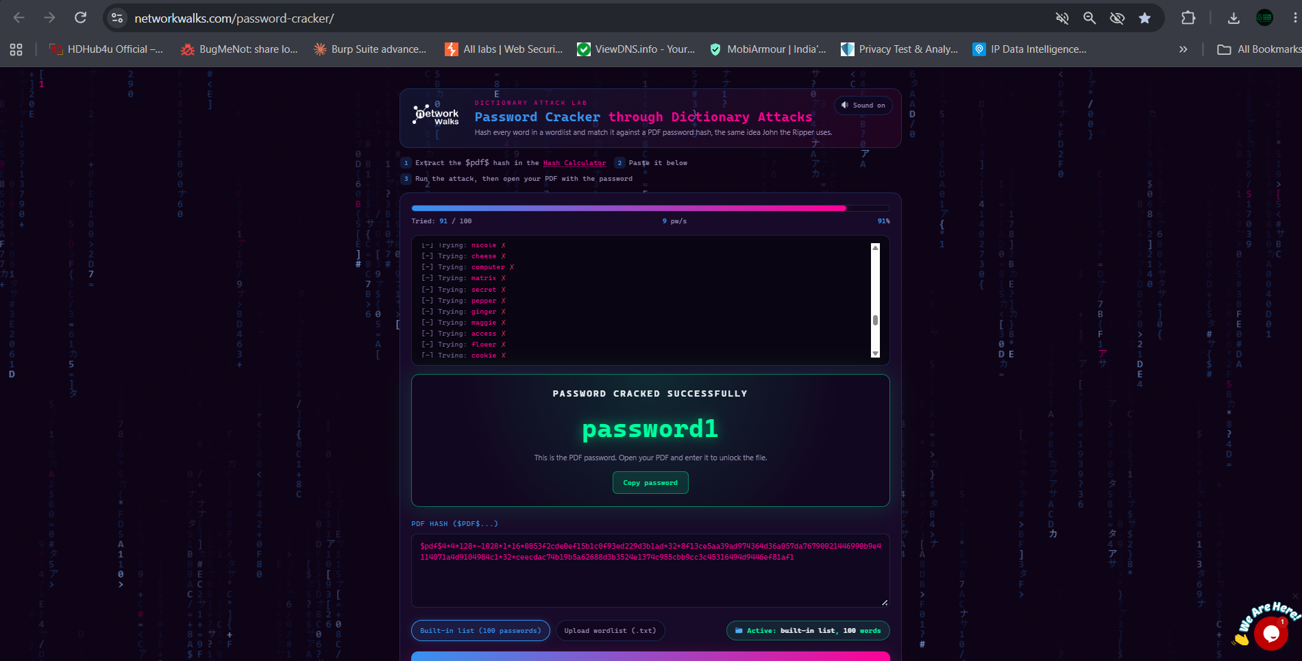
Figure 6: Password Cracker - PDF2 - Same result: password1 cracked

PDF 3 Cracking Result:
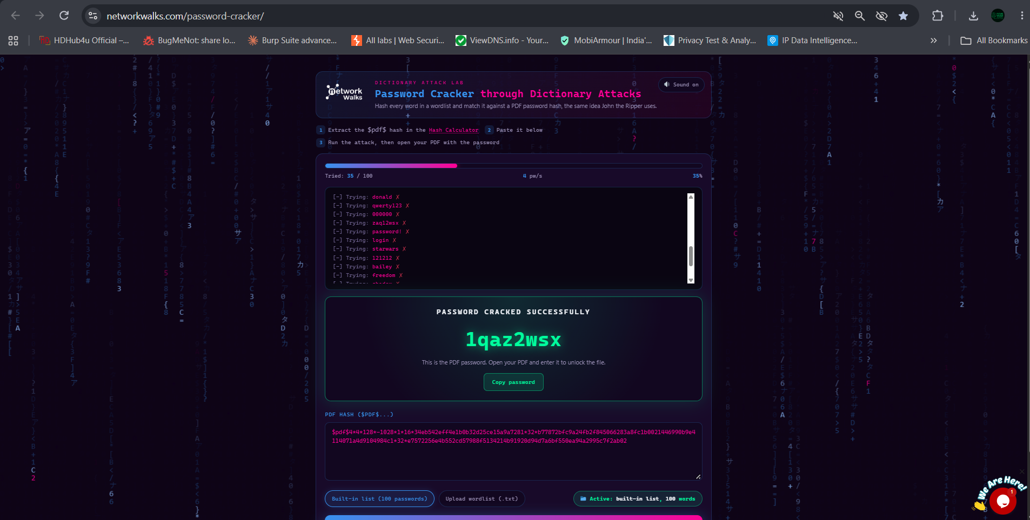
Figure 7: Password Cracker - PDF3 - Tried 35/100 words at 4 pm/s - Password Cracked: 1qaz2wsx

6. Task 4: Enter Password to PDF and Capture Flag
After cracking, we open the locked PDF in Chrome and enter the cracked password. The PDF opens and shows Congratulations message with flag.

PDF 1 Flag:
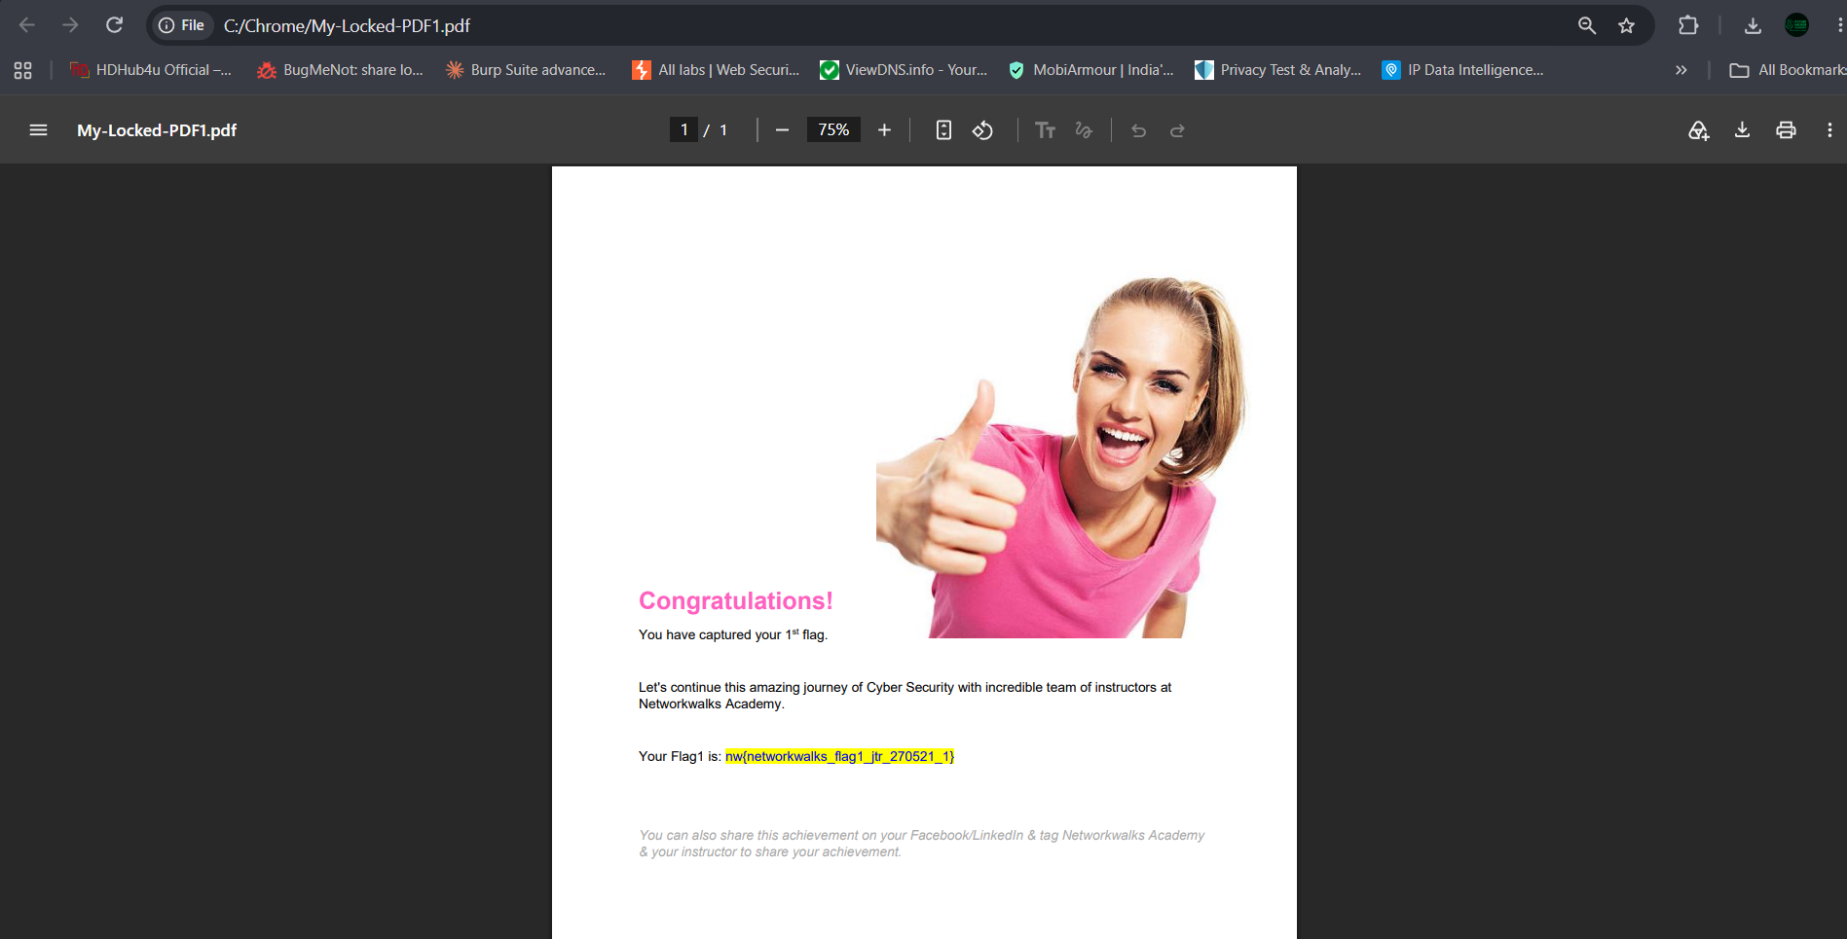
Figure 8: My-Locked-PDF1.pdf opened - Flag: nw{networkwalks_flag1_jtr_270521_1}

PDF 2 Flag:
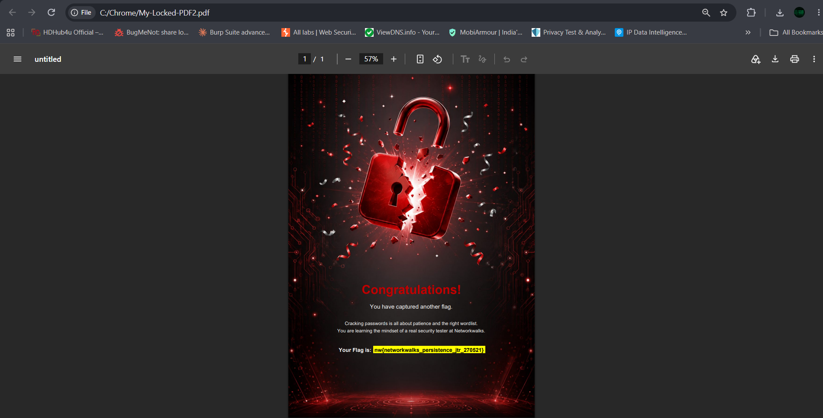
Figure 9: My-Locked-PDF2.pdf opened - Flag: nw{networkwalks_persistence_jtr_270521}

PDF 3 Flag:
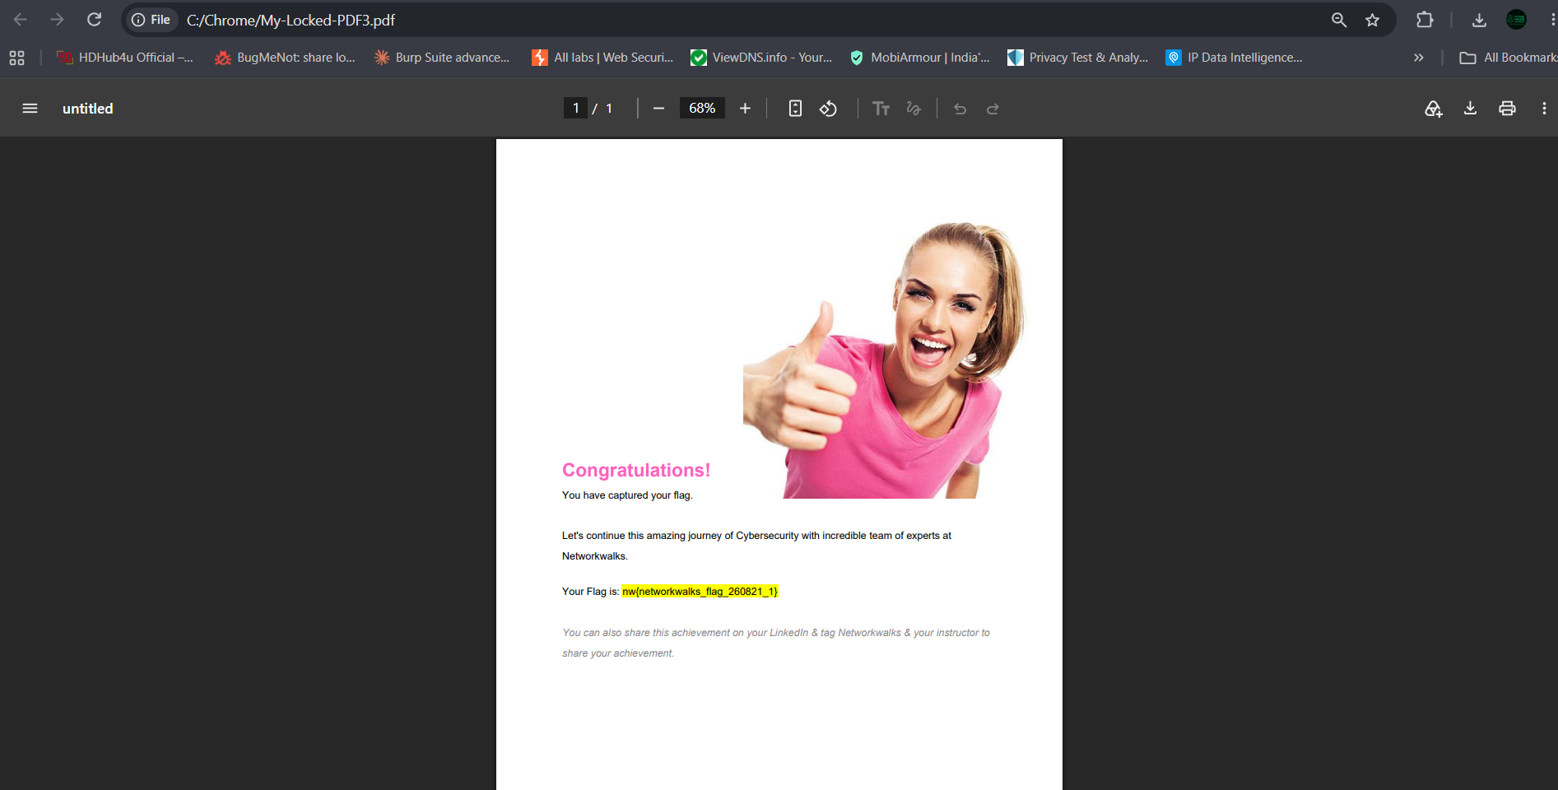
Figure 10: My-Locked-PDF3.pdf opened - Flag: nw{networkwalks_flag_260821_1}

7. Complete Results - Summary Table
PDF File | Size | Cracked Password | Flag
My-Locked-PDF1.pdf | 65.2 KB | password1 | nw{networkwalks_flag1_jtr_270521_1}
My-Locked-PDF2.pdf | 204.7 KB | password1 | nw{networkwalks_persistence_jtr_270521}
My-Locked-PDF3.pdf | 313.5 KB | 1qaz2wsx | nw{networkwalks_flag_260821_1}

All three PDFs were successfully cracked using Networkwalks online tools. The built-in wordlist of 100 common passwords was sufficient because passwords were weak.

8. Learning Outcomes
- Learned to use Networkwalks Hash Calculator to extract crackable hash from encrypted PDF without uploading file (local parsing).
- Understood PDF hash format: $pdf$4*4*128*-... compatible with pdf2john and hashcat.
- Learned to use Networkwalks Password Cracker - Dictionary Attack Lab that mimics John the Ripper in browser.
- Observed live dictionary attack: trying words like daniel, hannah, jessica, thomas, summer, etc.
- Cracked 3 PDFs: password1 (twice) and 1qaz2wsx (keyboard walk pattern) - both weak passwords in top 100 list.
- Understood why weak passwords are risky: common passwords like 'password1' are cracked in seconds at 9 passwords/sec.
- Learned importance of strong passwords: 12+ characters, mixed case, numbers, symbols, not in dictionary.
- Gained practical experience with online CTF-style flag capture methodology.
- Realized that online tools can perform same job as offline JTR without installation.

Security Insights:
• A simple 8-char lowercase password can be cracked in minutes
• Over 24 billion username/password pairs are available on dark web
• '123456' and 'password' are still most used passwords every year
• 2025 leak of 183 million Gmail logins shows old stolen passwords keep circulating
• Use password managers, enable 2FA, and use unique strong passwords

9. Conclusion
This Project Module 2 was successfully completed using only browser-based tools.
We achieved:
- Downloaded 3 locked PDFs from Networkwalks lab page
- Extracted hashes using Hash Calculator (R4, V4, 128-bit)
- Cracked passwords using Password Cracker dictionary attack (Built-in 100 wordlist)
* PDF1: password1 -> nw{networkwalks_flag1_jtr_270521_1}
* PDF2: password1 -> nw{networkwalks_persistence_jtr_270521}
* PDF3: 1qaz2wsx -> nw{networkwalks_flag_260821_1}
- Opened PDFs and captured flags
The lab demonstrates that password cracking is all about patience and the right wordlist. You are learning the mindset of a real security tester at Networkwalks. This browser-based approach is perfect for beginners.
Congratulations! All flags captured.

10. References & Tools
- Lab Task Page: https://networkwalks.com/password-cracking-with-networkwalks-tools-project-task-lab/
- Hash Calculator: https://networkwalks.com/hash-calculator/
- Password Cracker: https://networkwalks.com/password-cracker/
- Networkwalks Academy - www.networkwalks.com
- Related JTR Lab: Week3 Project Module1 used offline JTR + Johnny

Submitted By:
Sagar Shah
Week 3 - Project Module 2
Password Cracking with Networkwalks Tools
Networkwalks Cybersecurity Training
Date: 23 September 2026

